**Experimental Investigation and design of Arduino-powered Fire-fighting Vehicle**

Mr. Md Sanauwar*1, Mr. Shahil Ali*2, Mr. Mahtab Alam*3, Ms. Laxmi Khatri*4, Ms. Anushka Patel*5, Mr Anas Kamal*6, Mr. Syd Sabir Rizvi*7

*1,2,3,4,5,6 Students, Department of Electrical and electronics Engineering, Oriental institute of Science & Technology Bhopal, MP India

*7 Assistant Professor, Department of Electrical and electronics Engineering, Oriental institute of Science & Technology Bhopal, MP India

**ABSTRACT**

A firefighter's role involves identifying and putting out fires. In today's fast-paced technological landscape, there's a shift towards automation. However, firefighters face significant risks, especially from toxic gases present in fire situations, which contribute to many fatalities. To address these challenges, we have developed a firefighting robot. This robot utilizes ARDUINO and fire sensors. When a fire is detected, it alerts the ARDUINO, which then signals the motor driver to direct and spray water onto the flames. This robot aids firefighters by tackling fires in hard-to-reach areas, minimizing risks to their lives and preventing additional damage.

Keywords: Arduino, Fire fighting Robot, fire sensors

**I. INTRODUCTION**

One of the most crucial factors in fire emergencies is the preservation of life, particularly the lives lost while attempting to save others. Firefighters often struggle to reach fire sites due to hazards like explosive materials, smoke, and extreme heat. A quick response to fire detection can help avert significant disasters. Statistics reveal that fires can occur in both residential and industrial settings, where even a minor spark can trigger a catastrophic blaze. The safety of individuals in both sectors is threatened by inadequate fire management systems, but effective fire control measures can mitigate these risks. In our modern age, various robots are designed to eliminate human involvement in dangerous tasks. The use of robots has become increasingly prevalent for safely handling labor-intensive or perilous jobs. Our Fire Extinguishing Robot is based on IoT technology and aims to autonomously extinguish small flames by sensing and navigating to their source. This robot is equipped with flame sensors that detect fire from three directions: left, forward, and right. Upon identifying a fire, the robot will activate its navigation system to approach the source and deploy its built-in extinguishing mechanism. Once the fire detection system identifies flames, the water pump is triggered to spray water at the fire. The main feature of this system is its capability to monitor fire incidents, ultimately reducing the likelihood of major fire disasters and minimizing the loss of human lives.

**II. METHODLOGY**

The focus of this paper is to create a system that can automatically detect and extinguish environmental fires without human intervention. The methodology is divided into three sections: design structure, hardware description, and programming design. These components were integrated, and experiments were conducted to develop a functional fire-extinguishing system.

**Design Structure**

This section presents the prototype of the robotic system, which includes IR flame sensors, servo motors, a submersible water pump, a motor driver, a mini breadboard, BO motors, rubber wheels, a processor, and a communication module for data exchange between the firefighting robot and the Arduino software. The robot performs four main functions. First, it initializes itself; its sensors activate as soon as power is supplied. Second, the robot senses the surrounding environment (for example, monitoring temperature levels) to identify the location of the fire. Third, it transmits navigational information and begins to navigate itself toward the fire source. Fourth, the robot activates its extinguishing mechanism using the servo motors and submersible water pump to put out the flames.

**III. CIRCUIT DIAGRAM**

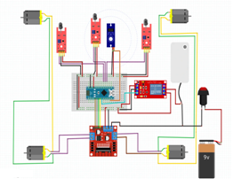

Fig. 1. Circuit Diagram

Arduino-based fire-fighting robot with three IR flame sensors that detects fire and autonomously moves, equipped with a robot chassis with a motor driver to control movement, and extinguishes fire using a DC water pump motor: Components:

1. Arduino board (e.g., Arduino Uno)

2. IR flame sensors (3x)

3. Motor driver module (e.g., L298N)

4. DC water pump motor

5. Robot chassis with motors (typically DC motors)

6. Power supply (e.g., battery pack)

7. Jumper wires Circuit Connections:

1. Connect the power supply to the Arduino board and the motor driver module.

2. Connect the Arduino board to the motor driver module as follows: - Connect the Arduino's 5V pin to the VCC pin of the motor driver module. - Connect the Arduino's GND pin to the GND pin of the motor driver module. - Connect two digital pins of the Arduino to the motor driver module's input pins (e.g., IN1 and IN2) for controlling motor movement.

3. Connect the robot chassis motors to the motor driver module: - Connect one motor to OUT1 and OUT2 pins of the motor driver module. Connect the other motor to OUT3 and OUT4 pins of the motor driver module.

4. Connect the IR flame sensors to the Arduino board: - Connect the VCC pin of each flame sensor to the Arduino's 5V pin. - Connect the GND pin of each flame sensor to the Arduino's GND pin. - Connect the output pin of each flame sensor to a separate digital pin on the Arduino (e.g., A0, A1, A2).

5. Connect the DC water pump motor to the Arduino board: - Connect the positive terminal of the water pump motor to an external power supply. - Connect the negative terminal of the water pump motor to the collector pin of a transistor (e.g., NPN transistor). - Connect the emitter pin of the transistor to the GND pin of the external power supply. - Connect the base pin of the transistor to a digital pin on the Arduino (e.g., D3). - Add a diode (e.g., 1N4001) across the terminals of the water pump motor to protect against voltage spikes.

Programming:

Upload the necessary code to the Arduino board to control the flame sensors, motor driver, and water pump motor. In the code, read the sensor outputs to detect the presence of fire. Based on the sensor readings, control the motor driver to move the robot autonomously. When fire is detected, activate the water pump motor using the Arduino's digital pin connected to the transistor's base.

**IV. WORKING/IMPLEMENTATION**

The core component of this project is the Arduino, while fire detection relies on the fire sensor module. This module includes an IR receiver (photodiode) designed to detect flames. When a fire burns, it emits a small amount of infrared light, which is captured by the IR receiver. We utilize an operational amplifier to monitor voltage changes across the IR receiver; if fire is detected, the output pin (DO) will output 0V (LOW), and if no fire is present, it will output 5V (HIGH).

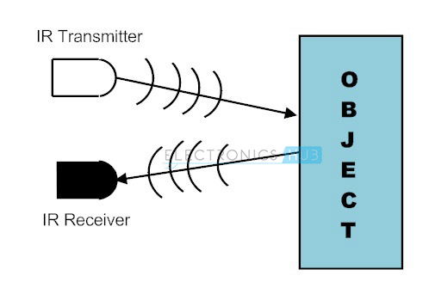

Fig. 2. Directivity Representation Of Ir Sensor On Chasis

To enhance fire detection, we position three such sensors in different directions on the robot, allowing it to identify where the fire is located. Once we determine the direction of the fire, we can maneuver the robot closer by controlling the motors through the L293D module. When in proximity to the fire, the robot uses water to extinguish it. A small container holds the water, and a 5V pump is placed within this container. The entire setup is mounted on top of a servo motor, enabling precise control over the direction of the water spray.

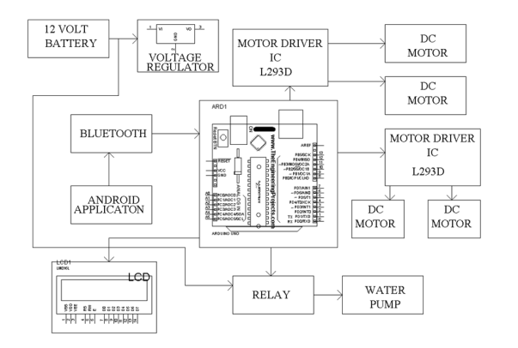

Fig. 3. FLOW CHART

**V. RESULTS**

The fire sensor will output a HIGH signal when it detects flames and a LOW signal when no fire is present. Therefore, we continuously monitor these sensors for any signs of fire. If no fire is detected, we instruct the motors to stop by setting all the pins to HIGH. When a fire is detected wavelength range 760 to 1100 nm and sensitivity varies from 10cm to 1.5feet. the robot can be directed to move toward the source by activating the corresponding motor. Once it arrives at the fire, the left and right sensors will no longer detect flames since the robot will be positioned directly in front of the fire. At this point, we use a variable called “fire” to trigger the function that extinguishes the flames.

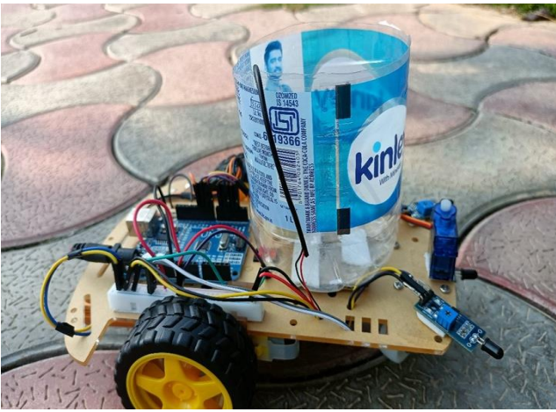

Fig. 4. Working Model

VI. Conclusion

In conclusion, the firefighting robot based on Arduino has proven to be a reliable and effective solution for combating fires. The robot's ability to detect fires, navigate through obstacles, and extinguish fires has been demonstrated in real-world scenarios. With the potential for future improvements in machine learning algorithms, thermal imaging, and swarm robotics, the fire fighting robot can become an even more valuable tool in the fight against fires.

References

[1]. Dr. N. K. Choudhari, Sai Ponnamanda, Gaurav Deshbhratar, Aashay Gajbhiye, Shivani Chaudhari, Shivani Harde, "Fire Fighting Robot", International Journal of Scientific Research in Science, Engineering and Technology (IJSRSET), Online ISSN : 2394-4099, Print ISSN : 2395-1990, Volume 10 Issue 2, pp. 514-518, March-April 2023. https://doi.org/10.32628/IJSRSET2310287

[2]. S. Kirubakaran, S.P. Rithanyaa, S.P. Thanavarsheni and E. Vigneshkumar, "Arduino based firefighting Robot", In Journal of Physics: Conference Series, vol. 1916, no. 1, pp. 012204, 2021.

[3]. C. Wu, F. Ge, G. Shang, M. Zhao, G. Wang, H. Guo, et al., "Design and Development of Intelligent Fire-fighting Robot Based on STM32", In Journal of Physics: Conference Series, vol. 1748, no. 6, pp. 062019, 2021.

[4]. M. Rivai, D. Hutabarat, Z. Muhammad, and J. Nafis, “2D mapping using omni-directional mobile robot equipped with LiDAR,” TELKOMNIKA Telecommunication, Computing, Electronics and Control, vol. 18, no. 3, pp. 1467–1474, 2020.

[5]. I. Prasojo, P.T. Nguyen and N. Shahu, "Design of Ultrasonic Sensor and Ultraviolet Sensor Implemented on a Fire Fighter Robot Using AT89S52", Journal of Robotics and Control (JRC), vol. 1, no. 2, pp. 55-58, 2020.

[6]. B. Sarwar, I. Bajwa, N. Jamil, S. Ramzan, and N. Sarwar, “An Intelligent Fire Warning Application Using IoT and an Adaptive Neuro-Fuzzy Inference System,” Sensors (Basel)., vol. 19, no. 14, pp. 1–18, 2019.