**A STUDY ON WORKING PROFESSIONALS PERCEPTION TOWARDS MUTUAL INVESTMENT**

Ramkumar P1, Dr.S.S.Onyx Nathanael Nirmal Raj2,

1MBA Student, School of Arts, Humanities and Management, Jeppiaar University, Chennai, India.

2Associate Professor, School of Arts, Humanities and Management, Jeppiaar University, Chennai, India.

1***ramkumar13131rk@gmail.com,***

[2***dronyx77@gmail.com,***](mailto:2dronyx77@gmail.com,)

**ABSTRACT**

Mutual funds are today one of the most popular and easily available investment tools for working people, offering them a single portfolio of diversified mutual funds managed by professionals. The present study is aimed at identifying the perceptions, preferences and behaviours of working professionals towards mutual investments. It examines the characteristics, advantages, disadvantages and performance of mutual funds from the viewpoint of this population. Based on the evaluation of different types of mutual funds, historical returns, risk factors, and the impact of market trends on mutual fund investments, the study aims to offer a comprehensive picture of how working professionals view mutual funds as a part of their investment plans and strategies, and thereby gain insights that can help in improving the decision-making process of working professionals regarding their mutual fund investments.

**INTRODUCTION**

The establishment of the Unit Trust of India (UTI) by the Indian government in 1964 marked the beginning of the mutual fund sector in that country. UTI has been a major force in the sector during the past 36 years, having assets of more over Rs. 52000 crores (Rs. 520 billion) as of the month of December 2001.In 1987, mutual funds were permitted to be established by public sector banks as well as two insurance firms (Life Insurance Company and General Insurance Company). The Indian capital market's regulatory agency, the Securities and Exchange Board of India (SEBI), introduced a thorough framework for mutual funds in 1993 and permitted private corporate entities to introduce mutual fund schemes. since then, the private and joint sectors have launched a number of mutual funds. There were 35 mutual fund companies as of March 2002, with 433 schemes and Rs. 100594 (Rs. 1005 billion) in assets under management. The Indian mutual fund business has been in competition for roughly ten years.

India's mutual fund industry has an interesting history of development and expansion. Here’s a brief overview:

1963: the establishment of the Unit Trust of India (UTI), the concept of mutual funds was first presented in India. The primary objective was to raise people's modest savings and use them to purchase a variety of assets.

1987: The first non-UTI mutual fund in India was SBI Mutual Fund, The mutual fund business began diversifying and become more competitive as a result.

1991: India's economy was founded to foreign capital flows and investments with the introduction of economic liberalization reforms. Therefore, it has a favorable effect on the mutual fund sector by raising interest from both domestic and foreign investors.

1993: Since the Securities and Exchange Board of India (SEBI) Act was passed, SEBI has been in control of supervising the securities market, which includes mutual funds. The mutual fund sector now has transparency, regularity, and investor protection thanks to SEBI's rules.

1996: The industry experienced a significant change with the SEBI (Mutual Funds) Regulations. The market was launched to private-sector mutual funds, which resulted in the growth of mutual fund offerings and the creation of multiple asset management firms (AMCs).

2003: In the process of enabling small, regular investments, Systematic Investment Plans (SIPs) have made mutual fund investing more accessible to regular investors. Long-term wealth growth and careful investing were encouraged by this strategy.

2009: The purpose of the Association of Mutual Funds in India (AMFI) is to promote the interests of the Indian mutual fund sector. In terms of industry research, investor education, and upholding moral principles, AMFI is essential.

2010: In India, the mutual fund sector developed quickly due to increasing disposable incomes, regulatory changes, and investor awareness. The implementation of rules such as the Total Expense Ratio (TER) and the classification and simplification of mutual fund schemes enhanced visibility and made it easier for investors to make decisions.

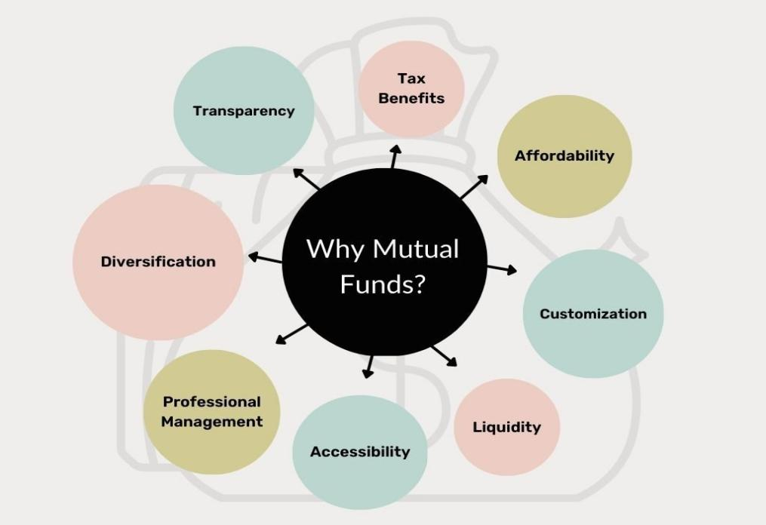

In essence, mutual funds are financial instruments that combine the assets of multiple people with comparable financial goals. In charge of managing the funds collected from various investors, a fund manager makes investments in a variety of financial products, such as shares, bonds, and company stocks. According to the Securities and Exchange Board of India (SEBI), which monitors mutual funds in India, investing in mutual funds is the most straightforward method of accumulating money. The net asset value (NAV) of the mutual fund, which is determined at the end of each trading session, is used by the fund management company to issue and redeem mutual fund units. The total value of the fund's shares, less expenses, is divided by the total number of units issued to determine the NAV.

**Objectives of the Study**

* Evaluate the awareness level of working professionals regarding mutual fund investments.
* Analyse the factors influencing working professionals' decision-making processes for mutual fund investments.
* Identify the challenges faced by working professionals in understanding and engaging with mutual fund investments.
* Identify potential barriers and opportunities for increasing working professionals' participation in mutual fund investments.
* Determine the level of knowledge and understanding working professionals have about mutual funds, including their benefits, risks, and potential returns.

**Need of the Study**

* The primary objective of this study is to analyse the perceptions of working professionals towards mutual fund investments.
* Additionally, the study aims to understand the challenges faced by investors and identify key factors that motivate working professionals to invest or reinvest in mutual funds.
* It explores the diverse financial decision-making approaches among working professionals, helping to tailor financial services to meet their unique needs and preferences.
* The insights from this study can support the development of policies, improve retirement planning strategies, and promote a more inclusive and diversified financial landscape that empowers working professionals.

**Limitations of the Study**

* The analysis of this study is based on information provided by working professional investors.
* The research was limited to the Chennai district, and due to time constraints, 105 respondents were considered.
* The results rely entirely on the data provided by working professionals, which may carry inherent biases.

**REVIEW OF LITERATURE**

**Dr. M. Raja and Jagadeeswaran B** **(2020)** explain that mutual funds pool money from small and medium investors, which expert fund managers then invest in different types of securities. This allows investors to join the capital market without taking on high risks. The study suggests that mutual fund companies should clearly share key details like returns, risks, asset numbers, and the fund's brand reputation in their brochures.

**Kumar, 2018** While analysing the performance of mutual funds involves many factors and dimensions, this study concentrated on five: the information measure, Treynor measure, Jensen differential measure, Sortino measure, and 22 Sharpe measure. The degree of connection between mutual fund performance and fund size was evaluated by computing correlation coefficients among all the factors. The results showed that there was no meaningful correlation between fund size and performance.

In his research, "Investment Choice of Individual Investors," **Jasmeen (2009)** discovered that while a significant portion of investors selected for high-risk investments, the majority of investors preferred low-risk options. When looking at risk-adjusted returns pre expenses, Jensen's and Fama-French's model yield significantly positive αs at the 5% significance level, and Carhart's model α is significant at the 10% level. Belgian mutual funds perform well enough to earn back their transaction costs and investment expenses. However, mutual funds mainly offer investors easy access to a diversified portfolio but don’t provide much extra value beyond that.

In their paper "A Study on Preferred Investment Options Among People and Factors for Investment" (Study on Preferred Investment Options and Factors Considered While Investing), Joseph and Prakash (2014) wanted to understand the preferred investment option among Bangalore City residents as well as the range of available investment options. There are new financial products accessible in the modern world. Because the average person lacks the financial understanding to determine what aspects should be taken into account to make wise investment decisions, selecting the best possibilities has become challenging and complex. Further analysis reveals that investors are more likely to stick with more conventional investments like bank deposits, insurance, postal deposits, etc., rather than investing in the stock market and shares. By being aware of investment opportunities and their benefits and drawbacks, you can make the best financial decisions for yourself.

**RESEARCH METHODOLOGY:**

"A Descriptive Study on Working Professionals' Perceptions Towards Mutual Fund Investments in Chennai". It has been dealing with the examination of Chennai customers' attitudes on mutual funds. A systematic questionnaire was used to get feedback from 105 customers.

**Working Professionals' Perception of Mutual Funds as an Investment Option**

1. **Respondents gender**

**Table 1 gender of respondents**

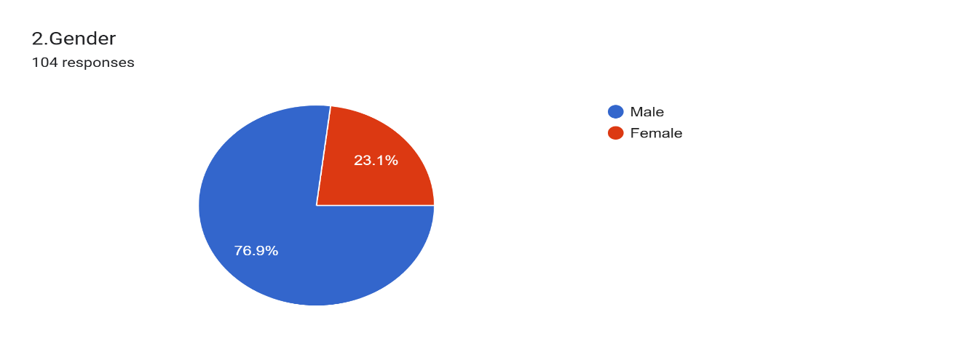

|  |  |  |
| --- | --- | --- |
| **Gender** | **No of responds** | **percentage** |
| **Male** | 80 | 76.9% |
| **Female** | 25 | 23.1% |
| **Total** | **105** | **100** |

**Interpretation& Finding;** The data indicates a notable gender disparity, with 76.9% of respondents being male and 23.1% being female. This highlights that working males are more engaged with the survey or possibly more involved in investment decisions than their female counterparts.

1. **Age of respondents**

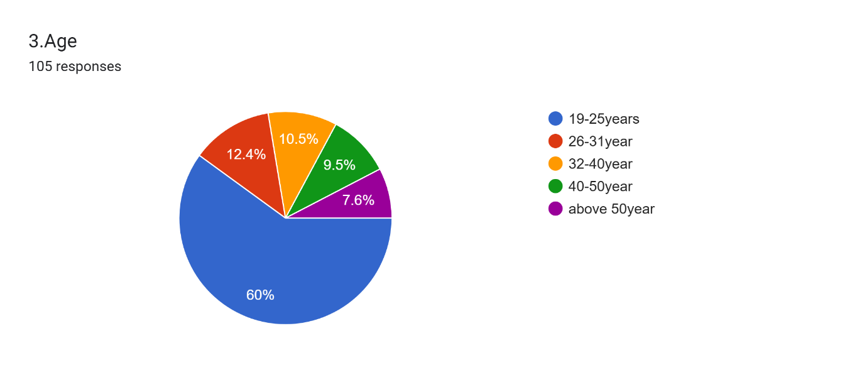

**Table 2** age of respondents

|  |  |  |
| --- | --- | --- |
| **Age** | **No of responds** | **percentage** |
| **18-25 years** | 63 | 60% |
| **26-31 years** | 13 | 12.4% |
| **32-40 years** | 11 | 10.5% |
| **41-50 year** | 10 | 9.5% |
| **Above 50 years** | 8 | 7.6% |
| **Total** | **105** | **100** |

**Interpretation& Finding:** The majority of respondents (60%) are young professionals aged 18 to 25, showcasing strong interest from the younger demographic. Participation gradually declines with increasing age, with only 7.6% of respondents aged above 50. This suggests that mutual funds and other investment avenues are more appealing to younger working professionals, possibly due to their longer financial planning horizon.

1. **Annual savings of respondents**

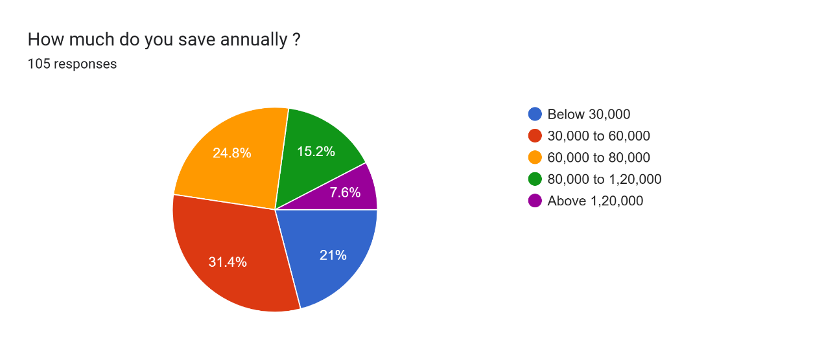

**Table 3** annual savings of respondents

|  |  |  |
| --- | --- | --- |
| **Annual savings** | **No of responds** | **percentage** |
| **Up to Rs. 30,000** | 22 | 21% |
| **Rs. 30,001 - Rs. 60,000** | 33 | 31.4% |
| **Rs. 60,001 - Rs. 80,000** | 26 | 24.8% |
| **Rs. 80,001 - Rs. 1,20,000** | 16 | 15.2% |
| **Above Rs.1,20,000** | 8 | 7.6% |
| **Total** | **105** | **100** |

**Interpretation& Finding:** A significant portion (31.4%) of respondents have annual savings between Rs. 30,001 and Rs. 60,000, followed by 24.8% saving between Rs. 60,001 and Rs. 80,000. Notably, only 7.6% of respondents manage to save above Rs. 1,20,000 annually. This indicates that most working professionals have moderate savings capacity, influencing their investment decisions toward accessible and growth-oriented options like mutual funds.

1. **Preference of respondents regarding different investment avenue**

Table .4 Preference of respondents regarding different investment avenues

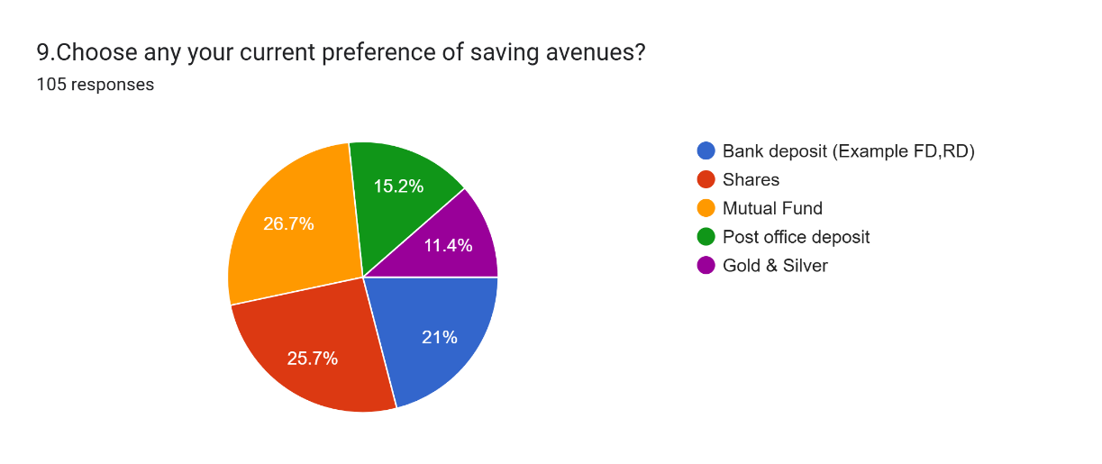

|  |  |  |
| --- | --- | --- |
| **Particulars** | **Responses** | **Rank** |
| **Bank deposit** (EG . FD,RD) | 22 | **III** |
| **Shares (Equity)** | 27 | **II** |
| **Mutual fund** | 28 | **I** |
| **Post office deposit** | 16 | **IV** |
| **Gold & silver** | 12 | **V** |

**Interpretation:** The given data reflects respondents' investment preferences across various investment avenues. The number of respondents selecting each option determines the ranking.

According to the latest data:

* **Mutual funds** are the most favoured choice among respondents, with **28 responses**, securing **Rank I**.
* **Shares (Equity)** follows with **27 responses**, taking **Rank II**.
* **Bank deposits** (e.g., FD, RD) hold **22 responses**, earning **Rank III**.
* **Post office deposits** receive **16 responses**, placing **Rank IV**.
* **Gold & silver** trails with **12 responses**, positioned at **Rank V**.

The data suggests a strong preference for mutual funds and shares, while traditional options like gold and post office deposits rank lower in respondents' choices.

The data collectively reflects a shift in investment behaviour — working professionals, particularly the younger generation, favour mutual funds and equities over conventional savings and gold-based options. This trend points toward a growing awareness of higher-return, market-linked instruments and professional fund management as key motivators for investment decisions.

**Overall Insight:**

The findings reveal a clear picture of working professionals' investment behaviour:

* Young, male professionals dominate the investment landscape.
* Moderate savings capacity guides investment choices.
* Market-linked options (mutual funds and equities) are preferred over traditional avenues (gold, post office savings).

This shift underlines the importance of financial literacy and easy access to professionally managed investment options in shaping modern investment preferences.

**Suggestion :**

* Explore how perceptions change based on age, income, education, and marital status. This can reveal valuable insights into the different needs and preferences of working professionals.
* Explore how work-life balance affects working professionals' investment decisions and shapes their financial choices.
* Assess working professionals' views on financial institutions offering mutual funds, focusing on trust, transparency, and customer service, which influence investment decisions.
* Explore how market trends, economic conditions, and global events shape working professionals' investment decisions and strategies.

**Conclusion**

This study highlights the diverse investment goals of working professionals, from short-term gains to long-term wealth building. It emphasizes the need for financial institutions to create flexible, user-friendly services that address key challenges like time constraints, perceived risks, and balancing work and personal life. With technology playing a growing role, adapting digital platforms to meet professionals' preferences is essential. Ultimately, this research serves as a guide for creating a more inclusive, supportive investment environment that promotes the financial wellbeing of working professionals.

**REFERENCE**

* An analysis of investor’s risk perception towards mutual funds services, Nidhi Walia, dr. Mrs. Ravi kiran,2009,9,4, Pg no 95 – 126.
* Abrol, R., and Kavitha, D. (2021). Mutual funds as an investment vehicle from the viewpoint of the consumer. Journal of Economics and Finance (IOSR-JEF), 12(3), pg,33–69.
* Silvester, A. Konnully, N. I., & Martin, A. (2023).A Special Reference Study on Investor Preference for Mutual Funds.
* Smith, J., & Johnson, A. (2021). The Mutual Fund Industry and Its Comparative Performance, 45(3), 103-135.
* Singh, B. K. (2012).A study on investors’ attitude towards mutual funds as an investment pg 2(a)51- 81
* Jain, M., and G. Agrawal (2013). Mutual funds are preferred by investors over other investment avenues. 115–131 in Journal of Indian Research, 4(a)2.
* Mittal, D. (2021). Investing in mutual funds was the best option for average people.
* Sharma, A., & N. Gupta (2016). An investigation on the variables influencing Jaipur City mutual fund investors' degree of satisfaction. SAMVAD 12,90-105.
* Parihar, B. B. S., Sharma, R., & Parihar, D. S. (2009). Analysing investors’ attitude towards mutual funds as an investment option.pg,55-66.
* International journal for scientific research & development, L. Meena , A study on investors’ perception towards mutual fund marketing strategies in Madurai, pg. volume 4ai 55-68.
* A referred international journal of multidisciplinary research, Bhavik u. Swadias.m. Patel, A study on investors perception towards mutual fund with reference to Ahmadabad city, Vol: 1, Issue: 2,2014, 25-36.