**Role of Financial Inclusion in realising Sustainable Development Goals SDGs**

**¹Ms. Seema Rani, ²Ms. Taranpreet Kaur, ³Mr. Gourav Kamboj**

**¹Assistant Professor, Department of Commerce, Guru Nanak Khalsa College, Yamuna Nagar**

**²Assistant Professor, Department of Management, SD Institute of Management and Technology, Yamuna Nagar**

**³Postgraduate Researcher at Guru Nanak Khalsa College, Yamuna Nagar**

**Abstract:** *Sustainable Development Goals are the blueprint to achieve a better and more sustainable future for all. They address the global challenges we face, those related to poverty, inequality, climate, environmental degradation, prosperity, peace and justice. The United Nations General Assembly adopted the 2030 agenda for Sustainable Development along with the development goals that are collectively called the Sustainable Development Goals on 25 September 2015. The Agenda was endorsed by all 193 member Nations of the General Assembly, both developed and developing—and applies to all countries. Though the global goals directly do not target financial inclusion, access of financial services to the masses is a key enabler for many of the goals. There are 17 SDGs which enhance economic development. Economic development requires sound foundations. Universal access to education and health services, access to financial and insurance services, new technologies and affordable bank loans, and improved distribution of resources are all important components of sound economic development. In early 1990s India took a giant leap by liberalizing its economy and eventually, the 2000s have seen India make its economic development just and socially progressive by bringing in a number of financial inclusion policies and initiatives. A good economy is both a necessary condition as well as the goal of any financial inclusion initiative. Financial inclusion models can support overall economic growth and the achievement of broader development goals. Digital Finance has played a major role in the delivery of Financial services to the vulnerable groups through mobile phones, personal computers, the internet or cards linked to reliable digital payment system. The objective of the paper is to study the role of Financial inclusion in achieving Sustainable Development Goals and also the impact of digitalisation on the same.*

**Keywords:** Finance, Sustainable, Inclusion, Development, SDGs, Economic, Growth, Environment.

**Introduction:** The role of financial inclusion in realizing Sustainable Development Goals (SDGs) is multifaceted and crucial. Financial inclusion, which refers to the provision of financial services to all segments of society, particularly the underserved and marginalized populations, is essential for achieving several SDGs. By providing access to financial services, financial inclusion enables individuals and households to manage their finances effectively, reduce poverty and inequality, and improve their overall well-being. Financial inclusion also promotes economic growth and development by providing opportunities for entrepreneurship, employment, and income generation. Furthermore, financial inclusion supports gender equality by providing women with access to financial services, enabling them to participate in economic activities, and make informed decisions about their lives. Additionally, financial inclusion helps reduce inequalities by providing marginalized populations with access to financial services, enabling them to participate in economic activities, and reducing the gap between the rich and the poor. Overall, financial inclusion is a critical component of the SDGs, and its realization is essential for achieving a more equitable, sustainable, and prosperous future for all. Effective financial inclusion strategies, including the use of technology, innovative business models, and robust regulatory frameworks, can help ensure that all segments of society have access to financial services, enabling them to participate in economic activities, manage their finances effectively, and improve their overall well-being.

**Review of Literature:**

**Sarma (2008) [1]** had conducted the research on Index of financial Inclusion. The purpose of the study was to develop an Index which can be used to measure the extent of financial inclusion in a country. For the purpose of calculating the index three dimensions were considered viz, Bank penetration, banking services and usage of banking services. It was found that the index developed could be used to determine the relationship between development and Financial inclusion.

**Park and Mercado (2015) [2]** did a study on Financial Inclusion, Poverty and Income inequality in developing Asia. The purpose of the study was to examine the correlation between Financial Inclusion, poverty and Income inequality. The required data were collected from 37 selected developing Asian economies. They developed a Financial inclusion indicator for the purpose of the study. They found that per capita income and demographic characteristics affects financial inclusion in Asia. The paper concluded that there is a significant correlation between Higher financial inclusion and lower poverty and inequality.

**Patil (2016) [3]** did a study on Financial Inclusion in India- An overview. He examined the scenario of financial inclusion at global and national level and covered the basic concepts of financial inclusion. He proposed that integrated efforts should be formulated by the government, RBI and the implementing agencies to develop methods and measures to take forward financial inclusion.

**Voica (2017)[4]**In his study explained that FI is considered as a part of social inclusion driver and social inclusion is a driver for sustainable development and on this basis he concluded that FI is a driver for sustainable development. He proposed that international initiatives should promote financial inclusion in an effective manner for the overall growth of the economy.

**Sujhlana and Kiran (2018) [5]** conducted a research on A study of status of financial inclusion in India. The study aimed to provide an overview of the status of financial inclusion in India in the past few years. It is found that financial inclusion is in progressive stage in India and efforts towards overall inclusive growth need to be given a concrete shape with proper implementation of the various Initiatives for the purpose of overall development of the people in the rural areas.

**Soyemi, Olowofela and Yunusa (2020) [6]** in their study evaluated the impact of financial Inclusion on sustainable development. For the purpose of their study they used error correction model and fully modified ordinary least square. The study proposes that more number of bank branches should be opened in the Rural areas and the rural people should be oriented in regards to the importance of having a bank account and indirectly contributing to the growth of the country.

**Makau and Olando (2021) [7]** conducted a research on Digital Banking strategy and Financial Inclusion among commercial banks In Kajiado County, Kenya. The study aimed to analyse the gap which is present during the process of realising financial inclusion and evaluated the effects of digital banking strategy on financial inclusion midst the commercial banks in Kajiado country. It is found that at 5% error level, digital banking channels, digital financial infrastructure and convenience of digital banking services have a statistical positive significant effect on financial inclusion.

**Objectives of the Study:**

* To Study the role of Financial Inclusion in achieving SDGs.
* To Study the contribution of various banks in financial inclusion.
* To Study the intersection of financial inclusion with environmental sustainability.
* To Study the impact of financial inclusion on economic growth.
* To Study the challenges in advancing financial inclusion for sustainable development.
* To Study the opportunities for enhanced financial inclusion.

**Research Methodology:** This paper’s methodology draws from prior Research as well As the literature. Secondary data were used for this analysis. The information was compiled from a variety of sources.

**Financial Inclusion:** Financial inclusion refers to the provision of financial services to all segments of society, particularly the underserved and marginalized populations, in a fair, transparent, and sustainable manner. It involves ensuring that individuals and households have access to a range of financial services, including savings, credit, insurance, payments, and remittances, regardless of their income level, geographic location, or social status. Financial inclusion aims to bridge the gap between the formal financial system and the unbanked or underbanked populations, who often rely on informal and expensive financial services. By providing access to formal financial services, financial inclusion can help reduce poverty, increase economic opportunities, and improve overall well-being. It can also promote financial stability, reduce inequality, and support economic growth and development. Ultimately, financial inclusion is about creating a more equitable and inclusive financial system that serves the needs of all individuals and households, regardless of their background or circumstances.

**Financial Inclusion and Sustainable Development Goals:**

Financial inclusion plays a vital role in achieving the Sustainable Development Goals (SDGs), which are a set of 17 global goals adopted by the United Nations in 2015. The SDGs aim to end poverty, protect the planet, and ensure peace and prosperity for all by 2030. Financial inclusion is a key enabler of several SDGs, including Goal 1 (No Poverty), Goal 5 (Gender Equality), Goal 8 (Decent Work and Economic Growth), and Goal 10 (Reduced Inequalities). By providing access to financial services, financial inclusion can help reduce poverty and inequality, promote economic growth and development, and support the achievement of other SDGs. For example, financial inclusion can help small-scale farmers access credit and insurance, enabling them to invest in their farms and increase their productivity, which contributes to Goal 2 (Zero Hunger). Similarly, financial inclusion can help women access financial services, enabling them to start and grow businesses, which contributes to Goal 5 (Gender Equality). Overall, financial inclusion is a critical component of the SDGs, and its achievement is essential for realizing the vision of a more equitable and sustainable world.

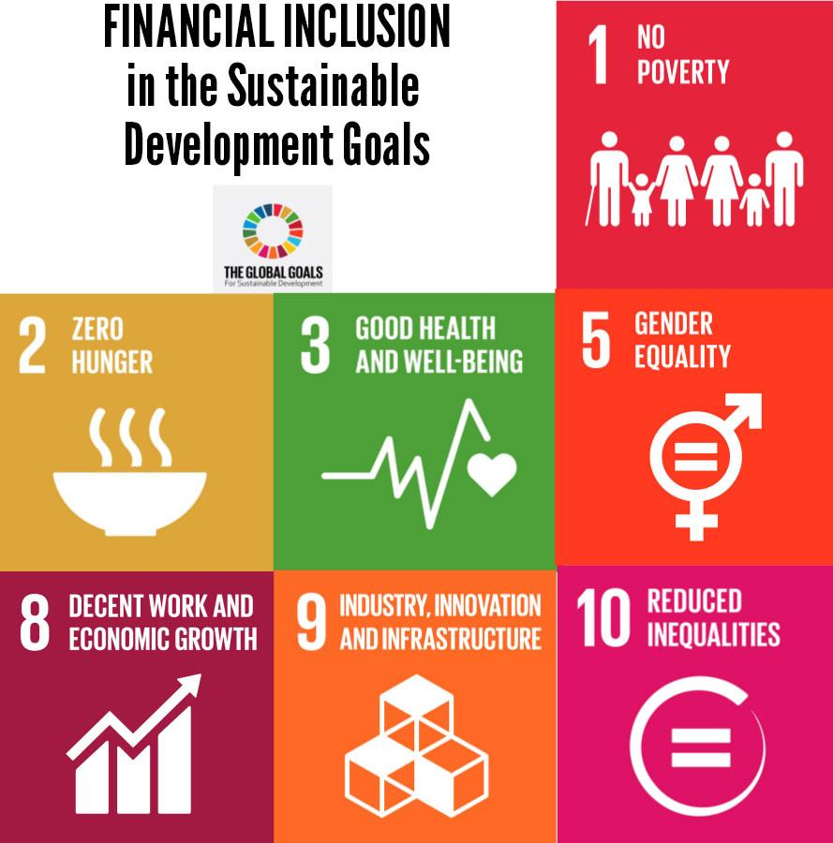

**Financial Inclusion as a catalyst for realising Sustainable Development Goals:**

Financial inclusion serves as a catalyst for realizing the Sustainable Development Goals (SDGs) by providing individuals and households with access to a range of financial services, including savings, credit, insurance, payments, and remittances. This, in turn, enables them to manage their finances effectively, invest in their future, and mitigate risks. Financial inclusion can help reduce poverty and inequality, promote economic growth and development, and support the achievement of several SDGs, including Goal 1 (No Poverty), Goal 5 (Gender Equality), Goal 8 (Decent Work and Economic Growth), and Goal 10 (Reduced Inequalities). By providing access to financial services, financial inclusion can empower individuals and households to make informed decisions about their financial lives, invest in education and healthcare, and start and grow businesses, ultimately contributing to sustainable development. Furthermore, financial inclusion can also help to promote financial stability, reduce inequality, and support economic growth and development, thereby creating a virtuous cycle of sustainable development. Additionally, financial inclusion can also help to leverage technology, innovation, and partnerships to achieve the SDGs, making it a critical component of the sustainable development agenda. Overall, financial inclusion has the potential to be a game-changer in realizing the SDGs, and its achievement is essential for creating a more equitable, sustainable, and prosperous world.

**Analysis of Contribution of Banks in Financial Inclusion:**

The contribution of banks in financial inclusion has been significant, with banks playing a crucial role in expanding access to financial services, promoting financial literacy, and supporting the development of a more inclusive financial system. Through various initiatives, such as the expansion of branch networks, the introduction of digital banking platforms, and the development of innovative financial products, banks have helped to increase access to financial services for underserved and marginalized populations. For instance, the Pradhan Mantri Jan-Dhan Yojana (PMJDY) scheme, launched by the Indian government in 2014, has enabled millions of unbanked individuals to open bank accounts and access basic financial services. Banks have also been instrumental in promoting financial literacy through various programs and initiatives, such as the Reserve Bank of India’s (RBI) Financial Literacy Program, which aims to educate individuals about basic financial concepts and the benefits of using formal financial services. Furthermore, banks have supported the development of a more inclusive financial system by partnering with fintech companies, NGOs, and other stakeholders to develop innovative financial products and services that cater to the needs of underserved populations. Overall, the contribution of banks in financial inclusion has been instrumental in promoting greater financial access, stability, and prosperity for millions of individuals and households.

**Linking Financial Inclusion to Sustainable Development:**

Linking financial inclusion to sustainable development is a critical step towards achieving a more equitable, sustainable, and prosperous future for all. Financial inclusion, which refers to the provision of financial services to all segments of society, particularly the underserved and marginalized populations, is essential for reducing poverty, promoting economic growth, and supporting the achievement of the Sustainable Development Goals (SDGs). By providing access to financial services, financial inclusion can help individuals and households manage their finances effectively, invest in their future, and mitigate risks. Furthermore, financial inclusion can promote economic growth by enabling entrepreneurs to start and grow businesses, create jobs, and stimulate innovation. Additionally, financial inclusion can reduce inequalities by providing marginalized populations with access to financial services, enabling them to participate in economic activities and improve their socio-economic status. Overall, linking financial inclusion to sustainable development can help achieve a range of SDGs, including SDG 1 (No Poverty), SDG 5 (Gender Equality), SDG 8 (Decent Work and Economic Growth), and SDG 10 (Reduced Inequalities), and can contribute to a more sustainable, equitable, and prosperous future for all.

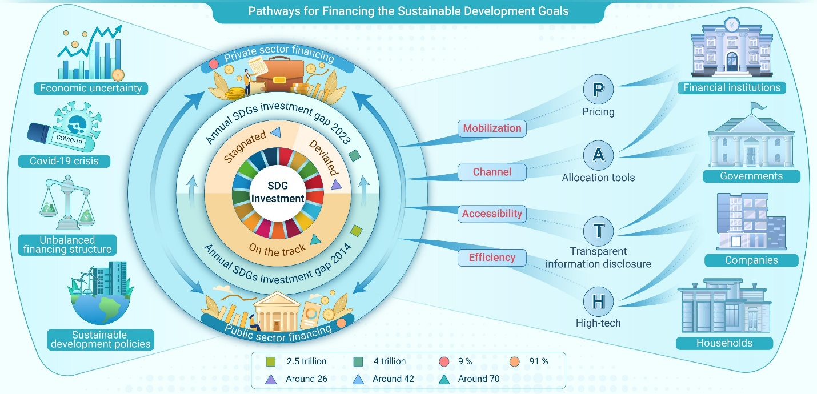

**Intersecting Financial Inclusion with Environmental Sustainability:**

Intersecting financial inclusion with environmental sustainability is a critical step towards achieving a more sustainable and equitable future for all. By providing access to financial services that support environmentally friendly practices, financial inclusion can promote sustainable livelihoods, reduce environmental degradation, and increase access to green finance. For instance, financial institutions can offer loans and other financial products that support sustainable agriculture, renewable energy, and climate-resilient infrastructure, thereby promoting environmentally sustainable practices and reducing greenhouse gas emissions. Moreover, financial inclusion can also support climate change mitigation and adaptation efforts by providing access to financial services that help individuals and communities prepare for and respond to climate-related disasters. By leveraging technology, infrastructure, and partnerships, financial institutions can play a critical role in promoting environmental sustainability and financial inclusion, ultimately contributing to a more sustainable and equitable future for all.

**Impact of Financial Inclusion on Economic Growth:**

1. Green Finance: Financial inclusion can promote green finance by providing access to financial services that support environmentally friendly practices, such as renewable energy and sustainable agriculture.
2. Sustainable Livelihoods: Financial inclusion can promote sustainable livelihoods by providing access to financial services that support environmentally friendly practices, such as sustainable agriculture and eco-tourism.
3. Climate Change Mitigation: Financial inclusion can support climate change mitigation efforts by providing access to financial services that support the development and deployment of climate-friendly technologies.
4. Environmental Risk Management: Financial inclusion can promote environmental risk management by providing access to financial services that help individuals and communities manage environmental risks, such as climate-related disasters.
5. Green Banking: Financial inclusion can promote green banking by providing access to financial services that support environmentally friendly practices, such as sustainable agriculture and renewable energy.
6. Sustainable Agriculture Finance: Financial inclusion can promote sustainable agriculture finance by providing access to financial services that support sustainable agriculture practices, such as organic farming and agroforestry.
7. Renewable Energy Finance: Financial inclusion can promote renewable energy finance by providing access to financial services that support the development and deployment of renewable energy technologies.
8. Eco-Friendly Financial Products: Financial inclusion can promote eco-friendly financial products, such as green loans and eco-friendly credit cards, that support environmentally friendly practices.
9. Financial Literacy for Environmental Sustainability: Financial inclusion can promote financial literacy for environmental sustainability by providing education and training on environmentally friendly financial practices.
10. Partnerships for Environmental Sustainability: Financial inclusion can promote partnerships for environmental sustainability by partnering with environmental organizations, NGOs, and government agencies to promote environmentally friendly financial practices.

**Challenges in Advancing Financial Inclusion for Sustainable Development:**

1. Limited Access to Technology: Many underserved populations lack access to technology, such as mobile phones and computers, making it difficult to access financial services.
2. Insufficient Digital Infrastructure: In many developing countries, digital infrastructure, such as internet and mobile networks, is insufficient, making it difficult to provide financial services.
3. Regulatory Frameworks: Regulatory frameworks may not be conducive to financial inclusion, with strict regulations and licensing requirements that can limit the provision of financial services.
4. Lack of Standardization: Lack of standardization in financial regulations and policies can create confusion and uncertainty, making it difficult to advance financial inclusion.
5. Inadequate Consumer Protection: Inadequate consumer protection regulations can leave vulnerable populations at risk of exploitation by financial service providers.
6. Limited Financial Literacy: Many underserved populations lack basic financial literacy, making it difficult for them to access and use financial services effectively.
7. Social and Cultural Barriers: Social and cultural barriers, such as lack of trust in financial institutions or cultural attitudes towards money management, can limit access to financial services.
8. Scalability and Sustainability: Financial inclusion initiatives may struggle to scale and sustain themselves, particularly in the absence of a clear business case or revenue model.
9. Data and Measurement Challenges: Collecting and analyzing data on financial inclusion can be challenging, particularly in countries with limited data collection infrastructure.
10. Partnerships and Collaborations: Building effective partnerships and collaborations between financial service providers, governments, and other stakeholders can be challenging, particularly in the absence of a clear shared vision or goals.

**Opportunities for enhanced financial Inclusion:**

Here are some opportunities for enhanced financial inclusion:

**Digital Financial Services:**

1. Mobile Banking: Mobile banking can expand financial inclusion by providing access to financial services through mobile phones.

2. Digital Payments: Digital payments can increase financial inclusion by providing a convenient and secure way to make transactions.

3. Online Banking: Online banking can enhance financial inclusion by providing access to financial services through the internet.

**Financial Technology (FinTech):**

1. Peer-to-Peer Lending: Peer-to-peer lending can increase financial inclusion by providing access to credit for underserved populations.

2. Digital Credit Scoring: Digital credit scoring can enhance financial inclusion by providing a more accurate and efficient way to assess creditworthiness.

3. Blockchain Technology: Blockchain technology can increase financial inclusion by providing a secure and transparent way to conduct financial transactions.

**Innovative Financial Products:**

1. Microinsurance: Microinsurance can enhance financial inclusion by providing access to insurance products for underserved populations.

2. Microsavings: Microsavings can increase financial inclusion by providing access to savings products for underserved populations.

3. Mobile Money: Mobile money can enhance financial inclusion by providing access to financial services through mobile phones.

**Partnerships and Collaborations:**

1. Public-Private Partnerships: Public-private partnerships can enhance financial inclusion by leveraging the resources and expertise of both public and private sector organizations.

2. Financial Inclusion Initiatives: Financial inclusion initiatives can increase financial inclusion by providing access to financial services for underserved populations.

3. International Cooperation: International cooperation can enhance financial inclusion by sharing best practices and expertise across countries.

**Regulatory Frameworks:**

1. Regulatory Sandbox: Regulatory sandbox can enhance financial inclusion by providing a safe and controlled environment for testing new financial products and services.

2. Licensing and Regulation: Licensing and regulation can increase financial inclusion by providing a framework for the provision of financial services.

3. Consumer Protection: Consumer protection can enhance financial inclusion by providing protection for consumers from unfair and deceptive financial practices.

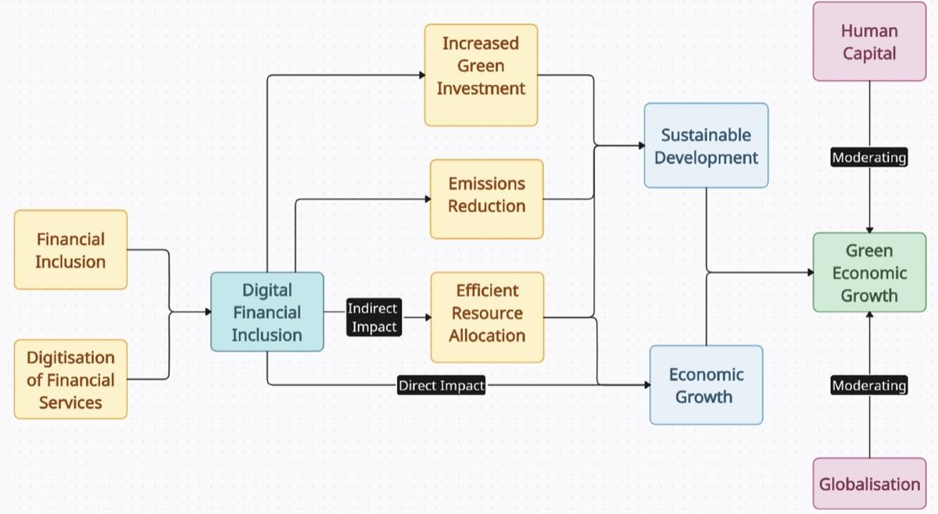

**Conclusion:** In conclusion, financial inclusion plays a pivotal role in realizing the Sustainable Development Goals (SDGs) and promoting economic growth. By expanding access to financial services, financial inclusion can reduce poverty, promote entrepreneurship, and support sustainable livelihoods. As a result, financial inclusion can contribute significantly to achieving the SDGs, particularly SDG 1 (No Poverty), SDG 5 (Gender Equality), SDG 8 (Decent Work and Economic Growth), and SDG 10 (Reduced Inequalities). By bridging the financial gap and providing opportunities for economic participation, financial inclusion can help create a more inclusive, sustainable, and prosperous future for all, ultimately driving economic growth and realizing the SDGs.

**References:**

1. Sarma M. Index of Financial Inclusion. Indian Council For Research on International Economic Relations Working Paper No 2008;215:1-20.
2. Park Y, Park Y, Mercado V. Financial Inclusion, Poverty and income inequality in developing Asia. ADB Economics working paper series No 2015;426:1-17.
3. Patil P. Financial Inclusion in India- An overview. International Journal in Management and Social Science 2016;4:595-601.
4. Voica M. Financial Inclusion as a tool for Sustainable Development. Romanian Journal of Economics 2017;44(1):121-129.
5. Sujhalana P, Kiran C. A study on status of Financial Inclusion in India. International Journal of Management Studies 2018;2(3):96-104.
6. Sayomi K, Olowofela E, Yunusa L. Financial Inclusion and Sustainable Development in Nigeria. Journal of Economics and Management 2020;39(1):105-131.
7. Makau J, Olando C. Digital Banking Strategy and Financial Inclusion among commercial banks in Kajiado County. A case of Kenya Commercial Bank in Kajiado County, Kenya. Asian Journal of Economics, Business and Accounting 2021;21(5):1-14.

8. Consultative Group to Assist the Poor (CGAP) (2019): Financial Inclusion for Sustainable Development.

9. International Finance Corporation (IFC) (2018): Financial Inclusion: A Key Driver of Economic Growth.

10. Asian Development Bank (ADB) (2019): Financial Inclusion in Asia.

11. African Development Bank (AfDB) (2019): Financial Inclusion in Africa.

12. Inter-American Development Bank (IDB) (2019): Financial Inclusion in Latin America.

13. World Bank (2019): Global Financial Development Report 2019/2020.

14. IMF (2019): Financial Inclusion and Economic Growth.

15. United Nations Conference on Trade and Development (UNCTAD) (2019): Financial Inclusion for Development.

16. Organisation for Economic Co-operation and Development (OECD) (2019): Financial Inclusion and Financial Literacy.

17. Sustainable Development Goals (SDGs) Knowledge Platform (2020): SDG 1: No Poverty.

18. World Bank (2019): Financial Inclusion for Women.

19. CGAP (2019): Financial Inclusion for Small and Medium-Sized Enterprises (SMEs).

20. IFC (2019): Financial Inclusion for Climate Change Mitigation.

21. ADB (2019): Financial Inclusion for Sustainable Development in Asia.

22. AfDB (2019): Financial Inclusion for Sustainable Development in Africa.

23. IDB (2019): Financial Inclusion for Sustainable Development in Latin America.

24. World Economic Forum (WEF) (2019): The Future of Financial Inclusion in the Digital Age.

25. IMF (2020): Financial Inclusion and Economic Growth in the Digital Age.