ArduinoBaseddoorAutomationSystemUsing

UltrasonicSensorandServoMotor

Dr. S. I. Bakhtar Miss Gayatri Dhakre, Miss Faiza Shaikh,Miss Tejal Chahurkar, Miss Eshwari Wankhade, Miss Divya Kamdi

Assistant Professor in Electronics & Telecommunication Department, Prof Ram Meghe College of Engineering and Management, Amravati (Maharashtra)1 Thirdl Year Student in Electronics & Telecommunication Department, Prof Ram Meghe College of Engineering and Management, Amravati (Maharashtra)2345

Abstract - Opening and closing of doors have always been a tedious and boring job, especially in

placeslike;hotels,shoppingmalls,theaters,etcwhereapersonisalwaysrequiredtoopenand close the door for visitors. This human involvement can be avoided by automating the process

usingdifferentsensorslikeinfrared,pressure,ultrasonic,laseretc.Inthispaper,automaticdoor control system using Arduino microcontroller was designed. The system combines ultrasonic

sensor, servo, and Arduino to achieve the desired goal. When the ultrasonic sensor installed at theentranceofthebuildingdetectsapersonoranobjectwithintherangeofthesensor,asignal is sent to the Arduino microcontroller which controls the servo motor to automatically open the door. The door remains open until the object goes out of range of the sensor and in turn closes the door automatically. The results clearly show that the system is cheap, effective, and areliable means of opening and closing doors in places like retail stores, super markets, factories

and the like.

Key words Arduino, Ultrasonic Sensor, Automation, Servo Motor, Arduino IDE, PWM

Introduction

Themarketforautomateddoorsisgrowingandbecomingmorespecialized.Thetypeof product that fits best with a particular application is determined by frequency of operation,

speed of operation required, new versus existing construction, traffic flow and cost. Automatic doors are a normal feature in many commercial buildings and infrastructures such as shopping centersandairports,aswellasinindustrialenvironmentssuchasfactories.Althoughtheycome in variety of types, including sliding, swing, folding, etc; they all need to conform to the highest standards of safety.

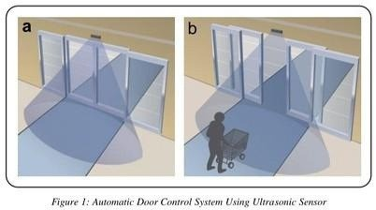

In an industrial environment, automatic doors enables the set temperature in cold storageroomstobemaintainedbyfastopeningandclosing,leadingtoconsiderableenergy efficiency and reduction of cost. Automated doors in commercial facilities are the preferred means of access for all users, not only people with disabilities, and are significant aid to accessibility. Moreover, their use minimizes heat or air conditioning loss, maintaining a constanttemperatureandconsequentlysavingmoney.

Arduino based door automation system was developed to automate the process of opening and closing of doors. The system uses ultrasonic sensor to detect the presence of an object within the range of the sensor and automatically opens the door or closes the door when the object goes out of range of the sensor as shown in figure 1.

Figure 1 shows two scenarios, first, the door remain closed because no object was detected and second scenario, the door automatically open immediately it detects of an object. In our system, upon detecting an object by the ultrasonic sensor, it sends an information to the Arduino microcontroller who in turn controls the servo motor to open the door and keep it open until the ultrasonic sensor sends another information that the object is no longer in its range of detection. That is, the sensor keeps the detection area under surveillance by emitting ultrasonic waves. The door is left open while people are in the area as shown in figure 1b.

1. LiteratureReview

Lucky[1]proposedpasswordprotectedhomeautomationsystemwithautomaticdoorlock

whichworksontheprincipleofbreakinganinfraredbeamoflight,sensedbyaphotodiode.It

consistsoftransmittinginfrareddiodesandreceivingphoto-diodes.Thesystemistodetect whethersomeoneiscominginornot.Thephotodiodesareconnectedtocomparators,which givealoweroutputwhenthebeamisbrokenandhighoutputwhentransmittingnormally.The

general operation of the work and performance is dependent on the presence of an object entering through the door and how close the object is to the door. This accomplished detecting an object that is approaching the door but has a drawback which is the distance the infrared can detect an object before it gets to the door.

Mahmood[2]designedanautomaticdoorsystemusingauniquewirelessIDbyusinginfrared

rayorBluetoothtechnology.Itconsistsofasensingunit,controlunitanddriveunittoopenand closedoorsattheentranceforacarthathastheuniqueID.Thisprocessiscontrolledbyusing ArduinoLeonardandprogrammedwithIDEfreeopensourcesoftware,thatreceivesthesignal

code from the car which sends the ID through IR LED or Bluetooth by using a mobile application, decode it. And switch ON the driver that controls the DC motor. Like [1] work, the system

detects a car successfully using infrared ray or Bluetooth technology but both technologies have short range detection which is not good because the door might hit the car during opening or closing process.

1. Methodology

This proposed ultrasonic sensor detects the person or objects and sends a signal to the Arduino microcontroller who in turn controls the servo motor to automatically open the door. The door stay open as long as the doorway in not clear and once the doorway is cleared, the ultrasonic sensor sends another information to the microcontroller to close the door until another object is detected.

* 1. HardwareOverview

Detailed description of the hardware components used in carrying out this work will be provided in this subsection.

* + 1. UltrasonicSensor

The ultrasonic sensor emits short and high frequency signal. These signals propagate in the air atthevelocityofsound.Ifthereisanobjectorobstacleonitspath,itwillbouncebacktothe module. The ultrasonic sensor consists of a multi vibrator, fixed to the base. The multi vibrator is combination of a resonator and vibrator. The resonator delivers ultrasonic wave generated by the vibration.Theultrasonicsensoractuallyconsistsoftwoparts;theemitterwhichproducesa40 kHz sound wave and a detector that detects 40 kHz sound wave and sends electrical signal back to the Arduino microcontroller [3]. The HC-SR04 ultrasonic module used in this project has 4 pins, ground, VCC, trig and echo. The Ground and the VCC pins of the module needs to be connected to thegroundandthe5voltspinsontheArduinoboardrespectivelyandthetrigandechopinsto any digital I/O pin on the Arduino board.

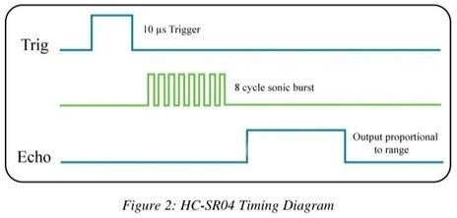

InordertogeneratetheultrasoundyouneedtosettheTrigonaHighStatefor10μsasin figure2.Thatwillsendoutan8cyclesonicburstwhichwilltravelatthespeedsoundandit willbereceivedintheEchopin.TheEchopinwilloutputthetimeinmicrosecondsthesound wave traveled.

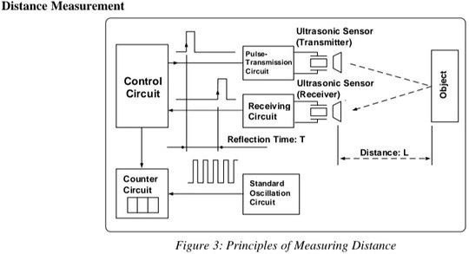

Figure 3 shows the principles of measuring distance and is called the "pulse reflection method" which makes it possible to count the number of reference pulses. This method is used to measure reflection time up to the object between transmitting pulse and receiving pulse of the ultrasonic wave. The relationship between the distance up to the object L and the reflecting time T is expressed by the following formula:

L=S · T/2 where S is the speed of sound

Thatis,thedistancetotheobjectcanbeascertainedbymeasuringthereflectiontime involved in reaching the object.

For example, if the object is 10cm away from the sensor, and the speed of the sound is

340 m/s or 0.034cm/μs the sound wave will need to travel about 294μs. But

what you will get from the Echo pin will be double that number because the sound

waveneedstotravelforwardandbouncebackward.Soinordertogetthedistanceincm we need to multiply the received travel time value from the echo pin by 0.034 and divide it by 2. Speed of sound = v = 340 m/s or 0.034 cm/μs

Time=distance/speed (1)

t= s /v = 10/ 0.034 = 294

Theobtaineddistancewillbetwicetheactualdistancesinceitgivestoandfrodistanceof the object as per the to and fro time equated to the equation:

= ∗ ( )

= ∗ = 294 ∗0.034 = 10

Thusthe obtained distance divided by 2gives actual distance ofthe obstacle.

= ( ∗

l = (t*v)/2 = 5cm

)/2

( )

Measurement Scenarios

Figure 4 shows three typical ultrasonic sensor measurement scenarios

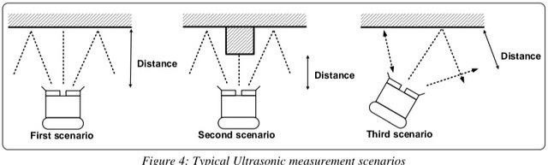

Thefirstscenarioinfigure4willgenerateaprecisemeasurementbecausetheultrasound sensor is opposite and perpendicular to the obstacle.

Thesecondscenariowillalsogenerateaprecisemeasurement,butwillgivea“view”of the obstacle located directly opposite the ultrasound sensor.

Whilethethirdscenariowillgenerateaninaccuratemeasurementhowever,giventhatitis the left side of the ultrasound sensor that is taking the measurement.

Itisessentialtoproperlyunderstandthebeamstructurefortheultrasoundsensorbeing used if it is intended for map building. This is less true for obstacle avoidance.

Servo Motor

AServoisasmalldevicethatincorporatesathreewireDCmotor,ageartrain,apotentiometer,anintegrated circuit, and an output shaft bearing [4]. Of the three wires that stick out from the motor casing, one is

for power, one is for ground, and one is a control input line. The shaft of the servo can be positioned to specific angular positions by sending a coded signal. As long as the coded signal exists on the input

line, the servo will maintain the angular position of the shaft. If the coded signal changes, then the angular positionoftheshaftchanges.Averycommonuseofservosisinradiocontrolledmodelslikecars,airplanes, robots, and puppets. They are also used in powerful heavy-duty sail boats. Servos are rated for speed

and torque.

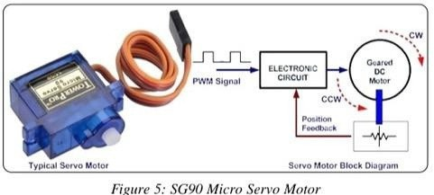

The servo motor in figure 5 use pulse width modulation (PWM) signal for controlling the DC motor; unlike norm usually used in ordinary DC motor; this PWM signal is not use for controlling the rotation speed, instead it is use the motor direction or position [5]. Most servo motor will work well on 50Hz of PWM frequency; this mean the P should have a period of 20ms. We can vary SG90 Micro servo motor angular rotation in between 0° to 180° angle signal as shown in figure 5.

OperationofServoMotors

It consists of dc motor, gear assembly and feedback control circuitry. PWM signal is used to control the servo m applied on control signal pin.

Servofeedbackcontrolcircuitrycontainscomparatorwhichcomparesthecontrolsignal(PWM)and potentiometerreferencesignaltogenerateerrorsignalwhichislateramplifiedandgiventotheDC

DCmotorshaftisconnectedtopotentiometershaft(knob)throughgearassembly.SorotatingDC

motorrotatespotentiometer,whichintermchangespotentiometerreferencesignalgiventothe

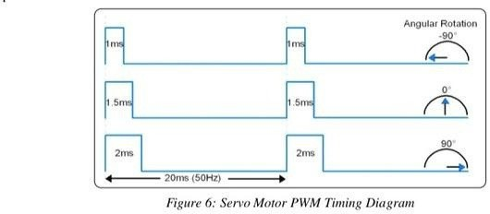Atsomepositionofshaft,bothpotentiometersignalandcontrolsignalstrengthmatch,whichproduceszero output.HencerotationcontinuestillcomparatoroutputerrorsignalbecomeszeroandDCmotorstops

Above figure 6 shows angular rotation of servo shaft. It uses PWM of 50Hz frequency with TON variationfrom 1ms to 2ms. The servo motor rotates 90° in CW (clockwise) and CCW (counter clockwise) directionfrom its middle position i.e. it gives control over 180° of its rotation. At ~1ms (5% duty cycle) we get shaft position at -90° (CCW) of its rotation. At 1.5ms (7.5% duty cycle) we get shaft position at 0° (center) of its rotation.At~2ms(10%dutycycle)wegetshaftpositionat+90°(CW)ofitsrotation.

3.1.3.ArduinoBoard

Arduino is a small microcontroller board with a USB plug to connect to computer. It has number of connect canbewireduptoexternalelectronics,suchasmotors,relays,lightsensorsetc.Theycaneitherbepoweredt USB (universal serial box) connection from the computer or from a 9V battery. They can be controlled from or programmed by the computer and then disconnected and allowed to work independently.

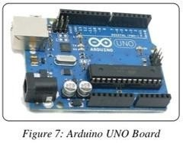

ArduinoUNO-TheArduinoUnoisamicrocontrollerboardbasedontheATmega168.Ithas14digita input/outputpins(ofwhich6canbeusedasPWM(pulsewidthmodulation)outputs),6analoginputs, 16MHzceramicresonator,aUSBconnection,apowerjack,anICSP(in-circuitserialprogrammingheader,andaresetbutton.Itcontainseverythingneededtosupportthemicrocontroller;simplyconnect toacomputerwithaUSBcableorpoweritwithanAC-to-DCadapterorabatterytogetstarted[6 Figure7abovedepictsatypicalArduinoUNOboard.

* 1. SoftwareOverview

sInubdseecpttihond.escriptionofthesoftwarecomponentusedincarryingoutthisworkwillalsobeprovidedin

* + 1. ArduinoIDE T

yohuetIoDwEri(tIentegratedDevelopmentEnvironment)isaspecialprogramrunningonyourcomputerthat

sketchesfortheArduinoboardinasimplelanguagemodeledaftertheprocessing([www.processing.org)](http://www.processing.org/)languag

[7].Itis d

iendeictoslriuwgidthnefesadtuartesocsoucihdnaestsryondtuacxehpigrohglirgahmtimngi,nbgrtaocearmtiasttschainndg,oathnedranuetwocmoamtiecrsinudnefnatmatiiloianr,wanitdhissoaftlswoacreapdaebvleelo

The basic structure of the Arduino programming language is fairly simple and runs in at least two parts. The of compiling and

Aupprldouaaorriadrnmcioantmtsiosgnnpthtrscpeerlorfbgsoeuoganbrldocwkisthofastsaintegmleecnlticsk.AprogramorcodewrittenforA s

avoreidwritteninCorC++.TheArduinoIDEcomeswithasoftwarelibrarycalled“Wiring”fromtheoriginal

wWsierhtuipsincpthag()tmemroakejeencstst;,manycommoninput/outputoperationsmucheasier.

{}

void

statements;

}loop()

Where setup() is the preparation, while loop() is the execution. Both functions are required for the program to wo function should follow the declaration of any variable at the very beginning of the program. It is the first function program, it runs only once and is used to set pinMode or initialize serial communication. The loop function follo includes the code to be executed continuously - reading inputs, triggering outputs, etc. This function is the core of program and does the bulk of the work [6].

1. AutomaticDoorControlSystem

The key component being utilized in automatic door control system using Arduino is the ultrasonic sensor HC-S motor.

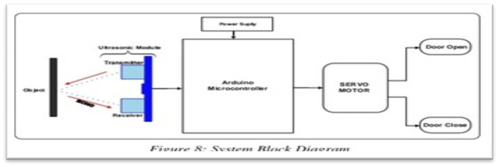

The block diagram of the proposed door automation system, which includes opening and closing actions, i depictedinfigure8.WhentheHC-SR04ultrasonicdistancesensorsensesanobjectwithinthespecifie rangeofdetection,asignalissenttothemicrocontrollerwhichinturnopensthedooraccordinglywithth helpoftheservomotor.Ontheotherhand,whenthereisnoobjectwithinthespecifiedrange,theclosingo thedoorisactivated.Thedoorremainsopenaslongasobjectsarestillwithinthespecifiedrangeo detection.

* 1. ControlFlow

Thecontrolflowdiagramoftheproposeddoorautomationsystem,whichincludesopeningandclosingactions,i figure 9.

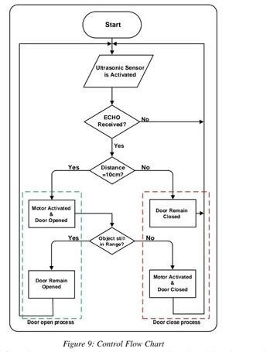

Figure 9 shows control flow of our system. When the ultrasonic sensor is activated, it waits to receive an ech which will be as a result of an object within the specified range of detection (10cm). At the initial state the doo wasclosedassumingnoobjectwasdetected.Onceanobjectisdetected,theservomotorisactivatedandth door open as a result. The ultrasonic sensor keeps on checking if the detected object is within its range. On thotherhand,iftheobjectisoutofrange,theservomotorisactivatedagain,thistimeforclosingofthedoorels thedoorremainsopened.TheArduinobaseddoorautomationsystemschematicdiagramisshowninfigur

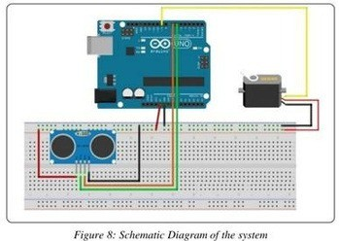10.Theschematichasthreeseparateparts;anultrasonicsensor,acontroller,andaservomotor.Th ultrasonicsensordetectspresencesofanobjectinthedetectionsareaand

sends a control signal to the microcontroller. The servo motor is there to perform a control action (opening and c from the microcontroller.

* 1. Results

Working Principle of Arduino based door automation system using ultrasonic sensor and servo motor illustrated follows:

If there is no person or object within radar of the ultrasonic sensor (10cm), the door remains closed as shown in fi there is an object or a person within the ultrasonic radar, the door will automatically open as in figure 8(b).

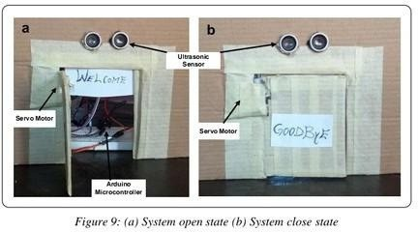

The door will remain open until the object goes out of the ultrasonic radar, then it will automatically close. Th system is setup with one Ultrasonic sensor (in front) for ease purpose, but can be extended by adding anothe sensor at the back using the same process. This will help to automate entry and exit of our system.

1. Conclusion

mThoitso pr.a Tpehre pdroeoser nted a prototype of Arduino bases door automation system using ultrasonisensor and servo

automationsystemusesultrasonicsensortodetectpresenceofhumanoranobjectwithinitsradarandsendsa

suilgtincarlratosAocrdouninnioctrsoelnlesorrwhoinstructstheservomotortoopenthedoorandkeepsitopen.Oncetheobjec m

radar,itsendsanothersignaltothemicrocontrollerforittoinstructtheservomotortoclosethedoo

eanuitnoemcragteicyatllyh.inetdhoeofrorismopenedonlywhenapersonisdetectedandremainscloseallothertimes,itcan S

airconditioningandcanbeusefulforagedanddisabledperson.5.1.Limitations

Although this technique is successful in opening and closing the door when a person or objects are detected, the system is not

capableofunderstandingthetypeandtheintentionoftheobjects.Forinstance,apuppyorapassingpedestria may accidentally

triggerthedoorandcauseafalseopeningaction.Frequentfalseactionisnotonlyannoying,andresultsinai

conditioning

energywaste,butalsoreducesequipmentlifetime.Alsothesystemonlyserveentrybutnonewassetupexitin using the same

door.

Reference

[1].LuckyGautam,ChinoySharma,AkshajArora,andPinkuyadav,"DevelopingInfrared ControlledAutomatedDoorSystem",InternationalJournalofModernEngineeringResearch(IJMER)Vol.3,Issue.5,Sep-Oct.2013pp-2872-2874.

[2d]e.nMtifaichamtiooond”,,SJo.Hur.,nHalaosfsaCno,mOp.Gut.,erAabnadssC,So.mF.maunndicKatwioands,,A2.0M16,,“4A,1u3to2-O14p1e.ningDoorandCar

I3]C.K.Pappa,N.Ashokkumar,P.Nagarajan,K.ThandapaniBluetoothbasedgaragedooropeningsystem

Proceedingsofthe5thInternationalConferenceOnSmartSystemsandInventiveTechnology(ICSSIT)(2023) nI[4]P.RTemperaturemonitoringandautomiactdooropeningsystemusingarduinoUno

t.J.Sci. Res.Manag.Stud., 06(05)(2022),,

[5]Designandimplementationofanti-collisionearlywarningsystemforautomobiledooropening ForeignLang.Sci.Technol.J.DatabaseEduc.Sci.(2021),10.47939/et.v2i10.34Oct.

[6]S.Lakshmi,V.A.Kanetkar,V.VenkataramananDesignandimplementationofLTEphysicallayeronFPGA Int. J. Comput. Appl. Technol., 61 (1/2) (2019), р. 127

[7]S.RPoddar,S.raha,K.Thakur,T.Dasgupta,D.S.Maity

FingerprintdoorlocksystemwithtemperaturesensorJ.Phys.Conf.Ser.,1797(1)(2021),Article012052, [8]P.K.Chakravarthi,D.Yuvaraj,V.Venkataramanan

IoT-basedsmartenergymeterforsmartgridProceedingsofthe6thInternational ConferenceonDevices,CircuitsandSystems(ICDCS)(2022)

[9]S.Rathkanthiwar,T.Chaudhary,A.Gajbhe,A.Kude,A.Kotwaliwale,

K.ChhapperghareAccesscontrolsystemwithcontactlesstemperaturedetectionInt.Res.J.Eng

.Technol.(IRJET),8(5)(2021),pp.3346-3349,

[10]A.Patel,A.Satpute,M.Pattani,V.VenkataramananVirtualPiano

ProceedingsoftheInternationalConferenceonWirelessCommunication,Singapore(2018),pp.265-272Springer[11]C.K.Primus,etal.Designanddevelopmentoflowcostautogatesystemforhouse

Proceedingsofthe2ndIntegratedDesignProjectConference(IDPC)(2015),pp.1-5 [12]K.Khreasarn,K.Hantrakul

AutomaticgateusingBluetoothtechnology(OpenthegatewiththestrengthoftheBluetooth signalonthesmartphone)ProceedingsoftheInternationalConferenceonDigitalArts,

MediaandTechnology(ICDAMT),Phayao,Thailand(2018),pp.54-58,