BUILDING A CV MODEL WITH TENSORFLOW

T.Sreeja1, A.Sai Divya Sree 2, N.Tejaswini 3,A.Yasaswini4

1,2,3,4 Department Of CSE (Artificial Intelligence & Machine Learning), SreenidhiInstitute Of Science & Technology, Hyderabad, Telangana, India. (tejan2906@gmail.com)

**ABSTRACT**

Computer vision is a transformative technology enabling machines to interpret and understand visual data, with applications spanning healthcare, autonomous vehicles, and surveillance systems. This project focuses on building a computer vision model using TensorFlow, leveraging its comprehensive ecosystem for deep learning. The model aims to address tasks such as image classification, object detection, or segmentation, employing state-of-the-art architectures and techniques. TensorFlow's tools for data preprocessing, model training, and optimization are utilized to ensure high performance and scalability. This work highlights the development process, from data handling to deployment, showcasing TensorFlow's capabilities in delivering efficient and accurate computer vision solutions for diverse real-world challenges.

**keywords**:computer vision,tensorflow,image classification,object detection.

1. **INTRODUCTION**

Computer vision is a rapidly growing field that empowers machines to analyze and interpret visual data, playing a crucial role in industries such as healthcare, automotive, retail, and security. Building effective computer vision models requires robust frameworks capable of handling complex visual patterns and large datasets. TensorFlow, a widely-used deep learning library, offers a comprehensive suite of tools and resources for developing scalable and efficient computer vision applications. Its flexibility and support for advanced techniques enable the creation of models for tasks like image classification, object detection, and image segmentation. This project explores the process of building a computer vision model with TensorFlow, highlighting key components such as data preprocessing, model design, and performance optimization. By leveraging TensorFlow's capabilities, the goal is to create a high-performing solution that addresses real-world challenges in visual data analysis.

**II. LITERATURE SURVEY**

This research [1] purpose is to find out if the uses of computer vision in medical imaging will harm the patient with the impact and challenges they faced while implementing computer vision in healthcare, especially medical imaging. [2]With the gradual improvement of artificial intelligence technology, image processing has become a common technology and is widely used in various fields to provide people with high-quality services. Starting from computer vision algorithms and image processing technologies, the computer vision display system is designed, and image distortion correction algorithms are explored for reference.

[3] In this paper, they proposed using TensorFlow Object Detection API, based on the combination of deep convolutional neural networks (CNNs). They investigated the performance of Faster RCCN, RFCN, and SDD frameworks in the context of cars, people, bike, and motorcycle detection from rural area images. They trained and tested these models on our own dataset. The Faster RCNN Resnet 50 model provides high performance in the bike, motorcycle and car recognition, however, the Faster RCNN inception v2 models are better at detecting bike and, motorcycle in complex scenarios.

[4]This paper presents a simplified approach to achieve this purpose using some basic Machine Learning packages like TensorFlow, Keras, OpenCV and Scikit-Learn. The proposed method detects the face from the image correctly and then identifies if it has a mask on it or not. As a surveillance task performer, it can also detect a face along with a mask in motion. The method attains accuracy up to 95.77% and 94.58% respectively on two different datasets. They explore optimized values of parameters using the Sequential Convolutional Neural Network model to detect the presence of masks correctly without causing over-fitting.

[5]They apply computer vision with deep learning — in the form of a convolutional neural network (CNN) — to build a highly effective boosted top tagger. Previous work (the “DeepTop” tagger of Kasieczka et al) has shown that a CNN-based top tagger can achieve comparable performance to state-of-the-art conventional top taggers based on high-level inputs.

[6]Tensor Flow, a relatively new framework from Google, was used to model our neural network in our project. Multiple objects in real-time video streams are detected using the TensorFlow Object Detection API. The system then detects trends and alerts the user if an abnormality is discovered. Finding REMO—detecting relative mobility patterns in geographic lifelines is a study reported by Laube et al. A neural network model is constructed and trained with the goal of being able to accurately identify digits from handwritten photographs.

[7]The growth of police operated surveillance cameras has out-paced the ability of humans to monitor them effectively. Computer vision is a possible solution. An ongoing research project on the application of computer vision within a municipal police department is described. The paper aims to discuss these issues. [8]To improve insufficient management by artificial management, especially for traffic accidents that occur at crossroads, the purpose of this paper is to develop a pro-active warning system for crossroads at construction sites. Although prior studies have made efforts to develop warning systems for construction sites, most of them paid attention to the construction process, while the accidents that occur at crossroads were probably overlooked.

[9]Manual monitoring is a conventional method for monitoring and managing construction safety risks. However, construction sites involve risk coupling - a phenomenon in which multiple safety risk factors occur at the same time and amplify the probability of construction accidents. It is challenging to manually monitor safety risks that occur simultaneously at different times and locations, especially considering the limitations of risk manager’s expertise and human capacity.

[10]Compared with the traditional one, the segmentation result obtained in this study is superior in aspects of noise control and defect segmentation. It completely proves that the segmentation method proposed in this study is better matches the requirements of FPC defect extraction and can more effectively provide the segmentation result. Compared with traditional human operators, this system ensures greater accuracy and more objective detection results.

The rapid advancement of digital technologies has led to innovative solutions in various sectors, including healthcare, cybersecurity, and artificial intelligence (AI). In healthcare, for example, the creation of digital twins holds immense potential to improve patient outcomes through personalized treatments. By simulating real-time data of a patient's organs or body systems, digital twins allow for more accurate predictions and interventions. Similarly, machine learning has been employed to address the challenge of recognizing false news, a growing issue in today's information-driven society. By utilizing sophisticated algorithms and deep learning techniques, it becomes possible to detect misinformation at scale, helping to reduce its harmful impact on public opinion[11-20].

In cybersecurity, AI and quantum computing are increasingly being integrated to enhance security measures and safeguard sensitive information. One such application is the development of intrusion detection systems that leverage deep learning features to monitor network applications and identify potential threats in real-time. As cyber-physical systems become more interconnected, the security of these systems becomes paramount, especially in the context of Industry 6.0, where smart factories and automated networks play a pivotal role. Additionally, the adoption of quantum computing is revolutionizing disaster recovery strategies, enabling faster and more efficient data encryption and decryption methods, which are crucial in critical situations[21-27].

The Internet of Things (IoT) has also found its place in smart cities, where innovations such as the Internet of Lighting are improving energy efficiency and city management. In parallel, AI is being utilized in mental health care, with intelligent systems able to detect early signs of mental disorders or track patient behavior over time. The application of AI in service marketing has proven to be another game-changer, allowing businesses to offer highly personalized and efficient services to customers. With the rise of deepfakes, however, comes a new set of challenges for cybersecurity professionals, who must stay ahead of malicious actors using AI to create highly convincing yet deceptive content. The integration of AI with quantum computing promises to address these challenges and unlock even greater potentials across various industries[28-35].

**III. RELATED WORK**

Algorithm Description:

Proposed System for Building a CV Model with TensorFlow

1. Define the Objective

* Clearly outline the problem the model will solve (e.g., image classification, object detection, segmentation).
* Define success metrics (e.g., accuracy, precision-recall, F1-score).

2. Prepare the Dataset

1. Data Collection:
   * Gather images relevant to your task. Consider publicly available datasets (e.g., ImageNet, COCO, MNIST) or collect your custom data.
2. Data Labeling:
   * Use tools like LabelImg for bounding boxes or VGG Image Annotator (VIA) for segmentation masks.
3. Data Preprocessing:
   * Normalize image pixel values (e.g., scale between 0-1).
   * Resize images to a consistent shape (e.g., 224x224 for classification tasks).
   * Augment data using TensorFlow’s tf.image module (e.g., flipping, rotation, brightness adjustments).
4. Dataset Splitting:
   * Divide the dataset into training, validation, and test sets (e.g., 70%-20%-10%).

3. Design the Model Architecture

1. Base Architecture:
   * Choose a base architecture based on the problem (e.g., CNNs like ResNet, MobileNet, or Vision Transformers).
2. Pretrained Models:
   * Use pretrained models from TensorFlow’s tf.keras.applications for transfer learning.
3. Custom Layers:
   * Add custom layers for the specific task (e.g., dense layers for classification, convolutional layers for segmentation).

4. Implement the Model

* Use TensorFlow/Keras APIs:

**Train a neural network to recognize articles of clothing**

**Import TensorFlow**

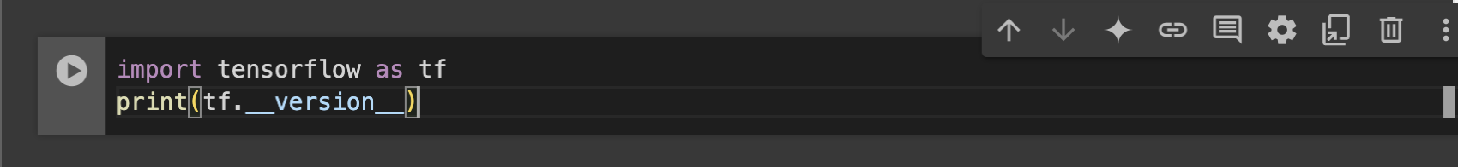

We trained a neural network to recognize items of clothing from a common dataset called [Fashion MNIST](https://github.com/zalandoresearch/fashion-mnist). It contains 70,000 items of clothing in 10 different categories. Each item of clothing is in a 28x28 grayscale image and it is shown in fig.1.

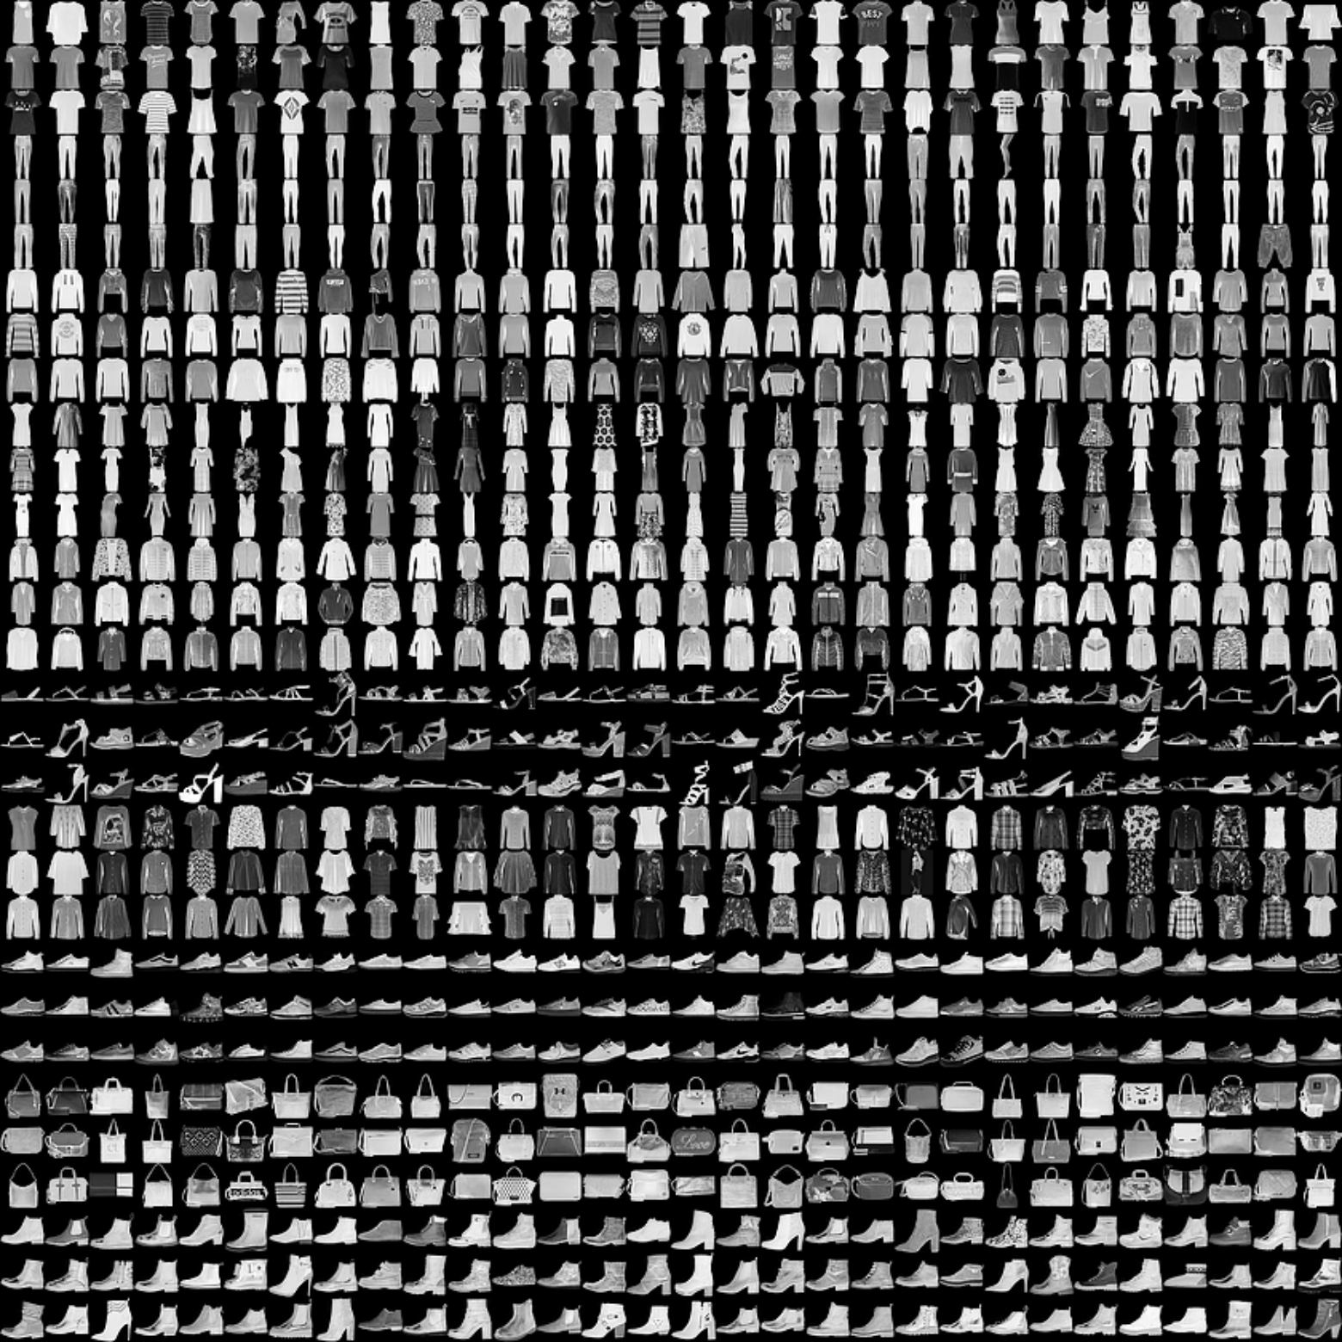

fig.1:28x28 grayscale image of FASHION MNIST dataset.

You can see some examples

table.1 represents the labels associated with the dataset

Table1: Labeling the clothes and accessories

| **Label** | **Description** |
| --- | --- |
| 0 | T-shirt/top |
| 1 | Trouser |
| 2 | Pullover |
| 3 | Dress |
| 4 | Coat |
| 5 | Scandal |
| 6 | Shirt |
| 7 | Sneaker |
| 8 | Bag |
| 9 | Ankle Boot |

**Step 1.The Fashion MNIST data is available in the tf.keras.datasets API. Load it like this:**

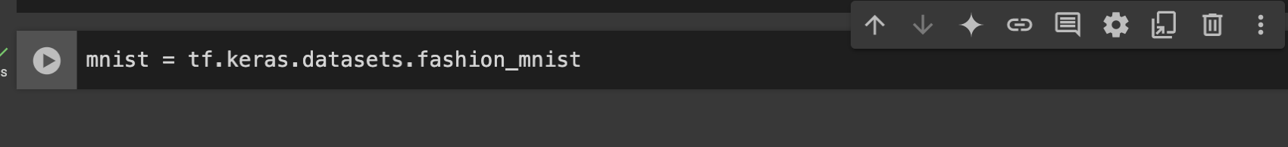

**Step 2 – Calling load_data on that object gives you two sets of two lists: *training* values and *testing* values, which represent graphics that show clothing items and their labels.**



**Step 3 – Print a training image and a training label to see these values.**

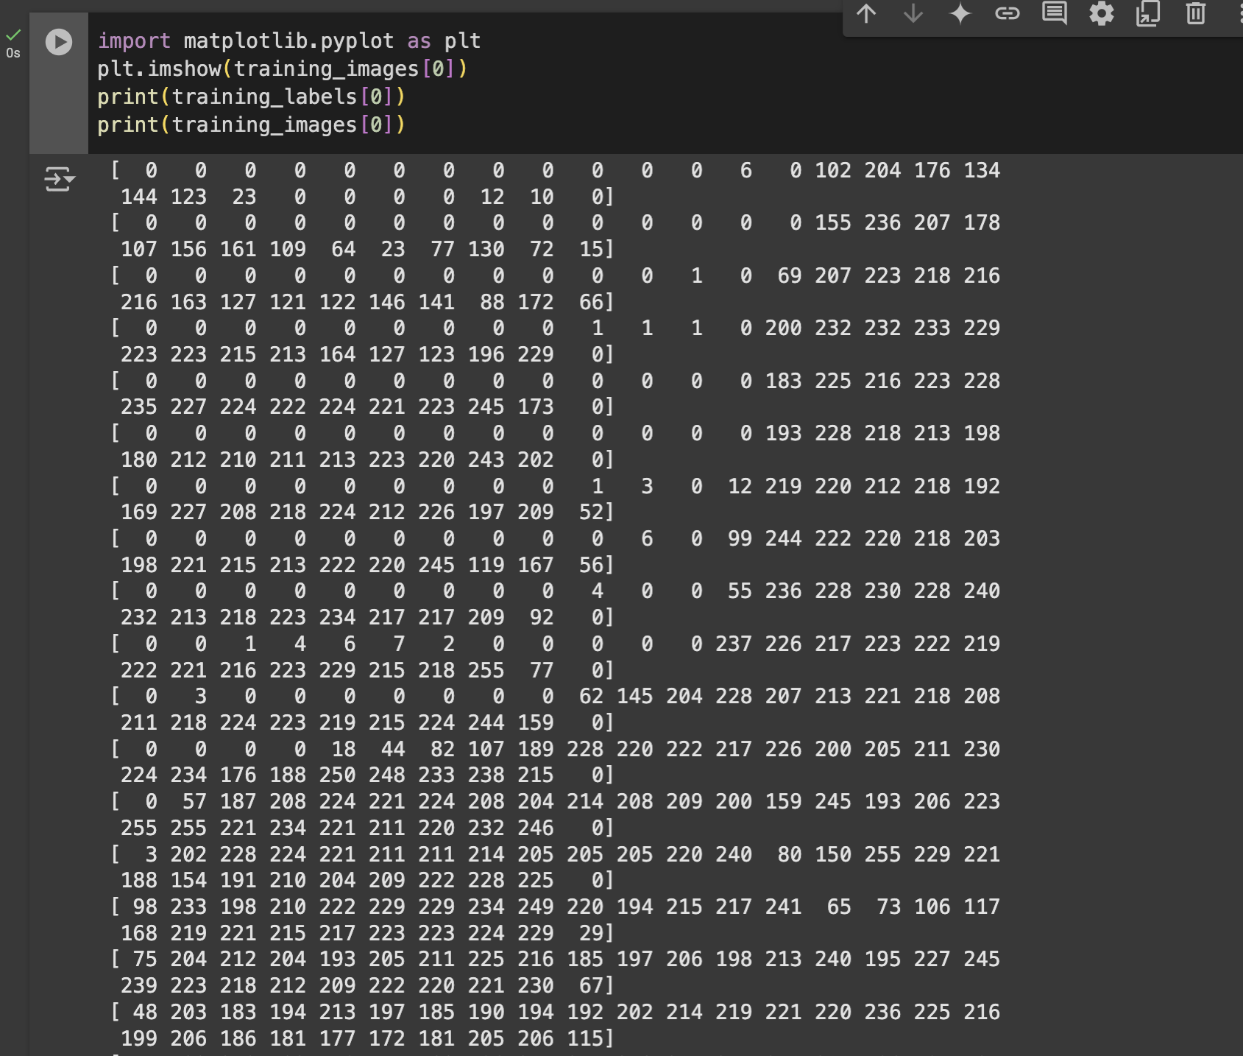

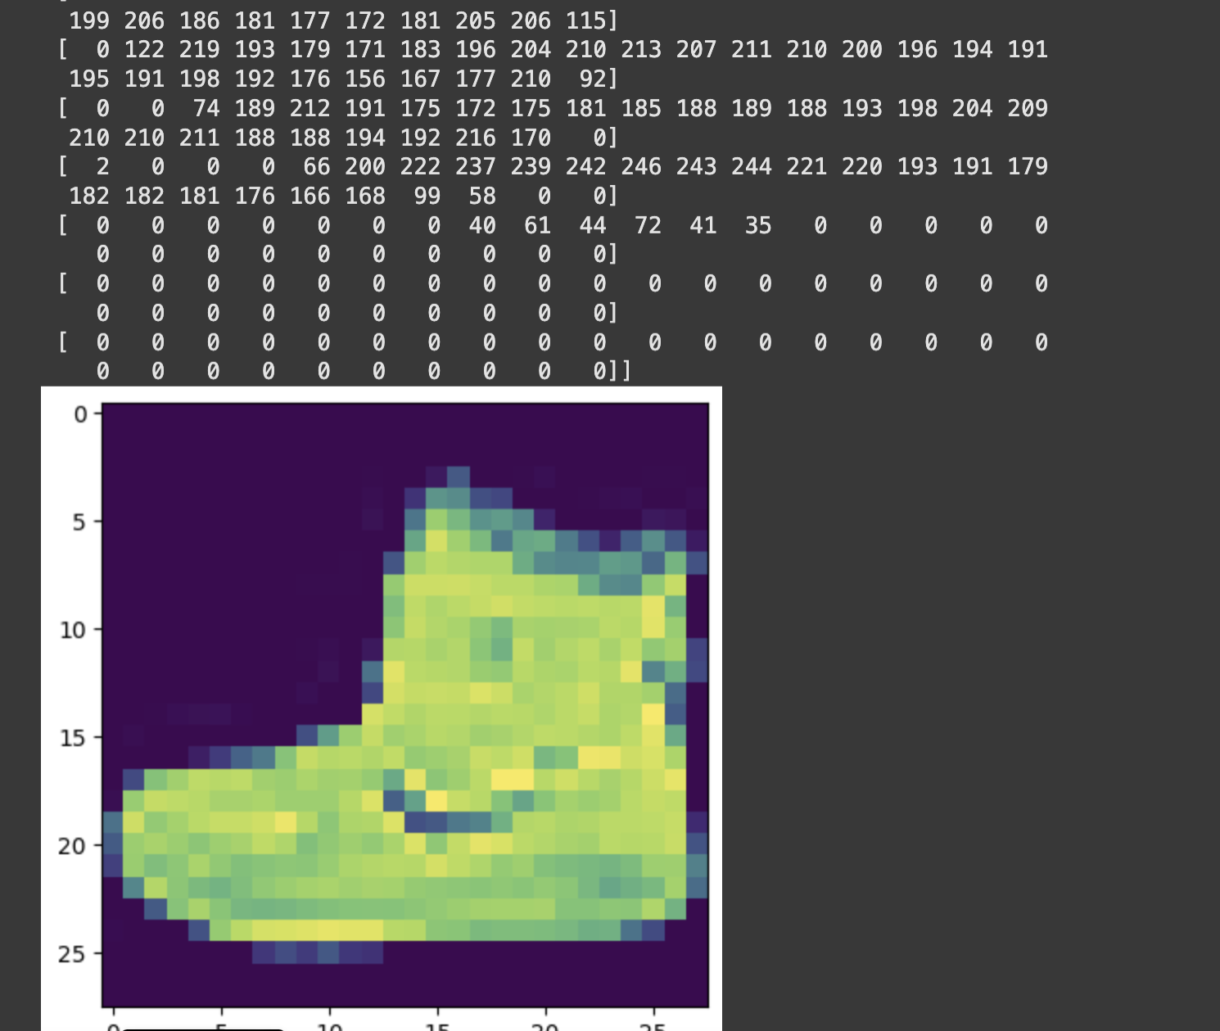

**Step 4 –Normalize a list without looping**



**Step 5 –Design the Model.**

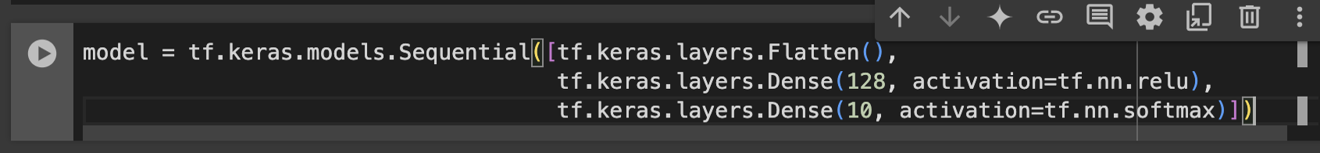

**Step 6 – Compile and train the model.**

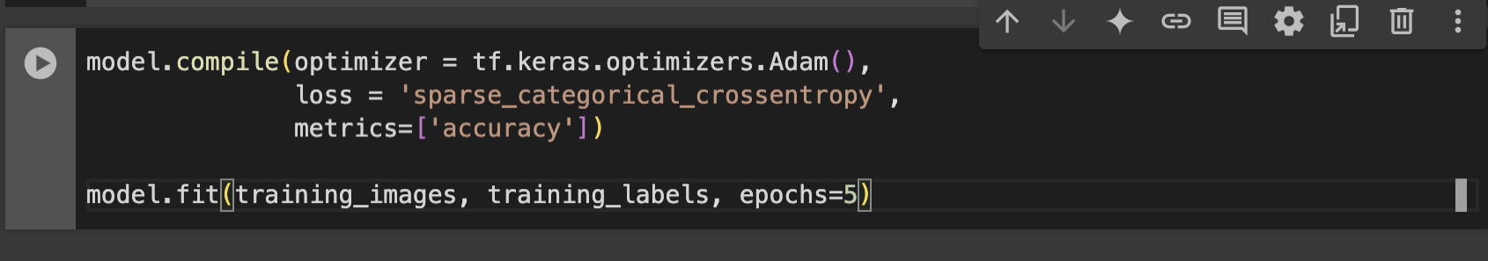

**Step 7 – Test the Model.**



**IV. RESULTS**

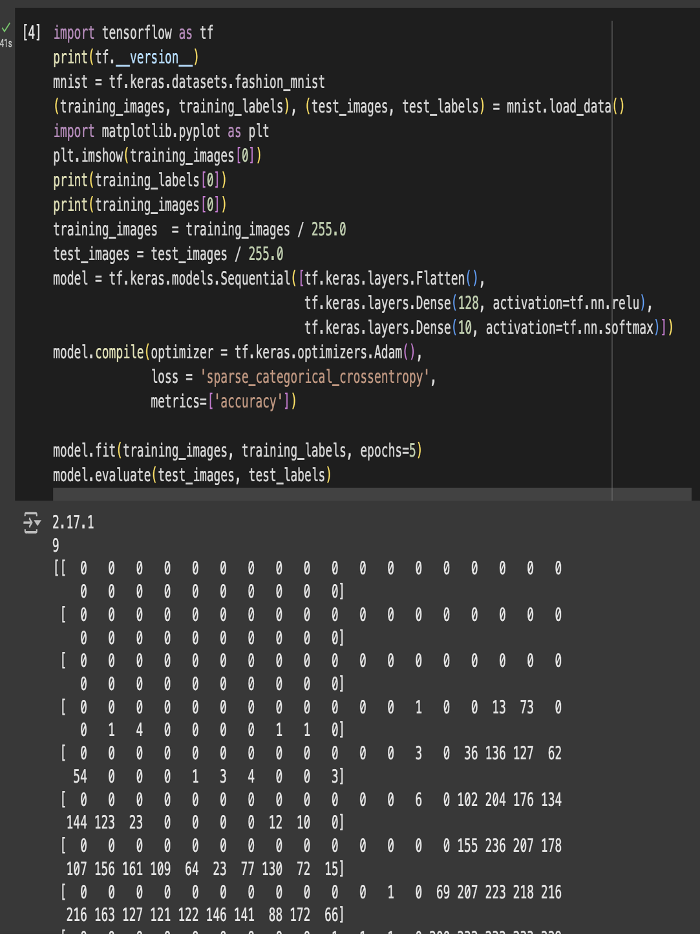

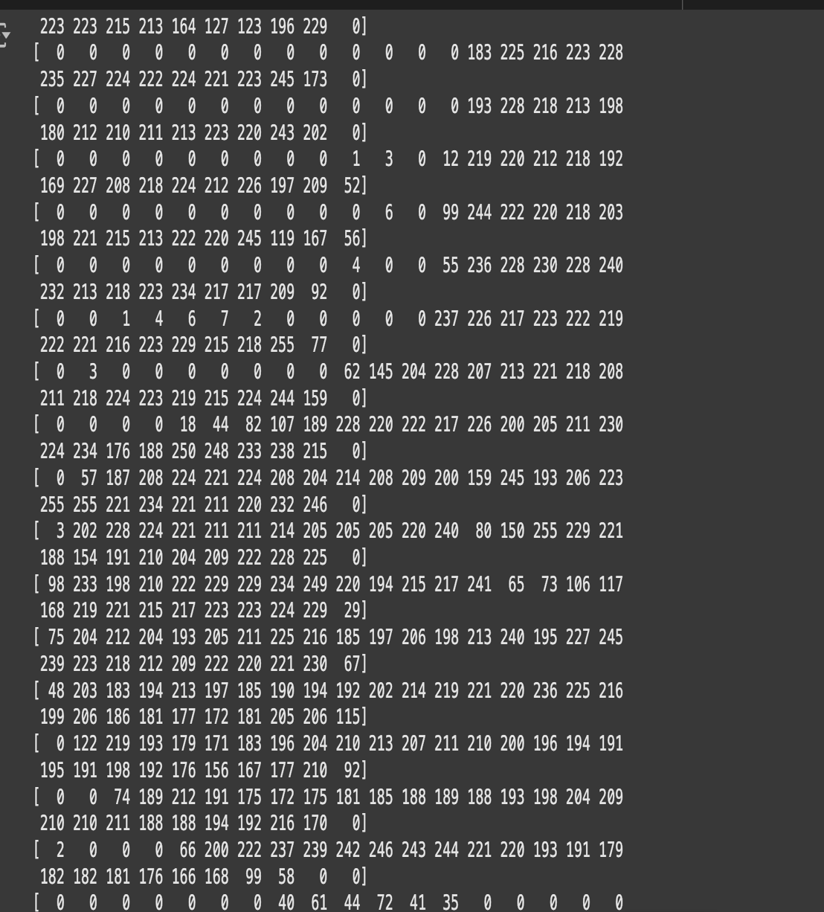

**V. CONCLUSION**

Building a computer vision model with TensorFlow provides a powerful and flexible solution for solving a variety of visual recognition tasks. By leveraging TensorFlow’s robust tools and pre-trained models, we can efficiently process and analyze images for applications in fields like healthcare, automotive, and security. The system demonstrates the effectiveness of TensorFlow in creating accurate, scalable models, with optimizations for both performance and deployment. As deep learning techniques continue to evolve, TensorFlow remains a key framework in pushing the boundaries of computer vision technology, offering a solid foundation for future advancements in AI-driven visual analysis.

**VI. REFERENCES**

[1]Charleen, C. Angelica, H. Purnama and F. Purnomo, "Impact of Computer Vision With Deep Learning Approach in Medical Imaging Diagnosis," 2021 1st International Conference on Computer Science and Artificial Intelligence (ICCSAI), Jakarta, Indonesia, 2021, pp. 37-41, doi: 10.1109/ICCSAI53272.2021.9609708.

[2]X. Zhang and S. Xu, "Research on Image Processing Technology of Computer Vision Algorithm," 2020 International Conference on Computer Vision, Image and Deep Learning (CVIDL), Chongqing, China, 2020, pp. 122-124, doi: 10.1109/CVIDL51233.2020.00030.

[3]L. Barba-Guaman, J. E. Naranjo and A. Ortiz, "Object detection in rural roads using Tensorflow API," 2020 International Conference of Digital Transformation and Innovation Technology (Incodtrin), Quito, Ecuador, 2020, pp. 84-88, doi: 10.1109/Incodtrin51881.2020.00028.

[4]A. Das, M. Wasif Ansari and R. Basak, "Covid-19 Face Mask Detection Using TensorFlow, Keras and OpenCV," 2020 IEEE 17th India Council International Conference (INDICON), New Delhi, India, 2020, pp. 1-5, doi: 10.1109/INDICON49873.2020.9342585.

[5]Pulling out all the tops with computer vision and deep learning,Sebastian Macaluso and David Shih Department of Physics and Astronomy, NHETC, Rutgers, The State University of New Jersey, Piscataway, NJ 08854, U.S.A.

[6]Y. Pachipala, M. Harika, B. Aakanksha and M. Kavitha, "Object Detection using TensorFlow," 2022 International Conference on Electronics and Renewable Systems (ICEARS), Tuticorin, India, 2022, pp. 1611-1619, doi: 10.1109/ICEARS53579.2022.9752263.

[7][Idrees, H.](https://www.emerald.com/insight/search?q=Haroon%20Idrees), [Shah, M.](https://www.emerald.com/insight/search?q=Mubarak%20Shah) and [Surette, R.](https://www.emerald.com/insight/search?q=Ray%20Surette) (2018), "Enhancing camera surveillance using computer vision: a research note", [*Policing: An International Journal*](https://www.emerald.com/insight/publication/issn/1363-951X), Vol. 41 No. 2, pp. 292-307. <https://doi.org/10.1108/PIJPSM-11-2016-0158>

[8][Zhu, D.](https://www.emerald.com/insight/search?q=Dianchen%20Zhu), [Wen, H.](https://www.emerald.com/insight/search?q=Huiying%20Wen) and [Deng, Y.](https://www.emerald.com/insight/search?q=Yichuan%20Deng) (2020), "Pro-active warning system for the crossroads at construction sites based on computer vision", [*Engineering, Construction and Architectural Management*](https://www.emerald.com/insight/publication/issn/0969-9988), Vol. 27 No. 5, pp. 1145-1168. <https://doi.org/10.1108/ECAM-06-2019-0325> Download as .RIS

[9][Li, X.](https://www.emerald.com/insight/search?q=Xuelai%20Li), [Yang, X.](https://www.emerald.com/insight/search?q=Xincong%20Yang), [Feng, K.](https://www.emerald.com/insight/search?q=Kailun%20Feng) and [Liu, C.](https://www.emerald.com/insight/search?q=Changyong%20Liu) (2024), "Automatic monitoring the risk coupling of foundation pits: integrated point cloud, computer vision and Bayesian networks approach", [*Engineering, Construction and Architectural Management*](https://www.emerald.com/insight/publication/issn/0969-9988), Vol. ahead-of-print No. ahead-of-print. <https://doi.org/10.1108/ECAM-02-2024-0149> Download as .RIS

[10][Wang, L.](https://www.emerald.com/insight/search?q=Liya%20Wang), [Zhao, Y.](https://www.emerald.com/insight/search?q=Yang%20Zhao), [Zhou, Y.](https://www.emerald.com/insight/search?q=Yaoming%20Zhou) and [Hao, J.](https://www.emerald.com/insight/search?q=Jingbin%20Hao) (2016), "Calculation of flexible printed circuit boards (FPC) global and local defect detection based on computer vision", [*Circuit World*](https://www.emerald.com/insight/publication/issn/0305-6120), Vol. 42 No. 2, pp. 49-54. <https://doi.org/10.1108/CW-07-2014-0027> Download as .RIS

[11] Lingala, Thirupathi & Gangula, Rekha & Ravikanti, Sandeep & Sowmya, Jujuroo & Shruthi, S. (2021). False News Recognition Using Machine Learning. Journal of Physics: Conference Series. 2089. 012049. 10.1088/1742-6596/2089/1/012049.

[12] Thirupathi, L., SrihaReddy, E., & Deepika, J. V. (2024). Challenges and Innovations in the Creation of Digital Twins in Healthcare. In A. Dubey, C. Kumar Reddy, S. Doss, & M. Hanafiah (Eds.), Exploring the Advancements and Future Directions of Digital Twins in Healthcare 6.0 (pp. 69-85). IGI Global Scientific Publishing. https://doi.org/10.4018/979-8-3693-5893-1.ch004

[13] Shailaja, K., Srinivasulu, B., Thirupathi, L. et al. An Intelligent Deep Feature Based Intrusion Detection System for Network Applications. Wireless Pers Commun 129, 345–370 (2023).<https://doi.org/10.1007/s11277-022-10100-w>

[14] Thirupathi, L., Bandari, M., Sreeramamurthy, K., Gangula, R. (2024). Cyber-Physical Systems Security and Quantum Computing Applications in Disaster Recovery for Industry 6.0. In: Reddy, C.K.K., Nag, A., Ouaissa, M., Bhushan, B., Hanafiah, M.M. (eds) The Rise of Quantum Computing in Industry 6.0 Towards Sustainability. Advances in Science, Technology & Innovation. Springer, Cham.<https://doi.org/10.1007/978-3-031-73350-5_14>.

[15] Thirupathi, L., Boya, T.R., Gattoju, S., Reddy, E.S. (2024). Quantum Computing and AI: Synergizing for Sustainable Disaster Management in Industry 6.0. In: Reddy, C.K.K., Nag, A., Ouaissa, M., Bhushan, B., Hanafiah, M.M. (eds) The Rise of Quantum Computing in Industry 6.0 Towards Sustainability. Advances in Science, Technology & Innovation. Springer, Cham.<https://doi.org/10.1007/978-3-031-73350-5_3>.

[16] Lingala Thirupathi et al 2021 J. Phys.: Conf. Ser. 2089 012049; DOI: 10.1088/1742-6596/2089/1/012049.

[17] Thirupathi, L., Rajesh, A., Sandeep, R. (2023). Internet of Lighting for Smart Cities. In: Tiwari, M., Ismail, Y., Verma, K., Garg, A.K. (eds) Optical and Wireless Technologies. OWT 2021. Lecture Notes in Electrical Engineering, vol 892. Springer, Singapore.<https://doi.org/10.1007/978-981-19-1645-8_41>

[18] Thirupathi, L., Rekha, G., Shruthi, S.K., Sowjanya, B., Jujuroo, S. (2023). A Novel Twitter Sentimental Analysis Approach Using Naive Bayes Classification. In: Bhateja, V., Sunitha, K.V.N., Chen, YW., Zhang, YD. (eds) Intelligent System Design. Lecture Notes in Networks and Systems, vol 494. Springer, Singapore.<https://doi.org/10.1007/978-981-19-4863-3_39>

[19] Thirupathi Lingala et al 2021 J. Phys.: Conf. Ser. 2089 012050; DOI: 10.1088/1742-6596/2089/1/012050.

[20] S. Pratapagiri, R. Gangula, R. G, B. Srinivasulu, B. Sowjanya and L. Thirupathi, "Early Detection of Plant Leaf Disease Using Convolutional Neural Networks," 2021 3rd Interna-tional Conference on Electronics Representation and Algorithm (ICERA), 2021, pp. 77-82, doi: 9.1109/ICERA53111.2021.9538659.

[21] Thirupathi, L., Srinivasulu, B., Khanapurkar, U., Rambabu, D., Preeti, C.M. (2023). Heart Disease Prediction in Healthcare Communities by Machine Learning Over Big Data. In: Bhateja, V., Sunitha, K.V.N., Chen, YW., Zhang, YD. (eds) Intelligent System Design. Lecture Notes in Networks and Systems, vol 494. Springer, Singapore.<https://doi.org/10.1007/978-981-19-4863-3_38>

[22] Padmaja P, Sophia IJ, Hari HS, Kumar SS, Somu K, et al., (2021) Distribute the Message over the Network Using another Frequency and Timing Technique to Circumvent the Jam-mers. J Nucl Ene Sci Power Generat Techno 10:9.

[23] Rekha Gangula, Lingala Thirupathi, Rajashekar Parupati, K. Sreeveda, Saritha Gattoju, Ensemble machine learning based prediction of dengue disease with performance and accuracy elevation patterns, Materials Today: Proceedings, 2021, ISSN 2214-7853,<https://doi.org/10.1016/j.matpr.2021.07.270>.

[24] L. Thirupathi, G. Rekha, "Future drifts and Modern Investigation Tests in Wireless Sensor Networks" , International Journal of Advance Research in Computer Science and Management Studies, Volume 4, Issue 8 (2016).

[25] L Thirupati, R Pasha, Y Prathima, “Malwise System for Packed and Polymorphic Malware”, International Journal of Advanced Trends in Computer Science and Engineering, Vol. 3 , No.1, Pages : 167– 172 (2014).

[26] Thirupathi Lingala, Ashok Galipelli, Mahesh Thanneru, “Traffic Congestion Control through Vehicle-to-Vehicle and Vehicle to Infrastructure Communication”, (IJCSIT) International Journal of Computer Science and Information Technologies, volume 5, Issue 4, Pages :5081-5084 (2014).

[27] M.Swathi, L.Thirupathi, “Algorithm For Detecting Cuts In Wireless Sensor Networks” in International Journal of Computer Trends and Technology (IJCTT) – volume 4 Issue10 (2013).

[28] L Thirupathi, Y Reddemma, S Gunti - SIGCOMM Computer Communication Review, “A secure model for cloud computing based storage and retrieval”, volume 39, Issue 1, Pages: 50-55 (2009).

[29] Sunanda Nalajala, Lingala Thirupathi, N.L.Pratap,”Improved Access Protection of Cloud Using Feedback and DeDuplication Schemes “, Journal of Xi'an University of Architecture & Technology, Volume XII, Issue IV ( 2020).

[30] V.Srividya, P.Swarnalatha, L.Thirupathi, “Practical Authentication Mechanism using PassText and OTP” in Grenze International Journal of Engineering and Technology, Special Issue,Grenze ID: 01.GIJET.4.3.27,© Grenze Scientific Society, 2018.

[31] Thirupathi, L., Vasundara, B., Sundaragiri, D., Ch, V. B., Gugulothu, R., & Pulyala, R. (2025). Understanding and Addressing Human Factors in Cybersecurity Vulnerabilities. In R. Kumar, S. Srivastava, & A. Elngar (Eds.), Human Impact on Security and Privacy: Network and Human Security, Social Media, and Devices (pp. 13-38). IGI Global Scientific Publishing.<https://doi.org/10.4018/979-8-3693-9235-5.ch002>

[32] Thirupathi, L., Akshaya, B., Reddy, P. C., Harsha, S. S., & Reddy, E. S. (2025). Integration of AI and Quantum Computing in Cyber Security. In B. Mishra (Ed.), Integration of AI, Quantum Computing, and Semiconductor Technology (pp. 29-56). IGI Global Scientific Publishing.<https://doi.org/10.4018/979-8-3693-7076-6.ch002>

[33] Thirupathi, L., Kaashipaka, V., Dhanaraju, M., & Katakam, V. (2025). AI and IoT in Mental Health Care: From Digital Diagnostics to Personalized, Continuous Support. In H. Joshi, C. Kumar Reddy, M. Ouaissa, M. Hanafiah, & S. Doss (Eds.), Intelligent Systems and IoT Applications in Clinical Health (pp. 271-294). IGI Global Scientific Publishing.<https://doi.org/10.4018/979-8-3693-8990-4.ch012>

[34] Thirupathi, L., Reddy, A. S., Vardhan, V., Panchagnula, T., Miriyala, N. S., Gattoju, S., & Kanth, T. V. (2025). Deepfakes: Understanding, Detection, and Mitigation in Cyber-Politics and Cyber-Economics. In A. Günar (Ed.), Economic and Political Consequences of AI: Managing Creative Destruction (pp. 351-374). IGI Global Scientific Publishing.<https://doi.org/10.4018/979-8-3693-7036-0.ch015>

[35] Thirupathi, L., Sunkara, S. H., Boodala, I. R., & Vempati, V. S. (2024). Personalization and Customization Strategies With AI in Service Marketing. In V. Nadda, P. Tyagi, A. Singh, & V. Singh (Eds.), Integrating AI-Driven Technologies Into Service Marketing (pp. 499-524). IGI Global Scientific Publishing. https://doi.org/10.4018/979-8-3693-7122-0.ch024.