Review Paper on Solar Based Seed Farming Remote Operate Robot

Department of Mechanical Engineering

Padm. Dr. V. B. Kolte college of Engineering, Malkapur.

**1Kunal Wankhade, 2Ajay Parse, 3Anjali Ingle, 4Gayatri Kshirsagar, 5Dr. Y.A.Kharche.**

1234Students, 5Professor.

**ABSTRACT**

The use of renewable energy technologies, especially solar power, in farming is drastically changing the dynamics of farming practices. Solar power remote operation technologies in seed cultivation provide a reliable and effective platform for farming instead of conventional agriculture. The use of autonomous cars, drones, and remote-control equipment, coupled with solar energy, minimizes environmental degradation while maximizing farm yield. This research paper delves into the evolution and implementation of solar-powered remote operation systems in seed cultivation. It examines the technological innovations, advantages, limitations, and future directions of this new technology, highlighting its ability to transform sustainable agricultural production.

**Keywords:** Solar Plate, MCU, Controller, DC Motor, Switches, Remote, Battery Detector, Wheel, Wooden Plate, etc.

**1 INTRODUCTION**

Agriculture is experiencing a technological revolution fuelled by the imperative to enhance efficiency, minimize environmental footprint, and enhance food security. Seed farming, a central activity in agriculture, has hitherto been based on labour-intensive and resource-intensive approaches. Recent breakthroughs in solar-powered remote operation systems have opened up new avenues for enhancing crop yield, enhancing precision in planting, and minimizing energy use. The integration of solar power with remote operation systems provides a viable answer to some of the most challenging issues in agriculture. Solar-powered autonomous tractors, drones, and remote-operated equipment are making it possible for farmers to perform seeding, monitoring, and field maintenance more efficiently and with less environmental impact.

**2 LITERATURE REVIEW**

1. Nivash et al (2018) [2]: The researcher states that the agriculture plays an important role in the life of economy. It is the backbone of our economy system. Sowing is one of the basic and best operations needed to get better revenue from agriculture. In Manual sowing has the problem of not giving acceptable spacing between row to row and plant to plant. It also leading to less population of crops than recommended by the agriculture. In this project work they focused on seed sowing processes and tried to solve the problem. In seed sowing machine system, they are used wheels.
2. Trupti A. Shinde et al. introduce a seed sowing machine equipped with battery-powered wheels and an integrated DC motor. The machine detects seed levels to prevent empty seed dispensing, triggering an alarm for replenishment. It also incorporates obstacle detection capabilities to navigate around obstacles efficiently. Each rotation of the wheel dispenses seeds from the seed drum, ensuring smooth and precise seed placement without wastage. The machine signals its completion with an alarm once the sowing process is finished.
3. D Ramesh et al. [6]: This research paper present “Agriculture Seed Sowing Equipment: A Review”. The present review provides brief information about the various types of innovations done in seed sowing equipment. The basic objective of sowing operation is to put the seed and fertilizer in rows at desired depth and seed to seed spacing, cover the seeds with soil and provide proper compaction over the seed. In this multipurpose seeding machine equipment consists of cylindrical shape container in which the seeds can fill. The container is attached on the four wheeled carrier assembly.
4. Kannan A et al. [7]: This research paper presents design modification in multipurpose sowing machine. In this they present that for sowing purpose we import the machinery which are bulk in size having more cost.
5. Swetha S. et al. have devised a solar-powered seed sowing machine utilizing solar panels to harness solar energy, which is then converted into electrical energy to charge a 12V battery. This battery powers a shunt wound DC motor, enabling the machine's wheels to be driven. To minimize reliance on labour, the machine incorporates IR sensors for autonomous navigation within the field. These sensors, along with 4 post sensors, define the territory, allowing the machine to sense track length and pitch for movement from line to line.

**3 PROPOSED METHODOLOGIES**

The prime intention of sowing operation is to place the Seeds in rows of required depth, to ensure seed to seed Spacing and cover the seeds by soil and supply Proper compaction over the seed. The desirable row to row spacing, seed rate, seed to seed spacing and depth of seeding may be different for different crops and under varying agro-climatic conditions in order to achieve optimum yield. General use of sowing seeds of Cereal's like ground nut, all sorts of dal's, oil seed crop's etc.

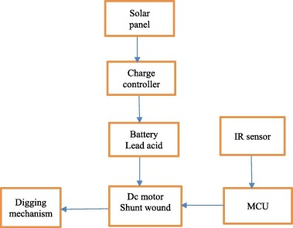

**Majored Components Used:**

**1 Solar Panel:**

Solar panel is a photovoltaic (PV) cell device that turns sunlight into electricity. PV cells consist of materials that generate excited electrons when exposed to light. The electrons pass through a circuit and generate direct current (DC) electricity, which can either be used to power devices or stored in batteries. Solar panels are also referred to as solar cell panels, solar electric panels, or PV modules.



Fig. Solar Plate

**2 Charge Controller:**

A charge regulator, charge controller or battery regulator restricts the rate at which electric current is charged to or discharged from electric batteries to avoid electrical overload, overcharging, and can prevent overvoltage. This avoids conditions that decrease battery performance or life and can be a safety hazard. It can also avoid fully draining ("deep discharging") a battery, or carry out controlled discharges, based on the battery technology, to safeguard battery life. “Charge controller" or "charge regulator" can be used to refer to either a stand-alone unit, or to control circuitry embedded in a battery pack, battery-powered equipment, and/or battery charger.

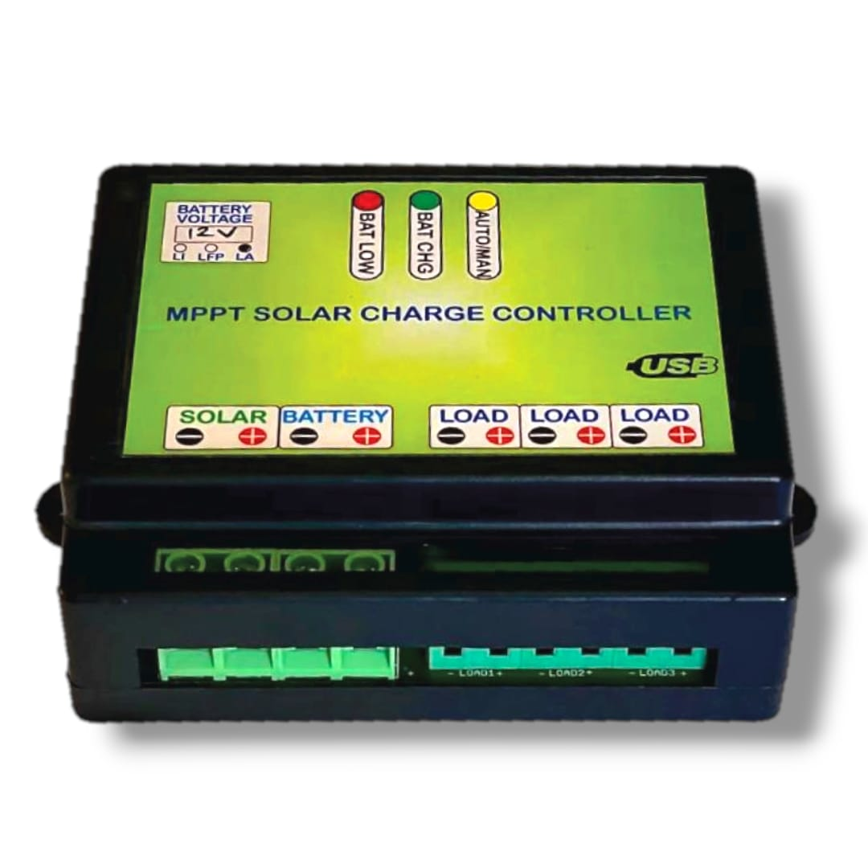

Fig. Charge Controller

**3 IR Sensor:**

Infrared (IR) sensors sense and measure infrared radiation, which is not visible to the human eye, and find application in many applications such as motion detection, security systems, remote controls, and even for meteorological studies, gas detection, and medical applications**.**

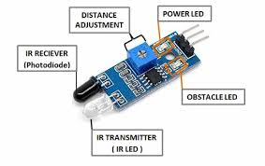

Fig. IR Sensor

**4 DC Motor Shunt Wound:**

DC motor (Direct Current motor) delivers mechanical energy by utilizing the coupling between magnetic field and current-conducting elements. It involves a stator (fixed piece with magnetic field), rotor (moving piece), commutator (switches direction of the current), and brushes (has contact with commutator). When DC voltage is used, the current passes through the rotor, generating a magnetic field that interacts with the stator's field to make the rotor rotate. DC motors find application in equipment such as fans, robots, power tools, and electric vehicles because of their ease of use and speed control.

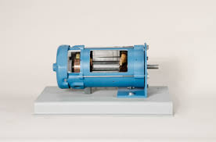

Fig. DC Motor

**5 MCU Controller:**

A MCU (Microcontroller Unit) is a compact, integrated chip with a processor (CPU), memory (RAM and ROM), and input/output peripherals. It is a runs program instructions, devices manage, and performs tasks in embedded systems such as robotics and home automation. Major components are the CPU, memory, I/O pins, timers, and communication interfaces. MCUs are employed in fields such as robotics (e.g., motor and sensor control in a robot), automotive, and consumer electronics. They are low power consumption, cost-efficient, and versatile devices that can be utilized in a broad spectrum of embedded applications.

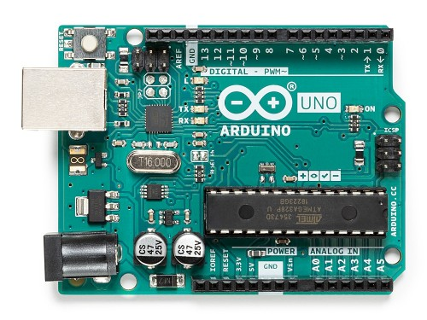

Fig. Arduino

**6 Battery:**

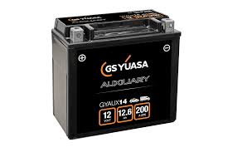A is a battery houses chemical energy and transfers it into electrical energy. It has an anode, cathode, electrolyte, and separator. Batteries are either primary (one-time use) or secondary (rechargeable). When a battery is discharged, chemical reactions at the anode release electrons, which travel through a circuit to deliver power. Rechargeable batteries, such as lithium-ion or lead-acid, can be used repeatedly. Batteries are employed in items like smartphones, electric cars, and renewable energy storage devices. They provide accessible, portable power for numerous applications.

Fig. Battery

**4 WORKING PRINCIPLE**

A solar-powered seed farming robot utilizes solar panels to energize its motors, sensors, and sowing systems. It saves energy in batteries, enabling it to function even without sunlight. The robot sow seeds automatically with accuracy, led by sensors of soil conditions and GPS for orientation. It may be controlled remotely through wireless communication (Wi-Fi or 4G) or function independently. Information gathered in the field is transmitted back for analysis, enhancing agricultural efficiency. The system is energy-efficient, environmentally friendly, and saves labour costs while maximizing planting procedures.

**5 PROPOSED CONCLUSIONS**

In summary, the solar-powered seed farming remote-controlled robot is a breakthrough in green agriculture. With solar power, it is an environmentally friendly way to automate seed planting and minimize the use of fossil fuels and environmental footprint. The use of autonomous navigation, accurate planting, and remote control maximizes efficiency and saves labour costs. Not only does it enhance productivity, but it also gives farmers useful data to maximize farming practice. Finally, this innovative method can potentially transform the farming industry, turning agriculture into an efficient, sustainable, and future-proof way of farming.

**6 REFERENCES**

1. Trupti A. Shinde et al. introduce a seed sowing machine equipped with battery-powered wheels and an integrated DC motor. The machine detects seed levels to prevent empty seed dispensing, triggering an alarm for replenishment. It also incorporates obstacle detection capabilities to navigate around obstacles efficiently. Each rotation of the wheel dispenses seeds from the seed drum, ensuring smooth and precise seed placement without wastage. The machine signals its completion with an alarm once the sowing process is finished.
2. Kannan A et al. [7]: This research paper presents design modification in multipurpose sowing machine. In this they present that for sowing purpose we import the machinery which are bulk in size having more cost.
3. Nivash et al (2018) [2]: The researcher states that the agriculture plays an important role in the life of economy. It is the backbone of our economy system. Sowing is one of the basic and best operations needed to get better revenue from agriculture. In Manual sowing has the problem of not giving acceptable spacing between row to row and plant to plant. It also leading to less population of crops than recommended by the agriculture. In this project work they focused on seed sowing processes and tried to solve the problem. In seed sowing machine system, they are used wheels.
4. H. heege and b. feldhaus. “Site specific control of seed-numbers per unit area for grain drills, “agricultural engineering international: the cigr journal of scientific research and development.