***Advancements in Sustainable Construction Materials***

***Author:-Munish Kumar1 Author:-Raj Kumar Verma2***

***Civil Engineering Department Production Engineering Department***

***Green Hills Engineering College Chandigarh College of Engg & Technology***

***State Himachal Pradesh State Chandigarh***

***Country – India Country- India***

***Email id-*** [**9191mishu@gmail.com**](mailto:9191mishu@gmail.com) ***Email id-*** [**9191mishu@gmail.com**](mailto:9191mishu@gmail.com)

***Abstract***

In order to address the pressing issues of environmental sustainability and resource efficiency, the construction industry is increasingly embracing sustainable materials. This paper researches the most recent headways in supportable development materials, featuring their capability to change building rehearse. It investigates imaginative materials like cross-overlaid lumber, reused concrete, bio-based composites, and self-recuperating materials, stressing their natural advantages, execution, and financial practicality. These materials' environmental footprints are compared to those of conventional alternatives through life cycle assessments, highlighting their potential to cut down on waste and carbon emissions. The study also looks at certification programs like LEED and BREEAM that encourage the use of sustainable materials and regulatory frameworks. Real-world case studies provide insight into best practices and lessons learned by illustrating successful implementations. Technical limitations, market acceptance, and supply chain issues persist despite the significant progress. To further enhance the sustainability of construction practices, the paper explores future directions, including emerging trends and technological innovations, as well as solutions to these obstacles. This exploration adds to the developing collection of information in reasonable development, offering an exhaustive outline of current progressions and a guide for future improvement in the mission for greener, more eco-accommodating structure arrangements.

**Introduction**

The development business remains at a crucial intersection, faced by the double objectives of natural maintainability and asset effectiveness. Construction practices have traditionally been significant contributors to environmental degradation, producing a lot of waste, consuming a lot of resources, and emitting a lot of carbon dioxide. The need for environmentally friendly construction methods has never been greater than it is now, given the growing global awareness of environmental stewardship and climate change.

Sustainable building materials represent a ground-breaking innovation in the construction of our homes, offices, and infrastructure. These materials, which range from cutting-edge bio-based composites to recycled concrete, promise to reduce construction's impact on the environment while maintaining or even improving performance and durability. The construction industry must develop and use these kinds of materials if it is to become more environmentally friendly and sustainable.

This paper examines how the most recent developments in environmentally friendly building materials are reshaping the sector. We will investigate a number of novel materials, including self-healing materials that can extend the lifespan of structures and cross-laminated timber, which is a renewable alternative to steel and concrete. By carrying out a life cycle assessment, our goal is to provide a comprehensive comparison of these materials' effects on the environment compared to those of conventional materials, highlighting their potential to significantly reduce waste and carbon footprints.

Moreover, the monetary feasibility of economical development materials will be investigated, tending to both the underlying expenses and long-term reserve funds they offer. It will also be looked at how regulatory frameworks and certification programs like LEED and BREEAM encourage the use of these materials. This will show how policy can change the industry.

In order to demonstrate how sustainable materials have been successfully used in construction projects, real-world case studies will be presented, providing practical insights and best practices. Nonetheless, in spite of the promising headway, a few moves and boundaries to far reaching reception remain. These incorporate specialized limits, market acknowledgment, and production network issues, which must all be addressed to understand the capability of practical development materials completely.

At last, this paper will look towards the future, investigating arising patterns and developments that guarantee additional upgrade the supportability of the development business. We hope that this in-depth investigation will shed light on the crucial role that environmentally friendly building materials play in constructing a greener future and provide strategic recommendations for researchers, practitioners, and policymakers to support the continued development and adoption of sustainable building materials.

1. **Innovative Sustainable Materials**

The construction industry's push for sustainability has resulted in the creation of a wide range of cutting-edge materials that reduce environmental impact while maintaining or improving performance. These materials influence science and innovation to offer greener options in contrast to conventional development materials, giving critical advantages with regards to asset productivity, solidness, and diminished carbon impression. The following are the absolute most encouraging and maintainable creative materials:

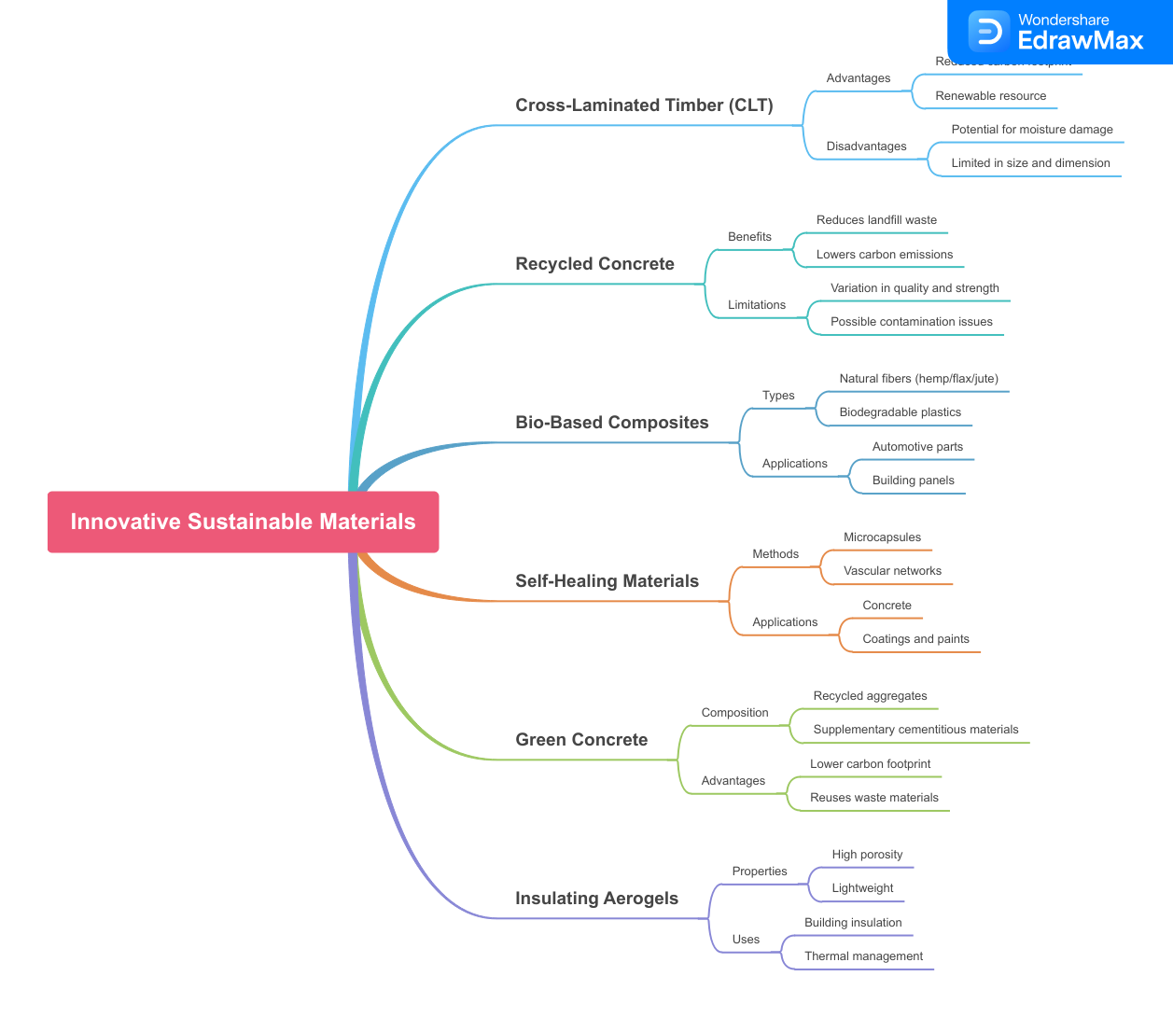

**Cross-Laminated Timber (CLT)**

A renewable alternative to conventional building materials like steel and concrete is cross-laminated timber. CLT has high strength and stability because it is made of layers of wood that are glued together at right angles. This makes it suitable for a variety of structural applications, including multi-story buildings. It uses less energy to produce and stores carbon, which helps reduce overall emissions of greenhouse gases.

**Recycled Concrete**

The aggregate for new concrete in recycled concrete is crushed concrete from demolished structures. This approach decreases the interest in virgin total and limits development squander. The performance of recycled concrete is comparable to that of conventional concrete, and it promotes the principles of the circular economy. For example, recycled concrete can be used as a road base and foundation material.

**Bio-Based Composites**

Natural fibers like hemp, flax, and bamboo are combined with bio-resins to create bio-based composites. Because they are biodegradable, lightweight, and strong, these materials are ideal for insulation and structural components in construction. Bio-based composites offer lower environmental impacts throughout their life cycle and reduce reliance on materials derived from petrochemicals.

**Self-Healing Materials**

Self-recuperating materials are intended to consequently fix damage, broadening the life expectancy of designs and diminishing support costs. These materials integrate microcapsules containing mending specialists that are delivered when a structure breaks. The material's integrity is restored during the healing process, which makes it more durable and less likely to require frequent repairs.

**Green Concrete**

Green cement integrates modern byproducts, like fly debris, slag, and silica seethe, as fractional substitutes for concrete. By reducing the amount of cement required, a significant contributor to CO2 emissions, this reduces the carbon footprint of concrete production. Green concrete also improves certain properties, like its resistance to chemical attack and durability.

**Insulating Aerogels**

Aerogels are extremely insulating, lightweight, and highly porous materials. They outperform conventional materials in terms of thermal insulation when made from silica or other compounds. Aerogels are used in building envelopes to cut down on energy consumption, demand for heating and cooling, and emissions of greenhouse gases.

**2. Environmental Impact and Life Cycle Assessment**

Promoting sustainability in the construction industry necessitates evaluating the environmental impact of construction materials. The Life Cycle Assessment (LCA) method is a comprehensive approach to assessing the environmental impacts of a material's lifecycle, from the extraction of raw materials to its production, use, and disposal. Here is a brief synopsis:

**Environmental Impact**

Through the production of waste, the use of energy, the emission of greenhouse gases, and the extraction of resources, construction materials have a significant impact on the environment. Important effects on the environment include:

**Carbon Footprint**:-A material's total lifetime emissions of greenhouse gases. The goal of sustainable materials is to lessen this impact.

**Resource Depletion** :-The use of resources that aren't renewable, like minerals and fossil fuels. Renewable or recycled resources are frequently used in sustainable materials.

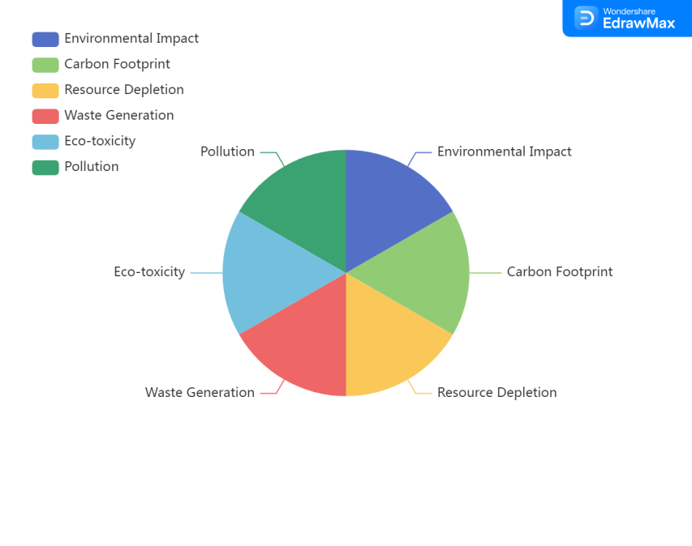

**Waste Generation** :-The amount of waste generated during the production of the material and at its end of life. Through recycling and efficient use, sustainable materials aim to reduce waste.

**Eco-toxicity and Pollution**: - The environmental release of harmful substances. Sustainable materials aim to cut down on pollutants and toxic emissions.

**3. Life Cycle Assessment (LCA)**

LCA is a deliberate way to deal with measuring the ecological effects of materials across their whole life cycle. The primary stages of LCA are:

**Raw Material Extraction**:-Evaluating the effects that raw material extraction, such as mining or harvesting, has on the environment.

**Manufacturing**:-Evaluating the production process's emissions and waste, as well as the energy and resources used.

**Transportation**:-Taking into account the effects that the transportation of materials to construction sites has on the environment, such as the consumption of fuel and emissions.

**Use Phase**:- Evaluating the performance and effects on the environment of building materials, such as energy efficiency and durability, during their use.

**End-of-Life**:- Evaluating the options for disposing of, recycling, or reusing materials at the end of their useful life, as well as the management of waste and the potential environmental advantages of recycling.

**Benefits of LCA**

**Informed Decision-Making:-** LCA gives an all-encompassing perspective on ecological effects, assisting partners with picking materials that limit adverse consequences.

**Sustainability Benchmarks** :- LCA sets benchmarks for reasonable works on, directing the turn of events and improvement of eco-accommodating materials.

**Regulatory Compliance** :- LCA guarantees consistency with natural guidelines and affirmation principles like LEED and BREEAM.

**Innovation and Improvement**:- LCA helps to drive innovation in environmentally friendly building materials by identifying areas where material production and use can be improved.

**4. Performance and Durability**

Construction materials' suitability for long-term use in building projects is largely determined by their performance and durability. To be viable alternatives, sustainable materials must meet or exceed traditional materials' performance requirements. An overview can be found here:

**Performance**

**Structural Integrity** :- Sustainable materials need to be able to support loads and withstand forces like wind, earthquakes, and other stresses from the environment. They also need to be stable and strong. They ought to show solid mechanical properties, including malleable and compressive strength.

**Thermal Performance** :- Effective warmth protection is significant for lessening energy utilization in structures. In order to improve energy efficiency and maintain comfortable indoor temperatures, sustainable materials ought to have excellent thermal properties.

**Acoustic Performance**:-The characteristics of sound insulation are crucial to the creation of conducive living and working environments. To meet acoustic performance standards, sustainable materials should have effective noise reduction capabilities.

**Fire Resistance** :- Fire security is a basic concept in development. In order to keep occupants safe and prevent the spread of fire, sustainable materials must have fire-resistant properties.

**Water Resistance** :-For structural integrity to be preserved and problems like mold growth and material degradation to be avoided, materials must be resistant to water infiltration and damage.

**Durability**

**Longevity**:-Sustainable materials must be able to withstand prolonged use and environmental conditions without significantly deteriorating. Because of their long lifespan, they don't need to be fixed or replaced as often, which makes them more sustainable.

**Resistance to Degradation** :-UV radiation, chemical exposure, biological attacks (like termites), and mechanical wear and tear should all not degrade materials. Materials are guaranteed to maintain their performance over time thanks to this resistance.

**Maintenance Requirements**:- Because they require less time and effort to maintain, materials with low maintenance requirements are preferred. To ensure their long-term viability, sustainable materials should require little upkeep.

**Recyclability and Reusability**:- Sustainable materials should be recyclable or reusable at the end of their life cycle to promote circular economy principles and reduce waste. The sustainability of the environment is aided by materials that can be easily recycled or repurposed.

**5. Economic Viability**

Sustainable building materials' widespread adoption in the construction industry depends on their economic viability. It includes the initial costs, long-term benefits, and overall value of these materials in comparison to conventional alternatives. Here is a brief synopsis:

**Initial Costs**

**Production and Procurement:-**Due to advanced manufacturing processes or limited availability, sustainable materials may have higher production costs. In any case, economies of scale and mechanical progression can lessen these costs after some time.

**Installation**:-Some environmentally friendly materials may necessitate specialized installation methods, which may result in increased initial labor costs. In the long run, employee skill development and training can reduce these costs.

**Long-Term Financial Benefits**

**Energy Efficiency**:- Sustainable materials frequently improve a building's energy efficiency, resulting in significant savings over the building's lifespan on lighting, heating, and cooling costs. Higher initial costs may be offset by these operational savings.

**Maintenance and Durability**:- Long-term costs associated with repairs and replacements can be reduced by using sustainable materials that require little upkeep. Over time, materials that resist mechanical and environmental degradation offer significant cost savings.

**Resale Value**:- Structures developed with feasible materials frequently have higher market esteem because of their natural qualifications and lower working expenses. Property owners may find a significant financial incentive in the increased resale value.

**6. Incentives and Policies**

**Government Incentives** :- Numerous states offer monetary motivating forces, for example, tax reductions, awards, and endowments, to energize the utilization of maintainable materials. Sustainable construction projects' economic viability can be significantly enhanced by these incentives.

**Certification and Market Demand** :- Green structure accreditations (e.g., LEED, BREEAM) and developing buyer interest for practical properties can drive market expenses for structures built with eco-accommodating materials.

**Life Cycle Cost Analysis (LCCA)**

**Comprehensive Evaluation:** The LCCA provides a comprehensive evaluation of the total cost of ownership, including costs associated with acquisition, operation, upkeep, and disposal. In LCCA, sustainable materials frequently exhibit favorable results, demonstrating their economic viability.

**Cost-Benefit Analysis:** The overall economic value of sustainable materials can be demonstrated by comparing their initial costs to their long-term benefits and savings. Stakeholders can use this analysis to make better decisions.

**7. Regulatory and Certification Standards**

The adoption of sustainable building materials is greatly aided by regulatory and certification standards. They guarantee that these materials meet explicit ecological, security, and execution models, giving a system for their assessment and coordination into building projects. Here is a brief synopsis:

**Regulatory Standards**

**Building Codes**:- Building codes, which mandate the use of environmentally friendly materials and other construction practices, are enforced by governments. Energy efficiency, fire safety, structural integrity, and the impact on the environment are all addressed in these codes.

**Environmental Regulations**:- The purpose of environmental regulations is to reduce the environmental impact of building materials. They may include requirements for energy conservation, recycling, waste management, and restrictions on the use of harmful substances.

**Standards for Health and Safety:-** These standards ensure that sustainable materials do not pose health hazards to workers or occupants. They address issues like volatile organic compound (VOC) emissions and safe handling practices, among others.

**Certification Standards**

**LEED (Leadership in Energy and Environmental Design):-** LEED is a well-known green building certification program that looks at a building's sustainability and environmental performance. It empowers the utilization of reasonable materials and practices to accomplish different affirmation levels (Guaranteed, Silver, Gold, and Platinum).

**BREEAM (Building Research Establishment Environmental Assessment Method):-** Another popular green building certification system that looks at buildings' sustainability is BREEAM. It covers energy use, materials, water management, health, and well-being, among other topics.

**Living Building Challenge**:- The goal of this rigorous certification program is to build buildings that benefit their surroundings. Sustainable, non-toxic, locally sourced, and biodiversity-promoting materials are emphasized.

**Cradle to Cradle Certified:-** This certificate assesses materials in view of their natural and human wellbeing effects, recyclability, and utilization of environmentally friendly power. By encouraging materials that can be recycled or reused at the end of their life cycle, it encourages a circular economy approach.

**ENERGY STAR**:- Products and methods that use less energy are the primary focus of Energy Star certification. It encourages the use of materials and systems that improve building performance and reduce energy consumption in construction.

**Benefits of Certification**

**Market Differentiation** :- By demonstrating a commitment to sustainability, certification gives you an advantage over the competition. Buyers and tenants who care about the environment frequently find certified buildings to be more appealing.

**Enhanced Credibility** :- Sustainability claims gain credibility when materials and procedures are certified by a third party to meet stringent environmental standards.

**Regulatory Compliance**:- Certification reduces the likelihood of legal issues and penalties by ensuring compliance with international and local regulations.

**Financial Incentives**:- Financial incentives like tax credits, grants, and lower insurance premiums may make certified buildings more financially viable.

**8. Case Studies**

Case studies shed light on the practical applications and advantages of environmentally friendly building materials in the real world. They show the way that creative materials can be effectively coordinated into different undertakings, displaying their exhibition, sturdiness, and financial reasonability. Some notable examples include:

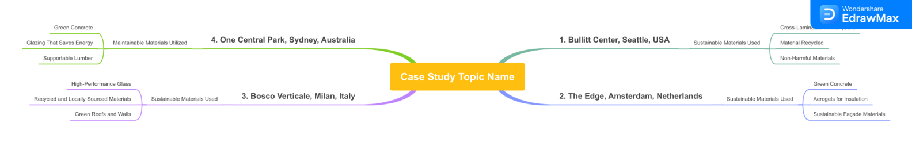

**Case Study 1: Bullitt Center, Seattle, USA**

***Project Overview:-***

The Bullitt Center in Seattle is often referred to as perhaps one of the greenest businesses working on the planet. It was finished in 2013 and is a living laboratory for environmentally friendly design and construction.

**Sustainable Materials Used:-**

**Cross-Laminated Timber (CLT):-** The building's structural framework is largely constructed of CLT, which reduces its carbon footprint in comparison to steel and concrete.

**Material Recycled:** In various areas of the building, recycled steel and reclaimed wood were utilized.

**Non-Harmful Materials:** The inside components were picked for their low VOC outflows to guarantee solid indoor air quality.

**Outcomes:-**

The building was certified by The Living Building Challenge because it met stringent sustainability requirements. It generates all of its energy locally through solar panels, making it a net-zero energy building. The utilization of reasonable materials contributed to huge decreases in typified carbon.

**Case Study 2: The Edge, Amsterdam, Netherlands**

***Project Overview:-***

The Edge is a landmark office building in Amsterdam that was finished in 2014 and is known for its innovative use of smart technologies and sustainable materials.

**Sustainable Materials Used:-**

**Green Concrete:** The structure utilized green cement with reused totals and modern side-effects, lessening its carbon impression.

**Aerogels For Insulation:** For better thermal insulation and improved energy efficiency, advanced aerogels were used.

**Sustainable Façade Materials:** The materials used in the façade maximize daylighting and natural ventilation.

**Outcomes:**

The Edge got the most elevated BREEAM rating of "Remarkable" for its supportability execution. The building's energy consumption was 70% lower than that of comparable structures thanks to the utilization of cutting-edge materials. The building's healthy and comfortable atmosphere boosts productivity and well-being for its occupants.

**Case Study 3: Bosco Verticale, Milan, Italy**

***Project Overview:-***

In Milan, the two residential towers known as Bosco Verticale, or Vertical Forest, were completed in 2014. The project creates a one-of-a-kind urban ecosystem by combining environmentally friendly materials with extensive vegetation.

**Sustainable Materials Used:-**

**High-Performance Glass:-** High-performance glass is used in the towers to maximize natural light and reduce heat loss.

**Recycled and Locally Sourced Materials**:- The sustainability credentials of the construction materials, such as their recycled content and local sourcing, were taken into consideration.

**Green Roofs and Walls:-** In addition to improving air quality and providing natural insulation, extensive use of vegetation also improves aesthetic appeal.

**Outcomes:-**

Bosco Verticale was awarded the International Highrise Award for its sustainable design. Urban heat island effects and CO2 emissions are significantly reduced as a result of the building's landscaping. The project has established itself as an example of how to incorporate nature into urban environments to enhance biodiversity and the well-being of residents.

**Case Study 4: One Central Park, Sydney, Australia**

***Project Overview:-***

One Focal Park, finished in 2013, is a blended use of private and business improvement in Sydney that highlights broad manageable plan components.

**Maintainable Materials Utilized:**

**Green Concrete:** To reduce its overall carbon footprint, the development used green concrete.

**Glazing That Saves Energy:** High-performance glazing systems were used to save energy.

**Supportable Lumber:** Guaranteed feasible wood was utilized for different primary and stylish purposes.

**Outcomes:** The Green Building Council of Australia gave One Central Park a 5-star Green Star rating, among other accolades. The building's energy efficiency and aesthetic value have both been significantly improved by the incorporation of green roofs and walls. The task fills in as a benchmark for feasible metropolitan living, showing the capability of green plans in high-thickness settings.

**9. Challenges and Barriers**

Despite their advantages for the economy and the environment, sustainable building materials face a number of obstacles. Strategies for overcoming these obstacles and expanding the use of eco-friendly materials can only be developed with an understanding of them. Here is a brief synopsis:

**Technical Challenges**

**Performance Standards**:- For sustainable materials to be considered viable alternatives to conventional materials, they must meet stringent performance and safety standards. It may be technically challenging and resource-intensive to meet these standards.

**Concerns About Durability**: The use of some sustainable materials in construction projects may be discouraged because they may have shorter lifespans or be less durable under certain conditions.

**Compatibility Issues**: Compatibility issues can arise when combining sustainable materials with existing construction methods and materials, necessitating adjustments to design and construction methods.

**Economic Barriers**

**Higher Starting Expenses**: Manageable materials frequently accompany higher introductory expenses contrasted with customary materials, which can be a critical obstacle for manufacturers and designers.

**Acceptance by the Market**: The market may resist new materials because of their unfamiliarity and skepticism regarding their benefits and dependability.

**Financial Incentives**: The adoption of sustainable materials may be hampered by insufficient financial incentives and government support. To cover the initial costs, incentives like tax breaks, grants, and subsidies are essential.

**Regulatory and Policy Challenges**

**Inconsistent Standards**: Variety in administrative norms and confirmation rules across districts can make disarray and ruin the reception of practical materials.

**Lack of Enforcement**: Efforts to promote sustainable materials may be undermined by inadequate enforcement of existing environmental regulations.

**Supply Chain Issues**

**Availability and Scalability**: The difficulty of scaling production to meet demand and the limited availability of sustainable materials can impede their widespread use.

**Logistics and Distribution**: The timely and cost-effective delivery of sustainable building materials to construction sites requires effective logistics and distribution networks.

**Knowledge and Awareness**

**Lack of Knowledge**:- It's possible that architects, developers, and builders don't know enough about the advantages and applications of sustainable materials to use them.

**Training and Education**:- Better education and training programs are needed to give professionals in the industry the skills and knowledge they need to work with sustainable materials.

**10. Future Directions and Innovations**

Due to ongoing research, technological advancements, and a growing emphasis on environmental stewardship, sustainable construction materials are poised for significant advancements in the future. The following is a comprehensive look at the expected industry-defining future directions and innovations:

**Advanced Material Science**

**Nanotechnology**: Nanomaterials are being made to make construction materials have better properties. Nanoparticles can work on the strength, solidness, and self-cleaning abilities of cement, glass, and coatings. Concrete, for instance, can have its tensile strength and resistance to cracking increased by adding carbon nanotubes.

**Bio-Based Materials**: The production of materials derived from biological sources is expanding at a rapid rate. Mycelium-based insulation, algae-derived bioplastics, and bio-composite materials made from agricultural waste are examples of innovations. These materials offer sustainable and biodegradable options in contrast to customary development materials.

**Self-Healing Materials**: Research into materials that can repair cracks and other damages on their own is progressing. When a material is damaged, healing agents in microcapsules are released, restoring the material's integrity and lengthening its lifespan.

**Smart and Adaptive Materials**

**Phase Change Materials (PCMs)**: PCMs can help regulate indoor temperatures by absorbing and releasing thermal energy during phase transitions. By decreasing the need for heating and cooling, PCMs can be incorporated into building materials to improve energy efficiency.

**Shape Memory Alloys**: When these alloys are subjected to a particular stimulus, such as heat, they are able to revert back to their original shape after deforming. They can be utilized in adaptive structural elements that adapt to changes in the environment, enhancing the resilience and functionality of buildings.

**Smart Concrete**: In Smart Concrete, embedded sensors can monitor the health of the structure, detect stress and strain, and provide real-time data for safety and maintenance evaluations. Infrastructure's longevity and dependability are improved by this technology.

**Circular Economy and Recycling**

**Material Reuse and Recycling**: Reclaiming and recycling construction materials are becoming simpler as recycling technologies advance. Concrete recycling processes, the creation of new building materials from construction waste, and fully recyclable composites are examples of innovations.

**Cradle-To-Cradle Design**: This method focuses on making products and materials that can be used and recycled over and over again. Materials are chosen and fabricated considering their finish of-life recyclability, advancing a roundabout economy that limits waste and asset consumption.

**Modular Construction**: Prefabricated and modular construction methods make it easier to disassemble and reuse building components and make more efficient use of materials. This strategy diminishes development waste and upgrades the adaptability and maintainability of structures.

**Energy Efficiency and Integration**

**Materials That Produce Energy**: Photovoltaic materials that are incorporated into building components, such as solar roof tiles and windows, have the potential to generate on-site renewable energy. It is now possible to incorporate solar energy into a variety of building surfaces thanks to advancements in transparent photovoltaics and thin-film solar cells.

**Protecting Materials**: Advances in protection materials, for example, aero gels and vacuum-protected boards, offer unrivaled warm execution with negligible thickness. These materials make it easier to save energy and use less energy for heating and cooling.

**Integration with Building Systems**: Smart building systems that optimize energy use, monitor environmental conditions, and improve occupant comfort are increasingly incorporating sustainable materials. In order to effectively manage lighting, HVAC, and other building operations, these systems make use of data from sensors and IoT devices.

**Policy and Market Trends**

**Green Building Certifications**: The extension and refinement of green structure confirmation programs, like LEED, BREEAM, and Indeed, keep on driving the reception of economical materials. These certifications encourage the use of eco-friendly materials and establish higher sustainability standards.

**Government Regulations and Incentives**: State-run administrations overall are executing stricter natural guidelines and offering impetuses to advance manageable development rehearses. For accelerating adoption, policies that require the use of low-carbon materials and provide financial support for green building projects are essential.

**Consumer Demand and Market Shifts**: Trends in the market are being influenced by rising awareness and demand for eco-friendly and sustainable buildings. Businesses and consumers are placing a greater emphasis on sustainability, which has resulted in increased funding for green material research and development.

### Conclusion

The modern construction industry must address the environmental and financial challenges it faces by developing sustainable building materials. The innovative properties, performance and durability, economic viability, regulatory standards, and real-world applications of sustainable materials have all been examined in this paper. In addition, the discussion of challenges and obstacles has brought to light the difficulties that must be overcome in order to encourage wider adoption.

Headways in material science, like nanotechnology, bio-based materials, and self-recuperating capacities, are changing the business by improving the strength, sturdiness, and natural execution of development materials. Phase-change materials, shape-memory alloys, and smart concrete are examples of smart and adaptive materials that present new opportunities for structural resilience and energy efficiency. The circular economy approach promotes sustainability throughout the material life cycle by placing an emphasis on material recycling and reuse.

The adoption of sustainable materials is frequently hampered by high initial costs, making economic viability an essential consideration. Nonetheless, long-term monetary advantages, like energy reserve funds, diminished upkeep, and expanded resale esteem, can counterbalance these expenses. Their economic attractiveness is further enhanced by market demand and financial incentives.

A framework for evaluating and promoting environmentally friendly materials is provided by regulatory and certification standards. To encourage industry-wide adoption, standards must be enforced and standardized consistently across regions. To ensure the widespread use of sustainable materials, supply chain issues like availability and scalability must also be addressed.

Sustainable building materials have a bright future ahead of them thanks to new directions and innovations. Combination with brilliant structure frameworks, improvement of energy-producing materials, and refinement of green structure affirmations will drive progress. In order to foster a construction environment that is sustainable, government policies and market trends will play a crucial role.

All in all, maintainable development materials are urgent for making eco-accommodating, tough, and financially savvy structures. The construction industry has the potential to significantly lessen its impact on the environment and contribute to a more sustainable future by adopting cutting-edge technologies, overcoming obstacles, and gaining support from regulatory authorities. To fully utilize the potential of environmentally friendly building materials, stakeholders must continue to conduct research, develop new products, and work together.

### References

1. **Ashby, M. F., & Johnson, K. (2013).** Materials and Design: The Art and Science of Material Selection in Product Design. Butterworth-Heinemann.
2. **Choi, J., & Kim, H. J. (2014).** The use of nanotechnology in construction materials. Construction and Building Materials, 43, 432-438.
3. **John, G., Clements-Croome, D., & Jeronimidis, G. (2005).** Sustainable building solutions: A review of lessons from the natural world. Building and Environment, 40(3), 319-328.
4. **Kibert, C. J. (2016).** Sustainable Construction: Green Building Design and Delivery. John Wiley & Sons.
5. **Lehmann, S. (2012).** Optimizing urban material flows and waste streams in urban development through principles of zero waste and sustainable consumption. Sustainable Development, 20(6), 370-380.
6. **Márquez, C. A., & Ramage, M. H. (2020).** Performance and potential of bio-based materials in sustainable construction. Construction and Building Materials, 247, 118-131.
7. **Meyer, C. (2009).** The greening of the concrete industry. Cement and Concrete Composites, 31(8), 601-605.
8. **Ortiz, O., Castells, F., & Sonnemann, G. (2009).** Sustainability in the construction industry: A review of recent developments based on LCA. Construction and Building Materials, 23(1), 28-39.
9. **Pacheco-Torgal, F., Cabeza, L. F., Labrincha, J., & de Magalhães, A. G. (2013).** Eco-Efficient Construction and Building Materials: Life Cycle Assessment (LCA), Eco-Labelling and Case Studies. Woodhead Publishing.
10. **Sodagar, B., & Fieldson, R. (2008).** Towards a sustainable construction practice. Construction and Building Materials, 22(4), 408-417.
11. **Turner, C., & Frankel, M. (2008).** Energy performance of LEED for new construction buildings. New Buildings Institute, 4, 1-42.
12. **Zabalza Bribián, I., Valero Capilla, A., & Aranda Usón, A. (2011).** Life cycle assessment of building materials: Comparative analysis of energy and environmental impacts and evaluation of the eco-efficiency improvement potential. Building and Environment, 46(5), 1133-1140.
13. **Zhang, X., & Shen, L. (2014).** Green building, energy efficiency, and its implications for residential building. Energy Policy, 55, 209-217.
14. **Zhou, L., & Lowe, D. J. (2003).** Economic challenges of sustainable construction. Management of Environmental Quality: An International Journal, 14(4), 472-481.
15. *John, F., Manoj, A., Manoj, A., J, R. O., S, V. C., & Professor, A. (2023). Mycelium Building Materials-A Future Sustainable Construction Material. International Research Journal of Innovations in Engineering and Technology (IRJIET), 7(7).*
16. *Yadav, M., & Mathur, A. (2021). Bamboo as a sustainable material in the construction industry: An overview. Materials Today: Proceedings, 43.https://doi.org/10.1016/j.matpr.2021.01.125*