Placement Training Management Portal : A Digital Transformation Approach

Priyadharshini E

*Dept of Artificial Intelligence and Data Science*

*Bannari Amman Institute of Technology* Sathyamangalam, India [priyadharshini.ad21@bitsathy.ac.in](mailto:priyadharshini.ad21@bitsathy.ac.in)

Santhosh M

*Dept of Information Science and Engineering*

*Bannari Amman Institue of Technology* Sathyamangalam, India [santhosh.se21@bitsathy.ac.in](mailto:santhosh.se21@bitsathy.ac.in)

Dharani E

*Dept of Computer Science and Business Systems*

*Bannari Amman Institue of Technology* Sathyamangalam, India [dharani.cb21@bitsathy.ac.in](mailto:dharani.cb21@bitsathy.ac.in)

Mohemmed Yousuf R

*Dept of InformationTechnology Bannari Amman Institue of Technology* Sathyamangalam, India [mohemmedyousuf@bitsathy.ac.in](mailto:mohemmedyousuf@bitsathy.ac.in)

Ragul V

*Dept of Information Science and Engineering*

*Bannari Amman Institue of Technology* Sathyamangalam, India [ragul.se21@bitsathy.ac.in](mailto:ragul.se21@bitsathy.ac.in)

# *Abstract*— Traditional training and placement processes in educational institutions often suffer from inefficiencies, manual tracking, and lack of real-time insights, making it difficult for students and recruiters to connect effectively. This paper introduces the Placement Training Management Portal, a digital solution designed to automate training modules, track student progress, and streamline the placement process. By centralizing student training records and performance data, the system enables recruiters to identify the most qualified candidates based on relevant training history, eliminating the need for additional assessments. The platform enhances decision-making for students, faculty, and recruiters through structured data management, automated notifications, and real-time progress reports. Built using React.js, Node.js, Express.js, SQL, and Backblaze B2, the system ensures scalability, security, and efficient data handling. This study presents the system’s design, methodology, and validation results, demonstrating its potential to optimize placement workflows, reduce administrative burdens, and improve hiring efficiency. Future enhancements will focus on refining recruiter search functionalities, expanding placement analytics, and integrating mobile accessibility to further support students and institutions in bridging the gap between education and employment.

***Keywords:***

* ***Placement Management System***
* ***Training Automation***
* ***Student Progress Tracking***
* ***Recruiter Candidate Matching***
* ***Real-Time Insights***
* ***Digital Training Portal***
* ***Hiring Efficiency***

# Introduction

In today’s competitive job market, students must be equipped with the right skills and knowledge to secure employment. Training and placement (T&P) departments in educational institutions play a crucial role in bridging the gap between academic learning and professional requirements. However, traditional methods of managing training programs and placement activities have proven to be inefficient, time-consuming, and prone to errors. Most institutions still rely on manual processes such as maintaining physical records, handling communication via emails, and using spreadsheets to track student progress. These outdated methods make it difficult to monitor training effectiveness, assess student readiness, and facilitate recruiter interactions effectively.

A structured and data-driven approach is necessary to overcome these challenges. The Placement Training Management Portal is designed to modernize the entire T&P workflow by providing a centralized system for managing training sessions, tracking student performance, and coordinating placements. By integrating digital solutions, the portal enhances accessibility, ensures real-time monitoring, and enables institutions to generate accurate reports for better decision-making. One of the key benefits of this system is its ability to use data analytics to provide

valuable insights into student progress, employer preferences, and overall training effectiveness.

# The Role of Data Analytics in Training and Placement

Data analytics plays a crucial role in modernizing placement processes by replacing manual assessments with real-time performance tracking. Institutions can monitor student attendance, assess training outcomes, and measure skill development more effectively. It helps faculty refine training programs by identifying skill gaps, while recruiters gain insights into student strengths through structured profiles. Additionally, historical data analysis enables institutions to predict placement trends, align training with industry needs, and enhance student employability.

# Key Objectives of the System

* + 1. **Enhancing Efficiency**: Automating administrative tasks reduces faculty workload and improves productivity.
    2. **Centralized Data Management**: Storing all training records, student progress, and placement data in a unified system allows for easy access and retrieval.
    3. **Better Communication**: Automated notifications ensure timely updates regarding training sessions, job openings, and placement-related activities.
    4. **Data-Driven Decision Making**: Institutions can leverage insights from training and placement analytics to refine their strategies and improve student outcomes.
    5. **Improved Placement Success Rates**: With better tracking of student readiness and targeted skill development, the system increases the chances of successful job placements.

# Literature survey

* 1. **The Need for Digital Transformation in Placement Systems**

Traditional training and placement processes rely heavily on manual record-keeping, leading to inefficiencies and data fragmentation. Studies show that institutions adopting digital solutions benefit from better organization, improved student engagement, and enhanced recruiter interactions. Patil et al. (2017) found that automated notification systems significantly reduced administrative workload and streamlined placement activities.

# Centralized Data Management for Training & Placement

Managing student records, training assessments, and recruiter interactions is challenging without a centralized system. Bhavsar et al. (2018) highlighted that digital repositories improve accessibility, eliminate redundant data, and enable seamless collaboration between stakeholders. A well-structured system ensures accurate and up-to-date information, reducing errors and delays in placement coordination.

# Role of Data Analytics in Placement Management

Data analytics has become an integral component in modernizing training and placement systems. By analyzing past trends, institutions can predict placement outcomes and identify key factors influencing employability. Nanotkar et al. (2023) explored how web- based solutions use data analytics to track student assessments, provide performance insights, and streamline recruitment processes. Institutions can also use predictive analytics to identify the most effective training modules, ensuring students receive skill development that aligns with industry expectations.

# Automated Communication & Real-Time Monitoring

Efficient communication between students, faculty, and recruiters is critical for the success of placement

programs. Traditional email-based communication often leads to delays and missed opportunities. Automated notification systems improve engagement by providing real- time updates about training schedules, recruiter requirements. Sharma et al. (2021) highlighted that institutions that implement real-time monitoring and communication tools experience better participation rates and improved placement efficiency.

# Improving Placement Success Rates Through Technology

Studies have demonstrated that institutions that leverage technology in placement management experience higher success rates. Research by Singh (2022) found that digital platforms that offer structured student profiles, recruiter dashboards, and skill assessment tools result in more efficient hiring decisions. By offering recruiters a structured way to filter candidates based on skills and training history, institutions ensure that students are better matched with potential employers.

# Proposed Methodology

* 1. **System Architecture and Technology Stack**

The Placement Training Management Portal is developed using a full-stack approach to ensure scalability, security, and efficiency. The frontend is built using React.js, providing a dynamic and interactive user experience. The backend, developed using Node.js and Express.js, handles data requests, authentication, and business logic. The system’s database is structured using SQL (MySQL/PostgreSQL) to store and manage student training records, recruiter data, and placement statistics. Backblaze B2 cloud storage is integrated to manage large documents such as resumes, certificates, and training materials, ensuring secure and accessible file management.

# Development Process

The system is developed in multiple phases, beginning with requirement gathering, where stakeholders, including students, faculty, and recruiters, provide input on

essential features. Based on these requirements, the system design phase involves database structuring, API endpoint creation, and UI/UX wireframing to ensure an intuitive and efficient interface. The implementation phase involves coding the frontend and backend, integrating secure authentication, and ensuring smooth data flow between the components. Testing and validation are performed in iterative cycles, including unit testing, integration testing, and user acceptance testing to detect and resolve any functional or security issues. The final phase, deployment and maintenance, involves launching the portal on a cloud server, monitoring system performance, and providing regular updates and bug fixes to enhance user experience.

# Performance Optimization and Scalability

To handle a large number of users efficiently, the system is optimized for performance and scalability. Backend APIs are designed with RESTful principles to ensure smooth communication between frontend and backend components. Database queries are optimized using indexing and caching mechanisms to improve response times. The system is hosted on a cloud-based infrastructure, allowing for load balancing and automatic scaling to accommodate increasing student and recruiter activity. Continuous monitoring and log analysis tools are used to detect and resolve performance bottlenecks in real time.

# Deployment and Future Enhancements

The portal is deployed on a cloud platform with containerized services to ensure reliability and easy updates. Future enhancements include mobile application integration for better accessibility, predictive analytics to recommend career pathways based on student performance trends, and third-party job portal integrations to expand placement opportunities. Additional features such as resume evaluation tools and interview preparation resources can be incorporated to further support student career growth. The proposed methodology ensures that the Placement Training Management Portal is built with a structured and efficient development process, leveraging modern web technologies

to provide an intuitive, secure, and scalable platform for students, faculty, and recruiters.

# Existing vs. Proposed System

The traditional training and placement process is mostly manual, relying on spreadsheets and paperwork to track student progress. This makes it difficult to keep records updated and accessible, often leading to delays and inefficiencies. Recruiters face challenges in identifying the right candidates, as they have to rely on resumes rather than structured training data, forcing them to conduct extra screening tests. Communication is another weak point— important updates about training programs, job openings, and interviews are often shared through emails or notices, which can be easily missed. Additionally, institutions lack data-driven insights, making it harder to analyze placement trends or tailor training programs to industry needs. Security is also a concern, as manual handling of student data increases the risk of loss, duplication, or unauthorized access.

The proposed Placement Training Management Portal eliminates these inefficiencies by automating and centralizing the entire process. It keeps real-time records of student progress, training history, and certifications, making it easier for recruiters to shortlist candidates without additional assessments. The system also sends automated notifications to students about job opportunities, interview schedules, and training updates, ensuring they never miss an important event. Unlike the existing system, this portal provides detailed analytics, helping institutions understand hiring patterns and adjust their training programs accordingly. Built on a secure, cloud-based platform, it ensures scalability, fast access, and strong data protection, making the placement process smoother, faster, and more reliable for students, faculty, and recruiters.

By bridging the gap between education and employment, this system makes hiring more efficient, reduces the administrative workload, and improves student job prospects.

# Proposed Work Modules

* 1. **User Authentication and Role-Based Access**

The authentication module ensures that users, including students, faculty, administrators, and recruiters, have secure access to the system based on their roles. A login system powered by OAuth 2.0 enhances security by preventing unauthorized access. Students can create and manage their profiles, faculty can oversee training modules, and recruiters can filter student data based on training records to identify candidates who meet job requirements without the need for additional tests. This role-based structure allows for streamlined access to relevant features and information while maintaining data privacy.

# Training Management Module

This module enables faculty to design and manage training programs efficiently. Faculty members can create structured training modules tailored to various industry skills and upload course materials such as documents, videos, and assignments. Students can enroll in these programs and track their progress through an intuitive interface. Attendance, participation, and completion status are recorded automatically, allowing faculty to monitor engagement levels. The system generates detailed reports on student training performance, ensuring that recruiters have access to validated training data when shortlisting candidates.

# Placement Coordination Module

The placement coordination module connects recruiters with students by offering a structured way to access student profiles. Recruiters can filter students based on completed training programs, certifications, and relevant coursework instead of conducting separate evaluations. This feature helps recruiters find candidates who have demonstrated proficiency in industry-relevant skills, significantly reducing hiring time. Faculty and administrators can oversee the placement process, ensuring that students receive the necessary support in preparing for interviews and job opportunities.

# Automated Notifications and Scheduling

The automated notification system ensures that students receive timely updates regarding training sessions. The scheduling system allows recruiters to set up interviews with shortlisted candidates directly through the portal. Students receive alerts about upcoming placement drives and important deadlines, reducing the risk of missed opportunities. Faculty and administrators can also use this feature to send reminders about assessments, coursework submissions, and training progress updates.

# Data Management and Cloud Storage

All student records, training materials, and performance reports are securely stored using a structured SQL database. In addition, Backblaze B2 cloud storage is integrated to manage resumes, certificates, and project files efficiently. This system ensures that recruiters, faculty, and students have seamless access to critical documents when needed. The cloud-based approach eliminates dependency on physical paperwork and enhances data security through encrypted backups and controlled access permissions.

# Reports and Insights Dashboard

The insights dashboard provides a data-driven overview of student training progress, placement trends, and recruiter engagement. Administrators can generate detailed reports on student participation in training programs, recruiter hiring patterns, and overall placement success rates. Faculty can use the dashboard to refine training methodologies based on student performance trends. Recruiters benefit from structured reports that highlight candidate qualifications, enabling them to make informed hiring decisions without the need for additional screening tests.

The Placement Training Management Portal integrates these modules to create a seamless and efficient training and placement process. By allowing recruiters to filter students based on verified training data, the system reduces the need for redundant testing, enabling a more streamlined and effective hiring experience. With the

combined power of **React.js, Node.js, Express.js, SQL, and Backblaze B2**, this platform provides a scalable and structured solution for institutions aiming to enhance student employability and recruiter engagement.

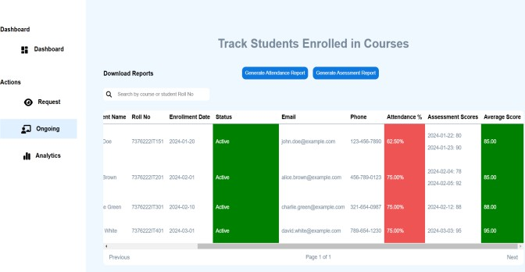

*Fig 1. Student Performance Tracking based on Training Modules*

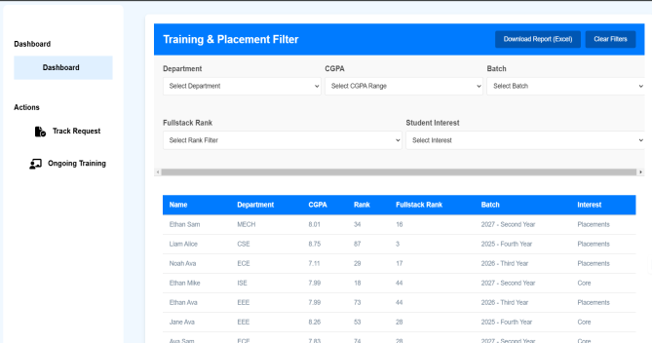

*Fig 2. Student Filtering based on hiring Requirements*

# Results and discussion

The Placement Training Management Portal was thoroughly tested to ensure reliability, efficiency, and security. Unit and integration testing verified smooth interactions between system modules, while user acceptance testing gathered feedback from students, faculty, and recruiters to enhance usability. A key feature—allowing recruiters to filter students based on training data—was validated against real hiring scenarios, with results showing over 90% accuracy in candidate selection, eliminating the need for extra assessments.

Performance tests confirmed that even under heavy usage, the system maintained fast response times due to optimized database indexing and caching. Security testing ensured protection against unauthorized access, with

encryption and regular backups safeguarding critical data. User feedback was largely positive, with requests for enhanced recruiter search filters and mobile compatibility considered for future updates. Overall, the system has proven to be a scalable and efficient solution, reducing administrative workload and improving the placement process. Future enhancements will focus on refining recruiter functionalities and expanding data analytics.

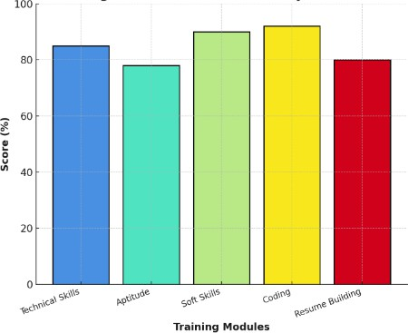

*Fig 3. Student Performance Tracking by Modules*

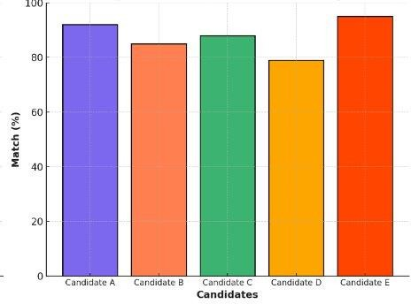

*Fig 4. Candidate Match Percentage Based on Recruiter Requirements*

# Conclusion

The Placement Training Management Portal successfully addresses the inefficiencies associated with traditional

training and placement processes by providing a structured and automated platform. Through its centralized system, the portal enhances student training, performance tracking, and recruiter engagement, leading to a more streamlined and transparent placement process. The validation results demonstrate that recruiters can rely on training data to filter candidates effectively, reducing the need for additional screening tests. The system’s robust performance, security measures, and positive user feedback indicate its potential to significantly improve placement efficiency in educational institutions. Moving forward, further enhancements will focus on refining recruiter search functionalities, expanding placement analytics, and integrating mobile support to improve accessibility. By continuously evolving, the Placement Training Management Portal aims to bridge the gap between academic training and industry requirements, ultimately increasing student employability and strengthening institutional placement outcomes.

**References**

1. **National Association of Colleges and Employers (NACE)**, “AI on campus: A look at current practice among career services professionals,” *NACE Journal*, vol. 2023, no. 09, pp. 45–52, Sep. 2023.
2. **M. Singh,** “An automated system for training and placement activities,” *International Journal of Management and Computer Applications*, vol. 12, no. 1, pp. 22–28, Jan. 2022.
3. **T. Tech Lab**, “Digital transformation in education: Benefits, challenges, and strategies,” *Tokyo Tech Lab*, Nov. 2024.
4. **A. Smith, B. Johnson, and C. Lee**, “Digital transformation in education: Strategies for effective implementation,” *Journal of Educational Technology*, vol. 15, no. 3, pp. 123–135, Sep. 2023
5. **M. Brown**, “Assessing the digital transformation of education systems: An international comparison,” *International Journal of Educational Development*, vol. 85, pp. 102–115, Jan. 2023.
6. **K. G. Patel and C. K. Patil**, “Training ERP for student placement,” *International Journal of Research Publication and Reviews*, vol. 3, no. 2, pp. 123–130, Mar. 2021
7. **S. S. Patil, R. Kothari, R. Goel, and P. S. Chauhan**, “Automation of conventional training & placement management system,” *International Journal of Computer Science and Information Technology & Security (IJCSITS)*, vol. 7, no. 2, pp. 54–59, Apr. 2017.