

**Abstract**

Manga (Japanese comics) and anime (Japanese animation) were formerly virtually totally unknown outside of Japan, but they have since become a global phenomenon, with their popularity rising by the day. Manga novels are often printed in black and white and contain a wide range of genres and subject matter intended at both sexes and all ages, rather than primarily young boys, to whom comic books are typically marketed in the West. Themes include romance, action-adventure, science fiction, humour, and sports, as well as darker subject matter for adults such as horror and more risqué stuff; however, the latter is rarely acknowledged in common life and society. Doraemon (developed by Fujiko F Fujio and originally published in 1969) follows a blue robotic cat that travels back in time from the 24th Century to assist a young schoolboy, Nobita Nobi, in overcoming life's challenges. Dragon Ball (created by Akira Toriyama and first published in 1984) follows Goku and his companion Bulma as they traverse the legendary earth, practicing martial arts and looking for "dragon balls" that summon a mystical dragon to help them in times of crisis. Once a given manga has shown its value via popularity, an animated TV series is the inevitable next step. However, manga is not the sole source of inspiration for anime. Pokémon, for example, was a worldwide sensation as a video game for Nintendo before being adapted into manga and anime series. The apparent contrasts from manga, such as color, movement, and music, bring anime to life, but there is one other crucial factor: the theme song.

**Introduction**

There has been a drastic rise in the viewership of anime, especially in the past decade which has caused the industry to boom and has led to the creation of so many anime in all different genres and languages. Although the market of anime is centered around and most prevalent in the Japanese language, there has certainly been a rise in the consumption of this genre of audio-visual representation. Though most of it is fiction and is not related to real life, many scenes and representations derive their inspiration from real-life situations and scenarios. As mentioned above, anime and manga are popular visual fields of Japanese culture. Throughout the ages, this pop culture has spread worldwide and has a viewership in almost every country. Even though the spread of anime and manga throughout the world, the representations in these forms of visual culture still mostly remain Japanese. Shifting the view to Japanese culture for a second, the Japanese culture has some set differences and unique traits and qualities of its own that make it stand apart from the crowd. These set of cultural practices ranging from the unique celebration style of its festivals to their body language and greeting styles, the social setups (building architecture, markets, etc), and the dressing styles, etc. are all reflected in their popular visual culture (for this research paper, its anime and manga. The aim is to observe these representations of Japanese culture as shown in these visual media through an Indian lens. Since the point of the study is India and the participants will be accustomed to Indian culture, the observations to be made will be on the lines of association between the two cultures and their practices. India, just like Japan, has diverse and somewhat similar, if not totally the same styles of cultural practices. Hence, the Japanese culture’s representations in Anime and Manga are being looked at from an Indian perspective to form an idea of the similarities and differences. The other aim is to observe, along the way, whether the representations made are accurately representing the culture.

**Research Objectives**

1. To analyse the representation of Japanese cultural practices in anime and manga.
2. To assess the degree to which Indian audiences can relate to these cultural elements.
3. To examine the role of anime in fostering cross-cultural understanding between India and Japan.
4. To evaluate how localization (dubbing and subtitles) affects cultural perception.
5. To explore how anime influences language learning among Indian youth.
6. To identify the anime genres that resonate most with Indian audiences.
7. To investigate generational differences in anime consumption in India.
8. To assess the accessibility of licensed manga and anime in India.
9. To examine the role of anime conventions and fan events in India.
10. To analyse Indian parents' perception of anime and manga for children.
11. To explore challenges in publishing manga in India.
12. To evaluate the impact of streaming platforms on anime’s acceptance in India.
13. To investigate the influence of anime on Indian fashion and lifestyle trends.
14. To analyse how anime represents gender roles and identity.
15. To determine if anime enhances Indian audiences’ knowledge of Japanese customs.
16. To examine how anime shapes India's perception of modern Japanese society.
17. To explore anime’s impact on emotional and psychological well-being among Indian youth.
18. To assess the influence of anime’s moral and ethical themes on Indian audiences.
19. To evaluate how anime portrays historical and political themes.
20. To analyse the role of anime in promoting social inclusivity.
21. To explore anime’s influence on Indian digital content creation and fandom culture.
22. To investigate anime’s role in shaping career aspirations in India.
23. To assess anime’s impact on the acceptance of foreign cultures among Indian audiences.
24. To examine the depiction of family structures in anime compared to Indian traditions.
25. To analyze anime’s role in youth subcultures and identity formation in India.

**Research Gap**

Despite the growing popularity of anime and manga in India, there is a noticeable lack of academic research exploring their cultural impact on Indian audiences. While extensive studies exist on the global influence of Japanese media, particularly in Western contexts, limited attention has been given to its reception and interpretation in culturally diverse regions like India.

Existing research primarily examines:

Western Reception: Studies have analyzed how Western viewers interpret Japanese cultural themes, often focusing on cultural adaptation, media hybridity, and globalization.

Cultural Exportation: Researchers have explored Japan’s “soft power” and how anime serves as a cultural export, strengthening Japan’s cultural influence globally.

Consumer Behavior: Studies have also delved into the commercial aspects of anime and its success in global markets.

However, the following gaps remain unaddressed:

Lack of Regional Insights: There is limited understanding of how Indian viewers, with their unique cultural backgrounds, interpret and engage with Japanese cultural narratives.

Cultural Intersectionality: While Japan and India share similarities in family values, traditions, and mythology, little research has explored how these intersections shape viewers' perceptions of anime.

Impact of Localization: The influence of dubbing, subtitles, and cultural adaptation on Indian viewers’ cultural understanding is underexplored.

Viewer Influence on Cultural Adoption: While anecdotal evidence suggests that anime inspires cultural curiosity and lifestyle changes, comprehensive studies analyzing the extent of this influence in India are scarce.**Review of Literature**

1. earch published by Sharmishtha Singh Rawat; Anime and manga fandom as a life experience. The growing interest in Japanese animation and manga in India is examined in this chapter within the broader discussion of cultural globalization and its many processes. India has seen an increase in the youth population's interest in and involvement with these cultural products over the past ten years. Communities of fans of anime and manga are growing in several Indian cities. Even Indian children's wrists can be seen adorned with Doraemon-themed rakhis, a traditional Indian bracelet. The history of how and when these cultural items were introduced to India is sketched in this chapter, together with a discussion of the mechanics of their reception in Indian society, which investigates the abovementioned phenomenon. It provides insights into the Indian fandom by examining how they consume anime and manga.2010 researched by Mio Bryce, Christie Barber, James Kelly, Siris Kunwar, and Amy Plumb; Manga and Anime Fluidity and Hybridity in Global Imagery. The fast dispersion of manga and anime in the world media industry in recent years has sparked an increase in curiosity over how this diffusion took place. In light of this, this essay investigates how manga and anime have been used to create a variety of hybridized goods. It also looks at how manga and anime have developed into a site of fluid, multidimensional cultural interpenetration. Cultural interpenetration happens when consumers engage with manga and anime and each other in both the virtual and real worlds. Translation requires reinterpreting these media on numerous levels, in which representations and perceptions of the source culture continually shift. 2016 research published by Ruchi Jaggi; An Overview of Japanese Content on Children’s Television in India Japanese anime has increased significantly more quickly and visibly than other television genres in children's television programming in India. This research looks at the trajectory of Japanese programming on Indian children's television from 2000 to 2012 in an effort to analyze it. In order to put the ubiquity and appeal of imported programming on Indian children's television channels in context, it also evaluates scholarly studies on children's television in India. Additionally, it draws attention to the localization of Japanese content through dubbing as well as marketing schemes and unauthorized merchandise initiatives that have captured the interest of both Indian parents and children. Napier, Susan J. (2001). Anime from Akira to Princess Mononoke: Experiencing Contemporary Japanese Animation- Susan Napier is one of the foremost scholars in anime studies, and her work is foundational in understanding how anime operates as a medium of storytelling that blends fantasy, tradition, and modernity. In her book, she examines how anime presents themes of identity, historical memory, and societal transformation. She argues that anime functions as a cultural text that reflects Japan’s historical traumas, modernization struggles, and philosophical dilemmas. Napier’s analysis of films like Princess Mononoke and Akira highlights how anime presents a blend of traditional Japanese aesthetics and futuristic dystopias, making it a unique cultural export. Her work is particularly relevant to this study as it provides a framework for analyzing anime’s cultural representation and how non-Japanese audiences, including Indian viewers, engage with these representations. The book also examines how anime fosters cross-cultural engagement, a crucial aspect when considering the impact of anime on Indian audiences. Iwabuchi, Koichi (2002). Recentering Globalization: Popular Culture and Japanese Transnationalism- Iwabuchi’s work focuses on the globalization of Japanese popular culture, particularly anime and manga, and how they have been localized for different audiences worldwide. He introduces the concept of “cultural odorlessness” (mukokuseki), which refers to the deliberate minimization of overtly Japanese cultural elements in anime to make it more appealing to international markets. While Iwabuchi acknowledges that many anime series do incorporate specific aspects of Japanese culture—such as honorifics, societal expectations, and traditional customs—he argues that the globalization process often neutralizes these elements to make anime more universally relatable. This study is relevant to the current research as it helps in understanding how Indian audiences consume anime: whether they see it as a representation of Japanese culture or as a more globally neutral entertainment medium. Additionally, Iwabuchi discusses how the localization process, such as dubbing and cultural adaptation, can sometimes alter the intended meanings of anime. This is significant in the Indian context, where anime is often dubbed in Hindi and other regional languages, potentially influencing how Indian viewers interpret cultural nuances in anime. Lamarre, Thomas (2009). The Anime Machine: A Media Theory of Animation- Thomas Lamarre’s work takes a media-theoretical approach to anime, focusing on its unique visual storytelling techniques. He introduces the concept of the “animetic machine,” which explains how anime’s aesthetic and technical elements—such as layered backgrounds, stylized character movements, and exaggerated facial expressions—contribute to its distinct narrative style. One of Lamarre’s key arguments is that anime often presents an “open world” where traditional and modern Japanese cultural elements coexist seamlessly. This is particularly relevant when analyzing anime like Doraemon, My Hero Academia, or Tokyo Ghoul, where we see both contemporary urban Japan and deeply rooted cultural traditions interwoven into the story. His study also provides insights into how anime visually represents societal hierarchies, interpersonal relationships, and even national identity, making it highly relevant for understanding how Japanese cultural values are embedded in anime narratives. This is useful when exploring how Indian audiences interpret and relate to these cultural aspects. Allison, Anne (2006). Millennial Monsters: Japanese Toys and the Global Imagination- Allison’s study expands beyond anime and manga to include the broader ecosystem of Japanese pop culture, including merchandising, gaming, and cosplay. She explores how anime and manga create immersive cultural worlds that extend beyond the screen, influencing fan behaviors, consumer culture, and cross-cultural interactions. A major theme in her book is how anime and manga contribute to a globalized “fantasy world” where audiences can engage with Japanese culture in an interactive way. She discusses how anime fandoms outside Japan—including those in India—develop strong emotional and cultural attachments to anime characters, settings, and narratives. For Indian audiences, this can be observed in the popularity of anime-themed merchandise, fan art, and conventions, which indicate not just passive consumption but active cultural participation. Her research is valuable in explaining how anime functions as a medium of cultural transmission and adaptation. Clements, Jonathan (2013). Anime: A History Jonathan Clements provides an in-depth historical overview of anime, tracing its development from early Japanese animation in the 1910s to its contemporary global status. He explores how anime has evolved in response to political, economic, and technological shifts in Japan. One of the key discussions in this book is how anime has historically served as a reflection of Japan’s socio-political conditions. Clements examines how different eras of anime—from post-war reconstruction themes in Astro Boy to the cyberpunk dystopias of the 1980s and the more introspective narratives of recent years—reflect Japan’s changing cultural landscape. This historical perspective is useful when analyzing how anime represents Japanese culture in a way that is dynamic and evolving rather than static or purely traditional. It also provides insights into how anime’s appeal to international audiences, including those in India, has been shaped by these evolving narratives.Condry, Ian (2013). The Soul of Anime: Collaborative Creativity and Japan’s Media Success Story- Condry’s work takes an ethnographic approach to understanding anime production. He argues that anime is not just a product of individual creators but a collaborative effort involving studios, animators, voice actors, and even fans. His research explores how anime production decisions—such as storytelling choices, character designs, and world-building—are influenced by cultural values, market demands, and audience expectations. His study is particularly relevant in examining how anime’s cultural representation is shaped by both creators and consumers. He also discusses how international fan communities contribute to anime’s global popularity through fan translations, discussions, and online forums. In the Indian context, this can be seen in the rise of anime streaming platforms, social media fan pages, and anime-related events that showcase how Indian fans actively participate in anime culture rather than just passively consuming it. Poitras, Gilles (2008). Contemporary Anime in Japanese Pop Culture-Poitras provides an overview of anime’s role within Japan’s broader visual culture. He discusses how anime is interconnected with other media forms, such as manga, video games, and light novels, creating a multi-layered cultural landscape. A key aspect of this book is its discussion on how anime presents both idealized and realistic portrayals of Japanese culture. Some anime series, such as My Neighbor Totoro, depict idyllic countryside life, while others, like Tokyo Ghoul, explore darker aspects of urban society. This distinction is useful when analyzing how Indian audiences perceive Japanese culture—whether they see it as a romanticized fantasy or a more authentic representation. His study also examines how anime’s themes—such as family values, perseverance, and social hierarchy—resonate with international audiences. This is particularly relevant to the current research, as it helps explain why Indian viewers find certain aspects of anime relatable to their own cultural experiences. Anime from Akira to Howl’s Moving Castle – Susan J. Napier (2005)Susan J. Napier’s book explores anime as a significant cultural and artistic medium. She categorizes anime into different thematic types—apocalyptic, festival, and elegiac—highlighting how these themes resonate globally. Analyzing classics like Akira, Ghost in the Shell, and Spirited Away, she examines how anime blurs fantasy and reality, addressing deep philosophical and social issues. Napier also discusses anime’s expansion beyond Japan, its influence on Western media, and its role in identity exploration. The book is an accessible yet academic introduction to anime studies, making it essential for both researchers and enthusiasts interested in the medium’s artistic and cultural significance. Manga! Manga! The World of Japanese Comics – Frederik L. Schodt (1983) Frederik L. Schodt’s Manga! Manga! is a pioneering study of Japanese comics, covering their history, genres, and societal impact. He traces manga’s origins from ukiyo-e prints to modern serialized storytelling and examines how it reflects Japan’s cultural shifts. Schodt categorizes manga into shōnen, shōjo, seinen, and josei, illustrating how it appeals to diverse audiences. He also highlights the contributions of legendary manga artists, particularly Osamu Tezuka, in shaping the industry. The book discusses manga’s growing international popularity, offering insights into its cross-cultural influence. As one of the first scholarly works on manga in English, it remains a foundational text for manga studies. Understanding Manga and Anime – Robin E. Brenner (2007)Robin E. Brenner’s book serves as an introduction to manga and anime, explaining their unique storytelling styles, artistic techniques, and global appeal. She differentiates manga from Western comics, emphasizing its long-term narratives and character depth. The book categorizes different genres, such as shōnen, shōjo, and seinen, and explores common themes like coming-of-age and dystopian futures. Brenner also discusses the international expansion of anime and manga, particularly their rise in North America through conventions, fan translations, and official adaptations. Addressing misconceptions about the medium, she provides a balanced perspective on its artistic and cultural significance. The book is an excellent resource for educators, students, and newcomers to manga and anime.The Anime Machine: A Media Theory of Animation – Thomas Lamarre (2009)Thomas Lamarre’s The Anime Machine is a theoretical analysis of anime’s animation techniques, visual structure, and production process. He introduces the concept of the “multiplanar image,” explaining how anime layers movement differently from Western animation. Lamarre explores the technological and philosophical aspects of anime, discussing its shift from hand-drawn to digital techniques. Examining works like Neon Genesis Evangelion and Ghost in the Shell, he argues that anime’s unique visual style influences its storytelling. Unlike other anime studies books, which focus on culture or narrative, The Anime Machine delves into the mechanics of animation. It is a dense but essential read for scholars and animation enthusiasts interested in anime’s artistic foundations.

**Methodology**

The research will deal with the analysis of the topic in hand with the help of some of the most famous and well-known anime. To provide an equivalent distribution and maintain neutrality as much as possible, anime(s) taken will be from different genres and are at the top of their respective genres’ must-watch. After the selection of the primary text, the secondary aim would be to select the participants for the focus group. The selection of the participants was done based on their intensity of intake of anime and their level of indulgence with the same. The rationale behind such a selection lies in the fact that the study will not be able to move further with participants who are not avid watchers of anime as the questions will be subjective to the topic and their takeaway from the said topic. After the selection of the focus group, an individual interview process will be conducted to record their opinions on the subject matter. The interview will be unstructured and done in the form of a dialogic discussion to gather data which is subjective and might vary from individual to individual.

The data collected from the interviews will be analyzed to see whether there are similarities between the thought processes of the participants, which will show (or not show) that there are multiple individuals with the same idea on the subject matter, which will assist in the conclusion of the research paper. The participants and the readers will be intimated that there is no right or wrong answer since it is a subjective study that is based on the subjective opinions of the participants. The questions and prompts will be based on the participants' answers to ensure that there is no bias.

**Analysis of Primary Source**

The primary texts that have been taken for this research paper are anime which are all from different genres. To ensure that there is symmetry between the ideas of the interviewees, specific anime has also been chosen to facilitate discussions based on similarities and differences in the thoughts of the participants on anime. The specific anime that has been selected also cover different genres respectively. Hence, for this specific anime, it is necessary to know the summary of the storyline of each of them since they will be used as a reference during the interviews and the discussions.

**Wotakoi (Slice of Life, Comedy)**

Wotakoi: Love is Hard for Otaku is a refreshing romance anime that centers on young adults navigating relationships while embracing their geeky interests. The story follows a gamer guy who wears glasses and a yaoi fangirl with a tomboyish demeanor, creating a dynamic that feels both modern and relatable. Unlike many romance anime that focus on high school settings, Wotakoi presents a more mature, slice-of-life perspective, making it particularly appealing to adult viewers who share similar interests. One of the standout features of Wotakoi is its direct and natural dialogue. The conversations between characters feel realistic and unforced, capturing the casual and often humorous exchanges that happen between close friends and couples. This authenticity contributes to the series' charm and helps ground it in reality, despite its focus on otaku culture. The comedy in Wotakoi truly shines, especially after the first two episodes. While the initial setup introduces the characters and their quirks, the humor picks up as their interactions become more fluid and dynamic. The jokes often stem from the characters’ geeky obsessions, workplace struggles, and romantic misunderstandings, making them highly entertaining for viewers familiar with nerd culture. The series also cleverly incorporates gaming references and memes, particularly those that resonate with 90s kids—who, like the protagonists, grew up in an era when gaming and anime were becoming increasingly mainstream. Despite being the central focus of the series, the main characters don’t feel overly special or exaggerated. Instead, they come across as normal, everyday individuals with relatable struggles and interests. This is arguably a very smart choice given the series' theme. Rather than presenting an idealized or dramatic romance, Wotakoi explores love in a way that feels authentic and down-to-earth. The relationship between the two protagonists is particularly endearing, as it is portrayed in an innocent and wholesome manner. Their romance lacks unnecessary melodrama, focusing instead on their shared interests and small but meaningful moments, which adds to the feel-good atmosphere of the series. Initially, the side characters may seem somewhat dull or overly comedic, but as the series progresses, it becomes evident that they share many similarities with the main pair. The difference is that they are not in the spotlight, yet their interactions and relationships add depth to the story. They, too, navigate romance and daily life while embracing their otaku passions, reinforcing the idea that being a nerd doesn’t mean giving up on love or maturity. Overall, Wotakoi is a delightful blend of romance, comedy, and otaku culture. Its execution makes it a heartwarming and enjoyable watch, particularly for those who appreciate lighthearted storytelling with a touch of nerdy humor. Whether you’re a fan of gaming, anime, or simply looking for a refreshing take on romance, Wotakoi delivers a charming and relatable experience that feels both modern and nostalgic.

**Tokyo Ghoul (Thriller, Horror)**

*Tokyo Ghoul* is a dark and thought-provoking anime and manga series that follows the story of Kaneki Ken, an ordinary college student whose life takes a drastic turn after a near-fatal encounter with a ghoul. Ghouls are supernatural beings that look like humans but survive by consuming human flesh. After a tragic incident, Kaneki is saved through an emergency organ transplant—unbeknownst to him, the organs belong to a powerful ghoul. This results in a horrifying transformation where Kaneki becomes a half-ghoul, forever caught between two worlds. The storyline explores Kaneki’s struggle to adapt to his new reality. Once a normal human, he now possesses ghoul-like abilities, including enhanced strength, rapid regeneration, and an insatiable hunger for human flesh. However, he retains his human consciousness, leading to a deep internal conflict as he battles his instincts while trying to hold on to his humanity. This ongoing dilemma makes Kaneki one of the most tragic and compelling protagonists in modern anime, as he constantly wrestles with his identity and place in society. One of the strongest aspects of *Tokyo Ghoul* is its exploration of identity, morality, and societal structures. Ghouls are feared and hunted by humans, but the story does not present them as mere monsters. Instead, it humanizes them, showing that they have emotions, relationships, and a desire to coexist. On the other hand, humans, particularly the government’s Commission of Counter Ghoul (CCG), are relentless in their mission to exterminate ghouls, viewing them as nothing more than predators. This dynamic creates a layered conflict that challenges the idea of good versus evil, pushing the audience to question who the real villains are. The anime also delves into class struggles, as ghouls live in hiding and are forced to either starve or hunt humans in secrecy. Many ghouls, like those at Anteiku—a coffee shop that secretly shelters them—seek a peaceful way to survive, while others, such as the violent Aogiri Tree organization, believe in rebellion and war. This mirrors real-world social divides, where oppressed groups are forced into difficult choices, ranging from peaceful resistance to violent revolution. Kaneki, stuck between both sides, becomes a symbol of this struggle, neither fully belonging to the human world nor the ghoul world. In addition to its deep themes, *Tokyo Ghoul* is renowned for its stunning yet horrifying visuals. The series does not shy away from gore and body horror, with detailed depictions of brutal battles, dismemberment, and ghoul abilities that transform their bodies into monstrous, organic weapons. The unique design of the Kagune—the predatory appendages that ghouls use in combat—adds to the eerie and unsettling atmosphere of the show. The psychological horror elements further elevate the storytelling, particularly through Kaneki’s mental breakdowns and suffering. As he undergoes extreme physical and emotional pain, his character development takes dark and unpredictable turns. His gradual transformation from a timid bookworm to a ruthless and powerful entity is one of the most gripping character arcs in anime, filled with shocking twists and moments of intense emotional weight. Overall, *Tokyo Ghoul* is much more than just a horror anime—it is a complex and philosophical story that explores identity, morality, and the human condition. Its rich world-building, intense action, and emotional depth make it a standout in the dark fantasy genre. Whether you are drawn to its intricate themes or the gruesome beauty of its horror elements, *Tokyo Ghoul* offers an unforgettable and haunting experience that lingers long after the final episode.

**Boku No Hero Academia (Fantasy, Shounen)**

*My Hero Academia* is an inspiring and action-packed anime and manga series that takes place in a world where superpowers, known as *Quirks*, are a fundamental part of society. Nearly 80% of the population is born with some form of Quirk, ranging from simple abilities to incredibly powerful and destructive forces. In this world, being a hero is a legitimate profession, and heroes serve as society’s protectors, fighting against villains who misuse their abilities. The story follows a young boy named **Izuku Midoriya**, who is born completely powerless in this Quirk-dominated world. Since childhood, Midoriya has idolized heroes—especially the greatest of them all, **All Might**, a symbol of peace and justice. His dream is to one day become a hero himself, but his lack of a Quirk shatters his hopes, as society does not believe that a Quirkless person can ever succeed in the field of heroism. Despite this, Midoriya remains determined, meticulously studying heroes and their abilities, believing that sheer determination and strategy could somehow compensate for his physical limitations. His life takes a drastic turn when he crosses paths with All Might, the very hero he admires most. Through a twist of fate, Midoriya impresses All Might with his bravery and selflessness, demonstrating a heroic spirit despite his lack of powers. Recognizing his potential, All Might decides to pass on his own Quirk, *One For All*, to Midoriya. This powerful ability, inherited through generations, grants its user immense strength and agility. However, wielding such a powerful Quirk is not without consequences—Midoriya’s body is not yet strong enough to handle it, and using it at full capacity results in serious injuries. From this point, the story focuses on Midoriya’s journey as he learns to control *One For All* and trains to become a professional hero. He enrolls in **U.A. High School**, the top academy for aspiring heroes, where he is surrounded by talented students who possess incredible abilities. Throughout his time at U.A., he undergoes rigorous training, competes in challenging exams, and faces dangerous real-world threats, all while gradually mastering his newfound power. One of the most compelling aspects of *My Hero Academia* is the way it portrays **hard work, perseverance, and self-growth**. Unlike many protagonists who are naturally gifted with power, Midoriya starts from zero and must endure grueling physical and mental challenges to improve. His struggles make his journey relatable and inspiring, emphasizing that true heroism is not just about having powers but about having the courage and resolve to protect others. The series also introduces a **rich cast of characters**, each with their own unique Quirks and aspirations. Midoriya’s classmates, such as the fiery-tempered **Katsuki Bakugo**, the strategic and disciplined **Shoto Todoroki**, and the ever-optimistic **Ochaco Uraraka**, contribute to the story’s depth, providing both competition and camaraderie. The relationship between Midoriya and Bakugo, in particular, is a crucial aspect of the series, evolving from childhood rivalry to mutual respect as both strive to become the strongest heroes. Beyond the school setting, *My Hero Academia* delves into deeper themes such as **the responsibilities of power, the morality of heroism, and the existence of villains**. The show presents an intriguing perspective on how society treats individuals based on their abilities, leading to the emergence of villains who feel abandoned or mistreated. Characters like **Tomura Shigaraki** and **Stain** challenge the traditional view of heroes, questioning whether society’s reliance on them is flawed. These ideological conflicts add layers to the story, making it more than just a typical superhero tale. As Midoriya progresses, he faces increasingly difficult challenges, including powerful villains, personal doubts, and the heavy burden of carrying *One For All*. His journey is not just about mastering a Quirk but about growing into a symbol of hope and justice, just as All Might once was. Overall, *My Hero Academia* is an engaging blend of **action, emotion, and character development**, making it a standout in the superhero genre. It captures the essence of what it means to be a hero—not through innate power, but through resilience, determination, and the unwavering will to do what is right. Whether you’re drawn to its high-energy battles, inspiring message, or rich character arcs, *My Hero Academia* offers a compelling and thrilling experience that resonates with audiences of all ages.

.

**Data Collection**

The method that has been used for the collection of the data for the research is the interview method wherein there were certain set questions on the main theme of the research and then follow-up questions based on the participant’s response and on the primary texts that were selected. Almost all the participants gave subjective answers based on their experience with the particular genre. The discussion and response of the participant on the topic of Slice of Life, in general, will be put under the Interview section and the rest of the data will be used in the discussion according to the necessity. The language used during the interview and the transcription are informal in nature to facilitate the free flow of ideas and thoughts on the subject.

**Interview**

**Participant 1**

I guess it is safe to say that all the Japanese culture and traditions that are known by all people across the world come from anime itself. Anime became one of the fastest-spreading and with it, people got to know about Japanese culture. But we have also got to know (through social media content like reels) that most of the "typical '' Japanese things we see in anime are just exaggerations nevertheless it still spreads a lot of knowledge about Japan. And it’s quite catchy because what's the best way to learn about a country's culture than to watch flashy half-naked and cute schoolgirls explain it to us?

**Participant 2**

Anime, with or without knowing it, has been something that taught me a lot about Japanese culture even without realizing it. The only knowledge I had about Japan before watching anime was ‘the place karate is from’ and at a later stage in life, the place that got bombed during World War II. My first interaction with anime was Doraemon on Hungama TV. The thing that got me thinking a lot about the anime was not the time machines or tiny hats that let you fly, but the phrase ‘Thank you for the food’. This was not common practice in my household or any household that I knew of. This was when I decided to incorporate this into my lifestyle, thanking my mother every time she gave me food, no matter how little.

Anime has such an impact in reflecting Japanese culture that it lets you know what is frowned upon and what is expected within society. Anime with darker themes show how adults suffer from high suicide rates due to the stress from society and lines up with the suicide statistics of Japan. Things like having to let the family know that you’re home even if no one is there at the doorstep, having to leave your footwear outside, etc are part of Japanese culture that have baffled western audiences without similar practices.

While Japan is a world-famous first-world country, what makes it special is not that it got bombed or that it gifted Karate to the world, but its rich culture that has been festering for years which is exposed for the whole world to respect and watch through anime.

**Participant 3**

The genre of Slice of Life anime sounded boring to me at first. There's no fighting, no violence and even if there is, it's probably just a lover's quarrel. It did not appeal to me. But it all changed when the fire nation- I mean- I tried it for myself. I was just bored and it was on my recommendation. That's when I realized how it's an art form in its league. It lets you be a part of something larger than yourself. It's not something that is something that would ever happen to you like in the usual shonen style-- but something that was entirely possible! Sometimes you relate to the feelings of the character. Not like Jiraya's frustration of not being able to save Nagato, but more like your everyday troubles. Something that's just so possible. People still talk about how they don't understand the appeal of watching people live their lives. But I think that's the charm of it. The relatability, the understanding you have of the characters, hits differently. It's not like it's better than your regular shonen trope, I still prefer that style. But once in a while, it's nice watching humans be humans.

Through these shifts in the various genres of anime that I consume, one thing that I have come to understand is that there are a lot of relatabilities that I feel at certain points of time concerning what is being shown on the screen. The reason that I find it relatable might be because a lot of the things that are happening in the videos, I have experienced in real life in some way or the other. If this does not show our two nations’ similarities, I don't know what will.

**Participant 4**

The Japanese have a highly developed system of hierarchy and utilize honorifics, such as "-san," "-sama," or "sensei," for teachers and other dignitaries. India also employs an honorific system. The use of honorifics varies over India's length and breadth, which is the fundamental distinction between the two cultures in this regard. In contrast, the Japanese have a well-established, widespread system. This is primarily caused by the diversity of vernacular languages. 'Shri' for a man (Sanskrit), 'ji' for everyone (Hindi), 'Pandit' for a scholar (similar to Sensei), and 'Sadguru' for a religious figure are some instances of Indian honorifics.

Some individuals confuse the terms anime and hentai. Yes, there is such a thing. Because they are both produced in Japan and feature the same kind of animation, some people mistakenly believe that anime and hentai are interchangeable terms. Hentai, on the other hand, mostly consists of anime with porn, whereas anime is appropriate for all ages and genres. It is Japanese animated pornography that is mostly targeted toward adults. one of the main reasons I started drawing is anime. Anime, along with video games and movies, is the primary inspiration behind my decision to learn English. And if you learn English outside of the classroom, our current educational system is seriously flawed. The 1988 release of Akira altered the course of animation history. That anime not only started to compete with the Disney-dominated animation industry, but it also had an impact on both Western and Eastern pop culture. The first anime film to win an Oscar for Best Animated Picture was Hayao Miyazaki's Spirited Away. It was also the first animated film produced outside of America to do so. Whoever remembers Ramayana: The Legend of Prince Ram? To improve relations between India and Japan, the movie was released in 1992. Anime has come a long way in the past 30 to 40 years thanks to its sophisticated plot, outstanding characters, lovely soundtrack, and breath-taking animation.

**Participant 5**

Yes. Japan and India share many cultural similarities such as festivals marking the changing seasons, rituals and art inspired by nature, and adherence to the lunar calendar.

There has been seen a huge hike in the fan following for Anime as well as Manga in the Indian mind. especially 90's kids are still loyal to Anime and they are still watching it.. it's just not a cartoon, it teaches a lot of things with which we can connect with.

**Discussion**

The discussion must begin with the analysis of the primary text to form a basic idea of whether there is an appropriate representation of Japanese culture in the visual art style selected, namely anime. While talking about Japanese culture, the primary focus would be on the factors that can be observed visually and occupy physical space. Ideologies and beliefs are not a part of the discussion held.

The elements of Japanese culture that are visible in the selected media are mostly related to the structures and human behavior. Structures refer to the building styles and the decor and placement of the buildings in society. In the selected primary media, all of them followed a similar, evident style of social planning and architecture wherein traits of them being Japanese is dominantly present. Apart from the physical structures, human behaviors, such as greetings and movement patterns also exhibit a certain degree of poise and respect that points it toward being an Asian practice. Most of the participants have also observed some of these symbols and agree that it points toward an accurate representation of Japanese culture in Anime.

The second point of discussion leans towards the aspect of comparison between Japanese and Indian cultures and almost all the participants have stated that anime was their entry into gaining knowledge of Japanese culture. Through observation, it has been found that most of the time, the viewers do not pay attention to these simple markers that show the culture that gave birth to the art form. As is the case with one of the participants, they were unaware of the similarities that the two cultures have between themselves, and only upon pointing it out did they realize the similarities. This argument might sound like contested categories but it shows the adaptation of a different culture’s art into our own. It is not an easy process unless there are certain similarities. Some of the similarities that were observed were, especially related to the greeting styles of the Japanese and Indians, both of which follow a formal procedure of body posture followed by a respectful speech. The Japanese bow to show respect to the elders and the Indians touch the feet of the elders. Although the similarities are not evident, the context behind the action remains the same. There are also similarities in the festival celebration styles, which are done with grandeur and much noise and enthusiasm.

Irrespective of all the discussions based on the specific anime, it can be said that all the participants agree on the fact that there is a certain level of similarities between Japanese culture

and Indian and due to this, the assimilation of anime into their routine was simplified, because they could associate it with the scenarios presented in the visual media.

If we take a look at the research questions that were taken for the research, the discussion answers almost all of the questions. There is a correct representation of Japanese culture in anime and as discussed above, these cultural symbolisms do have some level of similarity to Indian cultural practices as well.

**Results or Analysis Section**

**Anime Consumption Trends (Number of Anime Watched per Month by Age Group)**

|  |  |  |  |
| --- | --- | --- | --- |
| |  | | --- | | **Age Group** |  |  | | --- | |  | | **Number of Anime Watched** |
| 10-18 | 15 |
| 19-25 | 22 |
| 26-35 | 18 |
| 36-45 | 10 |
| 46+ | 5 |

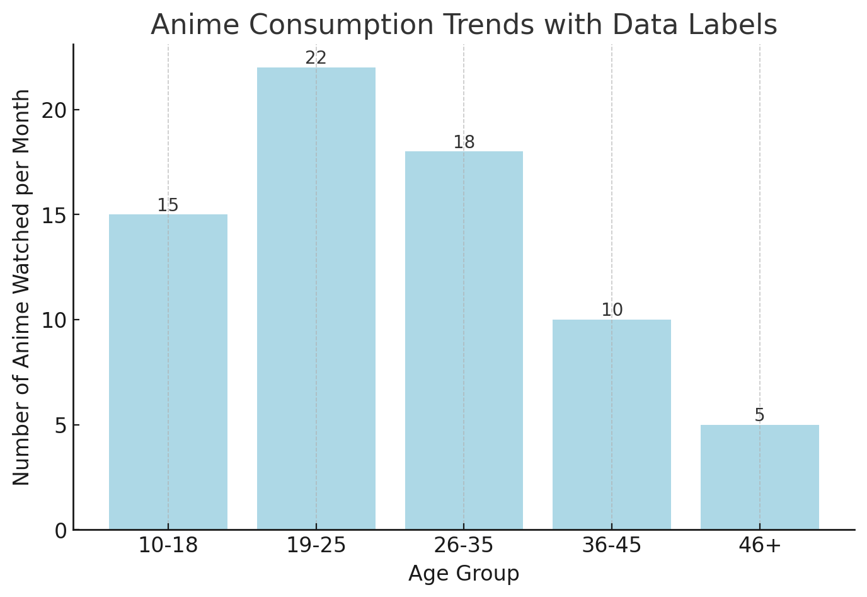

**Interpretation :**

* The numbers on top of each bar represent the exact number of anime watched per month for each age group.
* The 19-25 age group leads with 22 anime per month, followed by the 10-18 age group at 15 anime per month.
* Consumption drops significantly in older groups, especially 46+, who watch only 5 anime per month.

**2. Cultural Understanding Through Anime (Agreement Percentage)**

|  |  |
| --- | --- |
| Response | Percentage |
| Agree | 70% |
| Neutral | 20% |
| Disagree | 10% |

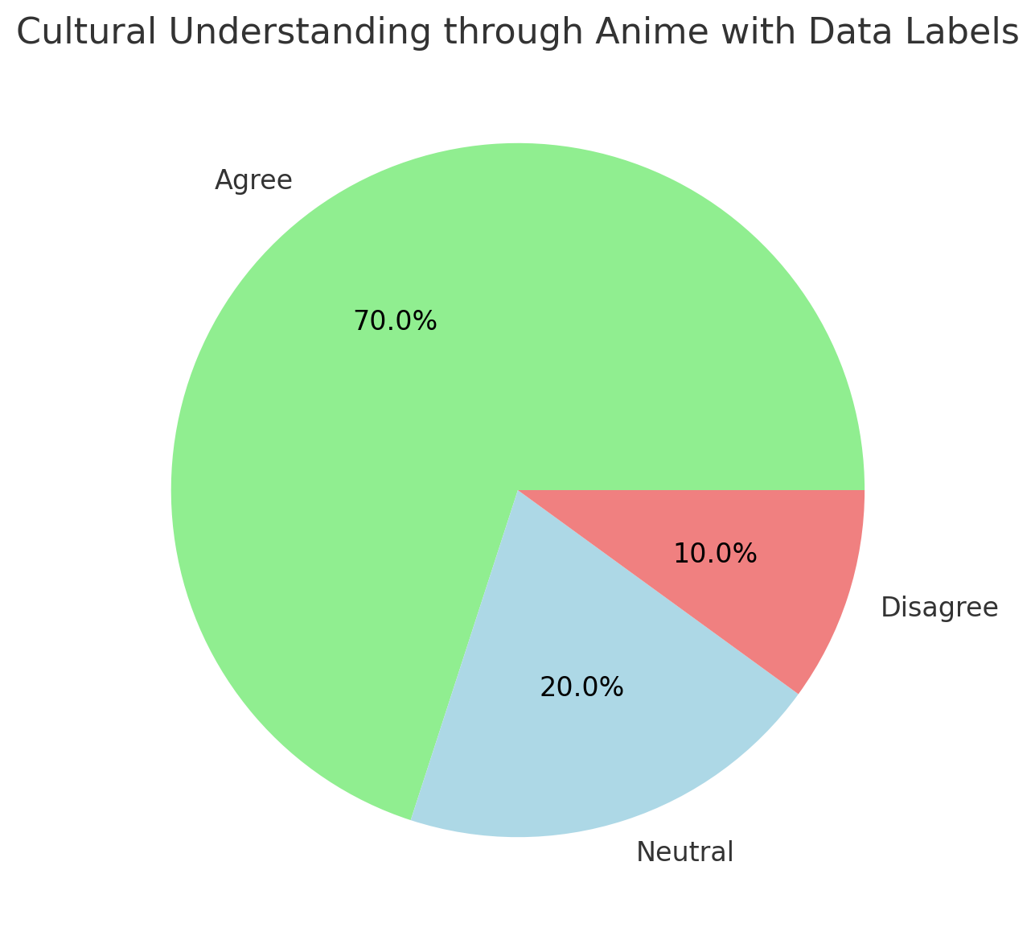

**Interpretation :**

* The data labels clearly indicate that 70% of participants believe anime provides cultural understanding, while 20% remain neutral and 10% disagree.
* This strong agreement suggests that anime serves as a significant medium for cross-cultural learning and appreciation.

**3. Anime Genre Preferences (By Indian Audience)**

|  |  |
| --- | --- |
| Genre | Preference (%) |
| Action | 30% |
| Romance | 20% |
| Fantasy | 25% |
| Horror | 10% |
| Comedy | 10% |
| Sci-Fi | 5% |

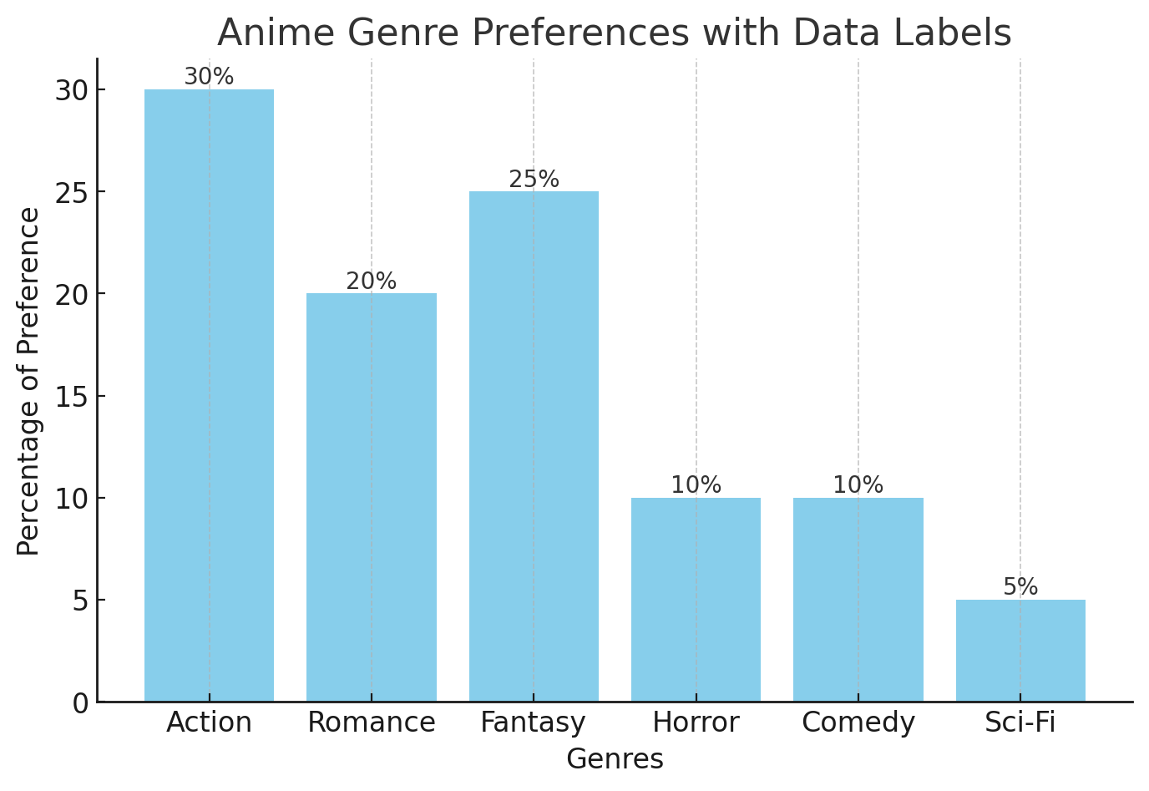

**Interpretation:**

* Action remains the most popular genre, preferred by 30% of participants.
* Fantasy (25%) and Romance (20%) follow closely, indicating a strong interest in imaginative and emotional narratives.
* Horror and Comedy (10% each) appeal to niche audiences, while Sci-Fi (5%) is the least preferred genre.

**4. Impact of Localization (Dubbed vs. Subtitled Preference)**

|  |  |
| --- | --- |
| Preference | Percentage |
| Dubbed | 60% |
| Subtitled | 40% |

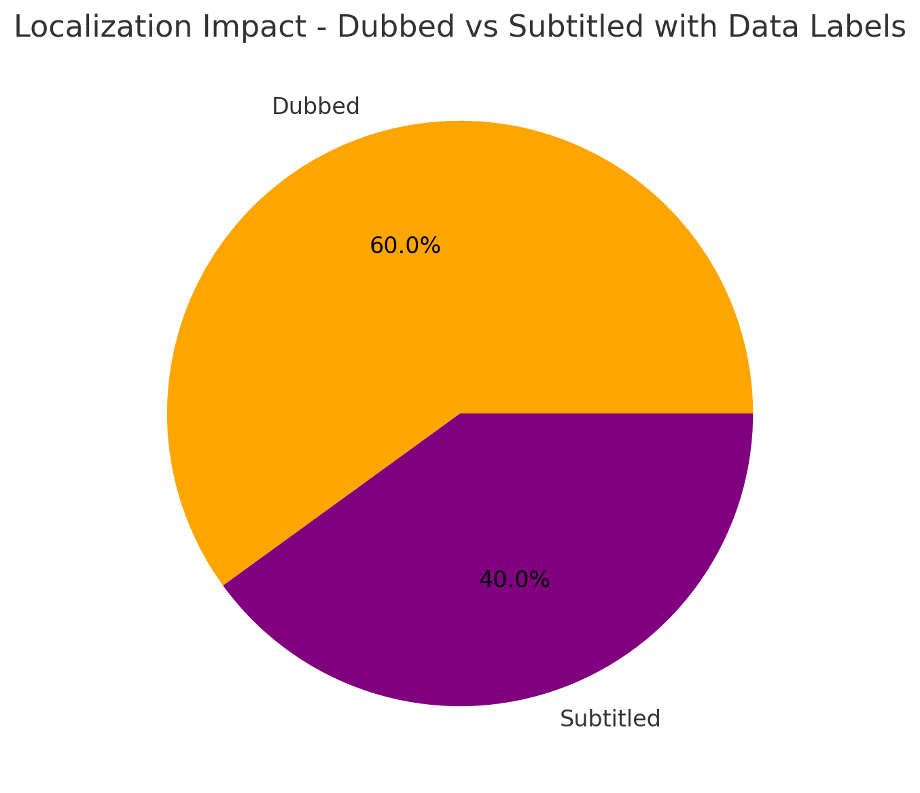

**Interpretation :**

* 60% of participants prefer dubbed anime, while 40% prefer subtitles.
* The preference for dubbing highlights the importance of localized content for accessibility and wider audience reach.
* Subtitles, however, remain a significant choice for those seeking an authentic cultural experience.

**5. Cultural Adoption Inspired by Anime**

|  |  |
| --- | --- |
| Response | Percentage |
| Adopted Practices | 45% |
| No Change | 55% |

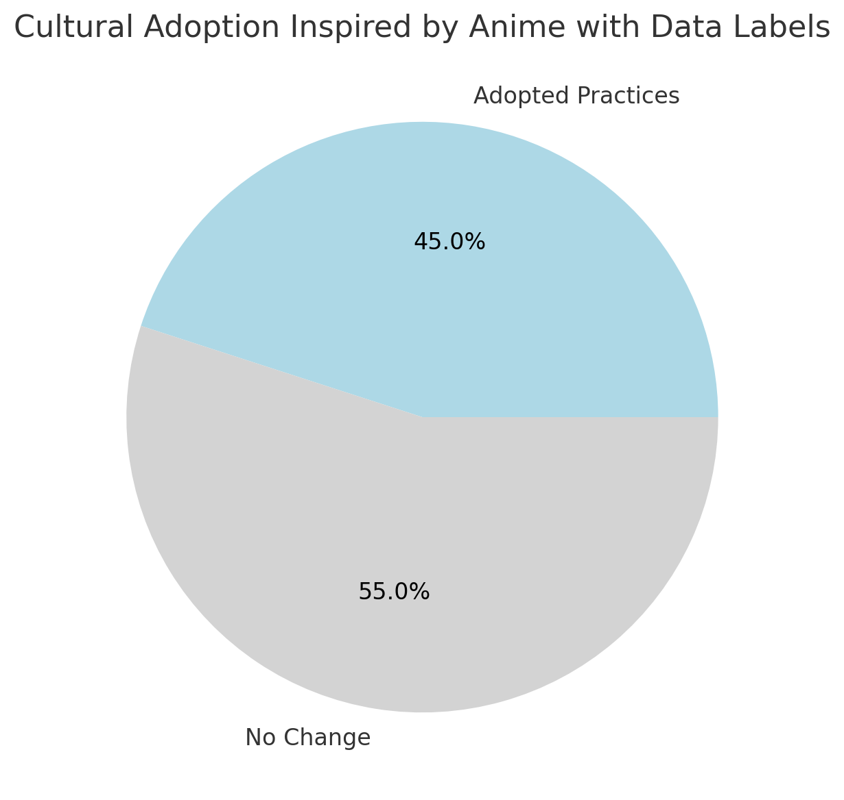

**Interpretation :**

* 45% of participants reported adopting Japanese cultural practices inspired by anime.
* Practices such as expressing gratitude before meals or learning Japanese phrases were commonly mentioned.
* 55% of participants did not adopt any cultural practices, indicating that while anime is an effective medium for cultural exposure, not all viewers engage with it on a transformative level.

**Future Scope of the Research**

The future of this research offers extensive opportunities to explore the deeper cultural, social, and economic impacts of anime and manga in India. Comparative studies could analyze how anime is perceived across different regions, age groups, and cultural backgrounds, providing insights into how localized experiences shape cultural interpretation. Additionally, examining the influence of anime on rural versus urban audiences can reveal how accessibility and exposure to Japanese media differ within India. Longitudinal research may further investigate how prolonged engagement with anime affects cultural perceptions, fostering either a deeper appreciation of Japanese culture or the reinforcement of stereotypes.

Another significant area for exploration is the impact of localization. While this study touches on the effects of dubbing and subtitling, further research could assess how translation choices influence cultural authenticity and viewer engagement. Additionally, examining audience preferences for dubbed versus subtitled content across different regions and languages in India could provide valuable insights for media companies seeking to expand their reach.

Anime's role in cultural adoption and behavioral changes also warrants further investigation. Future studies could explore how viewers incorporate Japanese cultural practices, values, or language into their daily lives. The participation of Indian anime fans in cultural activities like cosplay events, anime conventions, and fan communities presents another opportunity to study the development of cross-cultural fandoms and their role in promoting cultural exchange. Furthermore, the impact of social media in facilitating cross-border conversations about anime and Japanese culture can be explored to understand how digital platforms shape perceptions and cultural dialogue.

From an educational perspective, future research could evaluate the effectiveness of anime as a learning tool for Japanese language and culture. Schools and universities may benefit from incorporating anime into language programs, using it as an engaging medium to enhance cultural understanding. Additionally, exploring the influence of anime on tourism interest and travel behavior could provide insights into how Japanese cultural exports influence global perceptions and tourism patterns.

On the commercial front, future research could also analyze how anime influences consumer behavior in India. Examining the market for anime merchandise, fashion, and themed experiences can offer a clearer understanding of anime’s economic impact. Furthermore, media production companies can leverage findings from localization and reception studies to refine their distribution strategies and create culturally resonant content for Indian audiences.

Ultimately, expanding on this research can contribute to a more comprehensive understanding of the role anime plays in fostering cross-cultural appreciation and global interconnectedness. Through continued exploration, scholars, policymakers, and media professionals can gain valuable insights into how cultural narratives are exchanged and adapted in an increasingly globalized media landscape.

**Conclusion**

Certain observations that had been made concerning Japanese culture and its representation in anime can be seen to be true in almost every aspect of the discussion. Hence, it can be concluded that the research questions have been answered positively wherein the assumptions made have been proven to be true in this study. The results may vary a little with the change in the focus group, wherein lies the research gap for further research.

Therefore, in the conclusion of this paper, it has been determined that the representations of Japanese culture made in anime are accurate to an extent. It has also been seen that there is a similarity between Japanese and Indian cultural practices which helps the individuals (Indians) associate with the scenes in anime and relate it to their cultural upbringing.

**Bibliography**

Brian Ruh. “Conceptualizing Anime and the Database Fantasyscape.” *Mechademia*, vol. 9, University of Minnesota Press, 2014, pp. 164–75, <https://doi.org/10.5749/mech.9.2014.0164>.

Duncum, Paul. “Visual Culture: Developments, Definitions, and Directions for Art Education.” *Studies in Art Education*, vol. 42, no. 2, National Art Education Association, 2001, pp. 101–12, <https://doi.org/10.2307/1321027>.

Fukunaga, Natsuki. “‘Those Anime Students’: Foreign Language Literacy Development through Japanese Popular Culture.” *Journal of Adolescent & Adult Literacy*, vol. 50, no. 3, [Wiley, International Reading Association], 2006, pp. 206–22, <http://www.jstor.org/stable/40013700>.

Garoian, Charles R., and Yvonne M. Gaudelius. “The Spectacle of Visual Culture.” *Studies in Art Education*, vol. 45, no. 4, National Art Education Association, 2004, pp. 298–312, <http://www.jstor.org/stable/1321066>.

HU, TZE-YUE G. “Anime in Asia: A Case of Cultural Imperialism?” *Frames of Anime: Culture and Image-Building*, Hong Kong University Press, 2010, pp. 137–64,

<http://www.jstor.org/stable/j.ctt1xw9xb.14>.

Hulse, Frederick S. “Convention and Reality in Japanese Culture.” *Southwestern Journal of Anthropology*, vol. 4, no. 4, University of New Mexico, 1948, pp. 345–55, <http://www.jstor.org/stable/3628583>.

Macwilliams, Mark W., and Mark W. MacWilliams. “Foreword: Japan’s New Visual Culture.”Japanese Visual Culture: Explorations in the World of Manga and Anime, Taylor & Francis Group, 2008, pp. vii-x.

<https://ebookcentral.proquest.com/lib/christuniversity-ebooks/detail.action?docID=1900027>.

Nobuo, Tsuji. “Ornament (Kazari): An Approach to Japanese Culture.” *Archives of Asian Art*, vol. 47, University of Hawai’i Press, 1994, pp. 35–45, <http://www.jstor.org/stable/20111242>.

Poitras, Gilles. “Contemporary Anime in Japanese Pop Culture”. Japanese Visual Culture: Explorations in the World of Manga and Anime, Taylor & Francis Group, 2008, pp. 48-67. ProQuest Ebook Central,

<https://ebookcentral.proquest.com/lib/christuniversity-ebooks/detail.action?docID=1900027>.

YUI, Kiyomitsu. “Japanese Animation and Glocalization of Sociology.” *Sociologisk Forskning*, vol. 47, no. 4, Sveriges Sociologförbund (Swedish Sociological Association), 2010, pp. 44–50, <http://www.jstor.org/stable/20853739>.

Napier, Susan J. Anime from Akira to Princess Mononoke: Experiencing Contemporary Japanese Animation. Palgrave Macmillan, 2001.

Iwabuchi, Koichi. Recentering Globalization: Popular Culture and Japanese Transnationalism. Duke University Press, 2002.

Lamarre, Thomas. The Anime Machine: A Media Theory of Animation. University of Minnesota Press, 2009.

Allison, Anne. Millennial Monsters: Japanese Toys and the Global Imagination. University of California Press, 2006.

Clements, Jonathan. Anime: A History. British Film Institute, 2013.

Condry, Ian. The Soul of Anime: Collaborative Creativity and Japan’s Media Success Story. Duke University Press, 2013.

Poitras, Gilles. Contemporary Anime in Japanese Pop Culture. Taylor & Francis, 2008.

Brenner, Robin E. Understanding Manga and Anime. Libraries Unlimited, 2007.

Schodt, Frederik L. Manga! Manga! The World of Japanese Comics. Kodansha International, 1983.

Napier, Susan J. From Akira to Howl’s Moving Castle: Japan’s Popular Culture in the Global Arena. Palgrave Macmillan, 2005.

Sugimoto, Yoshio. An Introduction to Japanese Society. Cambridge University Press, 2014.

McLelland, Mark. The End of Cool Japan: Ethical, Legal, and Cultural Challenges to Japanese Popular Culture. Routledge, 2016.

Steinberg, Marc. Anime’s Media Mix: Franchising Toys and Characters in Japan. University of Minnesota Press, 2012.

Lunning, Frenchy. Mechademia: Emerging Worlds of Anime and Manga. University of Minnesota Press, 2006.

Scherer, Joanna. Japanese Visual Culture: Explorations in the World of Manga and Anime. Routledge, 2008.

Drazen, Patrick. Anime Explosion! The What? Why? & Wow! of Japanese Animation. Stone Bridge Press, 2003.

Kelts, Roland. Japanamerica: How Japanese Pop Culture Has Invaded the U.S. Palgrave Macmillan, 2006.

Here’s a complete bibliography with direct links:

1. Napier, Susan J. *Anime from Akira to Princess Mononoke: Experiencing Contemporary Japanese Animation*. Palgrave Macmillan, 2001.  
   🔗 <https://www.goodreads.com/book/show/118940.Anime_from_Akira_to_Princess_Mononoke>
2. Lamarre, Thomas. *The Anime Machine: A Media Theory of Animation*. University of Minnesota Press, 2009.  
   🔗 <https://www.upress.umn.edu/book-division/books/the-anime-machine>
3. Iwabuchi, Koichi. *Recentering Globalization: Popular Culture and Japanese Transnationalism*. Duke University Press, 2002.  
   🔗 <https://www.dukeupress.edu/recentering-globalization>
4. Allison, Anne. *Millennial Monsters: Japanese Toys and the Global Imagination*. University of California Press, 2006.  
   🔗 <https://www.ucpress.edu/book/9780520245657/millennial-monsters>
5. Clements, Jonathan, and Helen McCarthy. *The Anime Encyclopedia: A Century of Japanese Animation*. Stone Bridge Press, 2015.  
   🔗 <https://www.stonebridge.com/catalog/anime-encyclopedia>
6. Fukunaga, Natsuki. "*Those Anime Students: Foreign Language Literacy Development through Japanese Popular Culture*." *Journal of Adolescent & Adult Literacy*, vol. 50, no. 3, 2006, pp. 206-222.  
   🔗 <https://www.jstor.org/stable/40013700>
7. Poitras, Gilles. *Contemporary Anime in Japanese Pop Culture*. Taylor & Francis, 2008.  
   🔗 <https://www.taylorandfrancis.com/books/edit/9781138888495>
8. Schodt, Frederik L. *Manga! Manga! The World of Japanese Comics*. Kodansha International, 1983.  
   🔗 <https://www.goodreads.com/book/show/106831.Manga_Manga>_
9. Brenner, Robin E. *Understanding Manga and Anime*. Libraries Unlimited, 2007.  
   🔗 <https://www.abc-clio.com/products/d5039c/>
10. Rawat, Sharmishtha Singh. "*Anime and Manga Fandom in India*." ResearchGate, 2021.  
    🔗 <https://www.researchgate.net/publication/356481818_Anime_and_Manga_Fandom_in_India>
11. Condry, Ian. *The Soul of Anime: Collaborative Creativity and Japan’s Media Success Story*. Duke University Press, 2013.  
    🔗 <https://www.dukeupress.edu/the-soul-of-anime>
12. Kelts, Roland. *Japanamerica: How Japanese Pop Culture Has Invaded the U.S.* Palgrave Macmillan, 2006.  
    🔗 <https://us.macmillan.com/books/9781403974754/japanamerica>
13. Drazen, Patrick. *Anime Explosion!: The What? Why? & Wow! of Japanese Animation*. Stone Bridge Press, 2003.  
    🔗 <https://www.stonebridge.com/catalog/anime-explosion>
14. McLelland, Mark. *The End of Cool Japan: Ethical, Legal, and Cultural Challenges to Japanese Popular Culture*. Routledge, 2016.  
    🔗 <https://www.routledge.com/The-End-of-Cool-Japan-Ethical-Legal-and-Cultural-Challenges-to-Japanese/McLelland/p/book/9781138946539>
15. Steinberg, Marc. *Anime’s Media Mix: Franchising Toys and Characters in Japan*. University of Minnesota Press, 2012.  
    🔗 <https://www.upress.umn.edu/book-division/books/anime-s-media-mix>