Darshana Tushar Narkhede Electronics and Telecommunication MVP’s KBTCOE Nashik,India darshananarkhede1608@gmail.com

SMART TIMER SYSTEM FOR INDUSTRIAL AUTOMATION SYSTEM

Sarvadnya Sushil Kawade Electronics and Telecommunication MVP’s KBTCOE Nashik,India sarvadnyakawade5@gmail.com

**Abstract :** Industries often face stringent regulations that limit water consumption to control resource use and support environmental sustainability. Meeting these limits, such as the government-imposed restriction of 25 kiloliters (KL) per day, requires efficient automation systems capable of monitoring and managing water usage effectively. This project presents a ”Smart Timer System for Industrial Automation,” designed to automate motor control to help industries comply with these regulatory standards. This system offers a solution by implementing an automated timer that allows a water pump motor to operate for a total of 2.5 hours within a 24-hour period. The system is particularly relevant in today’s world, where energy efficiency and smart technology are becoming increasingly important. In educational institutions, for example, lights and fans are often left running unintentionally, leading to unnecessary energy consumption. This system enables real-time monitoring and control of such devices, ensuring they are only used when needed. By integrating IoT technology, the system not only reduces energy waste but also provides a scalable solution for managing appliances in large institutions or homes. The ability to

Using precise timing mecha nisms, the system accumulates operational minutes each time the motor runs, ensuring that once the cumulative

runtime reaches the limit, the motor is disabled, preventing further operation and avoiding overconsumption. Key features of this system include real-time monitoring, usage tracking, and a daily reset mechanism.

At midnight, the system automatically resets the usage counter, enabling the motor to operate within the defined time window for the new day. The ”Working Time Model,” a crucial component of the system, records the motor’s working time in real-time, adding up each usage session until the 2.5-hour threshold is reached. Additionally, the Smart Timer System integrates an AC power supply and an optocoupler to provide isolation and feedback, ensuring safe and reliable operation. This project employs the PIC18F24K22 micro controller, programmed in C, which efficiently handles control operations and timing management. The proposed system not only enhances compliance with water usage reg ulations but also reduces manual intervention, increasing operational efficiency. With its automated tracking and disabling features, the Smart Timer System for Industrial Automation offers industries a streamlined and effective way to meet regulatory limits, conserve water, and minimize environmental impact, setting a standard for automated industrial resource management.

Keywords: Smart Timer System, Motor control, PIC Microcontroller,7-Segment, Water Conservation,Government Regulations, Automation System

## 1. INTRODUCTION

In today's industrial landscape, efficient resource management is essential to ensure sustainable operations while complying with government regulations. Water-intensive industries, in particular, must adhere to stringent policies that limit their daily water consumption to prevent excessive depletion of resources. Many industries face regulatory restrictions, such as the 25 kiloliters (KL) per day cap, which necessitate the development of automated solutions for monitoring and controlling water usage.

The **Smart Timer System for Industrial Automation** :

designed to address this challenge by implementing an intelligent motor control mechanism. The system ensures that the water pump motor operates only for a predefined duration of 2.5 hours within a 24-hour period. By employing a real-time clock, the system accurately tracks operational time, resets usage limits at midnight, and prevents unauthorized operation beyond the allowed threshold. This approach enhances compliance with water conservation policies while optimizing industrial processes.

The system integrates key components such as a **PIC18F24K22 microcontroller**, **DS1307 real-time clock**, **74HC595 shift register**, and **optocoupler-based feedback system** to ensure reliability and efficiency. A **7-segment display** provides real-time feedback on motor runtime, enabling operators to track usage effectively. The automation of this process not only minimizes manual intervention but also reduces the risk of exceeding regulatory limits, thereby preventing potential fines or operational disruptions.

By offering a structured approach to motor operation management, the **Smart Timer System** serves as an innovative solution for industries aiming to balance productivity with sustainability. Through precise tracking and automation, it provides a streamlined mechanism for adhering to water usage policies, making industrial water management more efficient and environmentally responsible.

Necessity The Smart Timer System for Industrial Automation is essential in modern industrial practices to comply with government regulations on water usage, especially in water intensive industries. According to the regulations, industries are limited to a daily water usage cap—in this case, 25 kiloliters (KL) per day. To adhere to these guidelines, our model enables precise control of motor operation to ensure the motor runs only for a cumulative total of 2.5 hours within a 24-hour period. This time limit restricts excessive water consumption and prevents overuse by allowing the industry to operate the motor at convenient intervals until the maximum time limit is reached. Our system incorporates a real-time clock that resets the motor timer at midnight, allowing for daily compliance without manual resetting. The display on the model shows the incremental runtime, providing clear feedback on the motor’s cumulative operational time. This allows operators to track usage and strategically utilize the allotted runtime for maximum efficiency within the regulated limits. When the 2.5-hour cap is reached, the system automatically restricts further motor operation, thus ensuring that the industry remains compliant with government water regulations. This automated approach not only facilitates regulatory adherence but also promotes sustainable water management and resource efficiency in industrial operations.

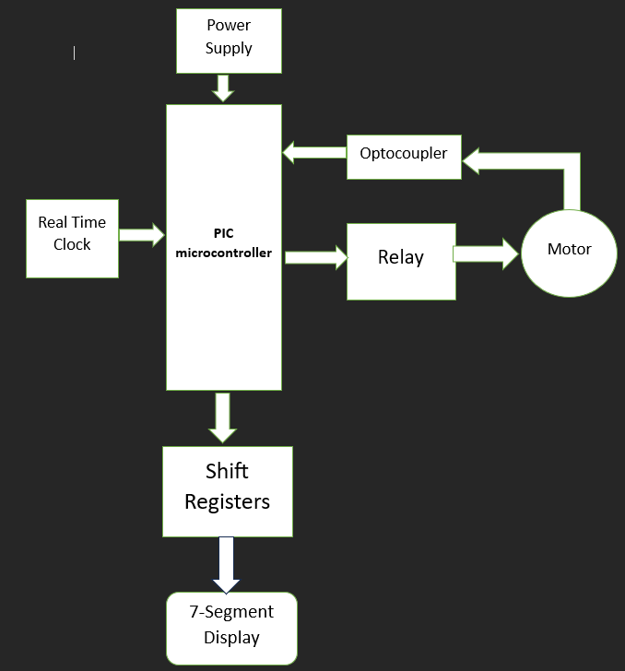

**Figure 1. SMART TIMER SYSTEM FOR INDUSRIAL AUTOMATION SYSTEM**

## 2. HARDWARE DESCRIPTION

The **Smart Timer System for Industrial Automation** is designed to regulate motor operation while ensuring compliance with industrial water usage regulations. The hardware components have been carefully selected to achieve precise time tracking, motor control, and user-friendly interaction. Below is a detailed breakdown of the system's hardware design.

## 2.1 PIC18F24K22 Microcontroller

## 



**Figure 2. PIC18F24K22 Microcontroller**

**1. PIC18F24K22 Microcontroller**

The **PIC18F24K22** microcontroller serves as the central processing unit of the system. It is responsible for monitoring the total operational time of the motor, interfacing with other hardware components, and enforcing the daily limit on motor operation

* **Operating Voltage:** 1.8V - 5.5V
* **Timers:** Three 16-bit timers, two 8-bit timers
* **Communication Interface:** Supports SPI, I2C, and UART
* **Application in Smart Timer:** Tracks cumulative motor runtime, resets daily at midnight using an RTC module, and controls relay switching based on time constraints.

**2. 74HC595 Shift Register**

Since microcontroller pins are limited, **74HC595 Shift Register ICs** are used to expand the number of digital outputs. These shift registers enable efficient control of multiple display segments while conserving microcontroller GPIO pins.

* **Operating Voltage:** 5V
* **Clock Frequency:** Up to 25MHz
* **Key Feature:** Serial-in, parallel-out data transmission
* **Application in Smart Timer:** Controls the **7-segment display**, allowing real-time visualization of motor runtime.

**3. 12V Relay Module**

The **12V Relay Module** acts as an electromechanical switch, allowing the microcontroller to control the high-power AC motor with a low-voltage control signal.

* **Coil Voltage:** 12V DC
* **Load Capacity:** Handles AC motors and industrial loads
* **Function in Smart Timer:** Engages or disengages motor power based on cumulative runtime, preventing operation beyond 2.5 hours per day.

**4. 7-Segment Display (SLT-30)**

To provide a clear and simple user interface, a **7-segment display** is integrated into the system.

* **Operating Voltage:** 5V
* **Current per Segment:** 10-20mA
* **Display Type:** Common anode
* **Application in Smart Timer:** Displays cumulative runtime, assisting operators in monitoring the remaining allowable motor operation time.

**5. BC557 PNP Transistor**

The **BC557 PNP Bipolar Junction Transistor (BJT)** is used for signal amplification and switching within the circuit.

* **Collector-Emitter Voltage:** 45V
* **Application in Smart Timer:** Controls relay operation by switching between high- and low-voltage signals.

**6. DS1307 Real-Time Clock (RTC)**

The **DS1307 RTC module** ensures accurate timekeeping, enabling the system to reset the motor's runtime at **midnight every day**.

* **Supply Voltage:** 4.5V - 5.5V
* **Communication Protocol:** I2C
* **Function in Smart Timer:** Keeps track of real-time motor operation and resets the runtime counter daily.

**7. Power Supply Unit**

The system is powered by a **regulated 5V DC power supply**, derived from an AC mains input.

* **Voltage Regulator:** 7805
* **Components:** Bridge rectifier, smoothing capacitor, filter capacitor
* **Function in Smart Timer:** Provides stable DC power for the microcontroller, RTC, display, and relay module.

**8. Optocoupler**

An **optocoupler** is used for electrical isolation between the **microcontroller** and the **relay module**, ensuring safety in industrial environments.

* **Function in Smart Timer:** Protects the control circuit from high-voltage surges from the motor.

speed, allowing users to adjust the speed of connected fans in three levels.

Specifications:

* Input voltage AC 220V
* Capacitors C1 1µF 400V C2 2.2µF 400V C3 3.3µF 400V
* Resistors R1 R3 R5 2.2Ω R2 R4 R6 220kΩ
* Switch type Rotary switch for fan speed control
* Load AC fan or similar device
* Configuration Capacitor-resistor network for speed control
* Speed settings 3-speed levels plus OFF

**5. CONCLUSIONS**

The Smart Timer System for Industrial Automation successfully addresses the grow ing need for resource-efficient and regulation-compliant motor control in industrial appli cations. As industries face stricter government limits on water usage, systems like ours are essential for automating control processes to avoid exceeding these limits. This project aims to limit motor operation based on water consumption regulations, specifically en suring that water usage does not surpass 25KL per day by allowing motor operation only up to a cumulative 2.5 hours in a 24-hour period. This design resets automatically at midnight, ensuring daily compliance without requiring manual monitoring or control. Our system provides significant advantages in water usage management. The auto mated timer, coupled with motor control, allows industries to operate within strict limits efficiently and reliably. The use of a microcontroller enables accurate time tracking, and by utilizing an optocoupler for electrical isolation, we ensure safe and effective commu nication between the motor and the controller. The system not only simplifies water consumption monitoring but also prevents excessive use, which is especially valuable in high-demand environments. By disabling the motor after the cumulative daily runtime has been reached, this system minimizes risks of non-compliance and reduces the need for constant human supervision, which can be time-consuming and costly. Overall, this project contributes to the industry by providing a smart solution that is both compliant with regulations and practical for everyday use in water-intensive industrial settingsre

1. **References**
2. Ministry of Environment, ”Water Usage Regulations for Industries,” Government of India, 2023.
3. Texas Instruments, ”Understanding and Using Optocouplers,” Appli cation Note AN-3005, 2020
4. D.P. Leach and A. P. Malvino, Digital Principles and Applications, 8th ed. New York: McGraw-Hill, 2020.
5. Kumar and P. Sharma, ”Microcontroller-Based Automated Motor Con trol System for Industrial Applications,” International Journal of Indus trial Automation, vol. 15, no. 2, pp. 45-52, 2021.
6. R. Patel, ”Cumulative Time-Based Motor Control for Energy Efficiency in Industrial Settings,” Engineering Review, vol. 28, no. 1, pp. 56-64, 2020