SMART WHEELCHAIR USING VOICE, GESTURE AND EYE MOVEMENT RECOGNITION

**Mr. M.Devi Venkata Sai Vardhan 1, Mr. B.Eedukondalu 2,** Ms. B.Kalyani 3,

Ms. K.Pavithra Lakshmi4 , Ms. B.Gayathri5 , Mr. S.Satya Sai Ram6, Dr.V.Kiran Babu7

Department of EEE, NRI Institute of Technology, Agiripalli, Andhra Pradesh, India

**ABSTRACT**

**This project proposes the development of a smart wheelchair that can be controlled using voice commands, hand gestures, and eye movements. The system aims to provide individuals with severe motor disabilities, such as quadriplegia, amyotrophic lateral sclerosis (ALS), and spinal cord injuries, with a more intuitive and independent way of navigating their surroundings. The smart wheelchair will utilize a multimodal interface, combining voice recognition, computer vision, and electroocoulogram (EOG) to detect and interpret user inputs. The system will consist of a wheelchair-mounted computer, a voice recognition module, a camera for gesture recognition, and an EOG sensor for eye movement detection. The voice recognition module will use machine learning algorithms to recognize and interpret voice commands, allowing users to control the wheelchair's movement, speed, and direction. The gesture recognition system will utilize computer vision techniques to detect and interpret hand gestures, providing an alternative mode of control. The EOG sensor will detect eye movements, enabling users to control the wheelchair using eye gestures. This feature will be particularly useful for individuals with severe motor disabilities who may not be able to use voice or hand gestures.**

**Keywords: Introduction,** Methodology, Objectives, **B**lock Diagram, Working,

1. **INTRODUCTION**

**The World Health Organization (WHO) estimates that almost 10% of the global population suffers from one or more forms of disability. Nearly 15-20% of the total physical disabilities in children are caused by Cerebral Palsy(CP).A Cerebral Palsy patient is subject to many complications like restricted muscle movements and frequent loss memory. In advanced they have to face many trouble situations. Signal acknowledgement is useful for processing data from people that aren’t transmitted by speech or type. Joystick , EEG, Image Processing are some of the various methods that have been used to solve the issues faced by these patients. But this project is something new and advanced technology is used to save the patients from the above methods.**

1. **METHODOLOGY**

The aim is to design and implement a smart wheelchair which can be controlled by gesture and voice commands. The wheelchair is fitted with ultrasonic sensor and voice recognition module. The wheelchair can be navigated in the four directions. By using the voice recognition module, the user can control the movement of the model by sending voice commands such as forward, reverse, left and right. The system mainly consists of Arduino UNO, Bluetooth module, Motor driver L293D and an Ultrasonic sensor.

**2.1 OBJECTIVES**

A sector of physically disabled people finds it very difficult to use traditional wheel chairs .This project is based on a design that aids the voice activation system for physically disabled people by incorporating manual operation.

* The objective of our project is to assist the physically challenged people.
* It uses speech recognition technology which voice can be realized and organized with smart phone device as an inter-media interface.
* It also uses an obstacle sensor to detect the hurdles in between wheel chair in the way of its direction.
* It is used to facilitate the movement of people who are disabled or handicapped . It also enables a disabled person to move around independent.

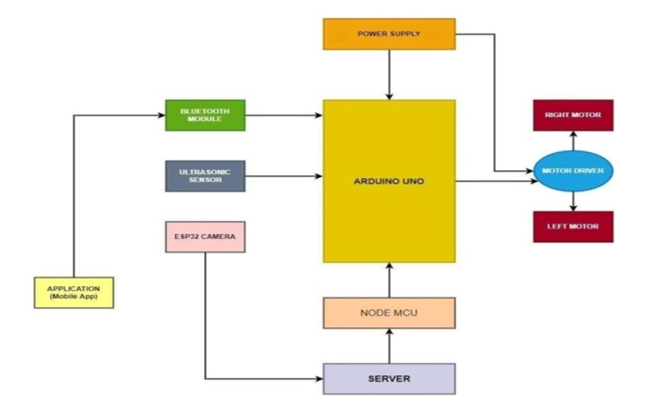

* 1. **BLOCK DIAGRAM**

This conncetions are to involves the development of a gesture and voice-controlled wheelchair using arduino, bluetooth, esp01 with esp-now rf communication, an mpu6050 deaccelerometer, and an 1298 motor driver. the wheelchair is designed to assist individuals with mobility impairments by allowing them to control the movement of the wheelchair through simple hand gestures and voice commands. The feeling of loss of autonomy that a person with disabilities experiences on a day-to-day basis is something that the rest of us often take for granted.

1. **WORKING**

Arduino UNO is powered by 5v regulated from a 12v battery. The Bluetooth Module is connected to the handset and the motion control is done through a mobile application. The input to the application is either voice or gesture as shown in fig(1).   
➢ Google voice search engine is used for recognizing the commands and controlling the model through voice. for gesture control gyroscope sensor in the smart phone is utilized.   
➢ Based on the input given to the Bluetooth Module, the direction of rotation of the motor is controlled by the motor driver. the motor driver used is l293d which is a dual h- bridge motor driver IC this, in turn, controls the movement of the prototype.   
➢ An ultrasonic sensor is used to detect any obstacles on the path that may hinder the movement of the model. the coding for the functioning of the prototype will be done using arduino IDE.   
 The arduino software (IDE) contains a text editor to write code, a message area, a text console, a toolbar with buttons for common functions and a series of menus. it connects to the arduino hardware to upload programs and communicate with the hardware.

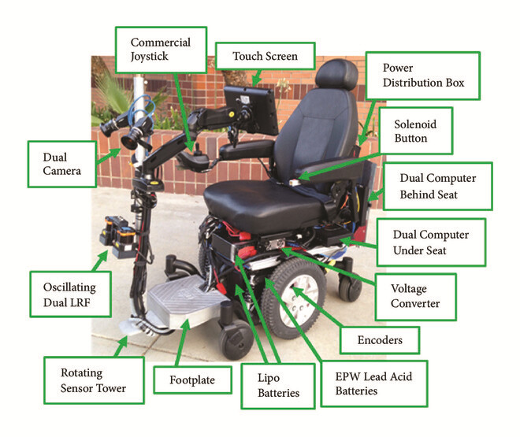

**Figure 1**:Smart Wheel Chair

1. **ADVANTAGES**

Enable young disabled children and their families to enjoy „ordinary‟ lives, through access to childcare, early education and early family support to enable them to care for their child effectively and remain socially and economically included;

* Ultrasonic sensors are used to detect obstacles.
* Improving the life chances of disabled people.
* Depending on the direction given through voice and gesture, the Arduino controls the wheelchair directions. Ultrasonic sensors are used to detect obstacles.
* The prototype is designed in such a way that it can be used independently and efficiently with less effort.
* It saves time, reduces cost and energy of the users.
* This gesture controlled wheelchair will help the handicapped person to be self- dependent for the purpose of movements for which they mostly dependent on other people.

1. **RESULT AND DISCUSSION**

The proposed method explains the design and construction of Voice and Gesture controlled Wheelchair using a Bluetooth module. The model works in accordance with the commands given by the user. The model aids physically challenged people to control their wheelchair using an android application in their smart phones.

1. **CONCLUSION**

The detection of any obstacle is successfully done using Ultrasonic sensor. As the person switches ON the prototype, it starts moving and any obstacle which is expected to lie within a certain range will be detected. The proposed system is contributed physically challenged people and older people for their self-dependency.

It is used for many applications like:

* Hospitals.
* Old age homes(health care).
* It is useful for physically challenged people for social interactions.
* For sports people.

1. **ACKNOWLEDGEMENTS**

All the success in every step of my Project involves great efforts of the masters who guided me all through the way, forbidding many obstacles and making me to achieve this project a grand success.

With the sense of gratitude, I wish to express profound regards to my head of the department **Dr. N. SAMBASIVA RAO, Professor and Head, Electrical & Electronics Engineering Department** and my project guide Sri **Mr. B.EEDUKONDALU Assistant Professor** for his supervision in framing my project in an outstanding manner and for his remarkable guidance and encouragement throughout the project.

We would like to sincerely thank to the Principal of NRI Institute of Technology **Dr. C.NAGA BHASKAR** for providing necessary facility to carry out my project work successfully

We are extending my sincere and honest thanks to the Chairman**, Dr. R. VENKATARAO** & Secretary, **Sri K. SRIDHAR** for their continuous support in completing the project work.

A special note of thanks to all the faculty members of Electrical and Electronics Engineering department, for sharing their years of experience and adding momentum to my project.

1. **REFERENCES**

[1] Apsana S, Renjitha G Nair (2016), “Voice Controlled Wheelchair using Arduino”, National Conference on Emerging

Trends in Engineering and Technology, Vol No: 3, Special Issue No:3, DOI: 10.17148/IARJSET, pg.332-335

[2] Banerjee C, Gupta H, Sushobhan K (2010), “Lowcost speech and vision based wheelchair for physically challenged”, The 2nd International Conference on Computer and Automation Engineering (ICCAE), Vol No: 1 pg-706-709

[3] Bourhis G, Moumen K, Pino P, Rohmer S, Pruski A (1993), “Assisted navigation for a powered wheelchair”, Systems Engineering in the Service of Humans: Proceedings of the IEEE International Conference

[4] Braga R.A, Petry M, Reis L.P, Moreira A.P (2011) “IntelwheelsModular development platform for intelligent wheelchairs”, Journal of Rehabilitation Research and Development Vol No:48 pg.1061-1076

[5] Coyle E.D (1995), “Electronic wheelchair controller designed for operation by hand- operated joystick, ultrasonic non-contact head control and utterance from a small word- command vocabulary”, IEEE Colloquium New Developments in Electric Vehicles for Disabled Persons, London, pg. 31-34