ACE

Engineering College

**An Autonomus Institution**

Ghatkesar, Medchal (Dist), Hyderabad, Telangana State – 501 301

(NBA Accredited B.Tech Courses Accredited NAAC with A Grade 3.20 CGPA

#### DEPARTMENT OF INFORMATION TECHNOLOGY

**Advanced ATM Security System**

**Using**

**Integrated Fingerprint and Iris Recognition**

INTERNAL GUIDE :-

Swetha

**TEAM MEMBERS:- B.Ganesh 21AG1A1210**

**T.SATHWIK REDDY 21AG1A1253 P.SAMPATH KUMAR 21AG1A1243**

# Abstract

Enhancing ATM security by combining two strong biometric technologies: fingerprint and iris recognition. This system captures and verifies both fingerprints and iris patterns to ensure that only authorized users can access their accounts, making it much harder for fraudsters to gain entry. By using both methods together, the system offers a higher level of security and accuracy compared to traditional single-method systems. This project involves developing the necessary hardware and software to integrate these technologies, creating a more secure and user- friendly ATM experience.

Introduction

* In today’s fast-paced technological era, security is a top priority for every individual. To stay protected, it is essential to keep up with advancements in technology. This project, titled "Advanced Security System," introduces a novel approach to ATM access. Traditional ATM security methods are vulnerable to fraud, such as card cloning, theft, and forced PIN disclosure under threats. To address these issues, biometric authentication offers a more secure alternative, ensuring that only the authorized user can access their account. This innovation enhances security and minimizes the risks associated with conventional ATM transactions.

# Literature Survey

* Paper 1: A Secure ATM System Using Fingerprint Authentication

Proposed Year: 2016

* Paper 2 : ATM Security Enhancement Using Biometric Fingerprint Recognition Proposed Year: 2019
* Paper 3 : A Secure ATM System Using Fingerprint and Facial Recognition Proposed Year : 2023

**Existed System :-**

In current ATM systems, they are prompted to enter their card's security PIN Following this, the system may require fingerprint and facial recognization authentication as an additional security measure the fingerprint scan and facial recognization verifies the user's identity through biometric data, providing a second, more secure layer of authentication

However, a drawback is that technological advancements have made it possible to duplicate

fingerprints and facial recognizations, potentially compromising this security measure.

## Proposed Statement :-

To enhance security further, integrating Iris authentication with the existing system can be proposed. By adding Iris recognition, the ATM system gains an additional layer of protection, reducing the risk associated with fingerprint duplication and Face duplication ensuring a more robust user verification process.

### FUTURE ENHANCEMENT

Incorporate additional authentication methods such as facial recognition, OTP via email or SMS, or voice recognition for enhanced security.

Store biometric data securely in the cloud with advanced encryption to allow seamless access across multiple ATMs.

Implement AI algorithms to detect unusual behavior or fraudulent activities, such as unauthorized access attempts or abnormal transaction patterns.

**Componenets**

## Hardware:

* Processor : intel i3/i5/i7
* Ram : 8GB or more
* Storage : 256GB or more
* GPU
* Finger Print Sensor
* Webcam

## SOFTWARE :

* *Operating System****:*** Windows 10/11
* Programming Language: Python
* Libraries:- TensorFlow/Keras/PyTorch/Open CV Iris Recognition
* Deep Learning : Neural Network Based Algorithm
* Database : SQLite

#### A diagram of a computer Description automatically generatedArchitecture

Data Flow Diagram(Level-0):

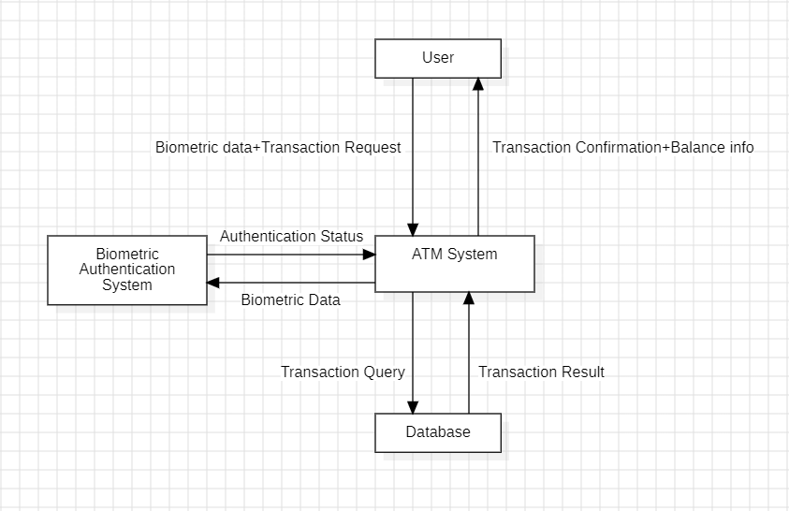

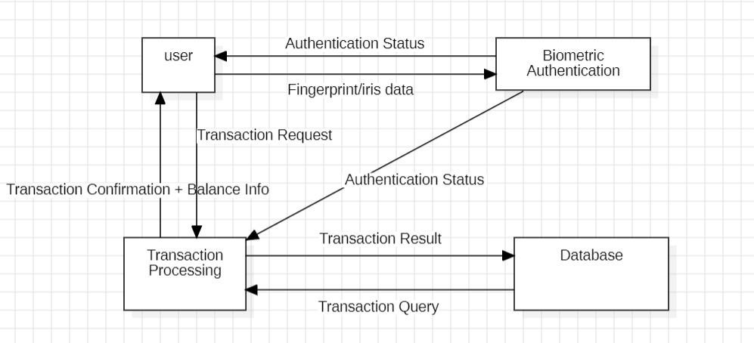Level-1:

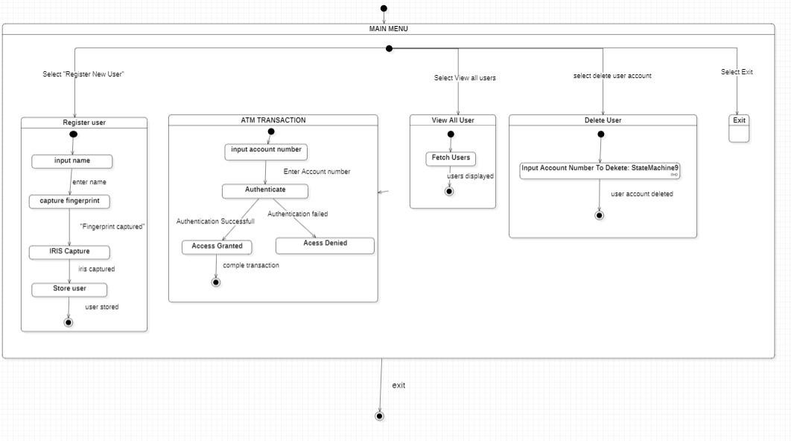

State Chart Diagram:

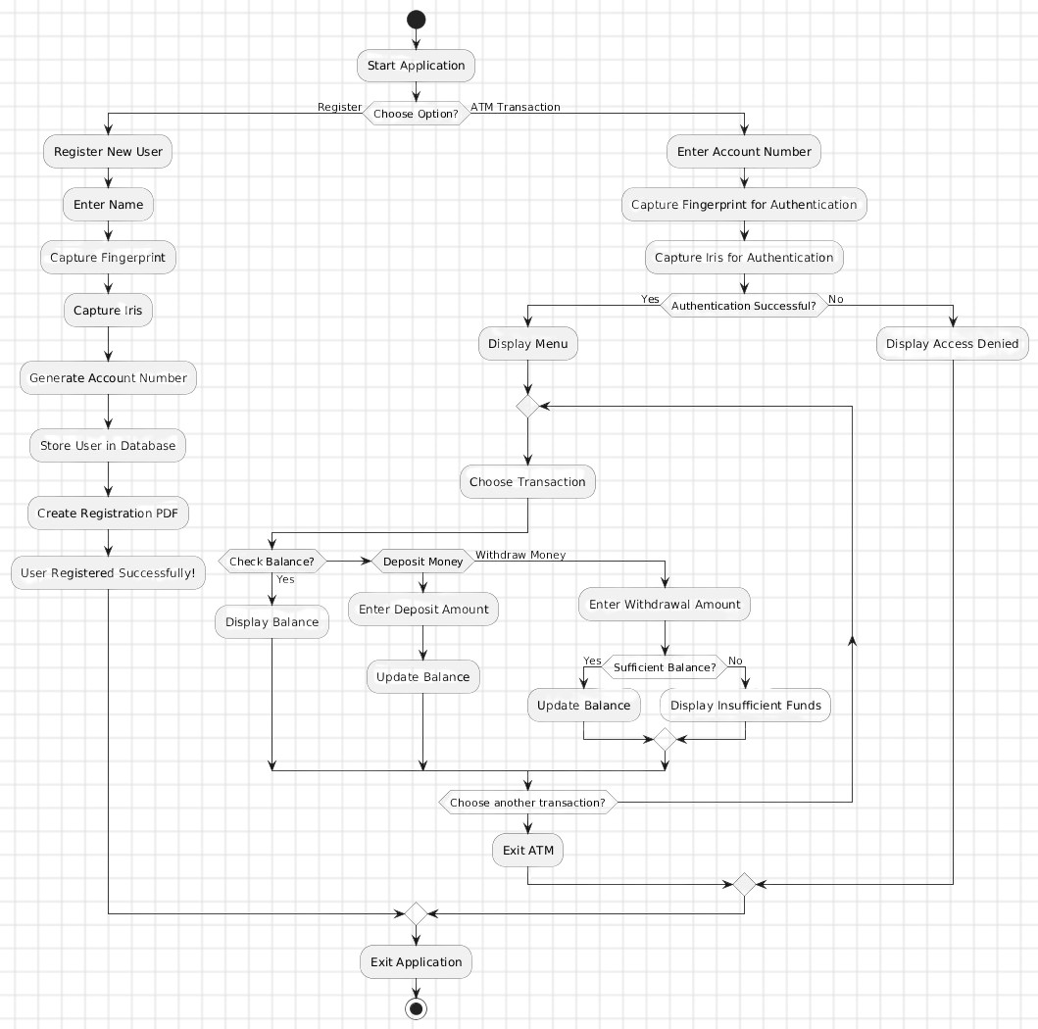Activity Diagram:

Component Diagram:

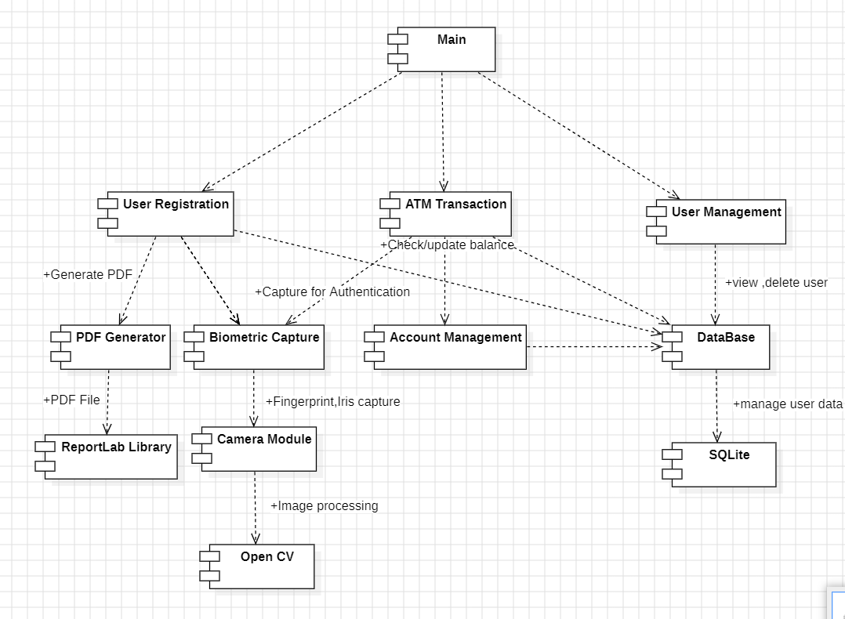

Sequence Diagram:

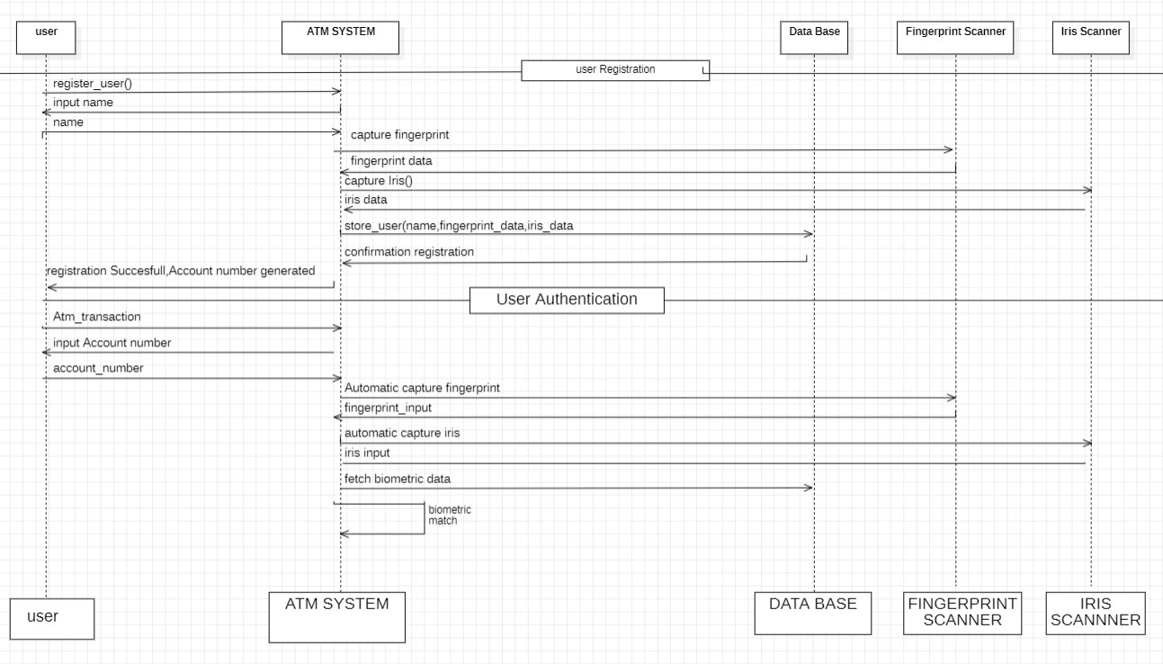

**CODE:**

**App.py**

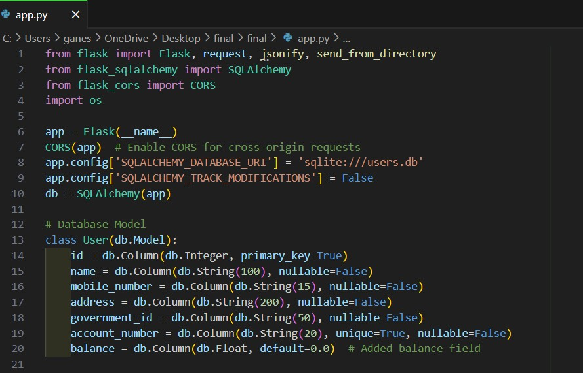

**Home page**

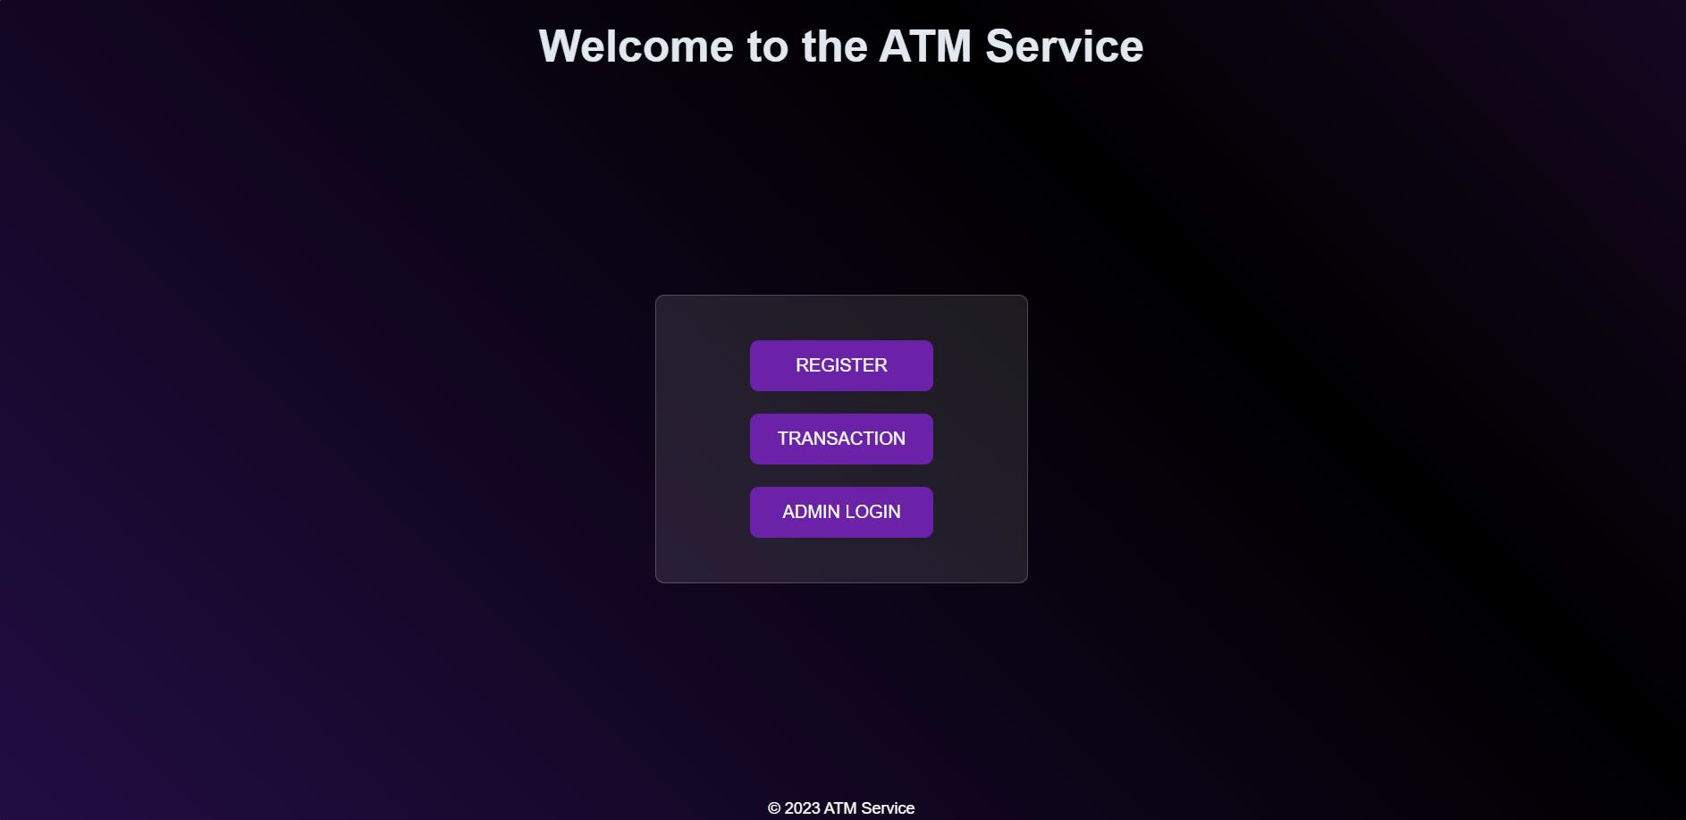

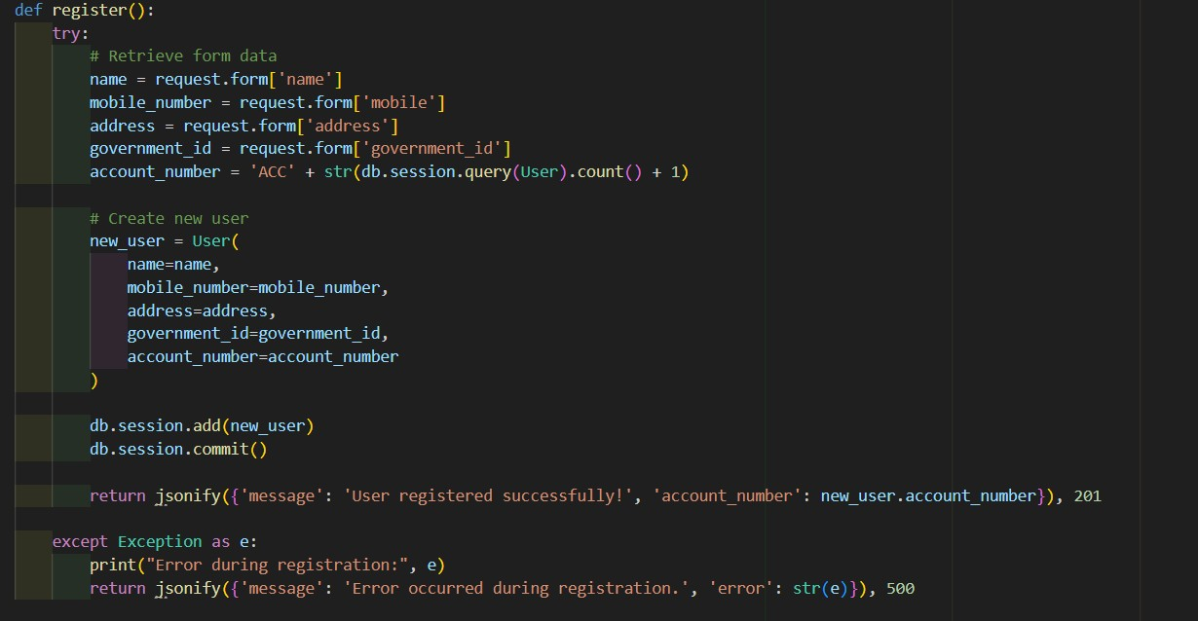

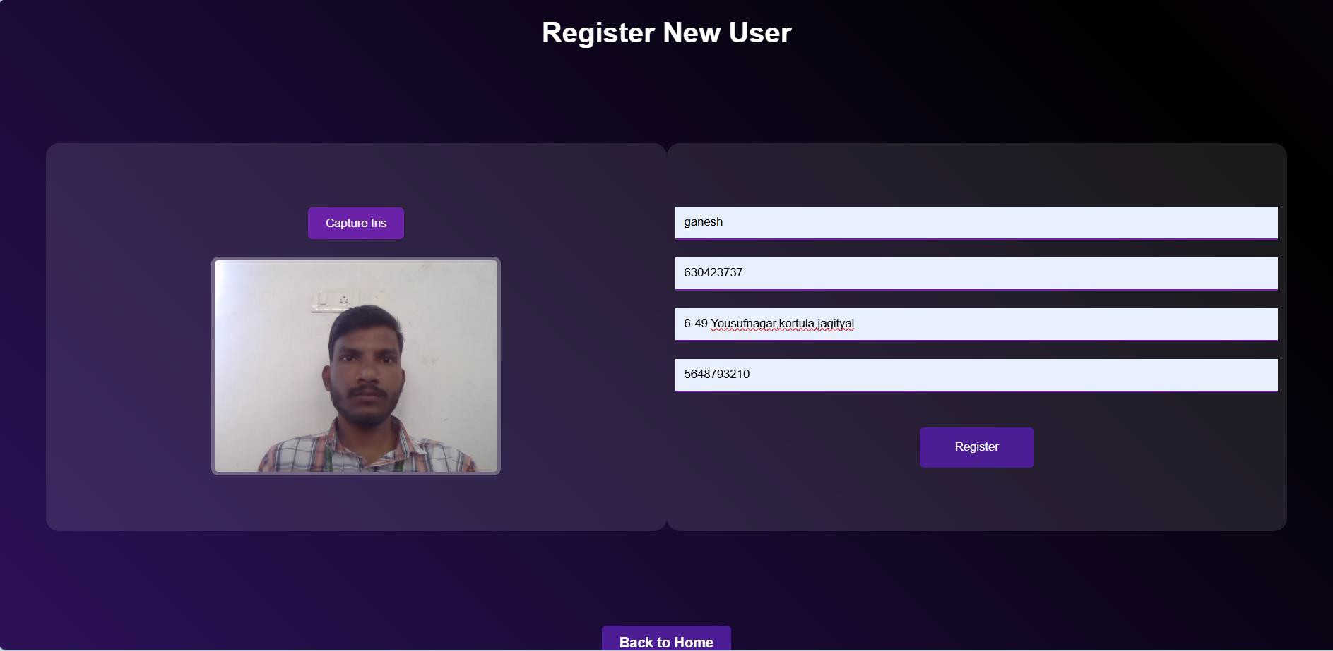

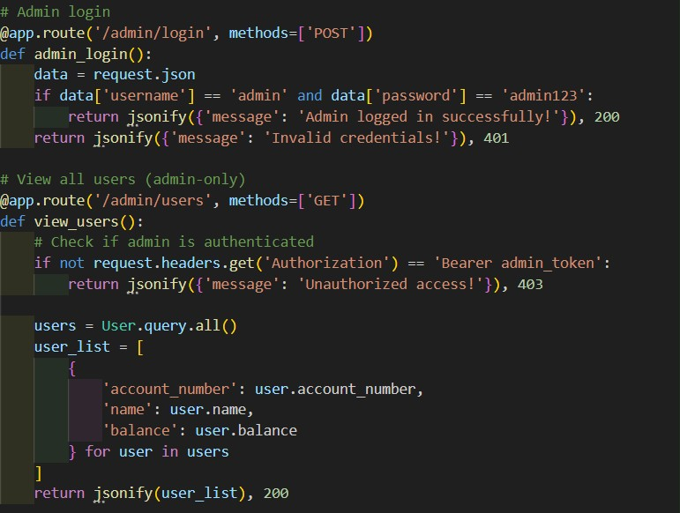



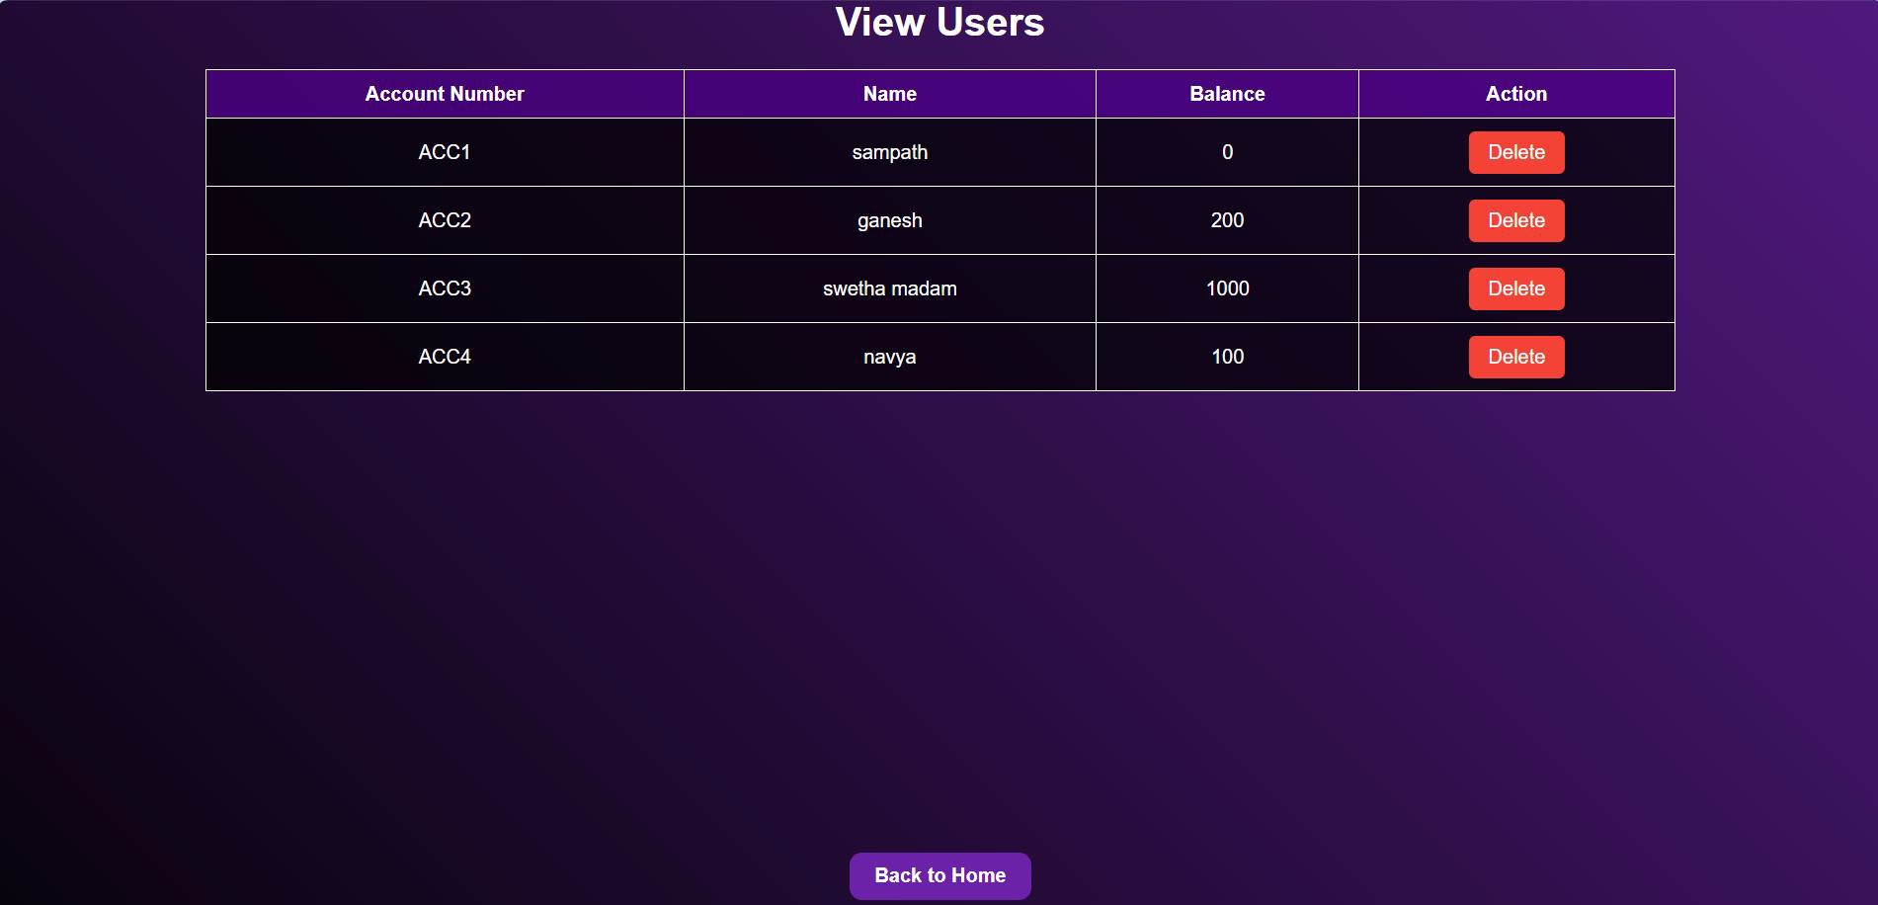

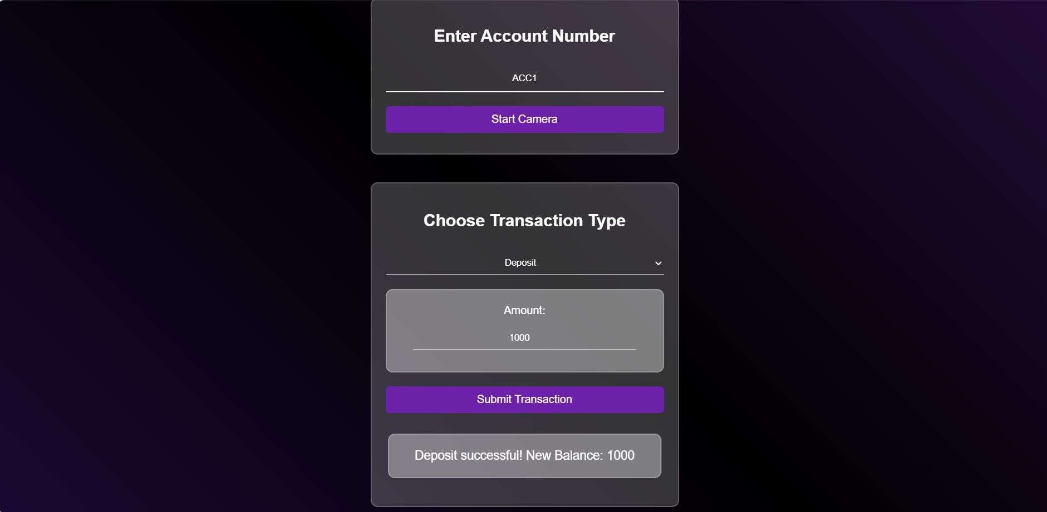

### CONCLUSION

The Advanced ATM Security System using fingerprint and iris recognition is a modern solution designed to make ATMs safer and more convenient. By using biometrics instead of traditional methods like PINs and bank cards, this system reduces the risk of fraud and unauthorized access to accounts.

This project is built in layers, each handling a specific part, like capturing fingerprints, storing user data, and generating receipts. This organized design makes it easy to maintain and upgrade. Using a lightweight database like SQLite keeps things efficient, and generating PDFs for user records adds a helpful feature for documentation.

In summary, this project makes ATM transactions faster, more secure, and easier for users by allowing them to use their fingerprint and iris for authentication, offering a glimpse into the future of secure banking.

Thank you