**Maximizing Energy Yield through Intelligent Maximum Power Point Tracking for Solar Automation**

**G.Manivannan, C.M.Arun Kumar**

1Teaching Fellow, Department of Electrical and Electronics Engineering,

University College of Engineering, Pattukkottai, Tamilnadu, India

2Teaching Fellow, Department of Electronics and Communication Engineering,

University College of Engineering, Pattukkottai, Tamilnadu, India

**ABSTRACT**

When solar photovoltaic (PV) panels operate at their maximum power point (MPP), they generate the maximum amount of electricity. The safety of people should be the top priority. As safety concerns are valid, it's essential to implement a reliable safety system in workplaces. Toxic waste from sewage areas can be difficult to detect with human senses. Unfortunately, many sewage systems lack proper safety measures. To address this issue, gas sensors can detect hazardous gases like hydrogen sulfide, methane, and carbon monoxide in sewage areas. These sensors can also monitor vital signs like heart rate and temperature, sending updates to clients. A solar power conversion system generates electricity using sunlight, providing a renewable energy source for future needs. Batteries convert chemical energy into electrical energy, producing a desired voltage. They can be connected in series, parallel, or a combination of both.

**Keywords:** Renewable energy, MPPT, Photovoltaic panels.

1. **INTRODUCTION (Font-Times New Roman, Bold, Font Size -12)**

Renewable energy is derived from natural resources such as sunlight, wind, rain, tides, and geothermal heat. These resources are sustainable and can be replenished naturally, making them virtually inexhaustible, unlike finite conventional fossil fuels [1]. The global energy crisis has accelerated the growth and development of clean and renewable energy sources. As a result, organizations worldwide are adopting Clean Development Mechanisms (CDMs) [2] to promote sustainable energy solutions. In addition to the world's rapidly depleting fossil fuel sources, one of the main arguments against fossil fuels is the pollution that results from their use. On the other hand, compared to its conventional equivalents, renewable energy sources are recognized to be significantly cleaner and generate energy without the negative impacts of pollution.

The PV system should ideally operate near or at its maximum power point (MPP). In recent years, the global focus on green technology has driven the growth of solar energy as a prominent form of renewable energy, amidst energy crises and environmental concerns [2,3]. However, the MPP varies with environmental conditions like temperature and solar irradiance, necessitating the development of maximum power point tracking (MPPT) algorithms [4,5]. Various techniques have been proposed, each with advantages and disadvantages, and research continues to improve their efficiency and practicality. The efficiency of solar panels relies heavily on the MPPT algorithm, driving the demand for modified algorithms with enhanced functionality. Numerical methods like Newton-Raphson, secant, and bisection provide a balance between efficiency and complexity. This paper implements the predictor-corrector method for solar PV panels. Due to the high initial investment, it is crucial to operate solar photovoltaic (SPV) systems at their MPP for optimal energy harnessing [6]. Solar energy can be harnessed in two primary ways. Firstly, captured heat can be utilized as solar thermal energy, which has applications in space heating. Alternatively, incident solar radiation can be converted into electrical energy, the most versatile and usable form of energy. This conversion can be achieved through solar photovoltaic (PV) cells or concentrating solar power (CSP) plants.

1. **METHODOLOGY**

To optimize solar panel efficiency, a Maximum Power Point Tracking (MPPT) algorithm is essential. Various MPPT techniques exist, including Perturb and Observe (P&O), Incremental Conductance, Fractional Short Circuit Current, Fractional Open Circuit Voltage, Fuzzy Control, and Neural Network Control. Among these, P&O and Incremental Conductance are the most widely used due to their simplicity, fast tracking, and economic benefits. However, under rapidly changing weather conditions, P&O may incorrectly identify changes in maximum power point (MPP) due to irradiance fluctuations rather than perturbations. In contrast, the Incremental Conductance method avoids this issue by sampling voltage and current twice to calculate MPP. Although Incremental Conductance offers higher efficiency, its complexity is significantly higher than P&O, increasing implementation costs. Therefore, a trade-off between complexity and efficiency must be made. The Figure 1. Shows the Schematic diagram of innovative Solar tracking system.



**Figure 1:** Schematic diagram of innovative Solar System.

1. **MODELING AND ANALYSIS**

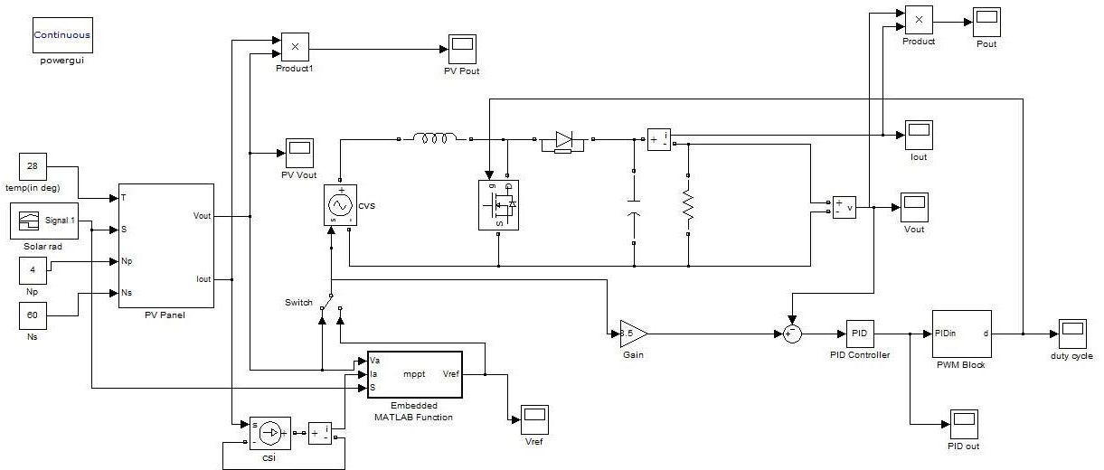

**Figure 2:** Schematic diagram used for design the MPPT

The PV panel in the proposed DC microgrid operates at its maximum power point (MPP) using an artificial neural network (ANN) approach. The MPP tracker generates the current at the MPP, which is then compared to the current of the solar converter inductor using an error detector. A proportional-integral (PI) controller examines the error to determine the duty cycle of the pulse-width modulation (PWM) signal that controls the switching of S2, as shown in Fig. 2.A conventional control method is employed to manage the hybrid energy storage system (ESS). The supercapacitor works in tandem with the battery to provide brief power surges, mitigating high-frequency fluctuations in the battery's transient response and ensuring a seamless transition. This method involves separating the battery inductor current into low-frequency components using a low-pass filter (LPF), generating a reference current for the battery inductor.

1. **RESULTS AND DISCUSSION**

A simulation of the microgrid shown in Fig.3 was conducted using MATLAB/Simulink to validate the effectiveness of the MPPT technique. The simulation aimed to verify the estimation of solar irradiance, temperature, and the ability to track the maximum power point (MPP). The PV array consisted of 40 modules, configured as 8 series-connected strings with 5 modules in parallel, totaling 10 kW. A variable resistor was used to simulate the load.

 

**Figure 3:** IV Characteristics using Proposed method.

As shown in the figure below, if the MPPT algorithm fails to identify the real MPP in such scenarios, the system will operate at a suboptimal power point, resulting in reduced conversion efficiency. In Proposed, MPPT algorithm is designed to quickly and accurately track the real MPP, maximizing the utilization rate of the solar array and minimizing resource waste. When the battery voltage reaches the predetermined constant voltage set point, the controller switches to constant voltage charging mode. During this phase, the charging current gradually decreases.

1. **CONCLUSION**

This study presents a novel maximum power point tracking (MPPT) method for photovoltaic (PV) systems. The proposed approach employs a dual artificial neural network (ANN) to predict solar irradiance and temperature. An adaptive computation block is then utilized to calculate the maximum power point (MPP). The algorithm accurately estimates solar irradiance, temperature, and maximum power point (IMP, VMP). Notably, the proposed MPPT method is non-searchable, resulting in stable output power that does not oscillate around the maximum power point. The performance of the algorithm was evaluated using MATLAB/Simulink. Initially, the algorithm's capability to estimate solar irradiance, temperature, and maximum power point (MPP) was assessed.

1. **REFERENCES**
2. A. Ben Zid, A. Lamari, F. Bacha, Seven-level grid-connected packed U-cells inverter using photovoltaic generators system, in: Proceedings of the Institution of Mechanical Engineers, Part I: Journal of Systems and Control Engineering, vol. 237, 2023, pp. 684–703, https://doi.org/10.1177/0959651820987955, 4.
3. P.K. Pathak, A.K. Yadav, S. Padmanaban, P.A. Alvi, Design of robust multi-rating battery charger for charging station of electric vehicles via solar PV system, Elec. Power Compon. Syst. 50 (14–15) (2022) 751–761, https://doi.org/10.1080/ 15325008.2022.2139870.
4. P.K. Pathak, A.K. Yadav, Design of battery charging circuit through intelligent MPPT using SPV system, Sol. Energy 178 (2019) 79–89, [https://doi.org/10.1016/j. solener.2018.12.018](https://doi.org/10.1016/j.%20solener.2018.12.018).
5. L. Abualigah, R.A. Zitar, K.H. Almotairi, A.M. Hussein, M. Abd Elaziz, M.R. Nikoo, A.H. Gandomi, Wind, solar, and photovoltaic renewable energy systems with and without energy storage optimization: a survey of advanced machine learning and deep learning techniques, Energies 15 (2) (2022) 578.
6. L. Chen, W. Han, Y. Shi, J. Zhang, S. Cao, A photovoltaic parameter identification method based on Pontogammarus maeoticus swarm optimization, Front. Energy Res. 11 (2023) 1204006, <https://doi.org/10.3389/FENRG.2023.1204006>.
7. P.K. Pathak, A.K. Yadav, P.A. Alvi, A state-of-the-art review on shading mitigation techniques in solar photovoltaics via meta-heuristic approach, Neural Comput. Appl. 34 (1) (2022) 171–209, https://doi.org/10.1007/s00521-021-06586-3.