SMART PHONE CONTROLLED HOME AUTOMATION SYSTEM

Manoj Dharmraj Pawar

Electronics and Telecommunication MVP’s KBTCOE Nashik,India mpawar9460@gmail.com

Sarthak Ramesh Pagare

Electronics and Telecommunication MVP’s KBTCOE Nashik,India sarthak.pag112@gmail.com

Nikhil Chhotu Marathe

Electronics and Telecommunication MVP’s KBTCOE Nashik,India marathenikhil53@gmail.com

**Abstract :** The "Smart Phone Controlled Home Automation System" is an innovative solution designed to enhance the management of lighting and electrical appliances in homes, classrooms, and other environments using smartphones. Traditional home automation systems often come with high costs, complex installation processes, and require advanced technical expertise, making them inaccessible to many users. This project addresses these challenges by offering a cost-effective, user-friendly, and easily deployable system based on the ESP8266 (NodeMCU) microcontroller and the Blynk IoT platform. By leveraging Wi-Fi connectivity, the system allows users to control appliances remotely, providing significant energy-saving benefits and unparalleled convenience.

The system is particularly relevant in today’s world, where energy efficiency and smart technology are becoming increasingly important. In educational institutions, for example, lights and fans are often left running unintentionally, leading to unnecessary energy consumption. This system enables real-time monitoring and control of such devices, ensuring they are only used when needed. By integrating IoT technology, the system not only reduces energy waste but also provides a scalable solution for managing appliances in large institutions or homes. The ability to

control devices from anywhere within Wi-Fi range makes it a practical tool for improving

energy management and reducing electricity costs.

At the core of the system is the ESP8266 microcontroller, which serves as the central control unit. It communicates seamlessly with the Blynk IoT platform, enabling users to interact with their appliances through a smartphone application. The Blynk platform offers a customizable interface, allowing users to create virtual buttons and switches for controlling individual devices. Additionally, the system supports scheduling and automation features, enabling users to set timers for appliances and monitor their usage statistics. This combination of hardware and software ensures a reliable and intuitive user experience, making the system accessible to both tech-savvy individuals and those with limited technical knowledge.

Overall, this project represents a significant step forward in making home automation affordable and accessible to a wider audience. By prioritizing simplicity, cost-effectiveness, and energy efficiency, the system provides a practical solution for modern households and institutions. It not only enhances convenience but also contributes to sustainable energy practices by reducing unnecessary power consumption. The integration of IoT technology with the ESP8266 and Blynk platform demonstrates the potential of smart systems to transform everyday life, paving the way for more advanced and scalable home automation solutions in the future

Keywords: IoT, ESP8266, Blynk, Relay Module, Switches & Push Buttons,etc.

## 1. INTRODUCTION

The "Smartphone Controlled Home Automation System Using ESP8266 and Blynk IoT" project introduces an advanced and scalable approach to home automation. This system leverages IoT (Internet of Things) technologies to enable users to remotely control home appliances such as lights and fans using a smartphone application. The integration of the ESP8266 microcontroller with the Blynk IoT platform allows seamless connectivity between the user and the appliances via Wi-Fi, making it a flexible and cost-effective solution for home automation. With the rising demand for smart homes, this project aims to offer a reliable and accessible system for automating household devices with minimal setup and maintenance.

The heart of the system is the NodeMCU (ESP8266), a popular microcontroller with built-in Wi-Fi capabilities. It acts as the central controller for all connected appliances. The ESP8266 communicates with the Blynk IoT platform, a cloud-based service that facilitates real-time interaction between the user and the appliances through the internet. Users can control appliances remotely using their smartphones from any location, provided they have internet access. This capability ensures that the system is not limited by physical proximity, offering convenience and enhanced energy management to homeowners.

A key component of the system is the multi-channel relay module, which allows multiple devices to be connected and controlled via the ESP8266. The relay module acts as an interface between the low-power ESP8266 and high-power home appliances, ensuring safe switching. In this setup, the relay module can manage the operation of various appliances such as fans, lights, and other electrical devices. Additionally, a voltage regulator circuit is included to ensure a stable power supply and protect the connected appliances from voltage fluctuations.

The Blynk IoT platform plays a crucial role in the system’s operation. It allows users to create a custom control interface on their smartphones by adding virtual buttons and switches for controlling individual devices. The platform also supports scheduling, monitoring, and automation features, enabling users to set timers for appliances and monitor their usage statistics. The user-friendly interface of the Blynk app ensures that both tech-savvy and non-technical users can easily interact with the system. Additionally, the platform offers support for various automation protocols, making the system highly adaptable for future expansion and upgrades.

Overall, this project demonstrates a practical, efficient, and user-friendly solution for modern home automation. It provides homeowners with greater control over their appliances, allowing for energy conservation and increased convenience. The use of IoT technology in conjunction with the ESP8266 and Blynk platform opens up new possibilities for remote management of household devices. Furthermore, the system’s modular design enables easy scalability, making it suitable for a wide range of applications, from small-scale home automation to large-scale implementations. This project serves as a foundation for more advanced smart home systems, demonstrating the potential of IoT in transforming everyday life.

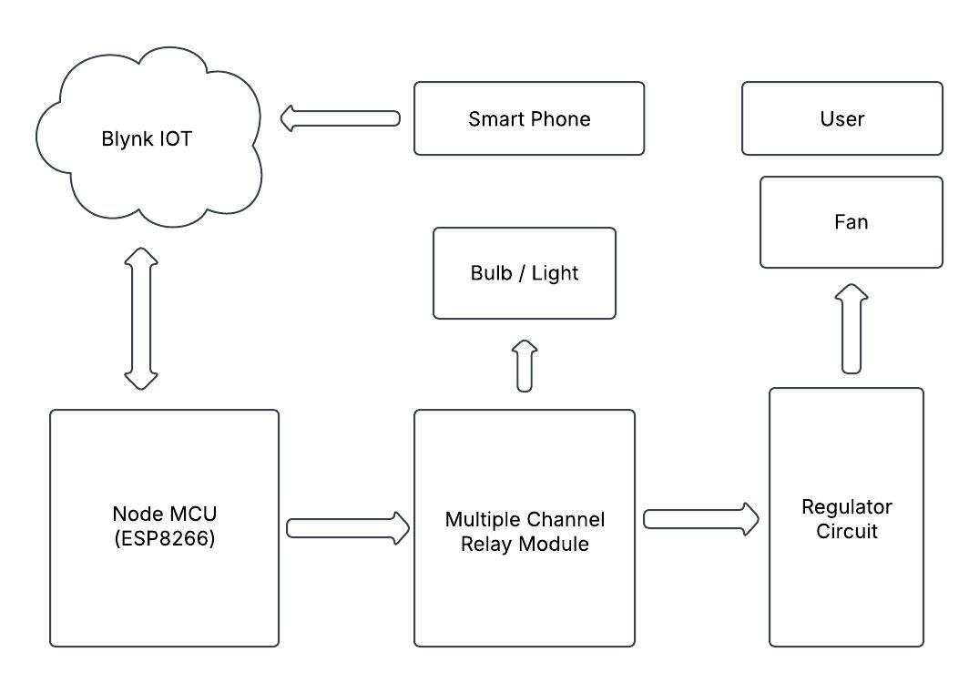

**Figure 1. Home automation system diagram**

## 2. HARDWARE DESCRIPTION

## 

## 2.1 ESP8266 microcontroller

## 

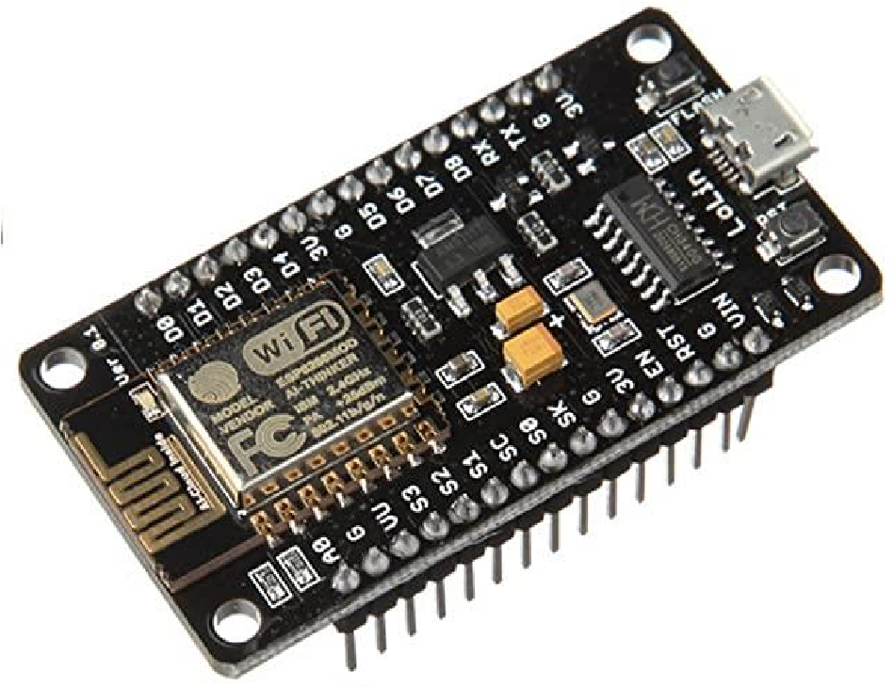

**Figure 2. ESP8266 microcontroller.**

The ESP8266 microcontroller is a highly versatile and cost-effective component widely used in IoT applications. It is equipped with the ESP-12E module, which integrates the ESP8266 chip, featuring a 32-bit RISC-based Tensilica Xtensa processor. This processor supports Real-Time Operating Systems (RTOS) and operates at a clock speed ranging from 80 MHz to 160 MHz, making it suitable for handling complex tasks in IoT projects. The microcontroller includes 4 MB of internal FLASH memory, which is used to store program code and data, ensuring efficient operation and flexibility for various applications.

One of the standout features of the ESP8266 is its built-in Wi-Fi connectivity, supporting the 802.11 b/g/n standard, along with Bluetooth 4.2 and Bluetooth Low Energy (BLE). This makes it an ideal choice for wireless communication in IoT systems. The microcontroller also offers 16 digital GPIO pins, enabling it to interface with a wide range of sensors and peripherals. Additionally, it supports multiple serial communication protocols, including SPI, I2C, I2S, and UART, providing flexibility for connecting external devices. The ESP8266 operates at a low voltage of 3.3V DC, with a maximum input voltage of 12V DC, and includes a Deep Sleep mode to minimize power consumption, making it suitable for battery-powered applications.

.

ESP8266 specifications:

* 32-bit RISC CPU
* 80 MHz – 160 MHz clock speed
* 64 KB SRAM
* 4 MB FLASH
* Wi-Fi 802.11 b/g/n, Bluetooth 4.2 and BLE
* 16 digital GPIO pins
* Serial connectivity: SPI, I2C, I2S, UART
* USB-TTL CP2102
* 1 analog input
* Operating voltage: 3.3 V D.C
* Input voltage: maximum 12 V D.C

### 2.2-channel relay module

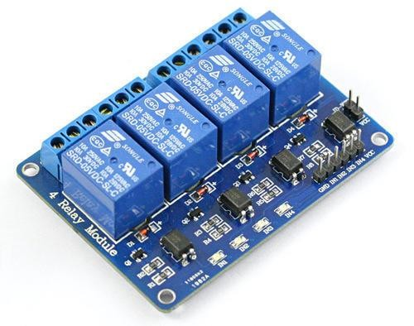

**Figure 5. 4-channel relay module.**

The 4-channel relay module is a critical component in the system, acting as an interface between the low-voltage ESP8266 microcontroller and high-power appliances such as lights, fans, and other electrical devices. Each relay channel operates as an electrically controlled switch, using a small voltage supplied by the microcontroller to generate a magnetic field. This magnetic field either opens or closes the electrical contacts, allowing the low-power microcontroller to safely control high-voltage circuits without direct electrical contact.

Each relay channel on the module has three terminals: NC (Normally Closed), NO (Normally Open), and COM (Common). The NC terminal is connected to the COM terminal when the relay is inactive, while the NO terminal connects to COM when the relay is activated. This configuration allows the relay to control the flow of electricity to connected devices. The relay module operates at a voltage range of 3.75V to 6V, with a quiescent current consumption of 2mA. When a relay is active, it consumes approximately 70mA of current, making it energy-efficient for home automation applications.

Relay module specifications:

* Operating voltage: 3.75V – 6V
* Quiescent current consumption: 2mA - Current consumption when relay is active: ~70mA
* Maximum contact voltage: 250V A.C, 30V D.C
* Maximum contact current: 10A
* Number of channels: 4

**2.3 Regulator**

The voltage regulator is an essential part of the system, ensuring that all components receive a stable and consistent power supply. The ESP8266 microcontroller operates at 3.3V DC, while the relay module requires 5V DC. The voltage regulator steps down higher input voltages, such as 12V from an external power source, to the required levels for these components. This prevents voltage fluctuations that could damage the sensitive electronics and ensures the system operates reliably.

The regulator circuit includes capacitors and resistors to stabilize the voltage and protect the components from power surges. For example, capacitors with ratings of 1µF, 2.2µF, and 3.3µF are used to filter out noise and maintain a steady voltage output. The circuit also includes resistors to limit current flow and protect the components. The voltage regulator is designed to handle an input voltage of up to 220V AC, making it suitable for use in a variety of environments. Additionally, the regulator includes a rotary switch for controlling fan speed, allowing users to adjust the speed of connected fans in three levels.

Specifications:

* Input voltage AC 220V
* Capacitors C1 1µF 400V C2 2.2µF 400V C3 3.3µF 400V
* Resistors R1 R3 R5 2.2Ω R2 R4 R6 220kΩ
* Switch type Rotary switch for fan speed control
* Load AC fan or similar device
* Configuration Capacitor-resistor network for speed control
* Speed settings 3-speed levels plus OFF

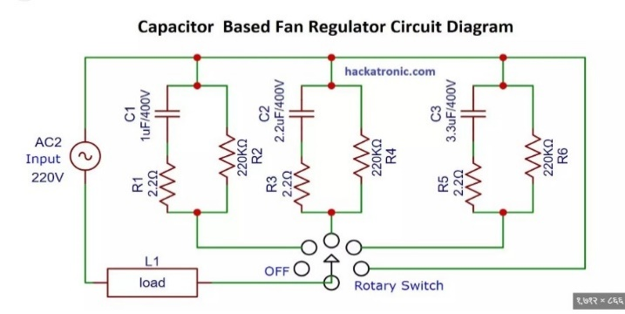

**3. BLYNK APPLICATION**

Blynk is a cloud-based Internet of Things (IoT) platform that enables users to build and control smart devices remotely via a mobile or web application. It simplifies the development of IoT applications by offering a user-friendly interface, seamless cloud connectivity, and support for various microcontrollers like ESP8266, ESP32, and Arduino.

Blynk is a versatile IoT platform that allows developers to create smart applications for controlling hardware remotely. It provides an intuitive drag-and-drop interface for designing dashboards without requiring extensive coding. The platform supports multiple communication protocols, including Wi-Fi, Bluetooth, and GSM, enhancing connectivity options

**Interface for project:**

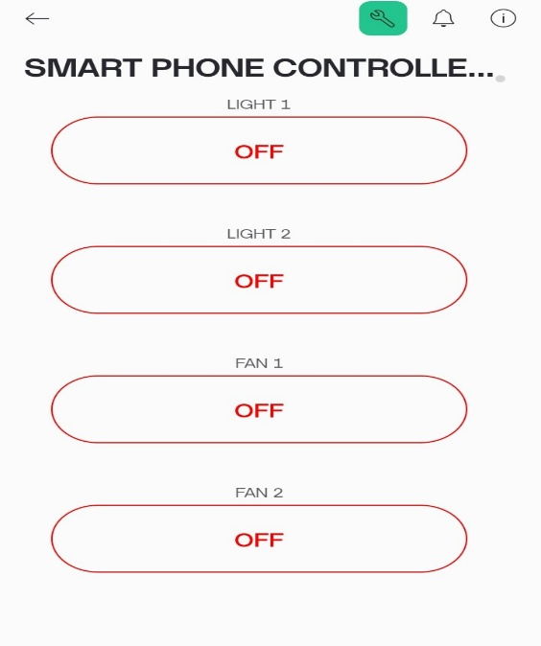

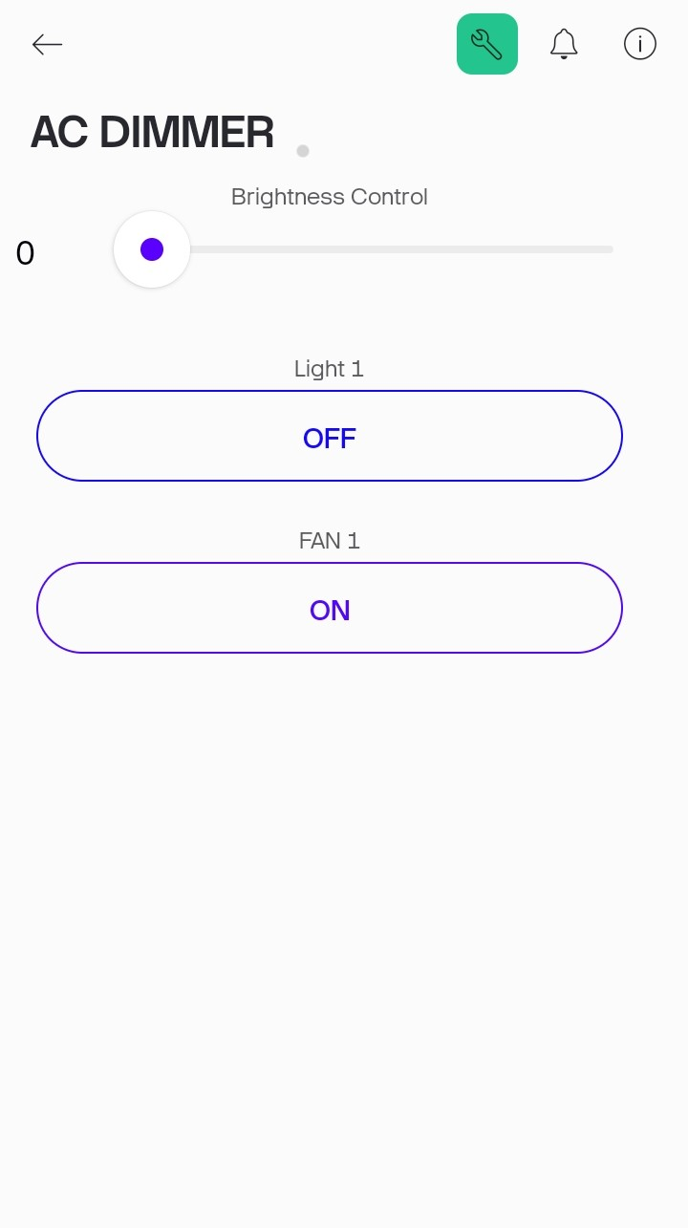

**Figure 7. Relay channel buttons and LED PWM slider.**

**Key Features of Blynk:**

1. **Customizable Dashboard** – Users can create personalized dashboards with widgets such as buttons, sliders, graphs, and gauges to monitor and control IoT devices.
2. **Real-Time Communication** – Devices connected to Blynk send and receive data instantly, ensuring a responsive experience.
3. **Cross-Platform Support** – Blynk is available on both **Android and iOS**, as well as a web dashboard for remote monitoring.
4. **Cloud-Based Connectivity** – No complex server setup is required. Devices communicate through **Blynk Cloud**, allowing global access.
5. **Virtual Pins for Interaction** – The platform provides **Virtual Pins** that simplify communication between the microcontroller and the app, reducing coding complexity.
6. **Automations & Scheduling** – Users can automate tasks, set timers, and create event-based triggers for their devices.
7. **Secure Authentication** – Each device is assigned a **unique authentication token**, ensuring secure and reliable connections.

**Setting Up Blynk with ESP8266:**

1. **Create a Blynk Account** – Sign up on the **Blynk app** or **Blynk Cloud**.
2. **Generate a New Project** – Assign a name, select hardware (ESP8266), and note down the **Auth Token**.
3. **Install the Blynk Library** – In Arduino IDE, install the **Blynk** and **ESP8266WiFi** libraries.
4. **Write and Upload Code** – Use the provided **Auth Token**, Wi-Fi credentials, and virtual pin configurations in the code.
5. **Run and Monitor** – Open the app, interact with widgets, and monitor real-time device activity.

**5. CONCLUSIONS**

The biggest obstacle often encountered in the implementation of commercial smart home systems is the very high cost for such a system. Existing systems on the market often require additional network adaptors such as hubs which in turn raise the total cost of the system. This paper has studied and revised the currently available home automation system, using the ESP8266 development platform and the Blynk IoT platform so that an economical system can be achieved. Above all, this system offers excellent convenience to the user, as it makes it possible to control the devices connected to the relay module and monitor the temperature, humidity and brightness from a remote location via a Wi-Fi internet connection using a mobile type that is available on Android and iOS operating systems.

1. **References**
2. **Howe, A**. (2018). The Smarthome Book: Simple Ideas to Assist with Your Smarthome Renovation. Independently Published.

This book provides practical ideas and guidance for implementing smart home technologies, including IoT-based systems.

1. **Vandome, N.** (2018). Smart Homes in Easy Steps: Master Smart Technology for Your Home. In Easy Steps Limited.

A beginner-friendly guide that covers the basics of smart home systems, including automation and IoT integration.

1. **Diaconu, E.** (2017). Controlul Sistemelor Electronice (Control of Electronic Systems). Valahia University Press.

This book discusses electronic control systems, including microcontrollers and relay modules, which are relevant to your project.

1. **Schwartz, M.** (2013). Home Automation with Arduino: Automate Your Home Using Open-Source Hardware. CreateSpace Independent Publishing Platform.

A comprehensive guide to building home automation systems using Arduino and other open-source hardware, including ESP8266.

1. **Berndt, H. J**. (2017). Measurement & Control Using Smartphone & Tablet. Independently Published.

This book explores the use of smartphones and tablets for controlling and monitoring electronic systems, which aligns with your project's use of the Blynk app.

1. **Espressif Systems.** (2023). ESP8266 Technical Reference Manual.

Official documentation from Espressif Systems, the manufacturer of the ESP8266 microcontroller. This resource provides in-depth technical details about the ESP8266's features and capabilities.

1. **Blynk Inc.** (2023). Blynk IoT Platform Documentation.

Official documentation for the Blynk IoT platform, including setup instructions, API references, and examples of how to integrate Blynk with microcontrollers like the ESP8266.

project's software implementation