Development of an Interactive and Website for Cafe Coffee Beans

# Abhijeet Kamble, Aditya kale

1 Thergaon, Computer Engineering, Marathwada Mitra Mandals Polytechnic, pune, Maharashtra, India

2 Thergaon , Computer Engineering, Marathwada Mitra Mandals Polytechnic, pune, Maharashtra, India

# ABSTRACT

Welcome to Café Coffee Beans! This is your top place for the best, fresh beans. Our site is for coffee lovers. We offer a big range of good beans from top coffee spots in the world. Whether you are an expert or new to coffee, our easy site gives a smooth shopping trip. You will find bean details, how-to-brew tips, and custom picks. Look through our great mix of single- origin and mixed beans.

.**Keywords :** Online Coffee Ordering System, Cafe Digital Marketing, cafe payment solutions

# INTRODUCTION

In order to improve customer engagement and the overall cafe experience, this paper investigates the creation of a website for event updates a cafe. The website uses contemporary digital solutions to improve operations and fortify the café's relationship with its patrons through a responsive, user- friendly design that offers menu browsing, online ordering, and

# METHODOLOGY

**Technology Stack**

* + **Direct Trade and Ethical Sourcing**
  + **Quality Control: Conduct rigorous quality checks**
  + **Sustainable Practices: Prioritize sustainable and eco-friendly sourcing**

# MODELING AND ANALYSIS

Using these methods, you can understand your Café Coffee Beans website better. See how it works, how users act, and how well the site performs. This helps you improve your business plans and user experience for best results:

**Website Snapshots:**

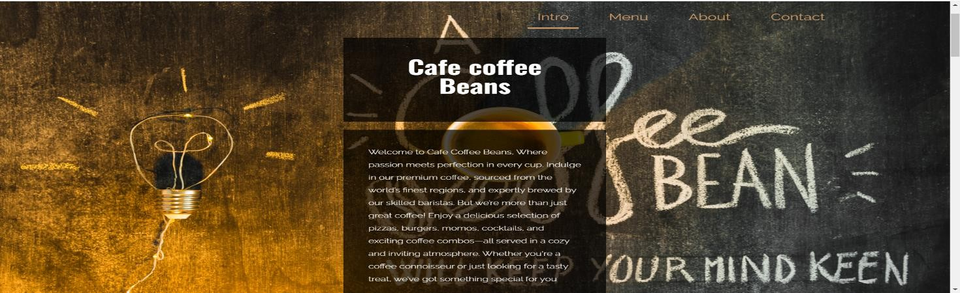

**Fig: Home Page**

Home page introduction:- Come to Cafe Coffee Beans, where love meets skill in each sip. Savor our fine coffee, picked from the best spots on earth and made by our expert baristas. But we’re not just about coffee! Relish a range of pizzas, burgers, momos, drinks, and fun coffee sets—all in a warm and friendly space. Whether you're a coffee lover or just want a good bite, we have something great for you.

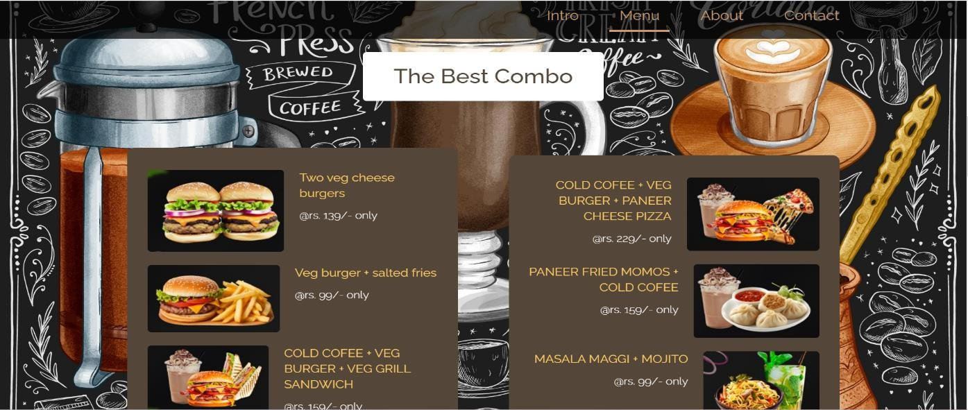

**Fig: Menu**

**Menu & Best Combos :-** The cafe site will show food to suit all tastes. It will have many foods and drinks, like special burgers and cool mojitos. Burgers, Cheeseburger, A juicy beef patty with melt-y cheddar, fresh lettuce, tomato, pickles, and special sauce in a soft bun. BBQ Burger: A tender beef patty with bacon, tangy BBQ sauce, lettuce, and onions. Veggie Burger: A chickpea and veggie patty with vegan mayo, lettuce, and tomato. Mojitos: Classic Mojito: Fresh mint, lime, sugar, and rum over crushed ice with soda water. Strawberry Mojito: Fresh mix with ripe strawberries for sweet and tart flavor.

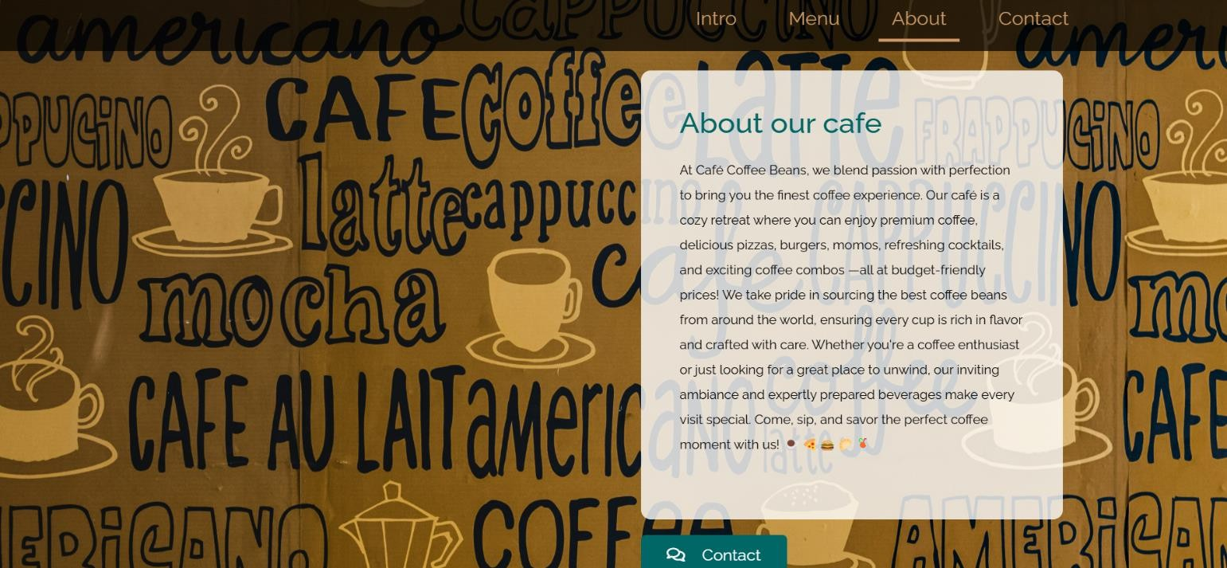

**Fig: About Cafe**

About cafe: At Cafe Coffee Beans, we mix love and skill to give you the best coffee. Our café is a warm spot where you can have top coffee, tasty pizzas, burgers, momos, cool drinks, and fun coffee deals —all at good prices! We proudly find the best coffee beans from around the world. Each cup is full of flavor and made with care. If you love coffee or just need a nice place to relax, our cozy place and well-made drinks make every visit great. Come, drink, and enjoy the perfect coffee time with us!

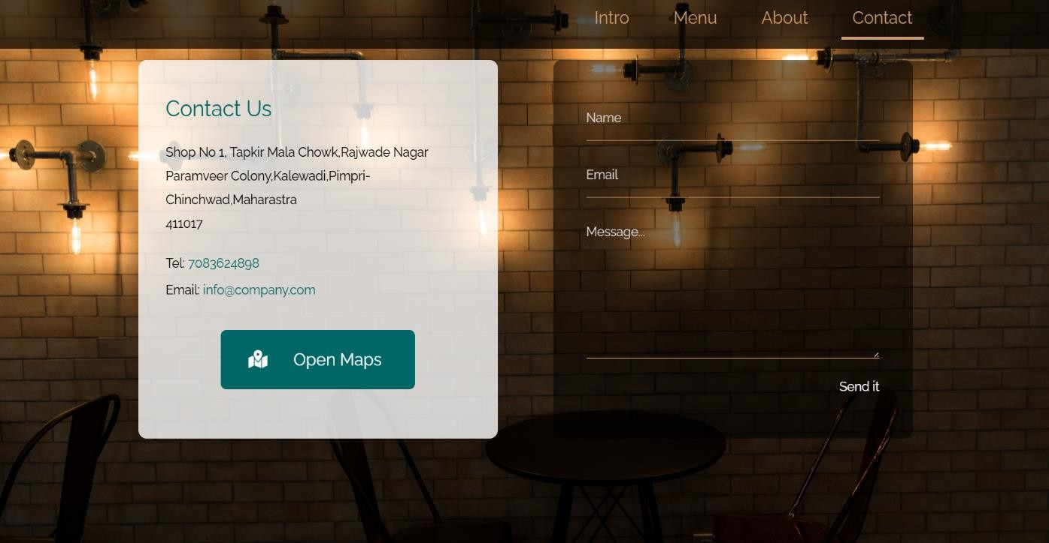

**Fig: Contact**

Contact: cafe location, phone number and email For contact cafe.

# RESULTS AND DISCUSSION

The Cafe Coffee Beans website effectively incorporates key functionalities like:-

Placed well, these steps guide users to order, sign up for news, or follow on social media.

Customers can earn points to get discounts or free items. This helps keep them coming back and feeling part of a group. The site shares the cafe’s history, where the beans come from, and tales behind blends.

This adds to the story of the brand and connects with customers.

The website is clean and simple, making it easy to find the menu, store, or contact info. This way, visitors find what they need fast without any confusion.

# CONCLUSION

In the end, Cafe Coffee Beans is more than a café. It's a place where every visit feels special. Our menu is filled with tasty burgers, fresh drinks, and yummy combos. We make sure there is something for everyone’s taste. We use the best local ingredients to keep our food fresh and of high quality. Our website is easy to use. From

home, work, or on the go, you can order food, book a table, or look at our menu. It's simple to browse

make plans, and check for deals and events. At Cafe Coffee Beans we don’t just serve food. We create special moments for everyone. Come for a coffee, a quick meal, or to celebrate with loved ones. We promise a warm place and great service every time. Our staff is here to make you feel at home. Join our café family. Feel the warmth, taste the flavor, and enjoy the kind service that sets us apart. Whether it's your first time or you visit often, we are happy to see you. Thank you for choosing Cafe coffee beans we can’t wait to see you again!

# REFERENCES

1. Vandelay Design's Collection of Café and Coffee Shop
2. CoffeeSpots.com's Tips for Successful Coffee Shop Website Design:
3. StartMyCoffeeShop.com's Website Design Tips
4. HubSpot's Guide to Coffee Shop Website Designs