**AUTOMATIC LOAD SHARING AND PROTECTION OF TRANSFORMERS USING MICROCONTROLLER**

**Mr.B.Emaneaul Raju1, Mr.R.Raghunadha Sastry2, Ms.K.Vishnu Poojitha3 , Ms.M.Sai Sree4 , Ms.D.Kalyani5, Mr.P.Ajay6, Mrs.Ch.Sirisha7**

1,3,4,5,6 Students, Department of EEE, NRI Institute of Technology, Agiripalli, Andhra Pradesh, India

2 Associate Professor, Department of EEE, NRI Institute of Technology, Agiripalli, Andhra Pradesh, India

7 Assistant Professor, Department of EEE, NRI Institute of Technology, Agiripalli, Andhra Pradesh, India

**ABSTRACT**

The Automatic Load Sharing and Protection of Transformers using a Microcontroller aims to enhance the reliability and efficiency of power distribution systems. This project ensures continuous power supply by automatically switching the load between two transformers based on real-time monitoring of voltage, current, and temperature. A microcontroller Arduino processes sensor data and controls a relay module to transfer the load if the primary transformer is overloaded or overheated. Additionally, an ESP8266 WiFi module can be integrated for remote monitoring via IoT platforms.This project is crucial for preventing transformer failures, reducing downtime, and ensuring a stable power supply in industrial and commercial setups. The automation improving system efficiency and safety. By implementing this intelligent transformer load-sharing system, the overall lifespan of transformers is extended, making power distribution more reliable and cost-effective.

**Keywords:** ACS712 current sensor, ZMPT101B voltage sensor, DHT11 temperature sensor, a two-channel relay module, ESP8266 WiFi module and an LCD display.

1. **INTRODUCTION**

Transformers play a vital role in power distribution systems, ensuring efficient transmission of electricity. However, issues such as overloading, overheating, and voltage fluctuations can cause transformer failures, leading to power disruptions and increased maintenance costs. To address this, an Automatic Load Sharing and Protection System for Transformers is developed using a microcontroller-based control mechanism.

This system monitors the voltage, current, and temperature of transformers in real time using ACS712 current sensor, ZMPT101B voltage sensor, and DHT11 temperature sensor. When the load on a transformer exceeds a predefined threshold or if the temperature rises beyond safe levels, the microcontroller automatically switches the load to a secondary transformer using a relay module. An LCD display provides real-time status updates, and a buzzer alerts users in case of falts.

The proposed system enhances the reliability, efficiency, and longevity of transformers by preventing overload-related failures and reducing downtime. By implementing an automated load-sharing mechanism, the need for manual intervention is minimized, ensuring uninterrupted power supply for industrial, commercial, and residential applications. This project ultimately contributes to a more stable and cost-effective power distribution network.

1. **METHODOLOGY**

The Automatic Load Sharing and Protection of Transformers using a Microcontroller is designed to monitor, analyze, and control the load distribution between two transformers. The system ensures uninterrupted power supply by automatically switching the load when a transformer experiences overloading or overheating. The methodology is divided into the following steps:.

**2.1 System Design and Component Selection**

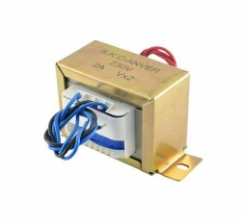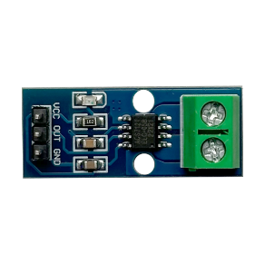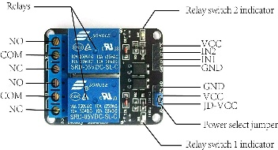The Automatic Load Sharing and Protection of Transformers using a Microcontroller is designed to monitor, analyze, and regulate power distribution by automatically switching loads between transformers based on real-time conditions. The system consists of various sensors, a microcontroller, a relay module, and a power supply unit that work together to ensure efficient load management and fault protection. The ACS712 current sensor is used to measure the current.

**Figure 1:** Step down Transformer **Figure 2:** Two channel Relay **Figure 3:** ACS712 Current Sensor

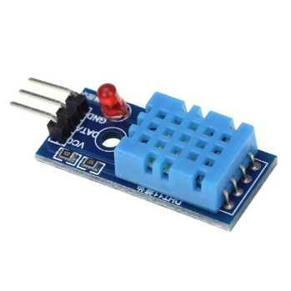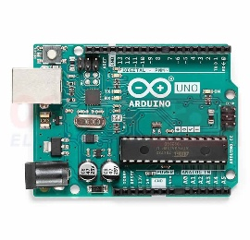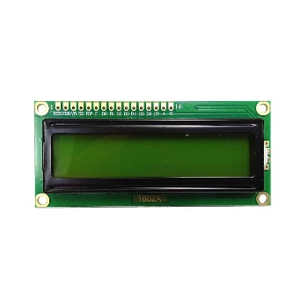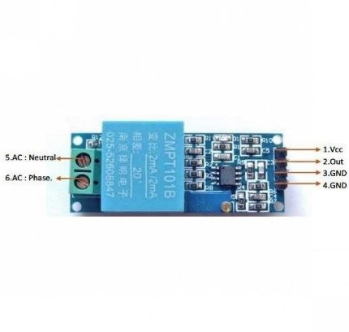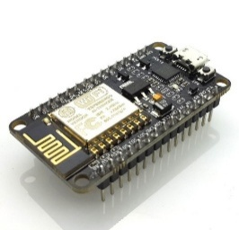**Figure 4:** ESP8266 WiFi module **Figure 5:** ZMPT101B voltage sensor **Figure 6:** LCD display **Figure 7:** Microcontroller **Figure 8:** DHT11 temperature sensor **Figure 9:** Software

The ZMPT101B voltage sensor continuously monitors voltage levels, ensuring the transformers operate within safe limits. The DHT11 temperature sensor detects overheating conditions, helping to prevent damage due to excessive temperature rise. The Arduino microcontroller serves as the central processing unit, receiving sensor data and making automated decisions to switch loads when necessary. The two-channel relay module is used to transfer the load from one transformer to another during faults or overloads. Additionally, an LCD display provides real-time monitoring, while a buzzer alerts users to abnormal conditions. A step-down transformer (230V to 12V) powers the system, ensuring stable operation. For remote monitoring, an ESP8266 WiFi module can be integrated to send real-time data to an IoT platform. The combination of these components results in a cost-effective, reliable, and efficient power management system for industrial and commercial applications..

**2.2 Software Development**

The software development for the Automatic Load Sharing and Protection of Transformers using a Microcontroller involves writing embedded C/C++ code to control the system’s operation efficiently. The Arduino IDE is used to program the Arduino microcontroller, which processes real-time data from sensors and makes decisions for load switching. The program begins with initializing the sensors, including the ACS712 current sensor, ZMPT101B voltage sensor, and DHT11 temperature sensor, to monitor transformer health continuously. .

1. **BLOCK DIAGRAM AND ANALYSIS**

The block diagram of the Automatic Load Sharing and Protection of Transformers using a Microcontroller represents the system's functional flow. It includes power supply, sensors (ACS712 for current, ZMPT101B for voltage, and DHT11 for temperature), Arduino microcontroller, relay module, LCD display, buzzer, and load. The sensors continuously monitor transformer parameters and send data to the microcontroller, which processes the readings and controls the relay module for automatic load switching. The LCD display shows real-time system status, while the buzzer alerts users in case of faults. If WiFi (ESP8266) is integrated, the system can transmit data for remote monitoring, ensuring reliable transformer operation.

Power supply

MICROCONTROLLER

T1



ADC

T2

Relay



Current sensor



Load

LCD

**Figure 9:** Block Diagram.

To evaluate the system's effectiveness, several tests were conducted under varying load conditions. The response time of the relay module was analyzed to ensure minimal switching delay between transformers. The accuracy of the sensors was validated by comparing their readings with standard measuring instruments. The system was also tested against different fault scenarios, including overload, voltage fluctuations, and excessive temperature rise, and it successfully switched loads without power disruption. Furthermore, Proteus and MATLAB simulations were used to analyze the behavior of the system before real-time implementation.

1. **WORKING AND RESULTS**

The Automatic Load Sharing and Protection of Transformers using a Microcontroller continuously monitors voltage, current, and temperature using sensors. If an overload, voltage fluctuation, or overheating is detected, the Arduino microcontroller processes the data and activates the relay module to shift the load from one transformer to another, ensuring uninterrupted power supply. The LCD display provides real-time updates on system parameters, while a buzzer alerts users in case of faults. If integrated with an ESP8266 WiFi module, the system can transmit data for remote monitoring. This ensures efficient power distribution, transformer protection, and reduced downtime in electrical networks.

The Automatic Load Sharing and Protection of Transformers using a Microcontroller was successfully designed, implemented, and tested under various load conditions. The system effectively monitored voltage, current, and temperature, ensuring seamless load transfer between two transformers in case of overload or overheating. The ACS712 current sensor accurately measured the current and triggered load shifting when it exceeded the predefined threshold. Similarly, the ZMPT101B voltage sensor provided real-time voltage monitoring, ensuring system stability. The DHT11 temperature sensor detected excessive heating, prompting the microcontroller to activate the relay module, which swiftly transferred the load to the secondary transformer, preventing damage. The system demonstrated a fast response time, ensuring minimal power loss during transitions. The LCD display updated real-time values, while the buzzer provided alerts for fault conditions. Additionally, when the ESP8266 WiFi module was integrated, real-time data could be accessed remotely, enhancing monitoring capabilities. However, minor relay switching delays and electromagnetic interference affecting sensor accuracy were noted. Overall, the system effectively reduced downtime, enhanced transformer lifespan, and ensured uninterrupted power supply. Future improvements could include AI-based fault prediction and multi-transformer scalability to further enhance performance and efficiency..

1. **CONCLUSION**

The Automatic Load Sharing and Protection of Transformers using a Microcontroller successfully enhances the reliability and efficiency of power distribution systems. By continuously monitoring voltage, current, and temperature, the system ensures that transformers operate within safe limits. In case of overloading or overheating, the microcontroller automatically switches the load to an alternate transformer using a relay module, preventing transformer failures and minimizing power disruptions.

The integration of ACS712 current sensor, ZMPT101B voltage sensor, and DHT11 temperature sensor allows for real-time condition monitoring, while the LCD display provides instant feedback to the user. The addition of a buzzer alerts operators to abnormal conditions, ensuring timely intervention. Furthermore, with IoT-based remote monitoring (ESP8266 WiFi module), the system can be accessed and controlled from any location, improving overall power management and efficiency.

**ACKNOWLEDGEMENT**

We express our gratitude towards to our head of the department **Dr. N. SAMBASIVA RAO, Professor and Head of Electrical and Electronical Engineering Department** and all the faculty members for their support and encouragement during this research study.

1. **REFERENCES**
2. Gupta, B. R. (2018). *Power System Analysis and Design*. McGraw Hill.
3. Wadhwa, C. L. (2017). *Electrical Power Systems*. New Age International.
4. ESP8266 WiFi Module Datasheet – Espressif Systems.
5. Arduino Official Website: <https://www.arduino.cc>
6. ResearchGate: <https://www.researchgate.net>