**SMART RAILWAY TRACTION SYSTEM**

**Mr.S.Sethu Pavan Sahith1, Mr.I.Prasanna Kumar2, Ms.E.Renuka3, Mr.Ch.Hemanth Kumar4, Mr.G.Lakshman Kumar5, Mr.A.Jayanth6, Mr.Dr.S.Chandrasekhar7**

1,3,4,5,6Students, Department of EEE, NRI Institute of Technology, Agiripalli, Andhra Pradesh, India

2Assistant Professor, Department of EEE, NRI Institute of Technology, Agiripalli, Andhra Pradesh, India

7Professor, Department of EEE, NRI Institute of Technology, Agiripalli, Andhra Pradesh, India

**ABSTRACT**

The Smart Railway Traction System project aims to enhance railway safety and efficiency by employing an automated control mechanism that monitors and manages train movements between loop lines and main lines. The system utilizes three **ultrasonic sensors** placed strategically at the start and end of the loop line and on the main line to detect the presence of trains and automatically adjust track positions through a **servo motor**. Visual signals using LEDs indicate safe passage or warnings for both lines, ensuring smooth transitions. An additional braking system, implemented via the L293D motor driver, halts the train in the event of conflicting signals, preventing accidents. The project is controlled using an Arduino **microcontroller**, offering a flexible and easy-to-program platform for integration. The system has been tested successfully, demonstrating reliable detection, track switching, and signal display in real-time. This smart railway solution presents a significant step toward improving safety, minimizing human error, and automating railway operations. It shows potential for real-world deployment and future scalability with the integration of technologies like RFID and LiDAR for enhanced train monitoring and management. This work highlights the importance of **embedded systems** in modern transportation safety and efficiency.

**Keywords:** Ultrasonic Sensor, Microcontroller, Embedded Systems, Servo motor

1. **INTRODUCTION**

Railways continue to serve as one of the most critical transportation systems worldwide, facilitating both passenger and freight movement efficiently. However, the increasing volume of railway traffic poses significant challenges in terms of safety, timely operations, and collision prevention. Traditional railway management systems often rely on manual monitoring and signaling, leaving room for human error and inefficiencies that can result in accidents or delays.

To address these challenges, this paper presents the design and implementation of a Smart Railway Traction System. The proposed system utilizes ultrasonic sensors to detect train presence on loop lines and main lines, allowing for automatic track switching via a servo motor. LED-based signaling provides clear visual cues to ensure safe and efficient train navigation. Furthermore, an automatic braking mechanism integrated through the L293D motor driver adds a layer of safety by preventing collisions in case of conflicting train detections.

The system is controlled using an Arduino microcontroller, chosen for its versatility, ease of programming, and robust hardware interfacing capabilities. This automated solution reduces human intervention, enhances operational safety, and demonstrates scalability for larger railway networks. The Smart Railway Traction System contributes to the advancement of intelligent railway infrastructure, paving the way for further integration with technologies like RFID and LiDAR for advanced monitoring and automation.

1. **COMPONENTS**

* Arduino UNO – Used for processing the signals from sensors.
* HC-SR 04 – used to detect objects.
* Servo motor – used for track switching.
* L298D Drive – used for applying brakes automatically.
* Resistors – limits the current flow for LED’s.
* Buzzer – used as an alert for emergency braking.
* LED’s – used for signaling purpose.
* Power supply – uses to power all the equipment’s.

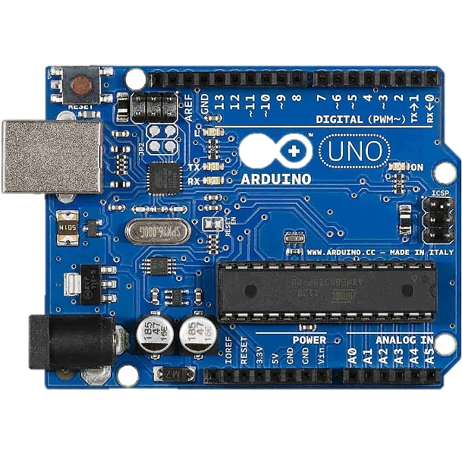 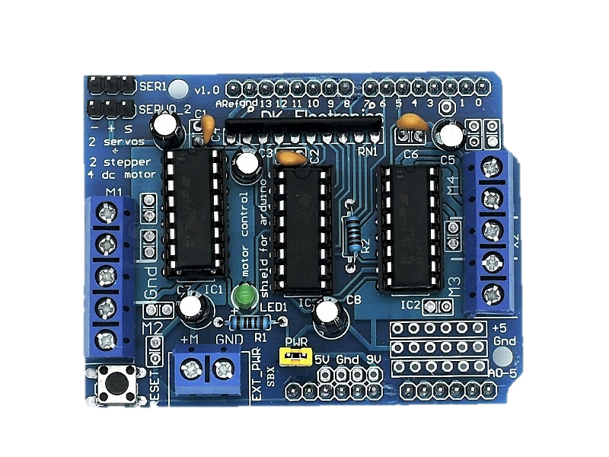 **Fig a**: Arduino UNO **Fig b**: L298D Motor Drive

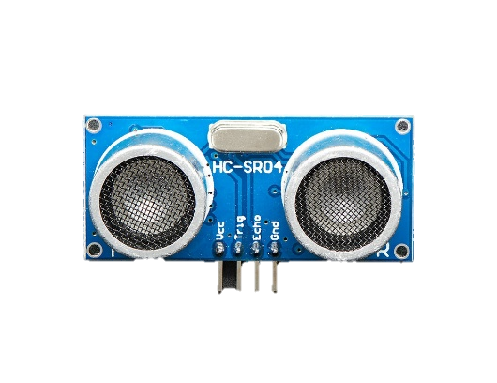

**Fig c**: HC-SR04  **Fig d**: Servo Motor

1. **METHODOLOGY**

The Smart Railway Traction System is designed to enhance railway safety and automation using ultrasonic sensors, a servo motor (or motor drive), Arduino microcontroller, and LED-based signaling. The system aims to efficiently control track switching and signal indications based on train detection, preventing collisions and ensuring smooth railway traffic. The entire setup works in the following stages:

**3.1 System Initialization**

This system consists of two paths-main line and loop line. In this our system is setup in the loop line. We divide this into three parts starting of the loop line, end of the loop line and at middle of the main line. Here, one ultrasonic sensor is placed at the starting of the loop line another is placed at the ending of the loop line and third is placed at the middle of the main line to detect the train in real-time and to change the track automatically. When, the system is powered once the Arduino initializes all the components.

**3.2 Track Switching System**

The sensor placed at the starting of the loop line continuously measures the distance between the object ahead. When the train is approaching the loop line will be detected based on the threshold value given. When the train is detected by the sensor then this signal will be sent to the Arduino, and this will activate the servo motor or motor drive to change the track direction to the main line to allow the train to the main line without allowing it into the loop line in order to avoid the collision with other trains fallowed by the accurate signaling system.

Another sensor placed at the end of the loop line continuously measures the distance between the objects ahead. When the train in the loop line is about to move into the main line then it is detected by the sensor there then the Arduino again will trigger the servo motor or motor drive to change the track position towards the loop line fallowed by the accurate signaling system in order to avoid the collisions.

And the sensor at the middle of the main line is use to detect the train in the main line. Here, when the train in the loop line is about to start and at the same time another train is coming in the main line in order to prevent the collision the train in the main line is detected by the sensor provided and a braking signal is sent to the train in the loop line. And this is known as the braking signal mechanism.

**3.3 Automatic braking system**

To enhance safety, we are integrating automatic braking system for this. Here, in the case of the braking signal when there is no proper signaling then this automatic braking system is used. When the signaling failed then the brakes will be applied automatically with the help of the L298D motor drive. This is used in the case of the loop line also as when the train was entering the loop line due to signal failure like in the case of the coromandel express. So, in this case when the train has accidentally entered into the loop line then the brakes will apply automatically to prevent the collisions.

1. **BLOCK DIAGRAMS & CIRCUIT DIAGRAMS**

The Smart Railway Traction System is designed with a clear and logical block diagram that illustrates the interaction between key components and the circuit diagram provides a detailed view of the electrical connections among all components:

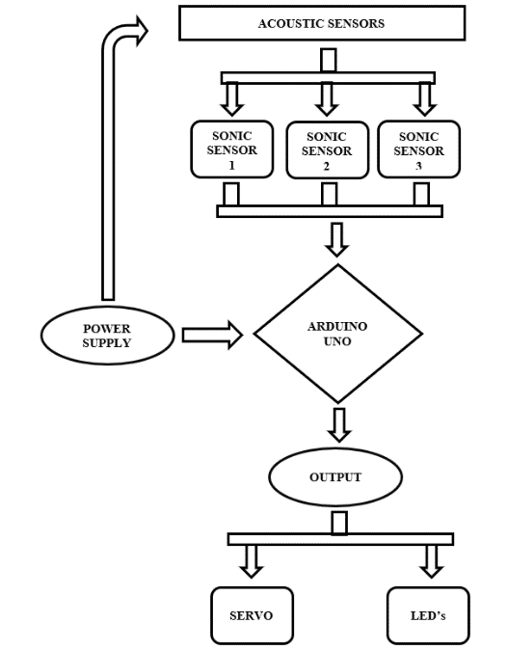 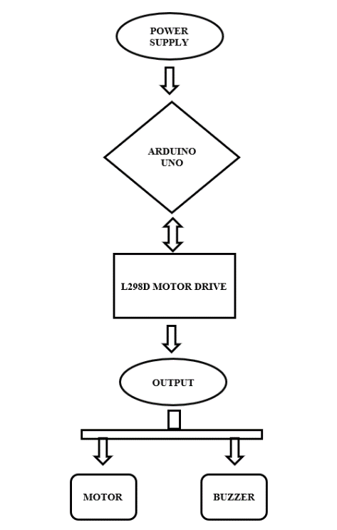

**Fig e:** Block Diagrams

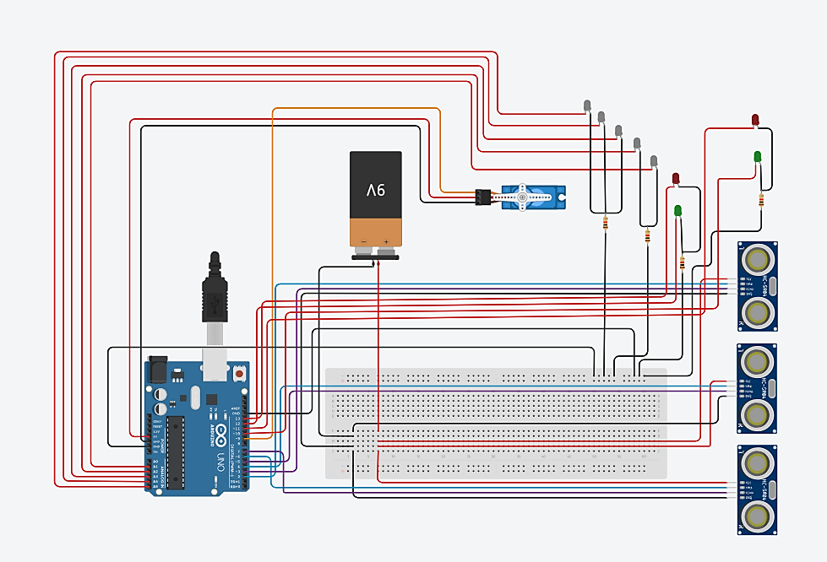

**Fig f**: Circuit Diagrams

1. **RESULT**

The smart railway traction system was successfully developed and tested. It demonstrates accurate detection of the train positions using ultrasonic sensors placed at the key points. Automatic track switching was efficiently controlled by the servo motor which responded accurately to the sensor signals. The integration of the L298D motor drive based automatic braking mechanism worked efficiently. Overall, the proposed system has proved to be reliable and efficient in managing the train operation.

1. **CONCLUSION**

The smart railway traction system represents a significant advancement in automatic railway safety and management. By integrating ultrasonic sensor, servo motor, motor drive and Arduino it reduces the human dependency and errors caused by manual operation. The real-time responsiveness of the system allows smooth transition between the main and the loop lines. It can be developed much more efficiently by adding the LIDAR and RFID systems to this will set the railway system to reduce the human errors and other malfunctioning easily.

1. **ACKNOWLEDGEMENT**

We express our gratitude towards to our head of the department **Dr. N. SAMBASIVA RAO, Professor and Head of Electrical and Electronical Engineering Department** and all the faculty members for their support and encouragement during this research study.

1. **REFERENCES**

[1] M. Banzi and M. Shiloh, Getting Started with Arduino, 3rd ed. Maker Media, Inc., 2014.

[2] M. Margolis, Arduino Cookbook, 3rd ed. O’Reilly Media, 2020.

[3] P. Scherz and S. Monk, Practical Electronics for Inventors, 4th ed. McGraw-Hill Education, 2016.

[4] L. Joseph, Learning Robotics using Python. Packt Publishing, 2015.

[5] J. Valvano, Embedded Systems: Introduction to the MSP432 Microcontroller, Vol. 1, CreateSpace Independent Publishing, 2017.

[6] M. F. L. Abdullah, Railway Signaling and Control Systems. CRC Press, 2019.