**Development of an Interactive and Accessible Website for Spectrum Bridge Autism Center**

**Meghraj Bhosale, Faizan Choudhary**

1 Thergaon, Computer Engineering, Marathwada Mitra Mandals Polytechnic, pune, Maharashtra, India

2 Thergaon , Computer Engineering, Marathwada Mitra Mandals Polytechnic, pune, Maharashtra, India

**ABSTRACT (Font-Times New Roman, Bold, Font Size -12)**

This paper is on the creation of an interactive website for the Spectrum Bridge Autism Center to enhance accessibility and communication for people with ASD, caregivers, and medical professionals. Some of the important features are admission forms, donations, appointments, and autism resources. The website is developed using HTML, CSS, JavaScript, PHP, and MySQL to facilitate operations for maximum efficiency.

**Keywords:** Website Development, Accessibility, User-Friendly Design, PHP, MySQL

1. **INTRODUCTION (Font-Times New Roman, Bold, Font Size -12)**

Autism Spectrum Disorder (ASD) impacts behavior, communication, and social interaction. With the increased number of autism cases in India, there is a need for digital solutions. This paper considers a website for the Spectrum Bridge Autism Center to improve access for individuals with ASD, families, and professionals.

1. **METHODOLOGY**

**Technology Stack**

* **Front-End:** HTML, CSS, JavaScript for a responsive UI.
* **Back-End:** PHP for server-side scripting, MySQL for database management.
* **Security:** HTTPS encryption, CAPTCHA, and data validation for privacy and security.

1. **MODELING AND ANALYSIS**

The development of the Spectrum Bridge Autism Center website involved structured modeling techniques to visualize system components and ensure effective implementation. Several modeling approaches were used, including:

**A. ER Diagram (Entity-Relationship Diagram)**

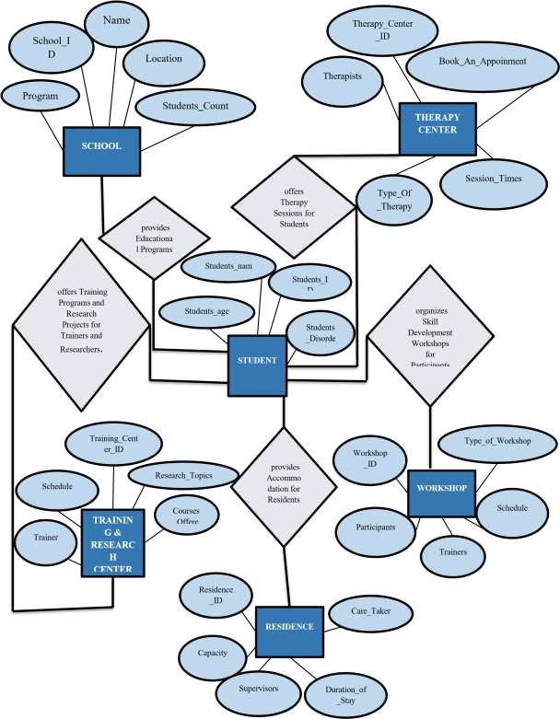

**Figure 1:** **ER Diagram**

**B. Database Schema Design**

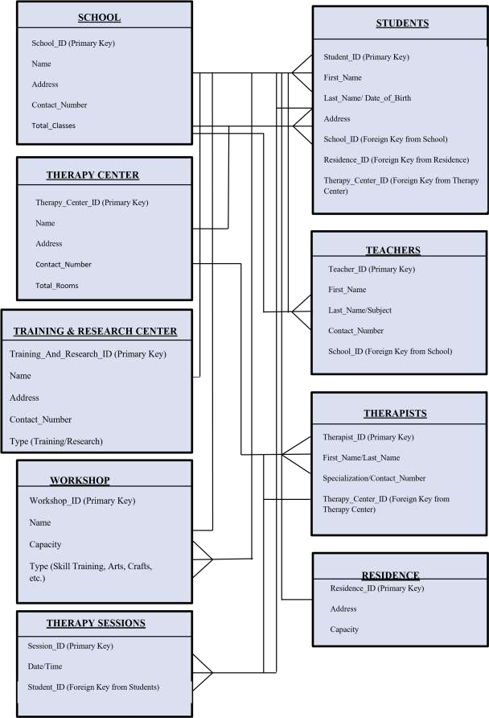

**Figure 2 Database Schema Design**

1. **RESULTS AND DISCUSSION**

The Spectrum Bridge Autism Center website effectively incorporates key functionalities like:

Admission System: Web-based application forms for convenient student admissions.

Donor Portal: Secure gateway for online donations.

Appointment Booking: Therapy and consultation session scheduling system.

Accessibility Features: Screen reader support, high contrast mode support, and simple navigation.

The usability and efficiency of the site were assessed through user testing. Caregivers' and professionals' feedback reflected an improvement in accessibility and efficiency in autism-related service management.

1. **CONCLUSION**

The creation of the Spectrum Bridge Autism Center website is a major milestone in using technology to support autism. The site provides convenience, effective communication, and protection of data. Future development can include chatbots fueled by artificial intelligence for supporting autism-related questions, telehealth services offered in real-time, and integration of mobile applications.

1. **REFERENCES**

[1] Section V Autism Spectrum Disorder, The_L.pdf

[2] India Autism Center, <https://www.indiaautismcenter.org/>

[3] Neuro Revolution International Autism and ADHD Treatment Center, [www.neurorevolution.com](http://www.neurorevolution.com)

[4] Home - Samarth Early Intervention Center (samarthautism.com)

[5] IEEE Standards for Web Accessibility, www.ieee.org/web-accessibility