COLLECTING ,REPRESENT ,PREDICATION OF DATA PROCESSING AND SUPERVISION TOOL FOR HFSS

# G PAVANI*1, Y URMILA*2, S POOJA*3, V S PAVAN KUMAR ASST.PROFESSOR*4, P VIJAYA ASST.PROF*5, A SIRISHA *6,T MADHU *7

SIMHADHRI EDUCATIOANL SOCIETY NARAPADU SABBAVRAM ANAKAPALLEFACULTY & STUDENTS

# ABSTRACT

In this thesis, we present an open-source graphical tool for automating the predication, Represent, computer reproduction, and supervision of several common collecting types in Ansys HFSS. This tool is Represent to boost the user-friendliness of scripting in Ansys HFSS for the batch creation of multiple projects and automatic optimization and Represent supervision via rules-based and machine learning techniques. Features and initial results for supervision are discussed.

**Keywords:**COLLECTOR,Represent,MachineLearning,Optimization,RulesEngine,AnsysHFSS.

# INTRODUCTION

For many scholars, hobbyists, and COLLECTING experts, the difficulty of COLLECTING creation is not the theoretical predication, but the CAD modeling and the recurrent manual editing needed to fine tune or optimize Represents. To automate specific tasks, Ansys, one of the most used computer reproductions software, allows for scripting in three major languages: VBScript, JavaScript, and Iron Python. However, the process of creating scripts can be as tedious as supervision HFSS Represents manually, or outright inaccessible for many. The aforementioned languages also do not integrate with several common, open-source machine learning libraries. The presented collecting predication and Auto supervision Tool (COLLECTING CAT) is a GUI-based tool that reduces the complexity of scripting Ansys HFSS by generating scripts for several Common COLLECTING Represents based on user input that can then either be imported into HFSS manually or automatically executed in HFSS via COLLECTING CAT for computer reproduction and Represent optimization.

# SOFTWAREREPRESENTANDFUNCTIONALITY

COLLECTING CAT is built on Python 3.9 and uses no HFSS specific integration libraries or APIs [1]. The GUI is created in wx Python (4.2.0), and all plots or 3D previews are visualized using Matplotlib (3.5.3). Automatic supervision uses either a custom rules engine or machine learning techniques supported by Keras (2.10.0). Current versions of COLLECTING CAT are available as open-source software from [2]. To boost the accessibility of this tool, COLLECTING CAT is developed using Ansys Electronic Desktop Student on a laptop with 32Gb RAM running Windows 10, and then transported for further testing on a desktop with commercial Ansys software. Navigation of the GUI is controlled by buttons on the sidebar.

## PREDICATION

PREDICATION of the initial collecting dimensions in collecting CAT use the collecting Calculator project from [3] imported as a package. The calculator currently supports quarter signal monopoles, half signal dipoles, and a rectangular patch with options for micro strip-fed or probe-fed Represents and is actively in evolution

## COLLECTING Represent

The Represent page, pictured in Fig. 1, takes user input for the type of COLLECTING, and then prompts for further related information. In the case of a rectangular patch COLLECTING, the user inputs the desired frequency, the substrate relative permittivity and height ,and the feed method.The collecting Calculatorin[3] will return values for width, length, Y0, X0, and the width of the strip if the Represent is strip-fed. A 3D representation of the collecting is generated in the bottom panel for preview. If using COLLECTING CAT for HFSS computer reproduction, the conductor material and substrate material are selected from the Ansys materials library. The relative permittivity will also be updated based on substrate selection if the values vary.

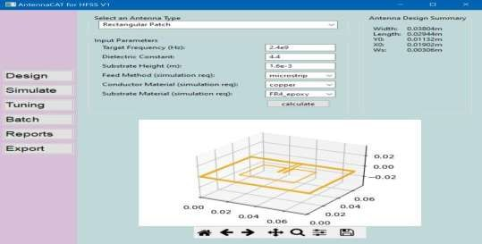

**Figure1:**TheinitialCOLLECTINGCATRepresentscreenforarectangularpatch

## Computer reproduction

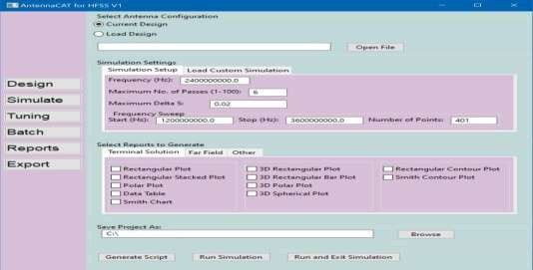The Computer Reproduction page, Fig 2., has configuration options for HFSS Expel computer reproductions, and report generation selections. Fields are automatically populated based on the input COLLECTING Represent from the Represent page, or earlier COLLECTING Represent can be loaded, in order to generate the Iron Python script, run by HFSS. A previously generated computer reproduction file can be loaded into the ‘Load Custom Computer reproduction’ tab. In the bottom panels, the user selects proclaim to be run during the computer reproduction. .The collecting computer reproduction script generated by this window includes both the 3D CAD model of the collecting and code to generate any selected proclaim.

**Figure2:**PageforcomputerreproductionsettingsandrunningtheHFSScomputerreproduction

## DATA PROCESSOR Supervision

Scripts generated by collecting CAT include parameterized values that can be programmatically controlled. The user has the option to select which values will be considered by the rules engine or used as inputs for any machine learning. Detected parameters can be set as constants, ranges, or lists of materials. To tune based on computer reproduction results, the initial COLLECTING Represent is simulated in HFSS, and then the report for the resonant frequency (Terminal Solution, Rectangular Plot) is compared to the target frequency. The rules-based engine will make adjustments and run several computer reproductions to gather data for Support Vector Machine

(SVM) supervision to be applied. Current metrics for Represent optimization, as pictured in Fig. 3, include frequency, return loss, and similarity to the ideal Q-factor.

## Batch Script and Project Creation

Similar to Supervision, the Batch page detects controllable parameters. The user selects desired combinations and COLLECTING CAT will either transport Iron Python scriptsforlater use or run scripts in a new HFSS project.

## Proclaim

Proclaim properly generated by HFSS during Supervision are imported into dynamically created Matplotlib graphs for resemblance purposes. These graphs can be saved as PNG files.

## Transports

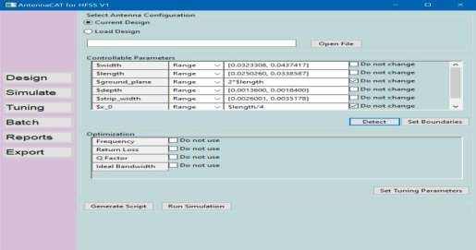TheCOLLECTINGCalculatorpackage[3]hasthecapabilitytotransportRepresentsas.dxf,.PNG,andasGerberfiles. COLLECTING CAT uses this functionality to transport Represents using simulated or tuned values.COLLECTING CAT can also transport any generated scripts created by the program and transport the report data into.csv files from any proclaim created in HFSS.

**Figure3:**Pageforsupervisionsettingsand runningtheHFSScomputerreproduction

## LoadingorCustomizingScripts

DuetothevariabilityofCOLLECTINGRepresent and computer reproduction,COLLECTING CATisRepresentwiththe abilityto importCOLLECTINGRepresentandcomputer reproductionfileswritteninIron Python.

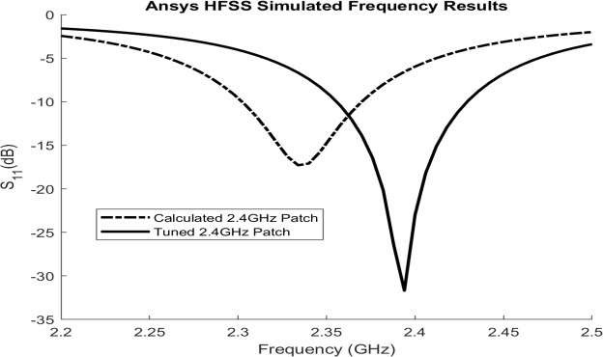Parameterizedvaluescanbedetectedandmodified programmatically even if they were notcreated in COLLECTING CAToriginally.

**Figure4:**S11forcalculatedandtunedrectangularpatchCOLLECTING

# SUPERVISIONRESULTS

Figure 4 shows a resemblance between a 2.4GHz strip line- fed rectangular patch COLLECTING as it was initially simulated and after 14 iterations using only a target of 2.4GHz resonance for supervision. The initial Collecting Represent achieved-17.29dB at 2.33GHz,while the tuned Collecting reached-31.68dBat 2.33GHzand22.98dBat2.4GHz.WewillpresentupdatedresultsforSVMbasedsupervisionandothertoolimprovements.

# REFERENCES

1. H. Wang, Q. Wu, C. Fan and X. Shi, "A Framework for DATA PROCESSOR FilterRepresent Software," 2018 International Conference on Micro signal andMillimeter Signal Technology (ICMMT), 2018, pp. 1-3, doi:10.1109/ICMMT.2018.8563652.
2. L.Linkous,(LC-Linkous)(2022)COLLECTINGCAT(Version2.0)[Sourcecode]
3. https://github.com/LC-Linkous/COLLECTINGPREDICATIONAutosupervisionTool

E.Karincic,(Dollarhyde)(2022)COLLECTINGCalculator(Version2.0)[sourcecode]. https://github.com/Dollarhy