**­EFFECT OF STACKING SEQUENCE ON THE MECHANICAL PROPERTIES OF RESIN TRANSFER MOULDED HYBRID RAMIE FLAX FIBER REINFORCED EPOXY ENHANCED WITH NANO SIO2 COMPOSITES.**

**Mr. P.V.V.S. Maneedra1,K.Nitheesh Kumar2, K.V Chandra Sekhar3, VN Mohan Kumar4, M.Syam Sundar5**

1,2,3,4,5Department of Mechanical Engineering, Godavari Institute of Engineering and Technology, Rajamundry, Andhra Pradesh, India.

**Abstract**

Over the past two decades, fiber-reinforced polymer composites have gained significant attention due to their excellent structural performance and lightweight nature. Extensive research has been conducted to evaluate the behavior of composite materials, focusing on factors such as fiber type, lamination sequence, matrix composition, and filler material inclusion. In this study, the effect of stacking sequence on the mechanical properties of hybrid ramie (R) and flax (F) fiber-reinforced epoxy composites enhanced with nano SiO₂ was investigated. Unlike previous studies that varied nano SiO₂ content, this research maintained a constant nano SiO₂ weight of 2.5 g and explored the impact of five different stacking sequences: RRFRR, RFRFR, FFRFF, FRFR, and RFFFR.

The composites were fabricated using the vacuum-assisted resin transfer molding (VARTM) technique, ensuring uniform fiber impregnation and resin distribution. Mechanical properties, including tensile strength, flexural strength, and interlaminar shear strength, were evaluated according to ASTM standards. The results demonstrated that stacking sequence played a crucial role in enhancing mechanical performance. Among the tested configurations, the RRFRR sequence exhibited the most favorable results, with a tensile strength of 41.308 MPa, flexural strength of 104.76 MPa, and interlaminar shear strength of 10.20 MPa. These findings provide valuable insights into the optimization of hybrid natural fiber-reinforced composites for structural and automotive applications.

# **1.Introduction**

The incorporation of natural fibers as reinforcement in composite materials has garnered substantial interest among researchers over the past two decades. Due to their favorable intrinsic properties, environmental benefits, and increasing industrial demand, bio-fiber composites are gaining popularity, particularly in the automotive industry. Factors such as enhanced fuel efficiency, regulatory requirements, and end-of-life recyclability are expected to further drive the adoption of bio-composites. Natural fibers such as ramie, flax, jute, sisal, and hemp have found applications in automotive components, including package trays, dashboards, seat backs, trunk liners, and door panels.

Despite their numerous advantages, the application of natural fibers in structural composites is limited by challenges such as high moisture absorption, low thermal stability, microbial degradation, insufficient fire resistance, variations in mechanical properties, and seasonal price fluctuations. Researchers have explored various methods, including hybridization, fiber surface treatment, fabrication techniques, and the incorporation of nano-fillers, to improve fiber-matrix adhesion and mechanical performance.

Several studies have been conducted to evaluate the mechanical properties of natural fiber-reinforced polymer composites. For instance, Huner et al. demonstrated that NaOH surface treatment of flax fibers enhances their mechanical and adhesion properties. Javanshour et al. investigated the effects of graphene oxide coating on flax-epoxy composites, reporting notable improvements in shear and transverse strength. Prabhakaran et al. explored the potential of natural fiber-based laminates to enhance acoustic and vibration damping properties, highlighting their advantages over conventional glass fiber composites. Similarly, Mohanavel et al. examined the reinforcement effects on hybrid composites using mechanical and thermogravimetric analysis, observing performance improvements in continuous fiber composites.

Additionally, Chaudary et al. highlighted the detrimental effect of moisture absorption on tensile and flexural strength in natural fiber composites, while Cavalcanti et al. demonstrated that variations in fiber treatment and hybridization techniques significantly enhance the mechanical behavior of intra-laminar hybrid composites. Furthermore, Jesuarockiam et al. investigated the thermal and dynamic mechanical properties of Kevlar/Cocos nucifera sheath (CS)/epoxy composites, emphasizing the potential of natural fillers in structural applications.

Previous studies on hybrid flax/ramie fiber epoxy composites have primarily focused on the impact of fiber surface treatment, filler content, and material hybridization on mechanical properties. However, limited research has been conducted on how stacking sequence variations affect mechanical performance. An in-depth understanding of fiber stacking sequence optimization is essential for advancing natural fiber-reinforced composites in structural and automotive applications.

In this study, the influence of stacking sequence on the mechanical behavior of ramie/flax fiber-reinforced epoxy composites enhanced with nano SiO₂ was examined. Unlike previous studies that varied nano SiO₂ content, this research maintained a constant nano SiO₂ weight of 2.5 g and analyzed the impact of five distinct stacking sequences (RRFRR, RFRFR, FFRFF, FRFR, and RFFFR) on tensile, flexural, and interlaminar shear strength. The composites were fabricated using the vacuum-assisted resin transfer molding (VARTM) process, and mechanical properties were evaluated following ASTM standards. The findings of this research will contribute to optimizing hybrid natural fiber composite structures and expanding their applicability in lightweight, high-performance engineering applications.

**2. Materials and Methods**

This section outlines the materials and fabrication methods used to prepare the composite laminates, which were pretreated with NaOH and fabricated with various stacking sequences: RRFRR, RFRFR, FFRFF, FRFR, and RFFFR. It also describes the procedures used to evaluate the mechanical properties of the laminates. The study examines five different stacking sequences of hybrid composites, which allowed for systematic testing of various configurations. This approach strikes a balance between comprehensiveness and feasibility, providing valuable insights into the design and optimization of hybrid composites.

2.1 Materials Used

Hybrid composites were synthesized using flax and ramie fibers as reinforcing agents, combined with an epoxy resin matrix. The fibers were pretreated with a NaOH solution to enhance their interaction with the matrix and improve moisture absorption. These raw materials, procured from Fiber Region, Chennai, are visually represented in Figures 1(a) and (b). The composition and physical properties of the flax and ramie fibers are provided in Tables 1 and 2, respectively.

2.2 Method of Fabrication

The hybrid composites were fabricated with different stacking sequences, including RRFRR, RFRFR, FFRFF, FRFR, and RFFFR. The vacuum-assisted resin transfer molding (VARTM) technique was employed for composite fabrication. Each composite laminate consisted of three layers of flax fiber (F) and two layers of ramie fiber (R).

The process used a 300 mm × 300 mm MS mold, and a matrix material blend of epoxy and hardener was prepared at a 10:1 weight ratio. Different stacking sequences were used for each laminate, and nano SiO₂ was incorporated in a fixed percentage of 2.5% into the matrix.

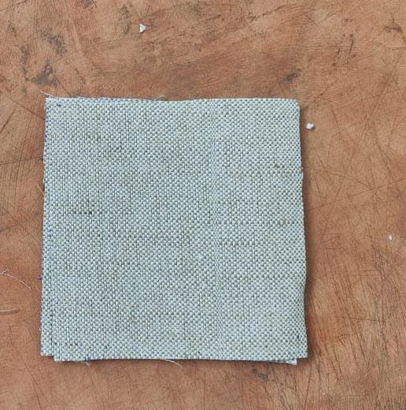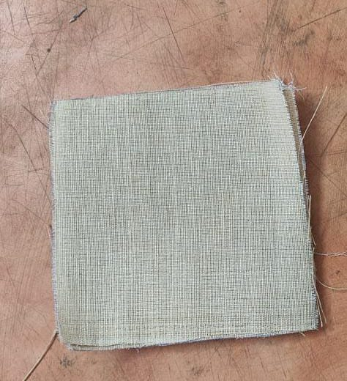

1. (b)

Figure 1. (a) Ramie fiber mat and (b) flax fiber mat

|  |  |  |
| --- | --- | --- |
|  |  |  |
|  |  |  |
|  |  |  |

|  |  |  |
| --- | --- | --- |
| Element | Flax fiber mat | Ramie fiber mat |
| Cellulose | 60–81 | 68.6–76.2 |
| Hemicellulose | 14–20.6 | 13–16.7 |
| Lignin | 2–3 | 0.6–1 |
| Pecting | 1.8–5 | 1.9–2 |
| Wax | 1.7 | — |
|  |  |  |

Table 1. Composition of Ramie and Flax Fibers

|  |  |  |  |
| --- | --- | --- | --- |
| Property | Flax Fiber Mat | Ramie Fiber Mat | Epoxy Resin |
| Density (g/cc) | 1.5–1.54 | 1.5–1.56 | 1.14–1.18 |
| Tensile Strength (MPa) | 345–1500 | 400–1000 | 68–80 |
| Youngs Modulus (GPa) | 27.6 | 27–128 | 2.9–3.2 |
| Elongation at Break (%) | 2.7–3.2 | 1.2–3.8 | 5–7 |

Table 2. Mechanical and Physical Properties of Flax and Ramie Fibers

The fabrication involved placing the fibers in the mold and applying a vacuum to draw resin into the dry fiber preform. A vacuum bag was placed over the fibers to remove air, creating a pressure differential to pull the resin through the fiber network. This process continued until complete saturation was achieved. After curing, the vacuum bag was removed, and the composite part was extracted from the mold.

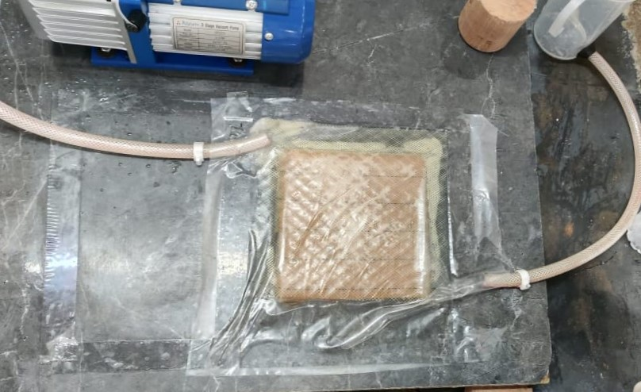

Figure 2. Vacuum-assisted resin transfer molding setup

|  |
| --- |
|  |
|  |
|  |
|  |
|  |

|  |
| --- |
|  |
|  |

|  |
| --- |
| Flax (F) |
| Ramie (R) |

Figure 3. Lamination sequence followed to fabricate the composite laminate

Prior to fabrication, the fibers were treated with a 5% wt. NaOH solution and dried for 24 hours. In all cases, the fiber orientation and sequence remained consistent, aligned along the longitudinal direction. The different stacking sequences employed during the fabrication process are shown in Figure 3.

The NaOH treatment enhances the ability of flax fibers to absorb moisture, improving the composites' water resistance. Additionally, the increase in nano SiO₂ content influences both the water absorption behavior and mechanical properties of the fiber composite. This is due to changes in stress distribution, crystallinity in the fibers, and interactions between nano SiO₂ and hydroxyl (-OH) groups in the natural fibers, which reduces their water affinity and enhances stiffness and toughness.

The detailed composition of the hybrid composites, along with the specific fiber content, is summarized in Table 3.

|  |  |  |  |  |
| --- | --- | --- | --- | --- |
| S. no. | Stacking  Sequence | % Weight of Flax | % Weight of Ramie | % Weight of Epoxy |
| 1 | RRFRR | 0.20 | 0.20 | 0.100 |
| 2 | RFRFR | 0.20 | 0.20 | 0.100 |
| 3 | FFRFF | 0.20 | 0.20 | 0.100 |
| 4 | FRFRF | 0.20 | 0.20 | 0.100 |
| 5 | RFFFR | 0.20 | 0.20 | 0.100 |

Table 3. The details of the fabricated hybrid composites

**2.3 TENSILE TEST**

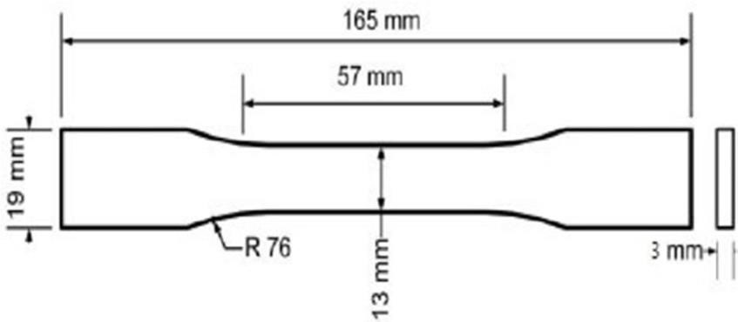 Tensile specimens were prepared following **ASTM D 638 guidelines**, as shown in **Figure 4**. The testing was conducted using a **Universal Testing Machine (UTM)** at Varchu Marc LLP Labs, Hyderabad. The load was applied in the longitudinal direction of the fibers with a loading rate of **10 mm/min.** A total of **five specimens** were tested for each sequence to ensure statistical relevance, and the average tensile strength values were recorded**.**

Figure 4. Tensile specimen as per ASTM D638

**2.4 FLEXURAL TEST**

The flexural properties were evaluated using the Universal Testing Machine (UTM), following ASTM D 790 standards for specimen preparation and testing, as depicted in Figure 5. The specimens were 130 mm in length and 12.7 mm in width, subjected to three-point bending with a span-to-depth ratio of 16:1. The test was conducted at a speed of 2 mm/min using a 10 kN load cell. For each sequence, five specimens were tested, and the average flexural strength was calculated.

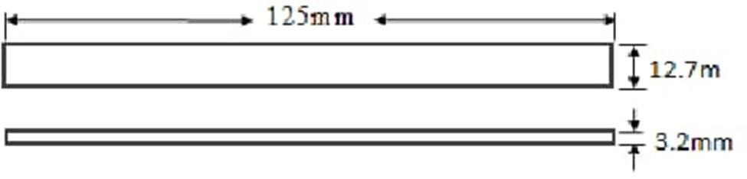

Figure 5. Flexural specimen as per ASTM D790

* 1. **SHORT BEAM STRENGTH TEST**

The interlaminar shear strength (ILSS) was measured using the **ASTM D2344-84** standard. Small beams (45 mm in length and square in cross-section) were prepared and subjected to three-point bending. The test was performed at a rate of **1.3 mm/min**. This method minimizes the effect of bending loads on the interlaminar shear failure, ensuring the cracking occurs along the horizontal plane between the composite layers.

**3. Results and Discussions**

In this section, the detailed results of the experiments were presented and dicussed.

**3.1 Tensile Strength**

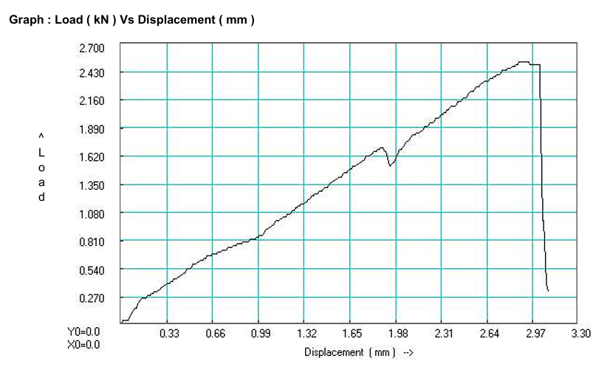The tensile strength of the specimens varied with different stacking sequences, showing significant differences across the configurations. For the sequence RRFRR, the tensile strength was measured at 41.308 MPa, while the sequence RFRFR showed a lower tensile strength of 16.744 MPa. The sequence FFRFF had a tensile strength of 24.434 MPa, while the FRFR sequence exhibited a strength of 31.556 MPa, and the RFFFR sequence achieved 28.984 MPa. These results suggest that the sequence RRFRR offered the highest tensile strength, indicating that the stacking sequence plays a critical role in determining the mechanical properties of the composite.

**3.2 Short Beam Strength**

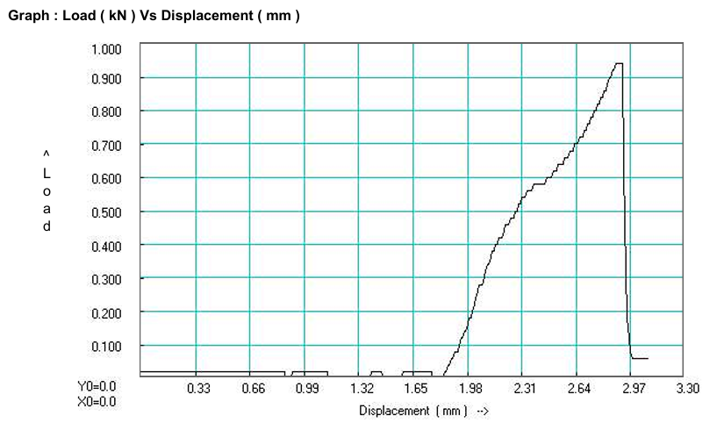 The short beam strength of the specimens with varying stacking sequences was evaluated to understand its effect on the interlaminar shear performance. The results indicate that the strength initially decreases with certain sequences. For the RRFRR sequence, the short beam strength was measured at 10.20 MPa, while the RFRFR sequence exhibited a strength of 9.52 MPa. The FFRFF sequence showed a value of 7.70 MPa, and the FRFR sequence had a lower value of 6.58 MPa. However, the RFFFR sequence showed an improvement to 8.65 MPa. These results suggest that while some stacking sequences contribute to higher shear strength, others may not perform as well, potentially due to fiber alignment and distribution within the matrix.

**3.3 Flexural Strength**

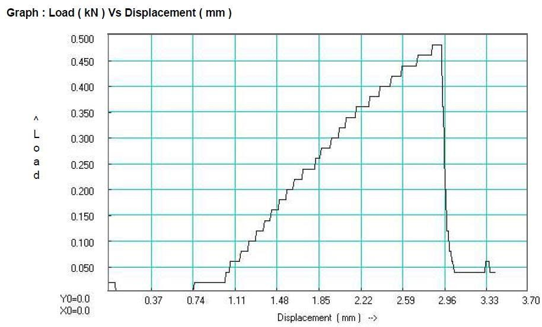 The flexural strength of the specimens varied across the different stacking sequences. The RRFRR sequence exhibited the highest flexural strength of 104.76 MPa, followed by RFRFR with 81.52 MPa, and FFRFF with 72.52 MPa. The FRFR sequence showed a flexural strength of 86.23 MPa, while the RFFFR sequence demonstrated a strength of 95.45 MPa. These results suggest that the RRFRR sequence provided the optimal flexural strength, highlighting the significant influence of stacking order on the bending performance of the hybrid composites.

­­­

**CONCLUSION**

* + - The current study investigates the mechanical and hygrothermal analysis of Ramie fiber and Flax fiber pretreated with NaOH solution mixed with Nano SiO2 reinforced epoxy hybrid composites utilizing VARTM.
    - The mechanical characteristics of Ramie and Flax fiber pretreated with NaOH solution mixed with Nano SiO2 reinforced epoxy hybrid composites, such as tensile strength, SBS and flexural strength, are based on a 50/50 weight ratio.
    - Hybrid composites with a 50/50 weight ratio have improved flexural, short beam strength and tensile characteristics.
    - The following conclusions are drawn:
    - The Tensile strength of 28.98 MPa was found in the RFFFR stacking sequence in Ramie and Flax hybrid composite, which is 17% higher than the 50:50 hand layup hybrid composite
    - The Short Beam Strength 9.31 Mpa was found at 0.5 % of Nano SiO2 in Ramie and Flax composite, which is 2.7 % higher than the 50:50 hand layup hybrid composite.
    - The Short Beam Strength of 10.20 MPa was found in the RRFRR stacking sequence in Ramie and Flax composite, which is 2.7% higher than the 50:50 hand layup hybrid composite.

**REFERENCES**

* + Gujjala R, Ojha S, Acharya S and Pal S 2013 Mechanical properties of woven jute glass hybrid-reinforced epoxy composite J. Compos. Mater. 48 3445–5
  + Ahmad F, ChoiHS and ParkMK2014 A review: natural fiber composites selection in view of mechanical, light weight, and economic properties Macromol. Mater. Eng. 300 10–24
  + HunerU2017 Effect of chemical surface treatment on flax-reinforced epoxy composite J. Nat. Fibers 15 808–21
  + Mohanavel V, Raja T, Yadav A, RavichandranMand Winczek J 2021 Evaluation of mechanical and thermal properties of jute and ramie reinforced epoxy-based hybrid composites J. Nat. Fibers 19 8022–32
  + Chaudhary V, Bajpai PKand Maheshwari S 2018 Effect of moisture absorption on the mechanical performance of natural fiber reinforced woven hybrid bio-composites J. Nat. Fibers 17 84–100
  + Kedari V R, Farah B I and Hsiao K 2011 Effects of vacuum pressure, inlet pressure, and mold temperature on the void content, volume fraction of polyester/e-glass fiber composites manufactured with VARTM process J. Compos. Mater. 0 1-16
  + Moudood A, Rahman A, Öchsner A, IslamMand FrancucciG2018 Flax fiber and its composites: an overview of water and moisture absorption impact on their performance J. Reinf. Plast. Compos. 38 323–39
  + Anil K C, Girisha K G and Sreenivas Rao K V 2015 Effect of fiber orientation on specific gravity, hardness and flexural strength and tensile property of jute/hemp hybrid laminate composite Appl. Mech. Mater. 766 75-78
  + Gholampour A. Hu RH, Sun M, young, Lim JK, (2010) Moisture absorption, tensile strength and microstructure evolution of short jute fiber/polylactide composite in hygrothermal environment. Mater Des 31:3167–3173Ozbakkaloglu T. A review of natural fiber composites: Properties, modification and processing techniques, characterization, applications. J. Mater. Sci. 2020;55:829–892.
  + attegazzore D, Alongi J, Duraccio D, Frache A (2018) All natural high-density fiber- and particleboards from hemp fibers or rice husk particles. J Polym Environ 26:1652 1660.
  + Chavhan GR, Wankhade LN (2020) Improvement of the mechanical properties of hybrid composites prepared by fibers, fiber-metals, and nano-filler particles—a review. Mater Today Proc 27:72–82.
  + Fiore V, Scalici T, Badagliacco D et al (2017) Aging resistance of bio-epoxy jute-basalt hybrid composites as novel multilayer structures for cladding. Compos Struct 160:1319–1328.
  + Jin P, Wang D, Tan X (2012) Review of hygrothermal effects on carbon fiber reinforced composite materials. Adv Mater Res 490–495:3611–3615.