The Evolution of Social Media Platform: An Analytical Perspective

**Dr. Kuldeep Kumar1 [**0009-0007-0423-7661**], Mrs. Poonam Devi 2 [**[0000-0002-3656-0654](https://orcid.org/0000-0002-3656-0654?lang=en)]

[**webkuldip@gmail.com**](mailto:webkuldip@gmail.com)**,** [**poonamsangwan11@gmail.com**](mailto:poonamsangwan11@gmail.com)

**1,2Assistant Professor, Chaudhary Devi Lal University, Sirsa**

***Abstract***: Social media platforms allow people to access information in real time, to connect with others, and to find niche communities. At its best, it makes the world more interconnected. On the other hand, social media is also very good at spreading information, creating polarization, and even causing harmful psychological effects. Social media have both positive and negative impact on society. Use of social media start from teenagers, overuse, of social media has raised questions about its effect on their physical and mental health. By “distracting them, disrupting their sleep, and exposing them to bullying, rumor spreading, unrealistic views of other people's lives, and peer pressure.” The data collected from 60 students of our department, where 73% of people use social media for entertainment, 83% use YouTube and Instagarm, 73 % use social media videos etc. Nowadays social media is also used by people for their source of income, 17% people agreed with this statement.

**Keywords:** Social Media, Social Network, Face book, Twitter

1. **Introduction:** Social media platforms are often divided into six categories: social networking, social bookmarking, social news, media sharing, micro blogging, and online forums. These diverse platforms serve a vast range of purposes and user interests [1]. Some appeal to hobbyists, others to people in their work lives. People use them to find others across the globe who share their political or other views. Entertainers use social media to engage with fans, politicians with voters, charities with donors [2]. Governments often use social media to convey vital information during emergencies for businesses, social media has become key marketing tool [5]. According to a 2019 survey by Pew Research Center, people's use of social media is correlated with having more friends and more diverse personal networks, especially within emerging economies. Some 80% of teenagers say social media allows them to feel more connected to their peers, according to 2022 Pew Research Center survey of U.S. teens ages 13 to 17 [3]. Companies use it to find and engage with customers, drive sales through advertising and promotion, identify fast-moving consumer trends, provide customer service, or support, and collect data on users, sometimes surreptitiously. Percentage of internet users aged 16 to 64 who visited a social networking site in the past month [6].

Social media are web-based services where people can generate, publish, and comment on content and engage with one another. These social media services include Facebook, Instagram, Twitter, TikTok, LinkedIn, and YouTube and have changed communication as well as how information is accessed, represented, and relationship constructed. Social media may come in many formats, such as text updates, images, videos, live streams, among others, making it easy for individuals to carry on live conversations, share individual experiences, or advertise ideas and businesses[7].

With over a billion active users globally, social media is now an indispensable platform for people, businesses, organizations, and personalities to connect with a worldwide audience. It also helps shape culture, public opinion, and serves as a platform for activism, entertainment, and education. Social media also presents some challenges, including misinformation, privacy invasion, and mental health effects, which makes it necessary for users to use these platforms critically[8].

1. **Literature Review:**

**(**Ates Bayazıt Hayta)in their research paper ― A study on the effects of social media on young consumers' buying behaviors determines the effects of social media networks on purchasing behaviors of young consumers. The study results indicate that social media tools directly affect the purchasing behaviors of consumer, depending upon their age group and educational status.

(Benjamin Ach)in their bachelor thesis highlighted the evolution of the marketing strategies of businesses and more specifically of their communication strategies, with the important rise of social media influence, which is changing the way people get informed as well as their purchasing decision process. This research under lined the fact that businesses, small or big sized, have to get online and to use social media and to adapt their business models if they want to stay on top of the competition on their markets. There search is supported by a case study of an Australian internet marketing company, in order to get valuable insights from internet marketing experts.

(Robert V. Kozinets, Kristine de Valck, Andrea C. Wojnicki and Sarah J. S. Wilner)reviewed and synthesized extant WOM theory. This article shows how marketers employing social media marketing methods face a situation of networked coproduction of narratives. It then presents a study of a marketing campaign in which mobile phones were seeded with prominent bloggers. Eighty- three blogs were followed for six months. The findings indicate that this network of communications offers four social media communication strategies—evaluation

(Embracing, endorsement), and explanation. Each is influenced by character narrative, communications forum, communal norms, and the nature of the marketing promotion. This new narrative model shows that communal WOM does not simply increase or amplify marketing messages; rather, marketing messages and meanings are systematically altered in the process of embedding them. The theory has definite, pragmatic implications for how marketers should plan, target, and leverage WOM and how scholars should understand WOM in a networked world.

(Hensel and Deis)have recommended that marketers must consider all possible avenues to positively use social media to increase advertising and improve marketing. Before implementing a specific social media strategy, the benefits, drawbacks, and challenges associated with it must be addressed.Thestrategymustassistinfacilitatingthesocialmediainputsanddiscussions.Inaddition, social media strategies should also be used to track a business.

(Edelman) in a study for Harvard Business Review, The Internet-based social media has made it possible for one person to communicate with hundreds or even thousands of other people about products and the companies that provide them on web. Thus, the impact of consumer to consumer communications has been greatly increased.

1. **Data Collection:** In this study we collect the data from our local area. My study is about the how people earn from the social media. We collect the data for make questionnaire. We spread this questionnaire to all friend circles and send to our colleagues. With the help of questionnaire, we know view of peoples regarding social media earning or revenue. In the questionnaire we ask from people from how many years you earn, which type of social media handle you used, which benefits of social media handles, which type of video, images you like to post, which type of post you watch more, and what suggestion you give to the other peoples.
2. **Research Methodology**

This study will examine the social media use patterns among students in terms of frequency, preferred platform, reasons for using social media, and its likely impact on their academic achievement, mental health, and social life. This will be accomplished through a primary dataset gathered from students to get insight into their behaviors and experiences related to social media.

a). **Research Design**

The research will employ a quantitative research design to systematically analyze data and draw out patterns of social media use. A cross-sectional survey strategy will be used, enabling data to be collected at one point in time across the population.

b). **Study Population**

The population to be targeted in this study will include students taking courses in higher learning institutions, both undergraduates and postgraduates. The sample will be drawn from a range of disciplines to promote diversity in age, gender, as well as areas of study.

c). **Sampling Technique**

Stratified random sampling will be employed so that the sample represents the student population. Stratification will be according to gender, age group, and discipline of study to control for any possible demographic differences in social media use.

Inclusion Criteria: Currently enrolled students in a degree program at a recognized institution with an age of 18 years or more.

Exclusion Criteria: Students who do not access social media websites or who are not interested in participating in the study.

60 students will be targeted as the sample size to ensure statistical significance and reliability of the results.

1. **Survey on social media:** This survey talks about the age ranges of individuals utilizing social media for various reasons, the number of individuals making a living from social media, the form of social media utilized for time consumption, and the forms of posts made on social media.

**Age group of people:** Table 1 represent the different age group of people to which we contact in our survey report. Where most people are from age group 18-24, and maximum are from age group 20-22.

|  |  |
| --- | --- |
| **Age group** | **No. of People** |
| 18-20 | 12 |
| 20-22 | 19 |
| 22-24 | 13 |
| 24-26 | 7 |
| 26-28 | 2 |
| 28-30 | 3 |
| Above | 4 |

Table : 1

**Social media platform in use regularly:** Table 2 represents the data number of people using different social media platform. Where we find that majority of people are using YouTube and Instagram.

|  |  |
| --- | --- |
| **Social media use by people** | **No .of people Using** |
| Facebook | 14 |
| Twitter | 6 |
| Instagram | 44 |
| YouTube | 49 |
| Snapchat | 27 |
| Other | 11 |

Table : 2

**Purpose of using Social Media:** Table 3 represent the purpose of people why they are using social media, where we find that majority of people are using social media for their entertainment.

|  |  |
| --- | --- |
| **Social media Use for** | **No. Of People** |
| Shopping | 20 |
| Keep in touch with Friends | 33 |
| Earning | 10 |
| Learning | 39 |
| Entertainment | 44 |
| Other | 1 |

Table: 3

**Social Media a Source of Income or not:** Table 4 represents that out of our survey who many people are agree that social media is a source of income or not, where we find that majority of people says that it is not a source of income.

|  |  |
| --- | --- |
| **Earn from social media** | **No. of peoples** |
| YES | 11 |
| NO | 49 |

Table 4

**Type of content prefers to see on social media:** Table 5 represent which type of content people prefer to watch or see on social media, where out of survey data we find that majority of people prefer to watch videos.

|  |  |
| --- | --- |
| **Preference of seeking on social**  **Media** | **No. of peoples** |
| Text Books | 25 |
| Image | 22 |
| Video | 44 |
| Memes | 28 |
| Music | 1 |
| Others | 5 |

Table 5

Analysis: In the above tables, what type of content preference seeing in the social media textbooks prefer by the 25 peoples image prefer by the 22 peoples videos prefer by the 44 peoples memes prefer by the 28 peoples and music prefer by the 1 and other prefer by the 5 peoples.

**People like to Post Videos:** Table 6 represents which type of videos people like to post, where out of our survey we find that majority of people like to post emotional, funny and technology related videos.

|  |  |
| --- | --- |
| **People Like Videos** | **No. of people** |
| Funny | 34 |
| Educational | 38 |
| Trendy | 24 |
| Sports | 18 |
| Technology | 35 |
| Other | 10 |

Table 6

**Age group which use maximum social media:** Table 7 represent the different age groups which use maximum social media, where we fine that the kids less than one year are watching maximum social media videos.

|  |  |
| --- | --- |
| **Time of use on Social Media** | **No. of People** |
| Less than one year | 24 |
| 1-2 year | 10 |
| 2-5year | 7 |
| More than 5year | 8 |
| Other | 18 |

Table 7

Analysis: In the above graph represent the from which time people earn from the social media, less than one year 24, between 1-2 year 10 , between 2-5 year 7 , more than five year 8 other not earn from social media.

**Factor effecting social media monetization:**  Table 8 represent the multiple factors which effect social media monetization and how much which factor effect it. In our survey data we find that sponsored content highly effecting the monetization of social media.

|  |  |
| --- | --- |
| **Monetize Social Media** | **No. of people** |
| Sponsored Content | 32 |
| Affiliate marketing | 13 |
| Selling product | 16 |
| Paid Membership | 14 |
| Other | 10 |

Table: 8

**6. Results:**

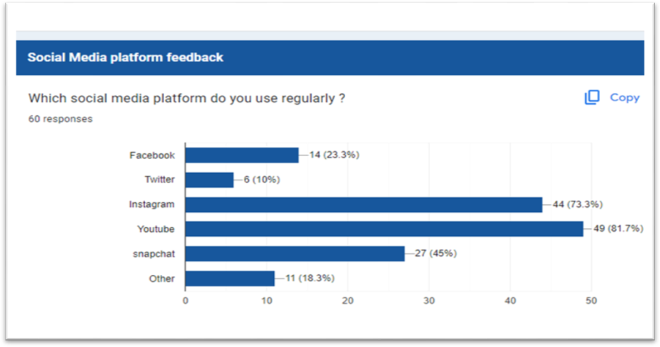

**Figure: 1**

Interpretation of table 2: In the above graph count the number of the social media used by the peoples like snapchat used by 27 persons, YouTube used by 49, instagram used by 44,twitter used by 6 , Facebook used by 14 all the ratio collect from multiple use of social media at a time and other is 11 .

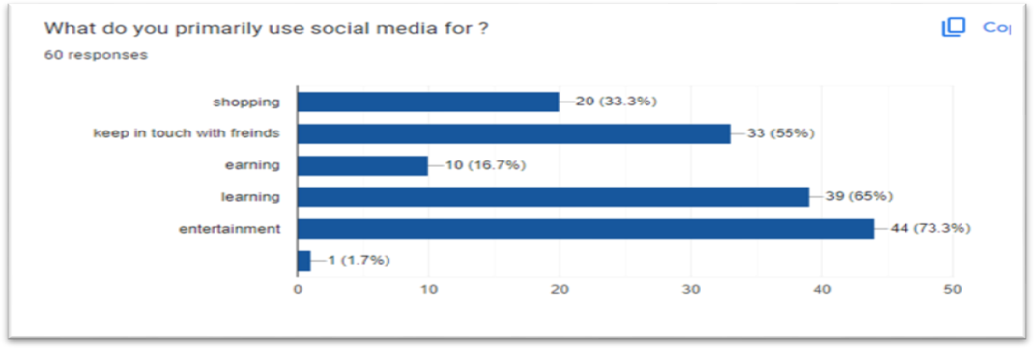

**Figure: 2**

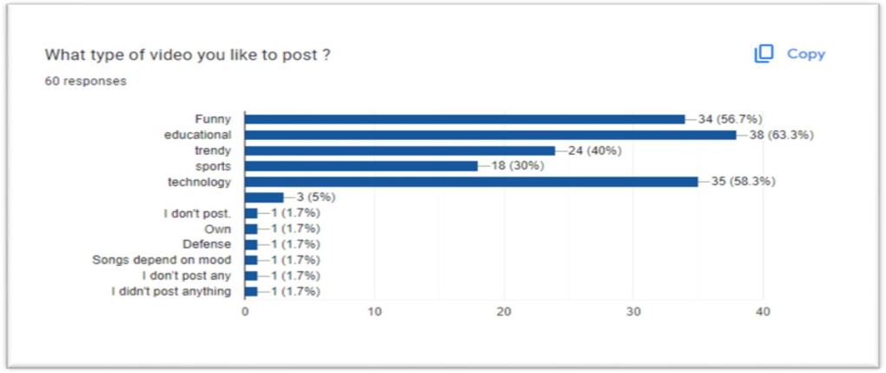Interpretation of table 3**:** In the below graph represent the social media used by the persons for which purpose. In the person s used for shopping 20keep in touch with friends 33 for earning 10 for learning 39 for entertainment 44 and other 1.

**Figure: 3**

Interpretation of table 6: In the above graph represent what type of video people like to post funny like by the34 peoples, sports like by the 18 peoples, technology like by the 35 peoples, and other.

7. **Conclusion**: Different research papers discussed above shows how social media is slowly becoming an important marketing tool offering different organizations opportunity to engage with their markets and to learn about customer’s needs, important segments, and profile. However, the implications are that this is an uncontrolled environment and therefore it requires a robust social media strategy that also manages the comments posted by consumers whether positive or negative. As these social network sites can pose a threat as well as an opportunity to companies by rapidly spreading the views of dissatisfied customer’s comments.

**8. Future scope:** The future of social media earning platforms is likely to evolve significantly, driven by technological advancements, user behavior shifts, and regulatory developments. Here are some key trends and potential scopes for social media earning platforms: Decentralization and Blockchain Integration, Creator Economy Expansion, Niche and Specialized Platforms, Virtual and Augmented Reality, AI and Personalization. Overall, the future of social media earning platforms is likely to be shaped by advancements in technology, changing user preferences, regulatory landscapes, and the ongoing evolution of the creator economy. Platforms that successfully innovate and adapt to these trends will be well-positioned to capitalize on the growing demand for digital content monetization and user engagement.

**References:**

1. Ates Bayazit Hayta (2013). A Study on the Effects of Social Media on Young Consumers‟ Buying Behaviors‟. European Journal of Research on Education, Special Issue: HRM, pp 65 -74
2. Barefoot, D., & Szabo, J. (2010)‟ Friends With Benefits: A Social Media Marketing Handbook,‟ San Francisco: No Starch Press
3. Benjamin Ach, “The current development and trends of social media marketing strategies for businesses-Case study on an internet marketing company” Lead Creation"(2013),Turku university of applied sciences thesis, bachelor thesis, degree program, international business.
4. Brendan James Keegan, Jennifer Rowley, (2017) "Evaluation and decision making in social media marketing", Management Decision, Vol. 55 Issue: 1, pp.15-31, https://doi.org/10.1108/MD-10-2015- 0450.
5. BusinessWeek(2009) Beware Social Media Snake Oil,[Online], Available at :<http://scaledinnovation.com/innovation/publications/2009-12-busweek.pdf>[10May2014]
6. Edelman, D.C. (2010) Branding in the digital age: You're spending your money in all the wrong places,HarvardBusinessReview,[Online],Available:<http://hbr.org/2010/12/branding-in-the-digital-age-youre-spending-your-money-in-all-the-wrong-places/ar/1> [15 May 2014]
7. Gil R. B., Andres E F. & Salinas E. M. (2007). Family as a source of consumer-based brand equity. Journal of Product and Brand Management, 16, 188-199.
8. Hensel K and Deis M H (2010), ―Using Social Media to Increase Advertising and Improve Marketing‖, The Entrepreneurial Executive, Vol.15, Available at: <http://www.freepatentsonline.com/article/Entrepreneurial-> Executive/243043185.html, accessed on20 April 2012.
9. Lazer,W.,Kelley,E.J.(2013).SocialMarketing:PerspectivesandViewpoints.Homewood:RichardD. Irwin
10. Lempert,P.(2006).CaughtintheWeb.ProgressiveGrocer,85(12), 18 Mangold W Gand Faulds DJ (2009), "SocialMedia:TheNewHybridElementofthePromotion Mix", Business Horizons, Vol. 52, No. 4, pp 357-365