**Balancing Innovation and Security: Data Privacy Challenges in Open Banking and API-Driven Financial Services**

**Rakesh Kopperapu**

**Cognizant Technology Solutions U.S. Corporation**

**Abstract**

This study examines the impact of API-based financial services and open banking on market competition, customer trust, and data privacy, highlighting key challenges such as compliance complexities, unauthorized access, and data breaches. The research explores cybersecurity threats, regulatory requirements, and technological advancements influencing data security. Mitigation measures, such as regulatory frameworks and technological safeguards, are analysed to improve security while fostering innovation. Findings show that improving API security, authentication protocols, and regulatory compliance is critical for a secure open banking ecosystem. A balance between innovation and security measures will improve consumer trust and facilitate the sustainable growth of digital financial services.

**Keywords**: *Application Programming Interface (API), Payment Services Directive (PSD2), General Data Protection Regulation (GDPR).*

# INTRODUCTION

API technologies and open banking systems enhance customer experience and build customers' trust in FinTech (financial technology). Open banking and API technologies increase the rapid evaluation of financial services. The open banking process assists customers in sharing financial services by providing secure APIs and enabling innovative services including seamless payments and personalised financial management [1]. The effective integration of API-driven financial services and open banking increases security and data privacy concerns. Third-party providers are allowed to manage the open banking services and it enhances the risk of cyber threats, data breaches, and unauthorised access. In 2020, the number of open banking users in Europe was 12.2 million and it has been forecasted that the number of open banking users will be 63.8 million in 2024 [2]. Revised payment services directives and general data protection regulations are required to be followed to handle sensitive data in balancing the innovation process with security. Data privacy issues increase in open banking systems as the banking system allows unauthorised users. Therefore, sensitive data of the customers can affect the quality of the services and damage the reputation of the open banking system. Relevant mitigation strategies are required to be implemented to improve the customer experience and reduce the risk of cyber threats.

**Aim**

The main aim of the research is to explore the data privacy issues associated with API-driven financial services and open banking while analysing strategies to balance security and innovation.

**Objectives**

* To explore the impact of API-driven financial services and open banking on market competition, customer trust, and data privacy
* To explain the effective factors influencing data security and privacy in open banking including cybersecurity threats, regulatory requirements, and technological advancements
* To address major data privacy issues associated with open banking and API-driven financial services including compliance complexities, data breaches, third-party risks, and unauthorised access
* To determine relevant mitigation strategies based on technological safeguards and regulatory frameworks for improving innovative and secure open banking ecosystem

# RESEARCH RATIONALE

Increasing API-driven financial services and open banking has improved the customer experience in the financial sector. The open banking service allows third-party and it increases the risk of data privacy. The main reason for the issue is to maintain a balance by managing innovation and security measures. The prime aim of the research paper is to determine the key risks and explore the relevant mitigation strategies for providing secure API frameworks and maintaining an innovative financial ecosystem.

# LITERATURE REVIEW

***Exploring the impact of open banking and API technologies on data privacy and customer trust***

Open banking services and API technologies in financial services can enhance customer trust and data privacy. Open banking system promotes competition by assisting third-party providers in managing financial services. The effective benefits of API integration in the finance sector help in providing real-time access to financial data [3]. Hence, the relevant API services have decreased the monopoly of the established financial sectors by introducing innovative products. Open banking services can improve service efficiency, enhance competition, and decrease costs for customers. Effective regulatory compliance and resources can improve the quality of financial services and create a positive impact on market competition. Customer trust plays a vital factor in managing open banking services and customer confidence depends on transparency, data security, and regulatory protection. Open banking helps businesses provide financial data that can improve business practices [4]. Innovative methods such as encryption and secure API designs can decrease risks in the financial sector. Payment Services Directive (PSD2) focuses on effective innovation that allows for enhancing payment safety, as well as consumer protection [5]. Hence, open banking services create a positive impact on enhancing customer trust, market competition, and data privacy in financial services.

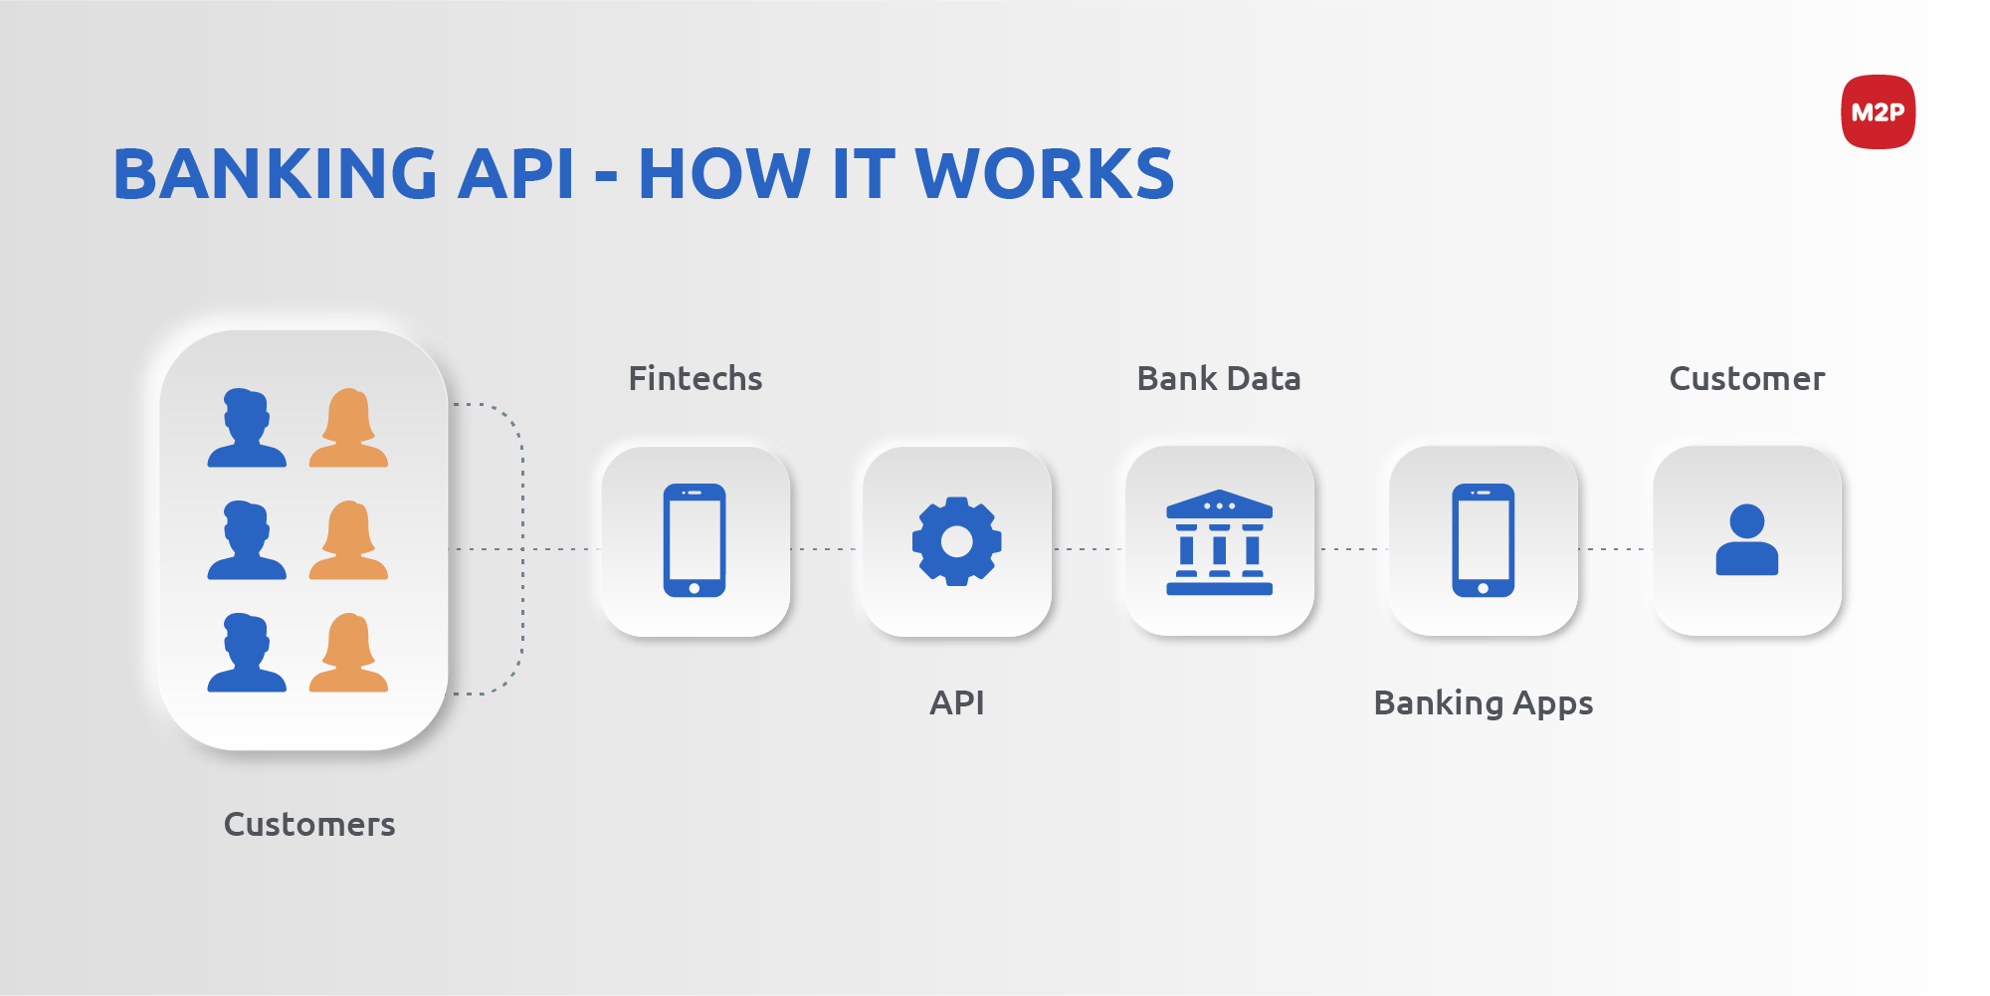

**Fig 1: Function process of banking API**

***Explaining the key factors influencing data privacy and security in open banking***

Several key factors including regulatory requirements, technological advancements, and cybersecurity threats influence data security and privacy of the financial data in open banking. API-driven technology in open banking can enhance the risks of cyberattacks. In this case, API vulnerabilities like broken access control, inadequate encryption, and weak authentication expose the financial data of open banking to fraud and data breaches [6]. Thus, API vulnerabilities affect the financial services of the open banking system and decrease data privacy. Cybercriminals or hackers can easily exploit weak API security configurations and in this case, effective penetration testing and security monitoring can decrease the risk of cyber-attacks. Relevant regulations play a vital role in decreasing the data privacy issues in open banking and financial services. Emerging technological advancements are required to be implemented to increase data security in financial services. Blockchain-based identity verification, advanced encryption methods, and AI-driven fraud detection can be implemented to manage financial data and improve the service quality of the open banking system [7]. Hence, multi-factor authentication can be implemented in financial services to decrease the risk of unauthorized access.

***Addressing the data privacy issues associated with API-driven financial services and open banking***

Open banking and API-driven technology increase data privacy concerns and improve the operational activities of the financial sector. In this case, different issues such as data breaches, unauthorised access, compliance complexities, and third-party risks affect the data security of financial firms. In open banking services, financial data is shared across several platforms, and it enhances the data breach issues of the financial services. Misconfiguration of access controls, weak encryption, and ineffective API security assist hackers in exploiting the financial and sensitive data of the customers in financial services [8]. Financial fraud in open banking affects the reputation of the banking services and FinTech firms. Compliance complexity in open banking decreased the operational activities and increased the operational difficulties. In Europe, the Payment Services Directive (PSD2) allows for maintaining consumer consent and data protection policies [9]. On the other hand, differences in global regulations can create issues in financial firms operating in several jurisdictions. Evolving effective legal requirements and compliance costs add to operational difficulties. Third parties can handle the stored and sensitive data of the customers from the open banking services and the issue affects the financial services. Insufficient user verification and poor authentication processes in the open banking system can increase risks regarding data privacy.

|  |  |
| --- | --- |
| **Issue** | **Impact** |
| Compliance complexities | Increased operational costs, legal risks, and regulatory penalties |
| Data breaches | Financial fraud, identity theft, and loss of consumer trust |
| Third-Party risks | Unauthorized data sharing, security vulnerabilities, and data misuse |
| Unauthorized access | Account takeovers, fraudulent transactions, and privacy violations |

**Table 1: Determining the impact of data privacy issues**

***Evaluating effective mitigation strategies based on regulatory frameworks and technological safeguards to enhance security and innovation of the open banking ecosystem***

The issues in the open banking system are required to be mitigated by implementing relevant strategies that can improve innovation and security of the open banking ecosystem. Secure API development plays a significant role in protecting data against unauthorised access and data breaches [10]. Implementation of OpenID and OAuth 2.0 can develop identity verification, as well as multi-factor authentication can be used to decrease unauthorised risks of financial services. Tamper-proof data sharing and decentralised identity management can mitigate the issues of open banking services. AI-driven fraud detection methods can be used to observe the suspicious activities and transaction patterns of customers in API-driven financial services. Zero-trust security model can be used to decrease data breach issues and reduce unauthorised access to sensitive data [11]. Hence, effective mitigation strategies based on technological advancements can increase innovation and data security in the open banking ecosystem. Moreover, PSD2 and GDPR can decrease the issues of financial services based on unauthorised transactions. Therefore, the issues regarding data security and privacy can be solved by implementing effective relevant strategies that can enhance financial services.

***Literature gap***

Existing literature focused on the impact of open banking and API-driven financial services on data privacy and data security. API-driven technology in the finance sector can easily provide secure service in enhancing customer trust [4]. The main gap in the literature is not focused on the mitigation strategies that improve innovation and security practices of the open banking ecosystem. Hence, the research paper explored the relevant mitigation strategies regarding the technological safeguards and regulatory frameworks.

# METHODOLOGY

Research methodology is an effective process to analyse the data privacy issues in API-driven financial services and open banking. ***Interpretivism*** philosophy was selected to analyse the impact of open banking services on enhancing data privacy and customer trust. Interpretivism philosophy can easily understand the meanings and subjective experiences regarding the research topic [12]. Hence, the effective research philosophy provided contextual depth and explored the impact of open banking services. ***Deductive approach*** was implemented to gather information based on the data security and privacy of the open banking system. Deductive approach in the research paper assists in providing a logical and structured way to explain the relationship between the variables [13]. Thus, the deductive approach evaluated the relationship between the innovation and data privacy risks in open banking services. However, the inductive approach has not been selected as the research approach takes more time to explore the impact of open banking and the approach provides complex findings that are difficult to interpret. The ***Mono method*** helps in evaluating the impact of financial services on data privacy and customer trust. The Mono method in this research paper is applied to maintain the clarity of the research outcome by focusing on open banking services and API technologies. However, the mixed method in this research is not implemented as it takes more time to analyse the impact of open services in financial services and delivers complex outcomes regarding the research topic.

***Secondary data collection*** is selected to improve the quality of the research and address data privacy challenges based on data breaches and third-party access. The data collection method increases understanding based on open banking and API-driven financial services and easily addresses deficiencies in the collected data. The main advantage of the secondary data collection process is to enhance the transparency of the research process and provide effective outcomes regarding the research findings [14]. A qualitative strategy has been used to determine the mitigation strategies regarding the issues associated with API technologies and open banking. Qualitative strategy provides a rich and deep understanding of the research topic and explores the complex issues of the research findings [15]. Hence, an effective strategy can easily provide the relevant conclusions of the research by understanding the goals. ***Thematic data*** analysis technique is used for understanding information regarding open banking and API-driven financial services by addressing key themes. In this research paper, 8 relevant themes are required to be selected to explain the impact of open banking and API-driven financial services by balancing innovation and security practices.

# DATA ANALYSIS

***Theme 1: The impact of open banking and API-driven financial services on data privacy, customer data, and market competition is shaped by cybersecurity challenges and innovation-driven competition, requiring a balance between data protection and technological advancements.***

Open banking services enhance competition by enabling third-party providers to improve innovative financial products. Financial technology firms can improve operational activities by managing transaction costs and enhancing service efficiency [16]. Innovation methods in financial services can provide transaction services by managing the secure operation. The application of APIs in financial services can manage business operations and increase data security and privacy of financial data. Customer trust is an effective factor in API-driven financial services. In open banking, customers are not free to share the financial data of the customers due to data privacy concerns. Regulatory enforcement like PSD2 and GDPR has enhanced customer trust and transparency of open banking services. On the other hand, innovation in financial services can enhance risks regarding API vulnerabilities and third-party risks affecting business practices [17]. Cybersecurity issues in open banking services decrease functional and operational activities. Hence, API-driven financial services can solve cybersecurity issues and make decisions regarding financial services.

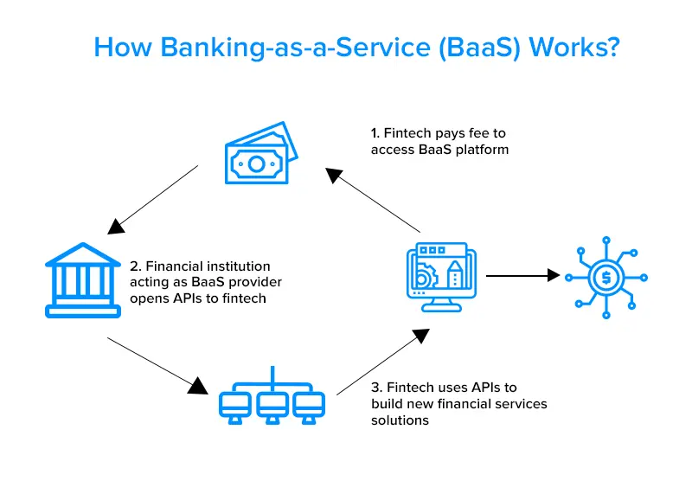

**Fig 2: Banking service based on API**

***Theme 2: Technological advancements, Cybersecurity Threats, and regulatory requirements in open banking are the key factors that can increase safety of the financial data.***

Cybersecurity threats in open banking services can affect operational efficiency and reduce the quality of financial services. Malware, phishing attacks, and API vulnerabilities in financial services affect operational efficiency and increase the misuse of financial data [18]. Appropriate API authentication is required to be followed to increase data security and enhance the operational activities of the open banking services. Identity theft and financial fraud of API-driven financial services increase the cybersecurity threats and affect operational difficulties. Technological advancements can be used in the open banking process to measure security in financial services. Financial data regulations can impact data privacy and security to manage financial services [19]. Secure and reliable factors can improve data security, as well as privacy of the financial services. The relevant factors such as the implementation of regulatory requirements, technological advancements, and cybersecurity threats can enhance the safety measurement of financial services. Hence, emerging technologies can maintain the shape of data privacy and security in open banking financial services.

***Theme 3: Compliance complexities, unauthorised access, and data breach issues affect the financial data of API-driven financial services and open banking.***

Unauthorized access is another primary issue for API-based financial services. Insecure API security, weak authentication protocols, and social engineering assaults are accountable for data breaches and financial fraud. Improper access controls, as well as the implementation of ineffective OAuth authentication, expose sensitive financial data to hackers (cyber attackers). Unauthorized access frequently leads to identity theft, fraudulent activity, and significant financial loss for consumers [20]. API weakness increases the data breach issues and hackers can collect sensitive information of the customers, login credentials, or credit card information. Therefore, the issues with financial services can increase the vulnerabilities and affect the reputation, as well as customer trust. Increasing access to third parties, inadequate encryption methods, and insecure data-sharing mechanisms enhance the risk of leaking financial data.

The expansion of API-based financial services and open banking has introduced serious challenges in the form of compliance complexity, unauthorized access, and data breaches that impact financial institutions, third-party providers (TPPs), and consumers. These issues challenge data security, regulatory compliance, and consumer trust in digital financial services. Regulatory compliance in open banking is fragmented across different jurisdictions, and it is difficult for financial institutions to provide consistent data protection standards [21]. Several regulations like GDPR (Europe), PSD2, CCPA (U.S.), and CDR (Australia) allow for managing the security control in financial services; however, variations in compliance regulations enhance the operational issues in FinTech firms and banks in several regions. Hence, ineffective compliance regulation in financial services increases the chance of reputation loss and customer trust.

***Theme 4: Mitigation strategies such as regulatory frameworks and technological safeguards have been implemented to improve secure and innovative operations in the open banking ecosystem.***

The implementation of mitigation measures, including regulatory regimes and technology safeguards, plays a key role in enabling safe and innovative operations in the open banking environment. Enhancing the API-based services on Open banking allows for providing effective security against third-party providers for protecting customer data and the service can increase customer trust [22]. Regulatory regimes have been implemented globally to address data security and privacy concerns in open banking. GDPR (Europe), PSD2 (Europe), CCPA (U.S.), and CDR (Australia) are some of the key regulations that impose strict data protection policies, consumer consent, and secure authentication procedures. These regimes ensure that financial institutions implement strong customer authentication (SCA), data-sharing transparency, and risk management policies. Studies confirm that financial institutions that comply with these regulations suffer fewer data breaches and enjoy higher consumer confidence. Compliance, however, remains an issue due to jurisdictional differences and evolving regulatory expectations.

Technology protections also increase the security of open banking by minimizing threats of unauthorized access, API weaknesses, and data breaches. Secure API-driven technology through the adoption of connecting OpenID, OAuth 2.0, as well as a strong data encryption method, allows for decreasing the access of unauthorised users and enhancing user authentication [23]. AI-driven fraud detection technology and multi-factor authentication can gather real-time detection based on financial data and block suspicious activities in financial services, as well as decrease the fraudulent risks in financial services.  Additionally, blockchain-based identity authentication offers tamper-proof data transactions, and the zero-trust security approach offers ongoing verification of users and devices prior to granting access.

# FUTURE DIRECTIONS

Future studies can focus on increasing security frameworks in API-based financial services and open banking based on AI-driven fraud detection and advanced encryption methods. Global regulations can identify increases the financial operations and determine compliance complexities of the open banking services [24]. Future research should analyse the impact of emerging technologies that can enhance the operational efficiency of financial services. Effective collaboration between regulatory bodies, technology providers, and financial institutions is effective in creating an open banking ecosystem that can balance innovation with data security based on customer trust and protection. Regulatory frameworks and technical safeguards are called for in creating an innovative and safe open banking ecosystem [25]. Moreover, future studies can focus on the better services of API based on the cybersecurity technologies that can support innovative practices in Open banking regarding cyber threats.

# CONCLUSION

It can be concluded that an API-driven interface helps in financial services and enhances client experiences by providing effective security. Unauthorised access affected the open banking system by reducing the quality of financial services. Relevant resources and regulatory compliance create a positive impact on the market competition, as well as data security, regulatory protection, as well as transparency of financial services enhance customer confidence. In payment services, API can increase customer trust, as well as data privacy in open banking services. Effective data encryption methods, as well as strong authentication, decreased data breach issues and fraudulent activities. The thematic data analysis method has been applied to analyse the role of balancing security and innovation processes for improving the financial services of open banking. Secure authentication processes, risk management, and data protection policies can be used as mitigation strategies to develop innovative and secure operations in an open banking ecosystem. Moreover, the blockchain-based identify authentication method can be followed to enhance data security and decrease the chance of fraudulent activities in financial services.

# REFERENCES

[1] Borgogno, O. and Colangelo, G., (2019). Data sharing and interoperability: Fostering innovation and competition through APIs. *Computer Law & Security Review*, *35*(5), p.105314.

[2]“Open banking users worldwide by region 2020,” *Statista*. https://www.statista.com/statistics/1228771/open-banking-users-worldwide/

[3] Ravi, V. and Kamaruddin, S., (2017). Big data analytics enabled smart financial services: opportunities and challenges. In *Big Data Analytics: 5th International Conference, BDA 2017, Hyderabad, India, December 12-15, 2017, Proceedings 5* (pp. 15-39). Springer International Publishing.

[4] Rashid, M.H.U., Nurunnabi, M., Rahman, M. and Masud, M.A.K., (2020). Exploring the relationship between customer loyalty and financial performance of banks: Customer open innovation perspective. *Journal of Open Innovation: Technology, Market, and Complexity*, *6*(4), p.108.

[5] Polasik, M., Huterska, A., Iftikhar, R. and Mikula, Š., (2020). The impact of Payment Services Directive 2 on the PayTech sector development in Europe. *Journal of Economic Behavior & Organization*, *178*, pp.385-401.

[6] Kellezi, D., Boegelund, C. and Meng, W., (2021). Securing Open Banking with Model‐View‐Controller Architecture and OWASP. *Wireless communications and mobile computing*, *2021*(1), p.8028073.

[7] Dhieb, N., Ghazzai, H., Besbes, H. and Massoud, Y., (2020). A secure ai-driven architecture for automated insurance systems: Fraud detection and risk measurement. *IEEE Access*, *8*, pp.58546-58558.

[8] Giese, G., (2020). Think like a hacker: Reducing cyber security risk by improving API design and protection. *Cyber Security: A Peer-Reviewed Journal*, *4*(1), pp.48-57.

[9] ESO, A. and MASŁOŃ-ORACZ, A.N.N.A., (2018). The Impact of Payment Services Directive 2 (PSD2) on Financial Services in the European Union Single Market. *The Review of European Affairs*, p.23.

[10] Dhaiya, S., Pandey, B.K., Adusumilli, S.B.K. and Avacharmal, R., (2021). Optimizing API Security in FinTech Through Genetic Algorithm based Machine Learning Model. *International Journal of Computer Network and Information Security*, *13*, p.24.

[11] Chen, B., Qiao, S., Zhao, J., Liu, D., Shi, X., Lyu, M., Chen, H., Lu, H. and Zhai, Y., (2020). A security awareness and protection system for 5G smart healthcare based on zero-trust architecture. *IEEE internet of things journal*, *8*(13), pp.10248-10263.

[12] Alharahsheh, H.H. and Pius, A., (2020). A review of key paradigms: Positivism VS interpretivism. *Global Academic Journal of Humanities and Social Sciences*, *2*(3), pp.39-43.

[13] Williams, T.A. and Shepherd, D.A., (2017). Mixed method social network analysis: Combining inductive concept development, content analysis, and secondary data for quantitative analysis. *Organizational Research Methods*, *20*(2), pp.268-298.

[14] Weston, S.J., Ritchie, S.J., Rohrer, J.M. and Przybylski, A.K., (2019). Recommendations for increasing the transparency of analysis of preexisting data sets. *Advances in methods and practices in psychological science*, *2*(3), pp.214-227.

[15] Moser, A. and Korstjens, I., (2018). Series: Practical guidance to qualitative research. Part 3: Sampling, data collection and analysis. *European journal of general practice*, *24*(1), pp.9-18.

[16] Zhao, Q., Tsai, P.H. and Wang, J.L., (2019). Improving financial service innovation strategies for enhancing china’s banking industry competitive advantage during the fintech revolution: A Hybrid MCDM model. *Sustainability*, *11*(5), p.1419.

[17] Wewege, L., Lee, J. and Thomsett, M.C., (2020). Disruptions and digital banking trends. *Journal of Applied Finance and Banking*, *10*(6), pp.15-56.

[18] Botacin, M., Aghakhani, H., Ortolani, S., Kruegel, C., Vigna, G., Oliveira, D., Geus, P.L.D. and Grégio, A., (2021). One size does not fit all: A longitudinal analysis of brazilian financial malware. *ACM Transactions on Privacy and Security (TOPS)*, *24*(2), pp.1-31.

[19] Chang, V., Baudier, P., Zhang, H., Xu, Q., Zhang, J. and Arami, M., (2020). How Blockchain can impact financial services–The overview, challenges and recommendations from expert interviewees. *Technological forecasting and social change*, *158*, p.120166.

[20] Burnes, D., DeLiema, M. and Langton, L., (2020). Risk and protective factors of identity theft victimization in the United States. *Preventive medicine reports*, *17*, p.101058.

[21] Zachariadis, M., (2020). Data-sharing frameworks in financial services: Discussing open banking regulation for Canada. *Available at SSRN 2983066*.

[22] Wolf, C., Imamovic, T., Arateanu, C. and Obetkova, M., (2020). Building CEE’s largest banking partnership ecosystem. *Journal of Digital Banking*, *5*(2), pp.110-125.

[23] Shehu, A.S., Pinto, A. and Correia, M.E., (2019, June). Privacy preservation and mandate representation in identity management systems. In *2019 14th Iberian Conference on Information Systems and Technologies (CISTI)* (pp. 1-6). IEEE.

[24] Gozman, D. and Willcocks, L., (2019). The emerging Cloud Dilemma: Balancing innovation with cross-border privacy and outsourcing regulations. *Journal of Business Research*, *97*, pp.235-256.

[25] Fotiou, N., Machas, A., Polyzos, G.C. and Xylomenos, G., (2015). Access control as a service for the Cloud. *Journal of Internet Services and Applications*, *6*, pp.1-15.