**ROBO THE SAVIOUR**

**S.MANASA1, P.LAKSHMI PARVATHI2, M.DHANUSH3, P.PAVAN4, B.RITHIKA5, R.RAGHUNADHA SASTRY6, Dr. N.SAMBASIVA RAO7**

Department of EEE, NRI Institute of Technology, Agiripalli, Andhra Pradesh, India

**ABSTRACT**

This project we suggest a ROBO THE SAVIOUR that uses night vision camera to protect any premises. The robotic vehicle is traveling at different intervals and is fitted with camera and sound sensors for the night vision. It uses a predefined route.

It stops at different points and if sound is heard it travels to next points. To patrol the allocated field, system uses the following IOT-based system.

It monitors every area using HD camera to detect any intrusion. It has the capability of tracking sound at the premises. Any sound after the firm is closed and on its predefined course it begins to capture the images.

It automatically captures the image whenever the sound detected and captured image will be sent to telegram along with the GPS coordinates.

This is where we use IOT Local Area Network (LAN) to receive transmitted images and display them with warning sounds to the user.

We are therefore proposing a fully autonomous security robot that works constantly and patrols wide areas alone to protect the facility.

1. **INTRODUCTION**

The implementation of an “ROBO THE SAVIOUR” is presented in this paper, utilizing an Arduino Uno, camera module, sound sensor, ultrasonic sensor, motor driver, motors, Nodemcu, and buzzer.

The proposed robot is designed to autonomously patrol a designated area and capture images and videos of the area using the camera module. The ultrasonic sensor is used to detect obstacles and prevent collisions, while the sound sensor is used to detect unusual sounds and alert the user.

The buzzer is included to provide an audible alarm in case of any significant disturbance in the patrolling area. The robot is designed to move around and change directions using the motor driver and motors, which are operated by an Arduino Uno. The Nodemcu provides internet connectivity, enabling remote monitoring and control.

1. **METHODOLOGY**

ROBO The SAVIOUR uses sensors like ultrasonic and sound detectors for obstacle avoidance and threat detection, along with cameras and communication modules for surveillance and data transmission, often controlled by a microcontroller like NodeMCU or Arduino

1. **PROPOSED MODEL**

**Arduino:** Arduino is open source physical processing which is base on a microcontroller board and an incorporated development environment for the board to be programmed.

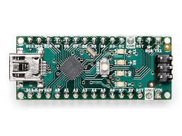

**Motor driver:** The L298N motor driver controls both the speed and direction of rotation of a dc electric motor.

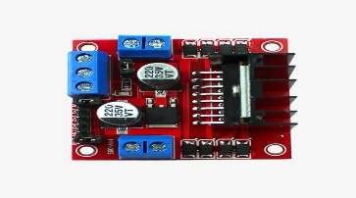

**Ultrasonic sensor:**. An ultrasonic sensor is an electronic device that uses sound waves to measure distance or detect ob-

jects

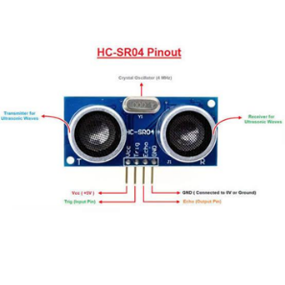

**ESP 32 camera:** The ESP32-CAM development board is based on the ESP32 microcontroller, which is a powerful and versatile microcontroller with built-in Wi-Fi and Bluetooth connectivity.

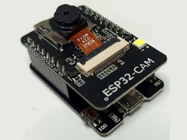

**Battery:** A battery is a device that stores electrical energy in chemical form and converts

it into electricity.

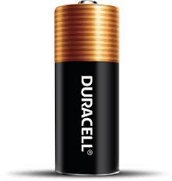

1. **WORKING**

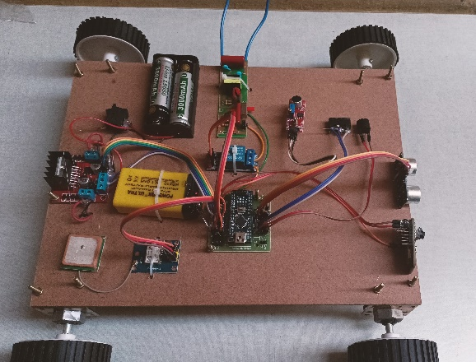

ROBO THE SAVIOUR ensures safety and security.It saves anyone from danger. when in we are in danger by pressing the panic button the sensors will sense and alarms through the buzzer.The ESp-32 cam automatically clicks the picture and sends to the police or registered number.The short circuit terminal will be activated.

Sensors detect obstacles, and the robot adjusts its route accordingly. IR sensors and cameras detect human presence or motion, triggering an alert. The robot sends real-time alerts to the control center or authorized personnel via wireless communication. The robot's camera records evidence of intruders or suspicious activity.

1. **CONCLUSION**

After carefully considering this system model, we can conclude that this technique will undoubtedly aid in the reduction of crime rates are at an all-time high. Grants are available through the project when it came to designing for crime, there were a lot of challenges. Current scenario and will assist in clarifying Using a compressed kit and concept, they can be studied scientifically. ROBO THE SAVIOUR has the ability to keep public safe. A difficult scenario it has an alarm, and SOS light, and a flashlight.

**ACKNOWLEDGEMENT**

With the sense of gratitude, we wish to express profound regards to our head of the

department Dr. N. SAMBASIVA RAO, Professor and Head, Electrical & Electronics Engineering Department and our project guide Sri R.Raghunadha Sastry, Associate Professor for his supervision in framing our project in an outstanding manner and for his remarkable guidance and encouragement throughout the project.

1. **REFERENCES**

[1]. S. Chavanke and T. Dnyandev Barhate, War Field Spying Robot with Night Vision Camera, Feb. 2017.

[2]. S. Hameed, M. Hamza Khan, N. Jafri, A. Azfar Khan and M. Bilal Taak, Military Spying Robot, vol. 8, no. 7C2, pp. 2278-3075, May 2019.

[3]. H. Salman, S. Acheampong and H. Xu, "Web-Based Wireless Controlled Robot for Night Vision Surveillance Using Shell Script with Raspberry Pi", Advances in Intelligent Systems and Computing, pp. 550-560, Jun. 2018.