Review and Approaches to Develop Digital Legal Assistance Using Artificial Intelligence and Machine Learning

Alpna Rani
Assistant Prof.
Inderprastha Engineering College
Ghaziabad, India
Laveena Gangwani
Student
Inderprastha Engineering College
Ghaziabad, India
Sandeep Vishwakarma
Student
Inderprastha Engineering College
Ghaziabad, India
Krishna Raghav
Student
Inderprastha Engineering College
Ghaziabad, India
Abhishek Sharma
Student
Inderprastha Engineering College
Ghaziabad, India

Abstract— The rapid advancements in Artificial Intelligence (AI) and Machine Learning (ML) have revolutionized various industries, including the legal sector. Digital Legal Assistants (DLAs) are emerging as powerful tools to streamline legal processes, reduce workloads, and enhance decision-making. By leveraging AI and ML techniques, DLAs assist legal professionals by providing precise case references, predictive insights, and relevant legal judgments, thereby optimizing case preparation and improving the quality of legal representation. Additionally, DLAs contribute to judicial efficiency by helping judges evaluate cases with greater accuracy and consistency.
This paper explores the methodologies, algorithms, and frameworks used in DLAs, such as Natural Language Processing (NLP) for legal document analysis, predictive analytics for case outcomes, and machine learning models for precedent identification. It also discusses the challenges in implementing DLAs, including data privacy concerns, algorithmic bias, and the complexity of legal language. The potential of DLAs to democratize access to legal resources is also highlighted.
By critically analyzing existing approaches and identifying gaps, this paper aims to provide insights into the development of more efficient, ethical, and user-friendly digital legal assistants, ultimately contributing to a fairer and more efficient justice system.

Keywords—Artificial Intelligence, Machine Learning, Natural Language Processing

1. Introduction
The Indian legal system is grappling with a massive backlog of cases, leading to significant delays in justice delivery. As of August 2022, the Supreme Court of India alone had 71,411 pending cases, including 56,365 civil cases and 15,076 criminal cases. The situation is even more dire in High Courts and District Courts, where over 4.5 million and 31 million cases, respectively, remain unresolved. With limited hearing time—often just 300 to 500 seconds per case in High Courts—lawyers face immense pressure to prepare case studies and trial strategies efficiently.
The manual-intensive nature of legal work, involving data collection, referencing, and searching for precedents, increases the likelihood of human errors, which can result in denied justice. The only current alternative often involves extending the duration of cases to gather adequate evidence and minimize misjudgments, further delaying dispute resolution.
In this context, AI and ML offer transformative solutions to streamline legal processes, reduce inefficiencies, and enhance decision-making. AI-based Digital Legal Assistants (DLAs) can automate tasks such as data collection, case referencing, and predictive modeling, significantly reducing the burden on lawyers and advocates. These systems not only save time but also improve the accuracy and quality of legal services by minimizing human error and providing better insights for case preparation and judgment.
Moreover, AI-driven prediction models can help legal professionals assess the complexity of cases and determine the required level of expertise. Enhanced infographics and analytical tools further aid in decision-making, leading to more efficient case resolution and reduced pendency in courts.
This review paper critically examines existing AI and ML techniques used in building DLAs, highlighting their applications, challenges, and potential to revolutionize the Indian legal system. By addressing inefficiencies and bottlenecks in the current legal framework, this study aims to provide insights into how DLAs can contribute to a faster, more accurate, and equitable justice delivery system.

Key AI and ML Techniques Used in DLAs:

- Natural Language Processing (NLP) for text analysis
- Supervised Learning
- Unsupervised Learning
- Deep Learning
- Information Retrieval Techniques

1.1 Problem Statement
Access to justice and legal awareness in India remains a significant challenge, particularly for rural populations and marginalized communities. Rural areas face acute challenges such as geographical isolation, lack of infrastructure, and inadequate legal representation. Marginalized communities are disproportionately affected by these barriers.
Legal literacy is alarmingly low in these areas due to socio-economic disparities, language barriers, and systemic discrimination. Existing digital legal platforms primarily cater to urban, educated users, leaving a significant portion of the population underserved. A DLA tailored for India's rural and marginalized communities could bridge this gap by providing legal awareness, accessibility, support for self-representation, and integration with legal aid services.

2. Natural Language Processing (Text Analysis)

Natural Language Processing (NLP) is a critical component for analyzing and processing legal documents effectively. Below are key NLP tasks required for text analysis:
- Tokenization
  - Definition: Tokenization is the process of breaking down a text document into smaller units called "tokens," which can be words, phrases, or sentences.
  - Purpose in Legal Documents: Legal documents are often long and complex. Tokenization helps in extracting key terms, case references, legal clauses, and other important elements from the text.
- Stop Words Removal
  - Definition: Stop words are common words like "and," "the," and "of," which don't add much semantic value to a sentence. These words are removed during processing.
  - Purpose in Legal Documents: Legal texts are often filled with filler words that don't contribute to understanding the core content. Removing stop words reduces noise and helps focus on significant legal terms and concepts.
- Stemming
  - Definition: Stemming reduces a word to its root form by removing prefixes or suffixes (e.g., "running" becomes "run").
  - Purpose in Legal Documents: Legal language often includes words with multiple derivations. Stemming standardizes these words to their base form, ensuring consistency and better understanding.
- Part of Speech (POS) Tagging
  - Definition: POS tagging identifies the grammatical categories (e.g., noun, verb, adjective) for each token in a sentence.
  - Purpose in Legal Documents: Legal documents frequently use complex sentence structures. POS tagging helps disambiguate meanings and identify relationships between legal terms, clauses, and references.
Together, these NLP techniques form the foundation for text analysis in the legal domain. They enable digital legal assistants to interpret, classify, and process legal content with greater accuracy, making it easier to retrieve relevant information, identify key legal concepts, and assist in case preparation.

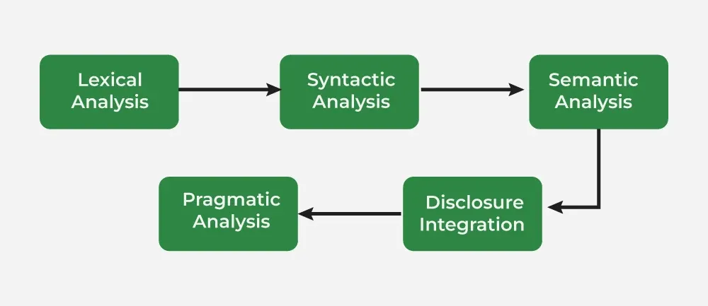
Figure 1.

3. Machine Learning Models in Digital Legal Assistants
In recent years, digital legal assistants have increasingly leveraged Machine Learning (ML) models to enhance their efficiency, accuracy, and scope of legal tasks. These ML models are used for various applications, including legal document analysis, contract review, legal prediction, and case summarization. Below are some commonly used ML models in DLAs:
- Natural Language Processing (NLP) Models
  - Transformer-based Models (e.g., BERT, GPT): These models are widely used for tasks like contract clause extraction, summarization, and question answering. Pre-trained language models fine-tuned on legal corpora (e.g., LegalBERT) have shown significant success in tasks requiring contextual understanding.
  - Named Entity Recognition (NER): Used for identifying key entities such as parties, dates, and monetary amounts in legal documents.
  - Semantic Similarity Models: Employed to find precedents or similar cases by comparing the semantic meaning of legal texts.
- Classification Models
  - Support Vector Machines (SVM): Used for binary or multi-class classification tasks like identifying legal topics or determining document relevance.
  - Random Forest and Gradient Boosting (e.g., XGBoost): Effective in classifying legal issues or outcomes based on structured and unstructured data.
  - Deep Learning Models (e.g., Convolutional Neural Networks, Recurrent Neural Networks): Applied to classify long legal texts and handle hierarchical relationships within legal documents.
- Prediction Models
  - Logistic Regression: A traditional yet effective model for predicting binary outcomes, such as win/loss probabilities in litigation.
  - Neural Networks: Multi-layered architectures are utilized for more complex predictions, like multi-factor case analysis.
  - Ensemble Models: Combining multiple models (e.g., Random Forest with Gradient Boosting) to improve predictive accuracy for legal outcomes.
- Clustering Models
  - K-Means Clustering: Used for grouping similar legal documents or clauses based on feature similarity.
  - Hierarchical Clustering: Helps in organizing case laws or statutes into meaningful hierarchies for research purposes.
- Reinforcement Learning Models
  - Deep Q-Learning: Applied to optimize strategies for legal decision-making or automated negotiation.
  - Policy Gradient Methods: Useful for modeling dynamic legal tasks where decisions evolve over time.

3.1 CNN Model with NLP for Text Extraction and Classification
A combination of Convolutional Neural Networks (CNNs) and Natural Language Processing (NLP) techniques is a powerful approach for text extraction and classification tasks. CNNs, initially designed for image processing, have been adapted to work with textual data by treating text sequences as one-dimensional input.
Workflow:
- Text Preprocessing and Embedding: Text is tokenized into words or sub words and converted into numerical representations using embeddings like Word2Vec, GloVe, or BERT.
- Feature Extraction with CNN: Convolution layers capture local patterns, while pooling layers reduce dimensionality, retaining key information.
- Classification Layer: Extracted features are flattened and passed to fully connected layers, followed by a softmax activation for predicting text categories.
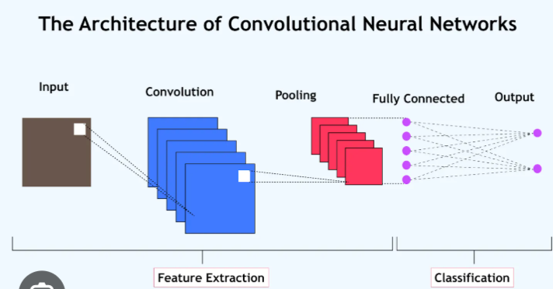
Figure 2.

3.2. Neural Network for Judgment Prediction
In digital legal assistants, predicting legal judgments based on keywords extracted from legal texts involves a combination of Natural Language Processing (NLP) techniques and Neural Networks. Keywords extracted using Convolutional Neural Networks (CNNs) and NLP serve as input features for a neural network, which then predicts the outcome or category of legal judgments. This workflow ensures both precise feature extraction and effective prediction.
Workflow of Neural Network for Judgment Prediction
- Input Layer:
  - The input layer receives keywords extracted through CNN and NLP techniques.
  - These keywords are converted into numerical representations using methods such as one-hot encoding, TF-IDF, or word embeddings (e.g., Word2Vec, BERT).
  - Example Input: Keywords like "breach," "contract," and "damages" are mapped into numerical vectors, which the neural network can process.
- Hidden Layers:
  - Fully Connected Layers: The hidden layers process the encoded keywords. Each neuron in these layers applies a weighted sum of inputs, followed by an activation function like ReLU (Rectified Linear Unit).
  - These layers learn patterns and relationships between keywords and potential outcomes. For instance, the combination of "breach" and "damages" might indicate a favorable ruling for the plaintiff.
  - Dropout Layers: To prevent overfitting, dropout layers are added. These layers randomly deactivate certain neurons during training, ensuring the model generalizes well to new data.
- Output Layer:
  - Softmax Activation: For multi-class classification tasks (e.g., predicting outcomes like "guilty," "not guilty," or "settlement"), the softmax activation function is used. It outputs probabilities for each class.
  - Sigmoid Activation: For binary outcomes (e.g., "win" or "loss"), the sigmoid activation function is applied to produce a probability score.
- Training the Neural Network:
  - Loss Function: The model uses cross-entropy loss for classification tasks, which measures the difference between the predicted probabilities and the actual outcomes.
  - Optimizer: To minimize the loss function, optimization algorithms like gradient descent or its variants (e.g., Adam) are used.
  - Evaluation Metrics: The model's performance is assessed using metrics such as accuracy, precision, recall, and F1-score, ensuring it makes reliable and accurate predictions.

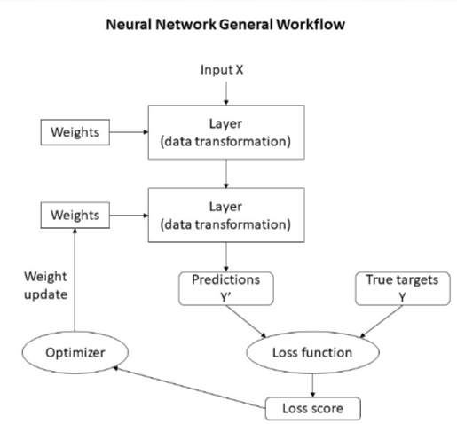
Figure 3. Neural Network Workflow

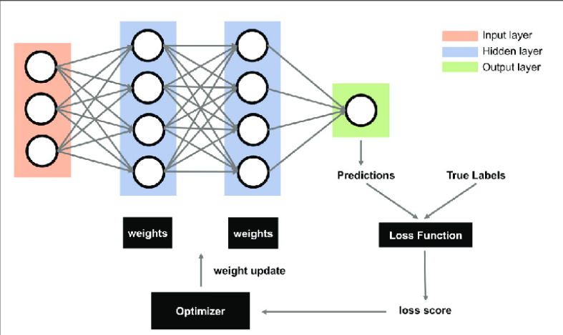
Figure 4. Neural Network Layers
4. Conclusion:
Digital Legal Assistants (DLAs) powered by AI and ML have the potential to transform the legal field by improving accessibility, efficiency, and accuracy. By leveraging NLP and machine learning techniques, these systems can automate tasks such as case research, legal document analysis, and reference retrieval, reducing the time and effort required by legal professionals for case preparation.
In India, where millions of cases remain pending, especially in rural and marginalized communities, DLAs can bridge the legal access gap. By offering user-friendly digital interfaces, DLAs can provide vital legal knowledge and guidance, making legal services more accessible and reducing reliance on physical legal consultation.
Furthermore, DLAs help mitigate human errors in legal processes by providing accurate references, predictions, and judgments. This enhances the overall quality of legal services and improves the efficiency of the judiciary. However, challenges such as data privacy concerns, the digital literacy gap, and the need for regulatory frameworks need to be addressed for broader adoption.
In conclusion, DLAs hold great promise in democratizing legal services, making legal assistance more efficient, accurate, and accessible to a wider audience. By leveraging AI and ML, these tools can ensure a more equitable legal system, especially for underserved populations, while improving the productivity and decision-making of legal professionals.

6. Reference:
[1] Masha Medvedeva, Michel Vols and Martijn Wieling." Using machine learning to predict decisions of the European Court of Human Rights". Published on Springer on 26 June 2019 open access, Creative Commons Attribution 4.0 International License. link.springer.com/article/10.1007/s10506-019-09255- y.
[2] Sandeep Bhupatiraju, Daniel L, Chen, and Shareen Joshi." The Promise of Machine Learning for the Courts of India". The Promise of Machine Learning for the Courts of India. National Law School of India Review, 2021, 33 (2), pp.462-474. ⟨hal-03629734⟩
[3] Jonathan Brett Crawley and Gerhard Wagner. "Desktop Text Mining for Law Enforcement".2010 IEEE
International Conference on Intelligence and Security Informatics. 10.1109/ISI.2010.548476.
[4] Jane Mitchell, Simon Mitchell, and Cliff Mitchell. "Machine learning for determining accurate outcomes in criminal trials". Law, Probability and Risk, Volume 19, Issue 1, March 2020, Pages 43–65, https://doi.org/10.1093/lpr/mgaa003
[5] Riya Sil and Abhishek Roy. "A Novel Approach on Argument-based Legal Prediction Model using Machine Learning". Proceedings of the International Conference on Smart Electronics and Communication (ICOSEC 2020). 10.1109/ICOSEC49089.2020

