**AUTHOR:**

**1:KALYBEKOVA KANYKEI DOSBAEVNA  
2:Ali Bilal**

**3:Ali Muhammad**

**4:Sattar Mohsan**

**5:Sohail Mohsin**

**6:Kifiyat Ullah**

**7:Waqas Niazi  
Incidence Rates and Disabilities**

**ABSTRACT**

The public health realm considers disability as a significant problem that occurs among individuals from every demographic and age bracket. Disability affects every aspect from physical to sensory to cognitive to mental health impairments thus restricting people from conducting their activities and functions in work and social situations. During a specified period the incidence rate of disability represents the total number of new disability cases occurring in a certain population group. The incidence rate exhibits changes because of distinct variables that combine age demographics with diseases, personal income, and construction limitations and hazards. Statistically 1.3 billion individuals or 16% of all people worldwide suffer from a disability. The population of vision impairment sufferers numbers at 246 million people with an additional 39 million people who are blind. Hearing loss affects 466 million people around the world and this figure continues to grow because of untreated infections and aging together with excessive noise exposure. Intellectual and developmental disabilities exist in 1% of the global population while Autism Spectrum Disorder receives increased diagnoses because better detection tools and awareness campaigns have emerged. Spinal cord injuries and cerebral palsy alongside strokes lead most people to develop mobility impairments but mental health disabilities specifically depression and anxiety have grown substantially during COVID-19. Multiple obstacles hinder the measurement of disability incidence because definitions vary between studies people avoid disclosure due to stigma and there are constraints in data collection methods.

**1. INTRODUCTION**

The worldwide public healthcare landscape considers disability as a major issue because it limits the human capability to take part in routine activities and employment along with social connections. During a distinct period new disability cases within specific population groups result in what we define as disability incidence rate. Healthcare professionals together with policymakers and social service providers can use disability rate data for making decisions about prevention strategies and support and treatment programs. Near one billion six hundred million people (16% of the global population) experience substantial disabilities based on the World Health Organization (WHO) estimate. The data points differ by geographic area as healthcare systems' population changes and economic standards play a determining role. People develop disabilities because of different origins such as birth defects, injuries, aging processes, and diseases spread through germs and environmental factors. Disabilities affect people individually but also influence their family members' healthcare services and countries' economic systems(Takahashi et al., 2024). Research investigates disability incidence rates and worldwide trends and measurement challenges of disabilities to recommend policy solutions for better living standards for disabled populations.

**2. DEFINING DISABILITY AND INCIDENCE RATES**

A person qualifies as disabled when physical sensory cognitive or mental impairments restrict their ability to carry out basic major life activities. The various impairments that individuals experience have direct impacts on their ability to function each day as well as their capacity to move around speak to others and engage in societal activities. People with physical disabilities experience impaired movement through conditions such as spinal cord injuries along with cerebral palsy and amputation of body parts that restrict self-sufficiency for daily physical activities. People suffering from sensory disabilities experience challenges in communication with their environment together with difficulties in sensory interactions because of conditions including blindness, low vision, deafness, and partial hearing loss. Internal conditions of the brain create cognitive disabilities through a mixture of developmental disorders like autism with Down syndrome and neurological disruptions that weaken memory functions and problem-solving capacity. The disabilities belonging to mental health categories including depression and anxiety along with bipolar disorder and schizophrenia create disturbances to emotional states and cognitive processes which produce social and occupational limitations(Kieling et al., 2024).

**2.2 Understanding Incidence Rates**

The incidence rate figure is based on the number of new injuries in a certain group during a certain period. Based on the data given, 100 new cases of injury are reported every year among 10,000 people, which is a 1% incidence rate. Keeping an eye on disability incidence rates shows new patterns in the number of people who are disabled. This information can help healthcare service providers and decision-makers make smart use of their resources. Health tactics that work as preventative measures keep people who are at risk safe by getting them medical care as soon as possible and making sure they are safe at work. The rates of incidence experience substantial impacts from demographic characteristics of populations combined with economic performance as well as medical system accessibility together with workplace safety standards. Disability incidence rates increase higher in aging nations because of age-related diseases together with low-income nations experiencing increased disability because of both poor medical care and workplace dangers(JC Allen Ingabire et al., 2024).

**3. GLOBAL INCIDENCE RATES OF DISABILITIES**

The incidence of disability varies depending on a combination of hospital environment, personal life choices, and healthcare accessibility and hospital facilities. Academic research generates essential statistical information about disabilities which demonstrates the requirement for swift policy solutions.

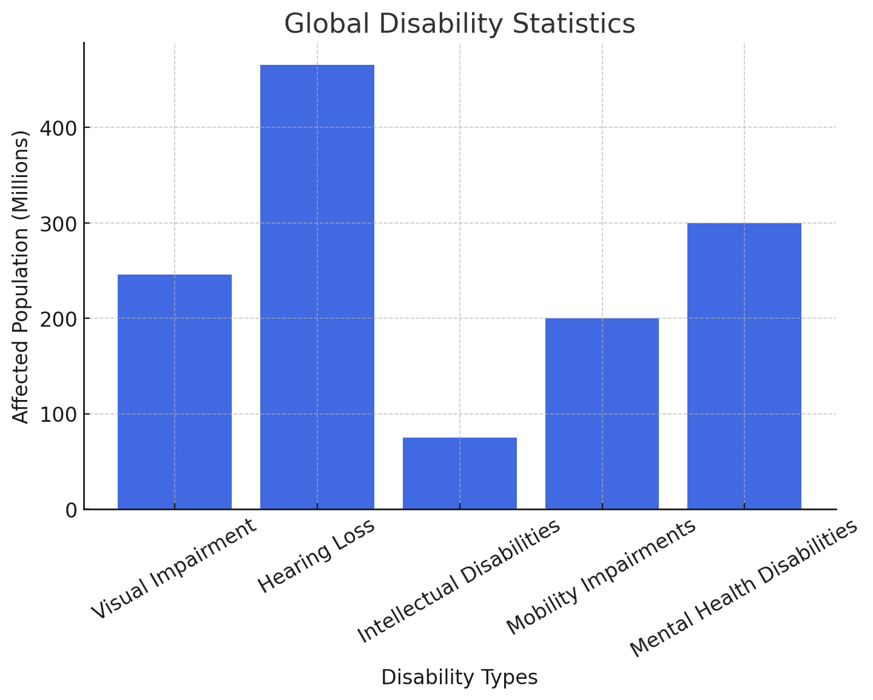

**3.1 Visual Impairments**

The World Health Organization (WHO) reports that 246 million people worldwide deal with visual impairment whereas 39 million people are identified as blind. The age-scale increase in elderly populations has produced more cataracts and macular degeneration patients which results in greater numbers of vision-related disabilities. Unattended ocular care along with insufficient medical surgeries will escalate the progression of these disabilities(Chen et al., 2024).

**3.2 Hearing Loss**

A total of 466 million people throughout the world currently experience disabling hearing loss. Hearing disabilities emerge mostly from three main factors: noisy settings, the natural process of aging, and untreated medical infections. People from low-income areas cannot obtain hearing aids or medical assistance that prevent enduring hearing impairment when they receive early medical care(Tahereh Afghah et al., 2024).

**3.3 Intellectual and Developmental Disabilities**

The prevalence rate of intellectual disabilities within the worldwide population amounts to 1%. The number of Autism Spectrum Disorder (ASD) diagnoses increased substantially because physicians now use better diagnostic instruments with better awareness about ASD. Early detection programs along with special education services and social inclusion policies must be implemented immediately because of the increased need(Smythe et al., 2024).

**3.4 Mobility Impairments**

The three main origins of mobility difficulties result from spinal cord injuries and cerebral palsy together with strokes. Lack of accessibility to rehabilitation services in developing regions causes disability rates to increase because individuals with mobility disabilities fail to get proper treatment for their recovery(Dominiak et al., 2024).

**3.5 Mental Health Disabilities\***

An outbreak of COVID-19 resulted in a sharp rise in anxiety alongside depression and stress-related disorders in society. Rising disability benefit claims for mental health conditions in the United Kingdom help demonstrate that mental health challenges are causing a worldwide crisis(Slade et al., 2024).

**4. FACTORS INFLUENCING DISABILITY INCIDENCE RATES**

The increasing number of disability cases worldwide is influenced by several factors, including demographic shifts, chronic diseases, accidents, socioeconomic conditions, and environmental or genetic influences. Understanding these contributing factors is essential for addressing the root causes of disabilities and implementing effective preventive measures.

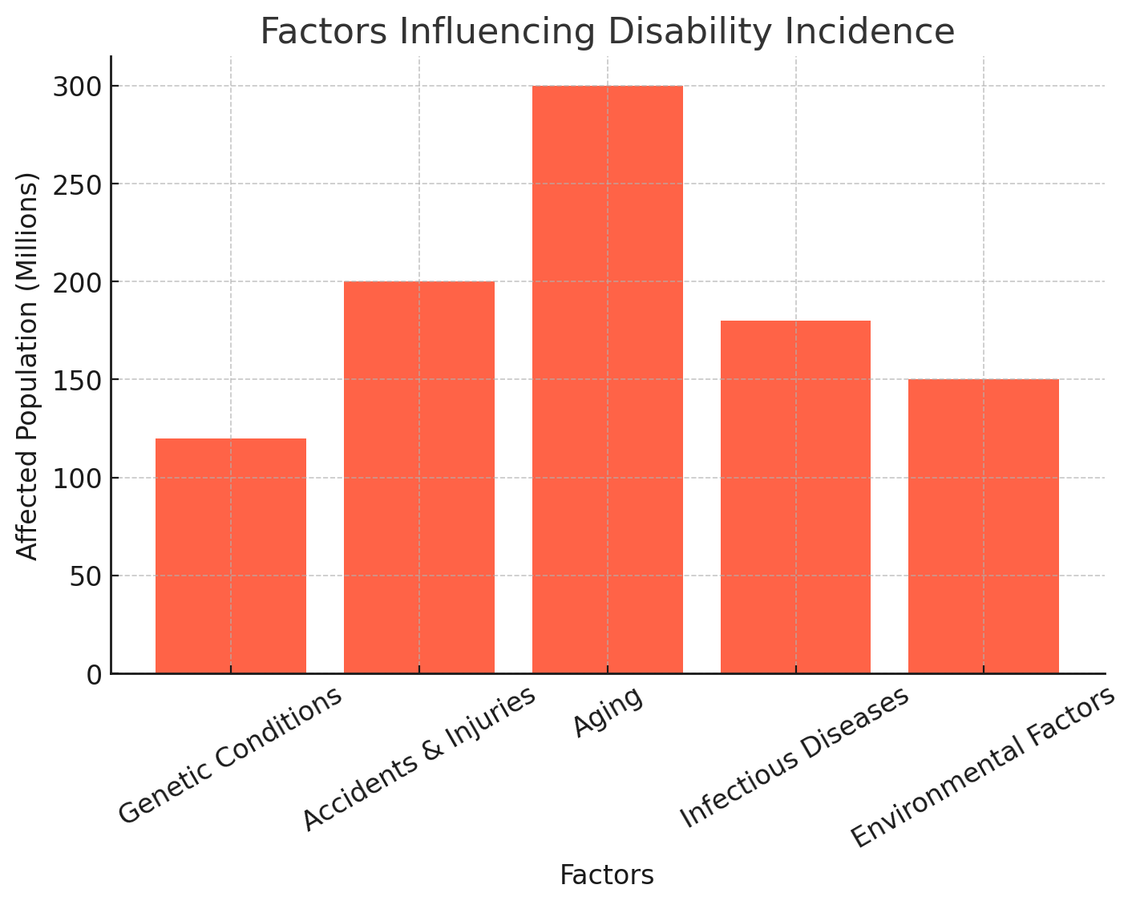

**4.1 Aging Population**

The world's population getting older is one of the main reasons why the number of people with disabilities is going up. By 2050, there will be more than 1.6 billion people aged 65 and up in the world. This is a big change in the population that will have a big effect on injury rates and healthcare systems. Chronic diseases like arthritis, osteoporosis, heart disease, and neurological diseases like Alzheimer's and dementia are more likely to happen to older people. These conditions often make it harder to move around, make it harder to think clearly and make people more reliant on help. Also, as life span grows, so does the chance of getting diseases that come with getting older. To get ready for this rising need, governments and healthcare systems need to make sure that older people get better senior care, therapy services, and helpful tools(OH et al., 2024).

**4.2 Long-Term Illnesses**

Disability rates are largely caused by long-term illnesses. Some of the most common diseases that cause long-term disabilities are diabetes, high blood pressure, and stroke. Diabetes, for instance, can lead to neuropathy, loss of vision, and amputations. A stroke, on the other hand, can leave people paralyzed, have trouble speaking, and lose their mental abilities. Disability rates are also getting worse because more and more people are getting diseases linked to fat. Joint problems, like osteoarthritis, which is often caused by being overweight, make it very hard to move around and cause constant pain. Without effective ways to stop them, like promoting a healthy lifestyle, finding diseases early, and getting medical help, chronic illnesses will continue to make more people disabled around the world(DeSouza et al., 2023).

**4.3 Mishaps and Injuries**

Unintentional accidents are still the main reason people become disabled around the world. For example, spinal cord injuries, serious head injuries, and amputations happen a lot in car crashes. The World Health Organization says that every year, over 50 million people are hurt in car accidents but do not die. Many of these injuries leave them permanently disabled. Dangers at work, especially in the manufacturing, building, and mining sectors, also play a big role in injury cases. Occupational injuries are more likely to happen when workers are exposed to dangerous chemicals, don't have the right safety gear, or work in unsafe circumstances. To lower the number of injuries caused by work, governments and companies must strictly follow workplace safety rules and set up preventative training programs(Elsherbini et al., 2024).

**4.4 Social and Economic Factors**

Access to health care, good diet, and avoiding diseases are all greatly affected by a person's economic situation, all of which have an impact on the number of disabilities. Poor healthcare facilities in low-income countries make it harder to find and treat disabling conditions early on. As a result, more people in these countries are disabled than in better countries. Children from poor families often have problems developing because they aren't getting enough food, they don't get prenatal care, or they are exposed to diseases. Conditions like slow growth, memory loss, and birth defects are more common in places where people can't get enough healthcare and a good diet. To fix these problems, we need to work on public health, make it easier for people to get medical care, and find ways to reduce poverty(Park, 2024).

**4.5 Genetics and the Environment**

Disability rates are also going up because of genetic and environmental factors. Birth abnormalities and problems during delivery are the main reasons why people are disabled for life. A lot of disabled people around the world have genetic diseases like Down syndrome, muscle dystrophy, and cystic fibrosis. People who are exposed to smog and industrial toxins may also develop brain disorders, lung diseases, and birth defects. Being around air pollution, heavy metals, and dangerous chemicals for a long time can make you more likely to get cancer, lung disease, and other long-term illnesses that can make you unable to work. To fix these environmental problems, we need tighter rules on industry trash, better pollution control measures, and more knowledge about the health risks of the environment(Jambi et al., 2024).

**Breakdown of Disability Type**

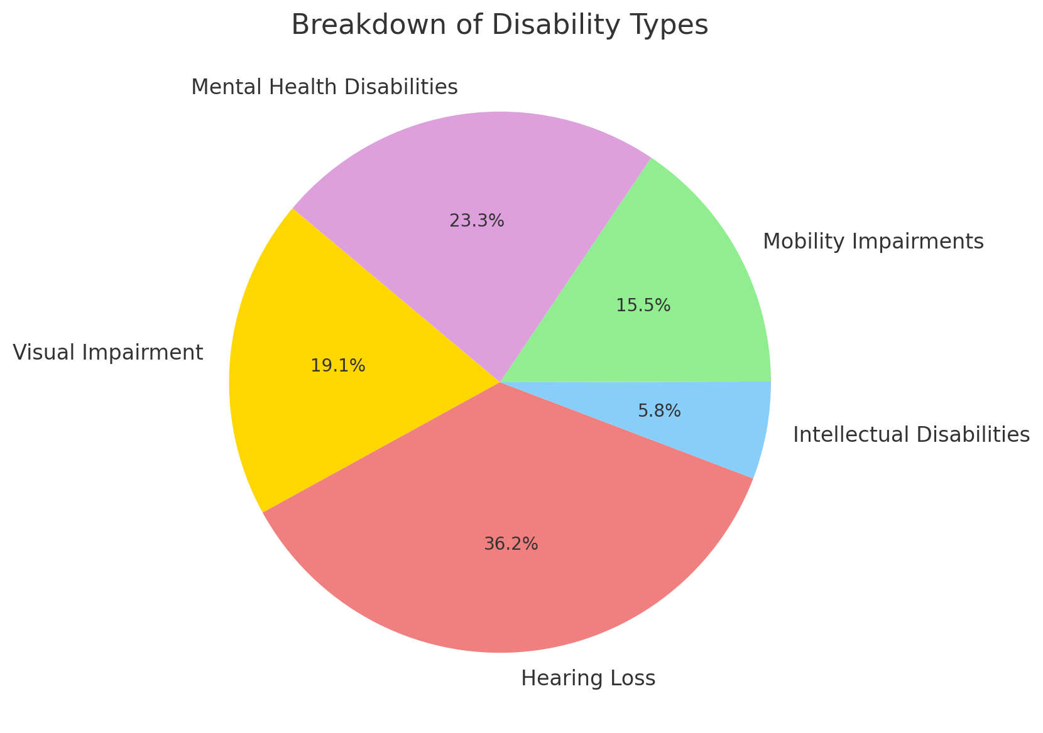

**5. Multiple difficulties exist in the process of measuring disability incidence rates**

Health service planning together with governmental policy development relies on precise measurement of disability incidence patterns. The accurate measurement of disability rates encounters several hindrances stemming from divergent definitions and underreporting from prejudice factors together with monitoring procedures that produce their measurement challenges.

**5.1 Variations in Definitions**

Different countries maintain separate criteria to define disabilities thus creating issues when they attempt to exchange disability data with each other. Worldwide assessment of physical disabilities has a standard definition while mental health and cognitive disabilities lack agreed definitions leading to limited global accuracy of comparison data. Around the world, the accuracy of disability incidence data is affected by various outlooks regarding the disabled status of depression and anxiety disorders. The standardization of universal disability definitions should take place to establish exact disability measurement methods(Rzońca et al., 2024).

**5.2 Underreporting and Stigma**

People in positions of economic disadvantage along with rural residents choose to stay away from medical diagnosis because they must deal with social stereotypes while lacking financial support and possessing low awareness of their health. Several health conditions such as autism combined with chronic pain syndromes and psychiatric disorders have a high chance of going undiagnosed because their indicators remain undetectable during medical evaluations. Workplace and educational discrimination creates fear that prevents disabled individuals from revealing their disabilities which results in wrong disability statistics(Alam et al., 2024).

**5.3 Data Collection Limitations**

The absence of official disability registration programs operated by developing states generates significant global data gaps leading to inaccurate disability statistics. When participants must provide personal information for data collection it leads to false results since participants may alter facts because of memory issues verify conditions from doctors or avoid discussing disabilities due to social status impressions. The accuracy of tracking disability rates becomes compromised because standard medical verification standards have not been established for data collection purposes(Pinheiro et al., 2023).

**6. POLICY AND INTERVENTIONS**

To lower the number of people with disabilities and improve their living conditions, a complete plan needs to be put in place. The main goal of the laws should be to avoid injuries while also supporting medical ease, social inclusion, and mental health services.

* Getting vaccinated against diseases like measles and polio, which can cause lifelong disabilities, is the first step in medically preventing disabilities. Lawmakers need to enforce safety rules in the workplace so that workers don't get hurt and become physically disabled. Accidents that leave people with serious movement problems can be avoided by following the rules of the road.
* There is an absolute need to help people find and get care for health problems like autism, diabetes, and hearing loss as soon as possible. Rehabilitation services need to be made available all over the country to improve medical care for people who have acquired disabilities.
* It is still very important for states to implement disability rights rules so that discrimination doesn't happen in places of work, schools, and public spaces. Educational and workplaces need to make policies that are based on inclusion. These policies should include accommodations that make it easier for people with disabilities to get around, as well as specialized learning facilities and tools.
* Because the number of people with mental health problems is going up, it's important to deal with them by putting more money into mental health services and making more people aware of the problem. The number of limitations caused by sadness and anxiety conditions will go down if counseling, therapy, and mental support services are easy to get.

**7. CONCLUSION**

The global population is experiencing an increasing disabled population because of population aging and chronic diseases combined with accidents and deteriorating mental health conditions. The support of disabled people depends on precise data collection prompt intervention and policies that include everyone. Better healthcare access combined with addressing fundamental causes will enable society to improve the quality of life experienced by disabled people.

**References**

Alam, M. B., Khanam, S. J., Rana, M. S., Khandaker, G., Kabir, M. A., & Khan, M. N. (2024). Effects of disability on adverse health outcomes and anthropometric deficits among under-five children in South Asian countries: evidence from multiple indicator cluster surveys. *The Lancet Regional Health - Southeast Asia*, *25*, 100401. <https://doi.org/10.1016/j.lansea.2024.100401>

Chen, J., Zhu, Y., Liu, Z., Chen, X., Chen, X., Huang, S., Xie, R., Zhang, Y., Ye, G., Luo, R., Shen, X., Lin, L., & Zhuo, Y. (2024). Global impact of population aging on vision loss prevalence: A population-based study. *Global Transitions*, *6*, 28–36. <https://doi.org/10.1016/j.glt.2023.12.003>

DeSouza, A., Wang, D., Wong, J. J., Furlan, A. D., Hogg-Johnson, S., Macedo, L., Mior, S., & Côté, P. (2023). Prevalence of Unmet Rehabilitation Needs Among Canadians Living With Long-term Conditions or Disabilities During the First Wave of the COVID-19 Pandemic. *Archives of Physical Medicine and Rehabilitation*, *105*(2), 268–279. <https://doi.org/10.1016/j.apmr.2023.07.010>

Dominiak, M., Gędek, A., Antosik, A. Z., & Mierzejewski, P. (2024). Prevalence, attitudes and concerns toward telepsychiatry and mobile health self-management tools among patients with mental disorders during and after the COVID-19 pandemic: a nationwide survey in Poland from 2020 to 2023. *Frontiers in Psychiatry*, *14*. <https://doi.org/10.3389/fpsyt.2023.1322695>

Elsherbini, D. M. A., Ali, L. S., Allam, N. M., Elshorbagy, R. T., Eladl, H. M., Ibrahim, A. M., Elbastawisy, Y. M., Eldesoqui, M., & El-Sherbiny, M. (2024). Epidemiology and Prevalence of Musculoskeletal Disabilities Following Motor Vehicle Accidents in Aljouf Region, Saudi Arabia. *Medicina*, *60*(10), 1562. <https://doi.org/10.3390/medicina60101562>

Jambi, L., Hamad, A., Salah, H., & Sulieman, A. (2024). Stroke and Disability: Incidence, Risk Factors, Management, and Impact. *Journal of Disability Research*, *3*(7). <https://doi.org/10.57197/jdr-2024-0094>

JC Allen Ingabire, Stewart, A., Jean Baptiste Sagahutu, Urimubenshi, G., Georges Bucyibaruta, Sonti Pilusa, Carine Uwakunda, Didace Mugisha, Ingabire, L., & Tumusiime, D. (2024). Prevalence and levels of disability post road traffic orthopaedic injuries in Rwanda. *African Journal of Disability*, *13*. <https://doi.org/10.4102/ajod.v13i0.1251>

Kieling, C., Buchweitz, C., Caye, A., Silvani, J., Ameis, S. H., Brunoni, A. R., Cost, K. T., Courtney, D. B., Georgiades, K., Merikangas, K. R., Henderson, J. L., Polanczyk, G. V., Rohde, L. A., Salum, G. A., & Szatmari, P. (2024). Worldwide Prevalence and Disability From Mental Disorders Across Childhood and Adolescence: Evidence From the Global Burden of Disease Study. *JAMA Psychiatry*, *81*(4). <https://doi.org/10.1001/jamapsychiatry.2023.5051>

OH, E., NGUYEN, V. C., MOON, S., CHOI, R., & HONG, G.-R. S. (2024). Trends and Factors Affecting Functional Limitations on Activities of Daily Living Performance Among Korean Adults With Disabilities, 2008–2020: A Longitudinal Study. *Journal of Nursing Research*, *32*(5), e351. <https://doi.org/10.1097/jnr.0000000000000634>

Park, E.-Y. (2024). Factors Influencing Suicidal Ideation in Persons with Physical Disabilities. *Behavioral Sciences*, *14*(10), 966. <https://doi.org/10.3390/bs14100966>

Pinheiro, L. S. P., Silva, A., Madaleno, F. O., Verhagen, E., de Mello, M. T., Ocarino, J. M., & Resende, R. A. (2023). Prevalence and incidence of health problems and their characteristics in Brazilian para athletes: A one-season single-center prospective pilot study. *Disability and Health Journal*, *17*(1), 101511. <https://doi.org/10.1016/j.dhjo.2023.101511>

Rzońca, P., Podgórski, M., Łazarewicz, M., Gałązkowski, R., Rzońca, E., Detsyk, O., & Włodarczyk, D. (2024). The prevalence and determinants of PTSD, anxiety, and depression in Ukrainian civilian physicians and paramedics in wartime–An observational cross-sectional study six months after outbreak. *Psychiatry Research*, *334*, 115836. <https://doi.org/10.1016/j.psychres.2024.115836>

Slade, T., Vescovi, J., Chapman, C., Maree Teesson, Arya, V., Pirkis, J., Harris, M. G., Burgess, P. M., Santomauro, D., O’Dean, S., Tapp, C., & Sunderland, M. (2024). The epidemiology of mental and substance use disorders in Australia 2020–22: Prevalence, socio-demographic correlates, severity, impairment and changes over time. *Australian & New Zealand Journal of Psychiatry*. <https://doi.org/10.1177/00048674241275892>

Smythe, T., Scherer, N., Nanyunja, C., Tann, C. J., & Olusanya, B. O. (2024). Strategies for addressing the needs of children with or at risk of developmental disabilities in early childhood by 2030: a systematic umbrella review. *BMC Medicine*, *22*(1). <https://doi.org/10.1186/s12916-024-03265-7>

Tahereh Afghah, Razan Alfakir, Meis, M., Mahmoud Hammady, Mostafa Youssif, Al-Ghaffar, M. A., Kramer, S. E., & Wagener, K. C. (2024). ICF-based hearing and functioning assessment: validation and research outcomes of utilizing the HEAR-COMMAND tool for patients with mild to moderately severe hearing loss and individuals with normal hearing. *Frontiers in Rehabilitation Sciences*, *5*. <https://doi.org/10.3389/fresc.2024.1389653>

Takahashi, T., Iwata, K., Morisawa, T., Kato, M., Kono, Y., Taya, M., Iida, Y., Funami, Y., Kamiya, K., Sakurada, K., & Saitoh, M. (2024). Incidence of Hospitalization-Associated Disability in Older Patients With Heart Failure. *Circulation Journal*, *88*(5), 672–679. <https://doi.org/10.1253/circj.cj-23-0722>