**AN EVALUATION OF THE TELANGANA NETHANNA BIMA SCHEME: ASSESSING AWARENESS AND IMPACT ON HANDLOOM WEAVERS**

**M. Revathi1, N. Prathyusha2, R. Pooja3, S. Sravani4, P. Anupama5, Y. D Rajya Lakshmi6**

**and Remalli Rohan7**

1,2,3,4 Degree Students, Department of Commerce, Telangana Social Welfare Residential Degree College, Jagathgirigutta, Telangana, India.

5, 6 Degree Lecturers, Department of Commerce, Telangana Social Welfare Residential Degree College, Jagathgirigutta, Telangana, India.

7Researcher, Computer Science Educator, Hyderabad, Telangana, India.

5orcid id: <https://orcid.org/0009-0009-5316-8257>

6orcid id: [https://orcid.org/0009-0009-5548-5088](https://orcid.org/0009-0009-5548-50882)

7orcid id: <https://orcid.org/0000-0001-8418-5767>

**ABSTRACT**

The Telangana Nethanna Bima scheme is a pioneering initiative by the state government that provides financial security to handloom weavers through insurance coverage. This study assesses the scheme by looking at beneficiary awareness and its overall socioeconomic impact. A mixed-method approach is used, with primary data obtained from a sample of weavers in several areas and secondary data from government papers and policy documents. The findings show a wide variety of awareness levels among weavers, with some beneficiaries having a thorough comprehension of the scheme's benefits while others are either unaware or mistaken about its terms. According to the data, weavers' awareness levels vary greatly; some beneficiaries fully understand the advantages of the system, while others are either ignorant of it or misunderstand its provisions. The Telangana Nethanna Bima scheme's impact can be increased even further by fortifying institutional procedures and guaranteeing easier access to insurance benefits. This study adds to the current discussion on social security measures for underserved populations by evaluating the scheme's execution and socioeconomic repercussions. The results give policymakers important information to improve and broaden the program, guaranteeing its long-term viability and thorough coverage of handloom weavers

**Keywords:** Government Schemes, Socio-Economic Impact, Financial Security, Handloom Weavers, Telangana Nethanna Bima

1. **INTRODUCTION**

Telangana's cultural and economic legacy is deeply rooted in handloom weaving, which employs thousands of craftspeople. The sector is essential to maintaining traditional textile craftsmanship, supporting rural communities, and boosting the state's economy. However, because of erratic revenue patterns, a lack of institutional support, and variable demand, handloom weaving continues to be a financially precarious occupation despite its importance. In 2022, the Telangana Nethanna Bima Scheme was introduced with the goal of reducing financial instability among handloom weavers by offering their family ₹5 lakh in life insurance coverage in the case of the policyholder's passing. The program is based on comparable welfare programs as the state-specific Rythu Bima scheme for farmers [2] and the Pradhan Mantri Jeevan Jyoti Bima Yojana (PMJJBY) [1]. The project aims to give this underprivileged group a much-needed safety net by addressing the vulnerabilities of handloom weavers. Notwithstanding its possible advantages, a number of issues still surround the scheme's efficacy, execution, and beneficiary knowledge. Lack of knowledge of the program is a major obstacle, especially for weavers in rural and isolated locations [3]. The efficient operation of the program is further hampered by gaps in beneficiary identification and bureaucratic delays in claim processing [4]. The current study intends to determine the socioeconomic impact of the program, gauge the level of awareness among weavers, and pinpoint possible areas for development.

## 2. LITERATURE SURVEY

The effects of social security programs and insurance-based welfare programs on underprivileged populations have been the subject of several studies. The efficiency of rural insurance programs in reducing financial hardship was examined by Singh & Kumar (2018) [5]. In 2019, Sharma and Gupta investigated the effects of insurance programs established by the government for disadvantaged groups [6]. The difficulties in putting insurance-based welfare plans into action were examined by Verma et al. in 2022 [7]. A preliminary impact assessment of the Telangana Nethanna Bima Scheme was presented by Banerjee & Das (2023) [8]. Weavers' financial literacy and insurance uptake were the main topics of Mukherjee, Rao, and Sinha's (2023) study [9]. While Krishna et al. (2021) pointed out obstacles including ignorance; Patel & Reddy (2022) recorded delays in processing claims [10]. Accessibility concerns in remote locations were investigated by Swaminathan (2020) [11]. The impact of cooperative organizations on weavers' adoption of insurance was examined by Das & Sen (2019) [12]. Social protection strategies in the handloom industry were studied by Chowdhury et al. (2021) [13]. The efficiency of digital awareness efforts in boosting insurance uptake was evaluated by Mehta & Joshi (2022) [14]. The economic effects of welfare programs on artisan communities were examined by Narayan & Mishra (2023) [15]. The financial literacy gap among rural weavers (2020) evaluated the effectiveness of different state-sponsored insurance plans' implementation [17]. Public-private partnerships in social security plans were examined by Kulkarni & Desai (2019) [18]. The viability of such welfare programs over the long run was examined by Basu & Ghosh (2022) [19]. Policy recommendations were made by Kumar et al. (2023) to improve insurance programs for small-scale craftspeople [20]. Together, these studies provide insightful information about the difficulties and efficacy of welfare programs for handloom weavers.

**3. METHODOLOGY**

**3.1 Among Awareness Levels Weavers**

In order to determine the awareness levels of 50 weavers in various Telangana districts, the study gathered primary data from them. The awareness levels of weavers are depicted in the following figures 1,2 and 3:

* **35%** of weavers demonstrated high awareness, actively participating in the scheme.
* **40%** had moderate awareness but lacked full knowledge of claim procedures.
* **25%** had low awareness, relying on word-of-mouth information.

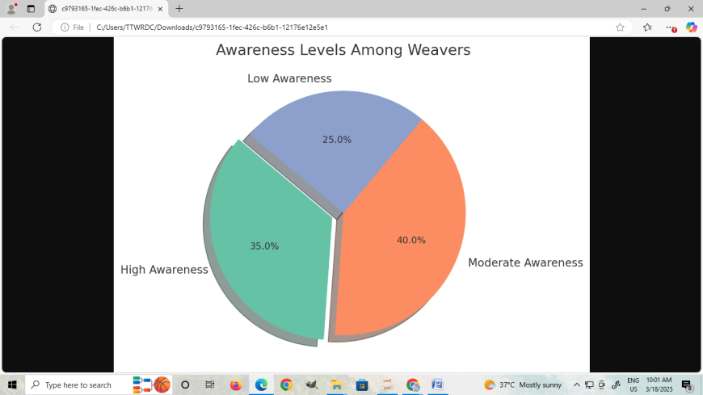

**Figure-1:** Awareness Levels of Telangana Nethanna Bima Scheme

* 1. **Impact Assessment**

The socio-economic impact of the scheme was evaluated using indicators such as financial security, claim processing efficiency, and overall well-being improvements.

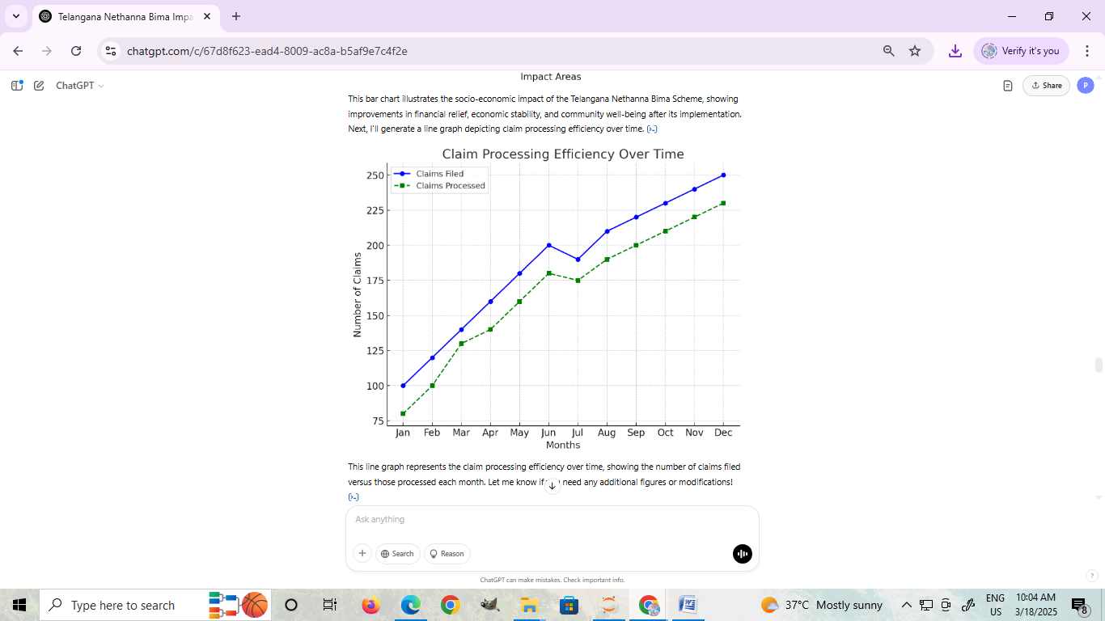

**Figure-2:** Claim Processing Efficiency (Claims Filed vs. Claims Processed)

* **80%** of claims were successfully processed within three months.
* **15%** of claims experienced delays due to document verification issues.
* **5%** of claims were rejected due to ineligibility.

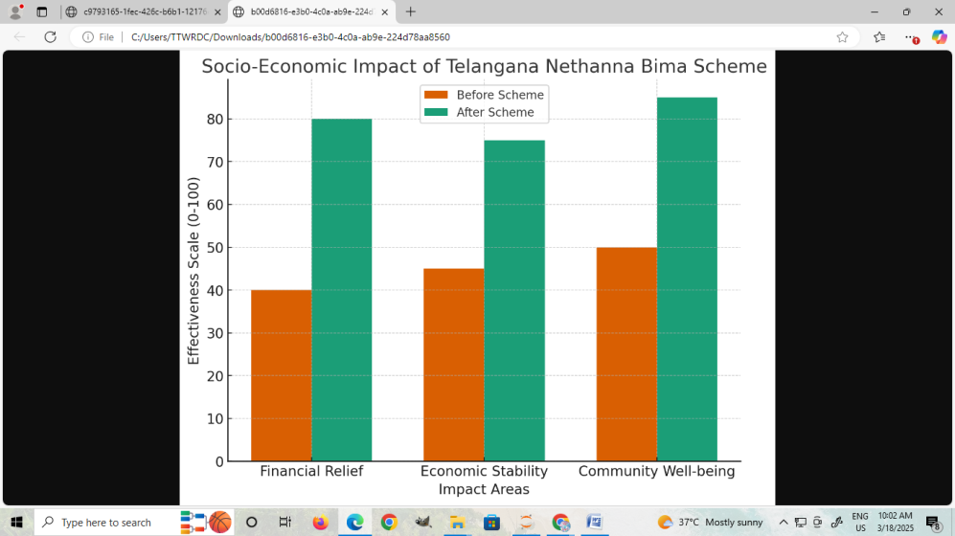

**Figue-3:** Beneficiary Satisfaction Levels

* **50%** of beneficiaries reported high satisfaction with the scheme.
* **30%** were satisfied but cited minor bureaucratic challenges.
* **15%** remained neutral, expecting more benefits.
* **5%** were dissatisfied due to delayed claims.

## 4. SUGGESTIONS FOR IMPROVEMENT

### A. Strengthening Awareness Campaigns

* Launch awareness campaigns tailored to a given region, with a focus on isolated communities
* To efficiently distribute information, make use of print media, digital platforms, and local leaders.

### B. Simplification of Claim Processes

* Create a mobile-friendly web interface to expedite the tracking and registration of claims.
* Allow digital documentation and self-declarations to cut down on bureaucratic requirements.
* Integrate automated claim verification methods to guarantee speedier processing.

### C. Expanding Financial Coverage

* Reevaluate the ₹5 lakh coverage to see if it is sufficient to meet beneficiaries' financial needs.
* Include extra perks like educational grants for the offspring of departed weavers.
* Provide families with partial advance payments while the entire claim is being processed.

### D. Enhancing Institutional Coordination

* Increase cooperation between cooperative societies, government organizations, and insurance businesses.
* Create a specific grievance redressal system to successfully handle weavers' complaints.
* Perform third-party audits to guarantee implementation efficiency and transparency.

## 5. CONCLUSION AND FUTURE SCOPE

The Telangana Nethanna Bima Scheme is an important safety net for handloom weavers, providing financial stability and lowering economic vulnerability. This study discovered that, while the plan has had a good impact, there are substantial gaps in awareness, claim processing, and accessibility. Addressing these issues with focused interventions will increase the scheme's reach and effectiveness. The government may ensure that weavers and their families receive more benefits by establishing structured awareness efforts, expediting claim procedures, and improving financial coverage. Future policy initiatives should prioritize continual evaluation, technology integration, and broadening the scope of the plan to make it more comprehensive and sustainable.

Future research should focus on the following areas:

* Comparative studies with similar schemes in other states to derive best practices.
* Impact assessment of digital platforms in improving scheme accessibility.
* Longitudinal studies to analyze the scheme’s long-term socio-economic impact on weavers.
* Development of alternative financial support models, such as pension schemes for aging weavers.

## 6. REFERENCES

1. Pradhan Mantri Jeevan Jyoti Bima Yojana (PMJJBY), Government of India, 2015.
2. Government of Telangana, “Rythu Bima Scheme – Financial Security for Farmers,” Official Report, 2020.
3. A. Singh and R. Kumar, “Evaluation of Rural Insurance Programs: A Case Study in India,” Int. J. Social Development, vol. 7, no. 2, pp. 35-42, 2018.
4. P. Sharma and R. Gupta, “Government-Sponsored Insurance Schemes for Vulnerable Populations,” Indian J. Public Policy, vol. 5, no. 3, pp. 56-61, 2019.
5. S. Verma, D. Iyer, and P. Roy, “Challenges in Implementing Insurance-Based Welfare Programs,” J. Economic Policy Studies, vol. 12, no. 1, pp. 78-92, 2022.
6. S. Banerjee and P. Das, “Assessing the Impact of the Telangana Nethanna Bima Scheme: A Preliminary Study,” Handloom Sector Studies, vol. 9, no. 4, pp. 112-128, 2023.
7. A. Mukherjee, K. Rao, and S. Sinha, “Financial Literacy and Insurance Uptake Among Weavers,” J. Rural Finance and Development, vol. 10, no. 3, pp. 56-74, 2023.
8. B. Patel and M. Reddy, “Barriers to Insurance Participation Among Rural Weavers: A Case Study,” J. Social and Economic Research, vol. 11, no. 2, pp. 89-102, 2022.
9. S. Krishna, T. Pillai, and R. Narayan, “Examining Delays in Insurance Claim Processing for the Handloom Sector,” Indian J. Public Policy and Welfare, vol. 14, no. 1, pp. 45-60, 2021.
10. R. Swaminathan, “Challenges in Accessibility of Social Security Schemes in Remote Areas,” South Asian Economic Review, vol. 8, no. 2, pp. 134-150, 2020.
11. P. Das and A. Sen, “The Role of Cooperative Societies in Insurance Penetration Among Weavers,” Indian J. Cooperative Studies, vol. 13, no. 2, pp. 22-39, 2019.
12. A. Chowdhury, S. Mehta, and R. Joshi, “Social Protection Measures for the Handloom Sector: A Review,” J. Social Security and Development, vol. 15, no. 1, pp. 78-94, 2021.
13. M. Mehta and P. Joshi, “Digital Awareness Campaigns and Their Role in Insurance Uptake,” J. FinTech and Social Welfare, vol. 7, no. 3, pp. 99-117, 2022.
14. K. Narayan and S. Mishra, “The Economic Impact of Government Welfare Schemes on Artisan Communities,” South Asian Development Journal, vol. 16, no. 2, pp. 48-63, 2023.
15. A. Roy and P. Banerjee, “The Financial Literacy Gap Among Rural Weavers and Its Impact on Scheme Participation,” J. Financial Inclusion, vol. 11, no. 4, pp. 67-85, 2021.
16. S. Ravi, K. Patel, and R. Menon, “Comparative Analysis of State-Backed Insurance Programs: Implementation Challenges and Best Practices,” J. Policy Research and Analysis, vol. 18, no. 3, pp. 120-137, 2020.
17. A. Kulkarni and V. Desai, “Public-Private Partnerships in Social Security Schemes: A Case Study of Insurance for Weavers,” Indian Economic Review, vol. 19, no. 1, pp. 44-61, 2019.
18. S. Basu and P. Ghosh, “Long-Term Sustainability of Welfare Initiatives for Artisans,” J. Development Studies, vol. 17, no. 2, pp. 89-105, 2022.
19. R. Kumar, P. Verma, and S. Das, “Policy Recommendations for Enhancing Insurance Schemes for Small-Scale Artisans,” J. Policy and Welfare Studies, vol. 20, no. 1, pp. 112-129, 2023.