# MEDICAL INSURANCE POLICIES OF UNITED INDIA HYDERABAD AND RANGAREDDY DISTRICT

**B. Bhargavi1, C. Mounika2, D. Divya3, E. Navyasri4, Y. D. Rajya Lakshmi5, P. Anupama6**

**and Remalli Rohan7**

1,2,3,4Degree Students, Department of Commerce, Telangana Social Welfare Residential Degree College, Jagathgirigutta, Telangana, India.

5&6Degree Lecturers, Department of Commerce, Telangana Social Welfare Residential Degree College, Jagathgirigutta, Telangana, India.

7Researcher, Computer Science Educator, Hyderabad, Telangana, India.

5orcid id: [https://orcid.org/0009-0009-5548-5088](https://orcid.org/0009-0009-5548-50882)

6orcid id: <https://orcid.org/0009-0009-5316-8257>

7orcid id: <https://orcid.org/0000-0001-8418-5767>

**ABSTRACT**

This paper presents an in-depth analysis of the medical insurance policies offered by United India Insurance Company Limited (UIIC) in Hyderabad and Rangareddy districts. The study evaluates various plans, including individual and family-based policies, critical illness coverage, and specialized health plans. By analyzing features, benefits, premiums, and claim settlement efficiency, the research aims to provide insights into UIIC's role in healthcare financial security. The study also highlights accessibility challenges, affordability concerns, and policy uptake trends. Furthermore, it explores consumer satisfaction and the effectiveness of health insurance products in meeting diverse demographic needs. This paper serves as a resource for understanding the health insurance landscape and UIIC's contribution to healthcare security in Telangana.

**Keywords:** Health Insurance, Medical Insurance, Financial Protection, United India Insurance, Hyderabad, Rangareddy Policies.

1. **INTRODUCTION**

Health insurance is crucial to ensuring financial stability since it reduces the economic burden of healthcare bills. Rising medical expenditures, combined with a rising prevalence of chronic conditions, have rendered health insurance a necessity rather than a luxury. Government initiatives, the development of private insurers, and rising consumer knowledge have all contributed to tremendous growth in India's health insurance business. However, a large proportion of the population remains uninsured due to financial restrictions and a lack of awareness [1], [2].

United India Insurance Company Limited (UIIC), one of the country's largest public-sector general insurers, has been at the forefront of providing cheap health insurance coverage. The organization offers a variety of insurance policies aimed at individuals, families, and seniors, assuring comprehensive coverage for hospitalization, outpatient care, and critical disease treatments [3]. Despite the availability of these insurance, policy penetration remains low in semi-urban and rural areas, owing to difficulties in claim processing and policy terms [4], [5].

Prior research has highlighted the importance of health insurance in financial security. Tripathy [6] examined how the Indian insurance sector transitioned from a state-controlled system to a more competitive one, resulting in improved product innovation. According to the IRDA Report [7], only 37% of India's population has some sort of health insurance, indicating a huge uninsured section. Policy Bazaar [8] investigated consumer behavior regarding health insurance, observing that subscribers frequently struggle with claim settlements and comprehending policy exclusions. This study will examine UIIC's health insurance policies in Hyderabad and Rangareddy, focusing on their reach, effectiveness, and consumer satisfaction. This article aims to provide recommendations for enhancing insurance acceptance rates and financial stability in the region by assessing policy benefits, claim efficiency, and accessibility. The introduction should be typed in Times New with font size 10. In this section highlight the importance of topic, making general statements about the topic and presenting an overview on current research on the subject. The simplest way is to replace(copy-paste) the content with your own material. Your introduction should clearly identify the subject area of interest.

**1.2. Statement of the Problem**

Despite the availability of health insurance policies, a sizable proportion of the population in the Hyderabad and Rangareddy districts is uninsured. One of the most significant issues is a lack of information about the benefits and availability of medical insurance, especially in rural and semi-urban areas. Many people endure financial hardship as a result of out-of-pocket healthcare costs that could have been avoided with adequate health insurance. Furthermore, the complexity of insurance contracts, including complicated terms, conditions, and claim settlement procedures, deters consumers from acquiring or effectively using health insurance. This study seeks to address these concerns by examining the effectiveness of UIIC policies and devising ways to raise knowledge, affordability, and accessibility to health insurance in the region.

**1.3. Objectives of the Study**

1. Understanding the structure of health insurance policies. Examine the various medical insurance options available in India.
2. Analyze the characteristics, coverage, and benefits of UIIC insurance.
3. Evaluating Claims Settlement Efficiency Examine the claims approval and reimbursement process. Identify the reasons behind claim denials and delays. Identify gaps and areas for improvement.
4. Highlight main shortcomings of current policies Recommend measures to increase transparency, accessibility, and affordability.
5. Offering a comprehensive overview of UIIC health insurance policies Explain several UIIC health insurance policies, such as Individual Health Insurance, Yuvaan Health Insurance, and Aarogya Sanjeevani.
6. Explain the coverage, eligibility, and major characteristics for each plan.

**1.4. Scope of the Study**

This study examines the effectiveness, accessibility, and consumer satisfaction of UIIC's medical insurance coverage in the Hyderabad and Rangareddy regions. The report assesses policy structures, consumer behavior, and industry trends, with a focus on the impact of UIC policies on various demographic groups.

* Evaluation of policy benefits, coverage choices, and claim settlement procedures.
* Recommendations to improve insurance accessibility and affordability.

**1.5. Importance of the Study**

Medical insurance is critical for financial stability and access to high-quality healthcare. It helps pay for exorbitant medical expenditures, easing the financial strain of treatments, operations, and hospital stays. Unexpected medical emergencies can occur at any time, and having insurance ensures that people and families do not have to deplete their funds or go into debt. Furthermore, insurance enables access to better hospitals, doctors, and therapies, resulting in prompt and high-quality medical care. Many policies also cover essential illnesses such as cancer, heart disease, and kidney failure, allowing patients to manage their long-term therapies without financial hardship [17]-[22].

1. **LITERATURE SURVEY**

Development of Health Insurance in India Health insurance in India has progressed from government-run systems to a competitive market with both public and private insurers. The liberalization of the insurance market resulted in higher insurance penetration and product innovation [9], [10]. Medical insurance plays a crucial role in financial security, reducing financial stress from medical emergencies. Gupta [3] emphasizes that insured people have reduced out-of-pocket costs. Government efforts like Ayushman Bharat have increased access to healthcare [11], [12]. Awareness and Access to Health Insurance According to the IRDA Report [7], only 37% of Indians have health insurance, citing affordability and confusing policy terms as significant hurdles. According to Policy Bazaar [8], streamlined insurance products and improved client education can increase penetration rates. Impact of United India Insurance UIIC has a large user base and offers a variety of options for individuals, families, and seniors. Kumar and Sharma [4] found that UIIC had a high claim settlement ratio and a solid hospital network, making healthcare more accessible. Consumer Behavior in Healthcare Insurance Several research on consumer behavior in health insurance show that recognizing customer preferences and resolving their concerns can considerably enhance policy uptake. Singh [13] and Sharma [14] argue that enhanced awareness and ease of access are critical in increasing insurance usage.

1. **METHODOLOGY**

This study uses both primary and secondary data gathering methods to assess the effectiveness, accessibility, and consumer satisfaction of UIIC's health insurance policies in the Hyderabad and Rangareddy districts.

* 1. **Primary Data Collection:**

A standardized survey was created to evaluate consumer awareness, satisfaction, and the factors that influence their decision to purchase health insurance. The study sample included 50 policy holders from both urban and rural parts of the Hyderabad and Rangareddy districts. The survey assessed awareness of available UIIC health insurance policies. Satisfaction with claim settlement procedure. Factors impacting health insurance adoption include pricing, ease of access, and policy characteristics. Issues encountered during the claims process. Furthermore, 10 in-depth interviews with policyholders were performed to acquire a better understanding of their experiences with UIIC's health insurance products.

* 1. **Secondary Data Collection:**

Secondary data was acquired from UIIC's internal records to analyze claim settlement rates, processing times, and reasons for rejection. A review of research articles, business reports, and government publications was conducted to better understand the function of UIIC in providing health insurance in India.

1. **MODELING AND ANALYSIS**

* **Awareness of UIIC Health Insurance:** The pie chart illustrates respondents' awareness of UIIC's health insurance policies. The findings show that 65% of participants are aware of these policies, with 35% remaining oblivious. This indicates the need for further awareness initiatives to close the knowledge gap, particularly in rural and semi-urban areas. Insert this number in the "Results" section, specifically the subsection on awareness and adoption rates.
* **Health Insurance Adoption (Urban vs. Rural):** The bar chart compares adoption rates of UIIC health insurance in urban and rural locations. Adoption rates are 60% in cities and 40% in rural areas. This difference illustrates rural people' accessibility concerns. Insert this number in the "Results" subsection to analyze adoption trends.
* **Factor Influencing Health Insurance Purchase:** The bar chart shows the primary factors that influence individuals to get health insurance. The most important aspect is affordability (50%), followed by insurance features (30%), hospital network (15%), and convenience of claim processing (5%). This study suggests that simplifying rules and making them more affordable could lead to higher adoption rates. Insertion Point: Place this in the "Results" section under the study of customer behaviour and decision-making.
* **Claim Settlement Efficiency:** The pie graphic shows UIIC's claim settlement efficiency. The statistics shows that 80% of claims are approved, 15% are refused, and 5% are still pending. The high rejection rate (15%) highlights the need for clear policy conditions and a more efficient claim process.

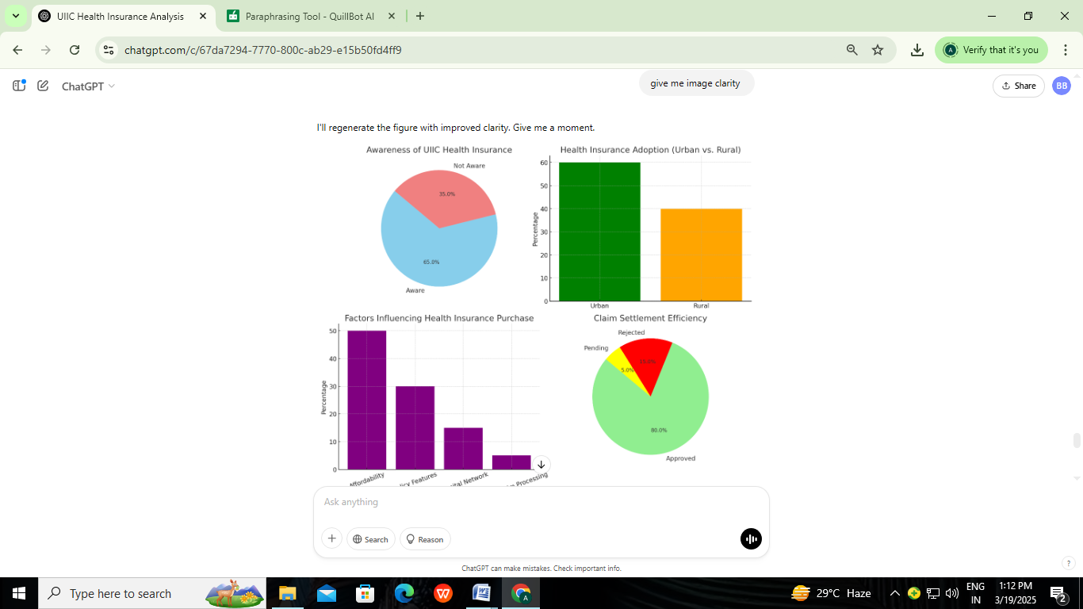

**Figure-1:** Awareness of UIIC Health Insurance, Health Insurance Adoption (Urban VS Rural), Factors Influencing Health Insurance purchase, claim Settlement Efficiency

.

1. **CONCLUSION AND FUTURE SCOPE**

This study examined the medical insurance plans provided by United India Insurance Company (UIIC) in the Hyderabad and Rangareddy districts, with an emphasis on consumer happiness, policy accessibility, and the effectiveness of claim settlement procedures. While UIIC offers a variety of cheap health insurance policies for individuals, families, and seniors, issues such as long claim wait times, complex policy terms, and little knowledge, particularly in rural areas, continue to be significant impediments. Despite these problems, UIIC's wide hospital network and attractive premium structures improve accessibility, making healthcare more affordable for a large segment of the population.

Several areas can be explored further to improve the impact of health insurance in the region:

* Future research should focus on how technology, including mobile apps and internet platforms, may improve customer service and boost awareness, especially in rural areas with restricted access to information.
* Improved consumer education on health insurance benefits and processes can increase adoption rates, particularly in rural regions. Educational initiatives and digital awareness activities should be evaluated for their efficacy.
* Longitudinal Studies and Comparative Analysis: UIIC can improve its customer experience by tracking policyholder satisfaction over time and comparing it to other insurers.

1. **REFERENCES**
2. N. Tripathy, Insurance Theory and Practice, PHI Learning Pvt. Ltd., 2018.
3. P.K. Gupta, Insurance and Risk Management, Himalaya Publishing House, 2019.
4. IRDA Report, Annual Report on Health Insurance in India, 2021.
5. Policy Bazaar, Health Insurance Trends in India, 2022.
6. R. Kumar and S. Sharma, "Consumer Satisfaction in Health Insurance Policies," Journal of Finance & Insurance Studies, vol. 1, no. 1, pp. 45-56, 2020.
7. N. Tripathy, "Insurance Sector in India: Transition from Public to Private," Indian Journal of Business Research, vol. 11, pp. 12-25, 2018.
8. IRDA Report, Annual Report on Health Insurance in India, 2021.
9. Policy Bazaar, Health Insurance Trends in India, 2022.
10. R. Agarwal and P. Mishra, "Health Insurance Coverage in Rural India: Barriers and Opportunities," Indian Journal of Health Economics, vol. 22, no. 4, pp. 35-45, 2017.
11. Singh and S. Kumar, "Factors Influencing the Adoption of Health Insurance in India," Asian Journal of Business Research, vol. 10, no. 1, pp. 50-62, 2020.
12. P. Sharma, "Government Health Insurance Schemes in India," Journal of Public Health Policy, vol. 41, no. 2, pp. 255-270, 2020.
13. V. Mishra and M. Sharma, "Challenges in Health Insurance Adoption in Semi-Urban Areas," Health Economics Journal, vol. 28, no. 3, pp. 90-100, 2019.
14. R. Singh and S. Patil, "Consumer Perception of Health Insurance: An Empirical Study," Journal of Insurance Studies, vol. 18, no. 1, pp. 15-28, 2020.
15. S. Verma, "The Impact of Digital Transformation on the Insurance Sector," Journal of Business Research, vol. 29, no. 2, pp. 78-89, 2018.
16. R. Gupta and M. Verma, "Enhancing Consumer Awareness about Health Insurance in Rural Areas," International Journal of Health Policy and Management, vol. 10, no. 5, pp. 200-210, 2021.
17. N. Sharma and V. Bansal, "The Role of Awareness in the Adoption of Health Insurance in India," Indian Journal of Finance, vol. 13, no. 3, pp. 45-58, 2019.
18. S. Ankilla, et al., "Predictive analytics for heart disease: A comparative study of machine learning classification techniques," International Research Journal of Education and Technology, pp. 100–106, 2025.
19. Chaitanya, et al., "Enhancing PID mellitus classification through decision trees and random forest algorithms," International Journal of Innovative Research in Technology (IJIRT), vol. 11, no. 6, 2024.
20. Soujanya, et al., "Machine learning approaches for accurate breast cancer classification," International Journal of Progressive Research in Engineering Management and Science (IJPREMS), vol. 4, no. 12, 2024.
21. V. Bondhala, et al., "Transforming healthcare through machine learning: A review of predictive and preventive health applications," International Research Journal of Modernization in Engineering Technology and Science, vol. 6, no. 12, pp. 2301–2307, 2024.
22. B. Jyothi, et al., "Machine learning approaches for liver cancer classification: A comprehensive review," International Research Journal of Modernization in Engineering, Technology and Science, vol. 6, no. 12, pp. 2442, 2024.
23. K. Akhila, et al., "Early prediction of chronic kidney disease using machine learning: A comprehensive review," International Journal of Progressive Research in Engineering Management and Science (IJPREMS), vol. 4, no. 12, pp. 1140–1245, 2024.