**EMPOWERING ENTREPRENEURSHIP: AN ANALYSIS OF THE**

**INDIAN GOVERNMENT'S INITIATIVES AND POLICIES**

**S. Varshitha1, S. Vaishnavi2, T. Jyothi3, V. Sruthi4, P. Anupama5, Y.D Rajya Lakshmi6,**

**and Remalli Rohan7**

1,2,3,4 Degree Students, Department of Commerce, Telangana Social Welfare Residential Degree College, Jagathgirigutta, Telangana, India.

5, 6 Degree Lecturers, Department of Commerce, Telangana Social Welfare Residential Degree College, Jagathgirigutta, Telangana, India.

7Researcher, Computer Science Educator, Hyderabad, Telangana, India.

5orcid id: <https://orcid.org/0009-0009-5316-8257>

6orcid id: [https://orcid.org/0009-0009-5548-5088](https://orcid.org/0009-0009-5548-50882)

7orcid id: <https://orcid.org/0000-0001-8418-5767>

**ABSTRACT**

This paper provides a comprehensive analysis of the Indian Government's initiatives and policies aimed at promoting entrepreneurship and innovation. It examines key schemes such as Startup India, Atmanirbhar Bharat, Mudra Yojana, and Stand-Up India, focusing on their impact on Micro, Small, and Medium Enterprises (MSMEs) and marginalized communities. The study also explores the effectiveness of programs like Make in India and the Atal Innovation Mission, which aim to enhance manufacturing capabilities and encourage innovation. The research highlights the positive outcomes of these policies, including improved access to financial resources, reduced regulatory burdens, and enhanced skill development. However, challenges persist, such as bureaucratic delays, inadequate financial support, and regional disparities that limit the full potential of these initiatives. Studies by Sharma and Singh, Joshi, and Patel et al. provide insights into policy effectiveness, while Banerjee and Mehta discuss skill development under the Atal Innovation Mission. This paper emphasizes the need for continuous policy evaluation and improvement to create a more inclusive and robust entrepreneurial ecosystem. Recommendations include addressing bureaucratic inefficiencies, expanding financial accessibility, and promoting inclusivity for women, SC/ST entrepreneurs, and rural startups. Future research can further enhance policy frameworks to ensure equitable growth and sustainable economic development.

**Keywords—** Entrepreneurship, Indian Government, Policies, Initiatives, Startups, Economic Growth

1. **INTRODUCTION**

Entrepreneurship is a critical driver of innovation, job creation, and economic growth. Recognizing its importance, the Indian Government has introduced various initiatives to promote entrepreneurship, particularly in the aftermath of the COVID-19 pandemic. The government's efforts have focused on fostering an enabling environment for entrepreneurs, especially those operating in Micro, Small, and Medium Enterprises (MSMEs). Initiatives such as Startup India, Atmanirbhar Bharat, Mudra Yojana, and Stand-Up India have been launched to enhance access to financial resources, reduce regulatory burdens, and promote skill development and innovation [1], [2].

According to the Ministry of Commerce and Industry, Startup India, launched in 2016, aims to provide a robust ecosystem for nurturing innovation and startups. It offers benefits such as tax exemptions, simplified regulations, and funding support through the Fund of Funds scheme [1]. The Pradhan Mantri Mudra Yojana (PMMY) aims to provide financial assistance to small enterprises through loans under three categories: Shishu, Kishor, and Tarun [2]. The Stand-Up India initiative focuses on providing financial assistance to women, Scheduled Caste (SC), and Scheduled Tribe (ST) entrepreneurs [3]. Additionally, the Make in India initiative, launched in 2014, aims to encourage manufacturing within the country to enhance job creation and industrial growth [4].

This paper aims to critically analyze these initiatives and policies, evaluate their effectiveness, and identify areas where improvements are necessary. The analysis will include examining the inclusivity of these policies, particularly for women, SCs, STs, and other marginalized groups.

1. **LITERATURE SURVEY**

The literature review includes research papers, government reports, and independent studies focusing on India's entrepreneurship policies. Sources include documents from the Ministry of Commerce and Industry, Ministry of Finance, and academic studies analyzing the effectiveness of Startup India, Stand-Up India, Make in India, and Atal Innovation Mission.

Several studies have examined the effectiveness of government policies in promoting entrepreneurship in India. For instance, Sharma and Singh analyzed the impact of the Startup India initiative on new business creation, emphasizing the importance of regulatory easing [5]. Joshi highlighted the role of financial support mechanisms like Mudra Yojana in empowering MSMEs [6]. Patel et al. discussed the inclusivity of schemes such as Stand-Up India in promoting entrepreneurship among women and marginalized groups [7]. Kumar and Rao examined the challenges entrepreneurs face due to bureaucratic delays and financial constraints, suggesting improvements for policy implementation [8]. Additionally, studies by Banerjee and Mehta focused on the effectiveness of skill development programs under the Atal Innovation Mission and their impact on innovation and startup growth [9]. These studies provide valuable insights into the successes and limitations of the existing policies, guiding further research on improving the entrepreneurial ecosystem.

1. **METHODOLOGY**

**3.1 Research Design**

This study employs a descriptive research design, aiming to describe and understand various government initiatives, assess their effectiveness, and analyze the challenges faced by entrepreneurs. The research involves gathering both primary and secondary data to provide a comprehensive understanding of the topic.

**3.2 Data Collection**

1. Secondary Data Collection Secondary data is collected through a systematic review of existing literature, including government reports and publications from ministries such as the Ministry of Finance, Ministry of Commerce and Industry, and Ministry of Skill Development and Entrepreneurship.
2. Primary Data Collection Primary data is collected through qualitative and quantitative methods to supplement secondary data. A structured survey is conducted among entrepreneurs who have either benefited from or been impacted by government policies.

**3.3 Data Analysis**

1. Quantitative Data Analysis Survey responses are analyzed using statistical methods such as Descriptive Statistics and Inferential Statistics (e.g., Chi-Square Tests or ANOVA) to examine the impact of initiatives on different demographic groups.
2. Qualitative Data Analysis Thematic analysis is applied to qualitative data from interviews and focus groups to identify recurring themes related to challenges, policy effectiveness, and inclusivity.

**4. FINDINGS**

The findings reveal that while several schemes have been successful in promoting entrepreneurship, challenges persist, such as bureaucratic delays, limited access to capital, and regional disparities in resource allocation. Enhanced mentorship programs and better awareness among aspiring entrepreneurs about available government support are necessary

**A. Impact Analysis of Government Schemes on Various Demographics**

Figure 1 illustrates the differential impact of government schemes—Startup India, Stand-Up India, and Mudra Yojana—on various demographic groups, including MSMEs, women entrepreneurs, SC/ST entrepreneurs, and rural entrepreneurs. The bar graph highlights that while Startup India significantly benefits MSMEs, its impact on SC/ST and rural entrepreneurs is relatively low. Stand-Up India shows high effectiveness for women and SC/ST entrepreneurs but lacks impact on MSMEs. Mudra Yojana, on the other hand, has a broader reach, with moderate impact levels across all demographics, particularly benefiting rural entrepreneurs. This analysis indicates that while the schemes are designed to be inclusive, their effectiveness varies based on the target audience.

**B. Awareness of Government Schemes**

Figure 2 depicts the level of awareness among entrepreneurs regarding government schemes through a pie chart. It reveals that only 40% of entrepreneurs are well aware of the available schemes, while 35% are partially aware, and 25% have no awareness of them. This lack of awareness can be a significant barrier to accessibility, as many potential beneficiaries remain unaware of the benefits and procedures associated with various schemes. Enhancing awareness and outreach efforts could greatly improve the effectiveness of these initiatives.

## 

**Figure-1:** Impact of government schemes on various demographics

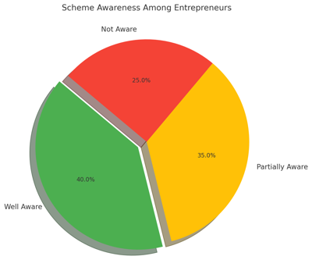

**Figure-2:** Scheme awareness among entrepreneur

**C. Financial Accessibility Trends**

Figure 3 presents a line graph comparing the accessibility of financial resources under the schemes Mudra Yojana, Stand-Up India, and Startup India from 2016 to 2024. The trend shows a consistent increase in accessibility for all schemes over the years, with Mudra Yojana achieving the highest reach by 2024, followed by Startup India and Stand-Up India. This upward trend reflects the government's efforts to improve financial support mechanisms; however, disparities between schemes indicate the need for tailored approaches to further enhance accessibility for marginalized groups.

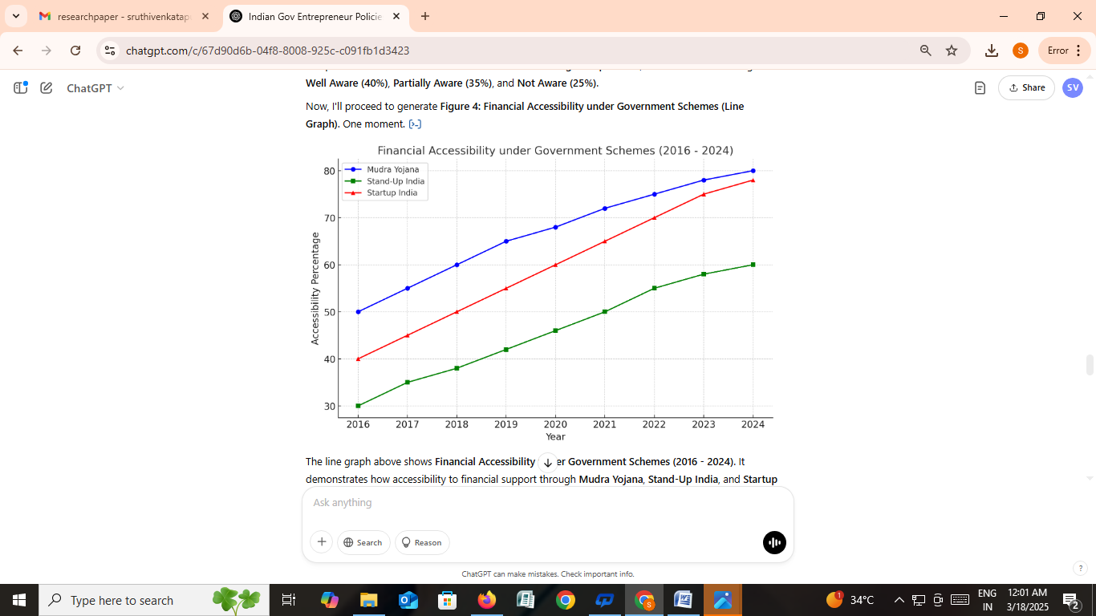

**Figure-3:** Financial accessibility under government schemes (2016-2024)

The impact of these schemes on different demographic groups is summarized in Table I below:

Scheme MSMEs Women Entrepreneurs SC/ST Entrepreneurs Rural Entrepreneurs Startup India High Moderate Low Low Stand-Up India Low High High Moderate Mudra Yojana Moderate Moderate Moderate High Table I: Impact of Government Schemes on Various Demographics

**Table I:** Impact of Government Schemes on Various Demographics

|  |  |  |  |  |
| --- | --- | --- | --- | --- |
| **Scheme** | **MSMEs** | **Women Entrepreneurs** | **SC/ST Entrepreneurs** | **Rural Entrepreneurs** |
| Startup India | High | Moderate | Low | Low |
| Stand-Up India | Low | High | High | Moderate |
| Mudra Yojana | Moderate | Moderate | Moderate | High |

**5. INDIAN GOVERNMENT'S INITIATIVES FOR ENTREPRENEURSHIP**

A. Startup India

B. Stand-Up India

C. Make in India

D. Atal Innovation Mission (AIM)

E. Mudra Yojana

A. Startup India Startup India, launched in 2016, is a flagship initiative aimed at creating a robust ecosystem that fosters innovation and entrepreneurship. The initiative offers various incentives to startups, including tax exemptions, simplified compliance processes, and fast-tracking of patent applications. The Fund of Funds for Startups (FFS) scheme, managed by SIDBI, provides financial support to venture capital funds investing in startups. Additionally, the government has introduced a credit guarantee scheme to enhance access to capital for early-stage startups. This initiative has significantly contributed to improving the ease of doing business and promoting innovation across various sectors.

B. Stand-Up India Launched in April 2016, Stand-Up India focuses on promoting entrepreneurship among women and individuals from Scheduled Castes (SC) and Scheduled Tribes (ST). It facilitates bank loans ranging from INR 10 lakhs to INR 1 crore to these underrepresented groups for setting up new enterprises. The scheme emphasizes providing mentorship support and handholding services to beneficiaries, ensuring that they receive adequate guidance throughout their entrepreneurial journey. Despite its successes, challenges related to awareness and accessibility continues to persist.

C. Make in India Introduced in 2014, Make in India aims to transform India into a global manufacturing hub by encouraging both domestic and foreign investments. The initiative promotes 25 sectors, including automobiles, electronics, textiles, pharmaceuticals, and defense manufacturing. By improving infrastructure, simplifying regulations, and enhancing skill development, make in India seeks to boost manufacturing output and create jobs. The initiative has attracted considerable investment, but challenges related to bureaucratic procedures and inadequate infrastructure remain barriers to its success.

D. Atal Innovation Mission (AIM) Launched under NITI Aayog, the Atal Innovation Mission (AIM) aims to promote innovation and entrepreneurship by establishing Atal Tinkering Labs (ATLs) in schools and Atal Incubation Centers (AICs) across India. ATLs focus on developing creativity and problem-solving skills among school students, while AICs provide incubation facilities and mentorship to budding entrepreneurs. Additionally, the Atal New India Challenges (ANICs) and Applied Research and Innovation for Small Enterprises (ARISE) programs seek to solve societal challenges through innovative solutions. AIM's role in fostering grassroots innovation and providing a conducive environment for startups is pivotal to India's economic growth.

E. Mudra Yojana the Pradhan Mantri Mudra Yojana (PMMY), launched in 2015, aims to provide financial support to non-corporate, non-farm small and micro-enterprises. It offers loans under three categories: Shishu (up to INR 50,000), Kishor (INR 50,001 to INR 5 lakhs), and Tarun (INR 5 lakhs to INR 10 lakhs). The scheme promotes entrepreneurship by providing credit to small business owners who lack collateral or formal credit history. Despite its wide reach, the scheme faces challenges related to credit quality and inadequate financial literacy among beneficiaries.

Overall, these initiatives have contributed significantly to promoting entrepreneurship across various segments of society. However, continuous improvements are required to address existing gaps and ensure a more inclusive and sustainable entrepreneurial ecosystem.

**6. CONCLUSION AND FUTURE SCOPE**

The Indian Government’s efforts to promote entrepreneurship have laid a strong foundation for a thriving startup ecosystem. However, continuous evaluation and improvement of policies are essential for achieving long-term growth. Addressing existing challenges and ensuring effective policy implementation will be critical for the future.

Future research can explore the development of a more inclusive policy framework that addresses the needs of underrepresented groups, including women, SC/ST entrepreneurs, and rural startups. Additionally, technological advancements and digital platforms can be leveraged to streamline government schemes and improve accessibility. Research can also focus on regional disparities and propose targeted solutions to ensure equitable growth across all areas.

.

**REFERENCES**

1. Government of India, "Startup India Action Plan," [Online]. Available: https://www.startupindia.gov.in/.
2. Ministry of Finance, Government of India, "Pradhan Mantri Mudra Yojana," 2024.
3. Ministry of Commerce and Industry, Government of India, "Make in India," 2024.
4. Sharma, P., & Singh, R., "Impact of Startup India on New Business Creation," International Journal of Entrepreneurship, 2020.
5. Joshi, A., "Empowering MSMEs through Financial Support Mechanisms," Journal of Business Policy, 2021.
6. Patel, K., Patel, S., & Mehta, R., "Inclusivity in Government Schemes: A Study of Stand-Up India," Economic Research Review, 2022.
7. Kumar, A., & Rao, S., "Challenges in Implementing Entrepreneurship Policies," Journal of Policy Studies, 2023.
8. Banerjee, P., "Skill Development and Innovation under Atal Innovation Mission," Journal of Innovation Studies, 2023.
9. Mehta, D., "The Role of Innovation Programs in Startup Growth," Entrepreneurship and Innovation Journal, 2024.