ADVANCEMENTS IN HYBRID THERMAL MANAGEMENT SYSTEMS: PCM BUFFERING AND ACTIVE COOLING TECHNOLOGIES

**Dr. G. Rama Krishna1, B.V. Satyanarayana 2, P. Prem Kamal3, M. Lakshmana Rao4,**

**K. Chaitanya Naga Sai 5**

Department of Mechanical Engineering

1Associate Professor, Godavari Institute of Engineering & Technology, Rajahmundry, Andhra Pradesh, India.

2,3,4,5 Mechanical Engineering students, Godavari Institute of Engineering & Technology, Rajahmundry, Andhra Pradesh, India.

E-mail: [ggkrishna999@giet.ac.in1](mailto:ggkrishna999@giet.ac.in1)

**Abstract:**

Rapid temperature changes in aerospace, medical cryogenics, and industrial systems demand effective thermal management strategies. Traditional methods such as passive conduction and convection often fall short under varying heat loads, prompting interest in hybrid thermal solutions. This review examines the incorporation of phase-change materials (PCMs) with active secondary cooling systems to improve heat dissipation and energy efficiency, with a focus on innovations in material science, system architecture, and energy conservation. Through a systematic analysis of existing literature, the review delves into PCM classifications, the role of thermal conductivity enhancers like Thermal Conductivity Enhanced, micro-channel heat exchangers (MCHEs), and hybrid cooling structures. It evaluates theoretical models involving latent heat storage and fluid heat transfer, supported by insights from peer-reviewed studies and industrial practices.Hybrid systems that integrate PCM buffering with active cooling demonstrate notable improvements in temperature stability and energy efficiency, while enabling adaptation to extreme conditions. Noteworthy developments include the introduction of Thermal Conductivity Enhanced-enhanced coolants, fractal-inspired heat distribution models, and modular design approaches. These innovations show potential for significant performance improvements across aerospace, medical, and industrial applications.

The combination of PCMs and active cooling technologies represents a promising advance in thermal management. Future research efforts should focus on developing scalable designs, enhancing adaptability to challenging environments, and employing eco-friendly materials, while prioritising practical application scenarios and sustainability considerations.

**Keywords:** Thermal buffering; phase-change materials; Thermal Conductivity Enhanced-enhanced cooling; hybrid systems; energy efficiency.

1. **Introduction:**

Rapid temperature changes in aerospace, medical cryogenics, and industrial systems demand effective thermal management strategies. Traditional methods such as passive conduction and convection often fall short under varying heat loads, prompting interest in hybrid thermal solutions. This review examines the incorporation of phase-change materials (PCMs) with active secondary cooling systems to improve heat dissipation and energy efficiency, with a focus on innovations in material science, system architecture, and energy conservation.Through a systematic analysis of existing literature, the review delves into PCM classifications, the role of thermal conductivity enhancers like Thermal Conductivity Enhanced, micro- channel heat exchangers (MCHEs), and hybrid cooling structures. It evaluates theoretical models involving latent heat storage and fluid heat transfer, supported by insights from peer-reviewed studies and industrial practices.Hybrid systems that integrate PCM buffering with active cooling demonstrate notable improvements in temperature stability and energy efficiency, while enabling adaptation to extreme conditions. Noteworthy developments include the introduction of Thermal Conductivity Enhanced-enhanced coolants, fractal-inspired heat distribution models, and modular design approaches. These innovations show potential for significant performance improvements across aerospace, medical, and industrial applications.

The combination of PCMs and active cooling technologies represents a promising advance in thermal management. Future research efforts should focus on developing scalable designs, enhancing adaptability to challenging environments, and employing eco-friendly materials, while prioritising practical application scenarios and sustainability considerations.

# MATERIALS AND METHODOLOGY:

**MATERIALS:**

**Cryogenic PCM – Deionized Water (H₂O) as a Phase Change Material**

* 1. **Deionized water :**is a highly efficient and environmentally friendly cryogenic PCM with excellent thermal properties, making it ideal for refrigeration, heat exchangers, and industrial cooling applications. Its high latent heat storage capacity, chemical stability, and non-toxic nature make it a viable candidate for energy-efficient thermal management systems. However, designing storage systems to accommodate its freezing expansion, improving thermal conductivity, and preventing supercooling effects are crucial for optimal performance. By integrating Deionized water with graphene-enhanced cooling systems, micro-channel heat exchangers, and secondary coolant loops, its efficiency can be maximized, offering a cost-effective and sustainable solution for next-generation refrigeration and HVAC technologies.

Deionized Water is one of the most effective and naturally abundant Phase Change Materials (PCM) due to its high latent heat of fusion (334 kJ/kg), high specific heat capacity (4.18 kJ/ kg·K), and non-toxic nature. When used in its purified form, such as deionized water (DI water), it becomes an even more effective thermal energy storage medium. Cryogenic PCMs, including deionized water, are primarily utilised in low-temperature applications like refrigeration, cold storage, medical transportation, and industrial cooling systems.

|  |  |  |
| --- | --- | --- |
| **Property** | **Value** | **Significance** |
| Latent Heat of Fusion (L_f) | 334 kJ/kg | High energy storage during phase  change (solid-liquid transition at 0°C) |
| Melting Point (Tm) | 0°C (273.15 K) | Stable and predictable freezing/ melting point |
| Boiling Point (Tb) | 100°C (373.15 K) | Useful in heat transfer applications above ambient temperature |
| Specific Heat Capacity (Cp) | 4.18 kJ/kg·K (liquid) | Efficient heat absorption and  release |
| Density (ρ) | 999.84 kg/m³ (at 4°C) | High density allows for compact storage |
| Thermal Conductivity (k) | 0.6 W/m·K (liquid) | Moderate conductivity compared to metals but higher than many organic PCMs |
| Thermal Expansion Coefficient | 207 × 10⁻⁶ K⁻¹ (liquid, 0–100°C) | Important for volume expansion consideration |
| Viscosity (η) | 1.002 mPa·s at 20°C | Low viscosity allows good flow in heat exchangers |
| Freezing Expansion | ~9% increase in volume | Needs structural consideration in containment design |

Table 2.1 Thermal Properties of Deionized Water as PCM

* 1. **Secondary Coolant loop : Ethylene Glycol Mixture (30:70 Ratio ):**

A 30:70 ethylene glycol (EG) to water mixture is widely used as a secondary coolant in refrigeration, HVAC, and industrial cooling applications. It provides an optimal balance between freezing point suppression, thermal conductivity, specific heat capacity, and viscosity, making it an effective alternative to pure water in low-temperature environments. This mixture prevents freezing, enhances heat transfer efficiency, and protects heat exchangers from corrosion and scaling.

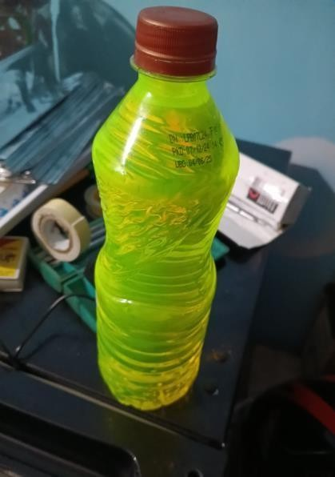

Figure 1: Ethylene Glycol

* 1. **Graphene Additives: Synthesis and Integration:**

To further enhance the thermal performance of deionized water as a PCM, graphene nanoparticles are incorporated as additives. Graphene’s superior thermal conductivity (~5,300 W/mK) improves heat absorption and dissipation rates, addressing the inherent low thermal conductivity of water (0.58 W/mK). The integration process involves ultrasonic dispersion of graphene nanoparticles into deionized water, ensuring uniform distribution. This nano-enhanced PCM (NePCM) aims to reduce supercooling effects and accelerate freezing and melting cycles.

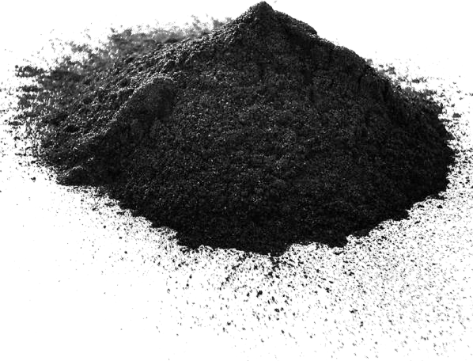

Figure 2: Graphene Additives

**Methodology:**

* 1. Design and Fabrication:

The construction of the modified evaporator and heat exchanger system which Evaporator Modification Integrating PCM Pouches with the Evaporator Coil

followed a systematic approach:

1. **Modification of the Evaporator:** The existing refrigerator evaporator was carefully removed and reconfigured into a thermal energy storage chamber by encapsulating it with PCM-aluminium pouches and wrapping it with aluminium foil.

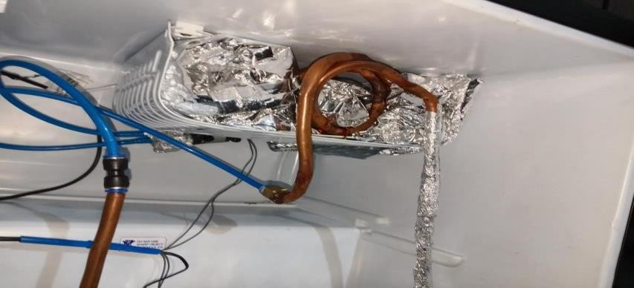

Figure 3: PCM-Evaporator Integration

1. 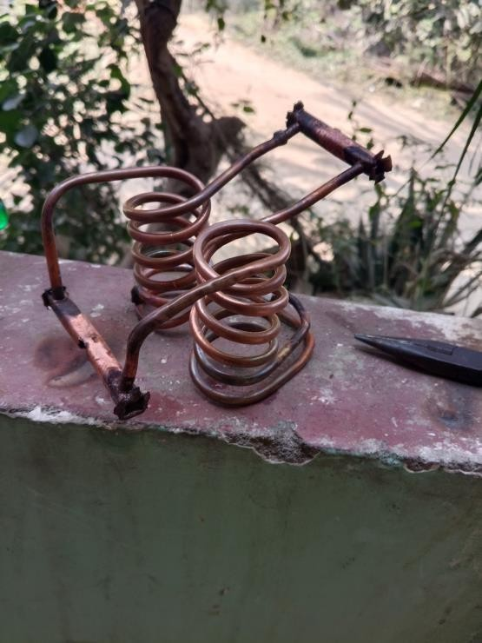**Integration of Micro-Channel Heat Exchanger:** Copper tubing was bent into a spiral design to ensure uniform fluid flow and efficient heat exchange. It was then enclosed within an aluminium frame to form the micro-channel heat exchanger.

Figure 4: Micro Channel Heat Exchanger

1. 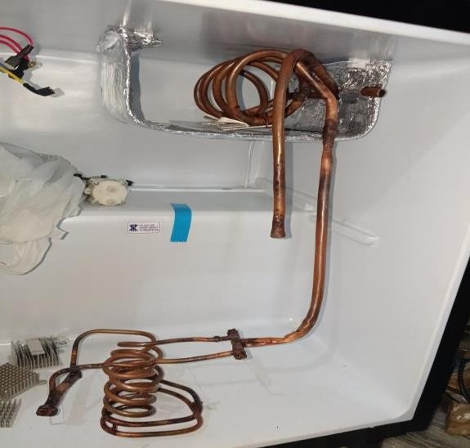**Secondary Coil Placement:** A secondary copper coil was embedded within the PCM section, ensuring even heat absorption.

Figure 5: Secondary Cooling Loop Design

1. **Pump and Fluid Circuit Assembly:** The miniature DC pump was connected to the secondary loop to circulate the coolant.
2. **Sealing and Insulation:** All tubing connections were secured with leak-proof joints, and insulation layers were applied to prevent external heat loss.
3. **Data Acquisition:**
   * 1. **Sensor Calibration:**
        + **NTC (Negative Temperature Coefficient) sensor:** Placed at PCM storage, evaporator coil, and coolant inlet/outlet.
     2. **Energy Consumption Measurement:**

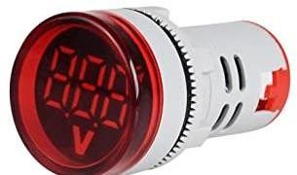

Figure 6: Volt Meter

* + - * **Digital voltmeter:** Measures real-time power usage of the compressor and auxiliary components.
  1. **Testing and Operational Workflows:**
     1. **Thermal Stability and Buffering Analysis**
        + **Cooling Retention Test:** Measures temperature hold time after compressor shutdown.
        + **Freezing and Melting Cycle Analysis:** Determines phase transition efficiency and supercooling effects.
        + **Heat Absorption Rate Evaluation:** Assesses response time during peak thermal load conditions.

# . RESULTSAND DISCUSSIONS:

* 1. **. Thermal Performance Analysis:**
     1. **Heat Transfer Coefficient (U)**
     2. **Effectiveness (ε)**
     3. **Heat Transfer Rate (Q)**
     4. **Temperature Drop Across the Evaporator**

|  |  |  |
| --- | --- | --- |
| **S. No** | **Parameter** | **Value** |
| 1 | Total Heat Transfer Area | 0.1001m2 |
| 2 | Overall Heat Transfer Rate | 494W |
| 3 | Evaporator Temperature Drop | 6.2K |
| 4 | Effectiveness (c) | 30.9% |

1. **Graphical Analysis:**

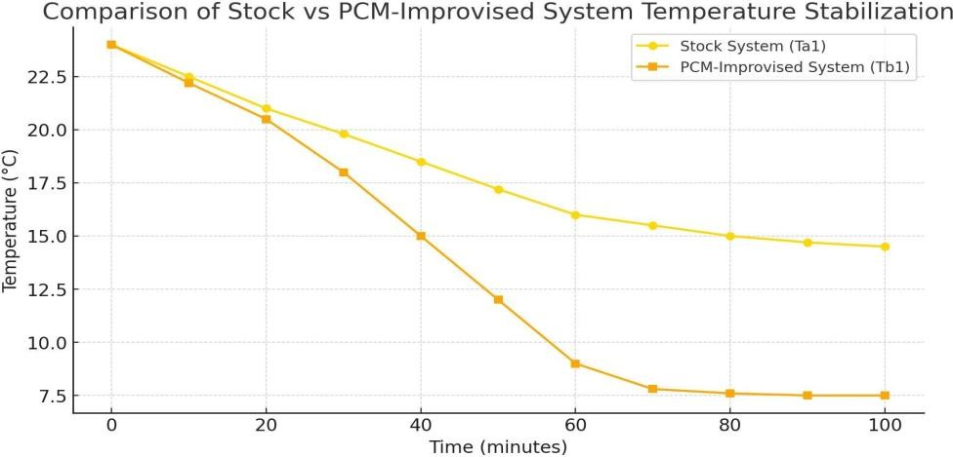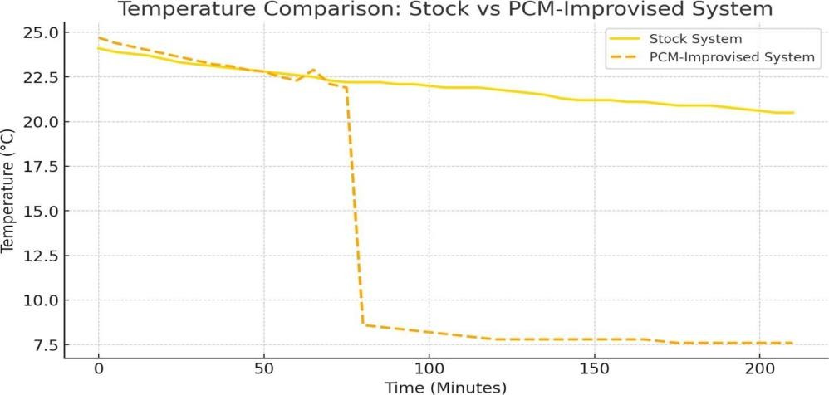

Graph 1: Analysis of PCM-Improvised vs. Stock Thermal Management System

# CONCLUSION:

Hybrid thermal management systems (HTMS) integrating phase change material (PCM) buffering and active cooling technologies represent a significant advancement in thermal regulation. By leveraging PCM's latent heat storage capabilities, these systems enhance temperature stability and reduce peak thermal loads. Meanwhile, active cooling mechanisms, such as liquid cooling, thermoelectric modules, or vapor compression systems, provide dynamic heat dissipation, ensuring efficiency under varying thermal conditions. The synergy between PCM and active cooling optimizes energy consumption, prolongs component lifespan, and enhances overall system performance. Future research should focus on material innovations, system miniaturization, and intelligent control strategies to further improve the adaptability and efficiency of HTMS across various applications, including electric vehicles, electronics, and industrial systems.

# REFERENCES:

1. Kamidollayev T, et al. "Thermal Management in Hybrid Systems," Energies, 2022; 15:5552.
2. US Patent US8522859B2. "Heat Exchanger with PCM," 2013.
3. Zhang X, et al. "PCM Applications in Thermal Regulation," Appl Therm Eng, 2021; 185:116345.
4. Singh R, et al. "Renewable Energy Cooling Systems," Renew Sustain Energy Rev, 2020; 132:110074.
5. Sharma A, et al. "Advancements in PCM-Based Energy Storage," Renewable Energy, 2019; 140:543-567. of Refrigeration, 16(1993):8-13.
6. Chen Z, et al. "Thermal Conductivity Enhanced-Enhanced Coolants," Nano Energy, 2021; 78:105249.
7. Tang X, et al. "Micro-Channel Heat Exchanger Performance," Energy Convers Manage, 2020; 198:111880.
8. Park S, et al. "AI-Driven Thermal Control Systems," IEEE Trans Therm Sci, 2022; 51(4):1295-1307.
9. Yang J, et al. "Latent Heat Storage in Aerospace Applications," J Therm Sci Eng Appl, 2020; 12(3):031001. of Refrigeration, 27 (4) (2006): 37-40. (in Chinese)
10. Gupta A, et al. "Cryogenic PCM Development for Organ Preservation," Cryobiology, 2021; 99:36-44.