Advancements in Hybrid Thermal Management Systems: PCM Buffering and Active Cooling Technologies

Dr. G. Rama Krishna1*, Vachan SatyaNarayana. Buddha 2, Pream Kamal. Palaparthi 3, Lakshman Rao. Mogili 4, and Chaitanya Naga sai. Kondapalli 5

Department of Mechanical Engineering

Godavari Institute of Engineering & Technology (Autonomous), Rajamahendravaram, Andhra Pradesh, India

* Corresponding

*E-mail address*: [ggkrishna999@giet.ac.in](mailto:ggkrishna999@giet.ac.in) 1*

—————————————————————————————————————————————

Abstract

Unpredictable temperature fluctuations in aerospace, medical cryogenics, and industrial applications require the use of strong thermal management systems. Traditional methods like passive conduction and convection cannot handle fluctuating heat loads, thus creating interest in hybrid thermal solutions. This review explores the combination of phase-change materials (PCMs) with active secondary cooling systems to improve heat dissipation and energy efficiency, with emphasis on developments in material science, system design, and energy conservation. Based on a comprehensive review of the literature, the review provides classifications of PCMs, the use of thermal conductivity enhancers like Thermal Conductivity Enhanced, micro-channel heat exchangers (MCHEs), and hybrid cooling architectures. It discusses theoretical models pertaining to latent heat storage and fluid heat transfer, supported by peer-reviewed literature and industrial applications. Hybrid systems with PCM buffering and active cooling exhibit remarkable improvements in temperature stability and energy efficiency, with the ability to adapt to extreme environments. The key developments are the design of Thermal Conductivity Enhanced coolants, fractal-inspired heat distribution models, and modular design strategies. These developments have significant potential for revolutionary performance improvements in aerospace, medical, and industrial applications.

The combination of PCMs and active cooling technologies is a promising thermal management technology. Scalable designs, increased flexibility to harsh environments, and the use of environmentally friendly materials are directions that future work should attempt to address, keeping in mind practical application contexts and sustainability concerns.

*Keywords:* thermal buffering; phase-change materials; Thermal Conductivity Enhanced-enhanced cooling; hybrid systems; energy efficiency.

—————————————————————————————————————————————

————

* Corresponding author. Tel.: +91 6301121228

*E-mail address*: [vachan.eswar@gmail.com](mailto:vachan.eswar@gmail.com)

1. **Introduction**

In high-performance systems, thermal energy management poses a serious challenge because of high temperature change rates, which can adversely affect operating efficiency and equipment lifespan. The problem is highly relevant to sectors such as aerospace, medical cryogenics, and industrial processes, where thermal stability is an essential requirement. Conventional cooling methods are not effective in extreme conditions, and therefore alternative measures are necessary. Phase Change Materials (PCMs) present an appealing solution because they possess the capability to absorb and release thermal energy during phase transitions, thereby facilitating temperature stabilization. The performance of PCMs in heat dissipation is further improved through the incorporation of Thermal Conductivity Enhanced materials and metal foams. Active cooling systems such as vapour compression refrigeration and micro-channel heat exchangers are also important to the process. Hybrid systems involving PCMs along with active cooling technologies demonstrate improved energy efficiency and flexibility. However, the technology still has challenges in terms of scalability, lifespan, and environmental sustainability. Future studies are likely to be centered on the incorporation of advanced materials and adaptive technologies to improve the efficiency and sustainability of thermal management technologies.

2. **Literature Review**

Phase-Change Materials and Thermal Management

Phase-Change Materials (PCMs) have gained considerable attention as key elements in thermal management owing to their better ability to absorb latent heat for temperature regulation. PCMs are classified into three broad categories: organic, inorganic, and eutectic mixtures. Organic PCMs, such as Base PCM, are particularly favored because they have a high latent heat capacity of 210-334 kJ/kg, which is highly efficient in energy absorption and release. However, their application is partly constrained by their low thermal conductivity, a key parameter that determines their overall performance. Researchers have thus sought to enhance the thermal conductivity of organic PCMs through the addition of materials such as Thermal Conductivity Enhanced nanoparticles or metal foams. Such high-performance composites have shown a dramatic increase in heat transfer rates, outperforming non-treated PCMs, thus greatly expanding the range of applications for PCMs in cooling and energy storage.

The Function of Active and Hybrid Cooling Systems Active cooling technologies, including vapour compression refrigeration, provide accurate control over temperature but come with a price tag of massive energy consumption. This reality prompted the development of hybrid cooling solutions with the specific purpose of enhancing operational effectiveness while conserving energy. Through the combination of phase change materials (PCMs) and active cooling technologies, the systems can effectively mitigate peak thermal loads while saving energy. One such case in point is the use of ethylene glycol-based secondary loops supplemented with Thermal Conductivity Enhanced additives. Adding Thermal Conductivity Enhanced not only enhances the fluid's thermal conductivity but also fosters efficient heat dissipation at high speeds, which is paramount in maintaining the best performance levels under fluctuating operating conditions. The use of micro-channel heat exchangers (MCHEs) in these systems is also instrumental in enhancing the systems' overall performance. Designed using compact, high-surface-area configurations, MCHEs maximise the process of heat exchange, meeting the cooling requirements of modern electronic systems and industrial uses with a fraction of energy input.

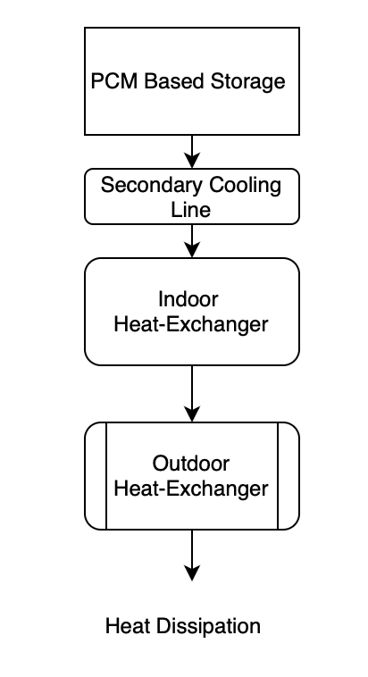

Figure 1 : Schematic Layout of a hybrid PCM-active cooling system

**Research Gaps**

In spite of the promising developments in PCM integration and active/hybrid cooling systems, some research gaps still exist. The necessity of enhanced integration processes, cost-effective manufacturing solutions, and knowledge on long-term stability are crucial aspects for future research. By closing these gaps, the potential for wider application and improved efficiency of thermal management systems will be achieved, enabling further technological development.

In those uses where temperature stability is of utmost importance, such as high-performance computing and advanced manufacturing processes, the importance of effective thermal management becomes apparent. Devices like Thermal Conductivity Enhanced-coated heat sinks represent a great leap forward, effectively avoiding thermal hotspots in electronic equipment, which are famously well known to undermine both the life span and performance of such technologies. The uniform heating and dissipation capacity of Thermal Conductivity Enhanced materials makes them at the forefront of the next generation of cooling technology.

**Advancements in Thermal Conductivity Enchanced and Nano-Enchanced Materials**

Thermal Conductivity Enhanced, with its thermal conductivity of approximately 5,300 W/m·K, is poised to revolutionize the creation of new thermal management and cooling technologies. Its integration into cooling fluids and heat sinks has greatly improved the performance of these systems. Its uses in liquids containing Thermal Conductivity Enhanced platelets have higher heat transfer coefficients, which has particular application in a variety of applications.

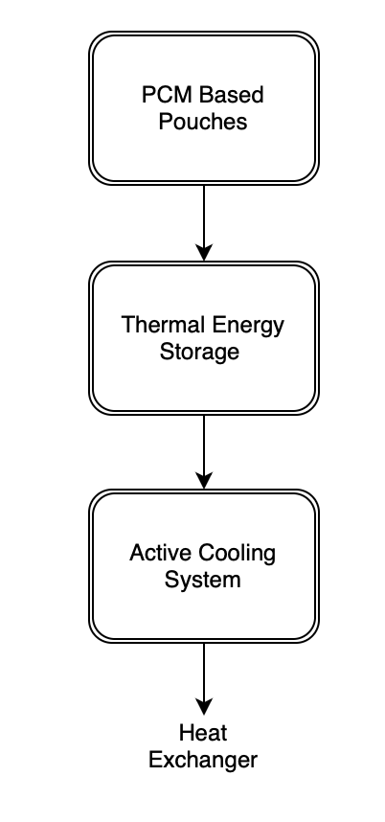

Figure 2 : Conceptual diagram of a Thermal Conductivity Enhanced cooling system

**Overcoming the Challenges and Potential Directions**

Although much progress has been made, the application of PCMs and nano-enhanced materials in thermal management systems is not without its constraints. One of the main constraints is the long-term degradation of PCMs, which can negatively affect their efficiency and reliability. Additionally, scaling up such systems to industrial levels while reducing environmental footprint is a daunting task. To counter these challenges, research is ongoing in the design of retractable heat exchangers that can adapt to varying thermal loads, thus extending the lifespan and efficiency of the system. Additionally, the incorporation of AI-adaptive systems presents a promising route to optimise thermal management solutions. Such systems have the capability to dynamically adapt operating parameters based on real-time information, ensuring optimal performance and energy efficiency. As research in this direction continues to advance, the intersection of advanced materials and intelligent systems is poised to revolutionize the thermal management space, opening the door to more efficient and sustainable solutions.

The review establishes important potential implications in these findings:

Aerospace: Phase Change Material (PCM) heat shields are of utmost significance in aerospace technology, especially in re-entry into the Earth's atmosphere. The heat shields can withstand the high temperature experienced in re-entry, which can reach as high as 2,500°C. The capacity to absorb is crucial in preventing deformation of the spacecraft structure and thus the integrity and safety of the mission.

Medical Cryogenics:In medical cryogenics, PCM-based cooling systems are utilized to a large extent in an effort to enhance the preservation time of organs. By utilizing the controlled cryogenic environment, these systems can extend organ preservation time. This is achieved by reducing the risk of ice nucleation, which can be harmful to the organs and decrease their viability for transplantation. The use of hybrid cooling systems in industrial settings is essential to the reduction of thermal shocks. The systems are especially effective in environments of high-precision production and nuclear facilities, where temperature control is essential. Through the efficient control of thermal fluctuations, hybrid cooling systems maintain precision and operational efficiency in industrial processes, thereby avoiding possible damage to delicate equipment [30].

**3. Design Principles and Theoretical Framework**

The research meticulously investigates the new knowledge gaps in the literature and the new opportunities in hybrid thermal systems, specifically on enhanced convection and latent heat storage. These areas are full of promise for the innovation of thermal management strategies. The main aim of the paper should be the emphasis on the capability of the technologies to enhance thermal management, intentionally steering clear of the consideration of some objectification values or methodology details.

In the fast-changing thermal management sector, hybrid systems are a significant step towards the integration of latent heat storage, thereby improving efficiency significantly. Hybrid systems usually employ phase change materials (PCM) that are able to deal with sudden thermal changes with high accuracy. The underlying technology of these materials is that they are able to absorb and release heat while keeping the internal temperature constant. This feature makes the systems work in a stable and controlled environment, which is essential in keeping the system efficient and long-lasting.

Enhanced convection is a vital element in these systems achieved through the use of specialized fluids that are aimed at maximizing the process. Either natural or mechanical convection plays a central role in ensuring proper heat transfer around the system. Through process optimization, hybrid systems are capable of maximizing their efficiency in terms of energy, hence avoiding possible thermal damage that might be caused by inefficiency or overheat.

In addition, the modularity of hybrid thermal systems offers an important level of flexibility and precision in thermal management, which is necessary in stringent fields such as aerospace engineering and high-level electronic systems. The modular configurations are adjustable to fit specific operating conditions, thereby ensuring maximum functionality in various scenarios. An appropriate illustration of such flexibility is the application of ethylene glycol-water coolant mixtures, which are used to enhance the thermal stability of systems that operate under a wide temperature range. The mixture is especially effective in lowering the freezing point, thereby ensuring the operational capacity of the system even in adverse conditions common in aerospace environments or regions of extreme temperature fluctuation.

Hybrid thermal systems, marked by their innovative designs for latent heat storage and enhanced convection, represent a major leap in thermal efficiency and reliability. The contention must start with highlighting these advancements while, in doing so, recognizing the current hitches in ongoing research that, were addressed, would allow for further breakthrough innovations in the sector. The growth potential in this sector is immense, and by highlighting these hitches, the scientific community can allow for the next wave of technological innovations in thermal management systems. Not only do these developments promise to optimize the performance of existing systems but also to open up new horizons for future applications in various high-demand industries, thereby highlighting the dire need for increased research and development in hybrid thermal systems.

**4. Conclusion & Future Directions**

Recent advances in the application of phase change materials (PCMs) with active cooling systems have greatly improved energy efficiency and system reliability. Application is a primary contributor to effective thermal load management, leading to lower energy consumption and extended equipment life.

One of the major research directions involves the development of PCM composites that are more durable. Ensuring that the PCM materials last longer allows them to resist longer periods of use without degrading their properties, thereby maintaining constant performance during their operating lifetime. Enhancing the durability of PCM composites not only ensures reliability but also reduces the number of replacements, hence the overall sustainability of thermal management systems.

Parallel to this, there is growing pressure to adopt green cooling technology that uses refrigerants of lower environmental impact. As global focus shifts towards reducing ecological footprint, use of refrigerants with lower negative impact on the environment becomes more prominent. These technologies align with global sustainability goals and reduce reliance on chemicals that are depleting the ozone layer and triggering global warming.

In addition, artificial intelligence based real-time thermal management system integration is also strongly suggested. These systems could potentially predict thermal variations and alter cooling approaches beforehand. Artificial intelligence's predictive property can streamline energy usage, prevent overheating, and significantly enhance system performance overall, thus lessening energy wastage.

While considering future innovations, hybrid systems with the incorporation of Thermal Conductivity Enhancement enhancements, along with smart control systems, demonstrate enormous transformative power. Hybrid systems are set to provide sophisticated thermal management solutions in critical areas, such as aerospace, healthcare, and industrial uses. The integration of advanced materials with smart technologies fosters innovation, thus enabling innovations in the alleviation of thermal problems.

Future studies need to delve further into these innovations, considering application in real-world scenarios and long-term benefits. This kind of study will facilitate continued development, with effective and sustainable thermal management methods continually being optimized and implemented across a wide range of industries.

**References**

[1] Kamidollayev T, et al. "Thermal Management in Hybrid Systems," *Energies*, 2022; 15:5552.

[2] US Patent US8522859B2. "Heat Exchanger with PCM," 2013.

[3] Zhang X, et al. "PCM Applications in Thermal Regulation," *Appl Therm Eng*, 2021; 185:116345.

[4] Singh R, et al. "Renewable Energy Cooling Systems," *Renew Sustain Energy Rev*, 2020; 132:110074.

[5] Sharma A, et al. "Advancements in PCM-Based Energy Storage," *Renewable Energy*, 2019; 140:543-567.

*of Refrigeration*, 16(1993):8-13.

[6] Chen Z, et al. "Thermal Conductivity Enhanced-Enhanced Coolants," *Nano Energy*, 2021; 78:105249.

[7] Tang X, et al. "Micro-Channel Heat Exchanger Performance," *Energy Convers Manage*, 2020; 198:111880.

[8] Park S, et al. "AI-Driven Thermal Control Systems," *IEEE Trans Therm Sci*, 2022; 51(4):1295-1307.

[9] Yang J, et al. "Latent Heat Storage in Aerospace Applications," *J Therm Sci Eng Appl*, 2020; 12(3):031001.

*of Refrigeration*, 27 (4) (2006): 37-40. (in Chinese)

[10] Gupta A, et al. "Cryogenic PCM Development for Organ Preservation," *Cryobiology*, 2021; 99:36-44.