

**A SECURE LI-FI MODERN HEALTHCARE SYSTEM USING BODY SENSOR NETWORK AND MACHINE LEARNING**

**A PROJECT REPORT**

***Submitted by***

**MARATHU DEEKSHITHA (111521104083)**

**MEDA CHARMIKA (111521104085)**

**GANDHAMANENI GOWRI (111521104037)**

***in partial fulfillment for the award of the degree***

***of***

**BACHELOR OF ENGINEERING**

***in***

**ELECTRONICS AND COMMUNICATION ENGINEERING**

**R.M.D. ENGINEERING COLLEGE**

**(An Autonomous Institution)**

**MARCH 2025**

**R.M.D. ENGINEERING COLLEGE**

**(An Autonomous Institution)**

**BONAFIDE CERTIFICATE**

Certified that this project report **“ A SECURE LI-FI MODERN HEALTHCARE SYSTEM USING BODY SENSOR NETWORK AND MACHINE LEARNING ”** is the bonafide work of **MARATHU DEEKSHITHA , MEDA CHARMIKA , GANDHAMANENI GOWRI** who carried out the project work under my supervision.

|  |  |
| --- | --- |
| **SIGNATURE**  **Dr.K.HELENPRABHA**  **PROFESSOR**  **HEAD OF THE DEPARTMENT**  **DEPARTMENT OF ELECTRONICS AND COMMUNICATION ENGINEERING**  **R.M.D ENGINEERING COLLEGE**  **R.S.M NAGAR,KAVARAIPETTAI - 601206** | **SIGNATURE**  **Mr.D.BHARATHI DHASAN**  **SUPERVISOR**  **ASSISTANT PROFESSOR**  **DEPARTMENT OF ELECTRONICS AND COMMUNICATION ENGINEERING**  **R.M.D ENGINEERING COLLEGE**  **R.S.M NAGAR,KAVARAIPETTAI - 601206** |

The Viva-Voce Examination for the students who have submitted this project work is

held on …………………….

**INTERNAL EXAMINER EXTERNAL EXAMINER**

**ACKNOWLEDGEMENT**

At the outset, we would like to express our gratitude to our beloved and respected **Thiru. R.S. MUNIRATHINAM**, Chairman, R.M.D. Engineering College. We would like to thank **Thiru. R.M.KISHORE**, B.E., M.B.A, Vice Chairman for his encouragement, and our deepest gratitude for **Dr.N.ANBUCHEZHIAN**, Principal for his support during the course of the project.

We take this opportunity to give profound and heartfelt thanks to the Head of the Department of Electronics and Communication, **Dr.K. HELENPRABHA**, for her constant encouragement during the project, providing all the facilities, guidance and valuable suggestions to complete the project successfully and punctually.

Our sincere thanks to our **Mr.D.BHARATHI DHASAN**, Assistant Professor for having extended his fullest co-operation and guidance. We also thank for his constant support and patience.

We also thank our **Parents** for their unparalleled love and moral support & finally the **Almighty** for showering his generous blessings on us, without whom we would have not gone this far.

Last, but not the least, we wish to thank all the teaching and non-teaching staff members of Electronics and Communication Engineering Department, for their blessings and constant support throughout our dissertation.

**TABLE OF CONTENT**

|  |  |  |
| --- | --- | --- |
| **CHAPTER NO.** | **TITLE**  **LIST OF FIGURES**  **ABSTRACT** | **PG NO.**  **i**  **1** |
| **1** | **INTRODUCTION** | **2** |
|  | * 1. BACKGROUND   2. OBJECTIVE   3. PROBLEM STATEMENT | **2**  **3**  **4** |
| **2** | **EXISTING SYSTEM** | **5** |
| **3** | **PROPOSED SYSTEM** | **7** |
| **4** | **LITERATURE SURVEY** | **9** |
|  | 4.1 EMBEDDED SYSTEM FOR EYE BLINK DETECTION USING MACHINE LEARNING  4.2 LIFI BASED HEALTHCARE  COMMUNICATION SYSTEM  4.3 BODY SENSOR NETWORK FOR PATIENT MONITORING  4.4 MACHINE LEARNING FOR HEALTH ANOMALY DETECTION  4.5 IOT AND GSM-BASED HEALTH ALERT SYSTEMS | **9**  **9**  **10**  **10**  **11** |
| **5** | **SYSTEM DESIGN** | **12** |
|  | 5.1 TRANSMITTING SECTION  5.2 RECEIVING SECTION | **12**  **13** |
| **6** | **DESCRIPTION** | **15** |
|  | 6.1 ARDUINO UNO  6.1.1 ARDUINO PINOUT  6.2 LCD  6.3 HEARTBEAT SENSOR  6.3.1 INTRODUCTION  6.4 LIFI MODULE  6.5 GSM  6.6 MEMS SENSOR  6.7 DALLAS TEMP SENSOR  6.8 EYE BLINK SENSOR | **15**  **16**  **17**  **18**  **19**  **20**  **21**  **22**  **24**  **25** |
| **7** | **SOFTWARE DESCRIPTION** | **27** |
|  | 7.1 ARDUINO IDE  7.2 PYTHON  7.2.1 PYTHON FEATURES  7.2.2 PYTHON APPLICATION AREAS | **27**  **32**  **33**  **34** |
| **8** | **RESULTS** | **37** |
| **9** | **CONCLUSION** | **41** |
| **10** | **REFERENCES** | **42** |

**LIST OF FIGURES**

|  |  |  |
| --- | --- | --- |
| **FIGURE NO.** | **NAME OF THE FIGURE** | **PG NO.** |
| **5.1** | BLOCK DIAGRAM OF TRANSMITTER | **13** |
| **5.2** | BLOCK DIAGRAM OF RECEIVER | **14** |
| **6.1** | ARDUINO UNO | **15** |
| **6.2** | ARDUINO PINOUT | **16** |
| **6.3** | LCD DISPLAY | **18** |
| **6.4** | HEARTBEAT SENSOR | **19** |
| **6.5** | LIFI MODULE | **21** |
| **6.6** | GSM | **22** |
| **6.7** | MEMS SENSOR | **23** |
| **6.8** | DALLAS TEMPERATURE SENSOR | **24** |
| **6.9** | EYE BLINK SENSOR | **25** |
| **7.1** | HARDWARE WIZARD WINDOW | **27** |
| **7.2** | CHOOSE FILE WINDOW | **28** |
| **7.3** | FINISH WINDOW | **28** |
| **7.4** | START PAGE | **29** |
| **7.5** | SKETCH SELECTION PAGE | **29** |
| **7.6** | CODE PAGE | **30** |
| **7.7** | SELECTING BOARD PAGE | **30** |
| **7.8** | SELECT PORT PAGE | **31** |
| **7.9** | OPTIONS PAGE | **31** |
| **7.10** | FILE PAGE | **32** |
| **8.1** | OVERALL PROJECT KIT | **37** |
| **8.2** | EYE BLINK SENSOR READING | **37** |
| **8.3** | DROWSINESS DETECTION | **38** |
| **8.4** | MEMS SENSOR READING | **39** |
| **8.5** | FALL DETECTION | **39** |
| **8.6** | ABNORMAL HEARTRATE DETECTION | **40** |

**ABSTRACT**

A secure Li-Fi-based modern healthcare system using a body sensor network is designed for real-time patient monitoring with high-speed and secure data transmission. The system uses an Arduino UNO as the main controller, interfacing with multiple sensors such as a heartbeat sensor to monitor heart rate, a MEMS sensor to detect movement, an eyeblink sensor, and a Dallas temperature sensor for body temperature measurement. A GSM module is integrated to send alerts in case of abnormal conditions, while an LCD provides real-time feedback. The system operates with two main modules: a transmitter (TX) kit and a receiver (RX) kit, where Li-Fi technology ensures secure and reliable communication between them.

Li-Fi, or Light Fidelity, was introduced by German scientist and physicist Harald Haas during his TED Global Talk in Edinburgh, Scotland. It is a bi-directional, high-speed wireless communication technology that uses visible light from LEDs for data transmission. Li-Fi offers advantages such as improved data security, reduced interference, and faster communication compared to conventional wireless systems. The proposed healthcare system leverages this technology to establish a secure and efficient communication framework within hospitals and healthcare facilities. By using Li-Fi for data transmission, the system ensures patient information remains secure and is transmitted in real time, ultimately contributing to better patient care and quicker emergency responses.

**CHAPTER 1**

**INTRODUCTION**

* 1. **BACKGROUND**

The rapid advancement of wireless communication and healthcare technologies has led to the emergence of secure and efficient healthcare systems. One such innovation is the integration of **Light Fidelity (Li-Fi)** in modern healthcare, providing a high-speed, secure, and interference-free communication medium. Unlike conventional **Wi-Fi**, which relies on radio frequency, Li-Fi uses visible light for data transmission, reducing security vulnerabilities and electromagnetic interference in critical healthcare environments. This technology is particularly beneficial in hospitals, where secure and high-speed data transmission is crucial for real-time patient monitoring and diagnosis.

In addition to Li-Fi, the implementation of **Body Sensor Networks (BSNs)** enhances the efficiency of remote patient monitoring. BSNs consist of wearable or implanted sensors that continuously collect physiological data such as heart rate, oxygen levels, and body temperature. These sensors transmit real-time data to healthcare providers, enabling early detection of medical conditions. The combination of Li-Fi and BSNs ensures secure, high-speed communication, mitigating the risks associated with conventional wireless systems, such as data breaches and network congestion

To further enhance the accuracy and reliability of healthcare systems, **Machine Learning (ML)** algorithms are employed to analyze the vast amount of data collected by BSNs. ML techniques enable automatic anomaly detection, disease prediction, and personalized treatment recommendations. By leveraging ML, healthcare providers can make data-driven decisions, improving patient outcomes and reducing the burden on medical professionals.

* 1. **OBJECTIVE**

The primary objective of this project is to design and implement a **Secure Li-Fi Modern Healthcare System Using Body Sensor Network** that enables efficient, real-time, and secure monitoring of patient health parameters. By integrating **biomedical sensors, microcontrollers, and Li-Fi communication**, the system ensures fast, interference-free, and reliable data transmission, making it a highly effective solution for modern healthcare applications.

The system collects critical patient data, including **temperature, heart rate, eye blink, vibration, and blood pressure**, using specialized **biosensors**. These sensor readings are processed by a **PIC 16F877A microcontroller**, which converts the data into a suitable format for transmission. The processed information is displayed on an **LCD screen** for local monitoring and is simultaneously transmitted via **Li-Fi (Light Fidelity) technology**, ensuring secure, high-speed, and energy-efficient communication.

This project aims to address limitations in traditional wireless healthcare monitoring systems, such as **electromagnetic interference, security vulnerabilities, and data transmission delays**. Unlike conventional wireless methods, **Li-Fi-based transmission** provides a more secure and interference-free channel for real-time patient data transfer, making it ideal for critical healthcare environments like **ICUs, remote monitoring, and telemedicine**.Additionally, the system is designed to be **cost-effective, scalable, and adaptable** for future enhancements. By integrating **IoT, cloud computing, and AI-based predictive analytics**, the system can evolve to provide advanced healthcare solutions, such as remote diagnosis, automated emergency alerts, and data-driven insights for preventive care.

* 1. **PROBLEM STATEMENT**

In traditional healthcare monitoring systems, real-time patient health tracking faces several challenges, including **delayed data transmission, electromagnetic interference, security vulnerabilities, and limited remote accessibility**. Conventional wireless technologies like **Wi-Fi and Bluetooth** are prone to network congestion, hacking risks, and interference from other medical devices, making them unreliable for critical healthcare applications such as **ICU monitoring, emergency response, and telemedicine**.

Additionally, **existing wired systems** in hospitals restrict patient mobility, causing discomfort and inconvenience, while wireless systems often suffer from data loss, latency, and security threats. The lack of a **fast, interference-free, and secure communication method** poses a significant risk in life-threatening situations where **timely and accurate health data transmission** is crucial for medical intervention.

To address these issues, this project proposes a **Secure Li-Fi Modern Healthcare System Using Body Sensor Network**, which leverages **Li-Fi (Light Fidelity) technology** for high-speed, interference-free, and secure transmission of real-time patient health data. By integrating **biosensors, a PIC microcontroller, and Li-Fi transmission**, this system ensures **instant and reliable monitoring** of key health parameters like **heart rate, temperature, eye blink, vibration, and blood pressure**.

This solution aims to **enhance healthcare efficiency, improve patient safety, and enable remote monitoring** by providing a **cost-effective, scalable, and secure** alternative to traditional healthcare communication systems.

**CHAPTER 2**

**EXISTING SYSTEM**

Traditional healthcare monitoring systems primarily depend on **Wi-Fi, Bluetooth, or Zigbee** for data transmission. While these wireless communication technologies provide connectivity, they are **susceptible to interference, security vulnerabilities, and limited bandwidth**. In hospital environments, the simultaneous operation of multiple medical devices can cause **network congestion and signal degradation**, leading to unreliable data transmission. This interference poses a significant challenge in critical care settings, where **real-time and uninterrupted patient monitoring** is essential.

To monitor vital signs such as **heart rate, temperature, and movement**, many existing systems use **wearable or bedside monitoring devices**. These devices typically transmit patient data via **GSM, cloud-based IoT platforms, or local network connections**, allowing remote access to health information. However, **latency in data transmission** is a common issue with these methods. Delays in sending and receiving health alerts can hinder **timely medical intervention**, which is crucial for patients in critical conditions, such as those in **ICUs, post-surgical recovery, or emergency care**.

In addition to transmission delays, **most healthcare monitoring systems rely on threshold-based alert mechanisms**. These systems generate alerts only when a specific vital sign exceeds a predefined limit, failing to recognize **gradual health deterioration or complex medical conditions**. This approach lacks adaptability and may result in **missed early warnings** of potential health issues. A more intelligent system capable of analyzing patterns and deviations in patient data is needed to improve healthcare outcomes.

Furthermore, the **absence of machine learning-based anomaly detection** significantly limits the ability to **predict potential health risks** before they become critical. Without AI-driven analytics, healthcare systems cannot detect subtle changes in a patient’s condition that may indicate an emerging medical issue. Incorporating **predictive analytics and intelligent decision-making algorithms** would allow for **early diagnosis, proactive treatment, and personalized patient care**, ultimately enhancing the efficiency and reliability of healthcare monitoring systems.

The absence of machine learning-based anomaly detection in traditional healthcare systems limits their ability to identify early warning signs of medical conditions. Most existing systems rely on fixed threshold values, which can overlook gradual or complex health deteriorations. This makes it difficult to detect patterns that could indicate an emerging health issue, resulting in delayed medical responses and potentially worsening the patient’s condition.

By incorporating AI-driven predictive analytics, healthcare monitoring systems can analyze real-time sensor data, recognize hidden trends, and **anti**cipate health risks before they become critical. Machine learning algorithms, such as Random Forest and deep learning models, can process large volumes of patient data to provide personalized insights and intelligent alerts. This enhances the efficiency of real-time patient monitoring, enabling healthcare providers to take proactive measures and deliver faster, more effective treatment.

Moreover, an AI-powered approach can reduce false alarms by distinguishing between normal fluctuations and actual health threats. This minimizes unnecessary interventions while ensuring that genuine emergencies are addressed promptly. As a result, integrating machine learning in healthcare systems notonly improves patient outcomes but also optimizes hospital resources and enhances overall healthcare efficiency.

**CHAPTER 3**

**PROPOSED SYSTEM**

The proposed system addresses the limitations of traditional healthcare monitoring by integrating **Li-Fi technology** for **secure, high-speed, and interference-free data transmission**. Unlike conventional wireless methods such as Wi-Fi, Bluetooth, or Zigbee, **Li-Fi (Light Fidelity)** transmits data through visible light, ensuring a **faster, more reliable, and secure communication channel** between the **transmitter (TX) and receiver (RX) modules**. This eliminates electromagnetic interference, making it ideal for **hospitals, ICUs, and other medical environments** where interference from multiple devices can disrupt communication.

At the core of the system, an **Arduino UNO** acts as the **primary controller**, interfacing with a **body sensor network** to monitor critical health parameters in real time. The system includes a **heartbeat sensor, MEMS (Micro-Electro-Mechanical Systems) sensor, eyeblink sensor, and Dallas temperature sensor**, continuously tracking the patient's **vital signs and movement**. If an irregularity is detected, the system processes the data and takes appropriate action.

To further enhance **emergency response and remote monitoring**, a **GSM module** is integrated, enabling **automatic alert notifications** to caregivers or healthcare providers in case of abnormal health conditions. Additionally, an **LCD screen** provides real-time feedback, allowing for local monitoring of patient vitals.

Unlike traditional threshold-based monitoring systems, this project incorporates **machine learning (ML) for intelligent health analysis**. The **Random Forest algorithm in Python** is used to analyze sensor data, significantly improving the **accuracy of anomaly detection**. By learning patterns in the patient’s health data, the system can **identify early warning signs** of potential medical conditions before they become critical. When an anomaly is detected, **an automatic alert is triggered**, ensuring that healthcare providers can respond promptly, reducing response time in emergencies.

This innovative approach **enhances real-time monitoring, improves patient safety, and ensures a more efficient healthcare communication system**. By leveraging **Li-Fi for secure data transmission and machine learning for predictive analytics**, the system **bridges the gap between traditional monitoring and intelligent healthcare solutions**. Future enhancements could further integrate **cloud computing, IoT, and AI-driven decision-making**, making it an adaptable and scalable solution for modern **smart healthcare systems**.

**CHAPTER 4**

**LITERATURE SURVEY**

**4.1 EMBEDDED SYSTEM FOR EYE BLINK DETECTION USING MACHINE LEARNING**

This paper introduces an embedded system designed for eye blink detection utilizing a machine learning technique. The authors propose a comprehensive system capable of detecting eye blinks in real-time, which has potential applications in various fields, including driver drowsiness detection, human-computer interaction, and healthcare monitoring. The system likely integrates sensors such as cameras or infrared sensors to capture eye movements and employs machine learning algorithms for eye blink detection. The paper discusses the design considerations, implementation details, and performance evaluation of the embedded system, demonstrating its effectiveness and reliability in detecting eye blinks accurately. Additionally, the authors may present experimental results or case studies to validate the practical applicability and performance of the system in real-world scenarios.

**4.2 LIFI BASED HEALTHCARE COMMUNICATION SYSTEM**

Sharma et al. (2020) conducted research on the application of Li-Fi technology in healthcare systems, emphasizing its potential for secure and high-speed data transmission. Their study highlighted the advantages of Li-Fi over traditional wireless communication methods like Wi-Fi and Bluetooth, particularly in terms of reduced interference, higher bandwidth, and enhanced security. Unlike conventional wireless technologies that are prone to network congestion and electromagnetic interference, Li-Fi leverages visible light for data transmission, making it a more reliable and efficient alternative in medical environments where uninterrupted communication is crucial. The researchers developed and demonstrated a prototype healthcare system where patient health data was transmitted using Li-Fi technology, significantly reducing latency and ensuring real-time monitoring of vital signs. Their findings reinforced the idea that Li-Fi-based healthcare systems could provide faster and more secure data transfer, improving emergency response times and overall patient care.

**4.3 BODY SENSOR NETWORK FOR PATIENT MONITORING**

Patel and Kumar (2019) conducted a comprehensive review of body sensor networks (BSNs) in healthcare, emphasizing the growing role of wearable technology in real-time patient monitoring. Their research highlighted the integration of multiple physiologicalsensors, including heart rate, temperature, and movement sensors, to create a continuous and detailed assessment of patient health. They pointed out that BSNs enable seamless remote monitoring, reducing the need for frequent hospital visits while ensuring that health anomalies are detected early.The study also explored how BSNs enhance medical decision-making by providing real-time data to healthcare professionals, allowing for quicker and more precise interventions. By leveraging wireless connectivity, BSNs facilitate continuous patient tracking, even outside hospital environments, improving home-based care and chronic disease management.

**4.4 MACHINE LEARNING FOR HEALTH ANOMALY DETECTION**

Gupta et al. (2021) explored the application of machine learning algorithms in analyzing biomedical sensor data to detect health abnormalities. Their study compared various models, including Decision Trees, Support Vector Machines (SVM), and Random Forest, to evaluate their effectiveness in classifying abnormalhealthconditions. The results demonstrated that the Random Forest algorithm outperformed other models, providing higher accuracy and reliability in detecting irregularities in vital signs and sensor data.The research highlighted how machine learning enhances automated patient monitoring systems by enabling real-time analysis and predictive insights, reducing the dependency on traditional threshold-based alert mechanisms. By leveraging advanced data processing techniques, machine learning models can identify subtle patterns in biomedical data, leading to earlier detection of health risks and improved clinical decision-making.

**4.5 IOT AND GSM-BASED HEALTH ALERT SYSTEMS**

Reddy et al. (2022) conducted research on the **integration of IoT and GSM** for **real-time health monitoring and alert systems**, emphasizing their role in **enhancing patient care**. Their study proposed a **framework where biomedical sensors** continuously monitor **vital signs**, and the collected data is **processed and transmitted via GSM** to caregivers and healthcare providers in case of any **abnormalities**. This system ensures **immediate alerts** in emergencies, enabling **quicker medical interventions** and improving patient safety.The findings demonstrated that **GSM-based alert systems** significantly enhance **emergency response times** by delivering **real-time notifications** to healthcare professionals, reducing **delays in critical situations**. The study also highlighted how **remote monitoring capabilities** allow caregivers to track patient health from any location, making the system particularly beneficial for **elderly patients, individuals with chronic illnesses, and those in remote areas**.

**CHAPTER 5**

**SYSTEM DESIGN**

This model involves two zones which are Transmitting and Receiving portions. Both the portions have their own one of a kind basic purposes for this endeavor, which is enlisted underneath. Related Power supplies are given in both the territories.

**5.1 TRANSMITTING SECTION**

In this system, patients are central to the monitoring process, supported by various sensors that track their vital health parameters. These sensors include a temperature sensor, vibration sensor, eye blink sensor, heartbeat sensor, and blood pressure sensor. Each sensor produces either analog or digital signals, which are sent to the PIC microcontroller for further processing and analysis.

The PIC 16F877A microcontroller acts as the central processing unit, interpreting the data from the sensors and displaying real-time health parameters on an LCD screen. To enable wireless data transmission, a Li-Fi transmitter (LED) is integrated with the microcontroller.After processing, the microcontroller sets up serial communication with the Li-Fi transmitter, allowing health data to be transmitted efficiently through light signals, ensuring a fast and secure communication channel.

The PIC 16F877A microcontroller serves as the brain of the system, managing sensor inputs and overseeing data processing. It collects vital health parameters from multiple sensors and ensures seamless real-time monitoring. The system employs Li-Fi technology for wireless communication, where the microcontroller controls an LED-based transmitter to send encoded health data through light waves. By utilizing serial communication, the microcontroller efficiently transfers processed information to the Li-Fi module, enabling rapid and secure data transmission without electromagnetic interference.

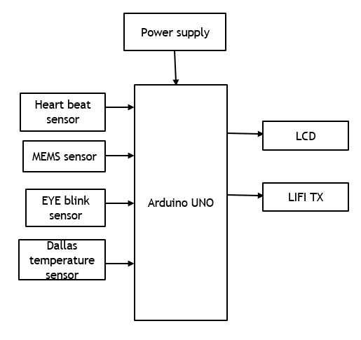

Fig(5.1) Block diagram of Transmitting section

**5.2 RECEIVING SECTION**

This section is also known as checking portion in light of the way that the patient's results are seen from to time through PC or adaptable. This fragment contains Li-Fi recipient (Photo Detector), TTL (Max 232) and PC.

Li-Fi receiver (photodetector) receives the information from the transmitter and is carried over to Max 232. Max 232 goes about as an IC level shifter which changes over the got information to a RS232 group which is perfect with PC. These last outcomes help in looking at patient's wellbeing conditions.

The monitoring section allows real-time observation of patient data on a computer or mobile device. It consists of a Li-Fi receiver (photodetector), a TTL (Max 232) converter, and a PC. The photodetector captures the transmitted data, which is then processed by the Max 232 IC to convert it into an RS232 format compatible with the computer. This enables efficient tracking of the patient's health status.

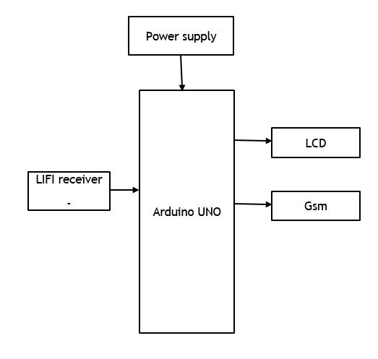

Fig(5.2) Block diagram of Receiving section

The block diagram represents a Li-Fi-based communication system using an Arduino UNO microcontroller for real-time health monitoring and wireless data transmission. The system is powered by an external power supply, ensuring stable operation for all components. A Li-Fi receiver captures incoming data transmitted via light signals and converts them into electrical signals, which are then processed by the Arduino UNO. Acting as the central processing unit, the Arduino UNO interprets the received data and communicates with output devices such as the LCD display and GSM module.

The LCD screen provides real-time monitoring by displaying essential health parameters, while the GSM module enables wireless communication by sending alerts or updates via mobile networks. By integrating Li-Fi technology, the system ensures fast, secure, and interference-free data transmission, making it an efficient solution for modern healthcare monitoring.

**CHAPTER 6**

**DESCRIPTION**

**6.1 ARDUINO UNO**

Arduino Uno is a very valuable addition in the electronics that consists of USB interface, 14 digital I/O pins, 6 analog pins, and Atmega328 microcontroller. It also supports serial communication using Tx and Rx pins.

There are many versions of Arduino boards introduced in the market like Arduino Uno, Arduino Due, Arduino Leonardo, Arduino Mega, however, most common versions are Arduino Uno and Arduino Mega. If you are planning to create a project relating to digital electronics, embedded system, robotics, or IoT, then using Arduino Uno would be the best, easy and most economical option.

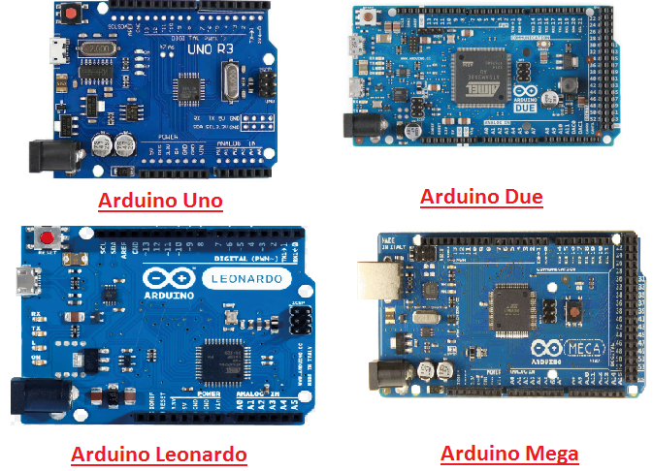

Fig(6.1) Arduino UNO

It is an open-source platform, means the boards and software are readily available and anyone can modify and optimize the boards for better functionality.

The software used for Arduino devices is called IDE (Integrated Development Environment) which is free to use and required some basic skills to learn it. It can be programmed using C and C++ language.

Some people get confused between Microcontroller and Arduino. While former is just an on system 40 pin chip that comes with a built-in microprocessor and later is a board that comes with the microcontroller in the base of the board, bootloader and allows easy access to input-output pins and makes uploading or burning of the program very easy.

**6.1.1 ARDUINO PINOUT**

Arduino Uno is based on AVR microcontroller called Atmega328. This controller comes with 2KB SRAM, 32KB of flash memory, 1KB of EEPROM. Arduino Board comes with 14 digital pins and 6 analog pins. ON-chip ADC is used to sample these pins. A 16 MHz frequency crystal oscillator is equipped on the board. Following figure shows the pinout of the Arduino Uno Board.

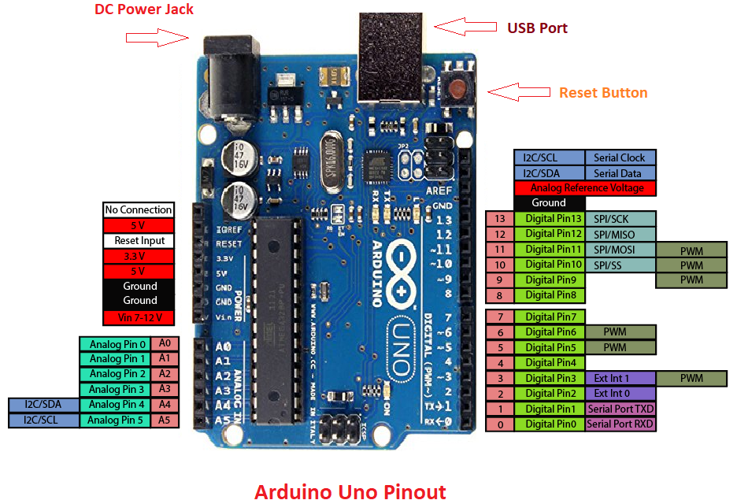

Fig(6.2) Arduino pinout

There are several I/O digital and analog pins placed on the board which operates at 5V. These pins come with standard operating ratings ranging between 20mA to 40mA. Internal pull-up resistors are used in the board that limits the current exceeding from the given operating conditions. However, too much increase in current makes these resisters useless and damages the device.

**6.2 LCD**

LCD (Liquid Crystal Display) technology is widely used in notebook screens, small computing devices, and various electronic circuits. Compared to older Cathode Ray Tube (CRT) displays, LCDs are much thinner and consume significantly less power. Unlike LED and gas-plasma displays that emit light, LCDs function by **blocking light** to create visuals. LCDs can be classified into two types: **passive matrix** and **active matrix (TFT)** displays.

In a passive matrix LCD, a grid of conductors controls each pixel by sending currents through intersecting points, whereas an active matrix LCD has a transistor at each pixel, reducing power consumption and improving display quality. Some passive matrix LCDs use dual scanning to improve performance, but **TFT-based active matrix displays** remain the superior technology due to their faster response time and better clarity.

A **16x2 LCD** module is commonly used in embedded systems and electronic circuits due to its cost-effectiveness, programmability, and ability to display custom characters and animations. The term "16x2" signifies that the display can show **16 characters per line** across **two lines**, with each character represented in a **5x7 pixel grid**. The LCD operates using two registers: **Command Register** (which stores instructions like screen clearing and cursor positioning) and **Data Register** (which stores ASCII values for characters to be displayed).

LCDs process two types of signals—**control and data signals**—which are managed through specific pins like RS (Register Select), R/W (Read/Write), and E (Enable). It typically takes **39-43μS** for a character to be displayed and **1.53-1.64ms** for certain commands like clearing the screen or resetting the cursor. Additionally, LCDs contain **DDRAM and CGRAM memory**; DDRAM determines character placement, while CGRAM allows users to create and display custom characters, enhancing flexibility in applications.

[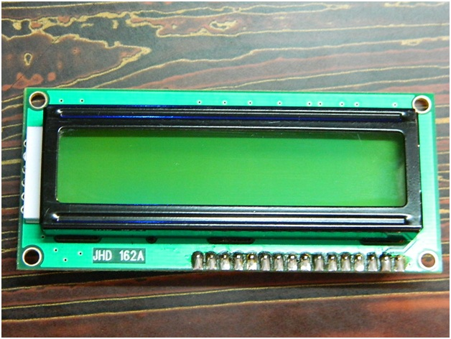](http://www.circuitstoday.com/wp-content/uploads/2012/02/LCD-Display-Front-Side.jpg)

Fig(6.3) LCD display

**6.3 HEARTBEAT SENSOR**

Heartbeat Sensor is an electronic device that is used to measure the heart rate i.e. speed of the heartbeat. Monitoring body temperature, heart rate and blood pressure are the basic things that we do in order to keep us healthy.In order to measure the body temperature, we use thermometers and a sphygmomanometer to monitor the Arterial Pressure or Blood Pressure. Heart Rate can be monitored in two ways: one way is to manually check the pulse either at wrists or neck and the other way is to use a Heartbeat Sensor.

**6.3.1 Introduction to Heartbeat Sensor**

Monitoring heart rate is very important for athletes, patients as it determines the condition of the heart (just heart rate). There are many ways to measure heart rate and the most precise one is using an Electrocardiography.

But the more easy way to monitor the heart rate is to use a Heartbeat Sensor. It comes in different shapes and sizes and allows an instant way to measure the heartbeat.

Heartbeat Sensors are available in Wrist Watches (Smart Watches), Smart Phones, chest straps, etc. The heartbeat is measured in beats per minute or bpm, which indicates the number of times the heart is contracting or expanding in a minute.

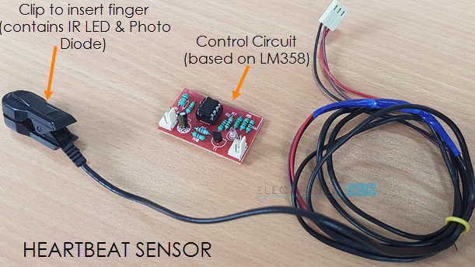

Fig(6.4) Heartbeat sensor

The principle behind the working of the Heartbeat Sensor is Photoplethysmograph. According to this principle, the changes in the volume of blood in an organ is measured by the changes in the intensity of the light passing through that organ.

Usually, the source of light in a heartbeat sensor would be an IR LED and the detector would be any Photo Detector like a Photo Diode, an LDR (Light Dependent Resistor) or a Photo Transistor. With these two i.e. a light source and a detector, we can arrange them in two ways: A Transmissive Sensor and a Reflective Sensor.

In a Transmissive Sensor, the light source and the detector are place facing each other and the finger of the person must be placed in between the transmitter and receiver. Reflective Sensor, on the other hand, has the light source and the detector adjacent to each other and the finger of the person must be placed in front of the sensor.

**6.4 LIFI MODULE**

Li-Fi, also known as Light Fidelity, is a wireless communication technology that uses light waves to transmit data between devices. Unlike Wi-Fi, which relies on radio frequency waves, Li-Fi works by modulating the intensity of light from LEDs to encode and transfer information. The concept of Li-Fi was first introduced by Harald Haas during a TED Global talk in 2011 in Edinburgh. This technology allows for high-speed data transmission across the visible light, ultraviolet, and infrared spectrums, with LED lamps serving as the primary medium for communication in visible light applications.

Li-Fi is often referred to as optical Wi-Fi because it uses visible light instead of radio waves to transmit data. It offers several advantages, such as faster data transfer rates, improved security, and minimal interference compared to traditional wireless communication methods. Theoretically, Li-Fi can achieve speeds of up to 100 Gbit/s, making it much faster than conventional Wi-Fi.Due to the affordability and widespread availability of LED lighting, Li-Fi can be implemented in various applications, such as vehicle-to-vehicle communication to prevent accidents, high-speed internet access in homes, and underwater data transmission where radio frequency signals do not work effectively.

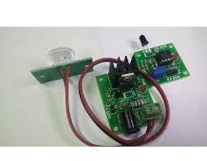

Fig(6.5) LIFI module

**6.5 GSM**

GSM is a mobile communication modem; it is stands for global system for mobile communication (GSM). The idea of GSM was developed at Bell Laboratories in 1970.  It is widely used mobile communication system in the world. GSM is an open and digital cellular technology used for transmitting mobile voice and data services operates at the 850MHz, 900MHz, 1800MHz and 1900MHz frequency bands.

GSM system was developed as a digital system using time division multiple access (TDMA) technique for communication purpose. A GSM digitizes and reduces the data, then sends it down through a channel with two different streams of client data, each in its own particular time slot. The digital system has an ability to carry 64 kbps to 120 Mbps of data rates.

There are various cell sizes in a GSM system such as macro, micro, pico and umbrella cells. Each cell varies as per the implementation domain. There are five different cell sizes in a GSM network macro, micro, pico and umbrella cells. The coverage area of each cell varies according to the implementation environment.

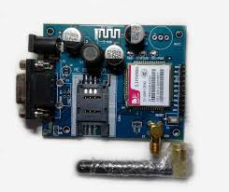

Fig(6.6) GSM

**6.6 MEMS SENSOR**

The term MEMS stands for micro-electro-mechanical systems. These are a set of devices, and the characterization of these devices can be done by their tiny size & the designing mode. The designing of these sensors can be done with the 1- 100-micrometer [components](https://www.elprocus.com/basic-components-used-electronics-electrical/). These devices can differ from small structures to very difficult electromechanical systems with numerous moving elements beneath the control of incorporated micro-electronics. Usually, these sensors include mechanical micro-actuators, micro-structures, micro-electronics, and micro-sensors in one package. This article discusses what is a MEMS sensor, working principle, advantages and it’s applications.

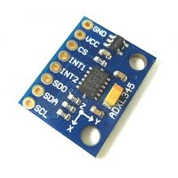

Fig(6.7) MEMS sensor

MEMS are low-cost, and high accuracy inertial sensors and these are used to serve an extensive range of industrial applications. This sensor uses a chip-based technology namely micro-electro-mechanical-system. These [sensors](https://www.elprocus.com/different-types-of-sensors-used-for-building-projects/) are used to detect as well as measure the external stimulus like pressure, after that it responds to the pressure which is measured pressure with the help of some mechanical actions. The best examples of this mainly include revolving of a motor for compensating the pressure change.

The MEMS accelerometers can be divided into two important micro system architectures: piezo resistive and capacitive. Even though both of these two types of accelerometers possess internal proof masses which are excited by acceleration, the differences of these two architectures lie in the transduction mechanism which is used to the movement correlation of the internal proof mass to accelerate. The Capacitive accelerometers possess a differential capacitor whose balance is disrupted by the proof mass movement. Piezo resistive accelerometers commonly rely on inducing, which attach the proof mass to the sensor which is used for identification of the movement of the mass.

**6.7 DALLAS TEMPERATURE SENSOR**

The Dallas temperature sensor, commonly known as the DS18B20, is a digital temperature sensor that communicates using the OneWire protocol. Manufactured by Maxim Integrated, it is widely used in various temperature measurement applications due to its high accuracy, ease of use, and reliable digital output. The sensor provides temperature readings with a resolution of up to 12 bits and supports a broad temperature range, making it suitable for both industrial and consumer applications.

One of the key advantages of the DS18B20 sensor is its simple interface with microcontrollers like Arduino, Raspberry Pi, and ESP8266. It requires only a single data wire for communication, allowing multiple sensors to be connected on the same bus without complex wiring. This feature makes it ideal for projects requiring multiple temperature measurements at different locations. Additionally, the sensor operates with low power consumption and can be powered through the data line using parasitic power mode, eliminating the need for an additional power source.

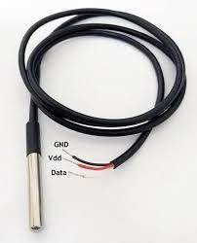

Fig(6.8) Temp sensor

The DS18B20 is commonly used in weather monitoring systems, industrial process control, HVAC systems, and smart home automation. Its ability to function in extreme conditions, along with its waterproof variant, makes it suitable for outdoor and submerged temperature measurements. With its digital output, high precision, and reliable performance, the Dallas temperature sensor remains a preferred choice for temperature sensing applications across various fields.

**6.8 EYE BLINK SENSOR**

The Eye Blink Sensor-based Driver Drowsiness Detection System is designed to monitor a driver's eye movements in real-time to detect signs of drowsiness or fatigue, which are leading causes of road accidents. At its core, the system utilizes an eye blink sensor that operates using infrared (IR) technology. This sensor tracks the driver's blink frequency and duration, providing critical data on eye behavior that can indicate fatigue.

The system is controlled by a microcontroller, such as an Arduino, which processes the sensor data and compares it to predefined thresholds. If abnormal blink patterns are detected—such as prolonged eye closures or rapid blink frequency—the system triggers an alert, typically using a buzzer, to immediately warn the driver of potential drowsiness.

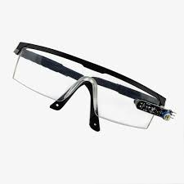

Fig(6.9) Eye blink sensor

The sensor’s working principle is based on infrared technology. The eye blink sensor consists of an IR emitter and receiver. The IR emitter directs a signal towards the driver's eye, and when the eyelid closes during a blink, the reflection from the eyelid is detected by the receiver. The sensor measures both the duration of the blink (how long the eye remains closed) and the frequency (how often the driver blinks). This data is crucial in determining whether the driver is exhibiting signs of drowsiness or losing focus on the road.

The system is powered by a microcontroller, such as an Arduino, which is programmed to process the eye blink sensor data. It continuously monitors the eye activity and compares it to predefined thresholds. Under normal conditions, a driver blinks 15 to 20 times per minute, with each blink lasting 100 to 300 milliseconds. If the blink duration exceeds 400 milliseconds or the frequency of blinks increases significantly, the microcontroller activates an alert mechanism, such as a buzzer, to warn the driver of potential drowsiness. The system runs in a continuous loop to ensure real-time monitoring of the driver's condition throughout the journey.

This alert mechanism plays a critical role in preventing accidents by giving the driver immediate feedback when abnormal blink patterns are detected. The system's thresholds for blink frequency and duration are set based on research into typical eye blink behaviors of attentive drivers. These thresholds are customizable and can be adjusted depending on specific user needs or driving conditions. When the driver receives the alert, it indicates that they may be too tired to drive safely, prompting them to take a break or refocus.

**CHAPTER 7**

**SOFTWARE DESCRIPTION**

**7.1 ARDUINO IDE**

The Arduino IDE software is a open source software, where we can have the example codes for the beginners. In the Present world there are lot of version in the Arduino IDE in which present usage is Version1.0.5. It is very easy to connect the PC with Arduino Board.

First we have to install the Arduino IDE software according to the below instructions:

* Insert the CD-ROM or PENDRIVE which Contains the software and then Copy the Setup File to your desired location.
* After Copying, now click on the setup you will see an window shown below
* 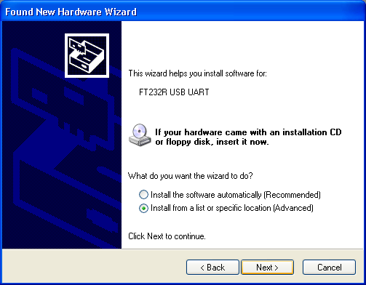Click On NO, not this time. Then after NEXT
* Another Window opens –select Install from a list of specific location

Fig(7.1) Hardware wizard window

* Select “include this location in the search” and then click Browse option available in it
* Now it will Automatically check the USB driver and the software is installed click Finish.
* Now click Finish, the Software will be downloaded.
* Now click on the Arduino IDE icon present on your Desktop. A window will appear like this.

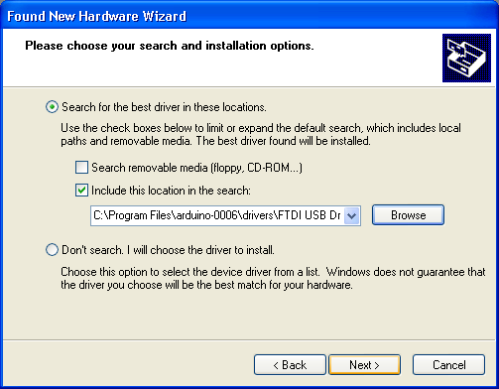

Fig(7.2) Choose file window

Fig(7.3) Finish window

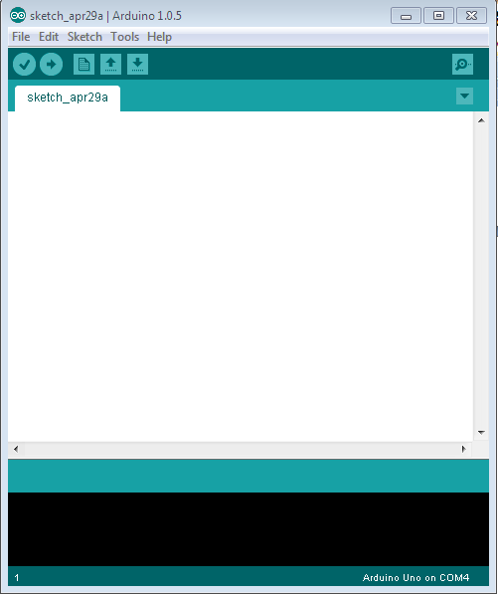

Fig(7.4) Start page

* For any sample programs, select FILE option🡪Examples.

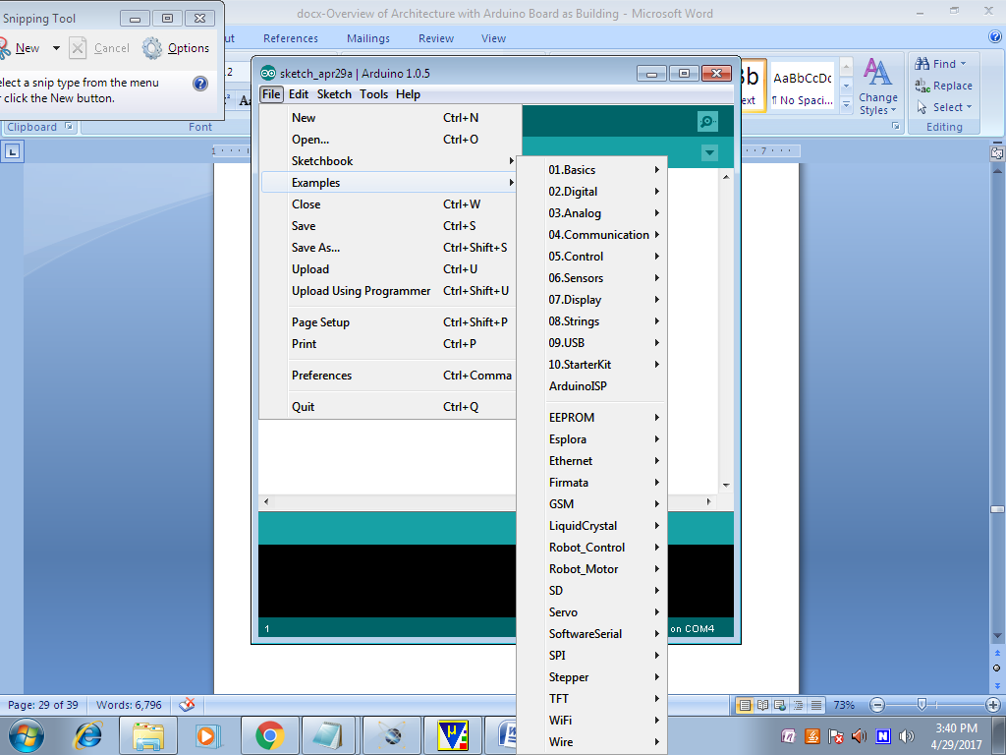

Fig(7.5) Sketch Selection page

* After Entering the Sample Code in the file, it would look like this

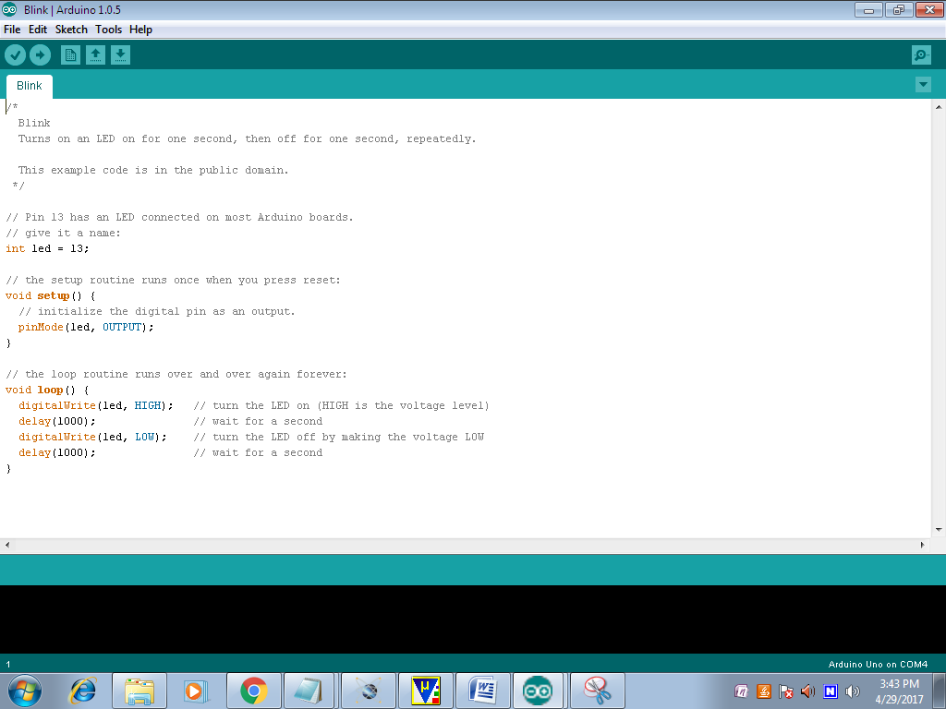

Fig(7.6) Code page

* Before Connecting we have to select which Board is used by the user, Basically UNO. By selecting TOOLS🡪Board🡪ARDUINO UNO

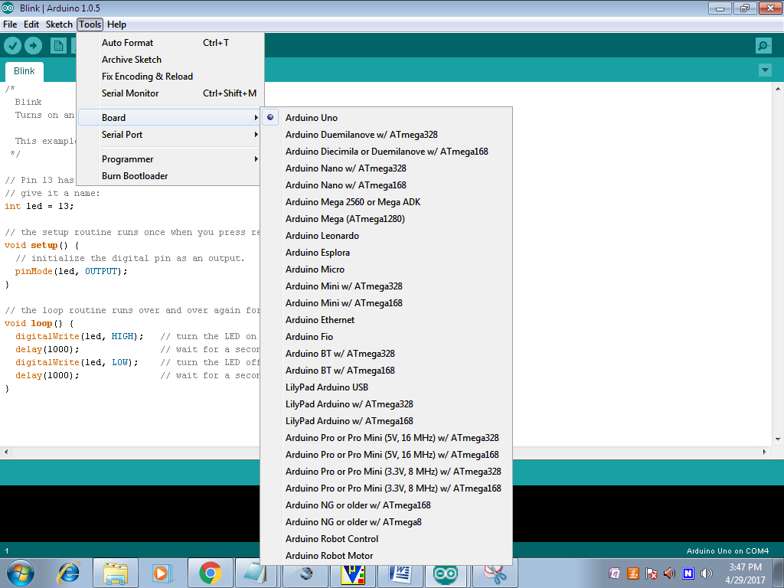

Fig(7.7) Selecting board page

* Now to dump the in the board Connect the Arduino to the PC through the USB port available in it. TOOLS🡪SERIALPORT🡪COMM4,COMM8 etc;

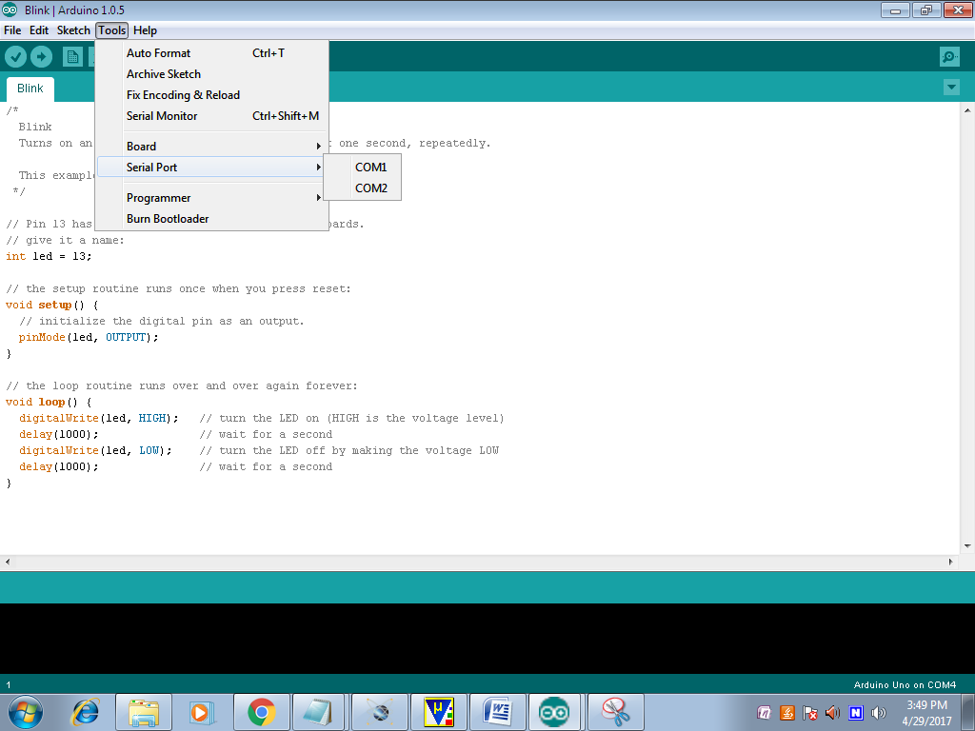

Fig(7.8) Select port page

* To verify the written Program select COMPILE option available in the software ($√$).
* Now Connect the Board and select the COMM port and then UPLOAD the file in ARDUINO(🡪)
* To OPEN the Previous ARDUINO FILE selects $(↑)$ option.
* To enter new files select NEW option.
* To Save the Existing File, Click on the $(↓)$.
* To Send the Data Through Serial Monitor, Click on the (Ǫ).



Fig(7.9) Options page

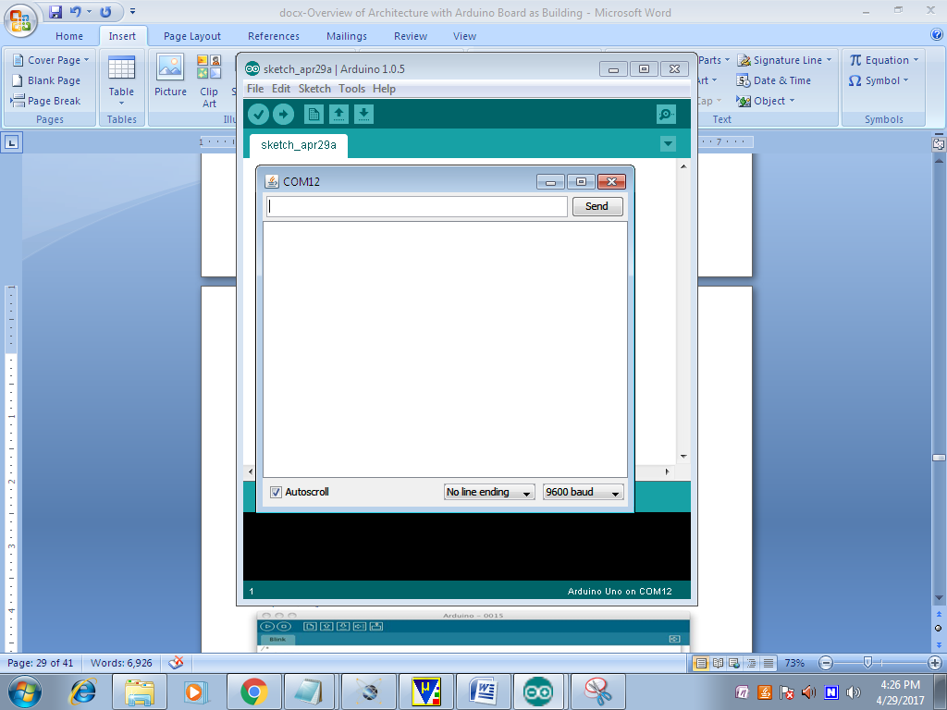

Fig(7.10) File page

* Here we can see the Serial Data.

**7.2 PYTHON**

Python is a general purpose, dynamic, high level and interpreted programming language. It supports Object Oriented programming approach to develop applications. It is simple and easy to learn and provides lots of high-level data structures. It is easy to learn yet powerful and versatile scripting language which makes it attractive for Application Development. It's syntax and dynamic typing with its interpreted nature, makes it an ideal language for scripting and rapid application development. It supports multiple programming patterns, including object oriented, imperative and functional or procedural programming styles. It is not intended to work on special area such as web programming. That is why it is known as multipurpose because it can be used with web, enterprise, 3D CAD etc. We don't need to use data types to declare variable because it is dynamically typed so we can write a=10 to assign an integer value in an integer variable.It makes the development and debugging fast because there is no compilation step included in python development and edit-test-debug cycle is very fast.

**7.2.1 PYTHON FEATURES**

Python provides lots of features that are listed below.

* Easy to Learn and Use

Python is easy to learn and use. It is developer-friendly and high level programming language.

* Expressive Language

Python language is more expressive means that it is more understandable and readable.

* Interpreted Language

Python is an interpreted language i.e. interpreter executes the code line by line at a time. This makes debugging easy and thus suitable for beginners.

* Cross-platform Language

Python can run equally on different platforms such as Windows, Linux, Unix and Macintosh etc. So, we can say that Python is a portable language.

* Free and Open Source

Python language is freely available at address. The source-code is also available. Therefore it is open source.

* Object-Oriented Language

Python supports object oriented language and concepts of classes and objects come into existence.

* Extensible

It implies that other languages such as C/C++ can be used to compile the code and thus it can be used further in our python code.

* Large Standard Library

Python has a large and broad library and provides rich set of module and functions for rapid application development.

* GUI Programming Support

Graphical user interfaces can be developed using Python.

* Integrated

It can be easily integrated with languages like C, C++, JAVA etc.

**7.2.2 PYTHON APPLICATIONS AREA**

Python is known for its general purpose nature that makes it applicable in almost each domain of software development. Python as a whole can be used in any sphere of development.

Here, we are specifying applications areas where python can be applied.

* Web Applications

We can use Python to develop web applications. It provides libraries to handle internet protocols such as HTML and XML, JSON, Email processing, request, beautifulSoup, Feedparser etc. It also provides Frameworks such as Django, Pyramid, Flask etc to design and delelop web based applications. Some important developments are: PythonWikiEngines, Pocoo, PythonBlogSoftware etc.

* Desktop GUI Applications

Python provides Tk GUI library to develop user interface in python based application. Some other useful toolkits wxWidgets, Kivy, pyqt that are useable on several platforms. The Kivy is popular for writing multitouch applications.

* Software Development

Python is helpful for software development process. It works as a support language and can be used for build control and management, testing etc.

* Scientific and Numeric

Python is popular and widely used in scientific and numeric computing. Some useful library and package are SciPy, Pandas, IPython etc. SciPy is group of packages of engineering, science and mathematics.

* Business Applications

Python is used to build Bussiness applications like ERP and e-commerce systems. Tryton is a high level application platform.

* Console Based Application

We can use Python to develop console based applications.

For example: IPython.

* Audio or Video based Applications

Python is awesome to perform multiple tasks and can be used to develop multimedia applications. Some of real applications are: TimPlayer, cplay etc.

* 3D CAD Applications

To create CAD application Fandango is a real application which provides full features of CAD.

* Enterprise Applications

Python can be used to create applications which can be used within an Enterprise or an Organization. Some real time applications are: OpenErp, Tryton, Picalo etc.

* Applications for Images

Using Python several application can be developed for image. Applications developed are: VPython, Gogh, imgSeek etc. There are several such applications which can be developed using Python.

**CHAPTER 8**

**RESULTS**

From this prototype model of the healthcare monitoring system, outputs result in abnormalities in temperature and MEMS sensors, detected for an eye-blink and calculated for heartbeat sensor.

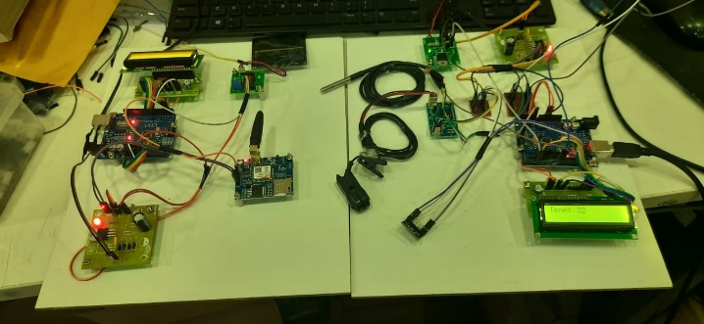

Fig(8.1) Overall Project kit

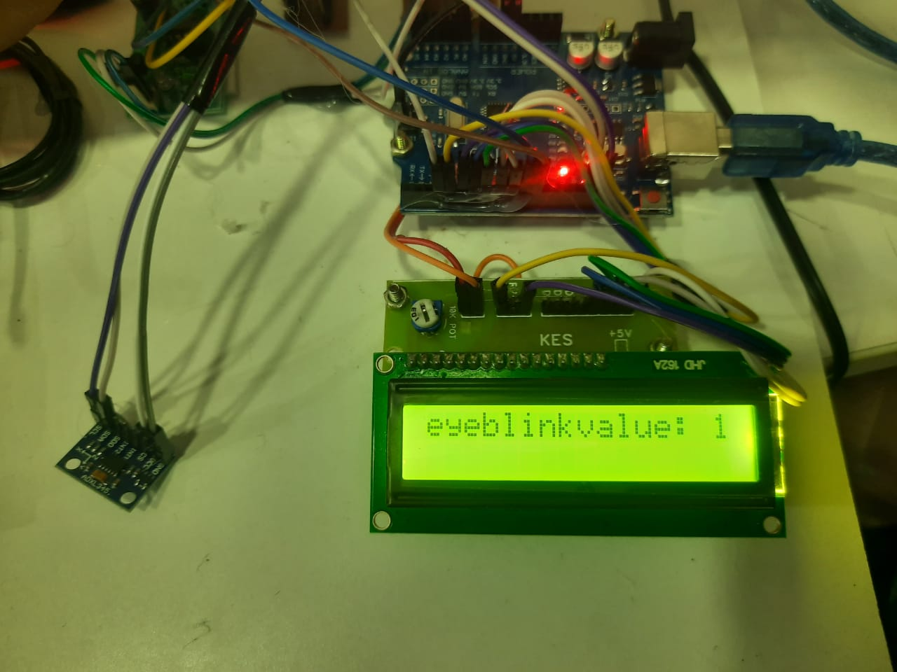

Fig(8.2) Eyeblink Sensor Reading

The image showcases a hardware setup featuring an Arduino board, an LCD display, and an eye-blink sensor module, which is detecting and displaying the "eyeblink value: 1" on the screen. The Arduino is powered via USB, and multiple jumper wires connect the components. This setup is likely part of the Secure Li-Fi Modern Healthcare System, where real-time eye-blink detection plays a role in patient monitoring.

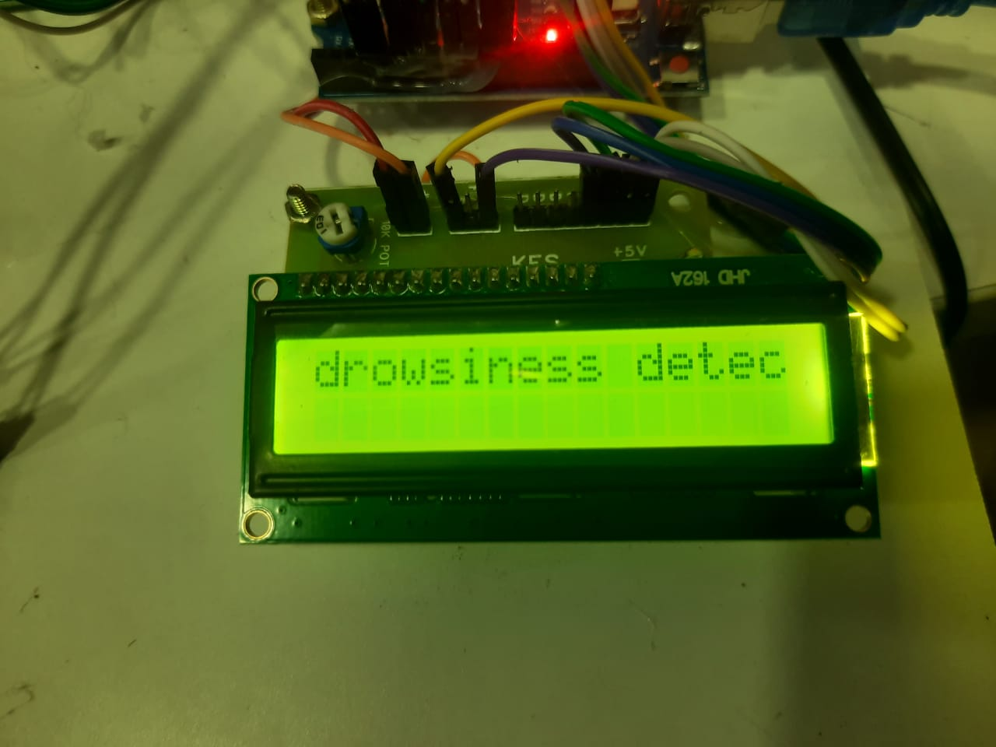

Fig(8.3) Drowsiness Detection

The image shows an LCD display connected to an Arduino-based system, displaying the message "drowsiness detected", likely indicating drowsiness detection through an eye-blink sensor. This setup is part of the Secure Li-Fi Modern Healthcare System, where drowsiness detection could be crucial for patient monitoring or driver safety applications. The system likely processes eye-blink patterns to determine prolonged closure, signaling potential drowsiness. Further integration with a Li-Fi transmitter or GSM module could enable real-time alerts or notifications in critical scenarios.

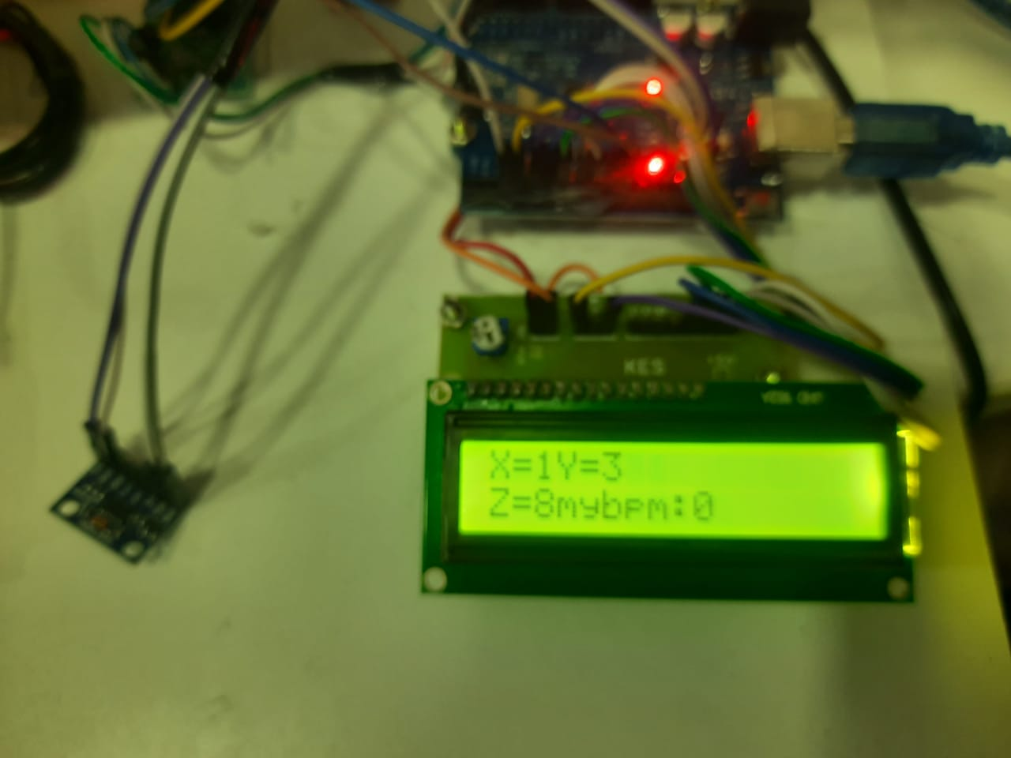

Fig(8.4) MEMS Sensor Reading

The image displays an LCD screen connected to an Arduino-based system, showing sensor readings: X=1, Y=3, Z=8, and my bpm: 0. These values likely correspond to MEMS sensor (accelerometer/gyroscope) data for movement detection, while bpm (beats per minute) indicates heart rate monitoring. This setup is part of the Secure Li-Fi Modern Healthcare System, where motion tracking and heart rate monitoring play a role in patient activity analysis or fall detection. Integration with the Li-Fi module or GSM can enable real-time health monitoring and alerts.

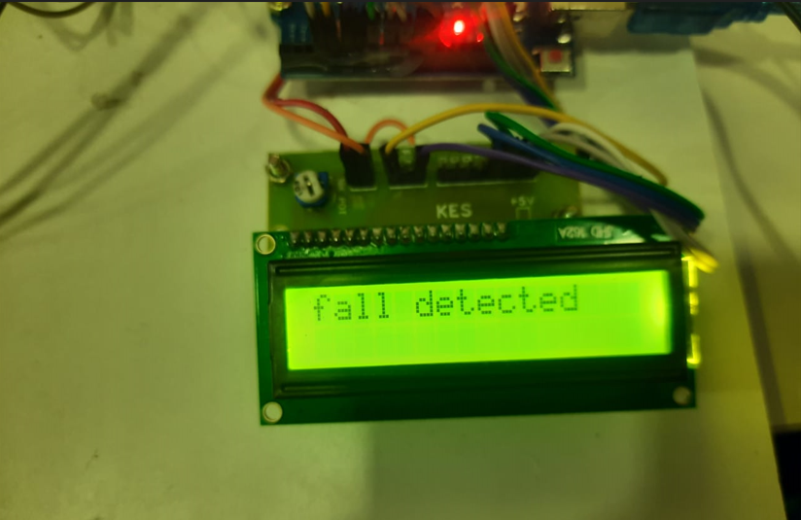

Fig(8.5) Fall Detection

The image displays an LCD screen connected to an Arduino-based system, showing the message "fall detected", indicating that the system has identified a fall event. This detection is likely based on data from a MEMS sensor (accelerometer/gyroscope), which tracks sudden changes in motion. As part of the Secure Li-Fi Modern Healthcare System, this feature is crucial for elderly or patient monitoring, enabling real-time fall detection. The system can be integrated with Li-Fi or a GSM module to transmit alerts to caregivers or emergency services for immediate assistance.

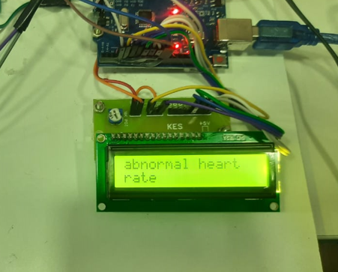

Fig(8.6) Abnormal Heartrate Detection

The image displays an LCD screen connected to an Arduino-based system, showing the message "abnormal heart rate", indicating irregular heartbeat detection. This setup is likely using a heart rate sensor to monitor bpm (beats per minute) and detect deviations from normal ranges. As part of the Secure Li-FiModern Healthcare System, this feature is essential for real-time cardiac monitoring, especially for patients with heart conditions. Integrating Li-Fi or a GSM module can enable alerts to caregivers or medical professionals, ensuring timely intervention in case of health emergencies.

**CHAPTER 9**

**CONCLUSION**

The Secure Li-Fi Modern Healthcare System Using Body Sensor Network offers an innovative and efficient solution for real-time patient monitoring. By integrating various biomedical sensors with a PIC microcontroller and employing Li-Fi technology for data transmission, it ensures secure, high-speed, and interference-free communication of critical health data. Unlike conventional wireless technologies like Wi-Fi or Bluetooth, Li-Fi provides enhanced security, minimizes electromagnetic interference, and supports faster data transfer rates, making it particularly suitable for sensitive medical environments.

Additionally, the system enhances healthcare efficiency by reducing the reliance on wired connections, increasing patient mobility, and enabling continuous health tracking. Real-time data from the sensors is transmitted securely to medical personnel, helping in the early detection and diagnosis of critical health conditions. This reduces hospital readmissions and facilitates remote monitoring, improving overall patient care. With future advancements like IoT integration, AI-powered health analytics, and the capability to monitor multiple patients simultaneously, the system has the potential to become a comprehensive healthcare solution, further revolutionizing patient management and medical diagnostics.

**CHAPTER 10**

**REFERENCES**

[1] Sharma, P., Verma, R., & Gupta, S. (2020). "Implementation of Li-Fi Technology in Healthcare Systems for Secure Data Transmission." International Journal of Healthcare Technologies, 8(3), 112-119.

[2] Patel, K., & Kumar, R. (2019). "A Review on Body Sensor Networks for Remote Patient Monitoring." Journal of Biomedical Engineering and Informatics, 6(2), 85-97.

[3] Gupta, A., Singh, D., & Malhotra, N. (2021). "Machine Learning Approaches for Health Anomaly Detection: A Comparative Study." Journal of Medical Systems, 45(4), 321-335.

[4] Reddy, S., Bansal, M., & Roy, P. (2022). "IoT and GSM-Based Alert System for Real-Time Patient Monitoring." International Conference on Smart Healthcare Technologies, 12(1), 45-52.

[5] Ali, Hasnain, M. Ibtehaj Ahmad, and Anoshah Malik. "Li-Fi Based Health Monitoring System for Infants." 2019 2nd International Conference on Communication, Computing and Digital systems (C CODE). IEEE, 2019.

[6] D. R. Bolla, Shivashankar, R. Praneetha and B. S. Rashmi, "LI-FI TECHNOLOGY BASED AUDIO AND TEXT TRANSMISSION," 2019 4th International Conference on Recent Trends on Electronics, Information, Communication & Technology (RTEICT), Bangalore, India, 2019, pp. 1532-1537, doi: 10.1109/RTEICT46194.2019.9016856.

[7] Aminian M, Naji HR. A hospital healthcare monitoring system using wireless sensor networks. J Health MED Inform 2013;4 (2): 1 6.

[8] P. Gope, T. Hwang, “Untraceable Sensor Movement in Distributed IoT Infrastructure,” IEEE Sensors Journal, Vol. 15 (9), pp. 5340 5348, 2015.

[9] K. Lorincz, D. J. Malan, T. R. F. Fulford-Jones, A. Nawoj, A. Clavel, V. Shayder, G. Mainland, M. Welsh, "Sensor Networks for Emergency Response: Challenges and Opportunities", Pervas. Comput. vol.3, pp.16–23, 2014.

[10] S. Pai, M. Meingast, T. Roosta, S. Bermudez, S. Wicker, D. K. Mulligan , S. Sastry, "Confidentiality in Sensor Networks: Transactional Information," IEEE Security and Privacy Magazine. 2018.