**AUTOMATED GARBAGE SORTING USING RASPBERRY PI**

**ABSTRACT:**

In today's world, waste management has become a crucial issue, with improper sorting leading to environmental pollution and increased landfill waste. Traditional garbage sorting methods rely on human intervention, which is prone to errors and inefficiencies. The "Automated Garbage Sorting Using Raspberry Pi" project presents a solution by designing an automated system that detects and classifies different types of waste (metal, non-metal) using sensors and a Raspberry Pi 2. The system will then separate the materials accordingly on a conveyor system.

The system employs a variety of sensors such as inductive proximity sensors (for metal). Once detected, the waste is sorted using servo motors to direct each type of waste to its designated bin. The Raspberry Pi processes sensor inputs and controls the sorting mechanism through Python programming.

1. **INTRODUCTION:**

The Automated Garbage Sorting Using Raspberry Pi project aims to enhance waste management efficiency through innovative technology. By integrating sensors, cameras, and machine learning algorithms with a Raspberry Pi, this project enables the identification and classification of different types of waste—such as plastic, metal, and organic materials. The system processes real-time data to distinguish between recyclable and non-recyclable items, directing them into appropriate bins. This automated approach not only minimizes human error and labor but also promotes environmental sustainability by improving recycling rates and reducing landfill waste. Ultimately, the project serves as a scalable solution to tackle the growing challenges of waste disposal in urban areas.

1. **METHODOLOGY:**
2. **System Design and Component Selection:**

The project begins with selecting appropriate components, including a Raspberry Pi, various sensors (infrared, ultrasonic, and cameras), and actuators for sorting mechanisms. The design focuses on creating a user-friendly interface and a robust physical setup for the sorting station.

1. **Sensor Integration and Data Collection:**

Once the hardware is assembled, the next step involves integrating the sensors with the Raspberry Pi. This includes programming the Pi to collect data from the sensors in real time. For example, infrared sensors can detect material types based on reflectivity, while cameras can capture images of waste items for further analysis.

1. **Machine Learning Model Development:**

To enhance classification accuracy, a machine learning model is developed using image datasets of various waste items. This involves training the model to recognize different materials based on features extracted from the images. The trained model is then integrated into the Raspberry Pi, enabling it to classify waste items effectively.

1. **Sorting Mechanism Implementation:**

The system incorporates mechanical actuators, such as servo motors, to physically sort the waste into designated bins based on the classifications made by the sensors and machine learning model. This part of the methodology includes programming the Pi to control the actuators based on the sorting decisions.

1. **Testing and Calibration:**

After the system is built, extensive testing is conducted to ensure accuracy in waste classification and effective sorting. Calibration may be necessary to fine-tune sensor readings and model predictions. Feedback loops are implemented to continuously improve the system's performance based on testing results.

1. **User Interface Development:**

Finally, a user interface is developed to provide real-time feedback to users, including status updates on sorting efficiency and educational prompts about waste disposal. This interface enhances user engagement and promotes awareness about recycling practices.

1. **MODELING AND ANALYSIS :**
2. **HARDWARE REQUIREMENTS**
3. IR Sensor
4. Proximity Sensor
5. Moisture Sensor
6. Servo Motor
7. Stepper Motor
8. Buzzer
9. **SOFTWARE REQUIREMENTS**
10. Python Scripts
11. Flask Web Application
12. Position Tracking
13. **SYSTEM DESIGN**
14. **Architecture Design**

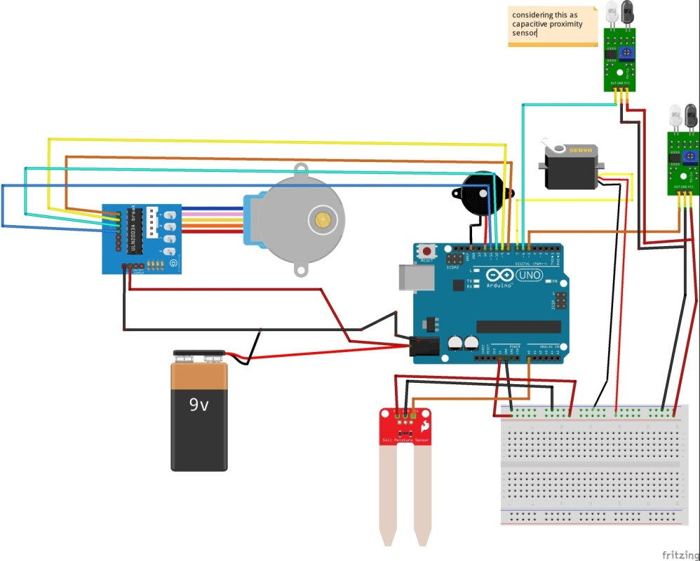

The project employs a modular architecture combining hardware and software components:

**Hardware Components:**

IR Sensor: Detects the presence of an object.

Proximity Sensor: Identifies whether the object is metallic.

Moisture Sensor: Detects moisture to classify waste as wet.

Servo Motor: Controls the disposal mechanism.

Stepper Motor: Rotates the disposal bins to the appropriate position.

Buzzer: Provides an audio alert.

**Software Components:**

Python Scripts: Handles hardware interactions and waste classification logic.

Flask Web Application: Displays system status and provides user interaction capabilities.

Position Tracking: Uses a file-based system to remember the last stepper motor position.

**Integration:**

The sensors feed data into the Raspberry Pi for processing.

Python scripts process sensor inputs and control hardware components.

The web application provides real-time updates and user interface.

1. **Data Flow Diagram**

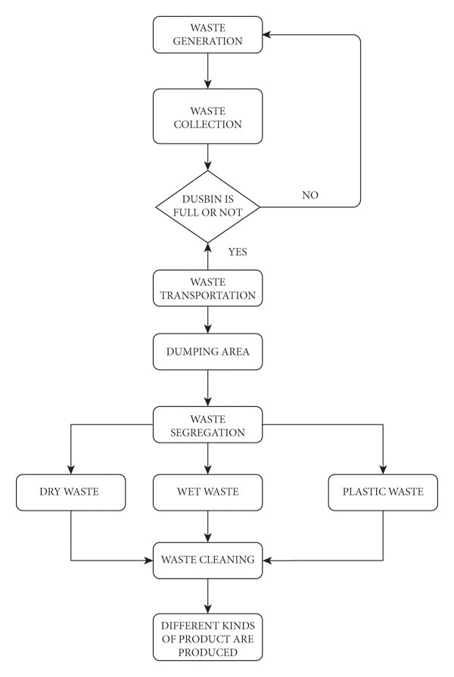

### ****Waste Generation****

* The process starts with waste being generated from households, industries, businesses, or public places.
* Waste generation is a continuous process, meaning it keeps occurring over time.

### ****Waste Collection****

* The collected waste is placed in dustbins or garbage collection points.
* This could involve municipal collection systems, waste pickup trucks, or smart waste collection technologies.

### ****Checking If the Dustbin is Full****

* A decision-making step checks if the dustbin is full or not.
* If the **dustbin is not full**, the process loops back to the waste generation stage (i.e., waste continues to accumulate).
* If the **dustbin is full**, the process moves forward to waste transportation.

### ****Waste Transportation****

* Once the dustbin is full, waste is transported to a designated dumping area.
* This is typically done by waste collection vehicles operated by municipal authorities or private waste management companies.

### ****Dumping Area****

* The waste is dumped at a designated disposal site or waste processing center.
* This could be a landfill, recycling plant, or waste treatment facility.

### ****Waste Segregation****

* The waste is separated into different categories:
  + **Dry Waste**: Includes paper, cardboard, metal, glass, textiles, etc.
  + **Wet Waste**: Includes organic waste like food scraps, vegetable peels, and garden waste.
  + **Metal Waste**: Includes Metal objects like Screw, Blade, etc.

### ****Waste Cleaning (for Wet Waste)****

* Wet waste undergoes a cleaning process before further processing.
* Cleaning involves removing impurities or contaminants to make it suitable for composting, biogas generation, or other uses.

### ****Product Formation****

* The final stage involves creating different kinds of useful products from the processed waste:
  + **Dry Waste** → Recycled paper, glass, metals, etc.
  + **Wet Waste** → Compost, biogas, organic fertilizers.

**Metal Waste** → Recycled Metal products or use high temperature through metal is melt & conversion.

1. **Sequence Diagram**

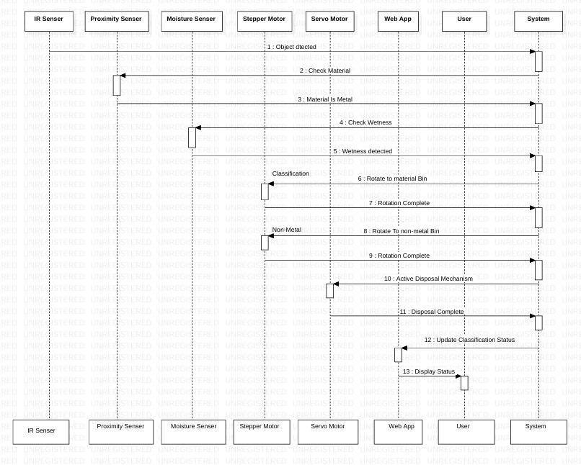

Object detected by the IR sensor.

Proximity sensor determines if the material is metal.

Moisture sensor checks for wetness.

Based on classification:

Rotate stepper motor to the corresponding bin.

Activate servo motor to open the disposal mechanism.

Update web application interface with classification status.

1. **Use Case Diagram**

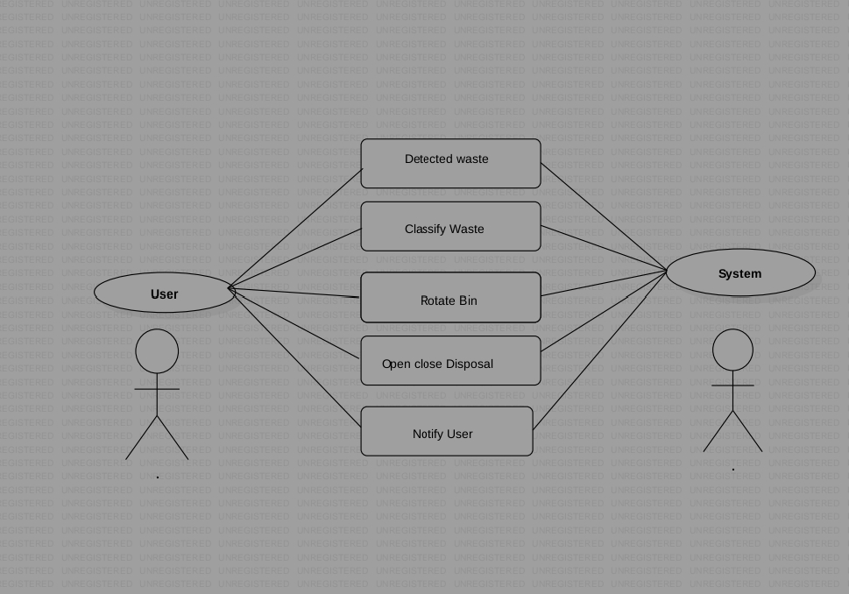

Actors:

User: Monitors the system and receives alerts.

System: Detects, classifies, and disposes of waste.

Use Cases:

Detect waste.

Classify waste.

Rotate bin.

Open and close disposal mechanism.

Notify user.

1. **RESULTS AND DISCUSSION :**
2. **Test Case**

### IR Sensor:

### Input: Object placed in front of the sensor.

### Expected Output: Object detected message.

### Proximity Sensor:

### Input: Metal object placed.

### Expected Output: "Metal detected" message.

### Moisture Sensor:

### Input: Wet material placed.

### Expected Output: "Wet material detected" message.

### Servo Motor:

### Action: Trigger disposal mechanism.

### Expected Output: Servo motor moves to open and close bottom cap.

### Stepper Motor:

### Action: Rotate to specific bin.

### Expected Output: Correct bin alignment.

1. **Hardware Output:**

**Waste is classified into metal, wet, and dry categories.**

**Bins rotate and open correctly for disposal.**

1. **Display Output**

**Web application displays classification results.**

**Console logs provide real-time updates for system operations.**

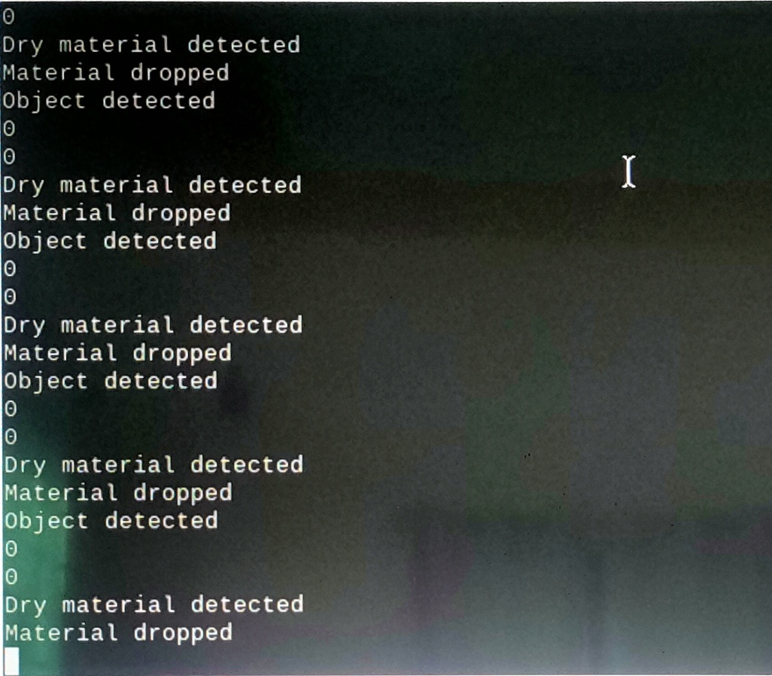

1. **CONCLUSION :**

The Automated Garbage Sorting System utilizing Raspberry Pi, IR sensors, proximity sensors, moisture sensors, servo motors, stepper motors, and a feedback mechanism provides an efficient, low-cost solution for waste segregation. By automating the sorting process, the system reduces the need for manual labor, increases accuracy in waste classification, and enhances the overall efficiency of waste management. The integration of various sensors ensures that different types of waste—biodegradable, recyclable, and non-recyclable—are sorted appropriately, minimizing contamination and promoting sustainability.

The use of Raspberry Pi as the central controller, along with its ability to process real-time sensor data and control the actuators, allows for a seamless, user-friendly experience. The system can be further enhanced by incorporating additional sensors, machine learning algorithms, or a more advanced user interface to handle a broader range of waste materials or improve the sorting accuracy. Furthermore, the modular design ensures that the system can be easily upgraded or adapted to different environments, making it a flexible solution for both residential and industrial use.

In conclusion, this project highlights the potential of combining low-cost hardware with advanced sensing and motor control technologies to address a pressing environmental issue. The Automated Garbage Sorting System not only offers a practical solution for waste management but also opens doors for future advancements in smart cities and automated waste systems, contributing to cleaner, more sustainable urban environments.

1. **REFERENCES :**
2. Raspberry Pi Foundation (<https://www.raspberrypi.org/documentation/>) :Official documentation and resources related to Raspberry Pi hardware and software
3. OpenCV Documentation (https://docs.opencv.org/master/) : Extensive resources on using OpenCV forimage processing, critical for the classification aspect of your project.
4. "Raspberry Pi for Dummies" by Sean McManus and Mike Cook :A comprehensive guide covering thebasics of Raspberry Pi, including hardware setup and programming