**CROP DISEASE DETECTION USING MACHINE LEARNING:**

**A REVIEW**

1. Mr. ADITYA TANPURE

2. Mr. PRATHMESH GUND

3. Mr. PURUSHOTTAM NIMBALKAR

4. MS. SABALE SNEHAL

VidyasPratishtan’ssKamalnayansBajajsInstitutesofsEngineerings&sTechnology,sBaramati

#[adityatanpure1784@gmail.com](mailto:adityatanpure1784@gmail.com)

#[prathmeshgund2004@gmail.com](mailto:prathmeshgund2004@gmail.com)

#[purushottamnimbalkar2004@gmail.com](mailto:purushottamnimbalkar2004@gmail.com)

#snehalsabale183@gmail.com

*Abstract* - Agriculture performs a essential function in human civilization, and plant diseases extensively impact crop yield, great, and normal manufacturing. traditional methods for detecting crop illnesses are exertions-in depth and time-consuming. The advancements in machine learning (ML) provide efficient, automated, and accurate disease detection methods. This paper reviews various machine learning approaches applied to crop disease detection, including image processing, deep learning, and predictive modelling. The study discusses different algorithms, datasets, and evaluation metrics used in disease classification and early detection, contributing to improved agricultural practices and food security.

**Key words** – Machine Learning, Crop Disease Detection, Image Processing, Deep Learning, Precision Agriculture.

**Ⅰ. INTRODUCTION**

Plant diseases significantly affect agricultural productivity and food supply chains. Traditional disease detection relies on manual inspection, requiring expert knowledge and labour-intensive efforts. Machine learning has revolutionized this domain by offering automated detection and category of plant illnesses the usage of pictures, spectral analysis, and environmental factors. By way of leveraging deep gaining knowledge of, convolutional neural networks (CNNs), and other AI-driven techniques, early ailment identification is now extra. Accurate and green .This paper provides an outline of device studying models and strategies employed in crop ailment detection and their actual-world programs.

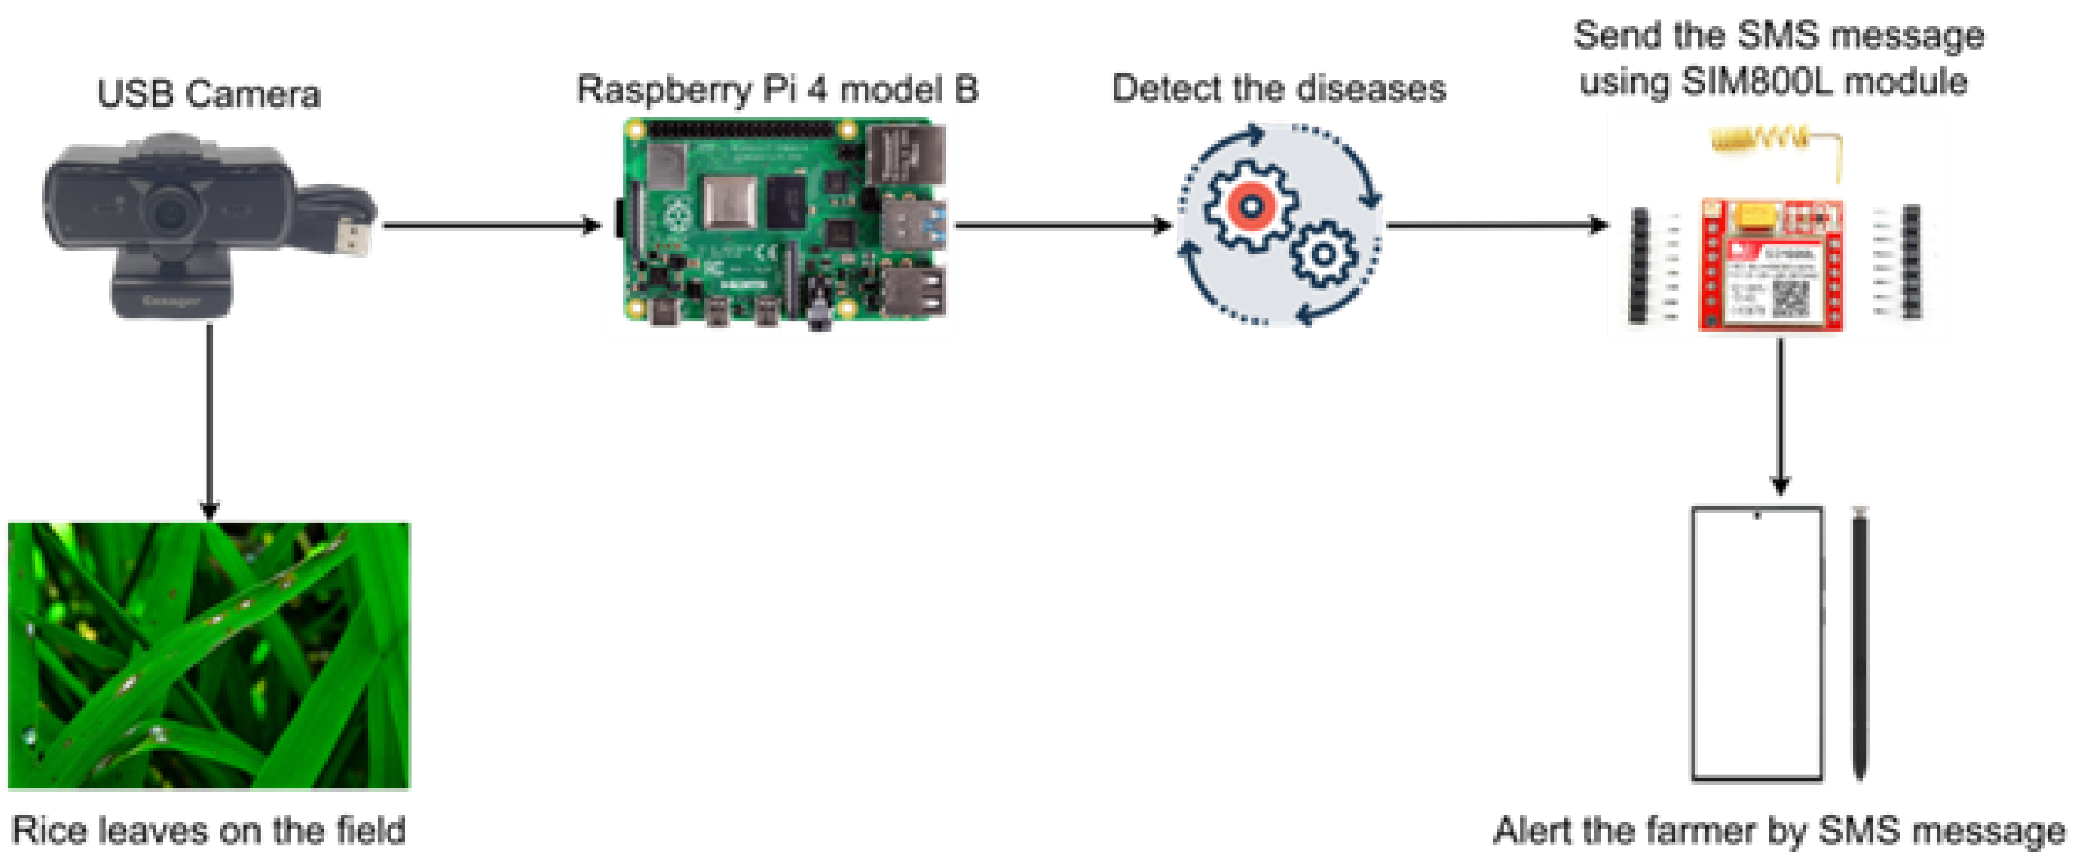

**Fig. No.: 1 Crop Disease Detection Using ML**

**Ⅱ. BLOCK DIAGRAM**

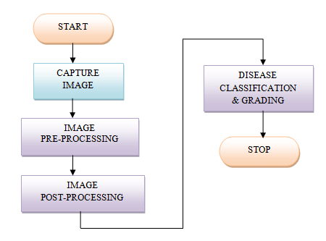

**Fig. No.: 2 Block Diagram of Systems**

The proposed system for crop disorder detection using ML follows a established pipeline, together with statistics series, preprocessing, model education, class, and disorder prediction.

**Components and Their Functions:**

1. **Image Acquisition**: High-resolution images of crops are captured using drones, mobile phones, or hyperspectral imaging.
2. **Preprocessing**: Image enhancement, noise reduction, and feature extraction techniques are applied.
3. **Feature Extraction**: Deep Learning models such as CNNs extracts relevant functions from photos.
4. **Classification Model**: Machine Learning algorithms (e.g., CNN, SVM, Random Forest) classify plant diseases.
5. **Disease Identification & Notification**: The system provides a diagnosis and suggests preventive measures.

**Ⅲ. PROS**

1. **Early Disease Detection:** Machine learning models help in identifying crop diseases at an early stage, reducing losses.
2. **Automated Analysis:** Reduces dependency on human experts and accelerates disease classification.
3. **High Accuracy:** CNN-based models achieve high precision in identifying diseases.
4. **Cost-Effective:** Reduces the need for extensive field inspections and manual monitoring.
5. **Scalability:** Can be deployed over large agricultural fields using drones and IoT devices.

**Ⅳ. CONS**

1. **Data Dependency:** Requires high-quality labeled datasets for accurate training.
2. **Computational Requirements:** Deep learning models demand high processing power and resources.
3. **Environmental Variations:** Performance may vary due to changing lighting and weather conditions.
4. **LimitedGeneralization:** models educated on particular datasets won't generalize properly to new plant species and illnesses.

**Ⅴ. CONCLUSION**

Machine learning is transforming crop disease detection, providing efficient and scalable solutions for farmers. This review highlights various ML techniques, their advantages, and challenges in disease detection. Future work should focus on improving model robustness, incorporating real-time IoT solutions, and expanding datasets to enhance model generalization.

**Ⅵ. REFERENCES**

[1] A., Neik, Dolatabadian, Upadhyaya, M. F., T. X., Danilevicz, S. R., Batley, J., & Edwards, D. “photo-primarily based crop sickness detection the usage of system mastering” ISSN: 2073-4395, Agronomy, 2024.

[2] Akinyelu, H. N., A. A., Ngugi, & Ezugwu, A. E. “system mastering and deep mastering for crop disorder analysis: overall performance evaluation and review”. ISSN: 2073-4395 Agronomy, quantity 14, difficulty 12, 2024.

[3] Lebrini, Y., & Gotor, A. A. “plant life illness detection, from leaves to place: What we're able to assume from artificial intelligence” Agronomy, ISSN: 2073-4395, volume 14, issue 11, 2719. 2024.

[4] Demilie, W. B. “Crop ailment detection and category techniques: A comparative have a look at of the performances”. magazine of massive information, ISSN: 2196-1115, volume: 11, issue: 1, Article 5. 2024.

[5] Deputy, okay. V., et al. “Crop sickness detection the use of deep studying strategies on photographs”.magazine of laptop technological know-how, ISSN: 1549-3636, volume: 12, issue: 12. 2023.

[6] Zhang, J. Ma, L., Yu, Q., Yu, H.,, “Maize leaf ailment identification primarily based on YOLOv5n set of rules incorporating interest mechanism”. ISSN: 2073-4395, extent: 13, trouble: 1, Agronomy. 2023.

[7] Al Arfaj , A. A., Al tamimi, A., Al jrees, T., Basheer, S., Umer, M., Samad, M. A., et al. “Multi-step preprocessing with UNet segmentation and transfer learning model for pepper bell leaf disorder detection”. IEEE get entry to, ISSN: 2169-3536, amount: 11, 2023.

[8] Alami, Z., Alrefaei, Abbas, A., Zheng, H.,Zhang, M. M., A. F., Naqvi, S. A. H., et al. “Drones in Crop illness assessment, inexperienced monitoring, and detection: A manner ahead to clever agriculture”. Agronomy, ISSN: 2073-4395, quantity: 13, problem: 1, 2023.

[9] HabibasN.sNgugisAbsalomsE.sEzugwu Andronicus A. Akinyelu. “Revolutionizing crop sickness detection with computational deep studying”, a comprehensive review Laith Abualigah acquired: 14 October 2023

[10] Najafi, E. Borhani, Y., Khoramdel, J., “A deep getting to know-based approach for computerized Crop ailment elegance the usage of vision transformer”. scientific critiques, ISSN: 2045-2322, extent: 12, trouble: 1, 2022.

[11] Abdulridha, J., Ampatzidis, Y., Qureshi, J., & Roberts, P. “identity and class of downysmildewsseveritysstagessinswatermelonsthesusesofsaerial and ground a long way off sensing and gadget studying”. Frontiers in Crop technological bdd5b54adb3c84011c7516ef3ab47e54, ISSN: 1664-462X, amount: 13, 2022

[12] Khan, R. U., Ullah, M., Ali, F., Akbar, M., Hussain, T., Shah, B., et al. “An powerful deep gaining knowledge of technique for the magnificence of bacteriosis in peach leaves. Frontiers in Crop era”, extent: thirteen, ISSN: 1664-462, 2022.

[13] Huang, N. F. & Bhat, S. A., “big information and AI revolution in precision agriculture: Survey and annoying situations”. IEEE get proper of entry to, ISSN: 2169-3536, extent: 9, 2021.

[14] Bayer, P. E., & Edwards, D. “machine studying in agriculture: From silos to marketplaces”, Crop Biotechnology journal, volume 19, 2021.

[15] Gole, P. & Bedi, P., “Crop Disease Detection the usage of a hybrid version primarily primarily based on convolutional autoencoder and convolutional neural network”, artificial Intelligence in Agriculture, ISSN: 2589-7217, volume: five, 2021.

[16] Ramanjot, et al. “Crop ailment detection and class” a scientific literature compare. 2023.

[17] Saleem, M. H., Potgieter, J., & Arif, okay. M. “Crop ailment class: A Comparative Evaluation of Convolutional Neural etworks and deep gaining knowledge of optimizers”. flora, volume: nine, problem: 10, 2020.

[18] Burdon, J. J., & Zhan, J. “climate exchange and sickness in Crop companies”. PLoS Biology, ISSN: 1545-7885, amount: 18, 2020

[19] Jeyaram, S., Gowtham, Arul, S., Devi, S., Rajasekaran, C. G., (2020). "Detection and classification of Turmeric Crop illnesses the use of synthetic Intelligence." presented on the worldwide conference on signal Processing and conversation. (2020).

[20] Al-Tuwaijari, M. A., & Jasim, J. M. “Crop Leaf diseases detection and classification the use of picture Processing and deep getting to know strategies”. global laptop technological know-how & software Engineering conference. 2020.