IOT Flood Monitoring and Alerting System Using Raspberry Pi-Pico

Bramhadev B. Rupanar#1, Vrushal S. Shilawant#2, Akansha R. Pawar#3, Prof. M. M. Zade#4

*#1,#2,#3UG Students Electronics & Telecommunication, SKN Sinhgad College of Engineering, Pandharpur.*

*#4Assistant Professor, Electronics & Telecommunication SKN Sinhgad College of Engineering, Pandharpur.*

**Abstract: -** Floods are dangerous natural disasters, as there are huge amount risk for life of peoples. The existing paper is a response to this significant challenge. This IoT-based flood monitoring and alerting system, designed with Raspberry Pi Pico, monitors water levels and other environmental conditions in real time. It uses sensors, like ultrasonic sensors to calculate the level of water, and also uses other sensors-temperature and Rain Sensor, Soil Moisture Sensor. The Raspberry Pi Pico analyzes the data that is sent to the cloud with the help of its embedded Wi-Fi to store and analyze the data. If the water level is highly high, instant alert messages are sent to mobile notifications. It also triggers local alarms like buzzers for immediate awareness. The system also offers the ability to have a user-friendly interface through a mobile application, which can facilitate real time monitoring and historic data analysis.

***Key Words: -*** *Raspberry Pi Pico, IOT, Ultrasonic Sensor, temperature Sensor, Rain Sensor, Soil Moisture Sensor,* LCD with I2C Module**,**

*Wi-Fi Module, Buzzer.*

# INTRODUCTION

We are going to develop a Real Time Solution of IOT Based Flood Monitoring and Alerting System Using Raspberry Pi Pico. Floods are the most devastating natural disaster which prevail in the world and usually close with fatalities and damages. The increase in frequency and intensity, caused by climatic change and unpredictable weather conditions make it a pressing concern thus calling for an effective authentic mechanism of monitoring and alerting. Addressing the serious issue, this project proposes an IoTbased flood monitoring and alerting system using Raspberry Pi Pico.

The system monitors real-time environmental conditions including water levels, rainfall intensity, soil moisture, and temperature. which include ultrasonic sensors for measuring the level of water, rain sensors to capture rainfall, temperature sensors, and soil moisture sensors for evaluating ground saturation.

These sensors send data continuously to Raspberry Pi Pico and Wi-Fi module [ESP 8266]. This data is processed, and then it transfers to the cloud server through Wi-Fi. Thereby, immediately when the rising water level or any other anomalies occur, it sends alert as a buzzer will on and mobile application notifications. This multi-channel alert system ensures timely communication, thereby allowing proactive measures to mitigate flood-related risks.

It is an accessible interface that real-time monitoring of environmental data and historical analysis through graphs and tables, which makes easy the understanding of trends by users and preparedness for emergencies. The system through the implemented IoT technology will also support scalability and adaptability of its use from rural to urban environments. IoT-based flood monitoring and warning systems combine advanced sensors, cloud computing, and instant notifications to enhance disaster preparedness and response. It is a modern and effective solution to protect communities and reduce flood damage.

# LITERATURE SURVEY

Garima Singh et al. [1] "Suggested IoT Based Flood Monitoring and Alerting System with Weather Forecasting". The five suggested steps same as follows: Temperature and humidity sensor DHT11 / AM2302 for analysing the moisture content, and a water flow sensor for evaluating the speed of water flow. Further, these values received by different sensors are to be transferred to the mobile Application which is the developed by the technologies. It would be monitoring every single element that could possibly cause flooding. In case of the water level rising with the added speed, it would send a message right away. Wahidah Md Shah et al. [2] "The Implementation of an

IOT-Based Flood Alerting System," in this paper is a system is proposed that is able to detect the water level rise speed and alerted the resident. the system is data collected from water sensor by using Raspberry Pi and sent to GSM module for sending an alert message through SMS. This analysis would be done to show how the Raspberry Pi is integrated with the smart phone and how it would give an alert. Mr. Muthamil Selvan S, [3] "Automatic Water Level Indicator Using Ultrasonic Sensor and GSM Module" This project on the water level Indicator will help us to know whether the water in our tanks is either full or empty and Turns the pump on and off when necessary. Basic principle of ultrasonic sensors, ie. ECHO method is used here we calculate the time required for the ultrasonic wave to continue travel to and before and after a few calculations the answer obtained will be the water level in the tank. Flood Monitoring and Early Warning System Using Ultrasonic Sensors. S. J. Priya et al. [4] Aims in helping citizens to be prepared and knowledgeable whenever there is a flood. Most of these developed technologies are generally applied in weather forecasting, flood detection, and monitoring system using sensing devices, modeling software, Internet, and mobile technology. The model also encourages the usage of real-time monitoring system through the developed web- based application and SMS notification system as easy media in information dispersal especially in remote areas.

# PROPOSED METHODOLOGY

Our proposed methodology includes Raspberry pi with water and rain sensors to reckon flood symptoms and alert official authorities with notification. He also warned the surrounding villages to evacuate due to floods. In this project, measurement of water level is done by utilizing water sensors. Moreover, rain sensors are used in order to calculate the amount of rainfall in some area. Later on, this information regarding measures of water and rain was sent to raspberry pi over IoT. Now, at controlling end once it crosses the threshold limit value then the system calculates the time period which will be presumed to flood in an area and alert the village people.

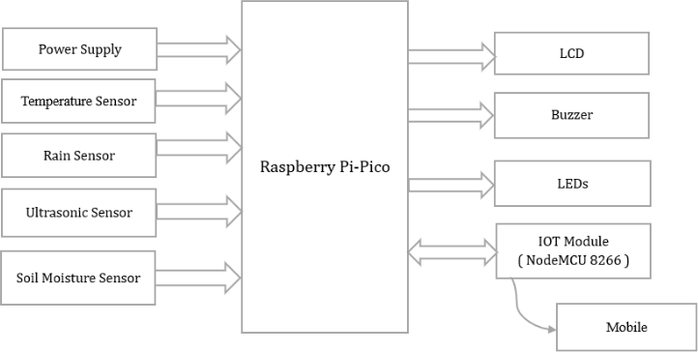

Fig. 3.1 Block diagram

## Working: -

DHT11 sensor will sense the temperature and humidity of the surrounding. The rain sensor will detect the rain and send a signal to pi pico. The ultrasonic sensor installed at reservoir. And it will detect the level of flood in respect to reservoir. Soil moisture will tell the soil whether wet or dry. And all the sensor's information will be displayed on 16×2 LCD display. If any sensor senses abnormal condition, then Red led will be ON along with buzzer that indicates emergency. Otherwise, Green led will be ON. Pico also sends sensor data to IoT cloud server via ESP8266 module. We can view the data from remote locations. Sensor data will be displayed in table format. For important things like temperature and humidity, the server will provide graphs.

## Hardware Description: -

* + 1. **NodeMCU 8266**

The NodeMCU 8266 is one of the smallest development boards, based on the ESP8266 Wi-Fi microcontroller offering many GPIO pins, with built-in Wi-Fi. This board can be used with the Arduino IDE or Lua. It simplifies sensor and actuator integration, ideal for any

Internet of Things project, and this way it helps the flood monitoring system send data wirelessly to the cloud. This, thus means that you can see the system from afar and receive instantaneous updates about water levels or even potential flooding.

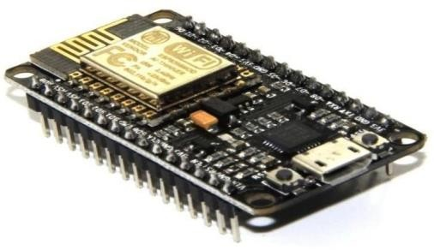

Fig:3.2 Node MCU ESP8266

## Raspberry pi Pico:

Raspberry Pi Pico is a microcontroller board that's based on the Raspberry Pi RP2040 microcontroller chip. Designed to be a low-cost, high-performance microcontroller board featuring flexible digital interfaces, Raspberry Pi Pico has gained fame as one of the most popular topics in the world of MCUs over recent times. This is the starter guide for Raspberry Pi Pico based on micro python, which will enable beginners to quickly get started with Raspberry Pi Pico. The central computing unit gathers sensor data and processes it and then sends it further. These critical water levels find an SMS or email message. It also takes care of the real-time generation of alerts based on flood risks.

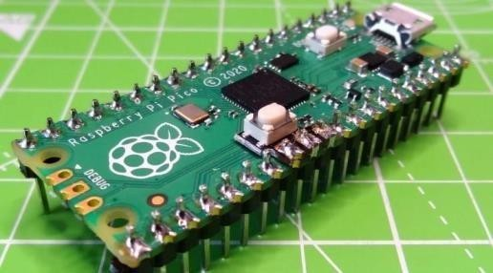

Fig: 3.3 Raspberry Pi Pico

## Ultrasonic Sensor

Ultrasonic sensors are commonly known as level sensors that measure distance with the help of ultrasonic waves. The sensor head emits an ultrasonic wave, which gets back after reflecting by the target. An ultrasonic sensor measures distance; it determines the distance by detecting a target through the timing while releasing and accepting the signal. Here, an ultrasonic sensor has been used in this project. It can measure the level of water in rivers, lakes, or any other water body. This sensor generates ultrasonic waves and gives the distance regarding the water level, so when the water level crosses above the limit then it creates a situation of flood.

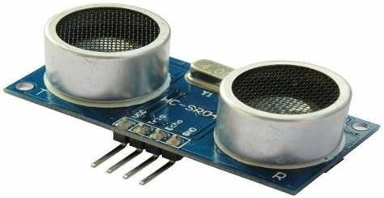

Fig: 3.4 Ultrasonic Sensor

## Rain Sensor

Below is the rain sensor module/board. It gauges the quantity at which it rains; one of the most important characteristics to detect a possible flooding. The sensor delivers updating information regarding the rate of raining and, therefore, aids in the predication of flood risks- especially in areas characterized by intensive rainfalls.

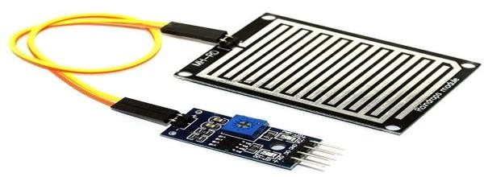

Fig: 3.5 Rain sensor

## Temperature Sensors (DHT11):

One of the most popular sensors for measuring temperature and humidity is the DHT11. The special part for temperature measurement is called NTC, and there's a small microcontroller to send data regarding the temperature and humidity in devices like NodeMCU WiFi8266 through a mobile application. The results of environmental monitoring in IoT have attracted great attention and provided important information for flood prediction and environmental assessment.

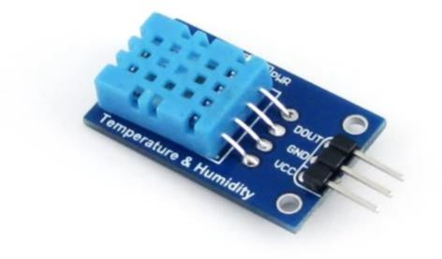

Fig:3.6 DHT11 sensor

## LCD Display

The LCD screen displays real-time data such as water levels, temperature, and humidity at the point where the sensors are mounted. This means that users can easily check flood risks quickly through the help of the screen without having to connect online. The screen is connected to the Raspberry Pi Pico with the help of NodeMCU WiFi8266 through mobile application and serves a clear, local display of important information.

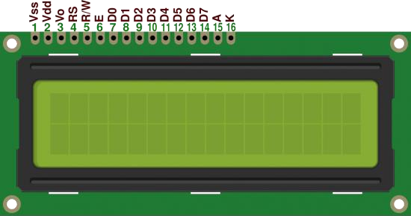

Fig:3.7 LCD Display

## Buzzer

Buzzer have numerous applications in IoT systems and are of very high importance as they communicate an audible signal, alert, or instruction to the user. Reports on criminal cases can lead to various lines or procedures. When the alarm for flood, fire, or medical is triggered, then there would be an audible alert that is sent in response to the emergency alert. Finally, the guides can offer feedback and enhance the access of accessible vehicles for visually impaired persons. This is a crucial function for the IoT applications as it is attributed to its voice alerts, short messaging, and security features.

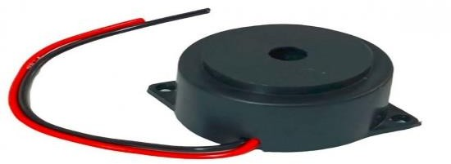

Fig:3.8 Buzzer

## Power Supply

The following sub-section shows how the power supply unit works along with channels, rectifiers, and what follows, regulators. Starting from AC voltage, smooth DC voltage is achieved by adjusting AC voltage and then filtering it through to DC voltage before finally obtaining ideal stable DC. This aspect is taken by the IC voltage control unit, which takes a DC voltage input and the provides a low DC voltage such that it remains unchanged no matter whether the DC voltage itself changes or whether the output load is affected by the change in the DC voltage.

## LCD With I2C Module

The I2C module equips the LCD display and works like a community map that shows real-time information about the amount of water measured by the sensor, so it allows the user to analyze the flooding risk in the I2C area of the LCD display and microcontro ller controller. Most of this information in the communication protocol is self-explaining.

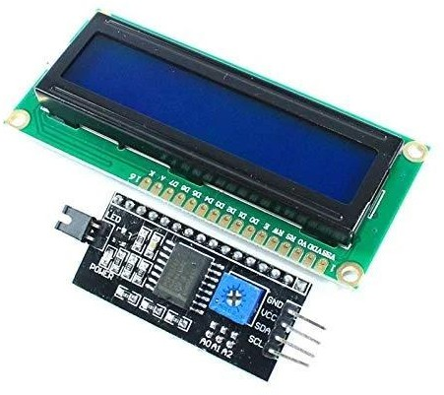

Fig:3.9 LCD with I2C Module

# RESULTS

The "Flood Monitoring and Alerting System Using Raspberry Pi Pico" was tested under several scenarios to ensure its working.

**Flood Monitoring:** Whenever the water level rose above 80%, the system correctly posted an alert message on the LCD and triggered the buzzer, which made it safe enough to provide notice of a flood well in time.

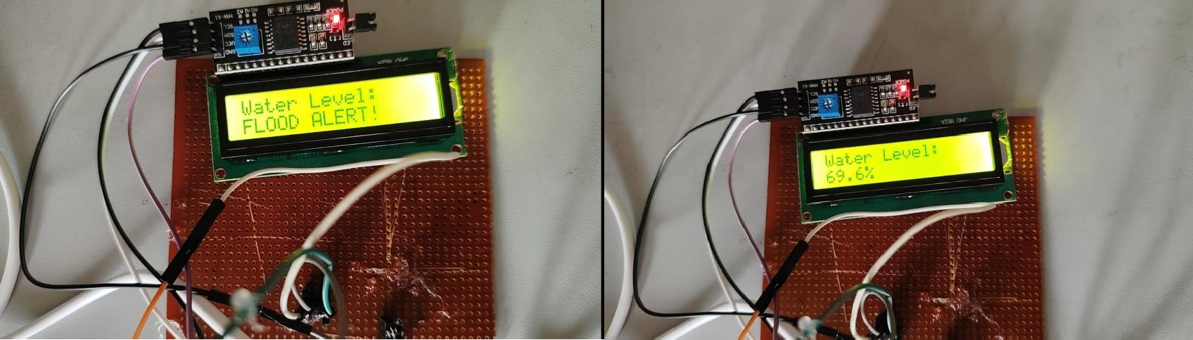

Fig. 4.1 Output of Flood Monitoring

**Soil Moisture, Temperature, and Rain Alert:** The soil moisture sensor indeed provided an accurate reading for the water content in the soil and transmitted the data to the Blynk app through the ESP8266. Similarly, temperature and rain status were well shown in real- time on the application, allowing for remote monitoring.

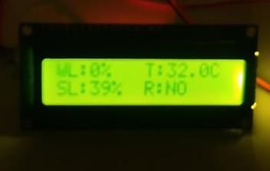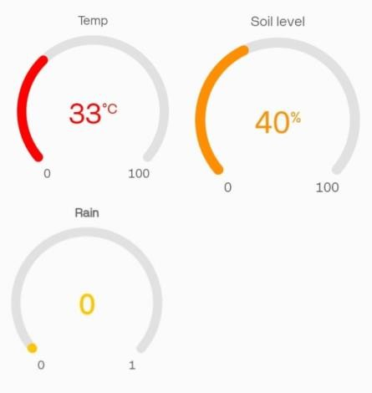

Fig. 4.2 Output of Soil Moisture, Temperature, and Rain Alert

# CONCLUSIONS

This smart IoT flood monitoring system has the capacity to detect early floods. The flood monitoring systems do contain sensors measuring levels of water, temperature, and humidity, Rain, and Soil Moisture. In case it detects a flooding risk, it gives alerts through SMS and a buzzer for local warning. It also provides information with real-time data on the screen for on-site monitoring, where it uploads the data to the cloud, thus detecting better floods in the future. It is affordable, easy to set up, and helps communities stay safe by giving advance notice to prepare for floods and reduce their impact.

# REFERENCE

1. S. Garima, B. Pravesh, S. Prajjwal, B. Nishita, "IoT Based Flood Monitoring and Alerting System with Weather Forecasting" International Journal of Innovative Technology and Exploring Engineering (IJITEE) ISSN: 2278-3075 (Online), vol.9 Issue-6, 2022.
2. Wahidah Md Shah, F. Arif, A. A. Shahrin, Aslinda Hassan, "The Implementation of an IoT-Based Flood Alert System, "International Journal of Advanced Computer Science and Applications(ijacsa), vol.9 Issue 11, 2020.
3. Mr. Muthamil Selvan, "Automatic Water Level Indicator Using Ultrasonic Sensor and GSM Module" International Journal of Advanced Research and Innovative Concepts in Education, vol.4, 2021.
4. S. J. Priya, S. Akshaya, E. Aruna, J. A. M. Julie, and V. Ranjani, “Flood monitoring and alerting system,” International Journal of Computer Engineering & Technology (IJCET), vol. 8, no. 2, p. 15, 2019.
5. Xue F, Gao W, Yin C, Chen X, Xia Z, Yunzhe Lv, Zhou Y, Wang M, “Flood Monitoring by Integrating Normalized Differential Flood Index and same as Probability Distribution of the Water Bodies”, IEEE Journal of the Selected Topics in is Applied Earth Observations and Remote Sensing, 15: p. 4170–4179, 2022.
6. D. Mysar and M.J. Babu, “Real Time Monitoring of Water Level Variation in Rivers and Flood Alerting System using ARM7”, International Journal of Advanced Research in Computer and Communication Engineering, vol. 4, no. 8, pp. 392-396, 2022.
7. Ghosh, A., & Mukherjee, A. (2021). Design and implementation of IoT-based flood monitoring system using NodeMCU and sensors. Proceedings of the 2021 IEEE International Conference on IoT, 1, 33-38.
8. S.K. Yadav, P. R. Mehta. (2020). IoT based flood alerting system using wireless sensor networks. International Journal of Computer Applications, 182(31), 32-37.
9. Manjula P., Balachandra P. (2018) An Analysis on Pricing Strategies of Software ‘I-Med’ in Healthcare Industry. In: Mishra D., Nayak M., Joshi A. (eds) Information and Communication Technology for Sustainable Development. Lecture Notes in Networks and Systems, vol 9. Springer, Singapore.
10. Subramanya Chari, Maturi Thirupathi, Hariveena. IOP Conf. Series: Materials Science and Engineering 981 042078 (2020).
11. [Raghu N,](https://www.researchgate.net/profile/Raghu-N-3?_tp=eyJjb250ZXh0Ijp7ImZpcnN0UGFnZSI6InB1YmxpY2F0aW9uIiwicGFnZSI6InB1YmxpY2F0aW9uIiwicHJldmlvdXNQYWdlIjoicHVibGljYXRpb24ifX0) [Md Firuz Mia,](https://www.researchgate.net/profile/Md-Firuz-Mia) [Md Asim Akram,](https://www.researchgate.net/profile/Md-Asim-Akram) [Abdur Nurlinkon,](https://www.researchgate.net/scientific-contributions/Abdur-Nurlinkon-2292027021) [Md Mottakin Hosen,](https://www.researchgate.net/scientific-contributions/Md-Mottakin-Hosen-2292054312) [M Mehedi Hassan](https://www.researchgate.net/scientific-contributions/M-Mehedi-Hassan-2292053315?_tp=eyJjb250ZXh0Ijp7ImZpcnN0UGFnZSI6InB1YmxpY2F0aW9uIiwicGFnZSI6InB1YmxpY2F0aW9uIiwicHJldmlvdXNQYWdlIjoicHVibGljYXRpb24ifX0) “Flood and Cyclone Detection System for Real-Time Monitoring and Early Warning”. International Conference on Image Processing and Capsule Networks (ICIPCN) (July 2024).
12. Vaibhav Godase. (2024). SMART PLANT MONITORING SYSTEM. In International Journal of Creative Research Thoughts (Vol. 12, Number 5, pp. b844–b849). Zenodo. <https://doi.org/10.5281/zenodo.11213525>
13. Vaibhav Godase, Akash Lawande, Kishor Mane, Kunal Davad and Prof. Siddheshwar Gangonda . "Pipeline Survey Robot." International Journal for Scientific Research and Development 12.3 (2024): 141-144.
14. Vaibhav Godase, Yogesh Jadhav, Kakade Vishal, Virendra Metkari and Prof. Siddheshwar Gangonda . "IOT Based Greenhouse Monitoring And Controlling System." International Journal for Scientific Research and Development 12.3 (2024): 138-140.
15. Godase, Vaibhav, Amol Jagadale, and SKNSCOE, Korti, Solapur University-413304, India. “Three Element Control Using PLC, PID & SCADA Interface.” Journal-article. IJSRD - International Journal for Scientific Research & Development. Vol. 7, 2019. <https://www.ijsrd.com>.
16. Godase, Vaibhav, Prashant Pawar, Sanket Nagane, and Sarita Kumbhar. “Automatic Railway Horn System Using Node MCU.” Journal of Control & Instrumentation 1 (2024): 11–19. <https://journals.stmjournals.com/joci>.
17. Godase, V., Mulani, A., SKN Sinhgad College of Engineering, Pandharpur, Godase, V., Mulani, A., Ghodak, R., Birajadar, G., Takale, S., SKN Sinhgad College of Engineering, Pandharpur, & Kolte, M. (2024). A MapReduce and Kalman Filter based Secure IIoT Environment in Hadoop. In SKN Sinhgad College of Engineering, Pandharpur [Journal-article]. <https://www.researchgate.net/publication/383941977>
18. Godase, V., & Godase, J. . (2024). Diet Prediction and Feature Importance of Gut Microbiome using Machine Learning. Evolution in Electrical and Electronic Engineering, 5(2), 214-219. <https://publisher.uthm.edu.my/periodicals/index.php/eeee/article/view/16120>
19. Godase, Vaibhav, et al. “Smart Agriculture Automation Using ESP8266 Node MCU.” Journal of Electronics, Computer Networking and Applied Mathematics (JECNAM) ISSN : 2799-1156, 1 Aug. 2023, journal.hmjournals.com/index.php/JECNAM/article/view/2417.
20. Mr. Sanket K Nagane, Mr. Prashant S Pawar, & Prof. V. V. Godase. (2022). Cinematica Sentiment Analysis. Journal of Image Processing and Intelligent Remote Sensing(JIPIRS) ISSN 2815-0953, 2(03), 27–32. <https://doi.org/10.55529/jipirs.23.27.32>