**HYBRID ELECTRIC CHARGING SYSTEM**

**K. ASHA DEEPTHI1, K. SRAVANI2, P. PAVAN KUMAR3, Y. TULASI RAMYA4, T. SHIVARAM5, B. EEDUKONDALU6, Dr. S. CHANDRA SEKHAR7**

Department of EEE, NRI Institute of Technology, Agiripalli, Andhra Pradesh, India

**ABSTRACT**

The Solar Piezo Wind Hybrid Electric Charging System integrates solar energy, piezoelectric energy, and wind power into a cohesive, sustainable solution for charging devices. This system leverages the complementary nature of these energy sources to maximize energy generation throughout the day and night. Solar panels harvest sunlight, wind turbines capture kinetic energy from the wind, and piezoelectric materials convert mechanical vibrations or pressure into electrical energy. By combining these sources, the system provides continuous and reliable energy, reducing dependency on conventional grid power.

The piezoelectric component of the system plays a unique role, tapping into vibrations from environmental sources like traffic, machinery, or natural wind forces. This feature makes the hybrid system versatile in urban and rural settings, where these vibrations are abundant. Additionally, the system’s modular design allows for scalability, enabling it to meet the energy demands of various applications, from small electronic devices to larger battery storage solutions for off-grid systems.

This hybrid approach offers significant advantages, including higher efficiency, reduced environmental impact, and improved reliability. By using renewable sources in conjunction, the system ensures a more consistent power supply, while minimizing reliance on fossil fuels. Moreover, this integration encourages sustainable development and energy independence, promoting a cleaner, greener future for energy generation and consumption.

1. **INTRODUCTION**

The introduction should be typed in Times New with font size 10. In this section highlight the importance of topic, making general statements about the topic and presenting an overview on current research on the subject. The simplest way is to replace(copy-paste) the content with your own material. Your introduction should clearly identify the subject area of interest.

The Solar Piezo Wind Hybrid Electric Charging System is an innovative solution designed to harness multiple renewable energy sources to provide efficient and sustainable charging capabilities. By combining solar energy, piezoelectric technology, and wind power, this hybrid system ensures a constant and reliable energy supply, even in areas with fluctuating weather conditions. Solar panels capture sunlight, piezoelectric devices generate power from mechanical vibrations or movements, and wind turbines convert wind energy into electrical power, all working together to optimize energy production.

This hybrid system is particularly beneficial in off-grid or remote locations where traditional power infrastructure may not be available or feasible. The integration of these three renewable energy sources enhances the overall efficiency and reliability of the charging system, making it a promising solution for various applications, including electric vehicle charging stations, remote monitoring devices, and other low-energy-demand technologies. As the world moves toward more sustainable energy solutions, the Solar Piezo Wind Hybrid Electric Charging System stands as a crucial step toward reducing dependency on fossil fuels and mitigating the environmental impact of conventional power generation.

1. **METHODOLOGY**

Solar Charging Systems: Traditional solar charging systems use photovoltaic (PV) panels to convert sunlight into electrical energy. These systems are widely used in various applications, from small-scale solar chargers for personal devices to large solar power plants. The key advantage of solar systems is their ability to provide clean and renewable energy.

Piezoelectric Energy Harvesting: Piezoelectric systems generate electrical energy by converting mechanical vibrations or pressure into electrical charge using piezoelectric materials. These systems are used in specialized applications, such as powering small sensors or wearable devices, where regular movement can provide the necessary mechanical input.

Wind Harvesting System: A wind energy harvesting system captures the kinetic energy of the wind and converts it into electrical power using wind turbines. The turbines consist of blades that rotate when wind blows, driving a generator to produce electricity.

Hybrid Energy System :

A Solar-Piezo-Wind Hybrid Electric Energy Charging System integrates three renewable energy sources—solar, piezoelectric, and wind—to efficiently generate and store electricity. Solar panels capture sunlight and convert it into electrical power, while wind turbines harness wind energy through rotating blades. The piezoelectric system generates power from mechanical vibrations or pressure changes, such as foot traffic or vehicle movement, converting them into electrical energy. This hybrid system can provide a continuous and reliable energy supply, even in variable conditions, by balancing the output of each energy source.

1. **PROPOSED MODEL**

**Solar Panel:** Solar panels convert sunlight into electricity using photovoltaic cells. They are a sustainable and renewable energy source, reducing reliance on fossil fuels.

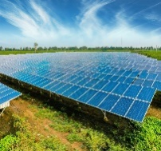

**Piezo Plate:** A piezo plate is a thin, flexible material that generates electrical charge when subjected to mechanical stress. It is commonly used in sensors, actuators, and energy harvesting devices

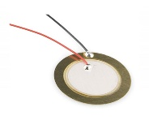

**Wind Turbine:** A wind turbine converts kinetic energy from wind into electrical energy through the rotation of its blades. It is a key technology in renewable energy generation.



**Arduino Uno:** The Arduino Uno manages the integration of energy inputs from solar, piezo, and wind sources. It optimizes charging and monitors energy flow to ensure efficient power distribution and storage.

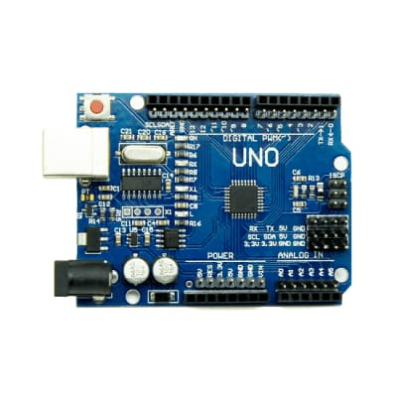

**Charge Controller:** A charge controller regulates the voltage and current coming from a power source to safely charge a battery. It prevents overcharging, deep discharging, and helps extend the lifespan of the battery.

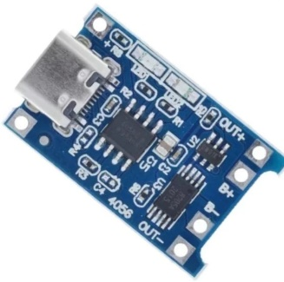

**Battery:** A charge controller regulates the voltage and current coming from a power source to safely charge a battery. It prevents overcharging, deep discharging, and helps extend the lifespan of the battery.

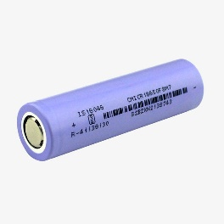

1. **WORKING**

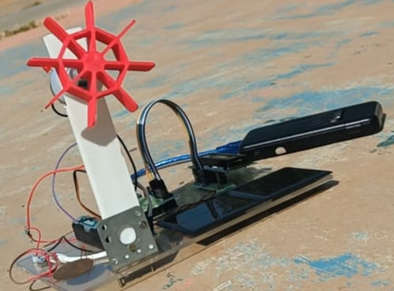

A Solar-Piezo-Wind hybrid electric energy charging system combines three renewable energy sources—solar, piezoelectric, and wind—into a single system for efficient energy generation. The solar panel captures sunlight and converts it into electrical energy, which is stored in a battery for later use. The piezoelectric elements, embedded in surfaces like roads or buildings, generate electricity when subjected to mechanical stress or vibrations, providing an additional power source. The wind turbine converts wind energy into electricity by harnessing the kinetic energy of the wind to rotate its blades, generating power that is also stored in the battery.

The integration of these three sources ensures that the system remains operational even when one or more of the energy sources are unavailable. For example, on cloudy or windless days, the piezoelectric system can still generate electricity from vibrations, and the solar panels can still charge during the day. This hybrid system helps to stabilize the power output and ensures a continuous supply of energy to the connected devices or batteries. The system is especially beneficial in areas where access to a single source of renewable energy is limited or intermittent.

The system uses a charge controller to regulate the flow of energy from the solar, piezo, and wind sources to the battery, preventing overcharging and optimizing charging efficiency. The battery stores the collected energy for later use, while an inverter or other power management system can convert the stored DC power to AC power if needed. This hybrid energy charging system is an efficient and environmentally friendly solution for powering devices or small electrical systems, reducing dependence on non-renewable energy system.

1. **CONCLUSION**

In conclusion, the Solar, Piezo, and Wind Hybrid Electric Charging System offers a promising solution to meet the increasing demand for renewable and sustainable energy sources. By integrating three different energy harvesting methods—solar, wind, and piezoelectric—the system maximizes energy generation efficiency, ensuring continuous power supply even in varying

environmental conditions. This hybrid approach not only provides reliable energy for remote or off-grid locations but also significantly reduces dependence on non-renewable energy sources, contributing to environmental sustainability and the reduction of carbon footprints.

Looking ahead, the potential for this hybrid energy system is immense, particularly with advancements in energy storage, material science, and grid integration technologies. The system can be further optimized for applications in electric vehicles, urban infrastructure, and smart grids, making it a versatile and future-ready solution for addressing global energy challenges. As we continue to innovate and improve these technologies, the Solar, Piezo, and Wind Hybrid Electric Charging System could play a vital role in creating a more resilient, decentralized, and environmentally-friendly energy infrastructure for the future.

**ACKNOWLEDGEMENT**

The Solar Piezo Wind Hybrid Electric Charging System represents a significant advancement in sustainable energy solutions, combining the power of solar, wind, and piezoelectric technologies. This innovative system harnesses renewable energy from multiple sources, optimizing efficiency and reducing reliance on conventional power grids. The integration of piezoelectric energy conversion adds an extra dimension by capturing vibrations and mechanical stress, making the system adaptable to various environments. By providing a reliable and eco-friendly method of charging, it contributes to energy independence and supports a cleaner, greener future. The system exemplifies the potential of hybrid technologies in addressing the growing demand for sustainable power generation.

1. **REFERENCES**
2. www.google.com
3. www.chrome.com
4. www.wikipedia.com
5. www.safari.com
6. www.gemini.com