**BUILDING MODEL AND CALCULATING THE TOURISM CAPACITY OF THE BEACH SYSTEM IN QUANG NINH PROVINCE**

**Tran The Hoang1, Doan Xuan Truc1**

1VNU University of Economics and Bussiness, Vietnam

Emai: Tranthehoanghtc7@gmail.com

**ABSTRACT**

Quang Ninh is one of the provinces with a huge number of tourist beaches, the revenue from tourism activities here is huge. Every year, Quang Ninh welcomes an estimated 19 million tourists, with an estimated revenue of over 40,000 billion VND/year. However, welcoming a large number of tourists can put great pressure on the resources and environment of Quang Ninh province. This article is designed to determine the effective carrying capacity that Quang Ninh province should aim for in order to optimize natural resources for sustainable tourism development in the future. The study used the tourism carrying capacity (TCC) method to determine the physical carrying capacity (PCC), actual carrying capacity (RCC) and effective carrying capacity (ECC) of beaches with a significant number of tourists in Quang Ninh province. Through calculations, we have come up with the results on capacity including: physical capacity (PCC) is 134,133,120/year, actual capacity (RCC) is 31,618,824 passengers/year and effective capacity (ECC) is 23,480,770 passengers/year. The research results are useful documents serving the planning and orientation of sustainable tourism management in coastal cities such as Quang Ninh.

**Keywords:** *coastal tourism, tourism carrying capacity, Quang Ninh province*

1. **INTRODUCTION**

Quang Ninh, known for its extensive coastline spanning over 250km and boasting more than 2,000 islands, holds a unique position in Vietnam's tourism landscape (Quang Ninh Newspaper, 2024). The province, recognized as having the most islands in the country, sees marine tourism as its primary avenue for development (Ministry of Culture, Sports, and Tourism, 2014). Over the years, island tourism has flourished, cementing Quang Ninh's status as a key player in Vietnam's island tourism sector. To further bolster this sector, Quang Ninh has strategically focused on enhancing infrastructure, facilities, and introducing innovative tourism products to keep pace with seasonal trends (Ministry of Culture, Sports, and Tourism, 2023). Taking a holistic approach, the Sustainable Coastal Destination Load (SCDL) represents the highest threshold of the natural, environmental, and socio-economic systems. It considers the carrying capacity of physical facilities, ecological limits, and tourists' preferences (Pearce, 1989). Through modeling and calculating capacity, we can establish limits on visitor flows, ensuring environmental sustainability and protection. This approach evaluates tourist reception capacity, resources, infrastructure, and emphasizes environmental conservation and effective traffic management. The research outlined aims to provide comprehensive insights into coastal tourism in Quang Ninh, focusing on capacity management and environmental protection. Key subjects include tourists, infrastructure, natural resources, local governance, and the community. The study, "Building models and calculating tourism capacity at some coastal destinations in Quang Ninh province," seeks to address critical aspects of tourism management and environmental conservation. Through a series of research questions, it aims to develop scientific models, assess tourism trends, protect natural resources, enhance visitor experiences, and inform policy decisions in Quang Ninh.

1. **LITERATURE REVIEW**

The field of cruise tourism has attracted significant attention from researchers and professionals in recent decades. Considered an important part of the tourism industry, cruise tourism provides not only entertainment and leisure opportunities for tourists but also a valuable resource for local communities. It also faces many challenges, including negative impacts on the marine environment and local communities.

Many studies have focused on the impact of cruise tourism on the marine environment. The results suggest that the increase in marine tourism may lead to negative impacts on the marine environment, including ocean water pollution, the loss of coral reefs, and climate change (Smith et al., 2018; Jones & Brown, 2020). Other research has looked at how to manage visitor traffic at developed beaches. They proposed measures such as limiting the number of daily visitors, managing travel schedules, and building monitoring systems to ensure sustainable tourism (Williams et al., 2019). Research has also focused on sustainable development in marine tourism. They discussed measures such as ecotourism, using renewable energy sources, and creating business opportunities for local communities (Gössling et al., 2017). Additionally, there is research focusing on the social and economic impact of marine tourism. They focus on creating employment opportunities, generating income for local communities, and providing services to visitors. However, issues such as urban intensification and pressure on local resources have also been addressed (Hall, 2018; Koens et al., 2018).

Tourism capacity at beaches is an important aspect of sustainable tourism management and environmental conservation. With the rise of marine tourism and interest in protecting marine resources and the environment, research on tourism capacity at beaches has become increasingly important. Tourism capacity at beaches is defined by Coccossis and Parpairis (2013) as "the ability of a beach or coastal area to accommodate visitors without significantly affecting the environment and tourism experience". Capacity represents a balance between supply and demand while ensuring visitors have a positive experience.

Several studies have focused on developing measures to assess and manage tourism capacity at beaches. The study by Gonçalves et al. (2017) proposed a model to evaluate carrying capacity based on factors such as physical space, infrastructure, and social factors. Management measures include limiting the number of daily visitors, managing travel schedules, and ensuring local community participation. The study by Alegre et al. (2020) examined the impact of capacity management on beaches and local communities. The results show that carrying capacity management can protect marine resources, reduce pollution, and create employment opportunities for local communities. Popular beaches often face heavy tourist traffic pressure. Research by Hughes et al. (2019) discussed the challenges and opportunities of capacity management at popular beaches. They proposed measures such as using information technology to manage tourist traffic and building a reservation system. On the one hand, tourism capacity at beaches can be assessed using mathematical and statistical methods. However, the study by Yan et al. (2018) discussed how to integrate capacity assessment methods using a combination of metric data and visitor opinions to create a comprehensive picture.

Previous studies have provided a theoretical basis and methods for measuring tourism capacity. The research in Quang Ninh will take advantage of the strengths of previous studies and adjust the approach to suit the special situation of this region. Combining different aspects of tourism and environmental conservation will help build a comprehensive model that focuses on integrating carrying capacity, managing visitor flows, and preserving the marine environment.

Although previous studies provide valuable knowledge, their limitations are the lack of diversity in approach and focus on specific destinations. The study is expected to try to improve this by creating a widely applicable model for many coastal destinations in Quang Ninh, helping to manage tourism capacity more comprehensively and effectively for both areas.

1. **METHODOLOGY**

Data collection: Collect data about beaches in Quang Ninh province, including area, infrastructure, tourism history, number of visitors by season, information about the local population, and other factors affecting tourism.

Data analysis: Analyze the collected information to understand the tourism situation at each beach, development trends, and factors affecting tourism capacity.

Calculate capacity: Use the built model to calculate the tourism capacity of each beach in Quang Ninh province. Evaluate capacity based on factors such as area, infrastructure, and environmental and security constraints.

Analyze results and propose solutions: Analyze the results of calculating tourism capacity and propose solutions to manage and develop sustainable tourism at the beaches of Quang Ninh province in order to optimize capacity and protect environmental resources.

Carrying Capacity Method: Based on the formula for calculating tourism capacity of Cifuentes (1992) and Ceballos-Lascurain (1996), the study has been applied to determine the following indicators: 1. Carrying capacity physical capacity (PCC) is the maximum number of tourists that can stay in a particular area at a given time; 2. Actual carrying capacity (RCC) is the maximum number of tourists arriving at a specific tourist destination when affected by a correction factor (CF) originating from the geographical characteristics of the area; 3. Effective carrying capacity (ECC) is the maximum number of tourists a destination can sustain with available management capacity (Mc).

The SCDL calculation method is viewed from a physical, ecological, psychological, and economic perspective, as shown in the research of (Cifuentes, 1992; Amador et al., 1996; Ceballos-Lascurain, 1996; Nguyen, 2000; Pham et al., 2002; Coccossis & Mexa, 2004; Tran Nghi et al., 2007; Segrado et al., 2008; Vo, 2008; Swagata Bera et al., 2015). From the perspective of human geography, socio-cultural carrying capacity is related to factors that are difficult to quantify. Commonly used research methods include field surveys, sociological surveys using Likert scales (Pereira da Silva, 2002; UNEP/PAP, 1997), and data analysis using Excel and SPSS 17.0 (Needham et . al., 2008; Brandolini, 2005; Subash Joshi & Rajiv Dahal, 2019).

1. **RESULT**

**4.1. Current status of coastlal tourism in Quang Ninh province**

Quang Ninh Province is a province in the Red River Delta region of Vietnam. The province has a prime location with areas bordering the sea, border gates, mountains, forests, and many famous tourist destinations. The area of the entire Quang Ninh province is 8,239,243 km2, with a total number of district-level administrative units of 14 units. With the advantage of being blessed by nature, the coastline of Quang Ninh province stretches more than 250km through 8 cities, districts, and towns, so Quang Ninh province has many conditions to develop marine economic tourism. Especially now, Quang Ninh province has exploited five district-level administrative units, including Ha Long City, Cam Pha City, Mong Cai City, Van Don District, and Co To Island District. These are areas with long beaches, many of which have been recognized as national key tourist areas. Quang Ninh province, with many characteristics of rich nature, unique culture,... brings outstanding cultural tourism potential. However, Quang Ninh province is even more unique because of the differentiation of the coastal terrain when the province's former coastal area was a flooded mountainous area, creating the terrain of Ha Long Bay. In 2000, Ha Long Bay was recognized by UNESCO as a World Natural Heritage twice, in 1994 and 2000, according to criteria (vii) and (viii). Tourism resources help Quang Ninh Province achieve certain achievements in marine tourism development in terms of the number of visitors, revenue, and tourism infrastructure.

*Source: General Department of Geology and Minerals of Vietnam*

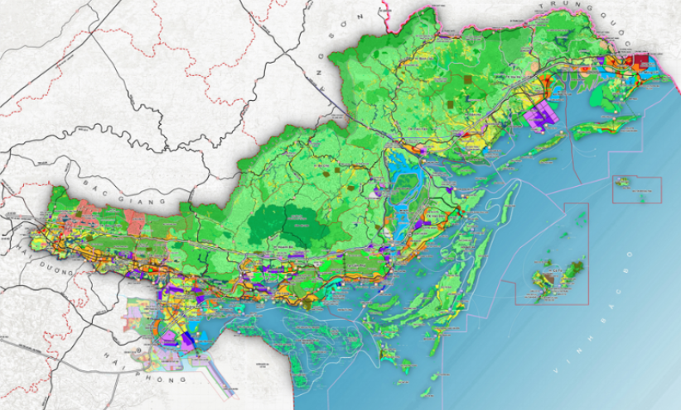

*Figure 4.1. Geological map of Quang Ninh province*

In 2023, the tourist growth rate at Quang Ninh's coastal destinations will have increased significantly. The number of tourists visiting and relaxing in coastal areas such as Ha Long, Co To, Mong Cai, Van Don, and Cam Pha has increased sharply. According to the government electronic newspaper, the number of tourists to Quang Ninh is estimated at 15.5 million, and the number of foreign tourists is 2 million, an increase of 33.6% over the period.

The average spending level of tourists in Quang Ninh has steadily increased by about 10% over the years. By 2023, according to survey data from the Quang Ninh Statistics Department, tourists will spend about 3,700,000 VND per trip (equivalent to about 1,900,000 VND per day).

Tourism revenue is estimated to reach 33,480 billion VND, an increase of 48% compared to 2022. Tourism in Quang Ninh Province has basically recovered compared to before COVID-19 occurred.

The number of accommodation establishments and restaurants in Quang Ninh tends to increase to meet the needs of tourists. Expanding and developing tourism infrastructure is an important part of the province's tourism development strategy.

The total investment capital in the tourism industry in Quang Ninh has increased steadily over the years, especially in the fields of accommodation, food services, art, entertainment, and entertainment activities.

The development of tourism has created many job opportunities for local workers. Tourism professional training is being focused on and tends to develop to meet the needs of the industry.

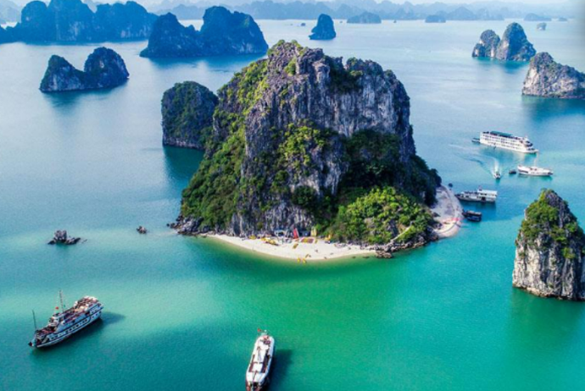*Source: Government News*

Figure 4.2. A typical scene of Quang Ninh province

**4.2. Practical research result**

***4.2.1. PCC – Physical carrying capacity***

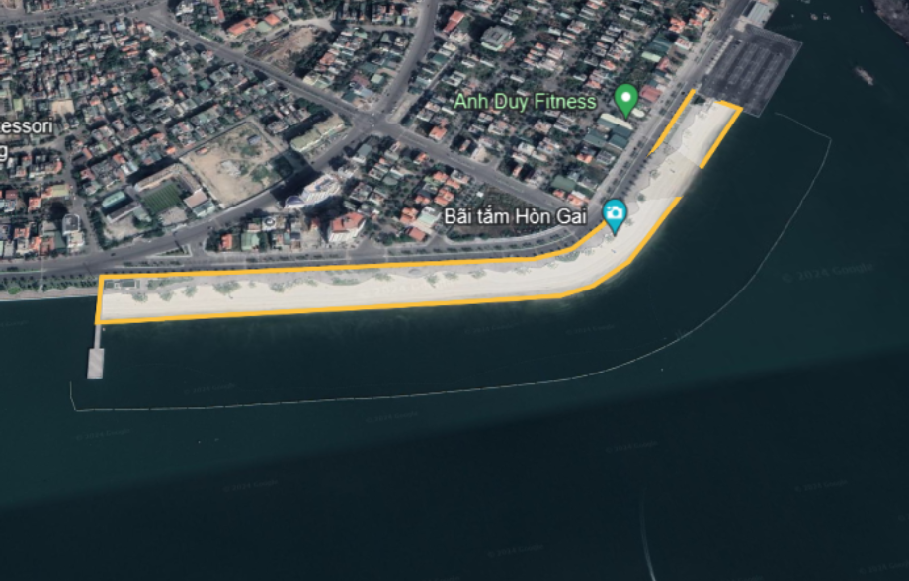

*Figure 4.3. Illustration of measurement method using Google Earth tool*

Physical capacity is defined as the maximum load-carrying capacity for a geographical area. From the physical capacity data, it can help us determine the maximum number of tourists that can participate in tourism. Quang Ninh province has a coastline stretching over 200km, with many beautiful beaches and huge tourism potential. However, many beaches are still abandoned and unexploited, so this research is measured and calculated based on beaches with favorable conditions for the economic development of marine tourism (including facilities, infrastructure, accommodation, and auxiliary services). Then list the beaches of five districts and cities. Area results are determined based on measurements on the Google Earth support tool (picture below).

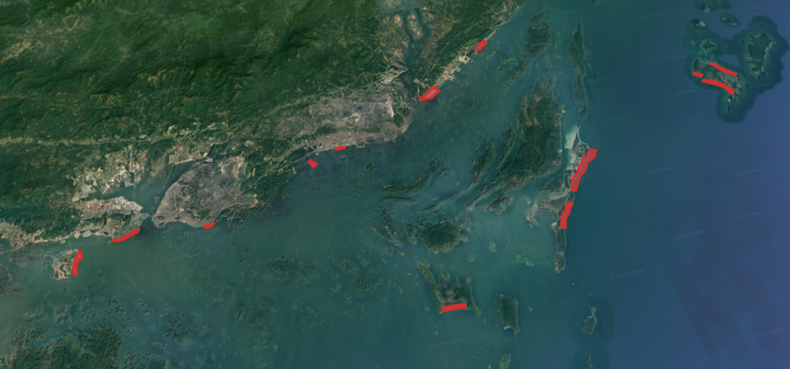

*Figure 4.4. Beaches were measured in 5 districts and cities in Quang Ninh province*

Physical carrying capacity is calculated according to the formula:

|  |
| --- |
| PCC = A/Au × Rf × 365 |

Including: A: Available area for tourist use;

Au: Area required per tourist to swim, applying the popular type of beach according to WTO 1981 (10m2);

Rf: Daily number of visitors swimming/average time a tourist stays (Rotation factor),

Rf = 12 hours/3 hours = 4

*Table 4.1. Area and Physical carrying capacity achieve*

|  |  |  |  |  |  |  |
| --- | --- | --- | --- | --- | --- | --- |
|  | **Acreage (A)** | **PCC** | **Acreage (A)** | **PCC** | **Acreage (A)** | **PCC** |
| **Ha Long** | *Bai Chay* | | *Hon Gai* | | *Tuan Chau* | |
| 269.927 | 39.409.342 | 39.985 | 5.837.810 | 25.207 | 3.680.222 |
| **Van Đon** | *Bai Dai* | | *Son Hao* | | *Wonder Island* | |
| 106.499 | 15.548.854 | 77.486 | 11.312.956 | 132.441 | 19.336.386 |
| **Cam Pha** | *Luong Ngoc* | | *TTP* | |  | |
| 7.925 | 1.157.050 | 26.500 | 3.869.000 |
| **Co To** | *Van Chay* | | *Tinh Yeu* | | *Hong Van* | |
| 6.307 | 920.822 | 11.937 | 1.742.802 | 29.293 | 4.276.778 |
| **Mong Cai** | *Tra Co* | |  | | | |
| 185.213 | 27.041.098 |

***4.2.2. RCC – Real carrying capacity***

Real carrying capacity is calculated according to the formula:

|  |
| --- |
| RCC = PCC × (Cf1× Cf2× Cf3× - - - Cfn) |

In which: Cf is the adjustment coefficient, affected by factors such as rainfall, monsoon, heat, storms and beach quality.

|  |
| --- |
| Cfx = 1 – Lmx/Tmx |

Including: Cfx: Correction factors of variable x;

Lmx: Limiting magnitude of variable x;

Tmx: Total magnitude of variable x

Correction factors play a crucial role in accurately estimating the carrying capacity of a destination. The adjustment coefficient, which accounts for natural conditions, environmental factors, ecology, and beach quality, is pivotal in this estimation process. Beach tourism, in particular, is heavily influenced by natural elements such as rainfall patterns, frequency of sunny days, occurrence of storms and tropical depressions, and the overall quality of the beach. These factors not only impose limitations on tourism activities but also impact tourist satisfaction levels.

* **Number of days of heavy rain**

Quang Ninh province belongs to the Red River Delta ecosystem, an area subject to the typical tropical monsoon climate of Vietnam. Rainfall in this province changes seasonally, and it usually rains a lot from early May to late September. Including the variable Cf1 as the number of rainy days helps eliminate the period of time affected by the weather during which visitors cannot participate in swimming. The data table below shows the average rainfall in Quang Ninh Province over the years.

*Table 4.2. Calculation of the number of days of heavy rain*

|  |  |  |  |
| --- | --- | --- | --- |
| Month | Number of days of heavy rain | Month | Number of days of heavy rain |
| I | 2,2 | VII | 18,5 |
| II | 2,6 | VIII | 18,9 |
| III | 4,3 | IX | 14,1 |
| IV | 6,8 | X | 8,3 |
| V | 13,4 | XI | 4,4 |
| VI | 17,2 | XII | 2,2 |
| Total number of days of heavy rain in a year: 114 days | | | |

**→ Cf1 = 1 - (113,8/ 365) = 0,6883**

* **Sea water temperature**

Quang Ninh Province is located in the north of Vietnam. The weather has four seasons: spring, summer, fall, and winter. Air temperature is also a factor in whether tourism is possible or not. The weather in the Red River Delta region becomes cold from September to April of the following year. To be able to measure the number of days visitors cannot swim, we used the water temperature index to represent the relationship between tourism and weather.

The recognized temperature for swimming is above 79 °F (26 °C). This is a moderate temperature for our bodies to feel most comfortable when performing swimming activities. In Quang Ninh, the average water temperature was over 26 °C from April 28 to November 16.

*Source: weatherspark.com*

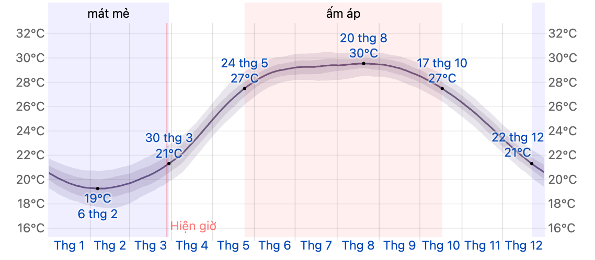

*Figure 4.5. Sea water temperature chart*

Thus, the total number of days tourists can bathe in Quang Ninh is 202 days/365 days.

**→ Cf2 = 1 - (163/365) = 0.5534**

* **Hot, sunny temperature**

During the year, there will always be sunny days with a very high UV index, which can be harmful to humans. The UV level causing damage to health is determined to be above 8. This level exists in the time frame of 11 a.m.–3 p.m. in the summer, from early May to late September.

*Source: World Health Organization*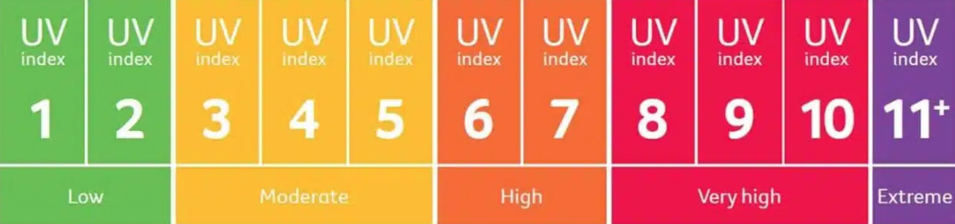

*Figure 4.6. Rating system of the UV Index*

The intensity limit for this parameter is determined to be 153 days x 4 hours, or 612 hours of bright sunshine per year. The total magnitude is determined by the total number of days per year, i.e., 356 days x 12 hours = 4380 hours. Therefore, the correction factor for excessive sunlight is determined:

**→ Cf3 = 1 – (612 hours/4380 hours) = 0.860**

* **Storm, tropical depression**

Storm season starts from August to November, especially in September and October, causing very serious harm, especially strong winds and heavy rain. The Gulf of Tonkin region in general and Quang Ninh province in particular receive about 3 storms and low pressure per year. This affects tourist activities for a period of 5 days; many activities are paralyzed, such as swimming, visiting the bay, playing, etc.

The limit size of the date parameter is defined as 15 days. The total intensity is 365 days, and the correction factor for storms and tropical depressions is:

**→ Cf4 = 1 minus (15 days/365 days) = 0.959.**

* **Beach quality**

Beach quality is evaluated using many different criteria, synthesized, and analyzed on the basis of previous research articles. Below are 7 criteria for beach quality compiled, including: Sand quality; slope; tide; yard area; sea water quality; waste; sea colors.

Based on field research results, comprehensive analysis of documents, and interviews with tourists and tourism managers, the following results were obtained:

*Table 4.3. Summary of Cf5 results*

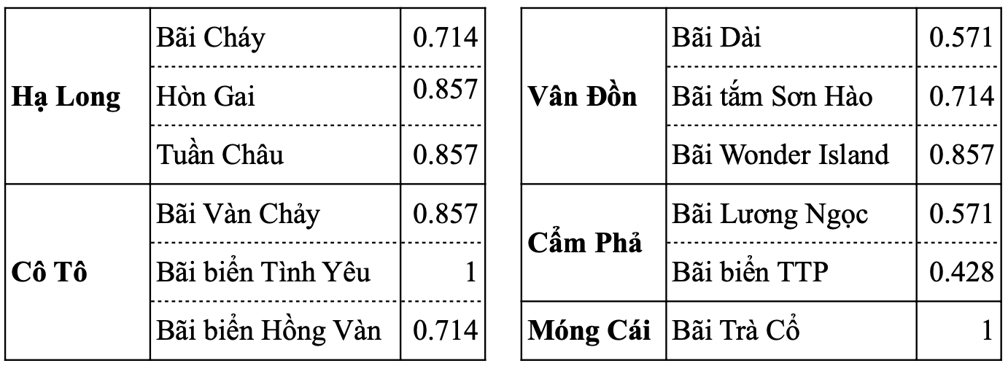

Applying the RCC calculation formula, we can calculate **the product of correction coefficients** for the Quang Ninh province area as follows:

*Table 4.4. Summarize the product of correction coefficients*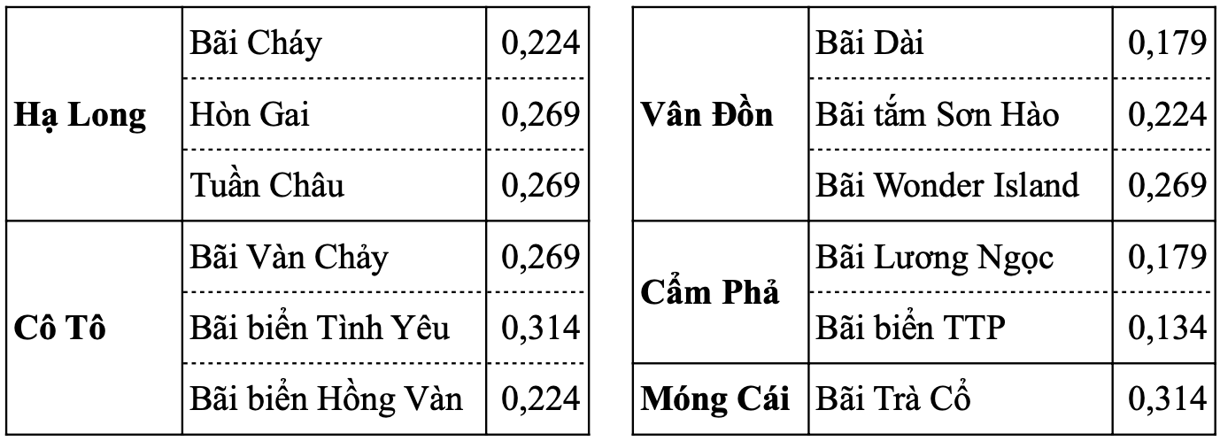

***4.2.3. ECC – Effective carrying capacity***

Effective carrying capacity is calculated according to the formula:

|  |
| --- |
| ECC = RCC × Mc |

Including: ECC: Effective carrying capacity;

RCC: Actual capacity;

Mc: Management capacity.

Management capacity (Mc) is a combination of development conditions for marine tourism management; however, this criterion is difficult to quantify. Basically, Mc is evaluated through the opinions of environmental and tourism experts and reports from local managers on facilities, amenities, legality, equipment, and tourist labor. Investment policies and schedules using field methods, sociological surveys, and data collection.

*Table 4.5. Survey contents*

|  |  |
| --- | --- |
| **No.** | **Contents** |
| 1 | How peaceful and quiet it is? |
| 2 | Diversity of attractions? |
| 3 | Amount of fresh water for daily use? |
| 4 | Quality of fresh water for daily use |
| 5 | Quality of waste collection? |
| 6 | Service and catering at coastal restaurants? |
| 7 | Public trash can? |
| 8 | Public restroom? |
| 9 | Diversity of entertainment and recreation service? |
| 10 | Services at attractions? |
| 11 | Swimming service? |
| 12 | Food service? |
| 13 | Quality of coastal accommodation types? |
| 14 | Control of social crime? |
| 15 | Are natural landscapes protected? |
| 16 | Food safety and hygiene? |
| 17 | Prices of services? |

After conducting field surveys and getting opinions from experts and local managers, the research team calculated the value of the Mc variable and came up with the following summary table.

*Table 4.6. Summary of Management capacity calculation results of localities*

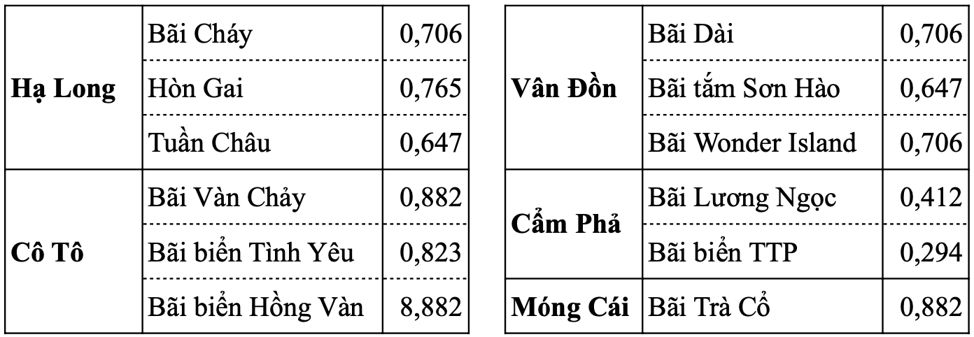

***4.2.4. Tourism capacity of beaches in Quang Ninh province***

Determine the formula to calculate effective carrying capacity (ECC), as shown in the summary table below. Determine the number of visitors that can be reached gradually, from physical capacity to actual capacity and finally to effective capacity. The reason given above is that the beaches in Quang Ninh are large in scale and have a long coastline, but other capabilities have not been met, such as accommodation capacity, facility capacity, etc. weather, climate,...

*Table 4.7. Summary of TTC calculation results of the coastal area of Quang Ninh province*

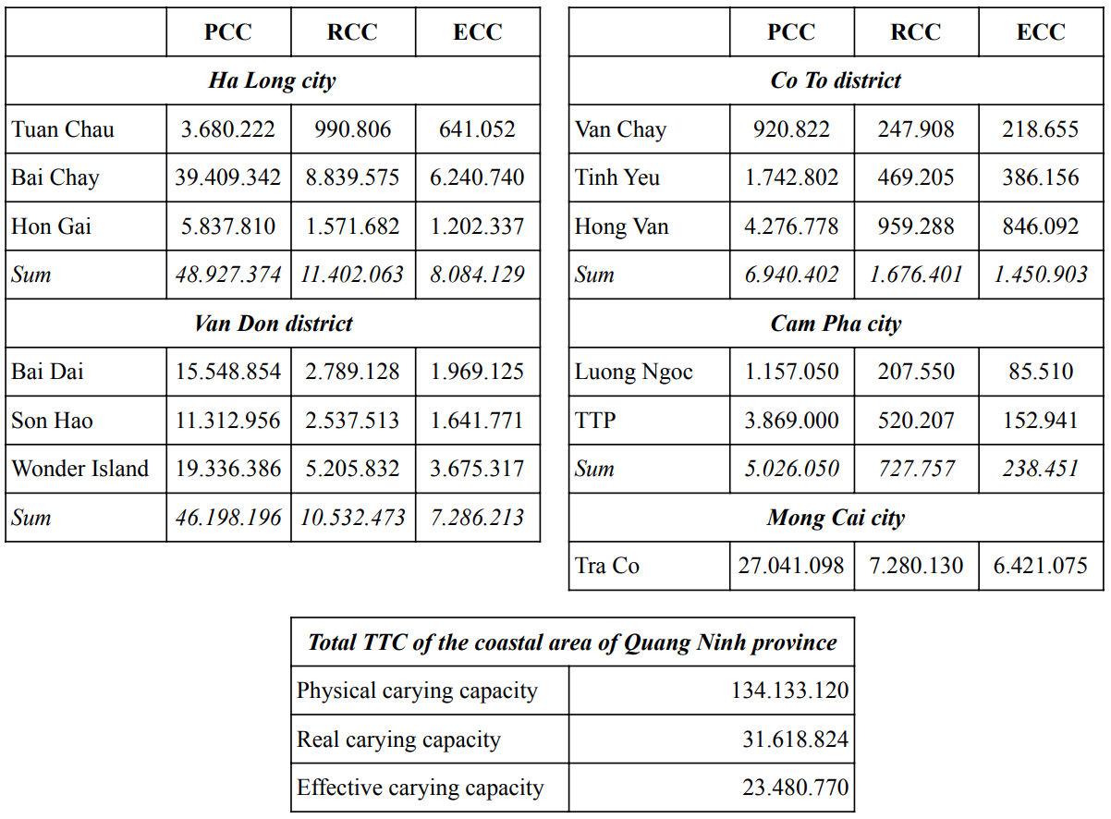

Through calculations of tourism capacity in Quang Ninh province, the highest physical capacity that this province has achieved is equivalent to 134 million tourists per year. This scale is relatively high, and in fact, Quang Ninh province has not been able to reach this level of tourists.

We calculate the actual carrying capacity (RCC) of the entire province to be about 31 million visitors. This number of tourists is completely reasonable when taking into account excluded factors including weather, rainfall, winter days, or intense sunlight.

We calculate the effective capacity (ECC) to be about 23 million visitors; this is a number that we consider to be completely reasonable because the capacity of Quang Ninh province is very good. If this level of tourists is maintained, Quang Ninh province can completely perform its tourism function well.

1. **CONCLUTION**

**5.1. General conclusions from research results**

Marine tourism, prevalent in coastal areas and islands, has left significant environmental, social, cultural, and economic imprints. In managing coastal resources, assessing tourism carrying capacity (TCC) stands out as a widely embraced tool. The threshold capacity is contingent upon various factors, including territorial size, temporal conditions, natural calamities, technological advancements, tourist preferences, community production structures engaged in tourism, and tourist consumption patterns.

The results of travel capacity calculations consistently indicate that Primary Carrying Capacity (PCC) surpasses both Recreational Carrying Capacity (RCC) and Effective Carrying Capacity (ECC). PCC garners greater acceptance due to its instrumental role in formulating beach tourism management policies. Among coastal districts and cities, Ha Long City emerges as the largest in scale, boasting the highest effective tourism capacity, with over 8 million visitors annually. This feat is attributed to its well-developed tourism infrastructure, encompassing hotels, resorts, restaurants, and a plethora of entertainment services, set against the backdrop of Ha Long Bay's breathtaking natural landscape. Specifically, Bai Chay holds the highest capacity value among the three, surpassing Tuan Chau and Hon Gai by 6–10 times, thanks to its abundance of accommodation options, dining establishments, and recreational amenities, facilitating the hosting of larger tourist volumes. Conversely, Cam Pha, despite possessing relatively substantial physical capacity, records the lowest actual and effective capacity, primarily due to its beach's pollution and the proximity of extensive coal mines.

On a provincial scale, Quang Ninh's PCC stands at 134,133,120 visitors annually, while RCC and ECC amount to 31,618,824 visitors per day and 23,480,770 visitors yearly, respectively. Presently, Quang Ninh's beach tourism experiences a manageable influx of tourists during the peak season from April to July, staying within the confines of the actual capacity threshold.

**5.2. Recommendations**

In 2023, Quang Ninh Province is poised to draw a notable influx of tourists compared to the national average, yet it has yet to fully capitalize on its tourism potential. Specifically, in Ha Long City, where the effective carrying capacity (ECC) exceeds 8 million visitors, last year's tally fell short at 7.5 million visitors. Similarly, in cities like Mong Cai, boasting high effective capacity of over 6 million visitors, the actual figures for 2023 reached merely 40% of the calculated estimate. These figures underscore the need for adjustments and enhancements to align with the province's capabilities.

To this end, leaders at all levels in Quang Ninh Province should consider implementing several measures. Firstly, efforts should be intensified to bolster the province's tourism reception capacity through initiatives like media campaigns to promote local attractions and reducing prices for island tourism activities such as bay visits and entertainment tickets. Presently, the province's tourism capacity stands at only 65% of its calculated target.

Secondly, addressing pollution in marine areas, particularly around the coast of Cam Pha City, is imperative to enhance the actual and effective capacity in these regions. Thirdly, Quang Ninh Province's robust infrastructure should be leveraged more effectively. Enhancing connectivity infrastructure, such as increasing flights to Van Don Airport and improving highway networks to tourist areas, seaports, and island districts like Co-To, is essential.

Furthermore, tapping into the significant potential of Chinese tourists, given Quang Ninh's extensive border with China, warrants attention. Implementing strategic short-term tourist visa exemption policies within the province's radius can attract visitors from this vast neighboring country.

In summary, despite Quang Ninh Province's abundant tourism resources, current figures indicate that tourism is only operating at 65% of its potential. Consequently, concerted efforts are needed to bolster tourism capacity in the province in the foreseeable future.

**REFERENCES**

1. Ceballos-Lascuráin, H. (1996). Tourism, ecotourism, and protected areas: the state of nature-based tourism around the world and guidelines for its development. IV World Congress on National Parks and Protected Areas, IUCN, Protected Areas Programme.
2. Chamberlain K. (1997). Carrying capacity. UNEP Industry and Environment, 1(20), 1-12.
3. Cifuentes A. M. (1992). Determinacion de Capacidad de Carge Turistica en Areas Protegidas CATIE. Turrialba, Costa Rica.
4. Coccossis, H., & Mexa, A. (2004). The Challenge of Tourism Carrying Capacity Assessment: Theory and Practice. Ashgate Publishing Ltd, UK.
5. Hens, L. (1998). Tourism and environment, Environmental Management in Practice, Vol. 2. New York, 317 p.
6. Lawson, S., Manning, R. E., Valliere, W. A., & Wang, B. (2003). Proactive monitoring and adaptive management of social carrying capacity in Arches National Park: an application of computer simulation modeling. Enviroment Management Journal, 68, 305-313.
7. Manning, R., Lime, D., & Hof, M. (1996). Social carrying capacity of natural areas: Theory and application in the national parks. Natural Areas Journal, 16(2), 118-127.
8. Needham, M. D., Tynon, J. F., Ceurvorst, R. L., Collins, R. L., Connor, W. M., & Culnane, M. J. W. (2008). Recreation carrying capacity and management at Kailua beach Park on Oahu, Hawaii. Hawaii Coral Reef Initiative research program, Oregon State University.
9. Pearce, D.G. (1989). Tourism Development, Longman, Essex, UK.
10. Pham, T. L., Hoang, H. Q, Nguyen, N. K., Nguyen, V.L., & Do, Q. T. (2002). Du lich sinh thai nhung van de li luan va thuc tien phat trien o Viet Nam [Ecotourism issues of theory and practice development in Vietnam]. Vietnam Education Publishing House Limited Company.
11. Queiroz, R. E., Ventura, M. A., Guerreiro, J. A., & Cunha, R. T. D. (2014). Carrying capacity of hiking trails in Natura 2000 sites: A case study from North Atlantic Islands (Azores, Portugal). Journal of Integrated Coastal Zone Management, 14(2), 233-242.
12. Tran, N., Nguyen, T. L., Nguyen, D. T., Dang, M., & Dinh, X. T. (2007). Tourism carrying capacity assessment for Phong Nha – Ke Bang and Dong Hoi, Quang Binh Province. VNU Journal of Science, Earth Sciences, 23, 80-87.
13. Tribe, J., Font, X., Grittis, N., Vickery, R., & Yale, K. (2000). Environmental management for rural tourism and recreation. Cassell, London.
14. Vo, Q. (2008). Ban ve tinh toan suc chua cho du lich quoc gia Ho Nui Coc Thai Nguyen [Discussing capacity calculation for national tourist area Nui Coc Lake Thai Nguyen]. Institute of Tourism Development Research Vietnam.
15. UNEP/PAP. (1997). Guidelines for carrying capacity assessment for tourism in Mediterranean coastal areas, Turkey: Priority Actions Programme Regional Activity Centre, Split.
16. WTO. (1981). Proceedings of the Workshop on Resort planning and Development, Baguio city, Philippines. WRP/info Note 4. WTO commission for East Asia and the Pacific.
17. WTO. (2005). Tourism’s Potential as a Sustainable Development Strategy. World Tourism Organization, Madrid, Spain, 156 pp.