Topic :- The Reviev Article On Anticancer Phytochemicals

**Name :- 1. Nikhil Antim Gaikwad**

1. **Manisha Bhagwan Chaudhari**
2. **Mayur Antim Gayakwad**
3. **Gayatri Vijayshing Rajput**
4. **Vaishnavi Shailendra Pawar**
5. **Aishwarya Ganesh Pardeshi**

**Guidance by :- Mr. Awais Mohammad , Mr. Nazeer Ahmed**

**Abstract :-**

Cancer has been regarded as one of the leading causes of mortality and has distressed people globally. There are many conventional treatments like chemotherapy, radiotherapy, surgery, hormone therapy etc. But these treatments have many harmful side effects, which have restricted conventional treatments efficacy. Many phytochemicals found in various plants have been studied largely for their anticancer properties. Many phytochemicals present in ayurvedic and homeopathic medicines have also been determined as good anticancer drugs. Hence, there are lots of opportunities for researchers to develop potent anticancer drugs from medicinal plants available in several countries. Researchers also need to acquire knowledge on the action of phytochemicals to develop more potent anticancer drugs. The present review discussed systematically the anticancer activities of different class of phytochemical compounds.

**Keywords**:

Anticancer, Phytochemicals, Cumarin derivatives, Quinoline and Isoquinoline derivatives, Macrocycle, Vinblastin.

**Introduction :-**

Cancer is the second most common cause of death in the world. In 2018, there were

18.1 million new cases and 9.5 million cancer-related deaths worldwide. The number of cancer cases annually will increase to 29.5 million by 2040, and cancer-related deaths are expected to reach 16.4 million.A great man of cancer, first recorded in 1600 BC. chr. Ancient Egypt [1] Has been thoroughly documented with papyrus, with eight cases of breast tumors recorded. It also stated that treatment cannot be used only if cancer is palliative care. There is evidence that older Egyptians can distinguish between benign and malignant tumors. The word cancer comes from the Greek word karquino to describe cancer tumors. Chr around 400 BC. Hippocrates, a Greek doctor known as the father of medicine, should first have his name: Karquinos. [1] celsus (25 v. The word comes from crab, and something happened when a tumor sends a finger or a finger to the body.

For centuries, we have found that cancer can occur throughout the body, but Hippocrates' HEMS theory [2] was popular until the 19th century. According to the following four humor (body fluid) blood, yellow bile, mucus and black bile. All kinds of imbalances caused illness, and excess black bile in certain organs was considered cancer. Lymph theory was discovered in the 17th century, where the theory of black bile, Hippocrates, was attributed to the origin of cancer. Marilyn Yalom After discovering the lymphatic system, she gave her new ideas about the causes of cancer. The latter is the latter of Rudolf Vircheau, which was discovered in the 19th century that cells, and even cancer cells, can be produced from other cells. [2] Carl Thiersel, a German surgeon, concluded that cancer can spread from malignant cells. [2] The genetic concept of cancer was recognized in 1902 by another German scientist Theodor Bauley [4] He gave the idea of cell cycle, carcinogenic, tumors, and tumor-inhibitory checkpoints, suggesting that mutations in the genes can be increased by rays, chemicals, and pathogenic microorganisms. Possibility of cancer in the human body. [4] Healthy cells can destroy themselves if they are damaged. It leads to mass or tumor. The comparison between normal and cancer cells is shown below (Figure 1).

## Self-sufficiency in development signals

Typically, ordinary cells require hormones and other particles that act as signals for them to extend and make a unused one. However, cancer cells can develop without these signals. There are different ways in which cancer cells can develop and known as autocrine signaling. For all time actuating the signalling pathways or by the pulverization of off switches which stops unnatural development of cell from negative input. Typical cell division is solidly controlled but cancer cell division is deregulated due to a alter of controlling proteins.[5]

## Uncaring demeanor to signals of anti-growth

The cell has a few strategies that anticipate cell division for controlling cell division firmly. These strategies are done by a few proteins which are called tumor silencer qualities. In cancer cells, tumor silencer qualities alter such a way that they cannot prevent legitimately cell division.[5]

## Avoiding apoptosis

Normal cells by and large have the capability to self-destruct which is called apoptosis. But cancer cells don't have this sort of capacity to apoptose.[5]

## Unlimited replicative potential

Normal cells of our body can not isolate inconclusively and they kick the bucket or get incapable to cell division after happening of a constrained number of cell division since telomeric DNA gets to be shorter for every division. But cancer cells maintain a strategic distance from this jump by controlling enzymes that make longer the length of telomeres. As a result, they can partition into boundless numbers.[5]

## Sustained angiogenesis

The strategy which shapes modern vessels of blood is called angiogenesis. An extending tumor needs unused satisfactory blood vessels to supply oxygen to cancer cells and hence keep up these

physiological processes regularly for its require. For this reason cancer cells obtain the capability to deliver unused vessels by enacting the angiogenic switch€™.[5,6]

## Tissue attacking and metastasis

An vital include of cancer cells is their capability to attack other neighboring tissues. Numerous changes are happening in the cancer cell and as result cancer cells get the capability to metastasize. It could be a multistep strategy that starts locally into the surrounding tissues.[5]

## Unique morphological feature

Cancer cells have an lopsidedly expansive molded core and small cytoplasm within the cell. An anomalous alter is watched on the chromatin of cancer cells cores which are called the miotic axle. The miotic shaft makes a difference to separate cells and causes diverse hereditary anomalies like a transformation of quality sequencing.[7]

# PROCEDURES FOR THE TREATMENT OF CANCER

The sorts of treatment depend on the sort of cancer and stages of cancer. In a few cases, as it were one strategy is connected, whereas in most cases amalgamation of medicines, such as surgery with radiation therapy and or chemotherapy is utilized

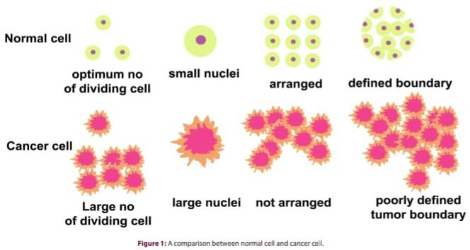

## Surgery

The surgical strategy points to evacuate cancer-affected tissues completely.[8] In any case, in the event that the crucial organs such as the liver, lungs, brain are influenced, total evacuation may not be conceivable to prevent organ harm. For these cases, other methods may be applied taken after by surgery.

## Radiation therapy

Radiation treatment works by harming the DNA of cancer cells. DNA harm is caused by coordinate or backhanded ionization. Straight accelerators, Cobalt-60 units, Caesium-137 treatment units, low to orthovoltage x-ray units, tall dosage and moo measurements rate brachytherapy units and customary brachytherapy units are used for radiation therapy.[9]

## Immunotherapy

Immunotherapy could be a sort of treatment that makes a difference your safe system to battle against cancer. Safe Checkpoint Inhibitors, Adoptive Cell Treatments, Monoclonal Antibodies, Oncolytic Virus Treatment, Cancer Immunizations, Safe Framework Modulators are used for immunotherapy.[10]

## Targeted therapy

There is another sort of cancer treatment which is known as targeted treatment. Focused on treatment may be a cancer treatment that employments drugs to target particular qualities and proteins included within the development and survival of cancer cells. In Focused on treatment utilized drugs can either influence the natural tissues that offer assistance cancer development or it can target cells related to cancer growth.[11]

## Hormone therapy

This treatment diminishes or totally ends the development of prostate and breast cancer which apply hormones for development. Aromatase inhibitors (AIs), such as anastrozole, exemestane, and letrozole and Particular estrogen receptor modulators (SERMs), such as tamoxifen and raloxifene and Estrogen receptor antagonists, such as fulvestrant and toremifene are utilized in hormone therapy.[12]

**Transplant of stem cell**

Stem cell treatment advances the repair of unhealthy, broken or harmed tissue utilizing stem cells or their subsidiaries. Stem cells are utilized in cancer patients to treat certain cancer like leukemia.

These are forms that restore blood-forming stems cells in patients for whom these are harmed by overwhelming measurements of radiation or chemotherapy.[13]

## Chemotherapy

Chemotherapy could be a exceptionally viable cancer treatment that applies specific drugs to crush cancer cells. Within the current application, the word chemotherapy by and large demonstrates cytotoxic drugs that impact rapidly isolating cells, in differentiate to focused on therapy.

Chemotherapy drugs avoid cell division in numerous possible instruments. In most cases of chemotherapy, not as it were cancer cells but moreover ordinary cells are influenced. Regularly more than one medicate is alluded together since some drugs' reactions are better in combination. This sort of chemotherapy is known as€combination chemotherapy•.[14]

# SIDE EFFECTS OF CANCER TREATMENT

It can take time to urge over the side impacts of treatment. Side effects depend on the sort of cancer, cancer arrange and sort of treatment. Side impacts may be both physically and rationally. Few problems are fathomed rapidly, others may take a long time (might be a year) to make strides. Side impacts by and large include:[15]

1. Feeling of tiredness.
2. Pain.
3. Misfortune of self€esteem and confidence.
4. Changes in sexual desire.
5. Menopausal indications for women.
6. Ripeness problems.
7. Lymphoedema.
8. Cognitive changes.
9. Depression.
10. Other side impacts.

# LIMITATION OF CONVENTIONAL TREATMENTS

Chemotherapeutic drugs don't work all the time and surprisingly, they may not completely devastate cancer when it is needed. Patients regularly may miss realizing its drawbacks.[16] The blood-brain obstruction makes a troublesome impediment to pass to deliver chemotherapeutic drugs to the brain. This can be the reason the brain contains a major framework in position to anticipate it to create harmful chemicals. Medicate carriers can release the drugs from the brain and blood vessel cells of brains and diminish their efficiency for brain tumor treatments.[17] Tumor blood vessels are very disparate from those which are display in typical tissues. Tumor cells furthermost separated from blood vessels ended up brief in oxygen since of tumor development. For that reason, blood vessels are made ineffectively and don't provide adequate blood to all areas of the tumors. Surgery of aggravating bigger, and few parts are intense, not reasonable for sub-clinical metastases. There are a few disadvantages to this sort of treatment. It cant completely evacuate the cancer cells. Now

and then this surgery can kill the whole organ.[8] Radiation treatment encompasses a parcel of side impacts.

Radiation treatment directly can either hurt DNA or deliver free radicals inside the cells which can harm the DNA. Dry mouth is made on the subjection of salivary organs to radiation in radiation treatment. The salivary organs oil the mouth with spit or dampness. After the therapy, salivary organs will restart work but rarely within the same way. Dry mouth made by radiation treatment may be a deep rooted issue. In expansion, radiation makes momentous side impacts which impact the way of life of youthful patients. The high-energy beams are used in radiation treatment such as X-rays and comparable beams for the treatment of cancer It devastates cancer influenced cells within the locale thats treated. In case the tumor was taken note within the late stage, it needs to provide higher radiation introduction which will be unsafe for the organs of patients. Radiation generally makes long-term side effects for children such as visual impairment and hearing misfortune. Children who take scalp radiation are anticipated at a huge hazard for instructive failure and mental delay.[18]

Targeted treatment is anticipated to be more effective than other treatments and less hurtful to typical cells. However, focused on therapies have a few restrictions. The particular thinks about that manifested that focused on treatment would modify tumor cell malignant phenotype associated treating Her 2/neu changed over cells in both in vivo and in vitro with monoclonal antibodies by the research facility of Stamp Greene in 1985.[19] Immune-based treatment for treating strong cancer remains an exciting approach. It is rapidly making progress to the clinic from the research facility.

Shockingly, with the later treatment autoimmune vitiligo is confronting trouble for immunotherapy for melanoma of dangerous and application of allogeneic bone marrow transplantation. An activity strategy of immunotherapy of leukemia is as often as possible complex by join vs. have disease.[20] It is significant to record that numerous later trials of immunotherapy enlist patients with remaining huge essential or metastatic disease. The insights illustrate that estimate of tumor straight impacts the capability to climb productive tumor-specific safe response.[21]

The development of a few cancers can be hindered by blocking or demonstrating certain hormones. So, the use of hormonal therapy is constrained. So it is an pressing have to be rummage around for a modern treatment line with higher activity and lower side impacts. Directly researchers appear that phytochemicals may be an imperative source of anticancer drugs and its utilize as the anticancer sedat became a hot range of investigate within the past few years.[22] The source, structure and action of a few phytochemicals are examined here.

# ANTICANCER PHYTOCHEMICALS

Anticancer phytochemicals work in several pathways likeDNA authoritative, protein official, etc.[23] The exercises of diverse phytochemicals may vary, but a comparable instrument may be observed within the phytochemicals with comparable structures. In common, the phytochemicals may be isolated into a few auxiliary buncheshaving the same action (Table 1).

## Coumarin derivatives

This bunch of phytochemicals (Figure 2) contains a coumarin ring which may be an critical pharmacophore of the drug.

## Kaempferol

Kaempferol is an dynamic compound show in Thuja Occidentalis and a assortment of plants and plant-derived foods,[24] such as Pteridophyta. It has anticancer movement on breast cancer,[25] ovarian cancer, leukemia, bladder cancer, prostate cancer, gastric cancer, lung cancer, pancreatic cancer and colorectal cancer. It has been moreover watched to initiate apoptosis in breast cancer cells through extracellular signal-regulated kinase Â½ activation,[25]

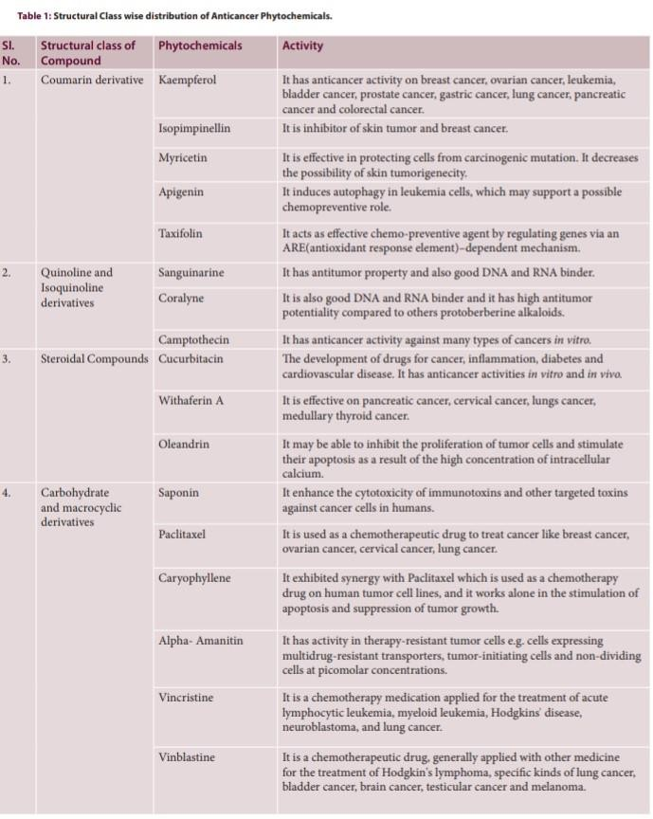

up-regulation of p53.[22] It interatomic with the Estrogen receptors and changes the flagging pathway which in turn decreases cancer cells development. VEGF (Vascular endothelial development figure), moreover known as VPF (vascular penetrability calculate), sigma protein is produced by cells that acts as a diminish MMP-3 protein movement inferring potential capacity to decrease metastasis,[23] fortifying agent to create blood vessels. Chen SS et al. appeared that Kaempferol can act as an anticancer sedate by hindering VEGF production.[26]

## Isopimpinellin

Plant Ruta Graveolens is the source of the anticancer compound isopimpinellin.[27] There have been a few thinks about looking into the effects of isopimpinellin as anticarcinogens. It is an inhibitor of skin tumor,[29] and breast cancer.[28] Mistry Sovereign et al. showed normally occurring coumarins (isopimpinellin) are anti-carcinogenic within the consider of mouse skin models. They moreover assessed the restraint of 7, 12-dimethylbenz [a] anthracene (DMBA) and DNA adduct arrangement by this.[28] The consider by Heather E. Kleiner et al. assessed the impacts of orally managed isopimpinellin on skin tumor started by applyingbenzo[a]pyrene(B[a]P) and 7, 12-dimethylbenz[a] anthracene(DMBA).Withine the first dose it inhibited essentially the arrangement of B[a]P-DNA adduct by 37% and within the moment dosage verbal organization of it (35,70 and 150 miligram per kg) repressed the arrangement of DMBA-DNA complex by 23,56 and 69 individually in reaction study.[29]

## Myricetin

Myricetin is additionally show in Thuja Occidentalis,[30] and it is commonly determined from vegetables, natural products, nuts, berries, tea,[31] and is additionally found in ruddy wine. It is viable in securing cells from carcinogenic transformation. It diminishes the plausibility of skin tumorigenicity which is created by polycyclic fragrant compounds such as benzo (a) pyrene, known as an amazingly carcinogenic compound. It too ensured against the improvement of skin tumors after tumour-initiating and promoter mediums were utilized to the skin in mice demonstrate. It was watched that topical use of myricetin made restraint to tie benzo (a) pyrene with DNA and local protein of epidermal skin cells.[32] It has moreover been assessed that it restrains the part of hereditary transformation as demonstrated by the Ames test. This test displayed that it viably prevented mutagenesis begun by particular carcinogenic fragrant polycyclic hydrocarbons (benzo (a) pyrene, dibenzo (a,h) pyrene and dibenzo (a,i) pyrene as compared to other compounds in which it anticipated less viably against mutagenesis.[32] This data demonstrates that myricetin isn't compelling singularly to anticipate the carcinogenic part of all fragrant polycyclic hydrocarbons.

## Apigenin

Apigenin, a phytochemical, is display in numerous plants like Bacopa monnieri (brahmi).[33] It actuates autophagy in leukemia cells, which may back a conceivable chemopreventive part. Initiated autophagy meddling with the part of the chemotherapeutic medicate vincristine.[34] Apigenin dimmers can change the greatest level of medicate resistance appeared in cancer cells. Through comes about on cell cycle, aggravation, cell flagging and protease generation apigenin have shown convenience against the expansive scale of types of cancer whereas not showing harmfulness on typical cells. [35] It is able to halt the phosphorylation of particular proteins in the course in which cases of cancer are communicated like NF-kB, P13K, etc. This has been illustrated to anticipatecancer

cell invasion and relocation in vivo and in vitro creature models. YZhu et al. demonstrated in prostate cancer DU145 cells, apigenin solidly inhibited tumor cell relocation and attack in a dose- dependent fashion.[36]

## Taxifolin

Taxifolin, flavanonol can be delivered from conifers like Cedar deodara.[37] Saet Byoul Lee et al. demonstrated that it acts as an effective chemopreventive agent by directing qualities by means of an ARE (antioxidant reaction element)â€“ dependent component. It has been shown to prohibit the development of ovarian cancer cells in a dose-dependent route.[38] In numerous considers, it was watched that it is additionally viable for anti-proliferation of numerous distinctive sorts of cancer cell lipogenesis by restraint of fatty corrosive synthase within the cancer cell. So, it is competent to avoid the development and spread of cancer cells.[39]

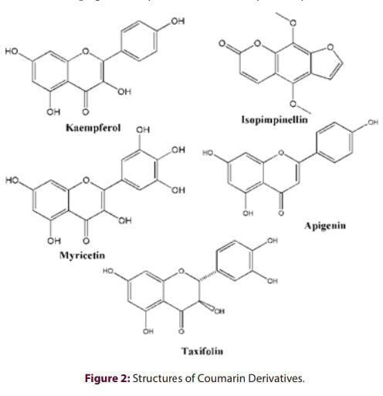

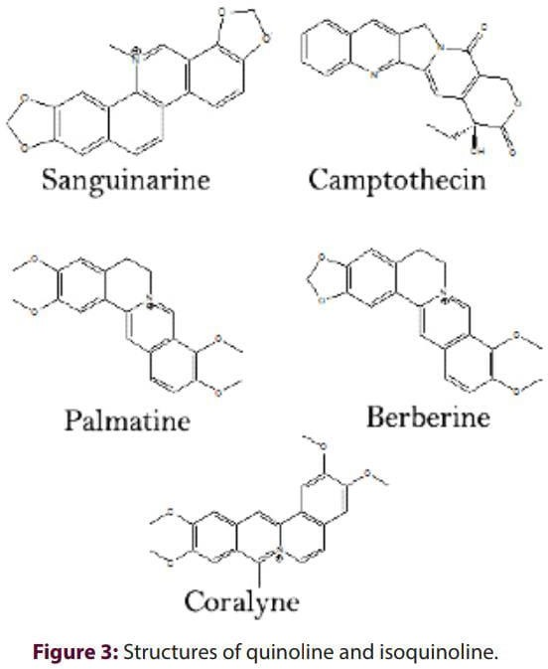

## Quinoline and isocinoline derivatives

Quinoline and Several phytochemicals belonging to the isotinoling group have been proven to be anti-cancer activity. We provide a detailed explanation of some important derivatives (Figure 3).

## sangunary

functions as a promising anti-cancer therapy and a very good nucleic acid binding property. [41] G. Suresh Kumar and his group exhibit optimistic derivatives like Berber and Palmatin protobarberinal caloids, possessing anti-tumor torque potentials, and they are also excellent DNA and RNA binding agents. Polynosic acid [poly(I)], polysylic acid [poly(c)] and polydridylic acid [poly(U)]. This study showed that Berber, palmatin, and ethidium were strongly bound to poly(g) and poly(i) with order affinities, and that poly(c) and poly(u) were very weak or practical. Antitumor potential was compared with other protoberberine alkaloids. Rahul Bhattacharyya et al. Wang Xian H et al. Her research showed that in vitro it has anticancer activity against many types of cancer. [45] a WK Eng et al. Camptothecin and its analogs have been shown to act as inhibitors of topoisomerase 1 (TOP1).

## Cukurbitacin

Cukurbitacin is chemically classified as a steroid found in many plants, such as Bacopa and Mansumi (Brahmi). [47] This continues to be related to biological properties, including toxicity and use in

pharmacology in the development of drugs for cancer, inflammation, diabetes and cardiovascular disease. [48] Fang et al. We reported that there was cancerous activity in in vitro and in vivo studies. [49]

## Withailer A:-

widthrianer a, steroid lactone becomes a member of withania somnifera, Indian Winter Cherry or Ashwagandha, acnistus-arborescens and other members of Sanskrita, acnistus and Sanskrita[50]. used in Ayurvedic Medicine. is a promising result of breast body. Her study showed that in apoptosis of cervical cancer cells, it repairs the expression of HPV E6/E7 oncogene, which repairs the p53 pathway.[51] For suicide and therapeutic purposes, pharmacotherapy for heart failure. It can inhibit tumor cell proliferation and stimulate apoptosis as a result of high concentrations of intracellular calcium. This is a promising tool for anticancer. Experiments show potential in vitro effects on non- small cell lung cancer, leukemia cancer[52][53].

## oleangrin

It is a toxic glycoside found in Nerium indicum (synonymous nerium -oleander). It can inhibit tumor cell proliferation and stimulate apoptosis as a result of high concentrations of intracellular calcium. This is a promising tool for anticancer. Experiments show potential in vitro effects on non-small cell lung cancer, leukemia cancer.

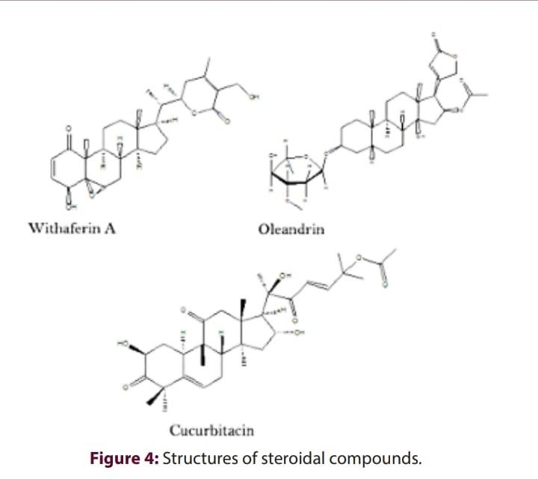

Dalmy, melanoma, prostate, pencrease. [55] S Pathak et al. We evaluated that oleanglin could be induced to induce cell death in human cancer cells. They also showed that their ability to kill is greater than Anvilzel.

## Carbohydrate and macrocyclic derivatives

These phytochemicals also have good sources of anti-canth drugs (Figure 5).

## Saponins

Saponins a class connection Saponins are found in a variety of plants, especially polygala senega [57], which are used as homeopathic drugs. Cytotoxicity of immunotoxins and other target toxins It has been observed that the cytotoxicity of human cancer cells is significantly enhanced. There are also signs of anti-cancer and anti-cholesterin activity under the direction of Professor Hendrick Fuchs (Charit University, Berlin, Germany) and Dr. David Flavell (UK). [58] K Xu et al. The cytotoxic activity of saponins extracted from pulsatilla chinensis was evaluated in human cancer cell lines (A549, SGC- 7901), which showed significant cytotoxic activity. [59]

## Paclitaxel

Paclitaxel is a phytochemical substance used as a chemotherapeutic agent in the treatment of cancers such as breast, ovarian, cervical, and lung cancer [60]. In 1979, it was reported that the critical concentration of subunits decreased and the proportion of compiled tubulin subunit units increased. [61] It has also been shown that paclitaxel increases the polymerization of tubulin and inhibits mitosis. [62] This is known as a cytoskeleton drug which Tablin's goal. Cells from paclitaxel- treated cells have myotinic spindle collection, chromosome separation, and cell division errors. It also inhibits microtubule assembly and creates a stable microtubule polymer.

## caryophylen

caryophylla, a natural bicyclic sesquiterpene, is present in homeopathic medicine Phytolacca decandra, [63] and many essential oils. It is an anti-inflammatory and anti-neurogenic carcinogen.

[64] It exhibits synergistic effects with paclitaxel, which is used as chemotherapy for human tumor cell lines, stimulating apoptosis and suppressing tumor growth (Legault and Pichette, 2007). Saads Dahham et al. We have shown that beta-caryophyllene apoptosis with a fragmentation route containing core condensation and mitochondrial membranes induces potential disorders. Furthermore, betacaryophyllene exhibited a strong prevention against clonogenicity, invasion, migration and spheroid formation in large intestinal cells. [65]

## Alpha amanitine

a cyclic peptide of eight amino acids Alpha amanitine is found in amanitapharoids. [66] Amanitine- based ADCs show untreated activity in treatment-resistant tumor cells. Cells Express multi-resistant vans, tumor-generating cells, and non-distributed cells at picomolal concentrations. [67] It is a model that binds in a preclinical prostate canal model, and is a model that uses anti-HER2 antibodies such as trastuzumab. Amanitine base antibody drug conjugates showed a high antitumor role in the group of preclinical tumors to determine the efficacy of experimental drugs against HER2+ breast

cancer. Amanitine binding not only leads to apoptosis of cells that share, but also from the slowly growing cells that are often observed in prostate cancer.

## Vincristine

Vincristine is a vinca alkaloid that can be collected from Madagascar Periwinkle Cathalantha Roses.

[69] This is a chemotherapy drug used to treat cancer types. Among other things, these include acute lymphoid leukemia, myeloid leukemia, Hodgkins' disease, neuroblastoma, and small cells of lung cancer. It is delivered via intravenous infusion using a variety of chemotherapy regimes. [70] His main use is in non-Hodgkin lymphoma as an element of chemotherapy Regime Chop, Hodgkin lymphoma as an element of MOPP, copp, Beacopp, or Stanford v chemotherapy treatment for leukemia and nephroblastoma [71 treatment of leukemia and nephroblastoma] [71 treatment of leukemia and 9-loblastoma: [71]

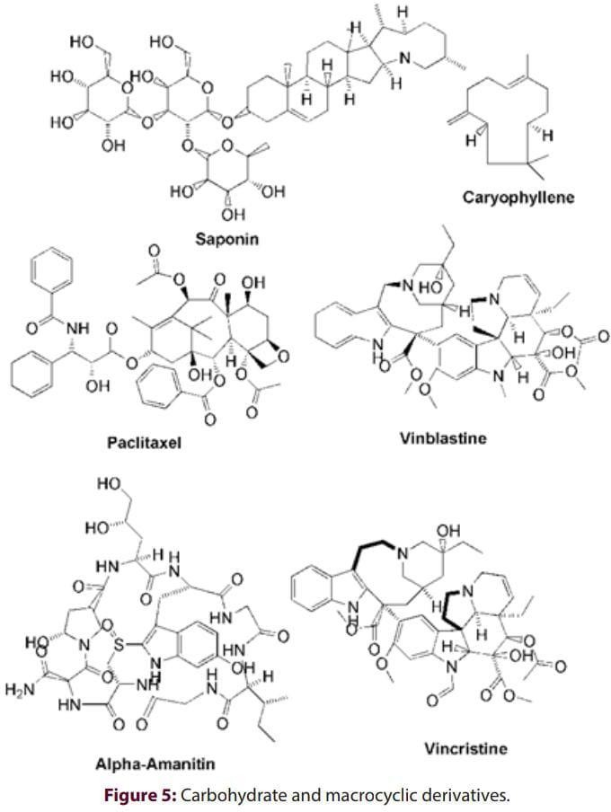

and to prevent the cell from its separation from chromosomes in the time of metaphase; then the cell undergoes apoptosis. [72] The vincristine molecule inhibits leukocyte production and maturation.[73]

## Vinblastin

Vinblastin, natural products, was first acquired by chemists by Robert Noble and Charles Thomas Beal of Vinca Rosea. [69] This is a chemotherapeutic agent commonly used in conjunction with other drugs to treat a variety of cancer types. This includes Hodgkin's lymphoma, certain types of lung cancer, bladder cancer, brain cancer, testicular cancer, and melanom. [74] Vinblastine, nocodazole, and corsemide are known as microtubule destructive agents. Various studies have shown that vinblastine, nocodazole, and corsemide function using two different mechanisms. These drugs suppress microtubule dynamics at very low concentrations and reduce microtubule-polymer mass at higher concentrations. [75]

## Other Anticancer Phytochemicals

In addition to the above phytochemicals, there are many other phytochemicals that can act as anticancer agents (Figure 6).

## Terpinol

Terpinol is an antibacterial, antifungal, anti-innsamnia, anti-proliferative and antioxidant. [76] The growth of cancer cells is inhibited. [76] This is available from a variety of plants, such as Thuja occidentalis. [30] Elanur Aydin et al. In 2013, it reported that it was a powerful antiproliferative link of brain tumor cells and could be played as an anti-cancer agent. [76] Okumura et al. Terpinol has been found to significantly reduce the level of protein expression from AKT1 in K562 cells and block cell proliferation. [77]

## Ajoene

ajoene is an organic sulfate connection that occurs in allium sativum (garlic). [78] He was first quarantined in 1983 by Raphael Apitz Castro and Mahendra K. Jain. [78] Tested as an anti-leukemia active ingredient for acute myeloid leukemia therapy. [79] Tumor size of basal cell carcinoma was found to be reduced by inducing apoptosis. At the same time, it has become useful to target the microtubule cytoskeleton and inhibit tumor cell growth by alternative mechanisms. [80] cmliTilli et al. In vitro and in vivo, we investigate how ajoene can prevent cancer by inducing a mitochondria- dependent apoptotic pathway. [81]

## S-allyl Cysteine

The s-alyl Cysteine is of course an organic connection available with fresh garlic. [82] Several studies have recently evaluated that it functions as a potential lowering of cholesterol and as a chemical identification. [82] Both experimental and epidemiological studies provide evidence that this has antitumor properties. [82] ya-si xu et al. In vitro inhibits the proliferation of S-allylcysteine (SAC) and induces apoptosis in A2780 altered cells. [83]

## 6-Pentesyl - Salicylic Acid

6-Pentesyl - Serisylic Acid is available at Anacardium occidentale. Yuanyuan Wu et al. We evaluated its function as a potent inhibitor of tumor angiogenesis by targeting the GTPase signal path from SRC/FAK/rho and ensuring significant suppression of prostate tumor growth. [85] J N Rashida Gnanapasam etbr> al. Reducing animals from animals to improve paclitaxel We have found that myelosuppression and leukopenia create an anti-tumor immunological microenvironment.

## 12-desoxyphorphor 13-Palmitat

It is a natural toxic connection isolated from many plants such as the baliospermum montanum. Results from the most recent research have demonstrated their potent use as a potential prevention and/or treatment of cancer. Hui-Yu Xu et al. c vegf/vegfr2 We evaluated it as capable of being used to target active angiogenesis via the signal pathway of c C Concer. [88] Study by Ying Yang et al.

Conclusion that the expression of VEGF and HIF-1î± was inhibited via the p13k/nude/mtor signal pathway, confirming that it is a potent therapeutic agent of the breast body. [89]

## Beta boswellic acid

Beta boswellic acid, pentacyclic triterpenes are extracted from boswellia serrate [90] Cancer cells were noted. [91] Jian-Jun Liu et al. HT-29 cells showed anti-proliferative and apoptotic effects. This effect depends on the activation of depecasepase-8, but occurs through the route, regardless of FAS/FASL interaction. [91] Saraswati and Agrawal have determined Boswell acid as a potent anticancer candidate against the MCF-7 breast cancer cell line. Impacts have been investigated for a variety of intracellular targets affecting angiogenesis (VEGF), inflammation (TNF-î±, IL-12) and apoptosis (quesepase-3 and 9). [92]. [92]. [92]

## Asian acids

Asia acids, pentacyclic triterpenes are made from centella asiatica, [93], which is used in Ayurvedic treatments for multipurple. It can be used as a potential anticancer drug, and its mechanism is associated with downregulation of focal adhesion kinase expression. Especially for multiple myeloma, it could be an effective tool for anti-tumor therapy. [94] Chadamas Sakonsinsiniri et al. It demonstrated that it effectively suppressed bile duct carcinoma (CCA) cells livelihoods in induction of the apoptotic pathway. [95]

## Plumbagin

Plumbagin is named after the plumbing genre Plumbago, which was originally isolated. [96] Many pharmacological properties are shown in a variety of cell and animal models: antibacterial, antimalarial, anti-inflammatory, anti-cancer, cardiac attitude, cardiac attitude, immunosuppression, anti-appendage composition, neuroprotection, melanoma, breast, etc., have been issued to activate cell cycle and apoptosis arrest in many cancer cell lines, including lung, melanoma, breast, etc.

Pranbagin Human Serum Serum of Cancer Cells Proven that 2-3-fold increase cytotoxicity In-vitro studies have proven that it does not affect normal cells, but interestingly. [9]

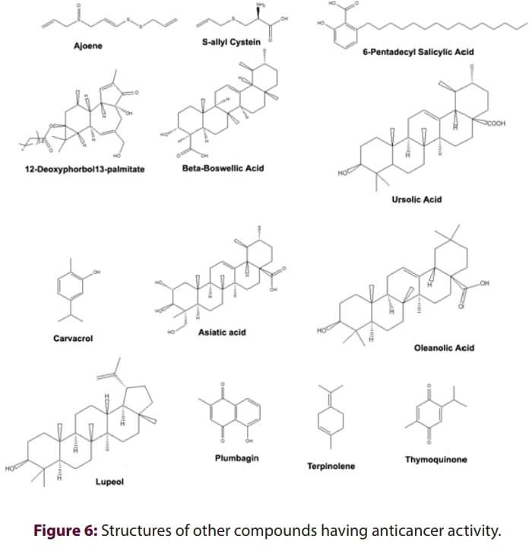

## Lupeol

Lupeol is a pharmacologically active triterpenoid. There are a variety of plants, including Hygrophila spinosa, Abronia Villosa, [99], and more. There are several potential medical properties. This demonstrates complex pharmacological properties that exhibit antibiotics, antiprotozoals, anti- inflammatory, chemicals, and anti-joint properties. [100] Sahdeo Prasadet al. Their study showed that reducing oxidation was useful. It is also a useful inhibitor in laboratory models of skin and cancer.

## Timothinone

Timothinone is a phytochemical connection that occurs in Nigelasativa plants. [102] It also comes from certain agriculturally grown Monardo Fisrosa plants. It has antioxidant and anti-inflammatory effects on animal cells and was evaluated in models of neurodegenerative diseases, cardiovascular diseases and diabetes and cancer. [103] Amin F Majdalawieh et al. Timothinone provides for it to serve as a useful therapeutic candidate for the suppression of tumor development and metastasis of large-scale cancer tumors. [104]

## Ulsolic acid

The phytochemical components of ocimum sanctum (tulsi) include ursolic acid, carvacrol, beta caliphurene, beta elene [105], etc. Used assitics additives. Many potential biochemical effects of ursolic acid have been evaluated, but no clinical tests have been used for human health. It will hinder The proliferation of various types of cancer cells by vitro STAT3 can inhibit inhibition of activation pathways, affect proliferation, and induce apoptosis. [106] Pengchen Liuet al. Her study showed that urinary acid significantly generates anticancer effects on metastatic melanoma cells by activating apoptotic cell death and cell cycle talent. [107]

## Carvacrol

It is a monoterpenoid phenol. It comes from many plants such as tulsi. [105] This inhibits the growth of several bacteria. A study conducted by Supriya Bavadekar reported in 2012 that it stimulates apoptosis of prostate cancer cells. [108] Another study using rats with carcinogenic DMH injections showed carvacrol at 40 mg/kg BT in 2015. External to Wi-Chrisms To Compution Colles. However, the therapeutic effect was significantly increased with the combination of when preparing x-ray.

[109] A follow-up study by the same senior researcher in 2016 provided additional evidence of this effect.

## Conclusion

As the trend towards cherry blossoms is increasing, a variety of new types of treatments and procedures arise. The processes currently in use have several side effects and limitations. Anticancer The use of phytochemicals may be an alternative to combat cancer with a small number of side effects. Therefore, knowledge about phytochemical anticancer is urgently needed for the development of anticancer drugs on a phytochemical basis. The current overview examines pharmacologically effective phytochemical compounds for the treatment of various types of malignant tumors. Finally, this overview conveys a variety of knowledge about cancer phytochemicals with promising anti-cancer activity

# REFERENCES

1. Hajdu SI. A note from history: landmarks in history of cancer, part 1. Cancer 2011;117(5):1097-

102. doi: 10.1002/cncr.25553, PMID 20960499.

1. The history of cancer. American Cancer Society; 2009.
2. Yalom M. A history of the breast. Knopf Publishing Group; 1997.
3. Boveri T. Concerning the origin of malignant tumours by Theodor Boveri. Translat and annotated by Henry Harris. J Cell Sci. 2008 Jan 1;121;Suppl 1:1-84. doi: 10.1242 jcs.025742, PMID 18089652.
4. Hanahan D, Weinberg RA. Hallmarks of cancer: the next generation. Cell. 2011;144(5):646-74. doi: 10.1016/j.cell.2011.02.013, PMID 21376230.
5. Bergers G, Benjamin LE. Tumorigenesis and the angiogenic switch. Nat Rev Cancer. 2003;3(6):401-10. doi: 10.1038/nrc1093, PMID 12778130.
6. Zink D, Fischer AH, Nickerson JA. Nuclear structure in cancer cells. Nat Rev Cancer. 2004;4(9):677-87. doi: 10.1038/nrc1430, PMID 15343274.
7. Subotic S, Wyler S, Bachmann A. Surgical treatment of localised renal cancer. Eur Urol Suppl. 2012;11(3):60-5. doi: 10.1016/j.eursup.2012.04.002.
8. Hill R, Healy B, Holloway L, Kuncic Z, Thwaites D, Baldock C. Advances in kilovoltage x-ray beam dosimetry. Phys Med Biol. 2014;59(6):R183-231. doi: 10.1088/0031-91 /59/6/R183, PMID 24584183.
9. Waldmann TA. Immunotherapy: past, present and future. Nat Med. 2003;9(3):269-77. doi: 10.1038/nm0303-269, PMID 12612576.
10. Cordo’ V, van der Zwet JCG, Canté-Barrett K, Pieters R, Meijerink JPPT-cell Acute Lymphoblastic Leukemia: A Roadmap to Targeted Therapies. Blood Cancer Discov. 2021;2(1):19-31. doi: 10.1158/2643-3230.BCD-20-0093, PMID 34661151.
11. Seifter EJ. Cancer: principles and practice of oncology De Vita VT, Jr Hellman S, Rosenberg SA, editors. Philadelphia: Lippincott-Raven Publishers, ISB 0-397-51573-4;1997. 3125p.
12. ParkB, YooKH, Kim C. Hematopoietic stem cell expansion and generation: The ways to make a breakthrough. Blood Res. 2015;50(4):194-203. doi: 10.5045/br.2015.50.4.1 94, PMID 26770947.
13. Frei III E, EderJP. Combination chemotherapy. In: Cancer Medicine H-F, editor. 6th ed.B C Decker; 2003.
14. Redd WH, MontgomeryGH, DuHamel KN. Behavioral intervention for cancer treatment side effects. J Natl Cancer Inst. 2001;93(11):810-23. doi: 10.1093/jnci/93.11.810, PMID 11390531.
15. Weeks JC, CatalanoPJ, Cronin A, FinkelmanMD, Mack JW, Keating NL, et al. Patients’ expectations about effects of chemotherapy for advanced cancer. N Engl J Med. 2012;367(17):1616-

25. doi: 10.1056/NEJMoa1204410, PMID 23094723.

1. DeekenJF, Löscher W. The blood–brain barrier and cancer: Transporters, treatment, and Trojan horses. Clin Cancer Res. 2007;13(6):1663-74. doi: 10.1158/1078-0432. CCR-06-2854, PMID 17363519.
2. Al-Mefty O, KershJE, Routh A, Smith RR. The long-term side effects of radiation therapy for benign brain tumors in adults. J Neurosurg. 1990;73(4):502-12. doi: 10.3 71/jns.1990.73.4.0502, PMID 2204689.
3. Drebin JA, Link VC, Stern DF, WeinbergRA, GreeneMI. Down-modulation of an oncogene protein product and reversion of the transformed phenotype by monoclonal antibodies. Cell. 1985;41(3):697-706. doi: 10.1016/s0092-8674(85) 80050-7, PMID 2860972.
4. Mutis T, Brand R, Gallardo D, Van Biezen A, Niederwieser D, Goulmy E, et al. Graft-versus-host driven graft-versus-leukemia effect of minor histocompatibility antigen HA-1 in chronic myeloid leukemia patients. Leukemia. 2010;24(7):1388-92. doi: 10.1038/leu.2010.115, PMID 20508613.
5. Stewart TJ, Abrams SI. Altered immune function during long-term host-tumor interactions can be modulated to retard autochthonous neoplastic growth. J Immunol. 2007;179(5):2851-9. doi: 10.4049/jimmunol.179.5.2851, PMID 17709499.
6. Singh S, Sharma B, Kanwar SS, Kumar A. Lead phytochemicals for anticancer drug development. Front Plant Sci. 2016;7:1667. doi: 10.3389/fpls.2016.01667, PMID 27877185.
7. Iqbal J, Abbasi BA, Mahmood T, Kanwal S, Ali B, Shah SA, et al. Plant-derived anticancer agents: A green anticancer approach. Asian Pac J Trop Biomed. 2017;7(12):1129-50. doi:10.1016/j.apjtb.2017.10.016.
8. Calderon-Montano M J, Burgos-Morón E, Pérez-Guerrero C, López-Lázaro M. A review on the dietary flavonoid kaempferol. Mini-Rev. Med. Chem. 2011; 11(4):298-344.
9. Aiyer HS, Warri AM, Woode DR, Hilakivi-Clarke L, Clarke R. Influence of berry polyphenols on receptor signaling and cell-death pathways: implications for breast cancer prevention. J Agric Food Chem. 2012;60(23):5693-708. doi: 10.1021/jf20408 f, PMID 22300613.
10. Chen SS, Michael A, Butler-Manuel SA. Advances in the treatment of ovarian cancer: a potential role of antiinflammatory phytochemicals. Discov Med. 2012;13(68):7-17. PMID 22284780.
11. Steck W, Bailey BK, Shyluk JP, Gamborg OL. Coumarins and alkaloids from cell cultures of Ruta graveolens. Phytochemistry. 1971;10(1):191-4. doi: 10.1016/S0031-9422(00)90269-3.
12. Prince M, Campbell CT, Robertson TA, Wells AJ, Kleiner HE. Naturally occurring coumarins inhibit 7, 12-dimethylbenz [a] anthracene DNA adduct formation in mouse mammary gland. Carcinogenesis. 2006;27(6):1204-13. doi: 10.1093/carcin/ gi303, PMID 16387742.
13. Kleiner HE, Vulimiri SV, Starost MF, Reed MJ, DiGiovanni J. Oral administration of the citrus coumarin, isopimpinellin, blocks DNA adduct formation and skin tumor initiation by 7, 12- dimethylbenz [a] anthracene in SENCAR mice. Carcinogenesis. 2002;23(10):1667-75. doi: 10.1093/carcin/23.10.1667, PMID 12376476.
14. Naser B, Bodinet C, Tegtmeier M, Lindequist U. Thuja occidentalis (arbor vitae): a review of its pharmaceutical, pharmacological and clinical properties. Evid Based Complement Alternat Med. 2005;2(1):69-78. doi: 10.1093/ecam/neh065, PMID 15841280.
15. Ross JA, Kasum CM. Dietary flavonoids: bioavailability, metabolic effects, and safety. Annu Rev Nutr. 2002;22(1):19-34. doi: 10.1146/annurev.nutr.22.111401.144957, PMID 12055336.
16. Ong KC, Khoo HE. Biological effects of myricetin. Gen Pharmacol. 1997;29(2):121-6. doi: 10.1016/s0306-3623(96)00421-1, PMID 9251891.
17. Chatterji N, Rastogi RP, Dhar ML. Chemical examination of Bacopa monniera Wettst.: part II- Isolation of chemical constituents. Ind J Chem. 1965;3:24-9.
18. Ruela-de-Sousa RR, Fuhler GM, Blom N, Ferreira CV, Aoyama H, Peppelenbosch MP. Cytotoxicity of apigenin on leukemia cell lines: implications for prevention and therapy. Cell Death Dis. 2010;1(1):e19. doi: 10.1038/cddis.2009.18, PMID 21364620.
19. Shukla S, Gupta S. Apigenin: a promising molecule for cancer prevention. Pharm Res. 2010;27(6):962-78. doi: 10.1007/s11095-010-0089-7, PMID 20306120.
20. Zhu Y, Wu J, Li S, Wang X, Liang Z, Xu X, et al. Apigenin inhibits migration and invasion via modulation of epithelial mesenchymal transition in prostate cancer. Mol Med Rep. 2015;11(2):1004-

8. doi: 10.3892/mmr.2014.2801, PMID 25351792.

1. Grover M. An overview on the ornamental coniferous tree Cedrus deodara (Roxburgh) G. Don (Himalayan cedar). J. Ayur. Integ. Med Sci. 2021;6(4):291-302.
2. Lee SB, Cha KH, Selenge D, Solongo A, Nho CW. The chemopreventive effect of taxifolin is exerted through ARE-dependent gene regulation. Biol Pharm Bull. 2007;30(6):1074-9. doi: 10.1248/bpb.30.1074, PMID 17541156.
3. Brusselmans K, Vrolix R, Verhoeven G, Swinnen JV. Induction of cancer cell apoptosis by flavonoids is associated with their ability to inhibit fatty acid synthase activity. J Biol Chem. 2005;280(7):5636-45. doi: 10.1074/jbc.M408177200, PMID 15533929.
4. Park JE, Cuong TD, Hung TM, Lee I, Na M, Kim JC, et al. Alkaloids from Chelidonium majus and their inhibitory effects on LPS-induced NO production in RAW264. 7 cells. Bioorg Med Chem Lett. 2011;21(23):6960-3. doi: 10.1016/j.bmcl.2011.09.128, PMID 22024033.
5. Kumar GS, Hazra S. Sanguinarine, a promising anticancer therapeutic: photochemical and nucleic acid binding properties. RSC Adv. 2014;4(99):56518-31. doi: 10.1039/C4RA06456A.
6. Islam MM, Suresh Kumar GS. RNA targeting by small molecule alkaloids: studies on the binding of berberine and palmatine to polyribonucleotides and comparison to ethidium. J Mol Struct. 2008;875(1-3):382-91. doi: 10.1016/j.molstruc.2007.05.004.
7. Islam MM, Pandya P, Kumar S, Kumar GS. RNA targeting through binding of small molecules: studies on tRNA binding by the cytotoxic protoberberine alkaloid coralyne. Mol Biosyst. 2009;5(3):244-54. doi: 10.1039/b816480k, PMID 19225615.
8. Bhattacharyya R, Gupta P, Bandyopadhyay SK, Patro BS, Chattopadhyay S. Coralyne, a protoberberine alkaloid, causes robust photosenstization of cancer cells through ATR-p38 MAPK-BAX and JAK2-STAT1-BAX pathways. Chem Biol Interact. 2018;285:27-39. doi: 10.1016/j.cbi.2018.02.032, PMID 29486184.
9. Wang XH, Huang M, Zhao CK, Li C, Xu L. Design, synthesis, and biological activity evaluation of campthothecin‐HAA‐Norcantharidin conjugates as antitumor agents in vitro. Chem Biol Drug Des. 2019;93(6):986-92. doi: 10.1111/cbdd.13397, PMID 30218487.
10. Eng WK, Faucette L, Johnson RK, Sternglanz RO. Evidence that DNA topoisomerase I is necessary for the cytotoxic effects of camptothecin. Mol Pharmacol. 1988;34(6):755-60. PMID 2849043.
11. Srivastava JK, Gupta S. Antiproliferative and apoptotic effects of chamomile extract in various human cancer cells. J Agric Food Chem. 2007;55(23):9470-8. doi: 10.1021/jf071953k, PMID 17939735.
12. Alghasham AA. Cucurbitacins – a promising target for cancer therapy. Int J Health Sci (Qassim). 2013;7(1):77-89. doi: 10.12816/0006025, PMID 23559908.
13. Fang X, Phoebe Jr CH, Pezzuto JM, Fong HH, Farnsworth NR, Yellin B, et al. Plant anticancer agents, XXXIV. Cucurbitacins from Elaeocarpus dolichostylus. J Nat Prod. 1984;47(6):988-93. doi: 10.1021/np50036a013, PMID 6549470.
14. Mohan R, Hammers HJ, Bargagna-Mohan P, Zhan XH, Herbstritt CJ, Ruiz A, et al. Withaferin A is a potent inhibitor of angiogenesis. Angiogenesis. 2004;7(2):115-22. doi: 10.1007/s10456-004-1026-3, PMID 15516832.
15. Thaiparambil JT, Bender L, Ganesh T, Kline E, Patel P, Liu Y, et al. Withaferin A inhibits breast cancer invasion and metastasis at sub‐cytotoxic doses by inducing vimentin disassembly and serine 56 phosphorylation. Int J Cancer. 2011;129(11):2744-55. doi: 10.1002/ijc.25938, PMID 21538350.
16. Gupta RC, Bansal SS, Aqil F, Jeyabalan J, Cao P, Kausar H, et al. Controlled-release systemic delivery – a new concept in cancer chemoprevention. Carcinogenesis. 2012;33(8):1608-15. doi: 10.1093/carcin/bgs209, PMID 22696595.
17. Munagala R, Kausar H, Munjal C, Gupta RC. Withaferin A induces p53-dependent apoptosis by repression of HPV oncogenes and upregulation of tumor suppressor proteins in human cervical cancer cells. Carcinogenesis. 2011;32(11):1697-705. doi: 10.1093/carcin/bgr192, PMID 21859835.
18. Turan N, Akgün-Dar K, Kuruca SE, Kiliçaslan-Ayna T, Seyhan VG, Atasever B, et al. Cytotoxic effects of leaf, stem and root extracts of nerium oleander on leukemia cell lines and role of the p- glycoprotein in this effect. J Exp Ther Oncol. 2006;6(1):31-8. PMID 17228522.
19. Yang P, Menter DG, Cartwright C, Chan D, Dixon S, Suraokar M, et al. Oleandrin-mediated inhibition of human tumor cell proliferation: importance of Na, K-ATPase α subunits as drug targets. Mol Cancer Ther. 2009;8(8):2319-28. doi: 10.1158/1535-7163.MCT-08-1085, PMID 19671733.
20. Pathak S, Multani AS, Narayan S, Kumar V, Newman RA. Anvirzel, An extract of nerium oleander, induces cell death in human but not murine cancer cells. Anticancer Drugs. 2000;11(6):455-63. doi: 10.1097/00001813-200007000-00006, PMID 11001386.
21. Katselis GS, Estrada A, Gorecki DK, Barl B. Adjuvant activities of saponins from the root of Polygala senega L. Can J Physiol Pharmacol. 2007;85(11):1184-94. doi: 10.1139/Y07-109, PMID 18066120.
22. Güçlü-Üstündağ O, Mazza G. Saponins: properties, applications and processing. Crit Rev Food Sci Nutr. 2007;47(3):231-58. doi: 10.1080/10408390600698197, PMID 17453922.
23. Xu K, Shu Z, Xu QM, Liu YL, Li XR, Wang YL, et al. Cytotoxic activity of Pulsatilla chinensis saponins and their structure–activity relationship. J Asian Nat Prod Res. 2013;15(6):680-6. doi: 10.1080/10286020.2013.790901, PMID 23659376.
24. Dhiware P, Jaiswar S, Giri AG. Paclitaxel: significance and awareness. In: Proceeding of; 2021. (p. 57).
25. Weaver BA. How Taxol/paclitaxel kills cancer cells. Mol Biol Cell. 2014;25(18):2677-81. doi: 10.1091/mbc.E14-04-0916, PMID 25213191.
26. Foley EA, Kapoor TM. Microtubule attachment and spindle assembly checkpoint signalling at the kinetochore. Nat Rev Mol Cell Biol. 2013;14(1):25-37. doi: 10.1038/nrm3494, PMID 23258294.
27. Kang SS, Woo WS. Triterpenes from the berries of Phytolacca americana. J Nat Prod. 1980;43(4):510-3. doi: 10.1021/np50010a013.
28. Russo EB. Taming THC: potential cannabis synergy and phytocannabinoid‐terpenoid entourage effects. Br J Pharmacol. 2011;163(7):1344-64. doi: 10.1111/j.1476-5381.2011.01238.x, PMID 21749363.
29. Dahham SS, Tabana YM, Iqbal MA, Ahamed MB, Ezzat MO, Majid AS, et al. The anticancer, antioxidant and antimicrobial properties of the sesquiterpene β-caryophyllene from the essential oil of Aquilaria crassna. Molecules. 2015;20(7):11808-29. doi: 10.3390/molecules200711808, PMID 26132906.
30. Litten W. The most poisonous mushrooms. Sci Am. 1975;232(3):90-101. doi: 10.1038/scientificamerican0375-90, PMID 1114308.
31. Moldenhauer G, Salnikov AV, Lüttgau S, Herr I Anderl J, Faulstich H. Therapeutic potential of amanitin-conjugated anti-epithelial cell adhesion molecule monoclonal antibody against pancreatic carcinoma. J Natl Cancer Inst. 2012;104(8):622-34. doi: 10.1093/jnci/djs140, PMID 22457476.
32. Karimi G, Vahabzadeh M, Lari P, Rashedinia M, Moshiri M. ’Silymarin’, a promising pharmacological agent for treatment of diseases. Iran J Basic Med Sci. 2011;14(4):308-17. PMID 23492971.
33. Ravina E. The evolution of drug discovery: from traditional medicines to modern drugs. John Wiley and Sons; 2011.
34. Kuboyama T, Yokoshima S, Tokuyama H, Fukuyama T. Stereocontrolled total synthesis of (+)- vincristine. Proc Natl Acad Sci U S A. 2004;101(33):11966-70. doi: 10.1073/pnas.0401323101, PMID 15141084.
35. Sisodiya PS. Plant derived anticancer agents: a review. Int J Res Dev Pharm Life Sci. 2013;2(2):293-308.
36. Jordan MA. Mechanism of action of antitumor drugs that interact with microtubules and tubulin. Curr Med Chem Anticancer Agents. 2002;2(1):1-17. doi: 10.2174/1568011023354290, PMID 12678749.
37. Silverman JA, Deitcher SR. Marqibo®(vincristine sulfate liposome injection) improves the pharmacokinetics and pharmacodynamics of vincristine. Cancer Chemother Pharmacol. 2013;71(3):555-64. doi: 10.1007/s00280-012-2042-4, PMID 23212117.
38. Dores GM, Metayer C, Curtis RE, Lynch CF, Clarke EA, Glimelius B, et al. Second malignant neoplasms among long-term survivors of Hodgkin’s disease: a population-based evaluation over 25 years. J Clin Oncol. 2002;20(16):3484-94. doi: 10.1200/JCO.2002.09.038, PMID 12177110.
39. Jordan MA, Wilson L. Microtubules as a target for anticancer drugs. Nat Rev Cancer. 2004;4(4):253-65. doi: 10.1038/nrc1317, PMID 15057285.
40. Aydin E, Türkez H, Taşdemir S. Anticancer and antioxidant properties of terpinolene in rat brain cells. Arh Hig Rada Toksikol. 2013;64(3):415-24. doi: 10.2478/10004-1254-64-2013-2365, PMID 24084350.
41. Okumura N, Yoshida H, Nishimura Y, Kitagishi Y, Matsuda S. Terpinolene, a component of herbal sage, downregulates AKT1 expression in K562 cells. Oncol Lett. 2012;3(2):321-4. doi: 10.3892/ol.2011.491, PMID 22740904.
42. Apitz-Castro R, Cabrera S, Cruz MR, Ledezma E, Jain MK. Effects of garlic extract and of three pure components isolated from it on human platelet aggregation, arachidonate metabolism, release reaction and platelet ultrastructure. Thromb Res. 1983;32(2):155-69. doi: 10.1016/0049- 3848(83)90027-0, PMID 6419374.
43. Hassan HT. Ajoene (natural garlic compound): a new anti-leukaemia agent for AML therapy. Leuk Res. 2004;28(7):667-71. doi: 10.1016/j.leukres.2003.10.008, PMID 15158086.
44. Terrasson J, Xu B, Li M, Allart S, Davignon JL, Zhang LH, et al. Activities of Z‐ajoene against tumour and viral spreading in vitro. Fundam Clin Pharmacol. 2007;21(3):281-9. doi: 10.1111/j.1472- 8206.2007.00470.x, PMID 17521297.
45. Tilli CM, Stavast-Kooy AJ, Vuerstaek JD, Thissen MR, Krekels GA, Ramaekers FC, et al. The garlic- derived organosulfur component ajoene decreases basal cell carcinoma tumor size by inducing apoptosis. Arch Dermatol Res. 2003;295(3):117-23. doi: 10.1007/s00403-003-0404-9, PMID 12756587
46. Arora A, Tripathi C, Shukla Y. Shukla Y. Garlic and its organosulfides as potential chemopreventive agents: a review. Curr Cancer Ther Rev. 2005;1(2):199-205. doi: 10.2174/1573394054021772.
47. Xu YS, Feng JG, Zhang D, Zhang B, Luo M, Su D, et al. S-allylcysteine, a garlic derivative, suppresses proliferation and induces apoptosis in human ovarian cancer cells in vitro. Acta Pharmacol Sin. 2014;35(2):267-74. doi: 10.1038/aps.2013.176, PMID 24362328.
48. Rajendran P, Ho E, Williams DE, Dashwood RH. Dietary phytochemicals, HDAC inhibition, and DNA damage/repair defects in cancer cells. Clin Epigenetics. 2011;3(1):4. doi: 10.1186/1868-7083-3- 4, PMID 22247744.
49. Wu Y, He L, Zhang L, Chen J, Yi Z, Zhang J et al. Anacardic acid (6-pentadecylsalicylic acid) inhibits tumor angiogenesis by targeting Src/FAK/Rho GTPases signaling pathway. J Pharmacol Exp Ther. 2011;339(2):403-11. doi: 10.1124/jpet.111.181891, PMID 21828260.
50. Gnanaprakasam JNR, López-Bañuelos L, Vega L. Anacardic 6-pentadecyl salicylic acid induces apoptosis in breast cancer tumor cells, immunostimulation in the host and decreases blood toxic effects of Taxol in an animal model. Toxicol Appl Pharmacol. 2021;410:115359. doi: 10.1016/j.taap.2020.115359, PMID 33290779.
51. Ogura M, Koike K, Cordell GA, Farnsworth NR. Potential anticancer agents VIII. Constituents of Baliospermum montanum (Euphorbiaceae). Planta Med. 1978;33(2):128-43. doi: 10.1055/s-0028- 1097367, PMID 652863.
52. Xu HY, Pan YM, Chen ZW, Lin Y, Wang LH, Chen YH, et al. 12-Deoxyphorbol 13-palmitate inhibit VEGF-induced angiogenesis via suppression of VEGFR-2-signaling pathway. J Ethnopharmacol. 2013;146(3):724-33. doi: 10.1016/j.jep.2013.01.007, PMID 23434607.
53. Yang Y, Cong H, Han C, Yue L, Dong H, Liu J. 12-Deoxyphorbol 13-palmitate inhibits the expression of VEGF and HIF-1α in MCF-7 cells by blocking the PI3K/Akt/mTOR signaling pathway. Oncol Rep. 2015;34(4):1755-60. doi: 10.3892/or.2015.4166, PMID 26239613.
54. Dragos D, Gilca M, Gaman L, Vlad A, Iosif L, Stoian I, et al. Phytomedicine in joint disorders. Nutrients. 2017;9(1):70. doi: 10.3390/nu9010070, PMID 28275210.
55. Liu JJ, Nilsson A, Oredsson S, Badmaev V, Zhao WZ, Duan RD. Boswellic acids trigger apoptosis via a pathway dependent on caspase-8 activation but independent on Fas/Fas ligand interaction in colon cancer HT-29 cells. Carcinogenesis. 2002;23(12):2087-93. doi: 10.1093/carcin/23.12.2087, PMID 12507932.
56. Saraswati S, Agrawal SS. Antiangiogenic and cytotoxic activity of boswellic acid on breast cancer MCF-7 cells. Biomed Prev Nutr. 2012;2(1):31-7. doi: 10.1016/j.bionut.2011.09.006.
57. Singh B, Rastogi RP. A reinvestigation of the triterpenes of Centella asiatica. Phytochemistry. 1969;8(5):917-21. doi: 10.1016/S0031-9422(00)85884-7.
58. Zhang J, Ai L, Lv T, Jiang X, Liu F. Asiatic acid, a triterpene, inhibits cell proliferation through regulating the expression of focal adhesion kinase in multiple myeloma cells. Oncol Lett. 2013;6(6):1762-6. doi: 10.3892/ol.2013.1597, PMID 24260073.
59. Sakonsinsiri C, Kaewlert W, Armartmuntree N, Thanan R, Pakdeechote P. Anti-cancer activity of Asiatic acid against human cholangiocarcinoma cells through inhibition of proliferation and induction

of apoptosis. Cell Mol Biol (Noisy-le-grand). 2018;64(10):28-33. doi: 10.14715/cmb/2018.64.10.5, PMID 30084792.

1. Van der Vijver LM. Distribution of plumbagin in the mplumbaginaceae. Phytochemistry. 1972;11(11):3247-8. doi: 10.1016/S0031-9422(00)86380-3.
2. Hsu YL, Cho CY, Kuo PL, Huang YT, Lin CC. Plumbagin (5-hydroxy-2-methyl-1,4-naphthoquinone) induces apoptosis and cell cycle arrest in A549 cells through p53 accumulation via c-Jun NH2- terminal kinase-mediated phosphorylation at serine 15 in vitro and in vivo. J Pharmacol Exp Ther. 2006;318(2):484-94. doi: 10.1124/jpet.105.098863, PMID 16632641.
3. Gou Y, Zhang Y, Qi J, Kong L, Zhou Z, Liang S, et al. Binding and anticancer properties of plumbagin with human serum albumin. Chem Biol Drug Des. 2015;86(3):362-9. doi: 10.1111/cbdd.12501, PMID 25534036.
4. Starks CM, Williams RB, Norman VL, Lawrence JA, Goering MG, O’Neil-Johnson M, et al. Abronione, a rotenoid from the desert annual Abronia villosa. Phytochem Lett. 2011;4(2):72-4. doi: 10.1016/j.phytol.2010.08.004, PMID 21617767.100. Gallo MB, Sarachine MJ. Biological activities of lupeol. Int J Biomed PharmSci. 2009;3(1):46-66.
5. Prasad S, Kalra N, Singh M, Shukla Y. Protective effects of lupeol and mango extract against androgen induced oxidative stress in Swiss albino mice. Asian J Andrology. 2008;10(2):313-8. doi: 10.1111/j.1745-7262.2008.00313.x.
6. Khazdair MR. The protective effects of Nigella sativa and its constituents on induced neurotoxicity. J Toxicol. 2015:841823. doi: 10.1155/2015/841823, PMID 26604923.
7. Asaduzzaman Khan MA, Tania M, Fu S, Fu J. Thymoquinone, as an anticancer molecule: from basic research to clinical investigation. Oncotarget. 2017;8(31):51907-19. doi: 10.18632/oncotarget.17206, PMID 28881699.
8. Majdalawieh AF, Fayyad MW, Nasrallah GK. Anti-cancer properties and mechanisms of action of thymoquinone, the major active ingredient of Nigella sativa. Crit Rev Food Sci Nutr. 2017;57(18):3911-28. doi: 10.1080/10408398.2016.1277971, PMID 28140613.
9. Sundaram RS, Ramanathan M, Rajesh R, Satheesh B, Saravanan D. LC-MS quantification of rosmarinic acid and ursolic acid in the Ocimum sanctum Linn. LEAF EXTRACT (HOLY BASIL, TULSI). J Liq Chromatogr Relat Technol. 2012;35(5):634-50. doi: 10.1080/10826076.2011.606583.
10. Wang X, Zhang F, Yang L, Mei Y, Long H, Zhang X, et al. Ursolic acid inhibits proliferation and induces apoptosis of cancer cells in vitro and in vivo. J Biomed Biotechnol. 2011;419343. doi: 10.1155/2011/419343, PMID 21716649.
11. Liu P, Du R, Yu X. Ursolic acid exhibits potent anticancer effects in human metastatic melanoma cancer cells (SK-MEL-24) via apoptosis induction, inhibition of cell migration and invasion, cell cycle arrest, and inhibition of mitogen-activated protein kinase (MAPK)/ERK signaling pathway. Med Sci Monit. 2019;25:1283-90. doi: 10.12659/MSM.913069, PMID 30772887.
12. Patel B, Shah VR, Bavadekar SA. Anti‐proliferative effects of carvacrol on human prostate cancer cell line, LNCaP. FASEB j. 2012;26(S1):1037-5. doi: 10.1096/fasebj.26.1_supplement.1037.5.
13. Arivalagan S, Thomas NS, Chandrasekaran B, Mani V, Siddique AI, Kuppsamy T, et al. Combined therapeutic efficacy of carvacrol and X-radiation against 1, 2-dimethyl hydrazine-induced experimental rat colon carcinogenesis. Mol Cell Biochem. 2015;410(1-2):37-54. doi: 10.1007/s11010- 015-2536-6, PMID 26264073.