**DUAL ACCESS CONTROL FOR CLOUD-BASED DATA STORAGE AND SHARING**

**B. Arun, Dr. D. Swamydoss**

Student, Master of Computer Application, Adhiyamaan College of Engineering, Hosur, Tamil Nadu, India

HOD, Master of Computer Application, Adhiyamaan College of Engineering, Hosur, Tamil Nadu, India

**ABSTRACT**

Cloud-based data storage service has drawn increasing interests from both academic and industry in the recent years due to its efficient and low cost management. Since it provides services in an open network, it is urgent for service providers to make use of secure data storage and sharing mechanism to ensure data confidentiality and service user privacy. To protect sensitive data from being compromised, the most widely used method is encryption. However, simply encrypting data cannot fully address the practical need of data management. Besides, an effective access control over download request also needs to be considered so that Economic Denial of Sustainability attacks cannot be launched to hinder users from enjoying service. In this scheme, we consider the dual access control, in the context of cloud-based storage, in the sense that we design a control mechanism over both data access and download request without loss of security and efficiency. Two dual access control systems are designed in this project, where each of them is for a distinct designed setting.

Keywords : User Enrollment, Data Access Scheduling, Permission Advancement, Secure Authentication, Real-time Access Control, Dynamic Data Sharing, Multi-Level Authorization, Download Request Validation, Role-Based Permission Management, Secure Data Transmission, Encrypted Storage System, Adaptive Access Control, Usage Monitoring and Logging, Privacy-Preserving Data Exchange and Dual-Layer Security Framework.

**1. INTRODUCTION**

Cloud-based data storage has become a popular solution due to its efficiency, scalability, and cost-effectiveness. However, ensuring data security and user privacy remains a critical challenge, especially in an open network environment. Traditional encryption methods safeguard data confidentiality but fail to provide comprehensive access control, leaving systems vulnerable to unauthorized access and attacks. In this project, we propose a dual access control mechanism that regulates both data access and download requests, mitigating risks such as Economic Denial of Sustainability attacks. Our approach enhances security and efficiency while allowing seamless data sharing among authorized users. Two distinct models are designed to cater to different cloud storage settings, ensuring robust protection. This dual access control framework aims to improve data security, user privacy, and overall service reliability.

**2. METHODOLOGY**

* 1. **Data Owner Module:**

Data owners are responsible for uploading, managing, and securing files in the cloud. They can define customized access policies to restrict unauthorized access and ensure compliance with security protocols. File encryption techniques are integrated before storing data to prevent leaks. Owners review file access requests from users and grant permissions based on predefined rules, ensuring controlled data distribution. They also regulate download activities to prevent malicious usage and excessive file requests.

* 1. **Data User Module:**

Users interact with the system by requesting access to stored files. Each request is subject to authentication and verification to prevent unauthorized downloads. A unique file access key mechanism is introduced, ensuring that only validated users can retrieve data. Real-time notifications keep users updated on their request statuses. The system logs all activities, ensuring auditability and transparency.

**2.3 Authority Center Module:**

The authority center oversees system security by validating data owner and user interactions. It manages encryption keys, enforces authentication policies, and detects suspicious activities. The system incorporates real-time monitoring to track data requests and downloads, ensuring compliance with security guidelines. Automated alerts and reports assist in mitigating potential threats before they escalate.

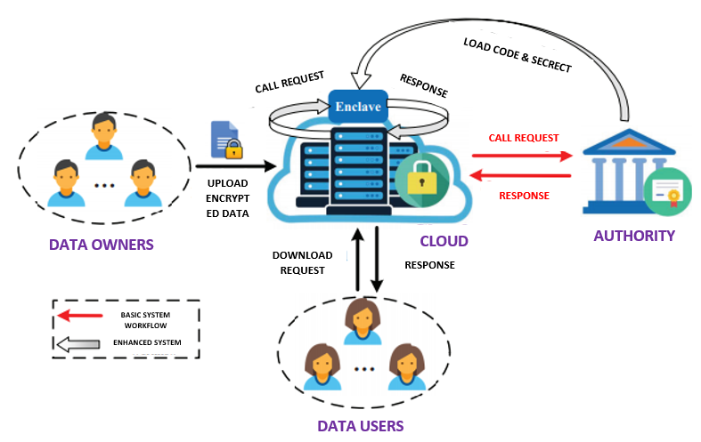

**Figure1:** ERP Flow

**3. RESULT**

The system enhances security with multi-layered authentication and role-based permissions. It ensures real-time access control to prevent unauthorized access. Download request validation optimizes data transmission efficiency. It offers a scalable and integrable framework for cloud storage. Dynamic authorization ensures flexibility without compromising security.

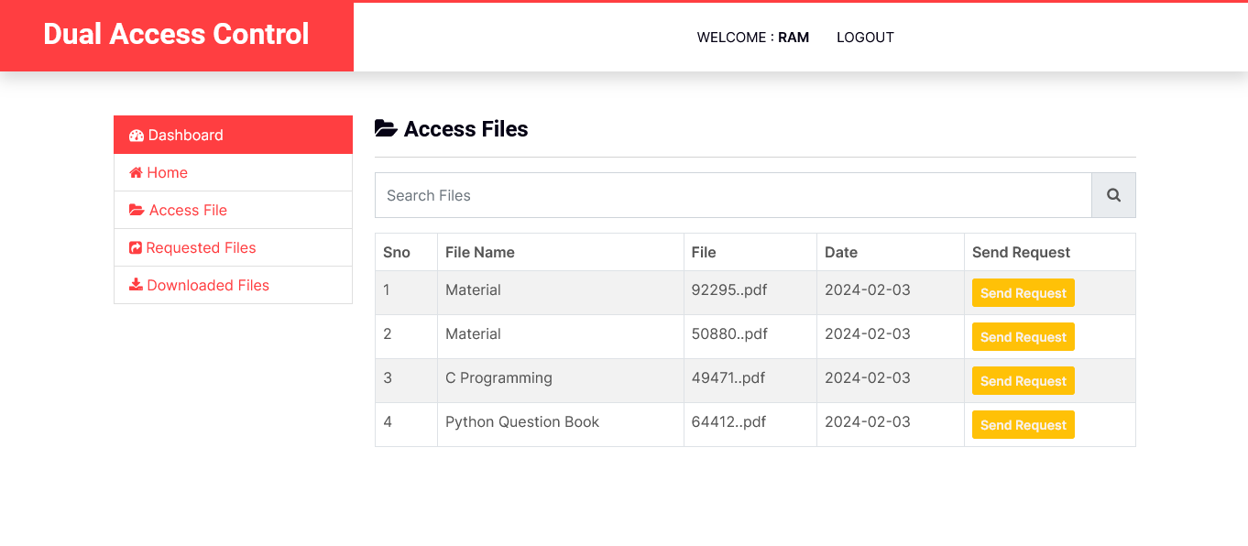

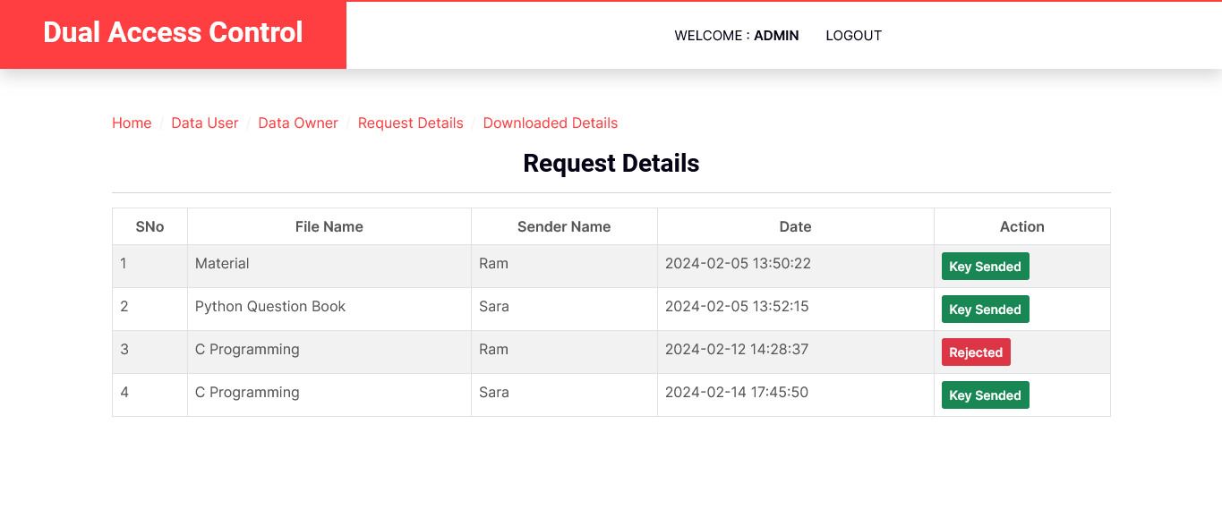

**4. CONCLUSION**

The Dual Access Control for Cloud-Based Data Storage and Sharing system enhances security, efficiency, and usability in cloud environments. By integrating multi-layered authentication and encryption, the system prevents unauthorized file access and excessive download requests. The inclusion of real-time monitoring, access tracking, and role-based access control ensures compliance with modern security standards. This system provides a scalable, cost-effective, and future-proof solution for secure cloud data management.

**5. ACKNOWLEDGEMENTS**

This journal paper was truly prepared by my itself I agree the terms and conditions.

**6. REFERENCES**

[1] Yu, S., Wang, C., Ren, K., & Lou, W. (2010). "Achieving secure, scalable, and fine-grained data access control in cloud computing". *IEEE INFOCOM 2010*, 1-9.

[2] Goyal, V., Pandey, O., Sahai, A., & Waters, B. (2006). "Attribute-based encryption for fine-grained access control of encrypted data".*Proceedings of the 13th ACM Conference on Computer and Communications Security (CCS)*, 89-98.

[3] Jiang, J., Xie, S., Wei, L., & Yu, J. (2019). "Secure data sharing and searching for cloud storage based on improved attribute-based encryption". *IEEE Access*, 7, 50858-50867.

[4] Yang, K., & Jia, X. (2012). "Expressive, efficient, and revocable data access control for multi-authority cloud storage". IEEE Transactions on Parallel and Distributed Systems, 25(7), 1735-1744.