IOT Based Smart Electricity Energy Meter

# SKN SINHGAD COLLEGE OF ENGINEERING, KORTI, PANDHARPUR-413304

**ELECTRONICS & TELECOMMUNICATION ENGINEERING**

**Project Group Member**

**Ms. Kalyani Giridhar Landage, Ms. Vaishnavi Banudas Manepatil, Ms. Rohini Rajendra Mokashi,**

**Prof. A. H. Shinde**

**Abstract: -** Smart energy metering systems are among the many industries that have been greatly impacted by the Internet of Things (IoT). The ESP32 microcontroller, SCT-013 current sensor, and ZMPT101B voltage sensor are used in this paper's design and implementation of an Internet of Things- based electricity energy meter. The goal of the project is to automate the process of energy measurement, allowing users to monitor their electricity consumption in real-time via a Blynk mobile app. The IoT-based system facilitates efficient energy management by continuously tracking parameters such as voltage, current, power, and total energy consumption, which are displayed on a local LCD as well as the Blynk app. The study highlights the enormous advantages of IoT technology in boosting energy efficiency, lowering manual work, and improving accuracy in energy metering systems.



**Key Words:** IoT, ESP32, SCT-013 current sensor, ZMPT101B voltage sensor, Blynk, energy monitoring, smart grid, real-time monitoring, LCD display, power consumption

# INTRODUCTION

The swift growth of IoT has resulted in remarkable advancements in energy management, primarily driven by smart metering technologies. Conventional energy meters need utility companies to take readings manually, which frequently results in delays, mistakes, and inefficiencies. Moreover, these meters do not provide real-time data to users, restricting their capability to enhance energy usage. The implementation of IoT-enabled smart meters resolves these issues by automating energy tracking and delivering real-time data on energy consumption. In this project, we investigate the

design and execution of an IoT-enabled electricity energy meter utilizing the ESP32 microcontroller, which incorporates the SCT-013 current sensor and the ZMPT101B voltage sensor. The system provides an all-encompassing energy tracking solution that shows live data on an LCD display and sends the information to a Blynk mobile application for remote viewing. This method minimizes the requirement for manual readings and allows users to monitor their energy usage from any location, empowering them to manage their energy consumption more efficiently and sustainably.

Accurate data collection, remote monitoring, real- time consumption analysis, and the possibility of integration with larger smart grid infrastructures are the main advantages of IoT-based energy meters. This project intends to offer a scalable and affordable solution that improves customer engagement and encourages energy conservation by utilizing widely accessible IoT components.

## Problem Statement

Traditional meters and manual readings are two of the existing energy monitoring technologies that present a number of difficulties. They are time-consuming, prone to mistakes, and do not give customers instant access to information on their energy use. This frequently results in wasteful energy use, erroneous invoicing, and a failure to identify issues or anomalies immediately.

Users are also unable to optimise their energy usage habits or make well-informed judgements on their consumption due to the absence of real-time monitoring.

Furthermore, energy providers are unable to promptly detect and resolve problems like power theft or excessive consumption. In order to solve these problems, this project suggests an Internet of Things (IoT)-based energy measurement system that offers remote monitoring, real-time insights, and continuous data transfer.

## Objectives

* + 1. To design a system to measure voltage, current, and power consumption with accuracy using appropriate sensors integrated with ESP32 microcontroller.
    2. To enable users to monitor their energy usage in real-time through a mobile application.
    3. To integrate IOT technology with energy monitoring systems.
    4. To create a low-cost, user- friendly energy metering solution.

## Scope of the Study

The scope of this study offers real-time energy usage monitoring and management is the main goal of this project. Using the ESP32 microcontroller in conjunction with the SCT-013 current sensor and ZMPT101B voltage sensor, this system is intended to monitor key electrical characteristics such as voltage, current, power, and total energy consumption. The concept allows customers to continuously monitor and analyse their energy usage by providing both local display through an LCD panel and distant monitoring using the Blynk mobile application. Through the elimination of manual readings, the reduction of errors, and the provision of insights into consumption patterns, the project seeks to provide a scalable and affordable solution that tackles the shortcomings of conventional energy meters.

# PROPOSED ARCHITECTURE

* 1. **ESP32**

With integrated Wi-Fi and Bluetooth, the ESP32 is a strong and adaptable microcontroller that is perfect for Internet of Things applications. Complex data processing and communication are made possible by its dual-core processor, which can reach clock speeds of up to 240 MHz, as well as a sizable amount of RAM and flash storage.

Smart metering and other energy-efficient applications benefit from the ESP32's low power consumption

architecture. The ESP32 is utilised in this project to gather data from the voltage and current sensors, process it to determine power consumption, and wirelessly transmit the data to a distant server for real-time monitoring via the Blynk app. For local data visualisation, its GPIO ports also make it simple to interface with sensors and an LCD display.

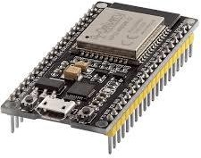

Fig.2.1.1 ESP 32

## SCT-013 Current Sensor

It is safe to use without direct electrical contact because the SCT-013 is a split-core, non- invasive current sensor that measures AC current by clamping around the live wire. It produces an analogue signal proportional to the measured current and has a 100A current measurement capability.

The electromagnetic induction principle underlies the sensor's operation; an AC current in the wire creates a magnetic field that causes a corresponding current to be induced in the sensor's core. Because of its dependability and simplicity of use, this sensor is a popular option for energy metering projects and is perfect for monitoring applications where precise AC current readings are needed. In this project, the ESP32 reads the analogue output from the SCT- 013 and computes the current in real time.

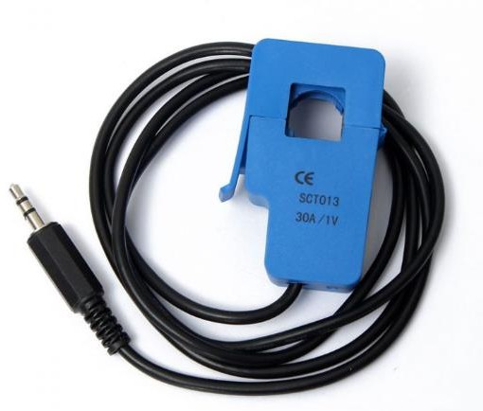

Fig. 2.2.1 Current Sensor

## ZMPT101B Voltage Sensor

The ZMPT101B operates within an input voltage range that generally accommodates standard AC line voltages. Its output signal is scaled to fall within the 0–5V range, making it compatible with most microcontrollers that can read analog input. The sensor also includes a trimmer potentiometer, which allows users to adjust the gain and calibration of the output signal, further enhancing its measurement precision. This feature is essential for applications that require fine-tuned voltage monitoring, such as energy meters, power monitoring systems, and industrial automation.

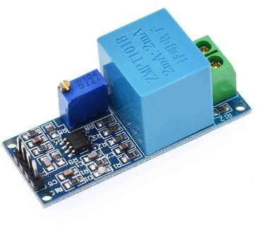

Fig. 2.3.1. Voltage Sensor

The ZMPT101B AC voltage sensor is designed specifically for high-accuracy measurement of AC voltage in embedded systems and IoT applications. This sensor module features a precision voltage transformer, which isolates the high-voltage side from the low-voltage side, ensuring safe measurement and minimizing interference. Its transformer-based design makes it ideal for monitoring applications, as it provides accurate voltage measurements even at low signal levels. Additionally, the sensor outputs an analog signal proportional to the AC voltage it senses, which can be read by a microcontroller’s ADC (Analog-to-Digital Converter) for real-time data processing.

## LCD Display

The 16x4 LCD is a liquid crystal display that consists of 16 columns and 4 rows, enabling it to present a total of 64 characters simultaneously. This module's low power consumption and straightforward interface make it a practical option for embedded projects. It connects to the ESP32 using the I2C communication protocol, which reduces the number of pins needed and frees up more GPIO pins for other parts. The LCD display in this project

allows users to examine their energy usage directly from the device by displaying local real-time voltage, current, power, and energy consumption statistics.

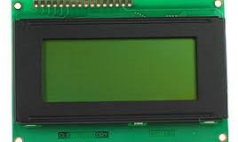

Fig. 2.4.1 LCD Display

# IMPLEMENTATION AND WORKING

## Working

The ESP32 microcontroller, the main processor of the Internet of Things-based electricity energy meter project, gathers and analyses electrical data from two important sensors. The ZMPT101B voltage sensor and the SCT-013 current sensor are used to measure the voltage and AC current in a circuit, respectively. Without making direct electrical contact, the SCT-013 sensor, a non- invasive current transformer, clamps around a live wire to measure the current. In the meantime, the ZMPT101B voltage sensor module isolates and records the AC voltage using a voltage transformer. The ESP32 uses its integrated 12-bit ADC to read and process the analogue signals from both sensors.

The major electrical parameters—real-time voltage, current, power (in watts), and total energy consumption (in kilowatt-hours)—are determined by the ESP32 after it has received the voltage and current data. The ESP32 continuously records and tracks energy consumption using these measurements. The voltage and current values are multiplied to determine power, and power is integrated over time to get total energy use. Users can track their energy use in real-time with the help of this data, which is essential for comprehending patterns in electricity usage.

A 16x4 LCD display is used in the project's local display component to visualise data on-site. Users may monitor voltage, current, power, and energy data without an internet connection thanks to the ESP32, which powers this display. Users can make

modifications in real time with the help of this instant feedback, which provides a clear picture of their current electricity use.The ESP32 connects to a Wi-Fi network to allow distant data access in addition to local monitoring. The Blynk app, an IoT project platform that allows real-time data viewing on smartphones, receives all monitored data from the device. Users may monitor their electricity usage from any location, follow their usage trends over time, and get notifications if their energy use above predetermined limits by using the Blynk app.

The ESP32's capability to conduct over-the-air (OTA) updates is an additional benefit of employing it in this project. By using OTA, developers can remotely update and change the firmware of the device, enabling the addition of new features or enhancements without having to physically contact the device. This functionality offers a practical and effective method of managing the device, making it especially helpful for Internet of Things applications that might be installed in remote or difficult-to-reach areas.

* 1. **Block Diagram**

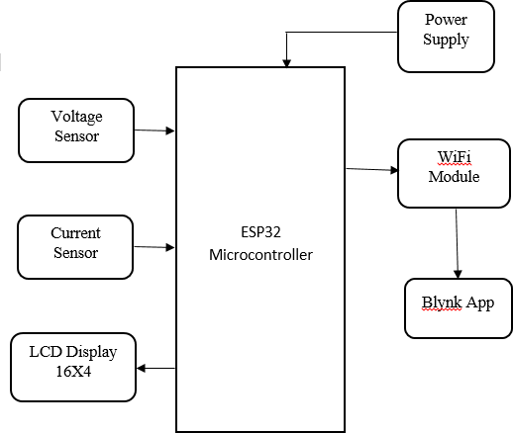

Fig.3.2.1.Block diagram

# RESULT

Important electrical metrics including voltage, current, power, and total energy consumption are successfully recorded and shown by the Internet of Things-based electricity energy meter. Together with the ZMPT101B voltage sensor and SCT-013 current sensor, the ESP32 microcontroller gathers real-time data that is shown on a 16x4 LCD and on the Blynk app. The app interface adds ease and management by enabling remote monitoring, which lets customers see how much energy they use from any location.The responsiveness of the setup is demonstrated by the system's accurate updating of values when a load, such as a light bulb, is connected. This feature can lower electricity expenses by giving consumers insights into patterns of power utilisation. All things considered, the project shows how well ESP32 and IoT technology work together to create useful, approachable energy monitoring solutions.

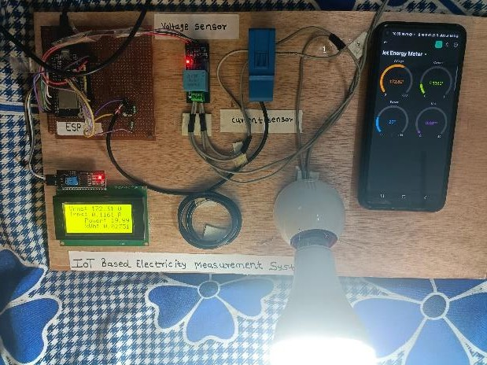

Fig.4.1. Result displaying on LCD and

# CONCLUSION

The Internet of Things (IoT)-based electricity energy meter project met its goals and provided a workable way to track and control energy use locally and remotely. The project offers a comprehensive picture of electricity use by utilising the ESP32's processing and connection capabilities in conjunction with precise current and voltage sensors. By using the Blynk app's real-time information, users may make well-informed decisions about how much energy they consume, which could result in lower energy expenditures and improved energy management.

The project demonstrates how the Internet of Things (IoT) can automate repetitive operations and offer remote accessibility, making it perfect for industrial and home energy monitoring applications.

## References

1. Kundu, T. (2024). Smart IoT Energy Meter Using ESP32, ACS712, ZMPT101B, an I2C LCD

Display, Blynk 2.0.

1. Elektor Magazine. (2023). ESP32-Based Energy Meter Project: Integration with Home Assistant. Elektor
2. Dhananjayan, S., & Kannan, S. (2021). IoT-Based Smart Energy Meter with Monitoring and Analysis Using ESP32. International Journal of IoT Research and Applications, 3(4), 220–230.
3. Ravindran, R., & Priyadarshini, T. (2020). Design and Implementation of IoT-Based Real-Time Energy Monitoring Using ESP32.
4. Zhou, H., & Feng, L. (2019). A Smart Energy Meter Based on ESP32 with Real-Time Monitoring and Notifications. Journal of Renewable Energy Systems, 8(1), 15-25.
5. Vaibhav Godase, Vijaya Dhope, Amruta Chavan, Namrata Hadmode, "SMART PLANT MONITORING SYSTEM", International Journal of Creative Research Thoughts (IJCRT), ISSN:2320-2882, Volume.12, Issue 5, pp.b844-b849, May 2024, Available at :http://www.ijcrt.org/papers/IJCRT2405203.pdf
6. Vaibhav Godase, Vijaya Dhope, Amruta Chavan, Namrata Hadmode, "SMART PLANT MONITORING SYSTEM", International Journal of Creative Research Thoughts (IJCRT), ISSN:2320-2882, Volume.12, Issue 5, pp.b844-b849, May 2024, Available at :http://www.ijcrt.org/papers/IJCRT2405203.pdf
7. Vaibhav Godase. (2024). SMART PLANT MONITORING SYSTEM. In International Journal of Creative Research Thoughts (Vol. 12, Number 5, pp. b844–b849). Zenodo. https://doi.org/10.5281/zenodo.11213525
8. Vaibhav Godase, Akash Lawande, Kishor Mane, Kunal Davad and Prof. Siddheshwar Gangonda . "Pipeline Survey Robot." International Journal for Scientific Research and Development 12.3 (2024): 141-144.
9. Vaibhav Godase, Yogesh Jadhav, Kakade Vishal, Virendra Metkari and Prof. Siddheshwar Gangonda . "IOT Based Greenhouse Monitoring And Controlling System." International Journal for Scientific Research and Development 12.3 (2024): 138-140.
10. Godase, Vaibhav, Amol Jagadale, and SKNSCOE, Korti, Solapur University-413304, India. “Three Element Control Using PLC, PID & SCADA Interface.” Journal-article. IJSRD - International Journal for Scientific Research & Development. Vol. 7, 2019. https://www.ijsrd.com.
11. Godase, Vaibhav, Prashant Pawar, Sanket Nagane, and Sarita Kumbhar. “Automatic Railway Horn System Using Node MCU.” Journal of Control & Instrumentation 1 (2024): 11–19. https://journals.stmjournals.com/joci.
12. Godase, V., Mulani, A., SKN Sinhgad College of Engineering, Pandharpur, Godase, V., Mulani, A., Ghodak, R., Birajadar, G., Takale, S., SKN Sinhgad College of Engineering, Pandharpur, & Kolte, M. (2024). A MapReduce and Kalman Filter based Secure IIoT Environment in Hadoop. In SKN Sinhgad College of Engineering, Pandharpur [Journal-article]. https://www.researchgate.net/publication/383941977
13. Godase, V., & Godase, J. . (2024). Diet Prediction and Feature Importance of Gut Microbiome using Machine Learning. Evolution in Electrical and Electronic Engineering, 5(2), 214-219. https://publisher.uthm.edu.my/periodicals/index.php/eeee/article/view/16120