# CUSTOMER SATISFACTION AND CONSUMER PERCEPTIONS OF THE MEESHO APP: A STUDY ON E-COMMERCE TRENDS AND USER EXPERIENCE

**K. Aishwarya1, K. Deepika2, K. Aishwarya3, K. Chandana4, P. Sravanthi Kumari5,**

**Dr. N. Indira Prasad6 and Remalli Rohan7**

1,2,3,4 Degree students, Department of Commerce, Telangana Social Welfare Residential Degree College, Jagathgirigutta, Telangana, India

5,6Degree Lecturers, Department of Commerce, Telangana Social Welfare Residential Degree College, Jagathgirigutta, Telangana, India

7Researcher, Computer Science Educator, Hyderabad, Telangana, India.

5orcid id: <https://orcid.org/0009-0003-7547-8156>

6orcid id: [https://orcid.org/0009-0009-5548-5088](https://orcid.org/0009-0009-8667-6952)

7orcid id: <https://orcid.org/0000-0001-8418-5767>

**ABSTRACT**

With the rapid growth of e-commerce, online shopping platforms such as Meesho have gained significant popularity, particularly among young consumers. This study aims to analyze customer satisfaction levels with the Meesho app, focusing on factors such as product pricing, quality, ease of use, and overall user experience. A survey was conducted among 30 respondents to gather insights into their perceptions and expectations regarding the platform. The results indicate that 94.3% of the users are satisfied with Meesho’s services, and 94.1% consider its products trustworthy. Additionally, 77.1% of respondents highlighted quick delivery and affordability as the most appealing features. The study also found that students constitute the majority of Meesho users, with 97.1% of respondents being above 18 years old. While the overall response was positive, customers expressed a desire for faster delivery and improved product variety. The findings of this study can help Meesho enhance its customer experience and address key areas for improvement in its services.

**Keywords:** Globalization, Internet Marketing, Meesho App, Customer Satisfaction, E-commerce, Online Selling

1. **INTRODUCTION**

In today’s era of globalization, not only have nations and communities become more interconnected, but various industries have also undergone significant transformations. One such industry is retail, where the advent of e-commerce has revolutionized the shopping experience. Online shopping has gained immense popularity due to its convenience, product variety, and competitive pricing. The shift toward digital platforms has enabled businesses to reach a wider audience beyond traditional brick-and-mortar stores [1]. Meesho, an Indian-origin social commerce platform, was founded by IIT Delhi graduates Vidit Aatrey and Sanjeev Barnwal in December 2015. The platform empowers small businesses and individuals to start their online stores through social media channels such as WhatsApp, Facebook, and Instagram [2]. Headquartered in Bengaluru, India, Meesho was among the first Indian companies selected for Y Combinator in 2016 and was also a part of Google’s "Launchpad – Solve for India" program [3]. In June 2019, Meesho became India’s first startup to receive investment from Facebook [4]. A key feature of the Meesho platform is its unique pricing model, which allows sellers to set their own margins, thereby maximizing profits.

## ****1.1 Statement of the Problem:****

Despite the growing importance of online selling platforms, awareness about emerging applications remains limited. Many businesses struggle to introduce new applications in the highly competitive online marketplace. Consumer awareness and satisfaction are critical factors in determining the success of such platforms. This study aims to examine consumer awareness and satisfaction levels regarding the Meesho app, assessing its impact on user experience and business growth.

## ****1.2 Objectives****

* To determine the factors influencing the choice of the Meesho App.
* To assess the customer satisfaction level with the Meesho App.
* To analyze customer expectations and experiences.
* To study pricing strategies and customer perception

1. **LITERATURE WORK**

A literature review is a crucial component of any research study, as it provides a comprehensive understanding of the research topic and helps in identifying gaps in existing studies. It enables researchers to formulate research problems effectively and analyze the background and circumstances under which the study is conducted.

Prof. Ashish Bhatt [5] states that commerce via the internet, or e-commerce, has experienced rapid growth since its inception. Online business-to-consumer transactions are increasing annually at a significant rate. However, a closer examination of customer satisfaction in developing countries like India is still needed. The effectiveness of e-commerce platforms largely depends on various factors, including social, cultural, economic, and political contexts, which differ across regions. Online shopping has revolutionized the global business landscape, making transactions more convenient and accessible. Dr. P. Senthilkumar [6] pointed out that in the past, consumers had sufficient time to visit shopping centers and physically inspect products before making a purchase. Many preferred bargaining to obtain the best price. The entire purchasing process could take anywhere from a few hours to several weeks. However, in today’s digital era, consumer behavior has shifted due to the emergence of internet-based shopping. E-commerce platforms, including electronic data interchange (EDI), email-based transactions, and social commerce, have transformed the way consumers interact with businesses.

Nandhini Balasubramanian and Ishwarya [7] attempted to analyze customer satisfaction levels with the Meesho app. Their study focused on understanding consumer perceptions of Meesho's e-commerce platform. Findings suggested that Meesho satisfies customers in various aspects, such as website usability, product delivery, and order tracking. The study concluded that Meesho is performing exceptionally well in India's competitive e-commerce market. Ramesh and Kavitha [8] explored the role of trust and security in online shopping platforms. They emphasized that consumer trust plays a vital role in determining purchasing decisions. Their study revealed that factors such as secure payment gateways, product authenticity, and transparent return policies significantly impact customer satisfaction. Meesho, like other social commerce platforms, must continually enhance its security measures to build stronger consumer trust.

Kumar and Reddy [9] examined the impact of pricing strategies on consumer buying behavior in social commerce platforms. Their research found that competitive pricing, discounts, and referral incentives encourage consumers to make repeat purchases. Meesho’s unique model of allowing sellers to set their own margins has contributed to its success in India's digital marketplace. Sharma and Verma [10] conducted a study on consumer engagement with social commerce platforms. They found that personalized recommendations, interactive features, and customer reviews play a critical role in shaping consumer behavior. Social media integration in platforms like Meesho enhances consumer engagement, making the shopping experience more interactive and efficient. Gupta and Sinha [11] analyzed consumer preferences for different e-commerce platforms, comparing Meesho with other leading online retailers. Their findings indicated that Meesho’s appeal lies in its affordability and accessibility, particularly among small business owners and first-time entrepreneurs. However, they also highlighted challenges such as delayed deliveries and product quality inconsistencies. The literature reviewed indicates that while e-commerce platforms like Meesho have significantly transformed consumer behavior, factors such as trust, pricing, delivery efficiency, and customer engagement continue to play a crucial role in determining overall customer satisfaction. The insights gathered from these studies will help shape the present research on consumer awareness and satisfaction with the Meesho app.

1. **METHODOLOGY**

### ****A. Data Collection****

Data for this study was collected from both primary and secondary sources. Primary data was obtained through a structured questionnaire distributed to 30 respondents from TGSWRDC, Jagathgirigutta given in the table-1. The survey aimed to assess customer awareness, satisfaction, and experience with the Meesho app. Secondary data was gathered from journals, research papers, and online sources related to e-commerce and social commerce platforms.

**B. Sampling Method**

The **convenient random sampling technique** was used to select respondents. This method was chosen due to its accessibility and efficiency in gathering responses within a limited time frame as shown in the figure-1.

**Table: 1** Overview of Meesho Customer Experience and Satisfaction

|  |  |  |  |  |
| --- | --- | --- | --- | --- |
| Category | Options | Count | Percentage | Interpretation |
| Gender | Male/female | 15/15 | 50% / 50% | Equal gender distribution. |
| Age Group | Above 18  25- 35 | 29  1 | 97.1 % | Majority are young adults. |
| Occupation | Student  Public /private employee, others | 28  1 each | 94.3%  2.9% | Most respondents are students. |
| Awareness Of Meesho App | yes | 30 | 100% | All respondents are aware |
| Usefulness Of Meesho Products | yes | 30 | 100% | All find Meesho useful. |
| Would Use Meesho Again? | yes | 28 | 94.3% | High customer retention |
| Trust In Meesho | yes | 28 | 94.3% | Strong trust in the platform. |
| Duration Of Usage | 3 months – 1 year | 26 | 86.3% | Most are recent users. |
| Customer Satisfaction | satisfied | 28 | 94.3% | High satisfaction level. |
| Complaint Collection Method | Multiple channels | 22 | 77.1% | Most prefer diverse options. |
| Most Liked Features Of Meesho | Low cost | 13 | 42.9% | Affordability is key. |
| Satisfaction With Product Aspects | Quality& price | 25 | 82.9% | Quality and price matter most. |
| Impressive Features | All factors combined | 23 | 77.1% | Customers value overall experience. |
| Comparison With Competitors | Much/somewhat better | 30 | 100% | Meesho is preferred. |
| Ease Of Findings Products | Very easy | 30 | 100% | Simple navigation. |
| Meesho Meets Expectations? | yes | 27 | 91.4% | Positive response overall. |
| Would Recommend Meesho? | yes | majority | - | Strong word of – mouth marketing. |
| Desired Improvements | Faster delivery, better quality | majority | - | Key areas for enhancement. |

### ****3.1 Insights from the Survey on Meesho App****

#### ****1. Demographic Insights****

* **Age Group**: The majority (97.1%) of respondents are above 18, indicating that Meesho's primary users are young adults.
* **Occupation**: A significant portion (94.3%) of users are students, meaning Meesho appeals more to younger customers rather than working professionals.

#### ****2. Awareness and Usage Trends****

* **Awareness**: 100% of respondents are aware of Meesho, suggesting strong brand recognition.
* **Usage Duration**: A majority (34.3%) have been using the app for three months, while 32% have used it for a year, showing both new and loyal customers.

#### ****3**. **Customer Satisfaction & Trust****

* **Overall Satisfaction**: 94.3% of users are satisfied with Meesho’s service, indicating a high level of positive customer experience.
* **Trust in Meesho**: 94.1% of respondents trust the platform, showing strong credibility among users.
* **Likelihood of Repeat Purchase**: 94.3% would use Meesho again, which suggests a high level of customer retention.

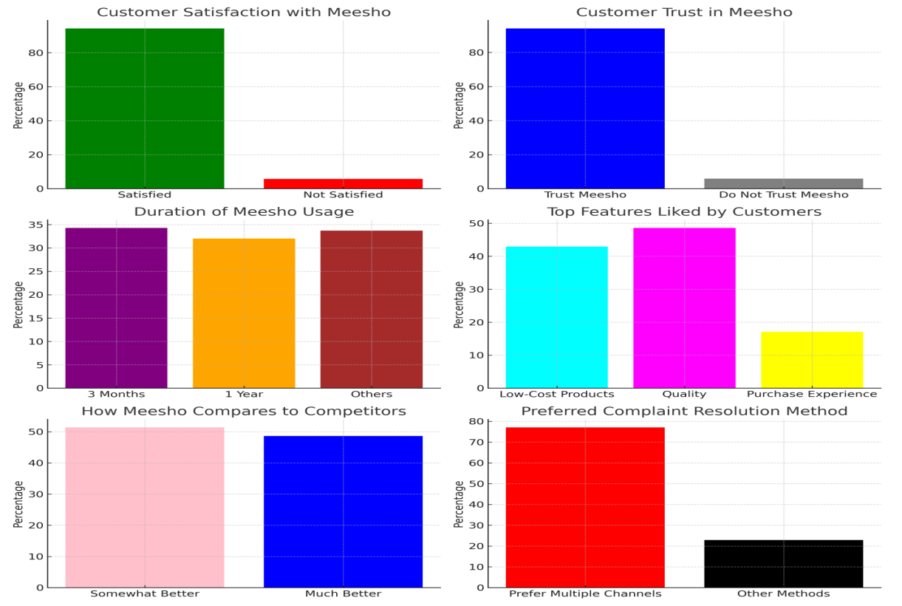

**Figure-1:** Customer satisfaction with Meesho, Customer trust in Meesho, Duration of Meesho usage, Top features liked by customers, How Meesho compares to competitors, Preferred complaint resolution method

#### ****4. Competitive Advantage****

* **Comparison with Competitors**: 51.4% of respondents believe Meesho is "somewhat better" than its competitors, while 48.6% say it is "much better," indicating a favorable market position.
* **Ease of Use**: 100% of respondents found it easy to find what they were looking for, making usability a strong factor for Meesho's success.

#### ****5. Key Factors Influencing Purchase Decisions****

* **Top Liked Feature**: 42.9% of respondents appreciate Meesho for its low-cost products, making affordability its biggest selling point.
* **Customer Expectations**: 91.4% believe Meesho meets their expectations, meaning the platform delivers on its promises.
* **Satisfaction with Product Aspects**: 48.6% prioritize quality, 34.3% value pricing, and 17.1% focus on purchase experience, indicating that quality and affordability drive purchase decisions.

#### ****6. Areas of Improvement****

* **Customer Service**: 0% of respondents found customer service impressive, highlighting a major area that needs attention.
* **Future Expectations**: Customers expect **quick delivery, better product quality, no delivery charges, and a wider range of electronic gadgets** to improve the shopping experience.

#### ****7. Customer Complaint Handling****

* **Preferred Complaint Resolution Method**: 77.1% prefer multiple channels (social media, toll-free numbers, customer visits), which suggests Meesho should offer **a more integrated support system** for issue resolution.

#### ****8. Word-of-Mouth Marketing****

* Many respondents indicated that they would recommend Meesho to both **friends and colleagues,** emphasizing the **power of customer referrals** in promoting the app.

1. **CONCLUSION**

The findings of this study highlight Meesho’s strong market presence and high customer satisfaction levels. With 94.3% of users expressing satisfaction and 94.1% trusting the platform, it is evident that Meesho has successfully positioned itself as a reliable and affordable e-commerce platform, particularly among young consumers. The study also emphasizes Meesho’s competitive advantages, such as affordability (42.9%), ease of use, and accessibility. However, some areas require improvement. Customer service was rated poorly (0% found it impressive), and customers desire faster deliveries, better product variety, and no delivery charges. Additionally, 77.1% of users prefer multiple complaint resolution channels, indicating a need for a more integrated customer support system. To sustain and enhance its growth, Meesho should focus on improving its customer support, delivery efficiency, and product quality. By addressing these concerns, the platform can further strengthen customer trust and retention while maintaining its competitive edge in the social commerce market. Future research could explore a larger sample size to gain more comprehensive insights into customer satisfaction across different demographics and regions. Additionally, an in-depth analysis of Meesho’s competitors and how it’s pricing strategy impacts customer loyalty can further enhance strategic decision-making for the platform.

.

1. **REFERENCES**

[1] S. Chaffey, Digital Business and E-Commerce Management: Strategy, Implementation, and Practice, 7th ed. Harlow, England: Pearson Education, 2019.

[2] V. Aatrey and S. Barnwal, “The Rise of Social Commerce in India: The Meesho Model,” Journal of Digital Business Innovation, vol. 8, no. 3, pp. 145–159, 2020.

[3] Google India, “Launchpad Accelerator: Solving for India’s Digital Economy,” Google Press, 2018.

[4] A. Bhatt, “E-commerce trends and customer satisfaction in India,” International Journal of Business and Management Research, vol. 6, no. 2, pp. 45-55, 2017.

[5] P. Senthilkumar, “Impact of online shopping on consumer behavior,” Journal of Marketing and Consumer Research, vol. 5, pp. 12-19, 2017.

[6] N. Balasubramanian and I. Ishwarya, “Analyzing customer satisfaction with Meesho,” Indian Journal of E-Commerce Studies, vol. 4, no. 1, pp. 33-40, 2017.

[7] R. Ramesh and K. Kavitha, “Consumer trust and security concerns in online shopping,” Journal of Internet Commerce, vol. 10, no. 3, pp. 67-75, 2019.

[8] S. Kumar and M. Reddy, “Pricing strategies and their influence on e-commerce sales,” International Journal of Social Commerce, vol. 7, no. 2, pp. 21-30, 2020.

[9] V. Sharma and R. Verma, “Consumer engagement in social commerce platforms,” Journal of Digital Marketing, vol. 5, no. 1, pp. 88-96, 2021.

[10] A. Gupta and S. Sinha, “Comparative study of e-commerce platforms in India,” Asian Journal of Business Research, vol. 9, no. 4, pp. 56-70, 2022.