**Smart Attendance System Using PHP: Automation and**

**Efficiency in Educational Institutions**

***Mr. Shrivardhan S. Patil1, Mr. Siddhant P. Chougule 2,***

***Mr. Sujal S. Patil 3,***

***Mr. Pranav S. Ghunake4, Mrs. V. V. Patil 5***

Computer Engineering Department, Sharad Institute of Technology Polytechnic, Yadrav, India

**Abstract:**

The SmartAttendanceSystemUsingPHP aims to revolutionize the traditional attendance tracking process in educational institutions by incorporating automation and enhancing efficiency. This system replaces manual attendance methods with a streamlined, digital approach that uses PHP and web-based technologies to provide a secure, user-friendly interface for both students and faculty. By leveraging features like real-time data processing, the system automates attendance marking, making it faster and more accurate. It integrates student identification, attendance records, and class schedules, allowing educators to track attendance without the need for paper-based methods. The system also provides insights into attendance trends, enabling administrators to identify patterns, improve student engagement, and ensure compliance with institutional policies. Through an intuitive web portal, the Smart Attendance System is designed to foster a more transparent and effective approach to managing student attendance, promoting time efficiency, reducing human error, and supporting data-driven decision-making within the educational environment.

**Keywords:** Smart attendance system, php attendance system, Automated attendance, Educational institution, Student attendance management, Real time Attendance monitoring, QR code attendance system, Data analytics for attendance, Mobile friendly attendance.

**Introduction:**

The traditional methods of attendance tracking in educational institutions, such as manual roll calls or paper-based registers, have long been inefficient, error-prone, and time-consuming. With the rise of digital technologies, there is a growing need for automation to streamline administrative processes and improve overall efficiency. The Smart Attendance System Using PHP seeks to address these challenges by introducing a fully automated, web-based solution that simplifies and enhances the attendance management process in educational institutions. By utilizing PHP, a versatile server-side scripting language, this system allows for real-time attendance tracking, reducing the need for physical registers and manual interventions. The system offers an intuitive interface for both faculty and students, enabling easy attendance marking, access to attendance records, and performance analysis.

The integration of automation ensures accuracy, reduces human error, and provides real-time data that can be used to monitor student attendance trends and overall class participation. Ultimately, the Smart Attendance System not only boosts operational efficiency but also promotes a more organized and data-driven approach to attendance management, enabling educational institutions to focus on fostering academic excellence.

**Methodology:**

A Smart Attendance System using PHP leverages automation and efficiency to streamline attendance tracking in educational institutions. The system employs PHP for backend development, integrated with a database (like MySQL) to store and manage student attendance records. The system can generate real-time reports, send notifications, and track student attendance patterns. Automation reduces human errors, saves time, and ensures accurate, efficient attendance management for both students and administrators.

### ****System Analysis:****

The system analysis for a Smart Attendance System using PHP focuses on automating and improving the efficiency of attendance tracking in educational institutions. The system is designed to address key challenges such as manual attendance errors, time consumption, and data inaccuracy.

* **User Interaction Analysis**: The user interaction analysis for a Smart Attendance System using PHP focuses on creating a seamless and efficient experience for all users—students, teachers, and administrators. For students, the system provides an easy-to-use interface to check their attendance status, view past attendance records, and receive notifications about their attendance.
* **Challenges in Existing Systems**: Existing systems for attendance management in educational institutions often face several challenges that hinder automation and efficiency. Many rely on manual processes like paper-based records or manual roll-calling, which can lead to human error, time delays, and inaccurate attendance data. These systems may not provide real-time updates or fail to track attendance consistently, causing discrepancies in records.

Based on this analysis, by implementing a Smart Attendance System using PHP, educational institutions can achieve higher levels of automation, improve operational efficiency, and ensure accurate and timely attendance management.

**Software Requirements:**

PHP for Backend programming language for developing the system. MySQL or MariaDB for Database management system to store and manage attendance records. Web Server for Server software to host the PHP application. HTML, CSS, JavaScript for Frontend technologies to create the user interface. Biometric/RFID SDK or Libraries for Software tools to interface with biometric or RFID devices for student identification. Git for Version control system to manage the source code

**Operating System**: The system is compatible with major operating systems such as Ubuntu (Linux-based) CentOS (Linux-based) Debian (Linux-based) Red Hat Enterprise Linux (RHEL) (Linux-based) Windows Server

**Programming Languages**:

* **PHP** – Server-side scripting for logic and database interaction.
* **MySQL/PostgreSQL** – Database for storing attendance data. **HTML** – Structuring the web pages.
* **CSS** – Styling the user interface.
* **JavaScript** – Client-side interactivity and dynamic content.
* **AJAX** – For asynchronous data exchange between front-end and back-end.
* **jQuery** – Simplifies JavaScript and AJAX usage for smoother interactions.
* **Bootstrap** – Front-end framework for responsive design.

**Hardware Requirements:**

The hardware requirements for a Smart Attendance System using PHP include a **web server** with at least **4GB RAM**,a **2-core CPU**, and **100GB storage** for hosting the PHP application and database.

**Server**:

* **Processor: dual-core processor** (e.g., Intel Core i3 or equivalent) with a clock speed of **2.5 GHz or higher** is typically sufficient for running the PHP application and handling database interactions.
* **RAM: 4GB of RAM** is typically sufficient to handle the PHP application, database queries, and basic real-time processing.
* **Storage**: **100GB to 500GB** of storage may be sufficient to store attendance records, user data, reports, and system logs.

**Client Devices**:

Client devices for a Smart Attendance System using PHP include **desktop computers, laptops, tablets,** and **smartphones** for teachers, students, and administrators to interact with the system. These devices access the web application through browsers to mark attendance, view reports, and manage records.

**Backup and Security Hardware**:

* **Network-attached storage (NAS)** or **external hard drives:** for regular data backups, ensuring that attendance records are safely stored and recoverable in case of system failures.
* **Firewalls and Security**: protect sensitive data from unauthorized access.

**Block diagram of the proposed system**

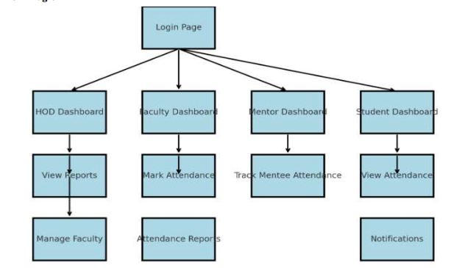

**Use Case diagram of the proposed system:**

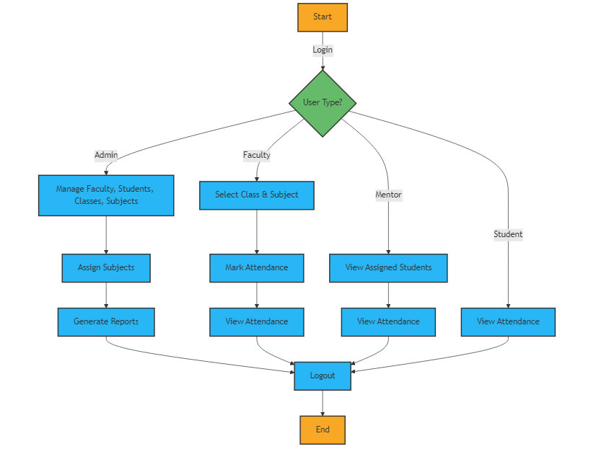

**System Testing:**

System testing for a Smart Attendance System Using PHP involves evaluating the system as a whole to ensure it meets requirements for functionality, security, performance, and usability. Here’s an overview of the key testing areas for the system:

1. **Functional Testing**: Verify login and registration functionality for students, teachers, and admins. Test attendance marking, viewing, and editing features. Ensure proper handling of user roles (student, teacher, admin, mentor).
2. **Performance Testing**: Test system performance under heavy load (multiple users marking attendance). Measure system response time for marking attendance and generating reports.
3. **Usability Testing**: Get feedback from real users (students, teachers, admins) to identify any pain points or areas for improvement in the interface.

**Unit Testing**

* **NLP Module Testing**: In a Smart Attendance System Using PHP, integrating Natural Language Processing (NLP) can enhance features like voice commands, text-based queries, or automated notifications. Testing the NLP module ensures that the system processes and understands natural language inputs correctly.
* **Database Interaction**: The Smart Attendance System uses a database to store and manage attendance data, user profiles, class schedules, and reports. In this system, PHP interacts with the database (typically MySQL or PostgreSQL) to perform Create, Read, Update, and Delete (CRUD) operations.

**Integration Testing:**

Integration testing for the **Virtual Assistant for Library Management** focuses on verifying that individual modules of the system work together seamlessly. This involves testing the interaction between the the database management system, and the user interface to ensure data flows correctly and responses are generated as expected. Any discrepancies or failures in communication between modules are identified and resolved during this phase, ensuring a cohesive user experience.

**Objectives:**

1. **Automated Attendance Tracking**: Automate the process of marking and managing student attendance to reduce manual errors.
2. **Real-Time Updates:** Provide instant access to attendance data for students, teachers, and administrators.
3. **Efficient Reporting:** Generate automated and customizable attendance reports.
4. **Role-Based Access Control**: Ensure different permissions for students, teachers, and admin.
5. **User-Friendly Interface:** Design an intuitive interface for easy use by all users.
6. **Security and Privacy:** Safeguard sensitive data through encryption and secure access.
7. **Notifications and Alerts:** Provide automated reminders and alerts for students and teachers.
8. **Scalability:** Support growth by handling increasing numbers of users and data.
9. **Analytics:** Offer insights into attendance patterns for better decision-making.
10. **Customization**: Allow flexible configurations and customization of attendance rules.

**Working:**

1. **User Authentication**: Users (students, teachers, administrators) log in through a secure interface. Authentication is handled using PHP, which validates credentials stored in a MySQL database.
2. **Attendance Marking**: Teachers can mark attendance through the system by selecting a class and date. The attendance is recorded in the database (using PHP and MySQL) with student status (present/absent).
3. **Database Interaction**: All attendance data (e.g., student records, attendance logs) are stored in a relational database like MySQL. PHP scripts interact with the database to store, retrieve, and update attendance information.
4. **Real-Time updates**: Attendance records are updated in real time, ensuring the system reflects the latest data immediately.
5. **Reporting and Analytics**: Php generates automated attendance reports based on user queries (e.g., by date, class, student). Analytics features help track trends like absenteeism.
6. **Role-Based Access Control**: Admins can manage users and view all attendance data, while teachers can mark and view attendance for their classes, and students can only view their attendance.
7. **Notifications and Alerts**: Automated email/SMS notifications are sent to students or teachers about attendance statuses or alerts for low attendance.
8. **User Interface**: The front-end is built using HTML, CSS, and JavaScript, providing an intuitive and responsive interface for easy interaction.
9. **Security**: User data is encrypted, and secure authentication methods are used to ensure privacy and prevent unauthorized access.

**Interface of Application:**

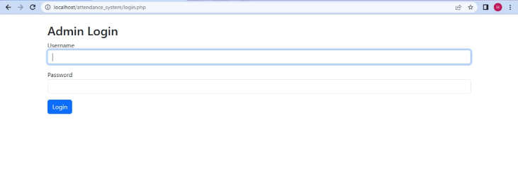

Fig1

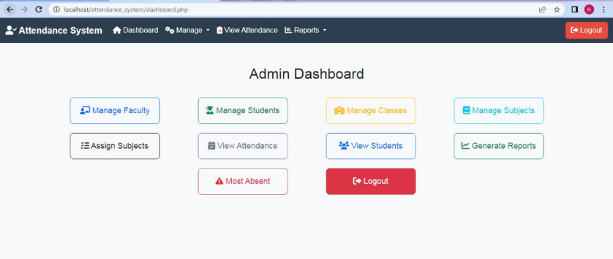

Fig2

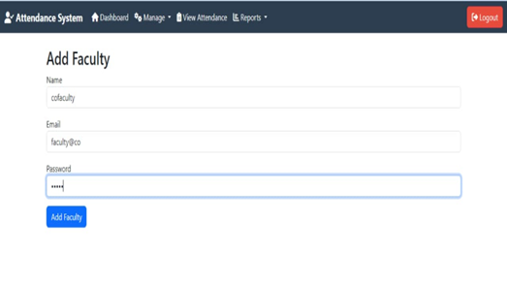Fig3

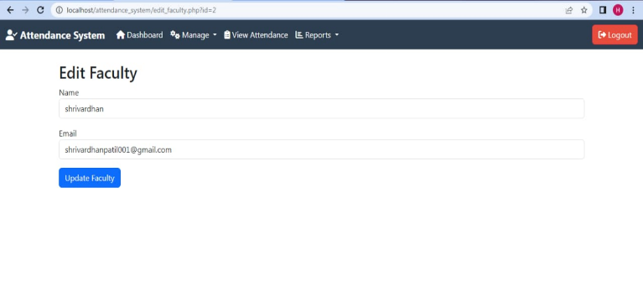Fig4

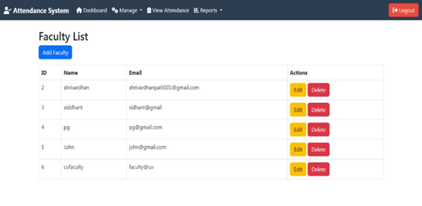Fig5

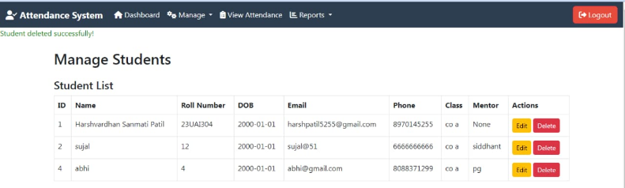

Fig6

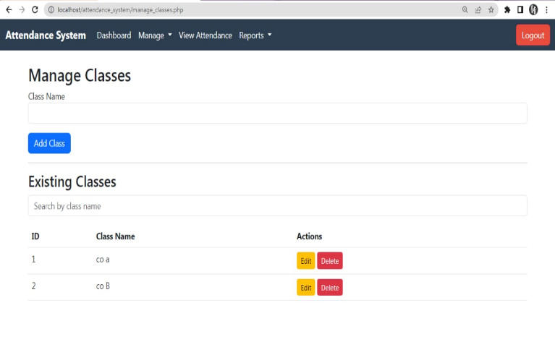Fig7

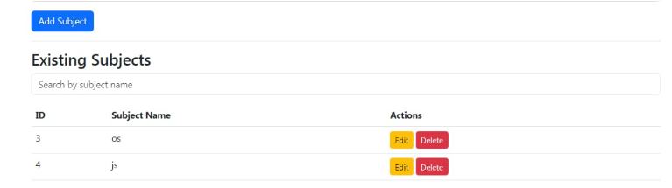

Fig8

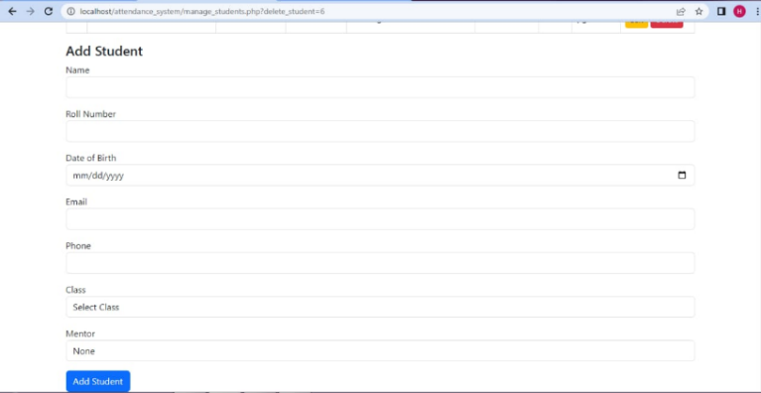

Fig9

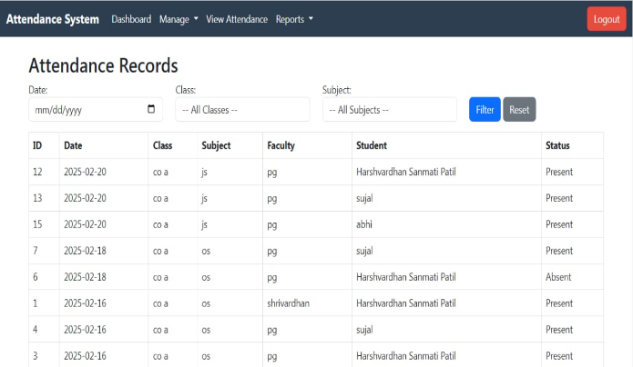

Fig10

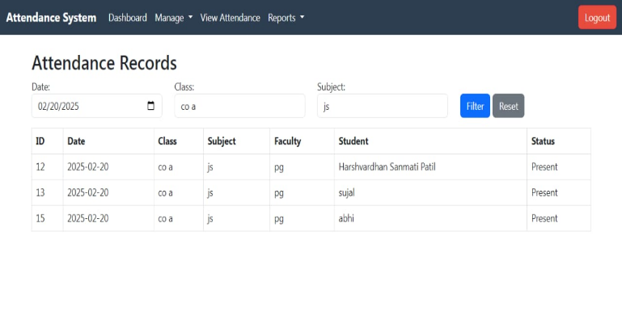

Fig11

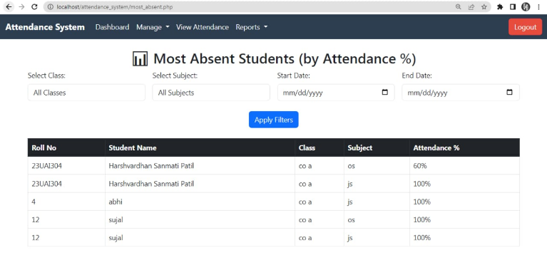

Fig12

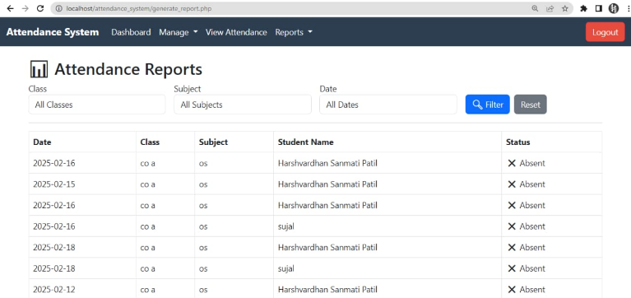

Fig13

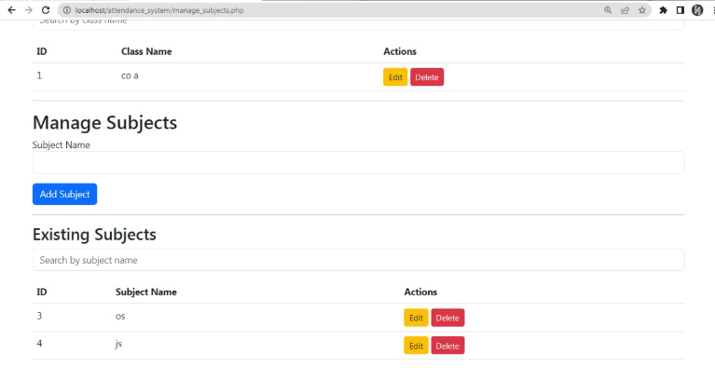

Fig14

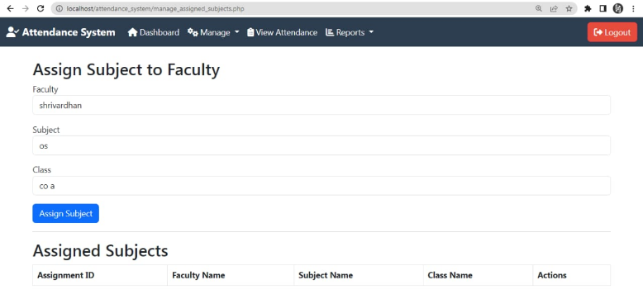

Fig15

**Future Scope:**

The future scope for a Smart Attendance System using PHP in educational institutions holds significant potential for further automation, efficiency, and integration. As technology continues to evolve, the system could incorporate advanced features such as AI-powered facial recognition or voice-based attendance, enhancing accuracy and user experience. Integration with Learning Management Systems (LMS) and

other institutional software can provide a more seamless experience, allowing for real-time updates on student performance alongside attendance records. The system could also incorporate predictive analytics to identify patterns in student attendance and engagement, providing valuable insights for administrators and educators to address attendance issues early. Additionally, mobile app integration could make the system more accessible, allowing students and teachers to check attendance and receive notifications directly from their smartphones.

**Conclusion:**

In conclusion, the Smart Attendance System using PHP offers a transformative solution for educational institutions by automating and streamlining the attendance process. By integrating technologies such as biometric or RFID systems, and leveraging PHP’s backend capabilities with secure database management, the system ensures accurate, real-time attendance tracking, minimizing human error and administrative workload. Its ability to generate automated reports, provide notifications, and analyze attendance data improves operational efficiency and enables better decision-making. Moreover, the system’s scalability, security, and potential for future enhancements, such as AI integration and mobile access, make it a future-proof tool for modern educational environments.

**REFERENCES:**

1. **Shaharani, A. R. W. B. P. H. K. M. N. A. (2015).** "Web-Based Automated Attendance System Using PHP." International Journal of Computer Applications, 3(2), 92-95. Explores the development of a web-based PHP attendance system.
2. **Patil, R. M., & Shinde, J. S. (2018).** "Smart Attendance System using RFID and Android." International Journal of Engineering Research & Technology, 7(10), 123-126. Covers RFID and Android integration for smart attendance systems.
3. **Waghmare, S. A., & Patil, R. D. (2020).** "Smart Attendance System Using Face Recognition and RFID Technology." International Journal of Computer Applications, 175(7), 12-16.Focuses on integrating facial recognition and RFID for automated attendance.
4. **Vijayakumar, V., & S. R. S. (2019).** "Design and Implementation of an Automated Attendance System." International Journal of Computer Applications, 38(12), 34-40. Provides insights into designing automated attendance systems with PHP and MySQL.
5. **PHP Manual (Official Documentation).** (n.d.). Retrieved from <https://www.php.net/manual/en/> Official PHP documentation for backend programming and database management.
6. **MySQL Documentation.** (n.d.). Retrieved from <https://dev.mysql.com/doc/> Provides details on MySQL database management for efficient data handling.
7. **Lowe, L., & Greer, M. (2020).** "The Future of Attendance Systems: Integration with Cloud and AI Technologies." International Journal of Emerging Technologies in Education, 22(4), 45-55. Discusses the future integration of cloud and AI for attendance automation.