**Real Estate Marketing And Sales**

**Shelke Kajal Santosh, Jadhav Trupti Sanjay, Bhor Shivani Nilesh, Jadhav Rutuja Raghunath, Auti.S.S.**

Student, Department of Computer Engineering, Samarth polytechnic, Belhe, Pune, India

Student, Department of Computer Engineering, Samarth polytechnic, Belhe, Pune, India

Student, Department of Computer Engineering, Samarth polytechnic, Belhe, Pune, India

Student, Department of Computer Engineering, Samarth polytechnic, Belhe, Pune, India

Guide, Department of Computer Engineering, Samarth polytechnic, Belhe, Pune, India

**ABSTRACT**

This generation views digital selling as part of the selling of anything from a house to a service. Realty incorporates all-new types of construction along with selling houses, and the most common class of realty are single-family homes: land, residential real estate, Residential, commercial, industrial, real estate investment trust, raw land, and vacation homes. In this very high energy and competitive and rapidly changing situation, agents are required to do a lot more than just get a license. The point is to purchase a home, for living in or use as leverage. This option allows someone to live a financially-happy life now and into the future. The real estate market as an industry maximizes profit potential from digital marketing. Buildings are being used for research, including production, storage, and distribution hub for making or selling goods. Realty has experienced the benefit of almost total more than traditional marketing techniques, from print and cold calling, for years/decades. Even though some of these same techniques are still present in the industry today, as the internet and social media grow, agents have begun the shift to digital marketing techniques in the last couple of decades.

**Keywords:** Real estate, Real estate sales, Real estate housing, Real estate CRM.

## **INTRODUCTION**

## The phrase "real estate" has two readings. As it includes real estate (the land and any buildings on it) and all the properties of that land (the natural resources such as crops, minerals, or water); real estate signifies urban property that is large and immovable; real estate possesses a proprietary value (which is often understood as real estate) refers to interests as significant as the nature of buildings or housing altogether. The term has also indicated the business of real estate; the profession of buying, selling, or renting land, buildings, or houses. Real estate is a legal term that has been adopted into the legal systems that have their matrix from English common law; such as, India, the UK, the USA, Canada, Pakistan, Australia, and New Zealand. Turning to India, real estate is a $12 billion industry, experiencing rapid changes in recent years. 100% FDI is now allowed in real estate development with minimum size limits: two categories – 25 acres for serviced plots or integrated townships; or 50,000 sq. mtr. built-up area for constructional development projects. The commercial and office complexes springing up in several major Indian metros create opportunities by the mile. Furthermore, a 20 million new housing units need to be constructed in the next five years. The real estate market forecasted to reach $50 billion by 2010. Over the next five years, the industry is projected to expand at a compound annual growth rate of more than 30%. This sector will gain momentum as demand for commercial and office space predominately arises from the rapidly growing retail, information technology and hospitality sectors, as well as the Urban Infrastructure Renewal Mission.

1. **METHODOLOG**

The research is carried out on real estate consumers to explore consumer buying behavior within real estate marketing the focus being on urban ascent. The data was collected by using a questionnaire that surveyed 109 respondents online. The research utilizes primary and secondary data. This paper examines consumer buying behavior in relation to real estate marketing. The primary data collected through a Google questionnaire targeted youth respondents. The demographics of the respondents were not strictly limited either. Convenience sampling of subjects were employed , which is a probability sampling technique in which subjects are selected for convenience of accessibility and nearness to the researcher. This technique is simple and readily appropriated especially when tucked for time, resources, or opportunity to access the population in a timely manner. For this research, the respondents were asked to complete a Google questionnaire on their own. There were many facets of the survey, which were explained prior to filling out the questionnaire. The survey questions were established and pre-determined with several open and closed end questions. Most of the questions would be interpreted qualitatively. However, only a few are quantitative method. Only the survey conducted by Google form is used for interpretation and analysis. The secondary method is to collect data through books, articles, research papers, journals, case studies and websites.

1. **USE CASE DIAGRAM**

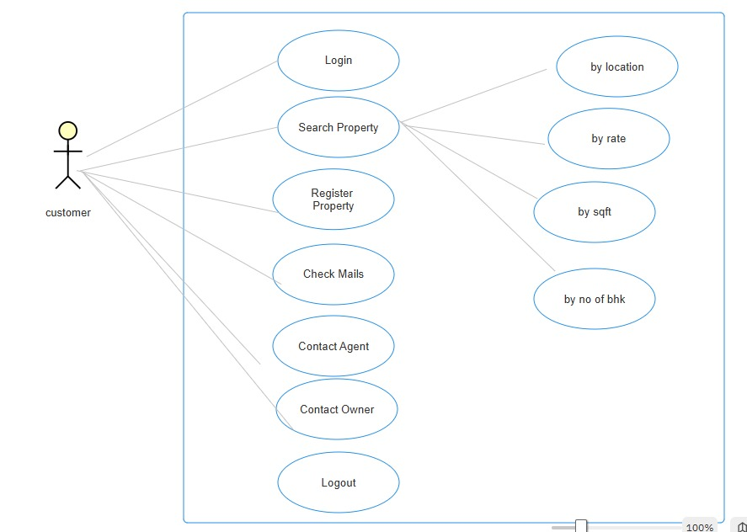

Fig. Use case diagram

1. **BLOCK DIAGRAM**

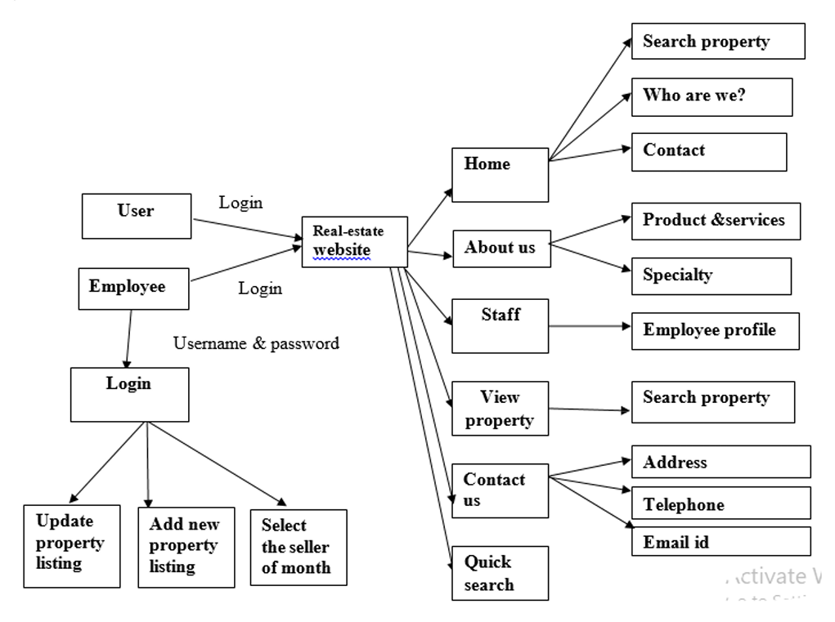

Fig. Block diagram

1. **FUTURE SCOPE**

Gainful engagement in real estate leads to success in marketing and sales in the age of digital presence. This entails utilizing social media, undertaking email marketing, and employing content creation to engage potential sellers and buying clients, while developing trust and the emotional appeal of storytelling and personalized experiences.

1. **LIMITATION**

Real estate marketing and sales can have its limitations. Some challenges may include fluctuations in the market as well as lead costs that can sometimes get really high. You also need to have a well-established process for your sale, and then there are always back-office challenges and managing staff or people who will lead technology efforts.

1. **RESULT DISCUSSION**

Discussions surrounding real estate marketing and sales generally focus on how to attract buyers and vendors but also evolving the business to the changing marketplace. Here are some highlights from the recent discussions:

1. Current Trends:
   1. The real estate marketplace is constantly changing; some of the most current trends include the growing demand for smart homes and buyers searching for properties online.
   2. The residential sales marketplace has picked up in recent years and the rental markets, as mentioned earlier will slow down.
2. Effective Marketing Ideas:
   1. Using digital tools (Seeking the help of other experts is always an option!) to promote your properties; virtual reality tours, drone videos, and professional photo shoots are some superb examples.
   2. Building a niche can improve your marketing strategy; is there a specific group you would like to work with or property type you would like to carry more inventory?
3. Engaging Content:
   1. You can share your marketing wins and failures for the purposes of education and inspiration to others in the industry.
   2. Maintaining a blog and social media presence can keep potential buyers, buyers, and vendors informed and engage in what's happening in the market and the marketplace.
4. Technology:
   1. Utilizing CRM software and/or analytics to study buyer behaviour will improve sales and efficiency in closing those sales.
   2. Using a 3D scanner or VR technology may be a good option, how buyers can effectively view a seller's property.
5. **CONCLUSION**

The Real Estate Web App discussed here is a commonly known type of web application built upon the Django framework including Postgres SQL. It is fundamentally built on typical client/server architecture employing the HTTP protocol. The application is developed in the Python programming environment in the VS Code editor. The buyer's purpose is to begin as a search for the property listings by the criteria of a Zip code or City or State in the search textbox. The business logic tier queries the database tier to get the expected results of the query. The results from the database are displayed on the data grid by refreshing just the data grid, not the web page. The app is more powerful because of this type of pixel web development on a higher-level framework. This application is fairly tested under many scenarios so that the application is intended to evaluate. Some suggestions on ways in which this system could be built out with enhancements to additional functionalities are discussed in the section.

1. **REFERENCES**

[1] Lan Ziyong. Analyzing Major Factors Influencing Marketing Strategies In The Real Estate, Chongqing, China: Chongqing University, 2006.

[2] Yang Pao. Researching The Innovations In Marketing Strategies Of Real Estate Enterprises, Nanchang: University, 2010.

[3] You-Cai Yang. Wl Jh Marketing Planning Proposal For Real Estate Projects, Changchun, China: Jilin University, 2013.

[4] Li-Xia Yan. The Application Of Experience Marketing In Real Estate Marketing. Journal Of Enterprise Economic, Pp.69-70, Nov. 2005.

[5] Guo-Jun Liu. A Company's Marketing Strategy Of Real Estate Project Research, Changsha, China: Hunan Normal University, 2014.

[6] Zhang Gengquan. Designing And Implementing Real Estate Marketing Planning Scheme Theory. Journal Of Commercial Economy, Vol. 10, Pp. 31-59,Oct. 2011.

[7] Chen Lei, Dejun Ma. New Introduction To Real Estate Marketing Strategy And Innovation. Journal Of Information Science And Technology, Vol. 20, Pp. 477-478,Oct, 2010.

[8] Various Real- Estate Websites like (www.zameen.com, www.makaan.com) .

[9] Book - Test-Driven Development with Django by Kevin Harv .

[10] Django Framework (<https://www.djangoproject.com/>)

[11] Search Engine - Google ([www.google.com](http://www.google.com))

[12](Scribd.com) [13](Udemy.com)

[14] ASP.NET and Web Development Overview, https://learn.microsoft.com/en-us/previous versions/4w3ex9c2(v=vs.140)?redirectedfrom=MSDN .

[15] Microsoft SQL Server 2005, https://en.wikipedia.org/wiki/Microsoft_SQL_Server .