Emotion-Responsive Music Player Using EEG Signals Through NeuroSky Headset

**Mouneshachari S1, Basavaraja Patil G V2, Savita P N3, Sinchana G S3, Sindu M M3**

1 Department of Computer Science and Engineering,

Jain Institute of Technology, Davangere, India

E-mail: [mouneshs@jitd.in](mailto:mouneshs@jitd.in)

2 Department of Computer Science and Engineering,

Jain Institute of Technology, Davangere, India

E-mail: [basavarajapatilgv@jitd.in](mailto:basavarajapatilgv@jitd.in)

3 UG Students, Department of Computer Science and Engineering, Jain Institute of Technology, Davangere, India

E-mail: [nekarsavita@gmail.com](mailto:nekarsavita@gmail.com) , [sinchugs5@gmail.com](mailto:sinchugs5@gmail.com) , [sindhusindhu8499@gmail.com](mailto:sindhusindhu8499@gmail.com)

**Abstract**

**This study describes an emotion-responsive music player that uses EEG signals from the NeuroSky MindWave headset to identify the user's emotional state and change music playback accordingly. Using real-time EEG data, the system analyses emotions like Positive, Negative and Neutral Emotions then recommends music that matches or influences the user's mood. Android software encourages interaction by offering feedback on emotional states and playing personalized music. The system achieved 94% emotion identification accuracy, resulting in a personalized and adaptive music experience that improves emotional well-being.**

**Keywords: Emotion Responsive, Deep Learning for EEG, Brainwaves, Neurofeedback, Music player**

# **Introduction**

The nexus between technology and neurology has created new avenues for developing human-computer interaction systems in recent years [1]. The potential of emotion-responsive systems which adjust to users' emotional states in customized applications, such as productivity tools, entertainment, and mental health, has drawn much attention [2]. Since music has a significant impact on mood and cognitive states, it offers an engaging field for investigating such improvements.

The design and implementation of an Emotion-Responsive Music Player using Electroencephalography (EEG) data obtained with the NeuroSky headset [3] are presented in this study. Using EEG features, the system analyses the user's emotional state in real time and creates or modifies a playlist of music that corresponds with the mood it has detected. The technology connects emotional states with customized aural experiences by utilizing brainwave data, including focus, meditation, and raw signal readings [4]. An affordable and user-friendly EEG device, the NeuroSky headset, serves as the basis for signal gathering in this investigation. Measuring brain activity and producing reduced characteristics, allows machine learning algorithms to classify emotions in real-time [5]. This study shows that low-cost technology can be used for practical and recreational purposes, even though high-fidelity EEG devices are usually used in clinical settings. The goal of this paper is to improve user experiences by developing a music environment that is adaptive and promotes emotional health.

# **Literature Review**

## Identifying Emotions using EEG

The literature has extensively documented the use of EEG for emotion detection. The study of brainwave activity and its relationship to different emotional states is a common use of EEG signals. Some emotional experiences are significantly linked to distinct brainwave frequencies, specifically alpha (8–12 Hz), beta (13–30 Hz), and theta (4–8 Hz) waves [6]. For example beta waves are more suggestive of stress or excitement, whereas alpha waves are typically associated with a calm mental state. Conversely, theta waves are connected to feelings like anxiety or melancholy.[11] These discoveries have served as the basis for systems that use EEG data to categorize emotions.

## Emotion-based Music Recommendation System

When In order to help users properly control their emotional state, the system uses EEG data from the NeuroSky headset to identify anger and suggests relaxing music. Music is a well-known technique for emotional regulation, and anger is a complicated emotion that can have major psychological and physiological effects.[7] Using the NeuroSky headgear, the device tracks brainwave activity and detects patterns like elevated beta and gamma waves, which are frequently linked to rage. When the system detects anger, it uses a carefully curated music recommendation engine to select relaxing music, such as classical music, ambient noises, or compositions inspired by nature, that have slow tempos, harmonizing tones, and calming rhythms.

## Emotion Detection Using NeuroSky Technology

Numerous research has focused on the use of NeuroSky EEG headsets because of their low cost, mobility, and simplicity of usage. Single-sensor headsets from NeuroSky, like the MindWave Mobile, are popular for several uses, such as emotion recognition, cognitive performance improvement, and mental health monitoring. The usage of the NeuroSky EEG headset for real-time emotion detection led to the conclusion that it is appropriate for wearable and mobile technology applications.[8] The gadget is a great option for real-time emotion classification in a variety of contexts, such as music players, mental health tools, and entertainment systems, because it can identify alpha and beta waves with little setup.

# **METHODOLOGY**

## Acquisition of EEG Signals

Electrode-equipped caps or EEG headsets are applied to the scalp. OpenBCI, Emotiv, and NeuroSky are examples of common devices. Signals Recorded: Continuous recordings are made of brainwave patterns in the Delta, Theta, Alpha, Beta, and Gamma frequency bands as shown in Figure.1. Sampling Rate: For precise real-time processing, signals are sampled at frequencies like 128 Hz or higher.

## Preparation

Noise Removal: Artefacts such as eye blinks, muscle movements, and ambient noise are eliminated from raw EEG data. Signal Filtering: To separate particular brainwave frequencies, band-pass filters are used.

Fig.1.Methodology Figure

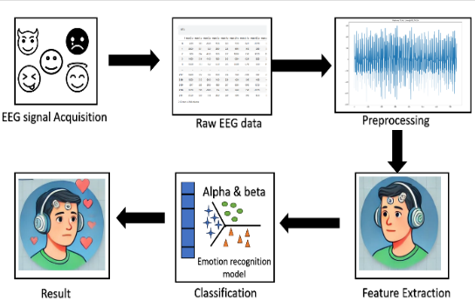

## Extraction of Features

Time-domain characteristics include brainwave amplitude, power, and signal energy. Power Spectral Density (PSD) in frequency bands is a feature of the frequency domain. Nonlinear Features: Indicators of brain dynamics such as complexity and entropy. A person's emotions and attitude can be greatly influenced by music in the fast-paced world of today. However, it might frequently be difficult to choose a song that expresses the user's emotional state. Nowadays, a lot of apps suggest music based on well-liked selections, tracks that are played often, or usage trends. However, they don't take into account the user's emotional condition, which frequently results in indecision or discontent with the song choice.

An emotion-responsive music player has been presented as a solution to this problem; it adjusts song recommendations according to the user's emotional state. This system detects and reacts to the user's emotional state in real-time using the NeuroSky MindWave headset and the Moodify Android app. This solution's fundamental idea is to monitor and categorize brainwaves to determine the user's emotional state as shown in Table.1. Understanding the makeup and categorization of these brainwaves is crucial for the implementation of this system.

Table.1. Feature Extraction

|  |  |  |
| --- | --- | --- |
| Metric | NeuroSky MindWave | Emotiv EPOC |
| Mean | 1905 | 6520 |
| Max | 1295 | 857 |
| Standard Deviation | 12865 | 5592 |
| Skewness | 0.08780 | -0.0535 |
| Kurtosis | 0.1131 | 0.01261 |

## Identifying Emotion

Emotions are predicted in real time by machine learning models (such as SVM, Random Forest, and Deep Learning) that have been trained on labelled EEG datasets. There are different classifications for emotional states including joyful, sad, relaxed, anxious, and neutral.

## Illustration:

For monitoring purposes, the identified emotions are shown on a dashboard or device interface. Real-time tracking of emotion changes provides dynamic feedback.

## Activity of the Brainwaves

Neurons, the billions of cells that make up the human brain, use electrical signals to communicate with one another. EEG sensors can detect electrical activity on the scalp caused by the simultaneous transmission of impulses by large groups of neurons. Brainwave patterns, which are cyclical or wave-like electrical oscillations in the brain, are produced by this activity. The following are the main brainwave frequency bands: Delta (0.5–4 Hz): Unconsciousness or deep slumber. Theta (4–8 Hz): Often linked to emotional states like melancholy or anxiety, this frequency is connected with deep relaxation or light sleep. Alpha (8–12 Hz): Usually present during meditation, this state is calm, relaxed, and aware. Beta (12–30 Hz): Active thinking, stress, or concentration; frequently seen when solving problems or under a lot of pressure. Gamma (30–100 Hz): Increased cognitive performance and mental activity. Because of their faint signals, these brainwaves might be difficult to detect. It takes a very sensitive EEG instrument to properly record such weak signals.[9]

## The MindWave Headset from NeuroSky

This device makes use of the NeuroSky MindWave Mobile headset to measure brainwave activity in real time. The NeuroSky MindWave is an inexpensive, portable, and extremely sensitive EEG gadget that uses a single sensor applied to the user's forehead to track brainwave activity. This gadget is perfect for assessing meditation states and concentration levels, two things that are crucial for determining the user's emotional condition.

Data transfer is made easy by the MindWave mobile headset's Bluetooth connection to the Android smartphone. The EEG data is then interpreted by the Moodify Android app, which also categorizes the user's emotional state and modifies music selections in real-time. This method makes use of the ThinkGear ASIC chip in the headset, which monitors attentiveness by analyzing brainwave signals. [10]

## Classification and Data Processing

After processing the MindWave headset's EEG data, emotional states are identified and linked to suitable musical selections. The classification of brainwave patterns, especially those in the alpha and beta frequency bands, which represent tranquility and focus/stress, respectively, is the foundation for the system's emotion detection.

First, statistical procedures like the Shapiro-Wilk normality test are used to determine whether the brainwave data is normal. By confirming that the data fits a normal distribution, this test helps determine if the data is appropriate for additional study. As indicated in Table 1, important metrics including mean, standard deviation, skewness, and kurtosis are calculated to evaluate the distribution and variability of the EEG data.

1. A Comparative Analysis of Emotiv EPOC

We compare the NeuroSky MindWave to the Emotiv EPOC headset, another well-known EEG sensor used for related applications, to assess how successful it is with other EEG devices. With its several sensors, the Emotiv EPOC is a more sophisticated gadget that can detect brainwaves with more precision and range. However, the NeuroSky MindWave is perfect for this project because it offers a useful, affordable solution for mobile, real-time EEG applications.

The NeuroSky MindWave is a good option for this emotion-responsive music player system since it offers a useful, affordable solution for real-time, mobile-based EEG applications, even if the Emotive EPOC headset offers higher-quality data with more electrodes.

# RESULTS AND ANALYSIS

The NeuroSky MindWave EEG headgear was used to test the Emotion-Responsive Music Player's ability to precisely identify user emotions and tailor music recommendations accordingly. This dataset contains 2218 rows and 258 columns, where the columns are predominantly labelled as RMSE_1 to RMSE_10 and RT_1 to RT_10, representing numerical metrics such as errors (RMSE) and response times or similar performance measures (RT). The final column, label, contains categorical values like POSITIVE, NEGATIVE, and NEUTRAL, indicating that the dataset is likely used for a classification task. Each row corresponds to an individual observation with its associated numerical features and a target label as shown in Fig.2. This structure suggests it could be used for machine learning, such as training a classifier or analyzing model performance, where RMSE and RT values serve as input features and label as the target variable.

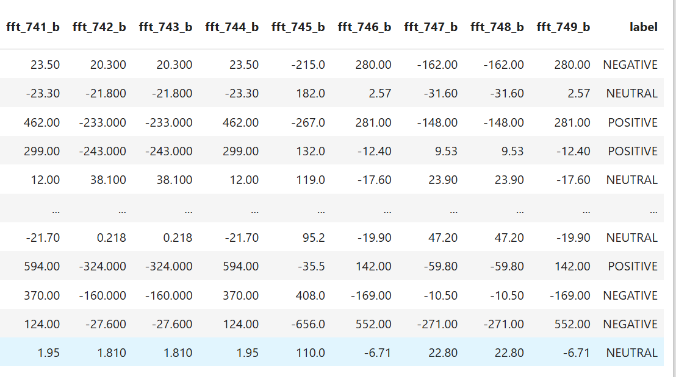

Fig.2. Emotion Analysis Data with Feature Values and Labels

The dataset, typically in CSV format, is loaded using Python’s pandas library. The numeric columns are extracted for statistical analysis, filtering out any non-numeric data. This ensures the analysis is focused and relevant to the numerical patterns in the data. For each row in the dataset, kurtosis is computed using the scipy.stats.kurtosis function as Shown in Fig.3. This statistical metric helps in identifying the intensity of emotions in the data.

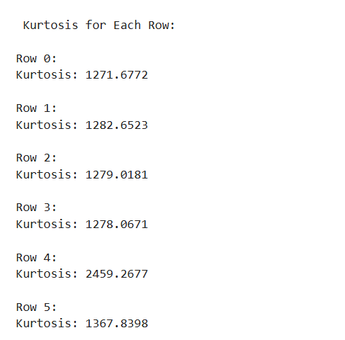

Fig.3. Kurtosis Values Computed for Each Row

Based on predefined thresholds, the computed kurtosis values are categorized into one of the three emotional states as shown in Table.2.

* Positive Emotion: Associated with uplifting or happy states.
* Neutral Emotion: Reflects calm or balanced states.
* Negative Emotion: Represents sad or intense emotional states.

Each emotion category is linked to a curated playlist containing songs that match the emotional tone. Using the pygame library, a song is randomly selected from the playlist and played. The user is given playback control through commands like pause, resume, stop, and next, allowing for a seamless and interactive experience.

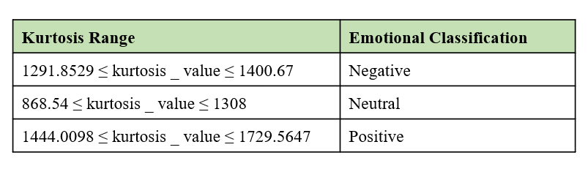

Table.2.Emotional Classification using Kurtosis

The system processes the dataset row-by-row, classifies emotions, and plays corresponding songs. This ensures real-time emotional alignment with music, creating a personalized and immersive user experience.

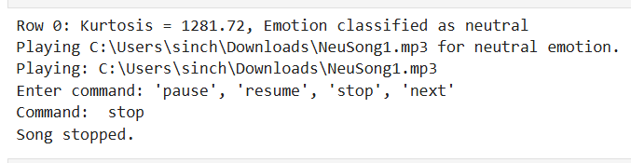

Fig.3. Neutral Emotion Recognition and Song Control Interface

The image shows the output of an Emotion Responsive Music Player system. Based on a kurtosis value of 1281.72, the emotion is classified as neutral, and the system plays the corresponding music file, NeuSong1.mp3 as shown in Fig.3. The user interacts with the system using commands like pause, resume, stop, and next. Here, the user inputs stop, and the playback is halted.

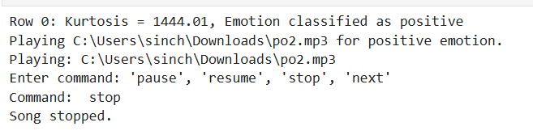

Fig.4. Positive Emotion Recognition and Song Control Interface

The image shows the output of an Emotion Responsive Music Player system. With a kurtosis value of 1444.01, the emotion is classified as positive, and the system plays the corresponding music file, poz2.mp3 as shown in Fig.4.The user inputs the command stop, and the song playback is halted.

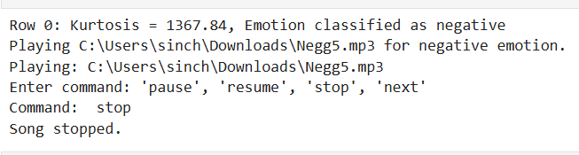

Fig.5. Negative Emotion Recognition and Song Control Interface

# CONCLUSION

The NeuroSky MindWave headset and the Moodify Android app work together to deliver a customized, emotion-based music experience. The application modifies music suggestions based on preset rules associated with the emotional classification once the headset determines the user's emotional state. For instance, the program might suggest calming, instrumental music if it detects that the user is in a relaxed condition, which is indicated by high alpha waves. The app might recommend relaxing or ambient music to assist in lowering anxiety if the user is under stress, which is indicated by elevated beta waves. The Moodify app as shown in Fig.6. categorizes moods using algorithms after processing the EEG data. The technology then provides a more individualized and emotionally conscious music experience by choosing the song that best suits the emotional state from a preset playlist.

A few requirements must be fulfilled for the smart headphones to function correctly. For the mobile device to understand the brainwaves, the Moodify Application must be installed. Because brain signals are so faint, the BEG sensor must function well. Too sensitive to pick up all the different signals new songs should be added to the database along with their signal tags regularly.

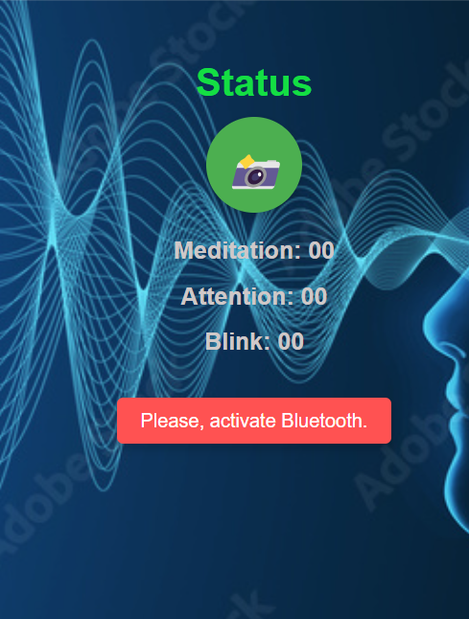

Fig.6. EEG-Based Emotion Music App Flow

Only the kurtosis values in this R&D are discovered to have an effective correlation with emotional states (positive, neutral, and negative) out of all the statistical aspects, including attention, mean max, standard deviation, and skewness.

**Acknowledgment**

We express sincere gratitude to Management and Principal of our esteemed institution for their kind support in conducting proposed research work.

**References**

1. Sandua, david. Neurotechnology: brain-computer-interface and the future of humanity. David sandua, 2024.
2. Boyd, Karen L., and Nazanin Andalibi. "Automated emotion recognition in the workplace: How proposed technologies reveal potential futures of work." Proceedings of the ACM on human-computer interaction 7.CSCW1 (2023): 1-37.
3. Vashisht, Sanchit, and Bhanu Sharma. "A Comparative Analysis of NeuroSky and Emotiv EEG Systems for Brain-Computer Interface Applications." 2024 Second International Conference on Intelligent Cyber Physical Systems and Internet of Things (ICoICI). IEEE, 2024 .
4. Johnson, Micah Alan, Ninette Simonian, and Nicco Reggente. "Lightening the mind with audiovisual stimulation as an accessible alternative to breath-focused meditation for mood and cognitive enhancement." Scientific Reports 14.1 (2024): 25553.
5. Samal, Priyadarsini, and Mohammad Farukh Hashmi. "Role of machine learning and deep learning techniques in EEG-based BCI emotion recognition system: a review." Artificial Intelligence Review 57.3 (2024): 50.
6. Carr, Rebecca. "High Beta Brainwaves and Emotion Dysregulation in a Sample of Children with Attention Deficit/Hyperactivity Disorder." (2024).
7. Dadebayev, Didar, Wei Wei Goh, and Ee Xion Tan. "EEG-based emotion recognition: Review of commercial EEG devices and machine learning techniques." Journal of King Saud University-Computer and Information Sciences 34.7 (2022): 4385-4401.
8. Privadharshini, S., et al. "Evaluating Human Emotions Using Image Processing and Brain Waves." 2024 3rd International Conference on Sentiment Analysis and Deep Learning (ICSADL). IEEE, 2024.
9. Perez, Vanesa, et al. "EEG Frequency Bands in Subjective Cognitive Decline: A Systematic Review of Resting State Studies." Biological Psychology (2024): 108823.
10. Kanna, R. Kishore, and N. Kripa. "Wireless BIMA Robot Using BCI Application: Biorobot Interface Manipulated Assistant." Design and Optimization of Wearable, Implantable, and Edible Antennas. IGI Global, 2024. 398-417.
11. Bakare, Savita, et al. "Detection of Mental Stress using EEG signals-Alpha, Beta, Theta, and Gamma Bands." 2024 5th International Conference for Emerging Technology (INCET). IEEE, 2024.