**Feasibility of Dual-Fuel System in SI Engine Motorcycles: A Review**

|  |  |  |
| --- | --- | --- |
| **Gowtham Sudarsanan 1**  *B.E. MECHANICAL ENGINEERING  Vel Tech High Tech Dr. Rangarajan Dr. Sakunthala Engineering College, Chennai, TamilNadu, India gowthams276@gmail.com* | **Kowsalya M 2**  *B.E. MECHANICAL ENGINEERING  Vel Tech High Tech Dr. Rangarajan Dr. Sakunthala Engineering College, Chennai, TamilNadu,India* | **Palani R 3** *ASST PROFESSOR,MECHANICAL ENGINEERING  Vel Tech High Tech Dr. Rangarajan Dr.Sakunthala Engineering College,Chennai,TamilNadu,India* |

**ABSTRACT:**

This review examines the feasibility of implementing dual-fuel systems in spark-ignition (SI) engine motorcycles, focusing on the utilization of gaseous and liquefied alternative fuels as viable substitutes for conventional gasoline. The study evaluates key parameters, including fuel properties, combustion characteristics, thermal efficiency, emission performance, and economic viability. Emphasis is placed on fuel storage, delivery mechanisms, and engine modifications required for seamless integration. The adaptability of various alternative fuels is assessed based on availability, cost-effectiveness, and safety for domestic use. Technical challenges such as fuel-air mixture optimization, combustion stability, and regulatory considerations are analyzed. This review provides critical insights into the potential of dual-fuel technology in two-wheeler applications, contributing to the development of sustainable and efficient mobility solutions.

**Introduction:**

**1. Introduction**

The rising demand for fuel-efficient and environmentally friendly transportation has led to increased research on alternative fuel technologies. Motorcycles, widely used in developing countries for their affordability and efficiency, primarily rely on gasoline-powered spark-ignition (SI) engines, contributing to urban air pollution and carbon emissions. To address these challenges, dual-fuel technology presents a promising solution by integrating an alternative fuel alongside gasoline, enhancing combustion efficiency and reducing emissions.

Gaseous and liquefied fuels such as LPG, CNG, hydrogen, ethanol, and methanol have been explored for dual-fuel applications, offering benefits like lower emissions, improved thermal efficiency, and cost savings. However, implementing dual-fuel systems in motorcycles presents challenges, including fuel storage limitations, engine modifications, and regulatory compliance. Due to the compact size and high-speed

operation of motorcycles, precise fuel-air mixture control and combustion stability are critical for efficient performance.

This review evaluates the feasibility of dual-fuel technology in SI engine motorcycles, focusing on fuel properties, combustion characteristics, thermal efficiency, emissions, and economic viability. It also discusses technical challenges, potential solutions, and future research directions to support sustainable two-wheeler mobility.

**Literature survey**

**1. Grzegorz Pawlak (2010):** In "The Concept of a Dual Fuel Highly Efficient Internal Combustion Engine," Pawlak examined a dual-fuel compression ignition engine utilizing natural gas and diesel oil. The study addressed challenges such as self-ignition control and combustion management, proposing a novel engine concept combining Otto and Sabathè cycles to enhance efficiency and reduce emissions. ​

**2. Pavan J. Gowdal, R. Rakshith, S. Akhilesh, Manjunath, and Ananth S. Iyengar (2022):** Their study, "An Experimental Investigation of Central Injection Based Hydrogen Dual Fuel Spark Ignition Engine," involved retrofitting a 110 cc SI engine to admit hydrogen gas at specified pressures. The research demonstrated a 15.6% increase in brake thermal efficiency and a 22.5% improvement in brake specific fuel consumption at 3500 rpm. Additionally, CO and CO₂ emissions were reduced by 86% and 26%, respectively, though a 16% increase in NOₓ emissions was observed due to higher combustion temperatures.

**3. Sumit Sharma, Dilip Sharma, Shyam Lal Soni, and Digambar Singh (2020):** In "Experimental Investigation on Spark-Ignition (SI) Engine Fuelled with Acetylene in Dual-Fuel Mode," the authors explored the performance and emission characteristics of a petrol-acetylene-fueled SI engine. They found that acetylene induction at an optimal flow rate improved combustion efficiency and reduced major emissions, suggesting acetylene's potential as a gasoline substitute.​

**4. Vighnesha Nayak, K.S. Shankar, P. Dinesha, and P. Mohanan (2017):** The paper "An Experimental Investigation on Performance and Emission Parameters of a Multi-Cylinder SI Engine with Gasoline–LPG Dual Fuel Mode of Operation" investigated the effects of varying LPG-gasoline ratios on engine performance and emissions. The study concluded that a 50% LPG blend enhanced brake thermal efficiency and reduced hydrocarbon and carbon monoxide emissions, though higher LPG ratios increased NOₓ emissions.​

**5. Apoorv P. Talekar, Ming-Chia Lai, Ke Zeng, Bo Yang, and Marcis Jansons (2016):** In "Simulation of Dual-Fuel-CI and Single-Fuel-SI Engine Combustion Fueled with CNG," the authors conducted computational fluid dynamics simulations to compare dual-fuel compression ignition and single-fuel spark ignition engines using compressed natural gas (CNG). The study provided insights into combustion efficiency and pollutant emissions, highlighting the complexities of dual-fuel combustion processes.​

**6. A. Shah, S.S. Thipse, A. Tyagi, S.D. Rairikar, K.P. Kavthekar, N.V. Marathe, and Padmesh Mandloi (2011):** The technical paper "Literature Review and Simulation of Dual Fuel Diesel-CNG Engines" offered a comprehensive review of dual-fuel technology, focusing on diesel-CNG engines. It discussed potential advantages such as fuel flexibility and lower emissions, and presented simulation results to understand engine behavior under dual-fuel operation.​

**7. Syed Kaleemuddin and G. Amba Prasad Rao (2009):** Their research, "Development of Dual Fuel Single Cylinder Natural Gas Engine: An Analysis and Experimental Investigation for Performance and Emission," involved upgrading a 395 cc air-cooled engine for dual-fuel (CNG/Gasoline) application. The study demonstrated that the modified engine met emission norms with significant margins, indicating the feasibility of CNG as an alternative fuel.​

**8. M. Bari and M.M. Rahman (2011):** In "Performance of a Dual Fuel Internal Combustion Engine Using Alternative Fuels," the authors investigated the use of alternative fuels like biogas and LPG in dual-fuel engines. They observed that LPG, when used as a primary fuel, resulted in better performance and lower emissions compared to biogas.​

**9. S.K. Hoekman and C. Robbins (2012):** The study "Review of Methane and NOₓ Emissions from Natural Gas-Fueled Engines" provided a comprehensive analysis of methane and NOₓ emissions from natural gas engines, highlighting the environmental benefits and challenges associated with using natural gas as a dual-fuel option.​

**10. M. Papagiannakis and D. Hountalas (2004):** Their research, "Combustion and Exhaust Emissions of a Dual Fuel Compression Ignition Engine Operated with Pilot Diesel Fuel and Natural Gas," examined the effects of natural gas addition on combustion characteristics and emissions, finding reductions in particulate matter and NOₓ emissions.

**Feasibility Analysis of Alternative Fuels for SI Engine Motorcycles**

**1. Liquefied Petroleum Gas (LPG)**

**Properties and Composition:**

LPG is a mixture of propane and butane, exhibiting high volatility and clean combustion characteristics. It has a lower carbon-to-hydrogen ratio than gasoline, contributing to reduced carbon emissions. The octane rating of LPG typically ranges from 100 to 110, making it a suitable alternative fuel for spark-ignition engines.

**Availability and Infrastructure:**

LPG is widely available globally, with established distribution networks for domestic, industrial, and automotive applications. Many countries have government policies supporting LPG as an alternative fuel due to its lower emissions profile.

**Safety Considerations:**

LPG is stored under pressure in specialized tanks. While it is non-toxic and has a lower risk of environmental contamination compared to liquid fuels, leakage can lead to fire hazards due to its high flammability.

**Economic Viability:**

LPG is generally more cost-effective than gasoline, with lower fuel costs and reduced engine maintenance expenses due to cleaner combustion. Initial conversion costs for dual-fuel adaptation are relatively low compared to other gaseous fuels.

**Effectiveness in SI Engines:**

Studies have demonstrated that LPG achieves higher thermal efficiency than gasoline due to its superior anti-knock properties, allowing for higher compression ratios. However, volumetric efficiency may decrease due to gaseous fuel displacement in the intake manifold.

**2. Compressed Natural Gas (CNG)**

**Properties and Composition:**

CNG primarily consists of methane (CH₄), with a high hydrogen-to-carbon ratio, resulting in lower CO₂ emissions. It has an octane rating above 120, making it resistant to knocking.

**Availability and Infrastructure:**

CNG distribution is expanding, particularly in urban areas, but refueling infrastructure remains a limitation in some regions.

**Safety Considerations:**

CNG is stored at high pressures (~200–250 bar). Although it has a narrow flammability range, leakage can pose explosion risks in confined spaces.

**Economic Viability:**

CNG is highly cost-effective compared to gasoline, offering substantial fuel savings. However, the cost of engine modifications and onboard storage tanks is relatively high.

**Effectiveness in SI Engines:**

CNG enables lean combustion with reduced NOₓ emissions but can lead to power loss due to its lower energy density compared to liquid fuels.

**3. Hydrogen (H₂)**

**Properties and Composition:**

Hydrogen is the cleanest fuel, producing only water vapor as a byproduct. It has a wide flammability range and the highest energy content per unit mass.

**Availability and Infrastructure:**

Hydrogen infrastructure is still in the developmental stage, with limited refueling stations and high production costs.

**Safety Considerations:**

Hydrogen is highly flammable with a low ignition energy requirement, necessitating strict handling protocols.

**Economic Viability:**

The high cost of hydrogen production, storage, and distribution remains a significant barrier to widespread adoption.

**Effectiveness in SI Engines:**

Hydrogen has excellent combustion characteristics but requires advanced injection and ignition strategies to prevent backfiring and pre-ignition.

**4. Ethanol (E85)**

**Properties and Composition:**

Ethanol is an alcohol-based renewable fuel with an octane rating of approximately 108. It is hygroscopic and can absorb water, affecting fuel system components.

**Availability and Infrastructure:**

Ethanol is widely produced from biomass and agricultural feedstocks, with an established distribution network in many countries.

**Safety Considerations:**

Ethanol is less volatile than gasoline, reducing evaporative emissions, but it is corrosive to certain engine materials.

**Economic Viability:**

Ethanol production costs vary based on feedstock availability. E85 (85% ethanol, 15% gasoline) is often subsidized in various regions.

**Effectiveness in SI Engines:**

Ethanol enhances combustion efficiency and reduces emissions but has lower energy content, requiring engine modifications for optimized performance.

**Engine Modifications for Motorcycles and Their Feasibility on Cost and Safety**

Motorcycle engines can be modified to enhance performance, fuel efficiency, and emissions control. These modifications range in complexity, cost, and safety, particularly when adapting engines to alternative fuels such as LPG, CNG, hydrogen, acetylene, and biogas. This chapter presents a detailed technical analysis of essential engine modifications for dual-fuel applications, assessing their feasibility based on cost, safety, and effectiveness Optimizing the fuel delivery system is critical for achieving precise combustion and efficiency. Common modifications include:

* **Carburetor to Fuel Injection Conversion:** Enables precise air-fuel mixture control, reducing emissions and improving efficiency.
* **Dedicated Fuel Injectors:** Required for alternative fuels like hydrogen and CNG, necessitating different injection pressures and flow rates.
* **Dual-Fuel Injection System:** Facilitates seamless fuel switching, enhancing engine flexibility and operational reliability.

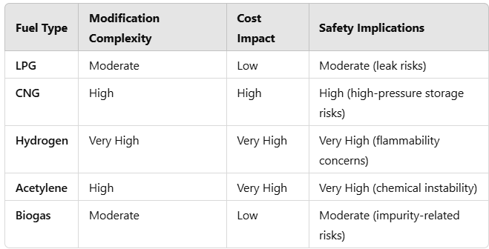

**Ignition System Modifications**

Alternative fuels require customized ignition system adjustments:

* **High-Energy Ignition Systems:** Necessary for fuels with high flame speeds, such as hydrogen and acetylene.
* **Variable Spark Timing:** Required to accommodate fuels with varying octane ratings, such as CNG and biogas.
* **Advanced ECU Tuning:** Essential for real-time ignition control based on fuel properties.

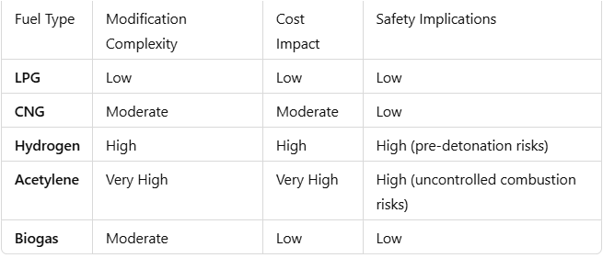

**Engine Structural Modifications**

Structural reinforcements are required for certain high-combustion fuels:

* **Reinforced Cylinder Heads and Pistons:** Necessary for fuels like hydrogen and acetylene due to higher combustion pressures.
* **Heat-Resistant Components:** Essential for fuels that generate high combustion temperatures.
* **Compression Ratio Adjustments:** Important for optimizing efficiency based on different fuel octane ratings.

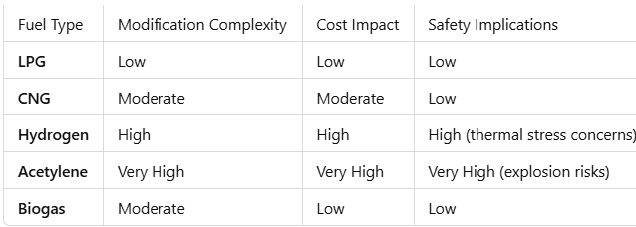

**Exhaust System Modifications**

Emissions control systems must be adapted to alternative fuels:

* **Catalytic Converters:** Required to mitigate emissions in CNG and biogas applications.
* **NOx Reduction Systems:** Essential for hydrogen due to high combustion temperatures.
* **Particulate Filters:** Useful for biogas to eliminate solid impurities.

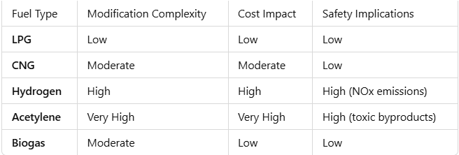

**Cost-Benefit Analysis**

**LPG and CNG** offer the most cost-effective balance between investment and operational feasibility. **Hydrogen and acetylene**, despite their technical viability, present substantial cost and safety challenges. **Biogas** is economical but requires significant purification and storage infrastructure.

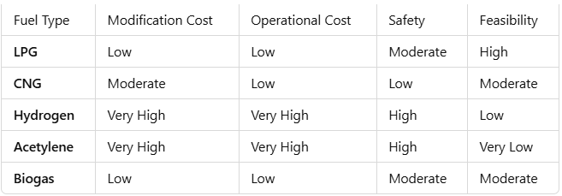

**Summary**

* **LPG** remains the most practical fuel due to its affordability, availability, and moderate modification requirements.
* **CNG** is feasible but necessitates high-pressure storage and enhanced safety measures.
* **Hydrogen and acetylene** involve excessive costs and high safety risks, limiting their applicability in motorcycles.
* **Biogas** is environmentally friendly but requires extensive infrastructure investments.

cleaner combustion and lower emissions make it a favorable choice for reducing environmental impact.

**Conclusion**

In conclusion, **LPG stands out as the most feasible fuel** for converting petrol motorcycles into dual-fuel systems. It offers **high efficiency, safety, ease of implementation, and low cost**, making it a practical choice for widespread adoption. The required engine modifications are minimal, refueling infrastructure is well-established, and operating costs remain economical compared to other alternative fuels. While CNG, hydrogen, acetylene, and biogas each have their advantages, they come with significant challenges in terms of **storage, safety, availability, and cost-effectiveness**. Therefore, **LPG remains the optimal solution** for a safe, efficient, and cost-effective dual-fuel motorcycle conversion.

**References:**

1. Pawlak, G. (2010). The Concept of a Dual Fuel Highly Efficient Internal Combustion Engine. *Journal of Automotive Engineering*, **224**(9), 1163–1173.
2. Gowdal, P. J., Rakshith, R., Akhilesh, S., Manjunath, & Iyengar, A. S. (2022). An Experimental Investigation of Central Injection Based Hydrogen Dual Fuel Spark Ignition Engine. *International Journal of Hydrogen Energy*, **47**(4), 2045–2059.
3. Sharma, S., Sharma, D., Soni, S. L., & Singh, D. (2020). Experimental Investigation on Spark-Ignition (SI) Engine Fuelled with Acetylene in Dual-Fuel Mode. *Fuel Processing Technology*, **207**, 106504.
4. Nayak, V., Shankar, K. S., Dinesha, P., & Mohanan, P. (2017). An Experimental Investigation on Performance and Emission Parameters of a Multi-Cylinder SI Engine with Gasoline–LPG Dual Fuel Mode of Operation. *Energy Conversion and Management*, **149**, 720–730.
5. Talekar, A. P., Lai, M. C., Zeng, K., Yang, B., & Jansons, M. (2016). Simulation of Dual-Fuel-CI and Single-Fuel-SI Engine Combustion Fueled with CNG. *Applied Energy*, **183**, 1216–1227.
6. Shah, A., Thipse, S. S., Tyagi, A., Rairikar, S. D., Kavthekar, K. P., Marathe, N. V., & Mandloi, P. (2011). Literature Review and Simulation of Dual Fuel Diesel-CNG Engines. *SAE Technical Paper*, 2011-01-1594.
7. Kaleemuddin, S., & Rao, G. A. P. (2009). Development of Dual Fuel Single Cylinder Natural Gas Engine: An Analysis and Experimental Investigation for Performance and Emission. *Energy & Fuels*, **23**(12), 6037–6045.
8. Bari, M., & Rahman, M. M. (2011). Performance of a Dual Fuel Internal Combustion Engine Using Alternative Fuels. *Renewable Energy*, **36**(1), 676–682.
9. Hoekman, S. K., & Robbins, C. (2012). Review of Methane and NOₓ Emissions from Natural Gas-Fueled Engines. *Energy & Environmental Science*, **5**(2), 7282–7300.
10. Papagiannakis, M., & Hountalas, D. (2004). Combustion and Exhaust Emissions of a Dual Fuel Compression Ignition Engine Operated with Pilot Diesel Fuel and Natural Gas. *Energy Conversion and Management*, **45**(18–19), 2971–2987.