IoT Based Smart Exhaust Fan

## SKN SINHGAD COLLEGE OF ENGINEERING, KORTI, PANDHARPUR-413304

**ELECTRONICS & TELECOMMUNICATION ENGINEERING**

### Project Group Member

**Ms. Salunkhe Snehal Pattyabapu, Ms.Sawant Pratiksha Dadaso, Ms.Devmare Vaishali Vijay**

### Under Guidence of Prof. Mali. A. S.

**Abstract :** This project presents an IoT-based smart exhaust fan system utilizing the ESP32 microcontroller for real-time monitoring and control. The system integrates, humidity, and air quality sensors to optimize exhaust fan performance, reducing energy consumption and improving indoor air quality. Wi-Fi connectivity enables remote monitoring and control through a mobile application. Automated control algorithms adjust fan speed based on sensor data and user preferences, ensuring optimal performance. The system also monitors energy consumption, providing insights for further optimization. This project demonstrates a cost-effective, user- friendly, and energy-efficient solution for smart home and industrial applications**,** contributing to a healthier and more sustainable environment.



**Key Words:** ESP32, Sensors, Blynk IOT

## INTRODUCTION

These days, exhaust fans are found in the majority of homes, offices, schools, workplaces, and enterprises. For some people, it has become a standard tool or equipment. An exhaust fan was designed to regulate the temperature, drain moisture, and get rid of smells in a room. When a space gets too hot, an exhaust fan can swiftly cool it down. People's bodies will begin to exhibit symptoms like nausea and cramping in the muscles if an area becomes overheated. These are early indicators of heat stress or weariness. A body begins to shut down if the temperature rises above 40°C, and critical organs like the kidneys and brain may sustain damage.

The world is gradually transitioning to an automated system, which is what inspired this project. Despite significant technological advancements, the exhaust fan is still not intelligent enough. When it comes to "traditional" exhaust fans, there are numerous issues, particularly with how they operate. The user's incapacity to specify the ideal temperature and air quality in a space is the true cause of this issue. It will be challenging for the user to sense temperature and air quality with their own body. wastage of money due to the device's inefficient operation and power use. Having a system or other gadget that can automatically control and monitor the exhaust fan is the only way to solve this issue. This research introduces an Internet of Things (IoT)- based smart exhaust fan that can operate autonomously based on ambient temperature and air quality. This gadget detects and activates the exhaust fan to force the gas or air outdoors using temperature and gas sensors. If installed in factories, enterprises, offices, schools, and homes, this Internet of Things- based smart exhaust fan will be quite beneficial.

## LITERATUERE REVIEW

To monitor and regulate environmental conditions,

V. Nagababu, M. Naga Yaswanth Pavan Kumar, Ch. Sai Pravallika, and N. Angel Sundari proposed an IoT-based smart exhaust fan [1]. Nowadays, exhaust fans are found in most houses, workplaces, schools, industries, and other structures. It has become a standard piece of equipment or tool for some people. An exhaust fan was created to remove moisture, control air temperature, and eliminate odors from a space.Heat may be quickly removed from an overheated area with an exhaust fan. An individual may suffer from symptoms like nausea and musclecramps when their body overheats.

These are early signs of heat stress or exhaustion. An individual may suffer from symptoms like nausea and muscle cramps when their body overheats. These are early signs of heat stress or exhaustion. A person's body starts to shut down and may suffer harm to important organs like the kidneys and brain if their body temperature climbs above 40°C [2].Without the use of an air conditioner, turning on the exhaust fan, for example, can assist in removing hot air from an overheated area by forcing it outside. Human life is impacted by air quality. Every day, an adult breathes in 15,000 liters of air. Concern over indoor air quality is growing because of its effects on general well-being, productivity, and health. Serious health concerns can arise from the buildup of pollutants such as smoke, carbon monoxide, and other toxic gases caused by inadequate ventilation (Fernández-Agüera et al., 2023). Conventional exhaust fans frequently require manual operation or operate continuously due to their lack of sophisticated automation. This results in ineffective energy use and uneven air quality control. Devices may now respond more quickly to real-time data thanks to the development of Internet of Things (IoT) technology, which has opened up new possibilities for smart home applications. To identify gas leaks and fire concerns, for example, Logeshwaran and Sheela (2022) created an Internet of Things-based kitchen monitoring system. Their technology demonstrated how well IoT can improve safety and deliver real-time alerts, highlighting the value of IoT-enabled air quality monitoring in homes.



The energy efficiency of IoT-based ventilation systems is also increasing. Research on IoT- enabled smart home automation devices shows that they can optimize energy use by operating according to particular environmental conditions. Shrestha et al. (2021) investigated how automated systems might enhance interior conditions and lower household energy consumption. This is especially important for air quality regulation systems, which can lower operating costs by reducing wasteful use.

When creating intelligent exhaust fans, it is crucial to include sensors that accurately track air quality. The MQ-2 gas sensor, for instance, identifies multiple gases including methane, propane, and smoke, providing excellent sensitivity and a quick response time (Fahim et al., 2021). This sensor is

commonly utilized in IoT applications for detecting gas leaks and maintaining safety. In a similar vein, the DHT11 humidity and temperature sensor delivers dependable information, essential for sustaining ideal environmental settings (Logeshwaran & Sheela, 2022). Blynk, an IoT platform designed for remote monitoring and control, is another essential element of this system. Using Blynk, individuals can retrieve live data and operate devices manually from their mobile phones. This platform has been successfully incorporated into IoT initiatives to offer ease and adaptability in controlling smart devices (Fahim et al., 2021). conclusion, the research highlights a significant transition towards IoT-driven automation in ventilation systems, underscoring the advantages of incorporating sensors, remote monitoring, and automated control mechanisms. This smart exhaust fan system, powered by IoT technology, corresponds with these innovations by delivering a complete solution to enhance indoor air quality, optimize energy efficiency, and facilitate control via the Blynk app.

**Problem Statement**

Indoor air quality is a critical factor affecting the health and well-being of individuals. Poor ventilation can lead to the accumulation of harmful gases, such as smoke, LPG, carbon monoxide, and other pollutants, causes serious health risks. Traditional exhaust fans often run continuously or are manually operated, leading to inefficient energy usage and inconsistent air quality management. There is a need for a smart, automated system that can monitor air quality in real-time and control ventilation based on detected gas levels to ensure a safe and healthy indoor environment while optimizing energy consumption.

### Objectives

To develop an intelligent, IoT-enabled exhaust fan system that autonomously monitors and controls indoor air quality using real-time data from temperature, humidity, and gas sensors. This system aims to optimize energy efficiency and ensure a safe, healthy indoor environment by providing automated fan operation and remote control through a mobile application.

### Scope for the Study



The goal of this project is to use the ESP32 microcontroller to design an Internet of Things- based smart exhaust fan system that will increase indoor air quality and energy efficiency. Based on real-time data, the system automatically regulates fan operations while keeping an eye on temperature, humidity, and gas levels. It offers a flexible solution for a range of indoor spaces by enabling remote monitoring and control using a mobile application. The project is to develop smart home technology and sustainable living practices by improving energy management, safety, and user convenience in residential, commercial, and industrial settings.

## PROPOSED ARCHITECTURE

* 1. **ESP32**

In this IoT-based smart exhaust fan project, the ESP32 acts as the central control unit, managing sensor inputs and executing the logic for activating the exhaust fan based on environmental conditions, thus enhancing indoor air quality and providing user-friendly control options. The ESP32 is a strong, affordable, and adaptable microcontroller created by Espressif Systems. It is commonly acknowledged for its built-in Wi-Fi and Bluetooth features, making it a perfect option for numerous IoT (Internet of Things) applications.

The ESP32 is an extensively integrated solution intended for various applications, ranging from wearable devices to industrial automation. It merges dual-core processing ability with integrated Wi-Fi and Bluetooth features, providing a versatile and economical platform for developers.

The ESP32 is an upgraded version of the ESP8266. It contains the essential elements of the ESP32, featuring a Dual-core 32-bit processor operating at speeds up to 240MHz. This dual-core architecture enhances multitasking capabilities and the management of more intricate applications. The inclusion of Bluetooth enhances the ESP32's versatility regarding connectivity choices.The ESP32 features SRAM, ROM, and generally between 4MB to 16MB of external flash. This notable rise in memory enables the management of more intricate programs and data. The peripheral interface capability provides increased adaptability for connecting to external components.

The ESP32 comes with improved security functions, including hardware designed to safeguard IoT devices against cyber threats.

The ESP32 is a robust and adaptable microcontroller, commonly utilized in Internet of Things (IoT) applications. Below are the main characteristics of the ESP32 microcontroller.

1. Dual-core CPU: The device is equipped with a dual-core Tensilica Xtensa 32-bit LX6 microprocessor that can operate at speeds of up to 240MHz.
2. Wireless connections: Compatible with both Wi-Fi (802.11 b/g/n) and Bluetooth (version 4.2 BR/EDR and BLE).
3. Recall: Includes 520 KB of SRAM and 4 MB of flash storage.
4. GPIO Connections: Provides a wide range of GPIO (General Purpose Input/Output) pins, supporting multiple functions such as ADC, DAC, UART, SPI, I2C, and PWM.
5. Extremely Low Power Use: Offers various power modes, making it ideal for battery-operated applications.
6. Incorporated Peripherals: Comprises a broad array of integrated peripherals including capacitive touch. sensors, Hall effect sensors, SD card connectivity, Ethernet, and CAN network.
7. Exceptional Performance: Able to manage intricate tasks because of its significant processing capability and support for real-time operating systems (RTOS).
8. Analog Functions: Offers 12-bit ADCs, 8-bit DACs, and accommodates numerous channels.
9. Range of Temperature: Functions across a broad temperature spectrum, rendering it ideal for industrial uses.

### MQ-2 Gas/ Smoke Sensor

The MQ-2 Gas Sensor is a versatile gas detection sensor capable of detecting a wide range of gases, including butane, propane, methane, hydrogen, and smoke. It comprises a sensitive material that reacts to the presence of gases in the air, changing its resistance as the gas concentration varies. This sensor is typically connected to an analog input of a microcontroller, allowing for the measurement of gas concentration in the air. The MQ-2 gas sensor is a multifunctional and commonly employed device created to sense gases like methane, butane, propane, hydrogen, smoke, and various air contaminants. It functions by detecting variations in resistance within a reactive material

sensitive to gas; as gas levels fluctuate, the resistance changes, allowing the sensor to generate an output signal corresponding to the gas concentration. Recognized for its excellent sensitivity and rapid response time, the MQ-2 is typically linked to the analog input of microcontrollers such as the ESP32, enabling ongoing monitoring and instantaneous gas detection. Featuring consistent performance over long durations, it is perfect for use in gas leak detection systems, fire alarm setups, and safety monitoring. The sensor's sturdy construction renders it very appropriate for settings where dependable, long-term gas monitoring is crucial, and it enhances indoor air quality and safety by identifying and addressing potential risks.



### DHT11 Temperature & Humidity sensor

The DHT11 Temperature & Humidity sensor is a temperature and humidity composite sensor with humidity sensing element and an NTC temperature measuring element and is connected to a high- performance 8-bit microcontroller. The DHT11 sensor for temperature and humidity is a widely used, affordable option for measuring temperature and humidity within one compact device. It combines a resistive humidity sensing element with an NTC (Negative Temperature Coefficient) thermistor, allowing for precise measurements.

The DHT11 offers calibrated digital output, simplifying the connection to microcontrollers such as the ESP32 for a range of IoT uses. Having a humidity measurement range of 20–90% RH (Relative Humidity) and a temperature range of 0– 50°C, it is ideal for use in regulated settings like residences, workplaces, and greenhouses. The digital signal output of the sensor and its straightforward communication protocol reduce noise interference, while its reliable performance and low energy usage render it perfect for ongoing monitoring. Due to its dependability and user- friendly nature, the DHT11 is commonly used in projects needing environmental data for monitoring and regulation, including smart exhaust fan systems, HVAC controls, and assessments of indoor air quality.

### 1-channel relay module

The 1-channel relay module is an essential component in the IoT-based smart exhaust fan system, as it serves as the switch for controlling the exhaust fan based on sensor inputs and the programmed logic. The relay module can control devices that operate at higher AC or DC voltages (e.g., 120V/240V AC) through the low-voltage signals provided by the ESP32 microcontroller, ensuring safe operation of the exhaust .

The 1-channel relay module is a crucial element in IoT and automation initiatives that need the management of high-voltage equipment through low-voltage signals. This module functions as an electric switch, enabling a microcontroller like the ESP32 to manage an external AC or DC device, like a fan, light, or motor, through a low-power signal. The relay module guarantees safe functioning through electrical isolation via an optocoupler, stopping high voltages from affecting the microcontroller circuitry. Upon activation, the relay alters its contacts, either providing or cutting off power to the attached device. The module generally accommodates voltages reaching 250V AC or 30V DC, allowing it to be used in both residential and industrial settings. Compact and dependable, the 1-channel relay module is perfect for projects requiring control over one high-power device, offering an effective, affordable solution for automation applications such as smart home systems, remote device management, and safety monitoring setups.

### Exhaust Fan

The exhaust fan in this IoT-based smart system is designed to improve air quality by automatically ventilating the area when specific environmental conditions are met, such as high humidity or gas concentration. An exhaust fan is a ventilation device designed to remove stale air, moisture, odors, and pollutants from an indoor space. It improves air quality by expelling humid or contaminated air and drawing in fresh air, helping to prevent mold, mildew, and other issues associated with poor ventilation. Commonly used in kitchens, bathrooms, and industrial settings, exhaust fans are essential for maintaining a comfortable and healthy indoor environment.

## IMPLEMENTATION AND WORKING



### Working

The IoT-based Smart Exhaust Fan system is designed to automatically monitor and control air quality in indoor environments using a combination of sensors and an ESP32 microcontroller. The fan is programmed to activate when the humidity or harmful gas levels (detected by a gas sensor) exceed a pre-set threshold, enhancing ventilation and ensuring a healthier indoor environment. The system also allows for remote control via a mobile app, providing flexibility to manually operate the fan as needed.

The IoT-based Smart Exhaust Fan System operates by continuously monitoring environmental conditions and activating the exhaust fan as needed. When powered on, the ESP32 microcontroller initializes connections to the DHT11 humidity and temperature sensor, MQ-2 gas sensor, relay module, and the Blynk app through WiFi, while keeping the fan off by default. The DHT11 sensor measures humidity and temperature, and the MQ-2 gas sensor monitors air quality by detecting levels of smoke and gases in the environment.

If humidity levels rise above 30% or harmful gases are detected, the ESP32 triggers the relay module, which powers the exhaust fan to improve ventilation and maintain air quality. This system can also be controlled manually through the Blynk app, allowing users to turn the fan on or off remotely, and monitor real-time sensor data. The fan turns off automatically once humidity and gas levels return to safe, preset thresholds. This automated approach ensures energy efficiency, as the fan only runs when necessary, contributing to a healthier and more comfortable indoor environment. The Smart Exhaust Fan system, which is based on IoT technology, functions by autonomously tracking and regulating indoor air quality using a network of sensors along with the ESP32 microcontroller. At first, the ESP32 interfaces with a DHT11 sensor for temperature and humidity, an MQ-2 gas sensor, along with a relay module that operates the exhaust fan. Upon powering up, the ESP32 sets up the sensors and links to the Blynk app through WiFi, allowing for remote oversight and management. The DHT11 sensor persistently tracks humidity and temperature

# Block Diagram

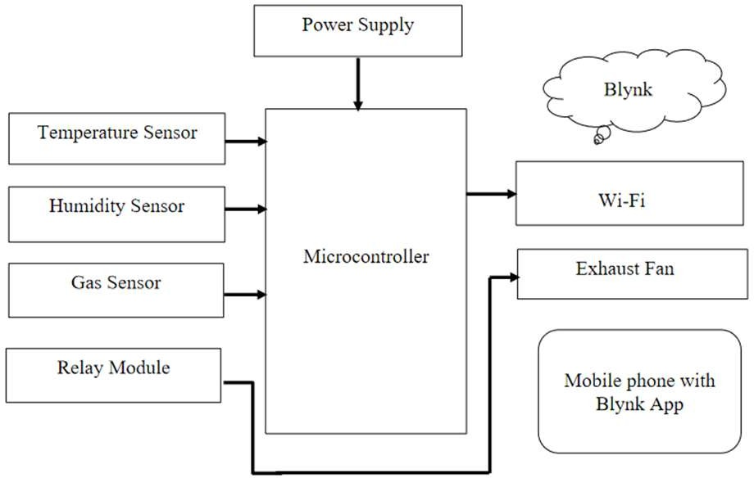

**Fig 3.2.1 Block Diagran**

# Blynk System

The profile for the IoT Based Smart Exhaust Fan was established in the Blynk application through a mobile device. The app can be downloaded from any mobile phone application store. The profile is referred to as IoT Based. Intelligent Ventilation Fan. There are two gauge meters designated for temperature and air quality. interpretations. A line graph was included for tracking purposes. This app also includes a notification feature to alert the user when the temperature or air The quality level surpassed the necessary threshold, triggering the exhaust fan to activate.

**Manual Switch**

The Smart Exhaust Fan Based on IoT is also equipped with a manual switch for the user to turn it ON, the exhaust fan although it is not necessary based on temperature and air quality level at encompassing. Although the manual switch is turned ON and OFF for the exhaust fan, the Data gathering for the temperature and air quality metrics can still be observed and stored in the BLYNK app. The switch can be utilized for maintenance tasks, allowing the user to examine the exhaust. The fan is functioning well. There are two types of switches: physical switches and virtual switches.

## CONCLUSIONS

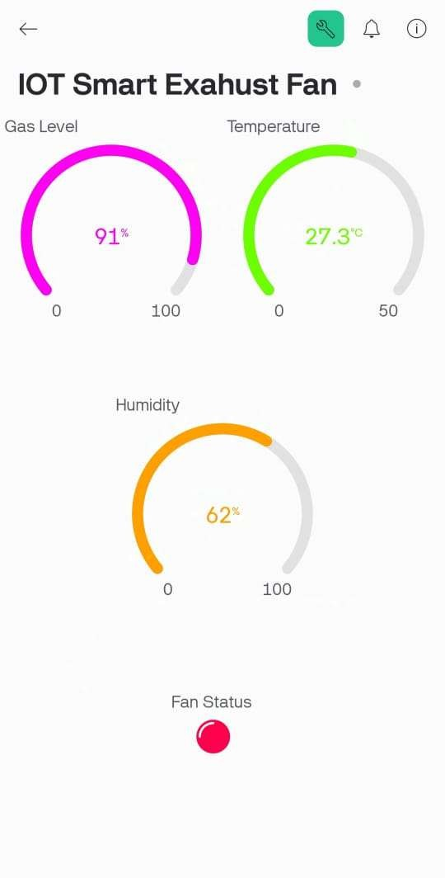

The IoT-based Smart Exhaust Fan system using ESP32 demonstrates a reliable, efficient, and user- friendly solution for managing indoor air quality and ventilation. By integrating humidity, temperature, and gas sensors, this system provides real-time monitoring and automatic control of the exhaust fan, ensuring optimal ventilation only when required. This results in significant energy savings and contributes to a healthier indoor environment by reducing pollutant levels. The remote monitoring and control capabilities through the Blynk app add to the convenience and flexibility, making it suitable for various applications in residential, commercial, and industrial settings. This smart exhaust fan system highlights the potential of IoT technology in enhancing everyday devices, leading to more sustainable and intelligent solutions for modern air quality management.

## RESULT

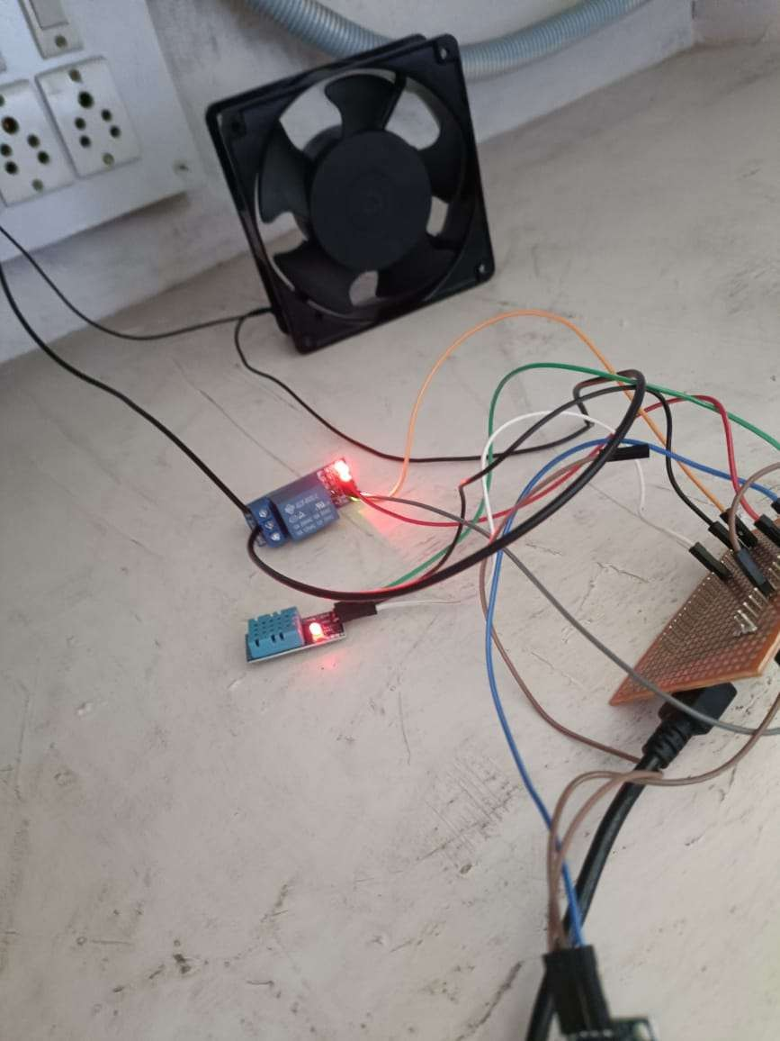

* + 1. **Fig. Blynk profile for this project Fig 1: IOT Based Smart Exhaust Fan**



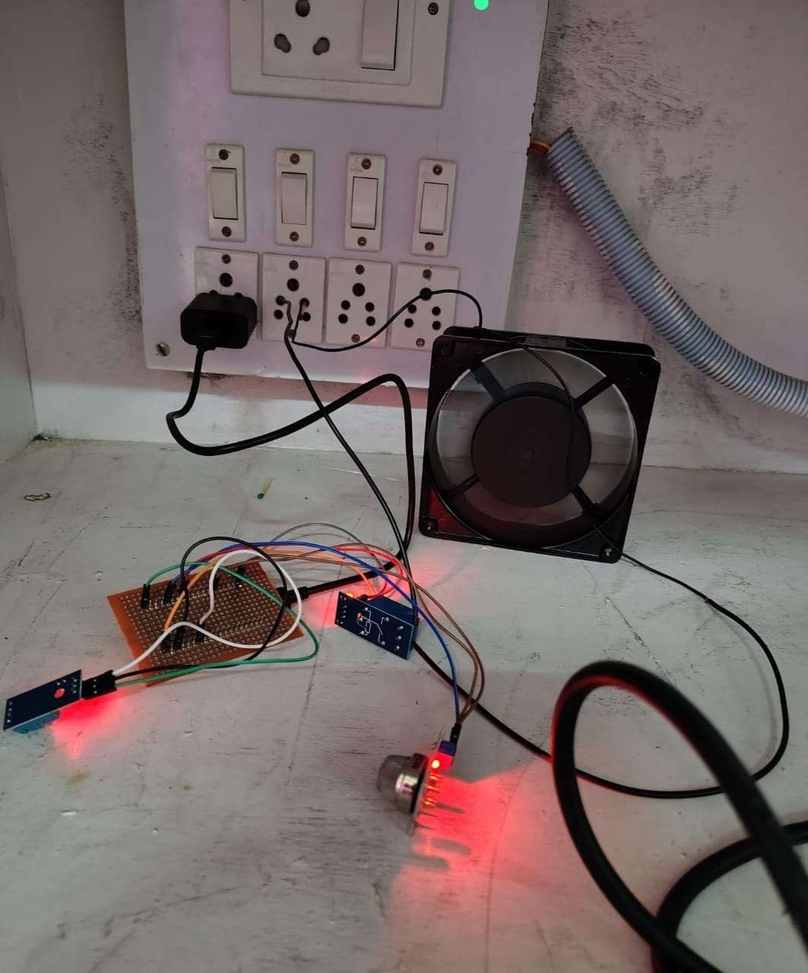

**Fig 2:** IOT Based Smart Exhaust Fan

## REFERENCES

1. Fernández-Agüera, Jesica, Samuel Domínguez- Amarillo, Miguel Ángel Campano,and Hanan Al-Khatri. "Effects of covid-induced lockdown on inhabitants’ perceptionof indoor air quality in naturally ventilated homes." Air Quality, Atmosphere &Health 16, no. 2 (2023): 193-212. https://doi.org/10.1007/s11869-022-01239-3
2. Logeshwaran, M., and J. Joselin Jeya Sheela ME. "Designing an IoT base Kitchen Monitoring and Automation System for Gas and Fire Detection”. In 2022 6th International Conference on Computing Methodologies and Communication(ICCMC),pp.346353.IEEE,202 2.https://doi.org/10.1109/ICCMC53470.2022.97

54118

1. Shrestha, Bindu, Sudarshan Tiwari, Sushil Bajracharya, and Martina Keitsch. "Role of gender participation in urban household energy technology for sustainability: A case of Kathmandu." Discover Sustainability 2 (2021). https://doi.org/10.1007/s436/21-021-00027-W
2. Fahim, Md Ibtida, Nowshin Tabassum, Abrar Ahamed Habibullah, Aritra Sarker,Sayeda Islam Nahid, and Mohammad Monirujjaman Khan. "Design of an IoT Based Gas Wastage Monitoring, Leakage Detecting and Alerting System." In 2021 IEEE 12th Annual Ubiquitous Computing, Electronics & Mobile Communication.Conference(UEMCON),pp.059 10597.IEEE,2021.https://doi.org/10.1109/UEM CON53757.2021.9666510