**Evaluation of Permeable Flexible Pavements: A Comparative Study Using**

**IRC 37-2018 and IIT PAVE**

**Amal Prasad1, Aniketh G Menon2, Anil Prasad3, Athul Krishna C S4,**

**Eldhose M Manjummekudiyil5**

1,2,3,4B. Tech student, Department of Civil Engineering, Mar Athanasius College of Engineering, Kothamangalam,

Kerala, India

5Assistant Professor, Department of Civil Engineering, Mar Athanasius College of Engineering, Kothamangalam,

Kerala, India

**ABSTRACT**

Pavement design is an integral part of sustainable and resilient infrastructure. In Kerala, flexible pavements undergo premature failure before their design life. There are many reasons for this, including inappropriate material selection and lack of dependable traffic and axle load data. The study analyzes the performance of permeable flexible pavement using IITPAVE software, which evaluates stresses, strains, and deflections in a linear elastic layered pavement system under applied loads. The research follows the mechanistic-empirical method, utilizing key input parameters such as layer thickness, Poisson’s ratio, elastic modulus, wheel load, and tire pressure. The study compares critical pavement strains computed using IITPAVE with allowable strain values from IRC:37-2018 guidelines. Results indicate that the actual horizontal tensile strain at the asphalt layer bottom and the vertical compressive strain at the subgrade top are well within permissible limits, ensuring the pavement's structural safety. The findings confirm that the design thickness of 595 mm is sufficient for anticipated traffic loads, demonstrating IITPAVE's effectiveness in pavement analysis.

**Keywords:** IIT PAVE, Pavement analysis, IRC:37-2018, Horizontal strain, Traffic loads, Poisson’s ratio

1. **INTRODUCTION**

The success of transportation programs is dependent on pavement structure design and pavement analysis, which are critical to maximizing performance, saving cost, and improving road safety. Increasing traffic loads and environmental conditions developed a need for more effective and precise pavement evaluation techniques. Existing pavement design methods are mostly empirical, and they might not reflect the comprehensive interaction of various pavement layers and loads applied. In contrast, mechanistic-empirical approaches, such as those implemented in IITPAVE software, provide a more comprehensive understanding of pavement behavior by analyzing stresses, strains, and deflections under realistic loading conditions.

IITPAVE is a widely used software tool recommended by IRC:37-2018 for the mechanistic analysis of flexible pavements, incorporating a multi-layer elastic theory to evaluate pavement performance. It calculates critical pavement responses, such as horizontal tensile strain at the bituminous layer bottom and vertical compressive strain at the subgrade top, to assess fatigue and rutting potential. These parameters are compared against allowable limits prescribed in IRC 37-2018 guidelines to determine pavement safety and durability. Current pavement engineering research focuses on improving analysis accuracy by integrating advanced material models and computational techniques. This study utilizes IITPAVE to evaluate a pavement design, ensuring its adequacy in handling anticipated traffic loads. The findings contribute to the ongoing efforts to optimize pavement design for improved sustainability and performance.

1. **METHODOLOGY**

The approach employed in data analysis is the mechanistic-empirical method, which takes into account the design lifespan of pavement until either the fatigue cracking in the bituminous surface extends to 20 percent of the pavement's surface area or the rutting reaches a terminal depth of 20 mm, whichever occurs first. The analysis of the flexible pavement by IIT-PAVE is based on the multi-layer theory. Stresses and strains at various points of layers were determined using a linear layered elastic model. Tensile strain(Ꜫt) at the bottom of the bituminous layer and the vertical subgrade strain, (Ꜫv) at the top of the subgrade are typically regarded as key factors for pavement design to prevent cracking and rutting in both the bituminous and non-bituminous layers. The calculation suggests that tensile strain near the surface, particularly at the wheel's edge, can become significant enough to trigger longitudinal surface cracking, followed by transverse cracking, well before the flexural cracking of the bottom layer if the mix's tensile strength is insufficient at elevated temperatures.

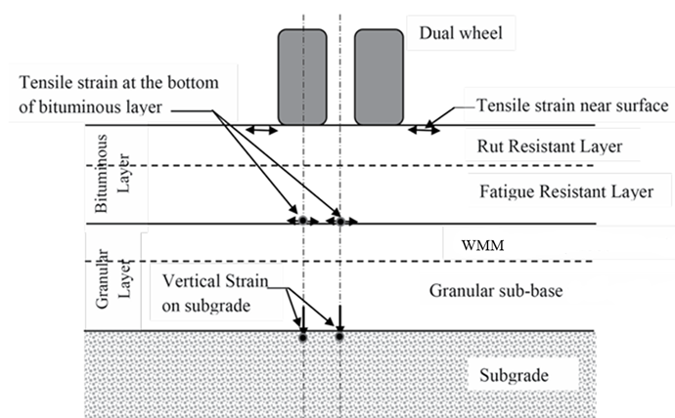

Fig A Pavement section with Bituminous Layer(s), Granular Base, and GSB showing the Locations of Critical strains.

1. **DESIGN AND ANALYSIS**

**3.1 Rutting Model**

Rutting is the lasting change in pavement that typically happens longitudinally along the route of the wheels. The rutting might be partially attributed to deformation in the subgrade and other non-bituminous layers, which can cause the upper layers to adopt a deformed shape.

The rutting model also has been calibrated in the studies using the pavement performance data collected during the studies at 80% and 90% reliability levels.

**NR = 4.1656 x 10-08 [1/Ꜫv]4.5337**(for80% reliability) ------------- (1)

**NR = 1.4100 x 10-08 [1/Ꜫv]4.5337** (for 90 % reliability) ------------- (2)

Where NR = subgrade rutting life

Ꜫv = Vertical compressive strain at the top of the subgrade.

**3.2 Fatigue model**

Fatigue cracking is traditionally seen as a 'bottom-up cracking' occurrence, resulting from heavy axle loads affecting the bottom of the bituminous layers.

Two fatigue equations were fitted, one in which the computed strains in 80 percent of the actual data in the scatter plot were higher than the limiting strains predicted by the model (and termed as 80 percent reliability level in these guidelines) and the other corresponding to 90 percent reliability level.

Nf = 1.6064*C*10-04 [1/Ꜫt ]3.89*[1/MRm ]0.854  ( for80% reliability) ------------- (3)

Nf = 0.5161*C*10-04 [1/Ꜫt ]3.89*[1/MRm ]0.854  ( for90% reliability) ------------- (4)

Where, C = 10M,

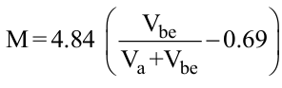

Va = percent volume of air void in the mix used in the bottom bituminous layer

Vbe = percent volume of effective bitumen in the mix used in the bottom bituminous layer

Nf = Fatigue life of bituminous layer

Ꜫt = Maximum horizontal tensile strain at the bottom of the bottom bituminous layer

MRm = Resilient modulus (MPa) of the bituminous mix used in the bottom bituminous layer

1. **RESULTS AND DISCUSSION**

**4.1 Determination of Vertical Compressive Strain (Rutting Model)**

The vertical compressive strain (Ꜫv) at the bottom of the subgrade layer is estimated by substituting the relevant data (NR = 187) to Equation (2) for 90% reliability and the obtained value of Ꜫv as 5851.2x10-6

* 1. **Determination of Horizontal Tensile Strain (Fatigue Model)**

The horizontal tensile strain (Ꜫt) at the bottom of the bituminous layers is estimated by substituting the relevant data (Nf = 53) to Equation (4) for 90% reliability and the obtained value of Ꜫt as 1443.04x10-6

**Table 1** Comparison of Ꜫt and Ꜫv values obtained from IRC 37-2018 and IITPAVE Software

|  |  |  |  |
| --- | --- | --- | --- |
| Type of Strain | Allowable Strain Values from IRC 37-2018 | Actual Strain Values from IITPAVE Software | Remarks |
| Horizontal Tensile Strain (Ꜫt) | 1443.04x10-6 | 326.1x10-6 | Safe |
| Vertical Compressive Strain (Ꜫv) | 5851.2x10-6 | 339.8x10-6 | Safe |

1. **CONCLUSION**

The study demonstrates the effectiveness of IITPAVE software in evaluating the structural performance of flexible pavements based on IRC 37-2018 guidelines. By analyzing critical pavement responses such as horizontal tensile strain at the bottom of the asphalt layer and vertical compressive strain at the top of the subgrade, the research confirms that the actual strain values are well within allowable limits. This indicates that the pavement design with a total thickness of 595 mm is structurally sound and capable of sustaining the expected traffic loads without premature failure. Using a mechanistic-empirical approach ensures a more accurate prediction of pavement behavior compared to traditional empirical methods. The results validate IITPAVE as a reliable tool for pavement design and analysis, contributing to improved road infrastructure planning.

1. **REFERENCES**
2. Kumar, P. P., Manjunatha, S., & Gnanamurthy, P. B. (2023). A Comparative Analysis of Flexible Pavement Design using IRC 37-2012 and IITPAVE Software. Indian Journal of Science and Technology, 16(43), 3875-3883.
3. Patil, C. C., Shivananda, P., & Vinod, B. R. (2018). Flexible Pavement Evaluation By Falling Weight Deflectometer Test Using IIT-Pave And KGP Back Software. International Journal of Applied Engineering Research, 13(7), 180-183.
4. Palla, H. K. (2024). Design of Flexible pavement using IITPAVE as per IRC-37-2018 and minimize the pavement thickness by using Geogrid. INTERNATIONAL JOURNAL OF SCIENTIFIC RESEARCH IN ENGINEERING AND MANAGEMENT, 08(05), 1–5. <https://doi.org/10.55041/ijsrem34322>
5. G R, H. & New Horizon College of Engineering, Bengaluru. (2017). Analysis of Flexible Pavements using IIT Pave [Research]. Imperial Journal of Interdisciplinary Research (IJIR), Vol-3(Issue-6), 815–816. <http://www.onlinejournal.in>
6. IRC: 37-2018 “GUIDELINES FOR THE DESIGN OF FLEXIBLE PAVEMENTS”(Fourth Revision)-November 2018, New Delhi