A STUDY ON GROWTH TRENDS OF MUTUAL FUNDS IN INDIA
*Dr. Deepak Agrawal ** Ms. Shweta Vyas

Abstract
Credit-based funding from financial institutions or financial securities from the capital market has a significant impact on a nation's economic development. In recent years, mutual funds have become a very important tool for mobilizing resources. These days, mutual funds are one of the most widely used investment strategies. Encouraging the public to engage in financial activities such as mutual funds and equity investing was the main objective of this campaign. The first mutual fund was established in the early post-independence era by the United Trust of India (UTI), which was founded in 1963. From its assessment in India, the current history can be categorized into five major periods. Based on the mutual fund industry's historical development and growth pattern, the current study adds to the body of existing literature. Even recently, India was largely ignored in the literature on the predictability of mutual fund returns. Research on this dimension in comparison to the Indian stock market still appears to be lacking and requires more study, especially in light of India's rapidly expanding economic importance. The study shows the importance of the Mutual Fund industry towards capital market growth in India.

Keywords: Asset Under Management (AUM), Association of Mutual Fund of India (AMFI)

* Dr Deepak Agrawal, Professor, Department of Management, Malwanchal University, Indore (M.P.), e-mail: deepakcupid@rediffmail.com
** Ms. Shweta Vyas, Research Scholar, Department of Management, Malwanchal University, Indore e mail: shwetavyas2001@gmail.com

I Introduction

A nation's capital development is correlated with its economic growth. The nation's savings determine the expansion of the capital market. In India, even though the population saves a lot of funds, the capital market cannot expand quickly because the average person lacks the skills and knowledge to choose the best investment opportunities for his personal needs. Given this, mutual funds—one of the primary components of the capital market—have become a significant market niche in the Indian financial industry.

One of the major investment options in the global financial industry is mutual funds. A mutual fund is a trust that combines the savings of numerous investors with similar financial objectives. Stocks, bonds, and other securities are among the capital market products that are subsequently purchased with the collected funds. Depending on the number of units they possess, unitholders distribute the income and capital gains from these investments. For the average investor, a mutual fund is therefore the best choice since it enables you to invest at an appropriate cost in a professionally managed, varying basket of securities.

Pierce (1996) defines a mutual fund as "It is a non-depository or non-banking financial intermediary, which acts as an important vehicle for bringing wealth holders and deficit units together indirectly,"
According to SEBI (Mutual Funds) Regulations (1993), a mutual fund is defined as "a fund established in the form of a trust by a sponsor to raise money by the Trustee through the sale of units to the investors for investing in various securities. According to the SEBI (Mutual Funds) Regulations of 1996, mutual funds in India are established as trusts under the Indian Trust Act of 1882. Association of Mutual Funds of India elaborates a mutual fund is a pool of money that has been provided by numerous investors and is managed by an experienced fund manager.
An asset management company (AMC) handles the actual fund management activity. To manage any other fund, an AMC or its affiliate must have a minimum net worth of Rs. 50 million. MFs may be subject to fines for defaults, including non-registration and disregarding AMC-imposed limitations. Mutual funds invested in money market instruments must be registered with the RBI, and the rest must be registered with SEBI.
According to a study done by Nooney (2018), the early history is traced back to Europe which pioneered in inception of MF. In early 1774 a Dutch merchant ‘Adriaan Ketwich’ created an investment trust, followed by King William First of the Netherlands in the early 1800s. Switzerland established similar pooled fund investment vehicles in the middle of 1849, and Scotland did the same in the 1880s. This method of investing was embraced by France and Great Britain, and in the 1890s, it eventually reaching the United States.
The first group in the United States to invest in this way were the staff and faculty at Harvard University in 1893 in US history. The first modern mutual fund was started in 1924 by the Massachusetts Investors Trust. According to Webster (1969) the size of the mutual fund business in the United States was about half that of closed-end investment trusts in 1936. However, by 1947, mutual funds had doubled in size compared to closed-end funds; by 1959, growth would speed up to ten times the size. The value of mutual funds in the United States was $2 billion in 1950 and around $18 billion in 1960. In the late 1970s, when interest rates were high, the introduction of money market funds significantly accelerated the growth of the business.
New Zealand and Australia commenced the mutual fund industry in the early 1960s. Due to political instability in most African countries, no much progress in the capital market has been identified. Except for South Africa, no other countries have embarked on financial growth. There are pockets of areas, such as Nigeria, French West Africa, and the Southern African region, that have secondary bond markets. Apart from the markets in South Africa, the derivative markets were non-existent until a few years ago.
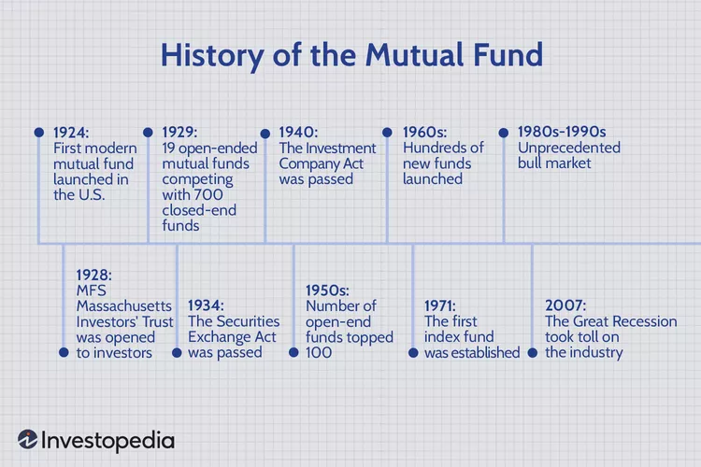
Chart 1: Historical Development of MF Industry in India
Source: Investopedia.com
For decades, it has been the state's monopoly. In 1964, the government established UTI as the country's largest mutual fund to attract small investors in the equity market; it now has an enormous marketing network of over 45,000 agents distributed across the country. Its shares have done relatively well in the market when compared to the market trend. UTI plays a vital role and investing more than Rs.14000 crore in the current investment (source: times of India 2003). Besides that, there are currently various types of mutual funds, which include participation by private and international companies, primarily banks, as well as foreign participation as open-ended, close-ended, debt, hybrid, growth funds etc.
In 1995, the RBI authorized private-sector organizations to establish Money Market Mutual Funds (MMMFs). They can invest in treasury bills, call and notice money, commercial paper, commercial bills accepted/co-accepted by banks, certificates of deposit, and dated government securities with an unexpired period of one year.

Panigrahi (1996). As economic reforms and liberalization keep going, mutual funds' investible resources are likely to promptly expand. The paper investigates why mutual funds have thrived in recent years, the level of growth, and whether the regulatory structure governing their operations reflects the changing environment.

Padmaja (2013) claims a mutual fund is a professionally managed combined investment vehicle that mixes the money of multiple investors to purchase securities. Mutual funds have a significant impact on household finances and provide both the benefits and drawbacks of direct investing in individual resources.

II Problem Statement
Despite being an attractive tax-saving alternative, most Indian investors are unaware of the primary characteristics, and benefits of investing in equity-linked savings schemes mutual funds. There is a paucity of product concepts and creativity. Weak distribution and marketing channels are another issue confronting the mutual fund sector today. The present study focused on identifying and suggesting ways to measure risk-return relation relationships by applying appropriate tools.
III Objective of the study
To explore the growth trends of the Mutual Fund industry in India.

IV Database & Methodology:

The current study is exploratory research that tries to explore the development of the Indian Mutual Fund industry from its inception to the present.

Database for current Study:
The required data is to be collected from the secondary sources available from the official websites and articles published by the Association of Mutual Funds of India (www.amfiindia.com), SEBI, RBI and other journal articles.

The various phases identified in the Indian Mutual Fund industry are:
The first phase: 1964 to 1987
UTI pioneered the mutual fund the Unit Scheme 1964 (US-64). It gained enormous popularity among the general public and became one of its signature programs. The Industrial Development Bank of India (IDBI) replaced the RBI as the regulatory and administrative authority after UTI split off from the RBI in 1978. In an attempt to accommodate the demands of various investors, UTI introduced more inventive schemes throughout the 1970s and 1980s. In the 1990s, it introduced Monthly Income Schemes (which provided guaranteed returns), Mastershare (India's first equity diversified plan) in 1987, Children's Gift Growth Fund and India Fund (India's first offshore fund) in 1986, and ULIP in 1971. UTI managed assets worth Rs. 6,700 crores by the end of 1988.

The second phase: 1987 to 1993

The year 1987 marked the entry of public sector mutual funds set up by Public Sector banks and Life Insurance Corporation of India (LIC) and the General Insurance Corporation of India (GIC). SBI Mutual Fund was the first ‘non-UTI’ mutual fund established in June 1987, followed by Canbank Mutual Fund (Dec. 1987), Punjab National Bank Mutual Fund (Aug. 1989), Indian Bank Mutual Fund (Nov 1989), Bank of India (Jun 1990), Bank of Baroda Mutual Fund (Oct. 1992). LIC established its mutual fund in June 1989, while GIC set up its mutual fund in December 1990. At the end of 1993, the MF industry had assets under management of ₹47,004 crores.

Third Phase from 1993–2003: Allowing Entry of Private Sector Funds

In 1993, the private sector was allowed to enter the mutual fund business as part of the government's efforts to liberalize the Indian economy between 1991 and 1996. Several private companies entered the market, such as Morgan Stanley Mutual Fund and ICICI Mutual Fund. To safeguard the interests of investors in the financial markets, the Securities and Exchange Board of India (SEBI) was given statutory authority by the government in 1992. By 1993, all AMCs were subject to SEBI's regulation. The first set of SEBI Mutual Fund Regulations, which applied to all mutual funds except UTI, were established in 1993.

The first private-sector MF to be registered in July 1993 was the former Kothari Pioneer, which has since merged with Franklin Templeton MF. A new era in the Indian mutual fund market began in 1993 with the arrival of private sector funds, which provided Indian investors with a greater selection of MF products. To establish uniformity in the computation of Net Assets Value (NAV), accounting procedures, exclusion from scheme listing, compensation for Asset Management Companies, and the establishment of a seven per cent band between purchase and repurchase prices, SEBI introduced new rules and regulations for mutual fund houses in 1996. UTI alone has an AUM of ₹44.54 thousand crores as of the end of January 2003, out of a total of 33 MFs with an AUM of ₹1.21 lakh crores.

Fourth Phase – from February 2003 to April 2014: Entry of Foreign Firms.

The Unit Trust of India Act was repealed by the government in February 2003. UTI was divided into UTI Mutual Funds and Specified Unit Trust of India. The global meltdown during this time was a sub-prime crisis that caused withdrawals from mutual markets and money, respectively. On January 21, 2008, the Indian Stock Exchange (BSE) dropped from 17605 to 8701 on October 24, 2008. AUM of more than Rs. 10 Lakh Crore was recorded in May 2014, even though the mutual fund sector in India had expanded multiple times over the years in terms of schemes, money raised, and investor base.

Fifth Phase - since May 2014 - to date.

To "re-energize" the Indian mutual fund business and boost the adoption of MFs, SEBI implemented some progressive steps in September 2012. The industry's AUM initially surpassed the ₹10 lakh crore mark on May 31, 2014, and within three years, it more than doubled in size, reaching ₹20 lakh crore in August 2017 and surpassing ₹30 lakh crore in November 2020, the AUM size for the first time. The AUM of the MF Industry more than doubled in just five years, rising from ₹27.86 trillion on January 31, 2020, to ₹67.25 trillion on January 31, 2025.

The number of investor folios has more than doubled in just five years, from 8.85 crore as of January 31, 2020, to 22.92 crore as of January 31, 2025. At the moment, India has 44 asset management firms, 35 of which are in the private sector.

The following Figure 1.2 indicates the growth of Assets under Management over the years.

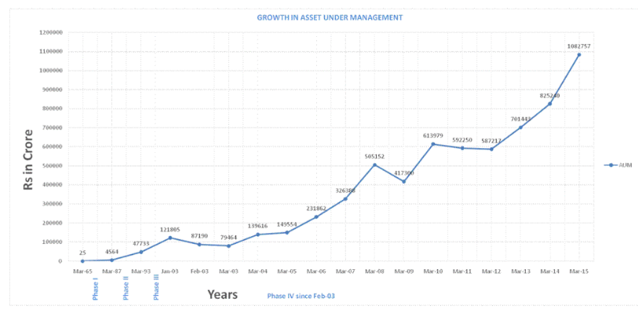

Fig. 1.2 Growth in Assets Under Management
Source: http://www/amfiindia.com. Retrieved on September 23’ 2024

V Outcomes:

The funds' future performance is influenced by their past performance.
Better incentives for fund management can significantly boost the funds' performance.

The Assets Under Management of the Indian mutual fund industry has witnessed exponential growth over the decades, reflecting increasing investor participation and confidence.

The Association of Mutual Funds in India has contributed to industry development by promoting best practices, investor education, and ethical conduct among fund managers.

Table 1: Status of MF Industry as on December 31’ 2024
Source: https://www.sebi.gov.in/statistics/mutual-fund/mf-fund-mobilised-public.html
The Indian mutual fund industry has seen the growth of both actively and passively managed index funds, providing mutual funds have also ventured into newer asset classes, such as real estate, commodities, and international equities, offering investors opportunities to diversify their portfolios.

The use of data analytics and artificial intelligence is gradually transforming fund management, risk assessment, and personalized investment recommendations.

The industry has evolved from offering basic investment schemes to a wide array of products catering to diverse investor needs and risk appetites, including equity, debt, hybrid, and specialized funds.

The growth of the mutual fund industry has contributed to increased financial literacy among Indian investors, as they become more aware of different investment options and the benefits of professional fund management.

A rapidly liberalizing economy and a high rate of domestic savings can boost the expansion of the MF Sector in our nation.

Expenses for mutual funds typically don't exceed 1% of your investment. Since index funds are not actively managed, their expenses are lower than that.

VI Limitations of Mutual Funds
Mutual funds have their certain limitations:
Data Availability and Reliability:
Comprehensive and reliable data on the early years of the mutual fund industry, particularly before the liberalization of the sector, might be limited. This can make it challenging to conduct in-depth analyses of that period.

Investor Behaviour: Detailed data on investor demographics, investment patterns, and behavioural biases might not be readily available for all periods, limiting the scope of research on investor behaviour.

Bias: Historical accounts might be influenced by the perspectives and biases of the authors or sources, requiring researchers to critically evaluate the information and consider alternative interpretations.
Limited Scope to Specific Areas:
While there is a growing body of research on the Indian mutual fund industry, some areas, such as the impact of technological advancements or the evolution of specific investment strategies, might require further investigation.

Professional Management: Although the majority of mutual funds generously compensate their top-tier experts to handle their investments, Indian fund managers often have an average tenure of just four years in a given fund.

Despite these limitations, the historical development of mutual funds in India remains a valuable area of study. By acknowledging these limitations and employing rigorous research methodologies, scholars can contribute to a deeper understanding of the industry's past, present, and potential future.

VII Conclusion:

Mutual funds play a significant role as the key contributors to the globalization of financial markets and are one of the main sources of capital flow to emerging economies. Despite their importance in developing nations, little is known about their investment priorities and approaches. The following paper provides an overview of mutual fund operations by measuring performance in emerging markets like India. It describes their size, and asset allocation. The study revealed that the performance is affected by the saving and investment habits of the people on the second side the confidence and loyalty of the fund Manager and rewards affect the performance of the MF industry in India. The ideal option to invest in equities is through an ELSS mutual fund. Since it is an easy way of investing in stock markets and offers tax savings, it is the best choice for small investors. There is nothing like ELSS, which combines the returns of equity funds with the section 80 C tax benefit, if one wants a taste of equities to increase overall portfolio returns.

VIII. Scope for Future Research
The research used to assess the performance of mutual funds has a lot of potential for improvement. The performance of mutual funds could be assessed using a variety of different multi-criteria decision methods. The historical development of mutual funds in India offers a rich field for further research. Here are some potential areas to explore the role of regulatory bodies like SEBI, the Association of Mutual Fund Industry, Fund houses like Assets Management Companies, and investor behaviour along with social and ethical considerations.

Journals articles
Agrawal, D. (2011). “Analytical Study on the Performance of the Indian Mutual Funds”. Finance India, XXV(2), 477-488.

Farina, Freeman & Webster 1969, p. 772.

Henriques, Diana B. (1995). Fidelity's World: The Secret Life and Public Power of the Mutual Fund Giant. New York: Scribner. ISBN 0-684-81299-1.

Nooney, L. K. (2018, September). Historical Background and Growth Trends of Mutual Funds in India. ResearchGate ISSN 2455-3085, Sept (2018), pp. 01-16.

Padmaja, R. (2013). A study of Consumer Behavior towards Mutual Funds with special reference to ICICI Prudential Mutual Funds, Vijayawada. International Journal of Management Research and Business Strategy, 2(2), 1-14.

Panigrahi, M.S. (1996). ‘Mutual Funds: Growth, Performance & Prospectus”. Economic & Political Weekly, 31(12), 765-775.

Sapar, Narayan Rao and Madava, Ravindran, Performance Evaluation of Indian Mutual Funds. Available at SSRN: https://ssrn.com/abstract=433100 or http://dx.doi.org/10.2139/ssrn.433100

TNN. (2002, August 31). Cabinet okays Rs 14,000-cr bailout plan for UTI. The Times of India; Times of India. https://timesofindia.indiatimes.com/business/india-business/cabinet-okays-rs-14000-cr-bailout-plan-for-uti/articleshow/20754642.cms
- Webliography

www.amfiindia.com
www.nseindia.com
www.sebi.gov.in

‌

