**BLDC MOTOR SPEED CONTROL BY EMPLOYING ZETA CONVERTER**

1**Dr. S. Arun,** 2 **Dhamodharan J,** 3**Santhosh Kumar N,** 4**Sarankumar M.K,**

5**Hariprasanth M**

1Associate Professor, Department of Electrical and Electronics Engineering, P. A. College of Engineering and Technology, Pollachi, Tamilnadu, India

2,3,4,5UG Student, Department of Electrical and Electronics Engineering, P. A. College of Engineering and Technology, Pollachi, Tamilnadu, India

**ABSTRACT**

This paper presents the implementation of a speed control system for a Brushless DC (BLDC) motor using a ZETA converter. BLDC motors are widely used in industrial automation, electric vehicles, and renewable energy systems due to their high efficiency, reliability, and precise control characteristics. However, achieving stable speed control requires an efficient power regulation technique. The ZETA converter is employed in this study to provide a regulated and ripple-free DC voltage to the motor driver circuit, ensuring smooth operation and improved performance. The ZETA converter, a fourth-order DC-DC converter, is chosen for its ability to operate in both step-up and step-down modes while maintaining a stable, non-inverted output voltage. The speed of the BLDC motor is controlled by adjusting the duty cycle of a Pulse Width Modulation (PWM) signal, which regulates the voltage supplied to the motor driver. MOSFET switches is used for electronic commutation, enhancing efficiency and minimizing switching losses.

**Keywords:**Speed control, BLDC motor, ZETA converter

1. **INTRODUCTION**

Brushless DC (BLDC) motors have gained widespread adoption in various applications, including industrial automation, electric vehicles, and renewable energy systems, due to their high efficiency, reliability, and superior speed control capabilities. Unlike conventional DC motors, BLDC motors operate using electronic commutation instead of mechanical brushes, resulting in lower maintenance, reduced energy losses, and improved performance. However, achieving efficient and stable speed control of a BLDC motor requires an effective power conversion technique to regulate the voltage supplied to the motor driver.The ZETA converter is employed to regulate the voltage supplied to the BLDC motor driver circuit. The ZETA converter is a fourth-order DC-DC converter capable of both stepping up and stepping down the input voltage while maintaining a non-inverted and stable output. This characteristic makes it particularly suitable for applications where precise voltage control is required to ensure smooth motor operation. The speed of the BLDC motor is controlled by varying the duty cycle of a Pulse Width Modulation (PWM) signal, which in turn adjusts the output voltage of the ZETA converter. MOSFET switches is used to drive the BLDC motor by providing electronic commutation, reducing switching losses, and improving overall system efficiency. The primary objective of this project is implement a BLDC motor speed control system using a ZETA converter, ensuring optimal performance under varying load conditions.

1. **LITERATURE SURVEY**

Sriballabh Acharya, Vikas Sharma, “Speed Control of Brushless DC Motor using Zeta Converter” International Conference on Smart Electronics and Communication (ICOSEC), IEEE 2020.

Motors consist of dynamic mechanism that drive almost all the nearby systems in motion. Numerous motor classification are dependent on their construction and the type of electrical input power given to the motor. The proposed research objective is to decrease the size and cost of a Brushless DC motor drive along with the better power quality given to the motor and also to enhance its reliability. The zeta converter is used for sensor-less motor speed control. A zeta converter has employed a fourth-order DC-DC converter that is constructed with two inductors and two capacitors and proficient of functioning in two modes which are both step-up or step-down mode. To deliver feedback position to the pulse generators the Hall-sensors are used. A MATLAB/Simulink environment setup is used to run the designed motor drive system to accomplish the extensive control and improvement in the high PF at the supply.

G.J. Su and W.Mckeever, “Low-Cost Sensorless control of Brushless DC motor with Improved Speed Range,” IEEE Trans. Power Electron.,vol.19 no. 2,pp.296-302,2004.

This paper presents a low-cost position sensorless control scheme for brushless DC motors. Rotor position information is extracted by indirectly sensing the back EMF from only one of the three motor-terminal voltages for a three-phase motor. Depending on the terminal voltage sensing locations, either a low-pass filter or a band-pass filter is used for position information retrieval. This leads to significant reduction in components count of the sensing circuit. Cost saving is further increased by coupling the sensing circuit with a single-chip microprocessor or digital signal processor for speed control. In addition, a look-up table correction for the non-ideal phase-delay introduced by the filter is suggested to ensure accurate position detection even at low speed. This extends the operating speed range and improves motor efficiency.

1. **MODELING AND ANALYSIS**

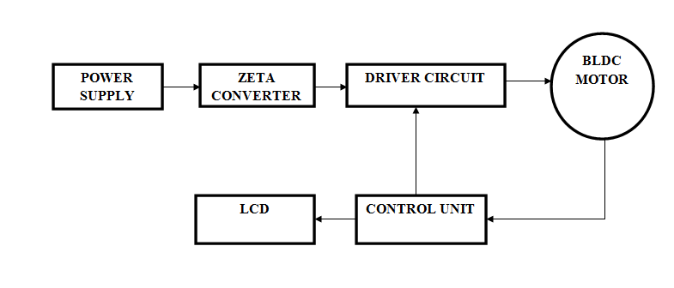

**Figure1:**Block Diagram

1. **HARDWARE DESCRIPTION**

To overcome the limitations of the existing BLDC motor speed control methods, this project proposes a ZETA converter-based speed control system that provides efficient, stable, and precise motor operation. The ZETA converter is used as an advanced DC-DC converter to regulate the input voltage supplied to the BLDC motor driver, ensuring a ripple-free and stable power supply even under varying load conditions. Unlike conventional converters, the ZETA converter can both step up and step down the input voltage, making it highly adaptable for applications where input voltage fluctuations occur. In the proposed system, a MOSFET is employed for the electronic commutation of the BLDC motor, reducing switching losses and improving overall efficiency. The motor speed is controlled by adjusting the Pulse Width Modulation (PWM) duty cycle, allowing for precise speed regulation. Additionally, a closed-loop feedback mechanism using a speed sensor (Hall sensors or an encoder) is implemented to monitor the actual motor speed and adjust the PWM signal accordingly, ensuring smooth operation and better dynamic response. By integrating the ZETA converter, the proposed system offers several advantages, including enhanced voltage stability, reduced torque ripple, improved power quality, and higher energy efficiency. This makes it a superior alternative to conventional BLDC motor control methods and suitable for applications such as electric vehicles, industrial automation, and renewable energy systems, where reliable and efficient motor control is crucial.

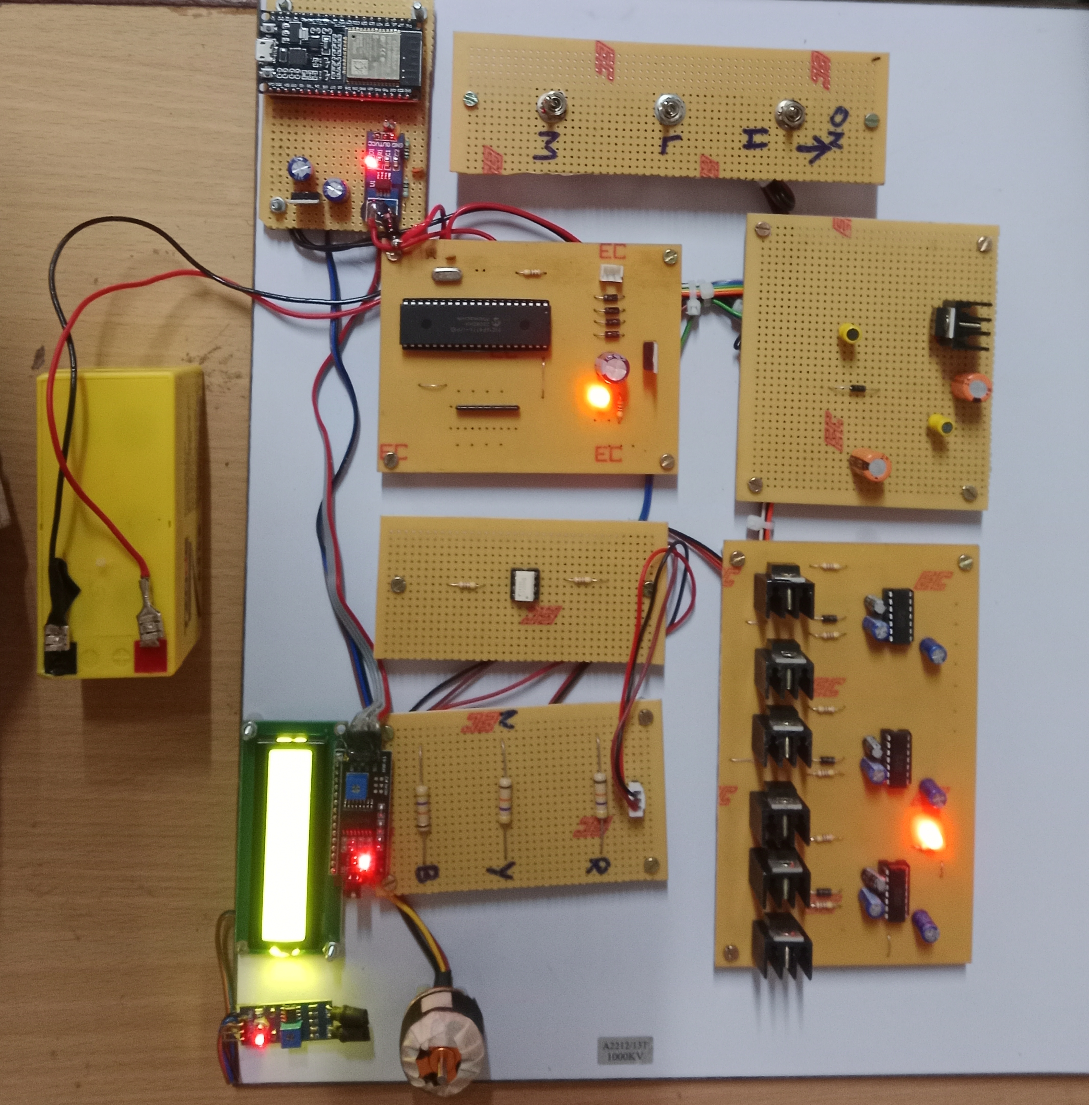

**Figure 2:**Hard ware

1. **RESULTS AND DISCUSSION**

The results of the project on BLDC motor speed control using a ZETA converter and PIC16F877A demonstrated effective speed regulation and power management. The BLDC motor's speed was successfully controlled through PWM signals generated by the PIC16F877A, with the ZETA converter efficiently regulating the voltage from the 12V battery. By varying the PWM duty cycle, the motor's speed could be precisely adjusted — higher duty cycles increased speed while lower ones reduced it. The ZETA converter provided a stable and regulated voltage, minimizing voltage ripples and ensuring consistent motor operation. The use of a single battery to power both the ZETA converter and the microcontroller simplified the design while maintaining efficiency. Feedback from the Hall sensors enabled accurate commutation, reducing the risk of stalling or reverse rotation. However, some challenges were encountered, such as maintaining stability at low PWM duty cycles and minimizing power losses in the 7805 voltage regulator. Future improvements could include implementing a more advanced control strategy like PID control for better speed stability and replacing the linear regulator with a more efficient DC-DC converter. Overall, the project successfully achieved its objective of controlling the speed of a BLDC motor with reliable voltage regulation and minimal harmonic distortion.

1. **CONCLUSION**

The implementation of a ZETA converter-based speed control system for Brushless DC (BLDC) motor has demonstrated significant improvements in voltage regulation, power efficiency, and motor performance compared to conventional methods. By integrating a ZETA converter, the system effectively provides a stable and ripple-free power supply, ensuring smooth and precise speed control even under varying load conditions. The use of a MOSFET for electronic commutation minimizes switching losses and enhances the overall efficiency of the motor drive system. Additionally, the control unit regulates motor speed through Pulse Width Modulation (PWM) techniques, while the LCD display provides real-time monitoring of system parameters, improving user interaction and diagnostic capabilities. The proposed system offers better dynamic response, reduced torque ripple, and improved power quality, making it a reliable and efficient solution for applications such as electric vehicles, industrial automation, and renewable energy systems.

**REFERENCES**

1. Kumar, R., & Singh, B. (2015) ‘BLDC motor driven solar PV array fed water pumping system employing Zeta converter’, IEEE Transactions Industry Application, 51(4), pp.2744-2753.
2. Sudhakarababu, C., & Veerachary, M. (2004) ‘Zeta converter for power factor correction and voltage regulation’, IEEE Transactions on Power Electronics, 19(3), pp.653-661.
3. Babu, P. R., Prasath, S. R., & Kiruthika, R. (2015) ‘Simulation and performance analysis of CCM Zeta converter with PID controller’, International Conference on Circuit, Power and Computing Technologies (ICCPCT), pp.1-5.
4. Rashmi, R., Manohar, J., & Rajesh, K. S. (2016) ‘Speed control of BLDC motor using PV powered synchronous Zeta converter’, International Conference on Computation of Power, Energy, Information and Communication (ICCPEIC), pp.182-186.
5. Singh, B., & Bist, V. (2012) ‘Power quality improvements in a Zeta converter for brushless DC motor drives’, IET Science, Measurement & Technology, 6(6), pp.497-505.
6. Bobba, P. B., & Rajagopal, K. R. (2010)‘Compact regenerative braking scheme for a PM BLDC motor driven electric two-wheeler’, In 2010 Joint International Conference on Power Electronics, Drives and Energy Systems & 2010 Power India, pp. 1-5.
7. Balaji, C., & Rajesh, R. G. (2014) ‘Speed control of brushless Dc motor using PID controller’, International Journals of Advanced research in Electrical, Electronics and Instrumentation Engineering, 3(4).
8. Bobba, P. B., & Rajagopal, K. R. (2010) ‘Compact regenerative braking scheme for a PM BLDC motor driven electric two-wheeler’, Joint International Conference on Power Electronics, Drives and Energy Systems.