# EXPERIMENTAL INVESTIGATION ON VCR CI ENGINE PERFORMANCE AND EMISSION BY THE USE OF NANO ADDITIVES (Al2O3+TiO2+AGO) IN (MAHUA) BIODIESEL BLENDS

**1 M r . KEDARANATH MAHAPATRO,**

**2 A. GANGA SAI GANESH NARASIMHA,**

**3 DANISH RAJA, 4 I.S.EASWAR VARMA , 5S.T.V.SATYA PHANI**

Department of Mechanical Engineering,

Godavari Institute of Engineering and Technology, Rajamundry-533296, Andhra Pradesh, India

***Abstract:*** By blending of nano additives in different proportions to the Bio-diesel fuel, testing is conducted using CI engine test rig. Performance and emission characteristics were found for the fuel with different proportions of the nano material. In this endeavor, first we have to extract Biodiesel from the Mahua oil by Transesterification method. By mixing 30% of Mahua biodiesel to the Diesel fuel and by the addition of nano particles (Al2O3 + TiO2 + AGO) 3 biodiesel blends are prepared. Performance, Combustion characteristics, Emission characteristic of these biodiesel Blends (B30 A30 + B30 T30 + B30 AGO 30), (B30 A60 + B30 T60 + B30 AGO 60), (B30 A90 + B30 T90 + B30 AGO

90) were found. For testing these three prepared mixtures an experimental setup of single cylinder 4-stroke VCR CI engine was used. Performance for these blends was calculated at different load conditions. It is observed that mechanical efficiency is increased up to 66.43%, 65.2%, 66.51% respectively for the first, second and the third blend. The volumetric efficiency is also increased by 1.8%., 1.9%, and 1.9% for these blends respectively. Heat exhaust gas temperature is decreased by 5% with respective with each blend and specific fuel consumption is decreased by 0.1 % for each blends. Emissions of CO is decreased by 0.193%, 0.171%, and 0.146%; HC by 104ppm, 94ppm, and 93ppm; CO2 by 10.5%, 10.3%, and 10%; NOX With by 1600ppm, 1703ppm, and 1762ppm; & also opacity with 66.7%, 64.5%, and 63.6% respectively. These emission characteristics were observed at the maximum load conditions.

**Keywords:** Mahua Bio-Diesel, Al2O3 + TiO2 + AGO nano-particles, Performance parameters, Combustion characteristics, Emission characteristics, VCR CI engine . **Nomenclature:**

* VCR CI Engine - Variable Compression Ratio Compression Ignition Engine
* Al2O3 - Aluminium Oxide
* TiO2- Titanium Oxide
* AGO - Amine Graphene Oxide
* B30A30,60,90 Biodiesel 30% Aluminium (30ppm, 60ppm, 90ppm)
* B30 T30, 60, 90 Biodiesel 30% Titanium oxide ( 30ppm,60ppm,90ppm)
* B30AGO30,60,90-biodiesel 30% Amine Graphene (oxide 30ppm, 60ppm, 90ppm)

***Index Terms* – Mahua oil, VCR Diesel Engine (**Aluminium Oxide + Titanium Oxide + Amine Graphene Oxide) **nano particles, Performance, Combustion and Emission characteristics**

## INTRODUCTION

Biodiesel is consider as a suitable fuel because of its sustainability, zero sulfur, and less pollution and at present days all fuel like diesel petrol etc. are decreasing so we use biodiesels to increase the fuel life and also biodiesels give less emission compared to pure diesel and is effective source of biodiesel fuel and also nano additives are used to improve the engine performance and emissions. Cylinder pressure of biodiesel blend with nano additive was higher than B20 because of the rapid vaporization and lower ignition delay. Introduction of nano additives Al2O3, TiO2, AGO these are the three nano particles Used for hybrid blending on VCR CI engine.

The demand for alternative fuels in internal combustion (IC) engines has increased due to growing energy demands and environmental concerns. Because it is renewable and produces fewer emissions than conventional diesel fuel, biodiesel which is made from non- edible oils—has shown great promise. Mahua oil is becoming more and more popular among the different sources of biodiesel because of its great availability and engine- suitability. But when compared to diesel, biodiesel fuels frequently have drawbacks like increased viscosity, decreased volatility, and decreased thermal efficiency. Nano particle additives have been thoroughly investigated for their ability to improve fuel properties, combustion characteristics, and emissions in order to get around these limitations. The incorporation of amine functionalized graphene oxide (AGO) nano particles, titanium oxide (TiO₂), and aluminum oxide (Al2O3) into biodiesel blends has demonstrated encouraging outcomes.

Moreover, using bio fuels benefits the environment in a number of ways, such as lowering greenhouse gas emissions, improving air quality, and reducing pollution of the air, land, and water. However, there is still a long way to go until alternative bio sourced fuels completely replace fossil fuels on a broad scale. This is due to a number of disadvantages, including low productivity, increased manufacturing costs, limited flexibility, and so on Because of this, and because there isn't a bio-based fuel that can fully replace diesel and is both widely accepted and economically practical, a lot of attention has been focused on an additive that can be added to diesel to enhance engine combustion while lowering emissions from exhaust. By employing eco recycling methods, biofuels emerge

When nano particle hybrid Al2O3 ,TiO2,AGO are mixed with each and every one with (a)

(30+30+30)ppm (b) (60+60+60) ppm, (c) (90+90+90) ppm concentration. we got brake thermal efficiency with increase of 0.1% for each and every blend and at a time it will increase the cylinder pressure compared other blends [1].when same as hybrid blending efficiency is increased up to 66.43%,65.2%,66.51% .and volumetric efficiency is increased by 1.8%.,1.9%,1.9%for each blend[2] and heat exhaust gas temperature is decreased with 5% difference with each blend and specific fuel consumption is decreased by 0.1 % for each blend[3]

And also, when coming to the emission parameters are the most important for the experimentation we got good results is decreased CO with 0.193% ,0.171%,0.146 ,HC with 104ppm ,94ppm, 93ppm,CO2 with 10.5%,10.3%.10%,NOX With 1600ppm,1703ppm,1762ppm[4] and also opacity with 66.7%, 64.5%, 63.6% so when these blends are used (B30A30+B30T30+B30AGO30),(B30A60+B30T60+B30AGO60), (B30A90+B30T90)[5]

Coming to the blend preparation the surfactant was used to maintain the stability and homogeneity of dissolved nano material in the fuel and the surfactant of 1:4 ratio was blended to archive higher absorption and after that we use magnetic stirrer to mix the blend preparation UV s spectroscopy is used to see the stability of nano particle [6].each and every blend is mixed by ultra-sonicator for good mixing. The nano particle homogeneity of the fuel was characterized by XRD and SEM methods.

1. **MATERIALS AND METHODOLOGY**

The manufacture of mahua biodiesel using (aluminium oxide +titanium oxide+ amine graphene oxide) nano particles comprises a transesterification procedure followed by the integration of (aluminium oxide +titanium oxide+ amine graphene oxide) nano particles to improve biodiesel characteristics. Methanol, mahua oil, and a catalyst (potassium hydroxide or sodium hydroxide) are combined in a reactor vessel.(aluminium oxide +titanium oxide+ amine graphene oxide) nano particles are added to the reaction mixture after being dissolved in methanol. Following the monitoring of the transesterification reaction, the biodiesel is separated from the glycerol. Next come measures for washing and purification, which include drying and separating the water. Bio diesel characteristics are evaluated by quality testing, and optional distillation can further refine the final product.(aluminium oxide +titanium oxide+ amine graphene oxide) nano particles in biodiesel must be thoroughly characterized using methods like TEM, SEM,UV-Vis and XRD. After verifying that nano particles are properly included and that safety and environmental laws are followed throughout, the finished biodiesel is stored.

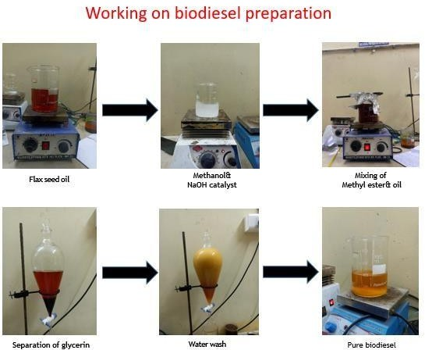

**MAKING OF MAHUA BIODISEL**

* 1. **Nano particle blend synthesis:**

By synthesis of all three nano particles together (aluminium oxide +titanium oxide+ amine graphene oxide) to prepare a blend by mixing of nano particle quantity is 30+30+30 ppm for all and like that 60 +60+60ppm and 90+90+90 ppm and B30 of mahua biodiesel and diesel of 70% they all combine to form 3 different blends and also we will see the analysis reports

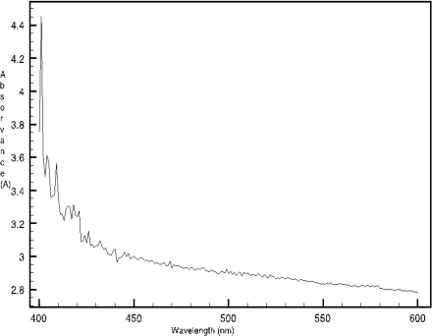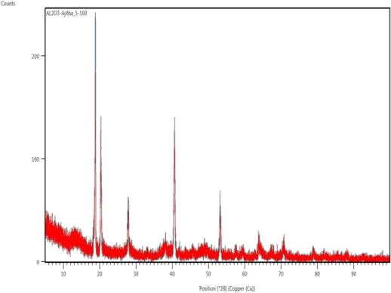

**UV-Vis spectrophotometer reading of Aluminium oxide nanoparticles**

**XRD Analysis of Nanoparticles**

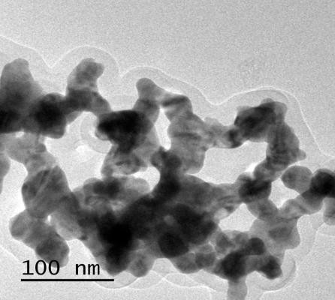 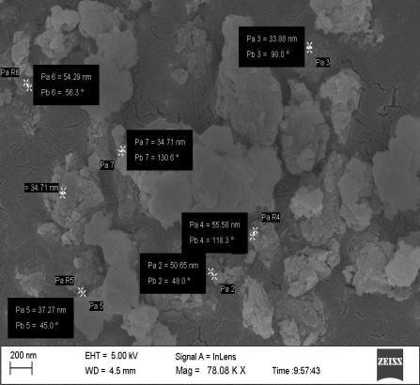

**TEM Analysis of Al2O3 nano particles SEM Analysis of Al2O3 nano particles nano particles**

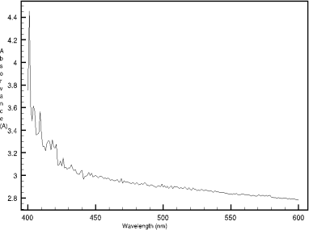

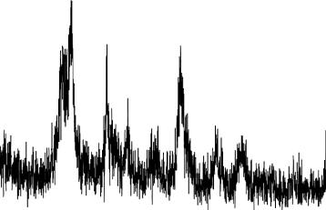

**UV Spectrophotometer analysis nano particles XRD Analysis of TiO2 nano particle**s

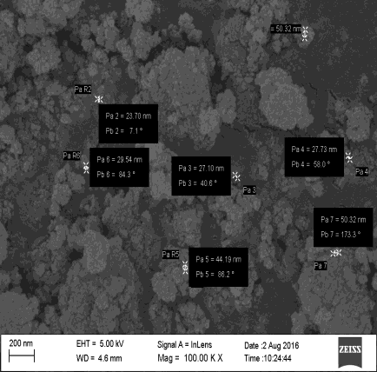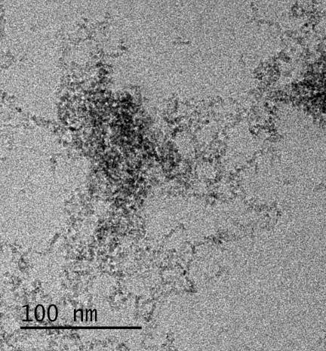

**SEM analysis of TiO2 nanoparticles TEM analysis of TiO2 nanoparticles**.

.

**Experimental setup**

The setup consists of single cylinder, four stroke, VCR CI engine connected to eddy current type dynamo-meter for engine loading. The setup has stand-alone type independent panel box consisting of air box, fuel tank, and manometer, fuel measuring unit, digital speed indicator and digital temperature indicator. Engine jacket cooling water inlet, outlet and calorimeter temperature is displayed on temperature indicator. Rota meters are provided for cooling water and calorimeter flow measurement.

The setup enables study of engine for brake power, BMEP, brake thermal efficiency, volumetric efficiency, specific fuel consumption, air fuel ratio and heat balance. It is supplied with MS Excel program for Engine Performance Analysis.

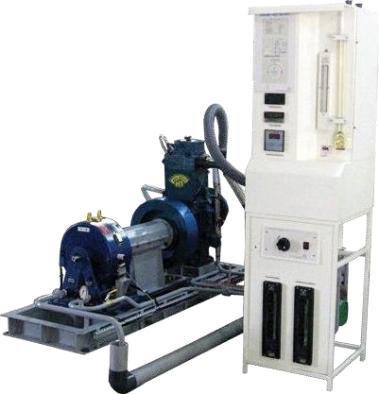

## Variable Compression Ratio Compression Ignition Engine

**Table 1 specifications of VCR CI engine**

|  |  |
| --- | --- |
| General details | 4 strokes, water cooled, VCR engine, compressio ignition |
| Compression ratio | 5:1 to 22:1 (variable) |
| No. of cylinder | Single cylinder |
| Rated power | 3.7 kw at 1500 rpm |
| Bore & stroke | 80mm & 110mm |
| Loading | Eddy current dynamometer |
| Speed | 1500 rpm (constant) |
| Connecting rod length | 234mm |
| Swept volume | 661 cc |
| Starting | Manual crank shaft |
| Air flow transmitter | Pressure transmitter |
| Load sensor | Strain gauge load cell |
| Rotameter | Pressure transmitter |
| Cooling | Water |

# PROCEDURE for manual mode of VCR CI engine

* + - Fill up the observations in “Cal225” worksheet to get the results and performance plots.
    - Ensure that all the nut bolts of engine, dynamo meter, propeller shaft, base frame are properly tightened.
    - Ensure that sufficient lubrication oil is present in the engine sump tank. This can be checked by marking on the level stick(Use SAE20W40 or equivalent make any company market available)
    - Ensure sufficient fuel in fuel tank. Remove air in fuel line, if any.
    - Switch on electric supply and ensure that RPM Indicator, Load indicator, Temperature Indicator and DLU (Dynamo meter loading unit), are switched on.
    - Start water pump. Adjust the flow rate of "Rota meter (Engine)" to 200-300 LPH and "Rota meter (Calorimeter)" to 75-100 LPH by manipulating respective globe valves provided at the rota meter inlet. Ensure that water is flowing through dynamo meter at a pressure of @ 0.5 to 1 Kg/cm2.
    - Keep the DLU knob at minimum position.
    - Change the Fuel cock position from "Measuring" to "Tank"
    - Start the engine by hand cranking and allow it to run at idling condition for 4- 5 minutes.
    - Adjust DLU knob and to set 0.5 kg load on Load Indicator. Wait for 3 mins. Ensure that load is constant/Temperature is steady state during this period. Change the Fuel cock position from "Tank" to "Measuring".
      * Note the time required for 10 ml fuel in seconds by using stopwatch. Turn fuel cock from “Measuring” to “ Tank”



**LOAD VS MECHANICAL EFFICIENCY**

70

60

50

40

30

20

10



**LOAD VS SPECIFIC FUEL CONSUMPTION**

20

15

10

5

0

* + - * Note all temperatures, load, speed, manometer reading and Rota meter flow rates. Refer observation table in excel sheet.
      * Adjust DLU knob to set 3 kg load on Load Indicator. Wait for 3 mins. Ensure that load is constant during this period. Change the Fuel cock position from "Tank" to "Measuring" and note the observations as explained in above two steps.
      * Repeat observations for various loads e.g. 6,9,12,15,18 kg (For VCR engine do not exceed 12 kg load)
      * After finishing all the observations decrease the load on the engine by DLU.
      * Stop the engine by pressing engine stop lever. Allow the water to circulate for about 5 minutes for engine cooling and then stop the pump.

Fill up the observations in “Cal225” worksheet to get the results and performance plot

1. **RESULTS AND DISCUSSIONS**

The study involved analyzing the combustion characteristics of a 4-stroke VCR engine using biodiesel blends, specifically mahua biodiesel (B30) and nanoparticle enhanced blends like following (B30A30+B30T30+B30AGO30),(B30A60+B30T60+B30AGO60),(B30A90+B30T90

+B30AGO90), the experimental procedure. The obtained results were measured and compared against neat diesel fuel. The combustion analysis included parameters such as performance and emission are assessed across different load conditions.

**RESULTS**

**FOR FIRST BLEND [(B30A30+B30T30+B30AGO30)+DIESEL 70%]**

|  |  |  |  |  |  |  |  |  |
| --- | --- | --- | --- | --- | --- | --- | --- | --- |
| Torque  (Nm) | BP  (kW) | FP  (kW) | IP (kW) | BMEP  (bar) | IMEP  (bar) | BTHE  (%) | ITHE  (%) | Mech  Eff. (%) |
| 0.05 | 0.01 | 2.46 | 2.47 | 0.01 | 2.94 | 0.18 | 59.46 | 0.31 |
| 8.17 | 1.29 | 2.46 | 3.75 | 1.55 | 4.50 | 16.81 | 48.70 | 34.51 |
| 16.35 | 2.56 | 2.60 | 5.16 | 3.11 | 6.26 | 25.40 | 51.20 | 49.61 |
| 24.50 | 3.76 | 2.61 | 6.37 | 4.66 | 7.89 | 28.85 | 48.88 | 59.01 |
| 32.69 | 4.95 | 2.50 | 7.45 | 6.21 | 9.35 | 30.95 | 46.59 | 66.43 |

|  |  |  |  |  |  |  |
| --- | --- | --- | --- | --- | --- | --- |
| 0 | 1 | 2 | 3 | 4 | 5 | 6 |
| Load (kg) | 0.03 | 4.5 | 9.01 | 13.5 | 18 |  |
| Mech Eff. (%) | 0.31 | 34.5 | 49.6 | 59 | 66.4 |  |

|  |  |  |  |  |  |
| --- | --- | --- | --- | --- | --- |
|  | 1 | 2 | 3 | 4 | 5 |
| Load (kg) | 0.03 | 4.5 | 9.01 | 13.5 | 18.01 |
| Fuel (kg/h) | 0.36 | 0.67 | 0.87 | 1.13 | 1.39 |

**FOR SECOND BLEND [(B30A60+B30T60+B30AGO60)+DIESEL 70%]**



**LOAD VS MECHANICAL EFFICIENCY**

80

60

40

20



**LOAD VS SPECIFIC FUEL CONSUMPTION**

20

15

10

5



**LOAD VS MECHANICAL EFFICIENCY**

80

60

40

20

0



**LOAD VS SPECIFIC FUEL CONSUMPTION**

20

15

10

5

0

Axis Title

Axis Title

|  |  |  |  |  |  |  |  |  |
| --- | --- | --- | --- | --- | --- | --- | --- | --- |
| Torque  (Nm) | BP  (kW) | FP  (kW) | IP (kW) | BMEP  (bar) | IMEP  (bar) | BTHE  (%) | ITHE  (%) | Mech  Eff. (%) |
| 0.05 | 0.01 | 2.36 | 2.36 | 0.01 | 2.81 | 0.18 | 56.78 | 0.32 |
| 8.17 | 1.30 | 2.63 | 3.93 | 1.55 | 4.71 | 18.16 | 55.08 | 32.97 |
| 16.34 | 2.55 | 2.62 | 5.17 | 3.10 | 6.28 | 26.85 | 54.35 | 49.40 |
| 24.50 | 3.77 | 2.56 | 6.33 | 4.66 | 7.82 | 30.19 | 50.70 | 59.55 |
| 32.69 | 4.96 | 2.64 | 7.60 | 6.21 | 9.51 | 32.11 | 49.19 | 65.28 |

|  |  |  |  |  |  |
| --- | --- | --- | --- | --- | --- |
| 0 | 1 | 2 | 3 | 4 | 5 |
| Load (kg) | 0.03 | 4.5 | 9 | 13.5 | 18.01 |
| Mech Eff. (%) | 0.32 | 32.97 | 49.4 | 59.55 | 65.28 |

|  |  |  |  |  |  |
| --- | --- | --- | --- | --- | --- |
| 0 | 1 | 2 | 3 | 4 | 5 |
| Load (kg) | 0.03 | 4.5 | 9 | 13.5 | 18.01 |
| Fuel (kg/h) | 0.36 | 0.62 | 0.82 | 1.08 | 1.34 |

**FOR THIRD BLEND [(B30A90+B30T90+B30AGO90)+DIESEL 70%]**

|  |  |  |  |  |  |  |  |  |
| --- | --- | --- | --- | --- | --- | --- | --- | --- |
| Torque (Nm) | BP (kW) | FP (kW) | IP (kW) | BMEP  (bar) | IMEP  (bar) | BTHE (%) | ITHE (%) | Mech Eff. (%) |
| 0.04 | 0.01 | 2.45 | 2.45 | 0.01 | 2.87 | 0.17 | 68.58 | 0.25 |
| 8.17 | 1.30 | 2.67 | 3.97 | 1.55 | 4.74 | 18.18 | 55.46 | 32.78 |
| 16.35 | 2.56 | 2.59 | 5.15 | 3.11 | 6.24 | 26.88 | 54.01 | 49.76 |
| 24.50 | 3.76 | 2.61 | 6.38 | 4.65 | 7.88 | 30.07 | 50.93 | 59.04 |
| 32.69 | 4.97 | 2.54 | 7.51 | 6.21 | 9.38 | 32.07 | 48.43 | 66.21 |

|  |  |  |  |  |  |
| --- | --- | --- | --- | --- | --- |
|  | 1 | 2 | 3 | 4 | 5 |
| Load (kg) | 0.03 | 4.5 | 9 | 13.5 | 18.01 |
| Mech Eff. (%) | 0.25 | 32.78 | 49.76 | 59.04 | 66.21 |

|  |  |  |  |  |  |
| --- | --- | --- | --- | --- | --- |
|  | 1 | 2 | 3 | 4 | 5 |
| Load (kg) | 0.03 | 4.5 | 9 | 13.5 | 18.01 |
| Fuel (kg/h) | 0.31 | 0.62 | 0.82 | 1.08 | 1.34 |

According to the three blend results ,we got good mechanical efficiency at maximum load condition when load increases mechanical efficiency also increases for three blends brake thermal efficiency is increasing and also at a time indicated thermal efficiency is decreasing according increase load conditions and also. we got the good emission results, very less results, we got CO% is less than 1%,HC ppm is less than 110ppm only ,CO2 is 11%,NOX highest ppm value is 1762 ppm and at the last Opacity is highest value is 66% these are the emission values.

**Emission results for the following three different blends**



2000

1800

1600

1400

1200

1000

800

600

400

200

0

30PPM30PPM30PPM30PPM30PPM60PPM60PPM60PPM60PPM60PPM90PPM90PPM90PPM90PPM90PPM LOAD CO % HC PPM CO2 % O2 % NOX PPM Opacity %

**CONCLUSION**

The current study experimental investigated on performance and emission characteristics on VCR CI Engine with utilizing fuels like diesel, (B30A30+B30T30+B30AGO30),(B30A60+B30T60+B30AGO60) and (B30A90+B30T90+B30AGO90),

The outcomes lead to the following conclusion:

* The fuel properties of mahua oil biodiesel (B30) improve with the addition of nanoparticles **(**aluminium oxide

+titanium oxide+ amine graphene oxide.

* The performance and emission characteristics like mechanical efficiency, volumetric efficiency, indicated thermal efficiency heat water jacket temperature. were improved with test fuels B30,66.64%,65.28%,66.21% mechanical efficiency and also emissions at maximum load conditions are CO is (0.193,0.171,0.146)%, HC is (102,94,93)ppm, CO2 is(10.5,10.3,10) , NOX is (1600,1701,1762)ppm, and at the end opacity will be (66.7,64.5,63.6)% respectively, at a load of 12 kg load conditions.

**REFERENCES**

1. V. Sharma, A. Kalam Hossain, A. Ahmed, and A. Rezk, “Study on using graphene and graphite nanoparticles as fuel additives in waste cooking oil biodiesel,” *Fuel*, vol. 328, Nov. 2022, doi: 10.1016/j.fuel.2022.125270.
2. C. Jit Sarma *et al.*, “Improving the combustion and emission performance of a diesel engine powered with mahua biodiesel and TiO2 nanoparticles additive,” *Alexandria Engineering Journal*, vol. 72, pp. 387– 398, Jun. 2023, doi: 10.1016/j.aej.2023.03.070
3. S. Sayyed, R. K. Das, K. Kulkarni, T. Alam, and S. M. Eldin, “Influence of additive mixed ethanol- biodiesel blends on diesel engine characteristics,” *Alexandria Engineering Journal*, vol. 71, pp. 619–629, May 2023, doi: 10.1016/j.aej.2023.03.091.
4. A. Singh Rajpoot, T. Choudhary, H. Chelladurai, U. Rajak, and M. Kumar Sahu, “Comparison of the effect of CeO2 and CuO2 nanoparticles on performance and emission of a diesel engine fueled with Neochloris oleoabundans algae biodiesel,” *Mater Today Proc*, 2023, doi: 10.1016/j.matpr.2023.03.233.
5. C. Thiagarajan, J. Senthil, M. Prabhahar, S. Sindhuraj, R. Natarajan, and G. Vasanth, “Experimental Investigation and Parameter Influence on VCR Engine Using Jojoba Biodiesel Fuel,” in *AIP Conference Proceedings*, American Institute of Physics Inc., Jan. 2023. doi: 10.1063/5.0110344.
6. M. E. M. Soudagar *et al.*, “Effect of Sr@ZnO nanoparticles and Ricinus communis biodiesel-diesel fuel blends on modified CRDI diesel engine characteristics,” *Energy*, vol. 215, Jan. 2021, doi: 10.1016/j.energy.2020.119094.
7. R. S. Gavhane, A. M. Kate, A. Pawar, M. E. M. Soudagar, and H. Fayaz, “Effect of Soybean biodiesel and Copper coated Zinc oxide Nanoparticles on Enhancement of Diesel Engine Characteristics,” *Energy Sources, Part A: Recovery, Utilization and Environmental Effects*, 2020, doi: 10.1080/15567036.2020.1856237.
8. A. Halwe-Pandharikar, S. J. Deshmukh, and N. J. Kanu, “Numerical investigation and experimental analysis of nanoparticles modified unique waste cooking oil biodiesel fueled C. I. Engine using single zone thermodynamic model for sustainable development,” *AIP Adv*, vol. 12, no. 9, Sep. 2022, doi: 10.1063/5.0103308.
9. B. Doğan, M. Çelik, C. Bayındırlı, and D. Erol, “Exergy, exergoeconomic, and sustainability analyses of a diesel engine using biodiesel fuel blends containing nanoparticles,” *Energy*, vol. 274, Jul. 2023, doi: 10.1016/j.energy.2023.127278.
10. S. K. Pillai, U. Rajamanickam, and S. Khurana, “Impact of Diethyl Ether on Performance and Emission Characteristics of a VCR Diesel Engine Fueled by Dual Biodiesel,” *Energies (Basel)*, vol. 16, no. 13, Jul. 2023, doi: 10.3390/en16134863.
11. N. S. Dugala, G. S. Goindi, and A. Sharma, “Experimental investigations on the performance and emissions characteristics of dual biodiesel blends on a varying compression ratio diesel engine,” *SN Appl Sci*, vol. 3, no. 6, Jun. 2021, doi: 10.1007/s42452-021-04618-0.
12. J. Kataria, S. K. Mohapatra, and K. Kundu, “Biodiesel production from waste cooking oil using heterogeneous catalysts and its operational characteristics on variable compression ratio CI engine,” *Journal of the Energy Institute*, vol. 92, no. 2,

pp. 275–287, Apr. 2019, doi: 10.1016/j.joei.2018.01.008.

1. K. Sundar, R. Udayakumar, C. Periasamy, and S. Khurana, “Cotton Seed Oil and Rice Bran Oil as a Source of Biodiesel in India,” in *Journal of Physics: Conference Series*, Institute of Physics Publishing, Aug. 2019. doi: 10.1088/1742- 6596/1276/1/012086.
2. H. Hosseinzadeh-Bandbafha *et al.*, “Environmental life cycle assessment of biodiesel production from waste cooking oil: A systematic review,” *Renewable and Sustainable Energy Reviews*, vol. 161, Jun. 2022, doi: 10.1016/j.rser.2022.112411.
3. H. Gupta, J. N. Gangwar, A. Vishwakarma, and S. Srivastava, “Comparative Investigation of the Effect of Diethyl Ether and Nanoparticles as Fuel Additives in Diesel-biodiesel Blends on Performance Characteristics of Diesel Engine,” *NanoWorld J*, vol. 9, no. Special Issue 1, pp. S249–S254, 2023, doi: 10.17756/nwj.2023-s1-049.
4. B. Maleki and S. S. A. Talesh, “Optimization of the Sono-Biodiesel in the Attendance of ZnO Nanoparticles, Process Yield Enhancement: Box Behnken Design,” *Journal of Chemical and Petroleum Engineering*, vol. 56, no. 1, pp. 1–14, Jun. 2022, doi: 10.22059/JCHPE.2021.330251.1361.
5. L. Razzaq *et al.*, “Influence of varying concentrations of TiO2 nanoparticles and engine speed on the performance and emissions of diesel engine operated on waste cooking oil biodiesel blends using response surface methodology,” *Heliyon*, vol. 9, no. 7, Jul. 2023, doi: 10.1016/j.heliyon.2023.e17758.
6. F. Binhweel, M. I. Ahmad, and S. A. Zaki, “Utilization of Polymeric Materials toward Sustainable Biodiesel Industry: A Recent Review,” *Polymers*, vol. 14, no. 19. MDPI, Oct. 01, 2022. doi: 10.3390/polym14193950.
7. A. Prabu, “Nanoparticles as additive in biodiesel on the working characteristics of a DI diesel engine,” *Ain Shams Engineering Journal*, vol. 9, no. 4, pp. 2343–2349, Dec. 2018, doi: 10.1016/j.asej.2017.04.004. [20]M. A. Bashir, S. Wu, J. Zhu, A. Krosuri, M. U. Khan, and R. J. Ndeddy Aka, “Recent development of advanced processing technologies for biodiesel production: A critical review,” *Fuel Processing Technology*, vol. 227. Elsevier B.V., Mar. 01, 2022. doi: 10.1016/j.fuproc.2021.107120.
8. R. Ennetta, H. S. Soyhan, C. Koyunoğlu, and V. G. Demir, “Current Technologies and Future Trends for Biodiesel Production: A Review,” *Arab J Sci Eng*, vol. 47, no. 12, pp. 15133–15151, Dec. 2022, doi: 10.1007/s13369-022-07121-9.
9. X. Zhao, F. Wang, X. Kong, R. Fang, and Y. Li, “Subnanometric Cu clusters on atomically Fe-doped MoO2 for furfural upgrading to aviation biofuels,” *Nat Commun*, vol. 13, no. 1, Dec. 2022, doi: 10.1038/s41467-022-30345-0.
10. S. Padmanabhan *et al.*, “Energy recovery of waste plastics into diesel fuel with ethanol and ethoxy ethyl acetate additives on circular economy strategy,” *Sci Rep*, vol. 12, no. 1, Dec. 2022, doi: 10.1038/s41598-022-09148-2.
11. S. Abel *et al.*, “Preparation and characterization analysis of biofuel derived through seed extracts of Ricinus communis (castor oil plant),” *Sci Rep*, vol. 12, no. 1, Dec. 2022, doi: 10.1038/s41598-022-14403- 7.
12. R. Devasan *et al.*, “Microwave-assisted biodiesel production using bio-waste catalyst and process optimization using response surface methodology and kinetic study,” *Sci Rep*, vol. 13, no. 1, Dec. 2023, doi: 10.1038/s41598-023-29883-4.
13. M. G. Weldeslase, N. E. Benti, M. A. Desta, and Y. S. Mekonnen, “Maximizing biodiesel production from waste cooking oil with lime-based zinc-doped CaO using response surface methodology,” *Sci Rep*, vol. 13, no. 1, Dec. 2023, doi: 10.1038/s41598-023-30961-w.
14. M. O. A. Sajjad, T. Sathish, M. Rajasimman, and T. R. Praveenkumar, “Experimental evaluation of soapberry seed oil biodiesel performance in CRDI diesel engine,” *Sci Rep*, vol. 13, no. 1, Dec. 2023, doi: 10.1038/s41598-023-32424-8.
15. S. Jaikumar, V. Srinivas, M. R. S. Satyanarayana, M. Rajasekhar, D. Vamsi Teja, and C. Tej Kamal, “Artificial neural networks approach on vibration and noise parameters assessment of flaxseed oil biodiesel fuelled CI engine,” *International Journal of Environmental Science and Technology*, vol. 18, no. 8, pp. 2365–2376, Aug. 2021, doi: 10.1007/S13762-020- 02975-8/METRICS.