**REVOLUTIONIZING EV BATTERY MANAGEMENT WITH AI: SMARTER, SAFE AND MORE EFFICIENT**

**Ware Tejas Vinod1, Patil Pradnya Dnyaneshwar2, Burkul Pratik Dilip3,**

**Joshi Shruti Badrinath4,Wagh Shrutika Suryabhan5**

1,4 Student, Department Of Electrical Engineering, Sardar Patel College Of Engineering, Mumbai, India.

2Student, Department Of Electrical Engineering, K.K.Wagh Polytechnic, Nashik, India.

3Student, Department Of Mechanical Engineering, Sardar Patel College Of Engineering, Mumbai, India.

5Student, Department Of Mechanical Engineering, COEP Technological University, Pune, India.

**ABSTRACT**

Electric vehicles (EVs) are pivotal in mitigating carbon emissions and addressing global environmental challenges. The performance and safety of EVs are inherently dependent on battery health, necessitating an advanced Battery Management System (BMS) to ensure operational reliability and prevent catastrophic failures. As batteries degrade over time, internal resistance increases while storage capacity diminishes, reinforcing the need for real-time monitoring of battery health and performance. Energy storage systems (ESSs) in EVs require SOP hesitated BMS algorithms to maintain efficiency and prolong battery lifespan. By integrating advanced battery performance algorithms that account for charging time, current flow, and energy storage capacity, the BMS must accurately estimate the State of Charge (SOC) and State of Health (SOH). As batteries age, the increase in internal resistance reduces constant current (CC) charging time. By systematically analyzing these temporal variations, a more precise prediction of SOH can be achieved. Conventional methods for SOC estimation and BMS optimization, such as deep neural networks, have been widely employed to minimize error margins. However, as battery aging introduces nonlinear degradation patterns, artificial intelligence (AI)-based approaches have gained prominence due to their superior diagnostic accuracy, fault detection capabilities, and thermal management efficiency. AI-driven methodologies significantly enhance safety and reliability across charging and discharging cycles by dynamically adapting to evolving battery conditions. To further ensure system integrity, an embedded fault detection algorithm is integrated within the BMS, proactively identifying and mitigating potential failures. This predictive mechanism enhances the overall resilience of the energy storage system, ensuring sustained performance and operational sustainability in EV applications. The efficacy of the proposed BMS algorithms is demonstrated through successful implementation in an ESS, validating their potential to optimize battery state estimation, enhance energy efficiency, and extend battery lifespan while maintaining stringent safety standards.

**Keywords:** Battery Management, State Of Charge, State Of Health, Artificial Intelligence In BMS , Fault Diagnosis Algorithm, Energy Storage System Optimization.

1. **INTRODUCTION**

Battery Management Systems (BMSs) are fundamental to ensuring the safe and efficient operation of battery-powered systems, including electric vehicles (EVs), renewable energy storage systems, and portable electronic devices. BMSs continuously monitor and regulate critical battery parameters such as voltage, current, temperature, and State of Charge (SOC) to prevent overcharging, deep discharging, and thermal runaway. Effective management of these parameters is crucial for optimizing battery performance and ensuring long-term safety and reliability[1-3]. The core functionalities of a BMS encompass state estimation, cell balancing, and fault detection, all of which rely on advanced computational algorithms and innovative technologies. State estimation is a key function that provides critical insights into battery SOC, State of Health (SOH), and State of Power (SOP) [4]. Recent advancements in deep learning techniques, such as Convolutional Neural Networks (CNNs) and Long Short-Term Memory (LSTM) networks, have significantly enhanced the accuracy and adaptability of SOC and SOH predictions. These machine learning models excel in capturing complex, non-linear battery behaviors and transient dynamics, leading to more precise diagnostics and predictive analytics.

Cell balancing is another essential BMS function that ensures uniform charge distribution among cells within a battery pack. This process is typically categorized into passive and active balancing techniques. Passive balancing, which dissipates excess charge as heat, has benefited from significant improvements in thermal management systems, enhancing both efficiency and longevity of battery operation [5]. By leveraging advanced BMS algorithms and intelligent balancing strategies, modern energy storage solutions can achieve higher performance, prolonged battery lifespan, and enhanced safety standards. Dynamic balancing, which involves redistributing charge between cells, has been significantly enhanced by advancements in power electronics and energy-efficient designs. Innovations such as high-efficiency inductors and capacitors have improved energy redistribution, reducing power losses and enhancing overall system efficiency. Fault detection and management are also critical for identifying and addressing potential issues within the battery system [6]. The integration of machine learning algorithms into fault detection has demonstrated superior capabilities compared to conventional model-based approaches. Techniques such as ensemble learning and hybrid models, which combine statistical methods with machine learning, have proven highly effective in increasing detection accuracy and system reliability. Furthermore, the development of real-time monitoring frameworks has enabled rapid feedback and proactive fault mitigation, ensuring enhanced battery performance [7-9].

Recent trends in BMS research focus on integrating machine learning and artificial intelligence to refine state estimation, fault detection, and predictive maintenance. These advancements have improved the adaptability of BMSs to diverse operational conditions and optimized decision-making processes. However, several challenges remain, particularly in thermal management, algorithm efficiency, and system reliability [10]. Maintaining thermal performance is crucial for ensuring battery safety and operational stability. Recent research has explored advanced cooling techniques and novel materials to improve heat dissipation. Innovations such as phase-change materials and next-generation cooling systems are being investigated for enhanced thermal regulation, minimizing the risk of overheating and performance degradation [11]. Optimizing algorithm efficiency remains a significant challenge, with ongoing efforts aimed at reducing computational costs and processing times. This is essential for the practical deployment of advanced methods in real-time applications, where high-speed decision-making is required. Additionally, ensuring system reliability under varying operating conditions is a key focus area, with research dedicated to enhancing system robustness and resilience, particularly in extreme environmental conditions and unexpected operational anomalies [12].Various BMS architectures are designed to accommodate different battery chemistries and configurations, each offering distinct features and capabilities tailored to specific energy storage applications. These developments continue to drive innovation in BMS technology, paving the way for more efficient, reliable, and intelligent battery management solutions.

1. **OBJECTIVE OF THE STUDY**

This study examines Battery Management Systems (BMS) in electric vehicles (EVs), focusing on their integration with advanced algorithms for state estimation, fault detection, and predictive maintenance. The research evaluates how BMS technology enhances battery performance, safety, and lifespan through machine learning, artificial intelligence (AI), and thermal management strategies. Additionally, it reviews the latest advancements in BMS technology to identify existing limitations and propose solutions for improving reliability and efficiency under diverse operating conditions.

**Gaps in the literature :**

**1. Algorithm Efficiency:** While considerable progress has been made in developing BMS algorithms, many still lack optimization for computational efficiency and real-time application, particularly in complex, nonlinear battery systems. Enhancing the speed and accuracy of these algorithms is essential for practical deployment.

**2. Thermal Management:** Current research has not fully addressed the thermal challenges asSOCiated with BMS, especially under extreme environmental conditions. Although advanced cooling techniques and materials are being explored, no universally adopted solutions have been developed for effective heat dissipation and temperature control.

**3. System Reliability:** Despite improvements in predictive maintenance and fault detection, ensuring system reliability across diverse operating conditions remains a challenge. More robust and adaptable BMS architectures are required to maintain performance under unexpected anomalies and harsh environments.

**4. Data-Driven Approaches:** The effectiveness of machine learning and AI in BMS depends heavily on the quality and quantity of available data. A significant gap exists in the availability of comprehensive datasets that can improve the accuracy of BMS predictions and diagnostics. Expanding access to high-quality training data is crucial for enhancing AI-driven BMS solutions.

**5. Integration of Emerging Technologies:** The incorporation of IoT, cloud computing, and big data into BMS is still in its early stages, with unresolved concerns regarding security, privacy, and interoperability. Further research is required to overcome these challenges and fully leverage these technologies for intelligent, next-generation BMS solutions.

1. **BATTERY MANAGEMENT SYSTEMS**

A Battery Management System (BMS) plays a critical role in ensuring the safety, longevity, and efficiency of battery packs by managing key functions such as cell balancing, thermal regulation, and state-of-charge (SOC) monitoring [13-14]. By integrating advanced algorithms and sensors, a BMS can precisely regulate and control individual battery cells, preventing issues such as overcharging, deep discharging, and overheating, which can significantly reduce battery lifespan and efficiency. Additionally, modern BMS designs incorporate predictive analytics and fault detection to enhance reliability and enable proactive maintenance, as illustrated in Figure 1. As battery technology continues to evolve, BMS solutions are becoming more SO Hesitated, striving to balance performance, safety, and durability while adapting to the specific requirements of various applications.

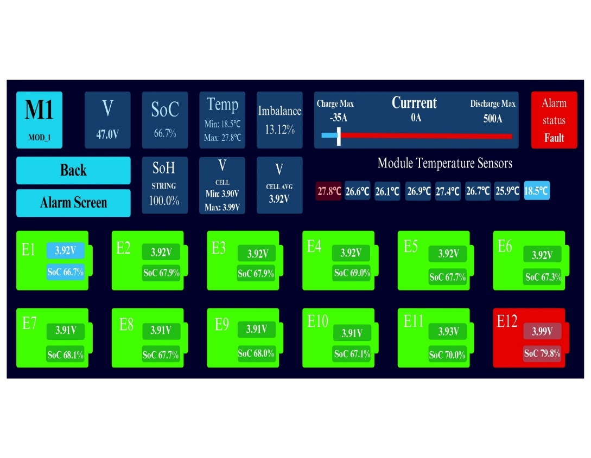Fig.1 The dashboard of the industrial BMS solution.

**3.1 Types of Batteries**

Batteries convert chemical energy into electrical energy, but the materials and technologies used can vary significantly. The following are the five primary types of batteries commonly used in electric vehicles (EVs) today.

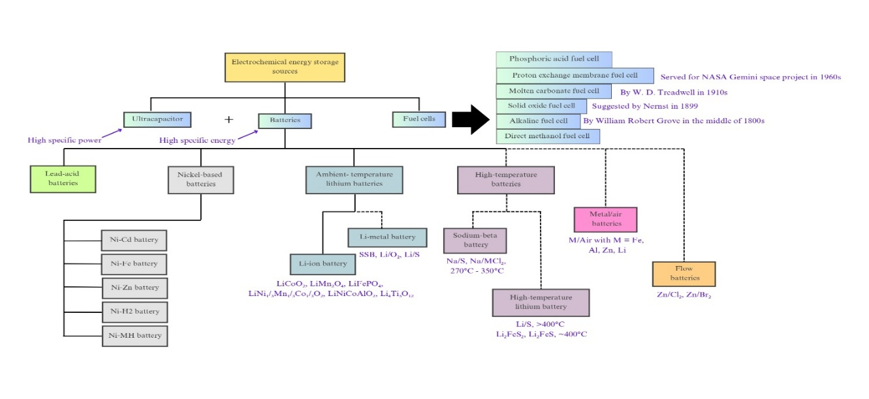

Fig.2 (a) Types of electrochemical energy storage sources.

*3.1.1 Lithium-Ion Batteries*

Lithium-ion (Li-ion) batteries are widely used in modern EVs, laptops, and smartphones due to their high energy density, excellent power-to-weight ratio, and strong thermal stability. Despite their widespread adoption, concerns regarding their environmental impact have driven ongoing research into more sustainable alternatives.

*3.1.2 Nickel-Metal Hydride Batteries*

Nickel-metal hydride (NiMH) batteries are commonly used in hybrid electric vehicles (HEVs). Although they have higher production costs and lower efficiency compared to lithium-ion batteries, they offer greater longevity and are well-suited for applications requiring frequent charging and discharging cycles. Additionally, hybrid vehicles typically use smaller battery packs than fully electric vehicles.

*3.1.3 Lead-Acid Batteries*

Lead-acid batteries are a well-established and cost-effective energy storage solution, primarily used as starter batteries in internal combustion engine (ICE) vehicles. In modern EVs, they are rarely used for primary propulsion but may serve as auxiliary power sources for secondary systems. Compared to newer battery technologies, lead-acid batteries have a shorter lifespan and lower energy density.

*3.1.4 Ultra-Capacitors*

Ultra-capacitors store energy through electrostatic charge separation, rather than chemical reactions. They are not designed to serve as the primary energy source but rather as a supplementary power system, assisting the main lithium-ion battery. Ultra-capacitors are commonly used to boost acceleration and help stabilize power loads in EVs.

*3.1.5 Solid-State Batteries*

Solid-state batteries are expected to be a major breakthrough in EV technology, with widespread adoption anticipated in the coming years. Unlike conventional batteries that use liquid electrolytes, solid-state batteries utilize ceramic or polymer electrolytes, making them more environmentally friendly and significantly improving stability, safety, and energy density. Additionally, this technology promises lower manufacturing costs, with experts estimating a potential 40% reduction in battery production expenses, marking a significant advancement in energy storage solutions.

**Table.1**. Comparison of Battery power density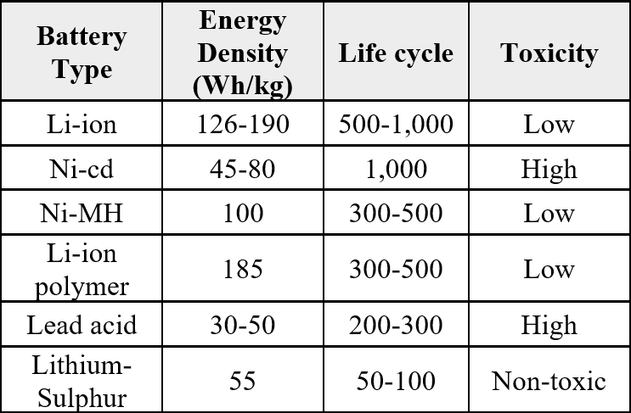

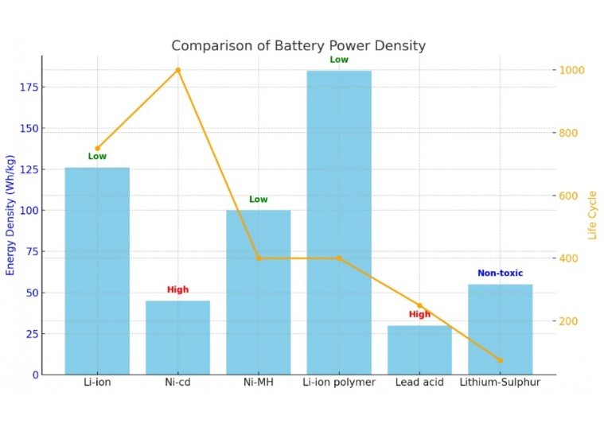  
Fig.2 (b) comparative analysis of battery performance.

**3.2 Battery-Related Issues**

A Battery Management System (BMS) encounters several challenges that can significantly impact the overall performance of an electric vehicle (EV), as illustrated in Figure 3. One of the most critical issues is battery degradation, which occurs due to repeated charge and discharge cycles, leading to a gradual loss of capacity. This degradation reduces the vehicle’s driving range and efficiency over time [15]. Another major concern is overcharging, where a battery exceeds its maximum voltage, resulting in excessive heat generation and a potential risk of thermal runaway. To mitigate this risk, the BMS must carefully regulate charging rates and enforce voltage limits. Similarly, deep discharging—allowing the battery to drop below its recommended voltage—can cause permanent damage, impairing its ability to retain charge and significantly shortening its lifespan [16].

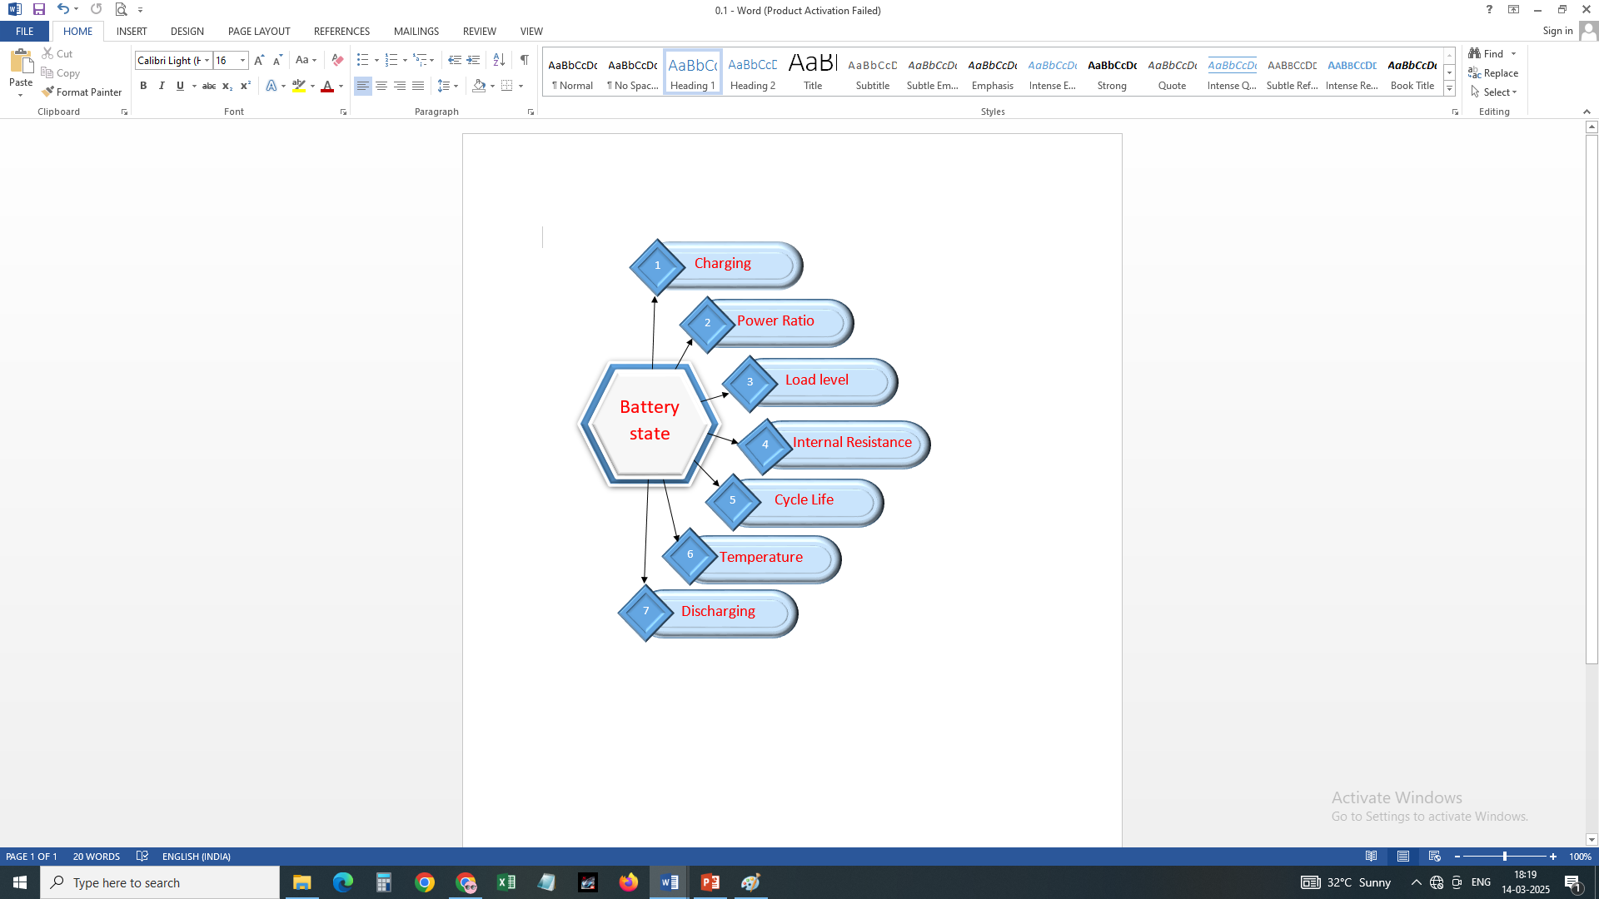

Fig.3. Factors affecting the battery [15]

**Key Challenges in Battery Management**

**1. Thermal Management**

Maintaining optimal battery temperature is essential for efficiency and longevity. Excessive heat accelerates degradation and increases the risk of thermal runaway, while extremely low temperatures can impair battery performance. The BMS must integrate temperature sensors and actively regulate cooling and heating systems to maintain stable operating conditions.

**2. Cell Imbalance**

Individual cells within a battery pack may charge and discharge at different rates, leading to cell imbalance [17]. Uneven charge distribution can reduce battery efficiency and lifespan. The BMS must implement cell balancing techniques, such as passive or active balancing, to ensure uniform charging and improve long-term reliability.

**3. Voltage Fluctuations**

Variations in voltage levels can stress battery systems and degrade performance. The BMS must continuously monitor and regulate voltage to prevent fluctuations that could cause inefficiencies or damage to the battery pack.

**4. Charging Strategy Optimization**

The method of charging significantly impacts battery health. Fast charging generates excess heat, accelerating battery wear, while slow charging is gentler but may be less time-efficient. The BMS must optimize charging protocols to balance efficiency, performance, and longevity.

**5. Fault Detection and Diagnostics**

Advanced fault detection and diagnostics are critical for early identification of battery issues [18]. The BMS should employ real-time anomaly detection algorithms to recognize abnormal temperature spikes, voltage drops, or unexpected performance variations. By issuing early warnings, the system can enable preventive maintenance and minimize the risk of critical failures.

**6. Aging Effects on BMS Accuracy**

As batteries age, their internal resistance increases, and their capacity declines, affecting the accuracy of BMS predictions. The system must adapt its algorithms dynamically to account for these aging effects, ensuring continued precision in state-of-charge (SOC) and state-of-health (SOH) estimations.

**7. Environmental Factors**

External conditions such as humidity, dust, and extreme temperatures can impact battery performance and longevity [19]. The BMS should incorporate protective mechanisms to shield the battery from adverse environmental influences, ensuring stable operation in diverse conditions..

**3.3 Cell Balancing in a Battery Pack**

Variations in State of Charge (SOC), State of Health (SOH), State of Energy (SOE), and State of Power (SOP) among individual cells within a battery pack can lead to inconsistencies in charging levels, voltages, and overall performance. Cell balancing is essential to maintaining uniform charge distribution, optimizing battery capacity, and enhancing overall system efficiency. Imbalances in these parameters can degrade battery performance and reduce lifespan [20]. To achieve balance, cells with lower charge require an increase in charge, current, or voltage, while cells with higher charge must undergo a controlled reduction of these parameters. This balancing process is primarily managed at the hardware level using a charger and monitoring unit, while software algorithms play a crucial role in regulating and optimizing the process. In passive balancing, balancing resistors within the Battery Management System (BMS) circuit dissipate excess energy from overcharged cells as heat, preventing overvoltage conditions. During charging, the first cell to reach full charge is stabilized before allowing subsequent cells to charge, ensuring that no single cell is overcharged. This method maintains a uniform voltage distribution across all cells in the battery pack, improving overall efficiency and longevity.

**3.4 Imbalance in Battery Charging**

Imbalances in lithium-based battery systems arise due to repeated charging and discharging cycles, leading to fluctuations in individual cell charge levels over time. Factors contributing to these imbalances include temperature variations, differences in chemical composition, and variations in initial state of charge. A battery is considered fully discharged when any single cell reaches its minimum discharge limit, regardless of the charge levels of the remaining cells [21].

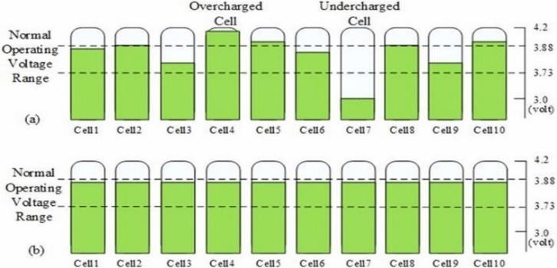

Fig.4. Imbalance vs balanced charging [21]

This imbalance reduces battery lifespan, as the affected cell can no longer support further discharge. Similarly, during charging, if a specific cell (e.g., cell 2) reaches full charge, the entire battery pack must stop charging to prevent damage, as shown in Figure 4. Without proper protection, overcharging other cells can lead to irreversible damage to the fully charged cell. The primary focus of this research is to investigate how the Battery Management System (BMS) addresses these issues through cell balancing, energy optimization, and extended battery lifespan. In electric vehicles (EVs), reliable battery safety diagnostics and fault-handling mechanisms are crucial, as even minor faults can severely impact battery health. BMS integrates SOP hesitated sensors, actuators, and failure detection mechanisms to ensure safe operation.

**a) Sensor and Actuator Failures**

1. **Current Sensor Failures:** Inaccurate current readings can compromise SOC (State of Charge), SOH (State of Health), and RUL (Remaining Usable Life) estimations, leading to incorrect battery diagnostics [22].
2. **Voltage & Temperature Sensor Failures:** Malfunctioning voltage or temperature sensors may disrupt thermal management systems or lead to improper battery balancing, as illustrated in Figure 5.
3. **Actuator Failures:** These include faults in wiring, high-voltage contactors, Controller Area Network (CAN) communication, terminal connectors, and cooling systems. Defective connections can increase resistance, generate excessive heat, and accelerate temperature rise, while poor connections may cause power supply disruptions and potential battery terminal melting, posing safety risks.

**b) Battery Failure Mechanisms**

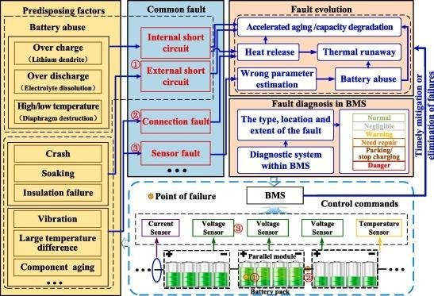 Battery failures can result from overheating, overcharging, deep discharging, internal and external short circuits, swelling, electrolyte leakage, and thermal runaway. Side reactions triggered by overcharging or excessive discharge can lead to battery swelling and electrolyte leakage. Additionally, gas generation during thermal runaway contributes to battery expansion and leakage, further jeopardizing safety. To mitigate these risks, an advanced BMS must integrate real-time monitoring, predictive fault detection, and robust safety measures to ensure battery reliability, performance, and longevity in demanding applications such as electric vehicles and energy storage systems.

Fig.5. Multi-fault detection and diagnosis of battery pack in EV [22]

**3.5 Challenges and Future Prospects**

In automotive applications, high-energy batteries encounter significant challenges related to energy density, rapid charging, and safety. Addressing these challenges is crucial for advancing carbon neutrality and facilitating the transition from gasoline-powered vehicles to electric vehicles (EVs). The effectiveness of electric propulsion depends on achieving high energy density to support both rapid acceleration and extended driving range. Additionally, fast-charging capabilities are essential, with the goal of charging batteries to 80% capacity within minutes. However, ensuring battery safety—while maintaining high energy density—is critical for protecting users and infrastructure [23].

**To overcome these challenges, future battery technologies are expected to evolve in three primary areas:**

1. Lithium-Ion Batteries (LIBs)

2. Lithium-Metal Batteries (LMBs)

3. Post-Lithium Innovations

**3.5.1 Advancements in Battery Technology**

**1. Lithium-Ion Batteries (LIBs):** LIBs are projected to remain the dominant technology for EVs in the near future. For fast-charging applications, lithium titanate-based variants offer long cycle life, although their energy density is lower than other alternatives.

**2. Lithium-Metal Batteries (LMBs):** Lithium-metal anodes are considered promising for next-generation batteries. However, developing practical Li–O₂ (lithium-oxygen) batteries requires extensive research and technological breakthroughs [24].

**3. Sodium-Ion Batteries (SIBs):** Alternative ion-based batteries, such as sodium-ion batteries, are gaining attention due to their competitive performance. These batteries could complement LIBs in future EV applications.

Research is actively exploring various chemical compositions within LIBs, LMBs, solid-state batteries, and non-lithium alternatives (such as sodium and magnesium-based systems). The goal is to develop high-performance batteries with a lifetime of at least 2,000 cycles and over 10 years of operational use, making them suitable for EV applications [25].The future of Battery Management Systems (BMS) will be significantly improved by sensor-on-chip technology, enhancing their ability to monitor, manage, and optimize battery performance.

**4. ADVANCED METHODS IN BATTERY MANAGEMENT SYSTEMS (BMS)**

**4.1 State of Charge (SOC) Estimation**

The State of Charge (SOC) represents the ratio of a battery's remaining capacity to its theoretical total capacity, expressed as a percentage using the equation:

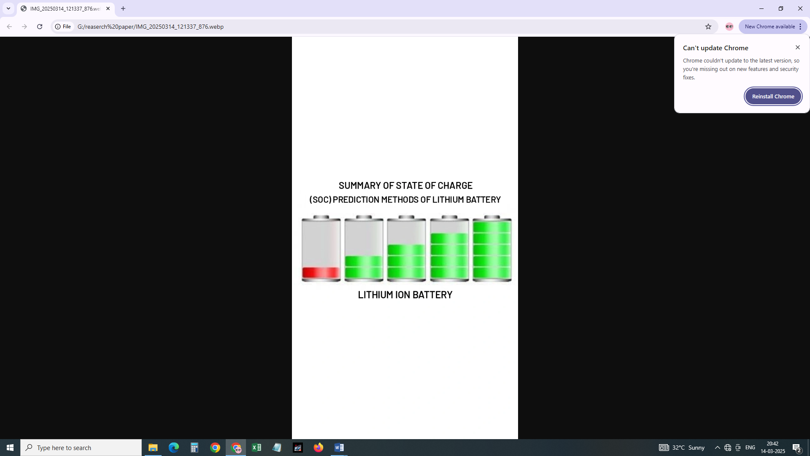Q remaining SOC = Q total*100%

Fig.6. State of charge [26]

SOC cannot be directly measured as a physical quantity; however, accurate estimation is crucial to ensure the battery system operates at optimal capacity and provides a precise assessment of the remaining driving range [26]. Additionally, SOC plays a key role in Battery Management System (BMS) functions, such as State of Health (SOH) evaluation, State of Power (SOP) estimation, charge flow regulation, and battery balancing [26].

Since the 1980s, SOC estimation accuracy has improved significantly. Modern onboard BMS systems employ various methods for SOC estimation, including:

1. Ampere-hour integration
2. Lookup tables
3. Model-based estimation approaches

Each of these techniques enhances battery system performance and management, as illustrated in Figure 6.

**4.2 State of Health (SOH) Prediction**

The State of Health (SOH) indicates a battery's current charge-holding capacity relative to a new battery. It provides insights into the battery’s ability to meet operational demands and helps determine when a battery replacement may be necessary.

Various techniques for SOH prediction in lithium-ion batteries include:

1. Feed-forward algorithms
2. Regression and probabilistic models
3. Recurrent neural networks (RNNs)
4. Entropy-based approaches [27]

A 100% SOH represents a brand-new battery, while SOH gradually decreases over time due to aging and degradation. Monitoring SOH is essential for evaluating battery condition and predicting replacement intervals, as depicted in Figure 7.

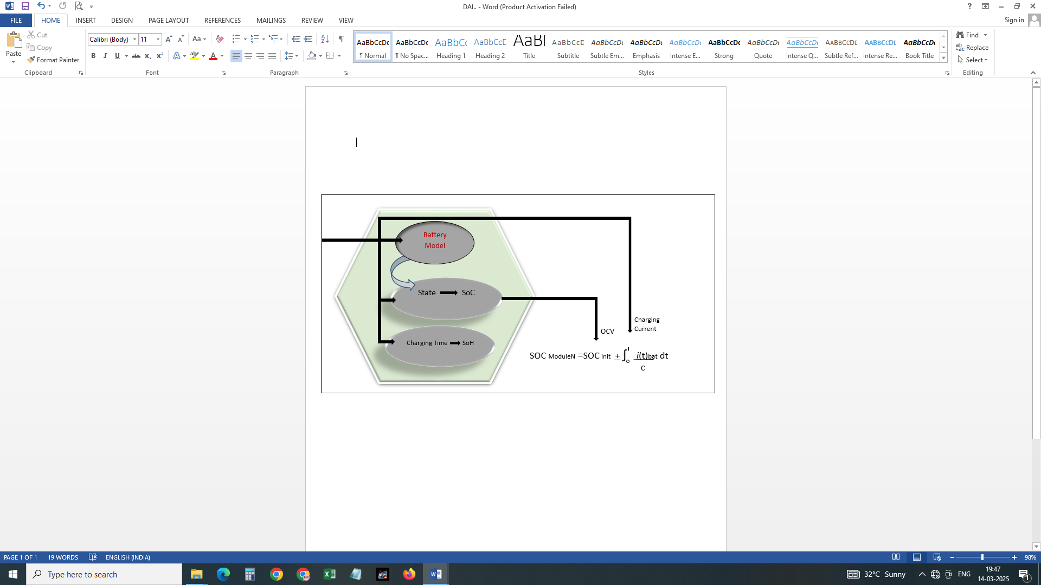Fig.7. State of health prediction [27]

**4.3 State of Energy (SOE) Estimation**

The State of Energy (SOE) represents the remaining usable energy of a battery relative to its maximum capacity [28]. It is assessed by analyzing the entire charge and discharge cycle of the battery. Figure 8 illustrates the method used for SOE estimation.

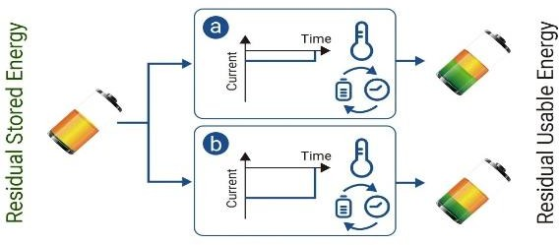

Fig.8 Tracking the battery’s remaining available energy and its maximum available energy [28]

**4.4 State of Power (SOP) Assessment**

The State of Power (SOP) refers to the maximum available power of a battery for a specific application. It is influenced by:

1. Discharge rate
2. Operating voltage
3. Temperature conditions

SOP is calculated using the equation: P = U * I

where P represents power, U denotes operating voltage, and I is the maximum discharge current. As the battery degrades, its rated current capacity fluctuates, causing variations in SOP. Accurate SOP estimation improves BMS performance, ensuring efficient battery utilization and enhanced system reliability, as shown in Figure 9 [29].

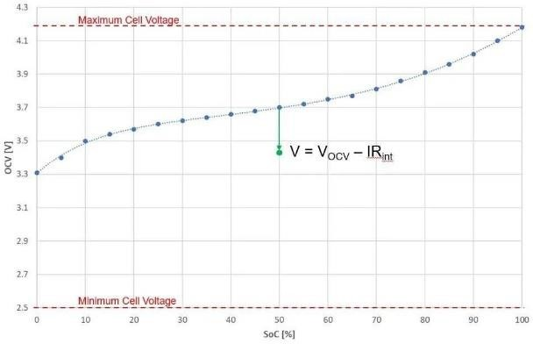

Fig.9. Behaviour of battery under State-of-power observation [29]

**4.5 Self-Discharge Algorithm**

Self-discharge occurs when a battery is left in an open-circuit condition, leading to a gradual loss of capacity. The self-discharge rate (SDR) indicates the battery’s ability to retain charge under varying conditions. Self-discharge can be classified into two categories:

1. **Irreversible self-discharge**: Results in a permanent loss of capacity that cannot be recovered in subsequent charge cycles.
2. **Reversible self-discharge**: Allows capacity to be restored in subsequent charge cycles. Batteries exhibiting reversible self-discharge have a higher charge capacity than discharge capacity within a single cycle, often caused by metal impurities or manufacturing defects [30].

Self-discharge rates can lead to State of Charge (SOC) inconsistencies, accelerating capacity degradation in battery packs. Traditional methods for measuring series cell self-discharge rate (SDR) include:

1. Direct capacity measurement
2. Open-circuit voltage (OCV) monitoring
3. Voltage drift analysis

In the capacity measurement method, the battery is charged to a specified SOC, stored for several days, and then evaluated for capacity variations. Figure 10 illustrates the impact of self-discharge on battery performance.

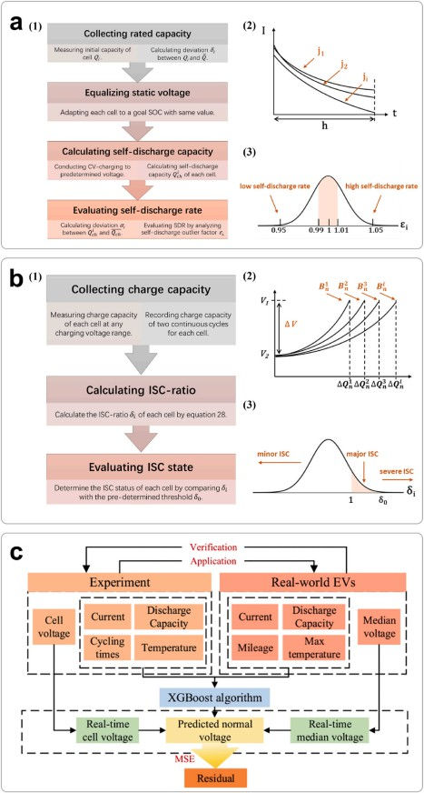

Fig.10 (a) Optimised SDR detection technique schematic

(b) Proposed ISC detection method schematic

(c) XGBoost-based voltage prediction technique and results.

**4.6 Thermal Management**

Battery temperature regulation is critical for optimizing electric vehicle (EV) performance and longevity. High temperatures can cause thermal runaway, a self-sustaining exothermic reaction that leads to rapid battery failure. When battery temperatures exceed 90°C, critical components such as the electrolyte, cathode, and solid electrolyte interface (SEI) layer begin to degrade. Among lithium-ion batteries, LiFePO4 (Lithium Iron Phosphate) is known for its exceptional thermal stability, generating less heat compared to other battery chemistries. Studies indicate that for every 1°C rise in temperature within the range of 30°C to 40°C, battery lifespan is reduced by approximately two months.

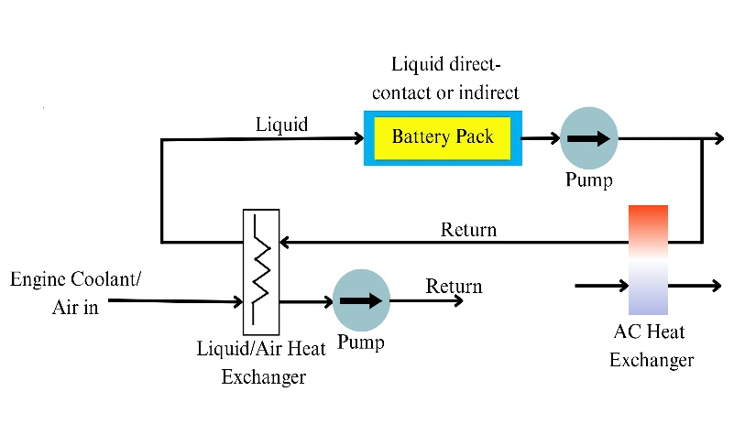Fig11. Schematic of active thermal management system

A well-designed Thermal Management System (TMS) is essential to maintaining optimal operating temperatures, as depicted in Figure 11. The TMS continuously monitors and regulates battery temperature, ensuring that each cell functions within a safe threshold. If the temperature exceeds predefined limits, the TMS activates heating or cooling mechanisms to prevent overheating, safeguard battery integrity, and ensure secure operation. Effective thermal management significantly reduces performance degradation and safety risks.

**4.7 Remaining Useful Life (RUL) Prediction**

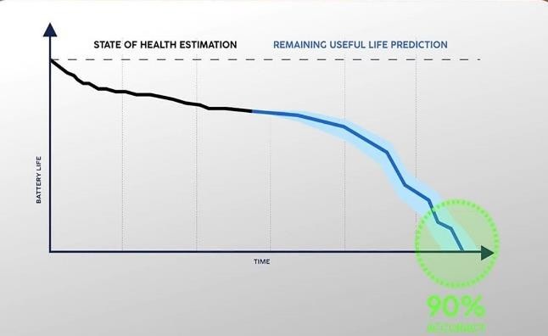The Remaining Useful Life (RUL) of a battery cell estimates the number of charge-discharge cycles or the time period it will continue to function effectively, as illustrated in Figure 12. Accurate RUL prediction is crucial for real-time decision-making, including fault detection, maintenance planning, and optimizing battery utilization.

Fig.12. Accuracy Remaining useful life prediction [32]

However, predicting RUL is challenging due to various uncertainties that influence battery performance over time. Several methodologies are used for RUL estimation, categorized into:

1. Machine learning algorithms
2. Time-series analysis
3. Statistical data-driven models
4. Monte Carlo simulations
5. Hybrid modeling approaches

By leveraging these advanced techniques, BMS can enhance battery longevity, minimize unexpected failures, and improve operational efficiency [32].

**5. INTEGRATION OF IOT AND CLOUD COMPUTING TECHNOLOGIES IN BATTERY MANAGEMENT SYSTEMS (BMS)**

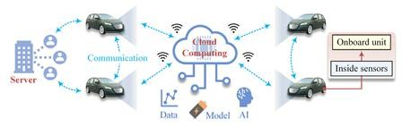In Battery Management Systems (BMS), cloud storage, cloud computing, and big data platforms enhance AI-driven algorithms, controller performance, and overall system reliability. Figure 13 illustrates how big data technologies facilitate advanced analytics while providing extensive storage, processing, and monitoring capabilities. These technologies enable real-time tracking of critical battery parameters such as State of Charge (SOC), State of Health (SOH), Remaining Useful Life (RUL), thermal runaway, and fault detection, ensuring improved efficiency and safety throughout the battery's lifecycle [33]. Once data is collected, it undergoes pre-processing before being analyzed by the battery monitoring and control center. This analysis provides actionable insights and recommendations for future system improvements. However, integrating IoT with cloud computing presents challenges related to security, privacy, interoperability, scalability, data management, communication protocols, and regulatory compliance. Addressing these challenges requires careful research and strategic implementation

Fig.13. Integration of IoT and Cloud Computing [33]

The Internet of Things (IoT) enables seamless data transmission to the cloud, facilitating the development of digital twins for battery systems. These digital models allow continuous monitoring of battery charge levels and aging processes using predictive analytics. The performance and reliability of cloud-based BMS have been validated through real-world testing in both stationary and mobile applications. Although various studies have proposed energy scheduling methods that leverage cloud computing, they often face obstacles such as high CPU disk space requirements, local storage limitations, and complex network configurations [34]. An alternative approach, Power Generation Control and Energy Management (PGCEM), employs a static, multi-metric machine learning framework to enhance energy scheduling efficiency. Figures 14, 15, and 16 illustrate the Intelligent Cloud Computing for Power Generation Control and Energy Management (ICC-PGCEM) system. This framework integrates energy generation monitoring, energy storage systems, energy consumption sensors, and real-time energy usage analysis [35]. In this architecture, most data processing occurs in the cloud, with IoT sensors transmitting information via various communication protocols. The choice of communication technologies depends on multiple factors, including network infrastructure, data transmission efficiency, and security requirements. By leveraging IoT and cloud computing, modern BMS solutions can achieve enhanced efficiency, real-time monitoring, predictive maintenance, and improved energy management, ultimately extending the lifespan and reliability of battery systems.



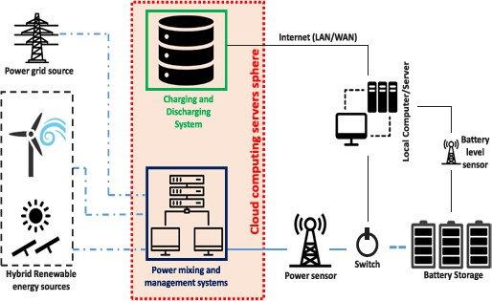Fig.14. Battery-powered cloud computing [34]

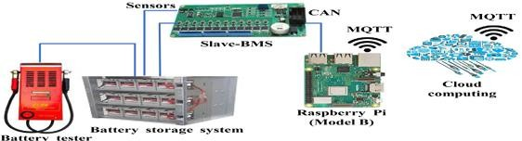Fig.15. Cloud computing framework to extend battery life

Fig.16 Unified Li-ion and lead-acid battery testing bench with cloud-based BMS prototype for SOC, DoD, and SOH algorithms [35]

**6. MACHINE LEARNING METHODS FOR BATTERY MANAGEMENT SYSTEMS (BMS)**

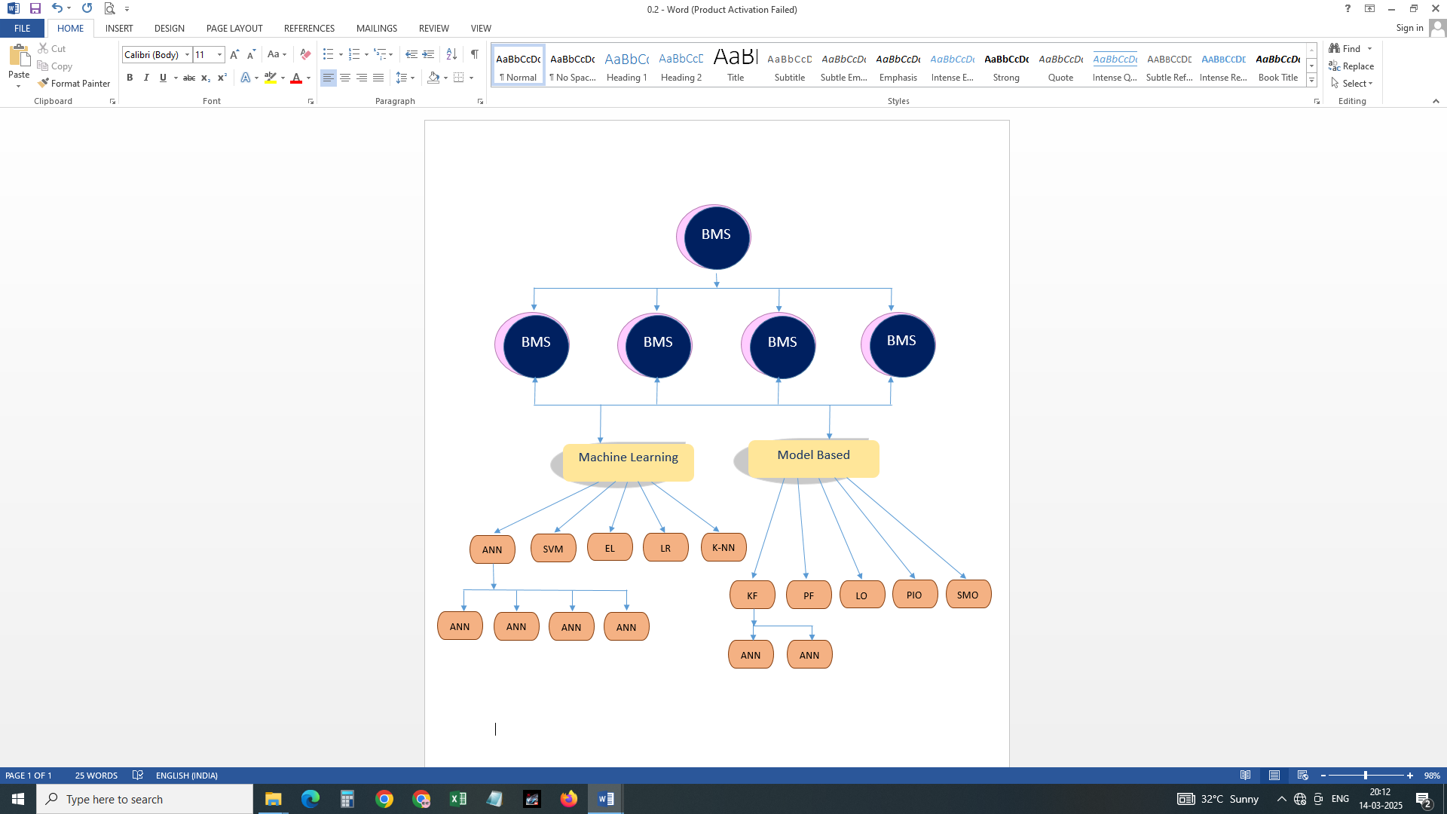Artificial Neural Networks (ANNs) are designed to mimic the way the human brain processes information. An ANN consists of an input layer, one or more hidden layers, and an output layer. The ANN operates through the following stages:

Fig.17. Different BMS algorithm [36]

The input layer receives data and transmits it to the first hidden layer. Each neuron in the hidden layer computes a weighted sum of inputs, applies an activation function, and passes the result to the next hidden layer. This process continues across multiple hidden layers until the output layer generates the final prediction or result. This architecture enables ANNs to perform effectively across diverse applications, making them valuable tools for solving complex problems [36]. Figure 17 illustrates how ANNs' computational operations are categorized into neural networks and deep learning algorithms based on their structure and depth. Accurate State of Charge (SOC) estimation is essential for efficient battery management. Traditional SOC estimation techniques, such as Coulomb counting, suffer from inaccuracies due to measurement errors, battery aging, and temperature fluctuations. In contrast, Neural Networks (NNs) can model complex relationships between battery parameters and SOC, providing more reliable and precise predictions even in the presence of noise and uncertainties. Neural networks can be trained on large-scale datasets containing battery performance and degradation information. This capability is crucial for predicting battery lifespan, which is essential for ensuring battery system safety and reliability. Traditional optimization methods rely on basic heuristics and often fail to capture intricate correlations between battery characteristics and charging/discharging conditions.

**Several advanced neural network architectures enhance BMS performance:**

Convolutional Neural Networks (CNNs), widely used in image processing, contain multiple hidden units in convolutional layers but fewer in their fully connected layers.

Recurrent Neural Networks (RNNs), designed for sequence prediction, use a variable number of hidden units depending on the complexity and length of the input sequence.

**6.1 Feedforward Neural Network (FFNN)**

As illustrated in Figure 18, the Feedforward Neural Network (FFNN) is a fundamental type of artificial neural network (ANN), where data flows in a single direction—from input to output nodes—through one or more hidden layers. This structure ensures a unidirectional information flow, eliminating cycles and feedback loops within node connections [37-38].

The performance and effectiveness of an FFNN depend on several factors:

1. Number of layers in the network
2. Number of neurons per layer
3. Activation functions used for processing inputs

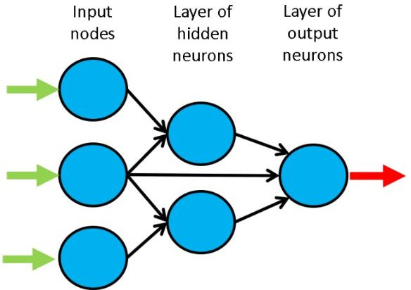

Fig.18. basic Feed-forward Neural Network [37]

Due to its ability to model complex input-output relationships, FFNNs are widely employed in classification, prediction, and feature extraction tasks. However, a primary drawback of FFNNs is their slow learning rate, which results from the gradient-based learning techniques used for training. This issue arises due to the need for repeated adjustment of network parameters, making the training process computationally intensive. In battery management applications, FFNNs are used for analyzing battery voltage during charging, significantly reducing error margins and computational requirements. FFNNs can also estimate the State of Health (SOH) by establishing upper and lower limits based on discharge voltage entropy, which incorporates local voltage variations and battery degradation trends [39]. To enhance model generalization, imposing monotonic input feature constraints on FFNNs can improve their performance. Advanced FFNN architectures may outperform conventional estimation methods. By integrating FFNNs with battery models, it is possible to achieve simultaneous SOC and SOH estimation, reducing training time and avoiding local minima during optimization. This hybrid approach has proven effective in low-power embedded systems, where FFNNs are used to predict the SOC of lithium-ion battery cells in electric vehicles, ensuring enhanced efficiency and reliability in battery management.

**6.2 Deep Neural Network (DNN)**

Artificial Neural Networks (ANNs) play a crucial role in Deep Learning (DL) by enabling the identification of complex data patterns. This capability is particularly valuable in battery management, where it facilitates accurate assessment of the State of Health (SOH) across varying initial SOC levels and C-rate conditions, as illustrated in Figure 19. The SOH is typically categorized into five stages, ranging from 100% to 80% [40].

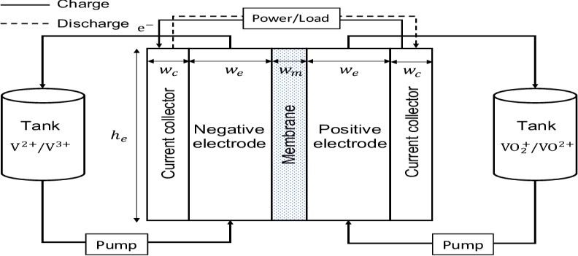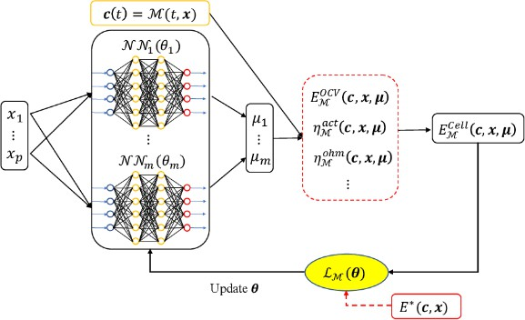

Fig.19. Constrained deep neural network method [40]

In battery management, the first-order derivative of the discharge curve is often utilized for SOH estimation. Deep Neural Networks (DNNs) enhance this estimation process by optimizing predictive accuracy. Various DNN architectures and training algorithms have been developed to improve State of Charge (SOC) estimation and battery management strategies for lithium-ion batteries.

Different DNN models employ varying numbers of hidden layers for SOC estimation in electric vehicles (EVs). Studies indicate that increasing the number of layers generally reduces the error rate, leading to more precise SOC predictions [41-42]. This improvement is particularly beneficial when training data is collected from lithium-ion batteries subjected to drive cycle loads under fluctuating ambient temperatures, enhancing estimation accuracy across diverse temperature conditions. Furthermore, modern DNN models help prevent overcharging and over-discharging of lithium-ion batteries, resulting in faster convergence and more accurate SOC assessments [43]. Beyond electrical parameters, non-electrical characteristics have also been explored for SOC estimation. These approaches analyze capacity degradation over prolonged charge/discharge cycles, leveraging DNNs to predict the Remaining Useful Life (RUL) based on varying charge and discharge parameters. By integrating DNN-based methodologies, battery management systems can achieve higher accuracy, improved lifespan estimation, and greater reliability, making them essential for next-generation EV battery technologies.

**6.3 Convolutional Neural Network (CNN)**

Battery Management Systems (BMS) are increasingly leveraging Convolutional Neural Networks (CNNs) for state estimation and prediction. CNN architectures consist of convolutional layers, pooling layers, and fully connected layers, which work together to extract and process essential features from battery data. As illustrated in Figure 20, CNNs operate as multilayer perceptron’s, where each neuron is connected to the next layer, facilitating efficient feature learning.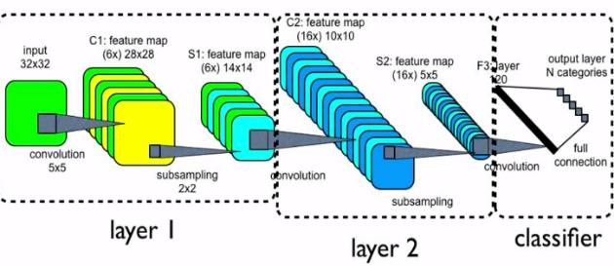 CNNs are particularly effective in estimating the State of Health (SOH) of Lithium-Ion Batteries (LIBs) by analyzing voltage, current, and charging capacity during partial charge cycles [44-45]. Compared to traditional methods, CNN-based approaches optimize memory

Fig.20. Convolutional Neural Network [44]

usage, enhance prediction accuracy, and accelerate computation speed. With STM32Cube.AI, pre-trained CNN models can be deployed on microcontrollers, enabling real-time SOH estimation, even under uncertain aging conditions and challenging operational environments. Recent studies have explored one-dimensional CNN algorithms to assess the impact of noise on state estimation and proposed transfer learning techniques for electric vehicles. CNNs also play a significant role in Remaining Useful Life (RUL) estimation, a critical component of predictive maintenance across various industries. These models fine-tune hyperparameters to optimize performance, improving BMS reliability and efficiency. Furthermore, CNN-based methodologies can identify and categorize defective battery sensor and communication data, enhancing Battery Energy Storage System (BESS) safety. Research indicates that CNN-driven models achieve 95.31% accuracy in detecting faulty battery balancing circuits, with a high F1 score, making them a powerful tool for battery diagnostics and fault detection.

**6.4 Recurrent Neural Network (RNN)**

Recurrent Neural Networks (RNNs) extend the capabilities of Feed forward Neural Networks (FFNNs) by incorporating sequential memory processing, allowing them to retain and utilize temporal dependencies in time-series data. As illustrated in Figure 21, RNNs are particularly effective in handling sequential data for battery state estimation and predictive analytics.

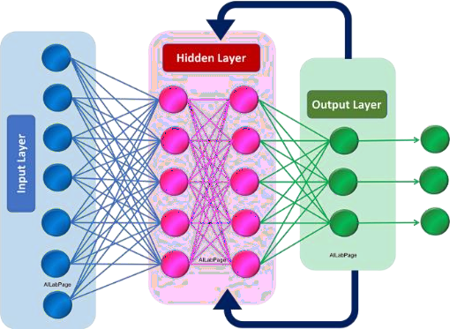Fig.21. Recurrent Neural Network [46]

However, RNNs face challenges in maintaining long-term dependencies, a problem known as the vanishing gradient issue [46]. To address this, advanced optimization techniques, such as sparse sampling, are employed to manage signal complexity and improve learning efficiency. These methods enable accurate representation of battery characteristics while minimizing data requirements. One of the most effective variations of RNNs is the Long Short-Term Memory (LSTM) network, which enhances model performance by improving gradient stability and capturing long-term dependencies. When applied to lithium-ion battery modeling and SOC estimation, time-delayed RNNs accurately capture complex non-linear battery behavior, making them essential for predicting capacity degradation and ensuring long-term battery health monitoring [47]. Beyond battery applications, RNNs are also utilized in aero-engine RUL estimation, enabling advanced health diagnostics in critical systems. By leveraging RNN-based architectures, BMS can achieve superior performance in battery state prediction, fault detection, and predictive maintenance, ensuring optimal efficiency and reliability across diverse energy storage applications.

**6.5 Machine Learning Algorithms for Battery Management System**

The widespread deployment of sensor technology and the rapid advancement of Internet of Things (IoT) devices have significantly improved data collection capabilities, enabling a more precise digital representation of battery behavior. As a result, machine learning techniques such as Support Vector Machines (SVMs), Radial Basis Functions (RBFs), and Recurrent Neural Networks (RNNs) are gaining prominence in Battery Management Systems (BMS) [48].

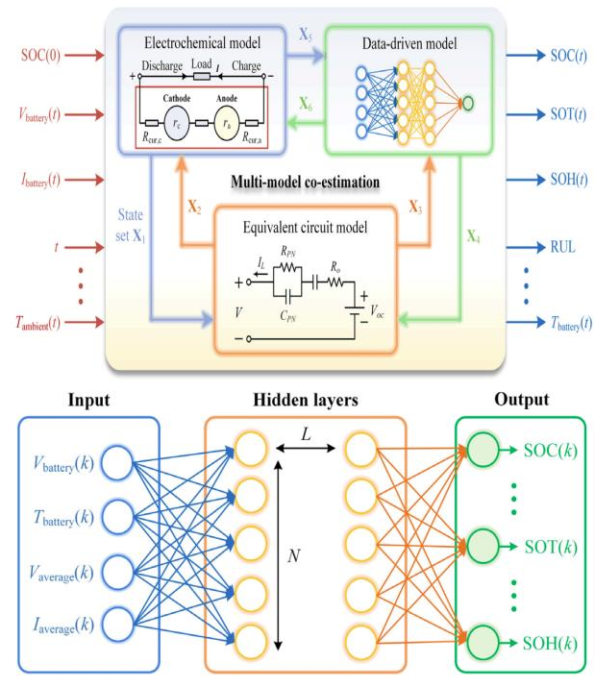

Fig.22. Estimating battery status using neural network [48]

The integration of Artificial Intelligence (AI) into BMS presents a transformative opportunity for developing a battery digital twin, a SOPhisticated system that enables highly accurate and efficient battery state estimation, as illustrated in Figure 22. Research has demonstrated the effectiveness of AI-driven approaches, including:

1. Artificial Neural Networks (ANNs) for predicting lithium-ion battery temperature
2. Genetic algorithms and advanced optimization techniques for managing State of Charge (SOC)
3. Deep Neural Network (DNN) architectures for precise battery state estimation

These AI-powered methodologies are expected to significantly enhance the future performance of BMS, improving efficiency, reliability, and predictive capabilities [49].

However, the implementation of machine learning in BMS introduces multidisciplinary challenges, including:

1. Data security concerns
2. Reliable data communication protocols
3. Scalability and interoperability

Addressing these challenges will require technological advancements in secure data transmission, communication networks, and intelligent algorithms, as depicted in Figure 23. Overcoming these hurdles will be essential for realizing the full potential of AI-driven battery management systems, ensuring optimal performance and longevity of energy storage solutions in various applications.

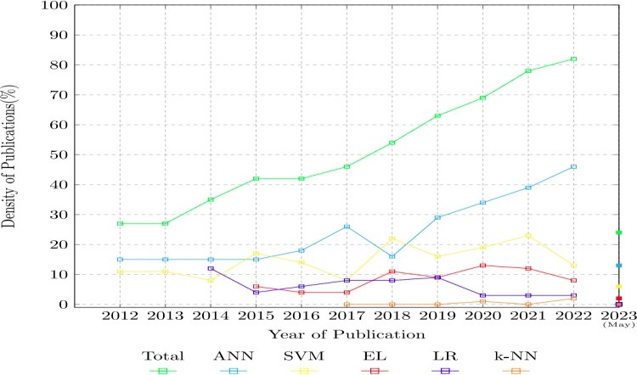

Fig.23. Statistics of WoS indexed publications on Machine Learning based BMS [49]

**7. BMS ISSUES AND CHALLENGES**

**7.1 Algorithmic Challenges in Battery Management Systems (BMS)**

Despite the advancements in intelligent computing approaches, several algorithmic limitations hinder the effectiveness of Battery Management Systems (BMS). Feedforward Neural Networks (FNNs) demonstrate strong performance, but their applicability is constrained by limited computational capacity and execution speed. Regression and probabilistic models help mitigate noise and uncertainty, but they struggle with high-dimensional and non-linear systems. Deep learning techniques provide accurate predictions for State of Charge (SOC), State of Health (SOH), and Remaining Useful Life (RUL); however, they demand large, high-quality datasets and significant computational resources. Optimization algorithms enhance machine learning and deep learning models, but they face challenges such as:

1. Local minima issues
2. Restricted search capabilities
3. Difficulty in selecting optimal parameters

**Other key computational techniques and their limitations include:**

1. Entropy-based calculations, which are effective in assessing signal complexity but require high computational power.
2. Monte Carlo (MC) methods, which are useful for handling probabilistic distributions and complex uncertainty modeling, yet are computationally intensive.
3. Statistical data-driven approaches, which perform well under noisy conditions and degradation but suffer from slow convergence due to intensive mathematical computations.
4. Fuzzy controllers, known for their robustness and adaptability, require extensive domain knowledge and expertise for optimal operation.
5. Model Predictive Control (MPC) improves transient response management and can handle multiple variables simultaneously, but its complexity and high computational demand pose significant challenges.

Addressing these algorithmic limitations is crucial for advancing next-generation BMS solutions that balance accuracy, efficiency, and computational feasibility.

**7.2 Implementation Challenges in Battery Management Systems (BMS)**

The implementation of a Battery Management System (BMS) presents several challenges that directly impact its performance, reliability, and safety.

**Key Implementation Challenges:**

**1. Accurate State of Charge (SOC) and State of Health (SOH) Estimation.**

Precise monitoring of voltage, current, temperature, and battery lifespan is essential.

Variations in cell manufacturing, individual cell characteristics, and environmental conditions complicate accurate assessments.

**2. Cell Balancing and Protection.**

Preventing overcharging and deep discharging is crucial to maintaining battery performance and safety.

Effective cell balancing techniques must be employed to ensure uniform charge distribution.

**3. Thermal Management.**

Batteries operate optimally within specific temperature ranges; exceeding these limits can cause performance degradation or safety hazards.

A well-designed thermal management system is required to prevent overheating or excessive cooling.

**4. System Integration and Compatibility.**

The BMS must seamlessly interact with other electrical and electronic systems in vehicles or devices.

Hardware and software modifications may be necessary, increasing development time and cost.

**5. Regulatory Compliance and Safety Standards.**

Ensuring compliance with industry regulations and safety protocols demands extensive testing and validation. Meeting these standards is critical to ensuring battery efficiency, reliability, and longevity in applications such as electric vehicles and other battery-powered technologies Addressing these implementation challenges is essential for advancing BMS technology, improving battery safety, and optimizing energy efficiency across various applications.

**7.3 Data Abundance and Data Integration Challenges in Battery Management Systems (BMS)**

The Battery Management System (BMS) generates and processes vast amounts of data from multiple sensors measuring voltage, current, and temperature in modern battery packs. Managing this extensive data efficiently poses significant challenges in terms of real-time processing, storage, and system integration.

**Key Data Challenges in BMS:**

**1. High Data Volume and Real-Time Processing**

Modern battery packs produce large volumes of sensor data, requiring advanced processing and storage solutions to support real-time analytics and operational decision-making.

**2. Diversity and Complexity of Data**

The BMS must integrate multiple data types, such as raw sensor outputs, derived metrics (State of Charge (SOC), State of Health (SOH)), and environmental conditions.

Efficiently correlating temperature data with voltage and current measurements is essential for thermal management and overheating prevention.

**3. Adaptive System Design for Battery Optimization**

The system must adapt to environmental factors and leverage machine learning algorithms to refine battery lifespan predictions and charging strategies.

**4. System Integration and Compatibility**

Ensuring data consistency across various hardware and software components is crucial for seamless system operation. Proper data handling is required for cell balancing, fault detection, and safety monitoring. To enhance battery performance, reliability, and longevity, the BMS must employ advanced data analytics, robust computational frameworks, and intelligent machine learning models for effective data interpretation and utilization.

**7.4 Challenges in Battery Management Systems (BMS)**

The accuracy of state estimation in Battery Management Systems (BMS) is influenced by multiple factors, including battery chemistry, aging cycles, thermal runaway risks, capacity degradation, and charging inconsistencies. Variations in battery composition affect estimation precision, even when using advanced computational models. Different battery chemistries exhibit distinct performance characteristics that influence state estimation accuracy. For instance, Lithium Iron Phosphate (LiFePO₄ or LiFP) batteries are cost-effective and secure, whereas Lithium Titanate (LiTO) batteries offer superior longevity. Studies using the Nonlinear Auto-Regressive Exogenous (NARX) method report Root Mean Square Errors (RMSE) of 0.53% for LiFP batteries and 0.7% for LiTO batteries, indicating chemistry-specific variations in performance. Battery aging cycles alter internal resistance, capacitance, electrode structure, and the solid electrolyte interphase (SEI) layer, complicating accurate state estimation. State of Charge (SOC), State of Health (SOH), and Remaining Useful Life (RUL) predictions become more challenging as batteries degrade. Generalized Particle Filter (GPF) models for RUL prediction have shown RMSE values of 1.58% at 60 cycles and 1.3% at 80 cycles, highlighting the impact of battery aging on estimation accuracy. As SOC increases and aging progresses, factors such as mechanical and electrical stress, lithium plating, overcharging, internal short circuits, and exothermic reactions elevate the risk of thermal runaway. Models have been developed to mitigate these risks by monitoring anode degradation, SEI layer stability, and electrolyte breakdown beyond 90°C. Additionally, discharge cycles degrade the active materials within batteries, leading to capacity loss and reduced power output. Increased internal resistance and declining operating voltage further reduce efficiency. Operating temperatures above 45°C, prolonged aging cycles, and excessive voltage accelerate battery deterioration. Furthermore, charging process optimization plays a critical role in battery longevity. Fast charging can overheat batteries, while slow charging may limit charging efficiency. Charge imbalances caused by manufacturing inconsistencies, material defects, and resistance variations can impact BMS state estimation and safety. Effective charge balancing algorithms enhance computational accuracy, system reliability, and battery longevity.

**8. CONCLUSION**

The advancement and widespread adoption of electric vehicles (EVs) depend on the continuous development and integration of modern Battery Management Systems (BMS). As EV battery technologies become increasingly complex and demanding, next-generation BMS solutions must be capable of accurately predicting State of Charge (SOC), State of Health (SOH), and Remaining Useful Life (RUL) under dynamic operating conditions. According to this study, the application of artificial intelligence (AI) and machine learning significantly enhances the accuracy and reliability of these estimations. Furthermore, robust fault detection algorithms integrated within the BMS improve battery safety and longevity by identifying potential failures at an early stage. To maintain optimal battery performance and safety, advancements in cooling techniques and thermal management materials are essential. Additionally, the integration of cloud computing and the Internet of Things (IoT) enhances BMS capabilities by enabling real-time monitoring and predictive maintenance, ensuring improved operational efficiency. In conclusion, ongoing research and innovation in BMS technology are crucial for addressing the evolving demands of the EV industry. By adapting to emerging battery technologies and supporting sustainable transportation, advanced BMS solutions will play a pivotal role in shaping the future of electric mobility.

**REFERENCES**

1. Ueda, M., Hirota, T., & Hatano, A. "Challenges of Widespread Commercial Adoption of Electric Vehicles—Towards a Zero-Emission Mobility SOCiety." SAE Technical Paper, 2010.
2. Vidal, C., Malysz, P., Kollmeyer, P., & Emadi, A. "Machine Learning Applied to Electrified Vehicle Battery State of Charge and State of Health Estimation: State-of-the-Art." IEEE Access, vol. 8, 2020, pp. 52796–52814.
3. Waag, W., & Sauer, D. U. "Adaptive Estimation of the Electromotive Force of Lithium-Ion Batteries Following Current Interruption for Accurate State-of-Charge and Capacity Determination." Applied Energy, vol. 111, 2013, pp. 416–427.
4. Wang, Q. "Battery State of Charge Estimation Based on Multi-Model Fusion." Chinese Automation Congress (CAC), 2019, pp. 2036–2041.
5. Wang, Y., Chen, Z., & Zhang, C. "On-Line Remaining Energy Prediction: A Case Study in Embedded Battery Management Systems." Applied Energy, vol. 194, 2017, pp. 688–695.
6. Wang, Z., & Du, C. "A Comprehensive Review on Thermal Management Systems for Power Lithium-Ion Batteries." Renewable and Sustainable Energy Reviews, vol. 139, 2021, 110685.
7. Wang, Q., Jiang, B., Li, B., & Yan, Y. "A Critical Review of Thermal Management Models and Solutions for Lithium-Ion Batteries in the Development of Pure Electric Vehicles." Renewable and Sustainable Energy Reviews, vol. 64, 2016, pp. 106–128.
8. Wang, D., Li, X., Wang, J., Zhang, Q., Yang, B., & Hao, Z. "Lithium-Ion Battery Equivalent Model Across Full-Range State of Charge Based on Electrochemical Process Simplification." Electrochimica Acta, vol. 389, 2021, 138698.
9. Wang, C. C., Lu, W. J., & Wang, S. S. "An On-Chip High-Voltage Current Sensor for Battery Module Monitoring." IEEE International Conference on IC Design & Technology, 2014, pp. 1–4.
10. Wang, Y., Tian, J., Sun, Z., Wang, L., Xu, R., Li, M., et al. "A Comprehensive Review of Battery Modeling and State Estimation Approaches for Advanced Battery Management Systems." Renewable and Sustainable Energy Reviews, vol. 131, 2020, 110015.
11. Wang, H. F., & Xu, Q. "Materials Design for Rechargeable Metal-Air Batteries." Matter, vol. 1, 2019, pp. 565–595.
12. Wang, P., Zhang, X., Yang, L., Zhang, X., Yang, M., & Chen, H. "Real-Time Monitoring of Internal Temperature Evolution in Lithium-Ion Coin Cell Batteries During Charging and Discharging." Extreme Mechanics Letters, vol. 9, 2016, pp. 459–466.
13. Wei, S., Xu, S., Agrawal, A., Choudhury, S., Lu, Y., & Tu, Z. "A Stable Room-Temperature Sodium–Sulfur Battery." Nature Communications, vol. 7, 2016, 11722.
14. Whittingham, M. S. "Electrical Energy Storage and Intercalation Chemistry." Science, vol. 192, 1976, pp. 1126–1127.
15. Whittingham, M. S. "Lithium Batteries and Cathode Materials." Chemical Reviews, vol. 104, 2004, pp. 4271–4302.
16. Whittingham, M. S. "History, Development, and Future Status of Energy Storage." Proceedings of the IEEE, vol. 100, 2012, pp. 1518–1534.
17. 17Ranjith Kumar, G., & Prasad, K. N. V. "Minimization of Torque Ripple in BLDC Motors Using a Current Controller with Multilevel Inverters." Procedia Engineering, vol. 38, 2012, pp. 3113–3121. doi: 10.1016/j.proeng.2012.06.362
18. Wong, Y. S., & Chan, C. C. "Vehicle Energy Storage: Batteries." Springer, 2012.
19. Wu, S.-L., Chen, H.-C., & Tsai, M.-Y. "AC Impedance-Based Online State-of-Charge Estimation for Li-Ion Batteries." Sensors and Materials, vol. 30, 2018, pp. 539–550.
20. Wu, Y., Wang, W., Ming, J., Li, M., Xie, L., He, X., et al. "Investigation of a New Energy Storage System: High Energy Density, High Safety, and Fast Charging Lithium-Ion Batteries." Advanced Functional Materials, vol. 29, 2019, 1805978.
21. Wu, B., Widanage, W. D., Yang, S., & Liu, X. "Battery Digital Twins: Perspectives on the Integration of Models, Data, and Artificial Intelligence for Smart Battery Management Systems." Energy AI, vol. 1, 2020, 100016.
22. Gireesh Kumar, D., Sireesha, N. V., Rao, D. S. N. M., Kasireddy, L., Bharath, K. N., Gatla, R. K., Babu, P. C., & Saravanan, S. "Modeling of Symmetric Switched Capacitor Multilevel Inverter for High-Power Applications." Journal of New Materials for Electrochemical Systems, vol. 23.
23. Senthil, C., Park, J. W., Shaji, N., Sim, G. S., & Lee, C. W. "Biomass Seaweed-Derived Nitrogen Self-Doped Porous Carbon Anodes for Sodium-Ion Batteries: Insights into Structure and Electrochemical Activity." Journal of Energy Chemistry, vol. 64, 2022, pp. 286–295.
24. Severson, K. A., Attia, P. M., Jin, N., Perkins, N., Jiang, B., Yang, Z., et al. "Data-Driven Prediction of Battery Cycle Life Before Capacity Degradation." Nature Energy, vol. 4, 2019, pp. 383–391.
25. Shang, Y., Lu, G., Kang, Y., Zhou, Z., Duan, B., & Zhang, C. "A Multi-Fault Diagnosis Strategy Based on Modified Sample Entropy for Lithium-Ion Battery Strings." Journal of Power Sources, vol. 446, 2020, 227275.
26. Shen, J., Dusmez, S., & Khaligh, A. "Optimization of Sizing and Battery Cycle Life in Battery/Ultracapacitor Hybrid Energy Storage Systems for Electric Vehicle Applications." IEEE Transactions on Industrial Informatics, vol. 10, 2014, pp. 2112–2121.
27. Shen, S., Sadoughi, M., Li, M., Wang, Z., & Hu, C. "Deep Convolutional Neural Networks with Ensemble and Transfer Learning for Capacity Estimation of Lithium-Ion Batteries." Applied Energy, vol. 260, 2020, 114296.
28. Shen, Y., Zhang, Q., Wang, Y., Gu, L., Zhao, X., & Shen, X. "A Pyrite Iron Disulfide Cathode with a Copper Current Collector for High-Energy Reversible Magnesium-Ion Storage." Advanced Materials, vol. 33, 2021, 2103881.
29. Singirikonda, S., & Obulesu, Y. "Dynamic Cell Voltage Balancing of Electric Vehicle Batteries Using an Optimized Switched Capacitor Methodology." Journal of Energy Storage, vol. 38, 2021, 102521.
30. Slater, M. D., Kim, D., Lee, E., & Johnson, C. S. "Sodium-Ion Batteries." Advanced Functional Materials, vol. 23, 2013, pp. 947–958.
31. Som, T., Dwivedi, M., Dubey, C., & Sharma, A. "Parametric Studies on Artificial Intelligence Techniques for Battery SOC Management and Renewable Energy Optimization." Procedia Computer Science, vol. 167, 2020, pp. 353–362.
32. Song, Y., Liu, D., Liao, H., & Peng, Y. "A Hybrid Statistical Data-Driven Approach for Online Joint State Estimation of Lithium-Ion Batteries." Applied Energy, vol. 261, 2020, 114408.
33. Song, Y., & Peng, Y. "Model-Based Health Diagnosis for Lithium-Ion Battery Packs in Space Applications." IEEE Transactions on Industrial Electronics, vol. 68, 2021, pp. 12375–12384.
34. Prasad, K. N. V., Kumar, G. R., Kumar, Y. S. A., & Narayana, G. S. "Realization of Cascaded H-Bridge 5-Level Multilevel Inverter as Dynamic Voltage Restorer." 2013 International Conference on Computer Communication and Informatics, Coimbatore, India, 2013, pp. 1–6. doi: 10.1109/ICCCI.2013.6466136.
35. Melody, M., Tan, H., Chao, D., & Fan, H. J. "Recent Advances in Zn-Ion Batteries." Advanced Functional Materials, vol. 28, 2018, 1802564.
36. Sudworth, J. "The Sodium/Nickel Chloride (ZEBRA) Battery." Journal of Power Sources, vol. 100, 2001, pp. 149–163.
37. Sun, L., Li, G., & You, F. "Combined Internal Resistance and State-of-Charge Estimation of Lithium-Ion Batteries Using an Enhanced State Observer." Renewable and Sustainable Energy Reviews, vol. 131, 2020, 109994.
38. Kurucan, M., Özbaltan, M., Yetgin, Z., & Alkaya, A. "Applications of Artificial Neural Network-Based Battery Management Systems: A Literature Review." Journal of Energy Storage, vol. 65, Article ID: 106409, 2024. https://doi.org/10.1016/j.est.2023.106409.
39. 39.. Kumar, D. G., Ganesh, A., Rao, D. S. N. M., Sireesha, N. V., Gatla, R. K., & Saravanan, S. "Grid Integration of Photovoltaic Systems with a Single-Phase Reduced Switch Multilevel Inverter Topology." 2022 IEEE 2nd International Conference on Sustainable Energy and Future Electric Transportation (SeFeT), Hyderabad, India, 2022, pp. 1–6. doi: 10.1109/SeFeT55524.2022.9909189.
40. Sun, D., Yu, X., Wang, C., Zhang, C., Huang, R., Zhou, Q., et al. "State of Charge Estimation for Lithium-Ion Batteries Using an Adaptive Extended Kalman Filter with an Advanced Noise Estimator." Energy, vol. 214, 2021, 119025.
41. Sun, H., Zhu, G., Zhu, Y., Lin, M. C., Chen, H., Li, Y. Y., et al. "High-Safety and High-Energy-Density Lithium Metal Batteries Utilizing a Novel Ionic-Liquid Electrolyte." Advanced Materials, vol. 32, 2020, 2001741.
42. Lipu, M. S. H., Miah, M. S., Jamal, T., Rahman, T., Ansari, S., Rahman, M. S., Ashique, R. H., Shihavuddin, A. S. M., & Shakib, M. N. "Artificial Intelligence Approaches for Advanced Battery Management Systems in Electric Vehicles: A Statistical Analysis and Future Research Directions." Vehicles, vol. 6, 2024, pp. 22–70. https://doi.org/10.3390/vehicles6010002.
43. Kuraku, N. V. P., He, Y. G., Shi, T., Gatla, R. K., & Yi, R. "Fuzzy Logic-Based Open-Circuit Fault Diagnosis in IGBT for CMLI-Fed PMSM Drives." Microelectronics Reliability, Elsevier, vol. 113, 2019, 113415. doi: 10.1016/j.microrel.2019.113415.
44. Tan, W. K., Kawamura, G., Muto, H., & Matsuda, A. "Advancements in Fe-Air Battery Development and Their Prospects for Next-Generation Energy Storage." Sustainable Materials for Next-Generation Energy Devices, Elsevier, 2021, pp. 59–83.
45. Tang, X., Liu, K., Wang, X., Gao, F., Large-Scale, J., & Widanage, W. D. "Model Transfer Neural Network for Predicting Battery Aging Trajectories." IEEE Transactions on Transportation Electrification, vol. 6, 2020, pp. 363–374
46. Kumar, D. G., Sireesha, N. V., Bhoopal, N., Gatla, R. K., Kotb, H., AboRas, K. M., Elrashidi, A., Alqarni, M., Ghadi, Y. Y., & Oubelaid, A. "Application of Soft Computing Algorithms for Hybrid Modular Multilevel Inverters." Measurement: Sensors, Elsevier, vol. 31, 2024, 100999. ISSN: 2665-9174. doi:10.1016/j.measen.2023.100999.
47. Kumar, G. R., Doss, M. A. N., Prasad, K. N. V., & Jayasankar, K. C. "Modeling and Speed Control of Permanent Magnet Synchronous Motors Under Constant Load Torque Using PSIM." International Conference on Sustainable Energy and Smart Systems (SEISCON), Chennai, 2011, pp. 485–489. doi: 10.1049/cp.2011.0411.
48. Tarascon, J., & Armand, M. "Challenges and Future Directions for Rechargeable Lithium Batteries." Nature, vol. 414, 2011, pp. 359–367.
49. Thackeray, M. M., Wolverton, C., & Isaacs, E. D. "Electrical Energy Storage for Transportation—Pushing the Limits and Beyond Lithium-Ion Batteries." Energy & Environmental Science, vol. 5, 2012, pp. 7854–7863.
50. Thangavel, V., Guerrero, O. X., Quiroga, M., Mikala, A. M., Rucci, A., & Franco, A. A. "A Three-Dimensional Kinetic Monte Carlo Model for Simulating the Mesostructural Evolution of Lithium-Sulfur Batteries During Discharge." Energy Storage Materials, vol. 24, 2020, pp. 472–485.
51. Tian, X., Chau, K. T., Liu, W., & Lee, C. H. T. "Selective Wireless Power Transfer Using Magnetic Field Modulation." IEEE Transactions on Power Electronics, vol. 36, 2021, pp. 2710–2719.
52. Bhoopal, N., Rao, D. S. M., Sireesha, N. V., Kasireddy, I., Gatla, R. K., & Kumar, D. G. "Modeling and Performance Analysis of an 18W PEM Fuel Cell Considering H₂ Pressure Variations." Journal of New Materials for Electrochemical Systems, vol. 25, no. 1, 2022, pp. 1–6. doi:10.14447/jnmes.v25i1.a01.
53. "Toshiba SCiB™ Technology." Toshiba, 2022. Available online: https://www.global.toshiba/ww/products-solutions/battery/scib.html.
54. Trimboli, M. S., Souza, A. K. D., & Xavier, M. A. "Stability and Control Analysis of Series-Input/Parallel-Output Cell Balancing Systems for Electric Vehicle Battery Packs." IEEE Control Systems Letters, vol. 6, 2022, pp. 1388–1393.